GL Calendar
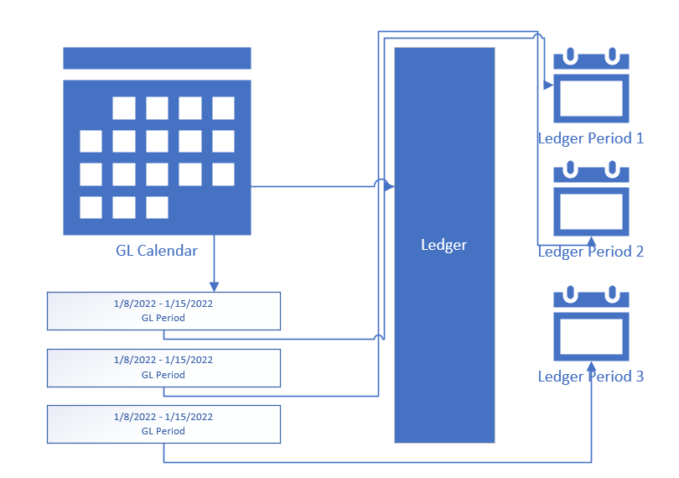
Each GL Calendar has several periods
GL calendar is assigned to the ledger
The ledger period shows all available periods on the GL calendar
When you open a period. The system creates a new period for that ledger
You can have multiple open periods but the system always uses the newest open period to post journals.
You can manually select periods only on manual journals.

