Linux Process Creation Using fork(), exec(), and wait() System Calls
-2520030561
2520030106
2520030183
2520030480
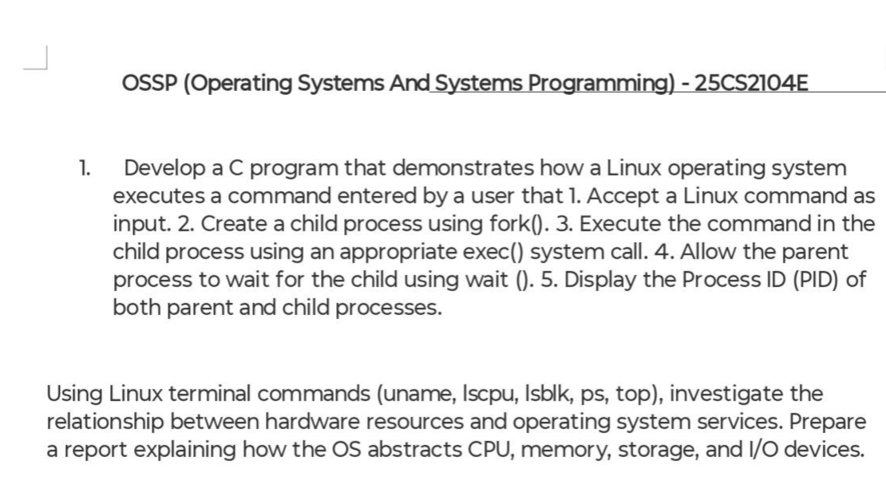
Aim
To develop a C program that accepts a Linux command from the user, creates a child process using the fork() system call, executes the command using the execvp() system call, synchronizes the parent process using wait(), and displays the Process IDs (PIDs) of both the parent and child processes.
Requirements
- Ubuntu Linux
- GCC Compiler
- C Programming Language
- Linux Terminal
Theory
Linux is a multitasking operating system that manages multiple processes efficiently. A process is a program in execution. Linux provides several system calls for process creation and management.
- fork() creates a new child process by duplicating the parent process.
- execvp() replaces the child process with a new program specified by the user.
- wait() makes the parent process wait until the child process completes execution.
- getpid() returns the Process ID (PID) of the current process.
- getppid() returns the Parent Process ID (PPID) of the current process.
These system calls are essential for understanding process management in Linux.

Algorithm
- Start the program.
- Include the required header files.
- Accept a Linux command from the user.
- Remove the newline character from the input.
- Split the command into individual arguments.
- Create a child process using fork().
- If the child process is created:
  - Display the Child PID and Parent PID.
  - Execute the command using execvp().
- If the current process is the parent:
  - Display the Parent PID and Child PID.
  - Wait for the child process using wait().
- Display the completion message.
- Stop the program.

Code
#include <stdio.h>
#include <stdlib.h>
#include <unistd.h>
#include <string.h>
#include <sys/types.h>
#include <sys/wait.h>
#define MAX_ARGS 20
int main()
{
char input[100];
char *args[MAX_ARGS];
// Read Linux command
printf("Enter a Linux command: ");
fgets(input, sizeof(input), stdin);
// Remove newline character
input[strcspn(input, "\n")] = '\0';
// Split the command into arguments
int i = 0;
args[i] = strtok(input, " ");
while (args[i] != NULL && i < MAX_ARGS - 1)
{
i++;
args[i] = strtok(NULL, " ");
}
// Create child process
pid_t pid = fork();
if (pid < 0)
{
printf("Fork failed!\n");
return 1;
}
// Child Process
else if (pid == 0)
{
printf("\n===== Child Process =====\n");
printf("Child PID : %d\n", getpid());
printf("Parent PID : %d\n", getppid());

// Execute Linux command
execvp(args[0], args);
// Executes only if execvp fails
perror("Execution Failed");
exit(1);
}
// Parent Process
else
{
printf("\n===== Parent Process =====\n");
printf("Parent PID : %d\n", getpid());
printf("Child PID : %d\n", pid);
// Wait for child process
wait(NULL);
printf("\nChild process completed successfully.\n");
}
return 0;
}

Commands Used
Compile the program:
gcc Week1_Task.c -o Week1_Task
Run the program:
./Week1_Task
Example Input:
uname -a

Linux Commands Studied
1. uname
Command:
uname -a
Purpose: Displays information about the Linux kernel, operating system, and architecture.

2. lscpu
Command:
lscpu
Purpose: Displays CPU architecture, processor model, number of cores, threads, and cache information.

3. lsblk
Command:
lsblk
Purpose: Lists storage devices, partitions, and mounted file systems.

4. ps
Command:
ps
Purpose: Displays the currently running processes.

5. top
Command:
top
Purpose: Displays real-time information about CPU usage, memory usage, and active processes.

Observation
- The fork() system call successfully created a child process.
- The child process executed the Linux command using execvp().
- The parent process waited until the child process completed execution using wait().
- Different Process IDs (PIDs) were observed for the parent and child processes.
- Linux commands such as uname, lscpu, lsblk, ps, and top provided useful information about the operating system and hardware resources.

Result
The program was executed successfully. The child process executed the user-entered Linux command using execvp(), while the parent process waited using wait(). The Process IDs of both the parent and child processes were displayed correctly, demonstrating Linux process creation, command execution, and process synchronization.

