MINI PROJECT REPORT
ON
"GWASOAT — Biometric Attendance Management System"
Under the Course
DATABASE MANAGEMENT SYSTEMS (ETCS302)

SUBMITTED BY
PRN | NAME OF STUDENT

2026-27
Third Year Electronics and Communication Engineering (TY ECE)
Division: B, Semester - I

Under the Guidance Of
Mr. Abhijeet Karve

School of Engineering and Technology
DES Pune University, Pune
2026-2027

Program: B. Tech Electronics and Communication Engineering
School of Engineering and Technology
DES Pune University, Pune

CERTIFICATE
This is to certify that the students _________________________ and _________________________, PRN ________________ and ________________, studying in TY ECE (Division B), Semester I, have successfully completed and submitted the Mini Project Report under the course “Database Management Systems”, entitled “GWASOAT — Biometric Attendance Management System”. This work is submitted in partial fulfilment of the requirements for the degree of Bachelor of Technology in Electronics and Communication Engineering of DES Pune University, Pune, during the academic year 2026-2027.

Abhijeet Karve | DR. PRACHI JOSHI
Mentor | HoS

ACKNOWLEDGMENT
We would like to express our sincere gratitude to our faculty mentor, Mr. Abhijeet Karve, for his valuable guidance, support and encouragement throughout this Database Management Systems mini-project titled “GWASOAT — Biometric Attendance Management System”. His review comments encouraged us to add role-based access control, a student self-service portal and a grades module, which made the project much more complete.
We would also like to thank the School of Engineering and Technology and DES Pune University, Pune, for giving us the opportunity and the academic environment to undertake this project.
We are grateful to the developers and documentation teams of MySQL, MySQL Workbench, Python, Flask, MySQL Connector/Python, Bootstrap and the ESP32 / Arduino ecosystem, whose tools made it possible to design the database, build the firmware and the desktop application, and test the system end to end.
This project strengthened our understanding of relational database design, SQL, transactions, triggers, views, stored procedures and the way a database connects to an embedded device and a desktop application.

ABSTRACT
A biometric attendance system must store students, classes, courses, fingerprint templates, attendance sessions and the attendance records, and must keep them consistent while many students are marked in a single session. This project designs and implements GWASOAT, a biometric attendance management system built around an ESP32 microcontroller with an FPM383C fingerprint sensor, a Python/Flask desktop application and a MySQL database named gwasoat. The database has fourteen tables (users, departments, classes, batches, students, courses, course_students, fingerprint_templates, attendance_sessions, session_attendance, grades, timetable, role_permissions and audit_log). It uses primary and foreign keys, UNIQUE and CHECK constraints, inner and outer joins, subqueries, aggregate functions with GROUP BY and HAVING, views, indexes, stored procedures, functions and triggers, and table-driven role-based access control.
The firmware is written in C++ on the Arduino framework; the desktop back end is built with Python Flask and rendered in a native window through pywebview, and the two talk to the ESP32 over WiFi HTTP with an automatic BLE fallback. Flask connects to MySQL through MySQL Connector/Python using parameterized queries. The system provides fingerprint enrolment, loading a class roster onto the device, live attendance marking, defaulter reports, CSV export, a grades module, a timetable and separate dashboards for three roles: Administrator, Teacher and Student. Role-based login uses hashed passwords and server-side permission checks driven by a role_permissions table. Attendance marking and cancellation run as transactions. The system was tested end to end and the results are reported in Chapter 4.
Keywords: DBMS, MySQL, ESP32, fingerprint biometrics, Flask, SQL joins, transactions, triggers, views, role-based access control, attendance

INDEX
CHAPTER NO. |  | TOPIC
1 |  | Introduction
 | 1.1 | Background
 | 1.2 | Need / Importance
 | 1.3 | Objectives
 | 1.4 | Scope
2 |  | Literature Review
 | 2.1 | Relevant concepts, theories
 | 2.2 | Technologies related to the project
 | 2.3 | Summary of similar works or case studies
3 |  | Proposed Methodology
 | 3.1 | System Overview
 | 3.2 | Architecture / Workflow Diagram
 | 3.3 | Data Collection / Input Description
 | 3.4 | Algorithms / Techniques Used
 | 3.5 | Tools, software, or equipment used
 | 3.6 | Module-wise Implementation Plan
 | 3.7 | Validation and Testing Strategy
4 |  | Results / Observations
 | 4.1 | Experimental / Implementation Setup
 | 4.2 | Performance Metrics
 | 4.3 | Comparison with Expected Results
 | 4.4 | Observations and Analysis
 | 4.5 | Validation and Verification with summary of findings
5 |  | Future Enhancement
6 |  | Conclusion & Recommendations
7 |  | References / Bibliography

CHAPTER 1: INTRODUCTION

1.1 Background
Colleges must record which students attend each class, keep the records for every course over a semester, and produce reports such as attendance percentages and defaulter lists. Manual roll-calls are slow, easy to fake through proxy attendance, and tedious to total at the end of a term. A biometric system removes proxy attendance because a fingerprint cannot be shared. A Database Management System (DBMS) stores the students, courses, sessions and attendance in related tables, enforces rules on them, and lets administrators, teachers and students read exactly the data their role needs. GWASOAT links an ESP32 device with an FPM383C fingerprint sensor to a Python/Flask desktop application backed by a MySQL database, so that a fingerprint scan on the device becomes a row in the attendance table almost immediately.

1.2 Need / Importance
An attendance system has problems a spreadsheet cannot solve. A student must not be marked present twice in the same session. Starting, marking and stopping a session must update several tables together, or not at all. A teacher should see only their own courses, and a student should see only their own attendance and grades. Fingerprint templates, which are sensitive biometric data, must be stored safely and linked to exactly one student. This project uses relational design, constraints, triggers, views, transactions and table-driven role-based access control to solve these problems, and shows how a database connects to both an embedded device and a working desktop application.

1.3 Objectives
- Design and use a relational database, gwasoat, for biometric attendance management across departments, classes, batches, courses and students.
- Demonstrate SQL concepts: joins, nested queries, aggregate functions, GROUP BY and HAVING, views, indexes, stored procedures, functions, cursors and triggers.
- Build an ESP32 firmware and a desktop application for fingerprint enrolment, live attendance marking, reports, CSV export, grades and a timetable.
- Connect the application to MySQL using Flask and MySQL Connector/Python with parameterized queries.
- Prevent invalid and duplicate attendance using validation, UNIQUE constraints and transactions.
- Add role-based login with three roles (Administrator, Teacher, Student), a student self-service portal and an audit log, as requested in the faculty review.

1.4 Scope
The work is a college DBMS mini-project that runs on a local computer with an ESP32 device on the same WiFi network (or paired over BLE). It covers department, class, batch, course and student management, fingerprint enrolment, loading a class onto the device, live attendance marking, defaulter reports, CSV export, grades, a timetable and dashboards for Administrator, Teacher and Student. It does not cover a public cloud deployment, a mobile app, face recognition, payroll or fee integration, or multi-campus synchronisation; the cloud-sync layer is an optional local backup, not a hosted service.

CHAPTER 2: LITERATURE REVIEW

2.1 Relevant Concepts and Theories
- Relational model and keys: Data is stored in tables. A primary key identifies a row, and a foreign key links to a primary key in another table (for example students.class_id to classes.id).
- Constraints: NOT NULL, UNIQUE, DEFAULT and CHECK constraints keep data valid inside the database itself (for example a unique (session_id, student_id) pair prevents duplicate marking).
- Joins: An inner join returns only matching rows; a left join returns every row from the left table and fills NULL where the right table has no match (used so a student with no attendance row still appears in reports).
- Subqueries and aggregates: A query inside another query, and the functions COUNT, SUM, AVG, MIN and MAX with GROUP BY and HAVING, used for attendance percentages and defaulter lists.
- Views: Saved queries that behave like virtual tables, used to give each role a ready-made summary (student directory, attendance summary, course defaulters).
- Triggers, stored procedures, functions and cursors: A trigger runs automatically on an event such as INSERT or DELETE; a stored procedure or function is saved SQL called by name; a cursor walks a result set row by row.
- Indexes: Structures that speed up searching on a column, such as an index on attendance_sessions(course_id, started_at).
- Transactions (ACID): A group of operations that either all succeed (commit) or all fail (rollback). InnoDB supports transactions, foreign keys and row locking.
- Authentication and authorization: Authentication checks who the user is (login with a password hash); authorization checks what that user may do (role and permission checks on each request, driven by the role_permissions table).
- SQL injection: An attack where input is inserted into an SQL string. Parameterized queries (%s placeholders) prevent it.

2.2 Technologies Related to the Project
MySQL 8.0 with the InnoDB engine and MySQL Workbench are used for the database. Python with the Flask framework is used for the desktop back end, rendered in a native window through pywebview; the front end uses HTML, CSS, JavaScript, jQuery and Bootstrap 5. The mysql-connector-python driver connects Flask to MySQL and Werkzeug / a SHA-256 salted hash protects passwords. The ESP32 firmware is written in C++ on the Arduino framework (PlatformIO) and talks to the FPM383C fingerprint sensor, an SSD1306 OLED and a MicroSD card; it communicates with the desktop over WiFi HTTP (AsyncTCP / ESPAsyncWebServer) with an automatic BLE GATT fallback (bleak on the PC, NimBLE on the device). A small SQLite store keeps local device and network settings.

2.3 Summary of Similar Works
College attendance products and RFID- or fingerprint-based systems follow the same pattern: identify the student, record a timestamped attendance row, and report percentages per course. Many student projects stop at an SQL schema in a database client, or store attendance in a single flat table. GWASOAT goes further by linking a real biometric device to a relational database, normalising the data across fourteen tables, protecting it with table-driven role-based access control, keeping a fingerprint template as sensitive data in a one-to-one table, and handling the start/mark/stop workflow with transactions so that attendance stays consistent even when the device connection drops to BLE.

CHAPTER 3: PROPOSED METHODOLOGY

3.1 System Overview
The web UI, rendered inside a pywebview window, sends requests to Flask routes. Each route checks the user's role and permissions, runs parameterized SQL through MySQL Connector, and returns JSON that the page renders with jQuery. To run attendance, the Flask app talks to the ESP32 device over WiFi HTTP (or BLE if WiFi is down): it loads the enrolled fingerprint templates, starts the session, polls the device for matches, and writes the results to MySQL. Three roles use the system: Administrator, Teacher and Student.

3.2 Architecture / Workflow Diagram
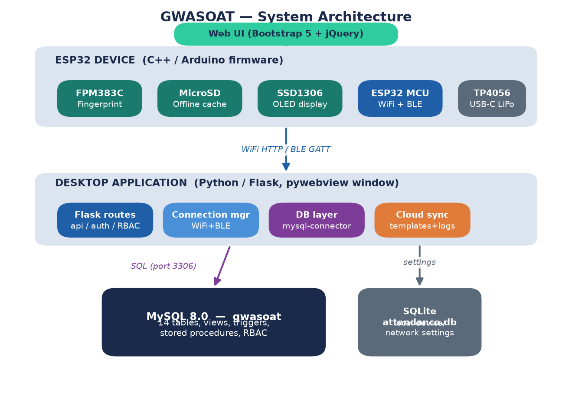
Fig. 3.1 System architecture (three tiers: ESP32 device, Flask desktop app, MySQL database)

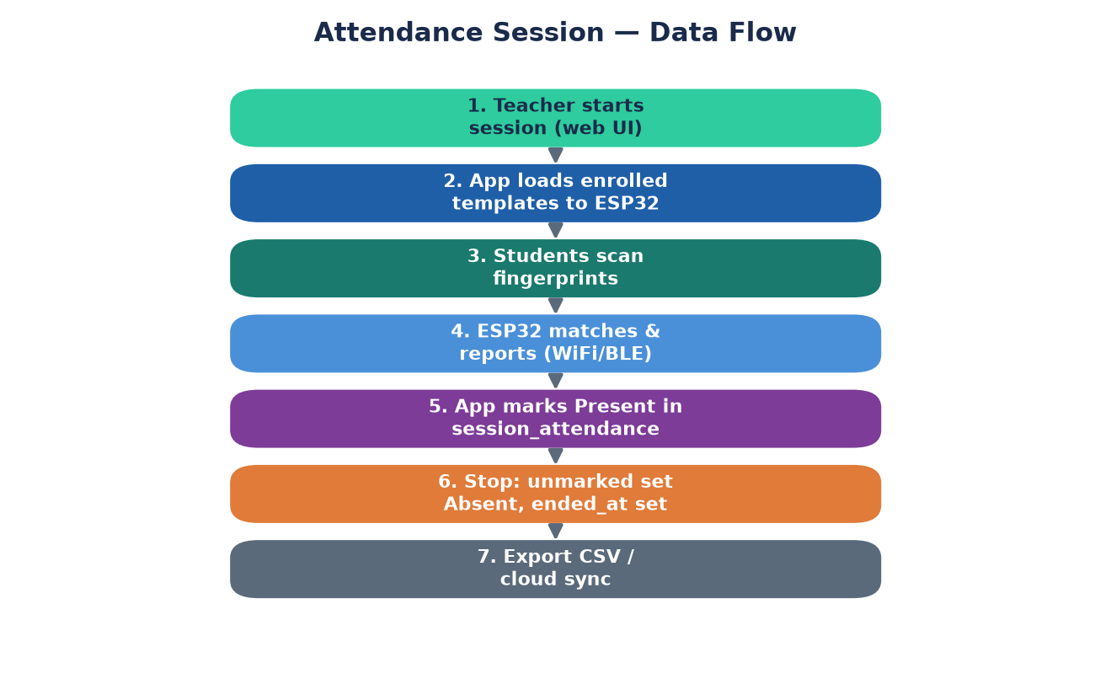
Fig. 3.2 Attendance session data-flow
The system has three layers: the ESP32 device (fingerprint sensor, OLED, SD card, WiFi/BLE); the desktop application (Flask routes, role checks, the connection manager and the MySQL database layer); and MySQL 8.0 holding all domain data. A small SQLite file keeps local device and network settings only.
Attendance workflow: the teacher opens a course and starts a session; the app clears the sensor and uploads the enrolled templates to the ESP32; students scan their fingers; the device matches each scan and reports the student id; the app marks that student Present in session_attendance; when the teacher stops the session, every student still unmarked is set to Absent and ended_at is recorded. Records can then be exported to CSV or synced to the optional cloud backup.
Database schema summary
Relationships: a department has many classes; a class has many batches and many students; a teacher (user) teaches many courses; a course has many enrolled students through course_students (many-to-many); a student has exactly one fingerprint template (one-to-one); a course has many attendance sessions; a session records many students through session_attendance (many-to-many); a student receives many grades; and a student login account links one-to-one to a students row.

3.3 Data Collection / Input Description
- Sample data: one or more departments, classes (with a year) divided into batches, courses with a code and a teacher, and students with a PRN and roll number. The test data used one class with six registered students and three courses.
- User inputs: login email and password with a role hint; department, class, batch, course and student details; CSV roster files for bulk import; a fingerprint scan during enrolment; a session description (topic covered); and grade components and scores.
- Device inputs: the FPM383C captures a fingerprint and returns a template (a LONGBLOB) that is stored once per student in fingerprint_templates and re-loaded onto the sensor at the start of each session.
- Roles and permissions: the role_permissions table seeds admin ('*'), ten teacher permissions (course.view, attendance.run, report.export, grade.edit, ...) and six student permissions (self.attendance.view, self.grade.view, ...).

3.4 Algorithms / Techniques Used
1. Fingerprint enrolment. The app asks the ESP32 to scan a finger, polls /register_status until success, downloads the template with /get_template and stores it with an INSERT ... ON DUPLICATE KEY UPDATE into fingerprint_templates (so re-enrolling a student replaces the old template); students.registered is set to 1.
2. Loading a class. At the start of a session the app selects the enrolled students and their templates with a join of fingerprint_templates, students and course_students, clears the sensor, and uploads each template (base64) to the device.
3. Start-session transaction.
- Close any session left open for the course (set its unmarked rows to Absent and set ended_at).
- INSERT a row into attendance_sessions with the course, teacher, class, batch and started_at, and read back the new session_id.
- INSERT IGNORE one session_attendance row per enrolled student with status '--' (unmarked); the UNIQUE (session_id, student_id) key makes this idempotent.
- Commit, or roll back on any error.
4. Marking attendance. When the device reports a matched student id, the app checks the student's current status; if not already Present it sets status = 'Present' and marked_at = now. The same student cannot be counted twice because of the UNIQUE (session_id, student_id) key and the status check.
5. Stop-session transaction. Every session_attendance row still '--' is set to 'Absent', and attendance_sessions.ended_at is set. The records are then available for export and optional cloud upload.
6. Reports and defaulters. For a course, the app counts the sessions held and, per student, counts the Present rows with COUNT and SUM(CASE WHEN status = 'Present' ...), groups by student, and computes the percentage; a student below a configurable threshold (default 75%) is flagged a defaulter.
7. Role-based access. Passwords are stored as salted SHA-256 hashes, sessions are signed with a secret key, and each protected route uses a decorator (login_required, permission_required('grade.edit'), course_owner_required) that checks the role_permissions table on the server. A teacher can manage grades only for their own courses; a student is contained to the /student area.
8. Views (one per summary). v_student_directory, v_student_attendance_summary and v_course_defaulters give ready-made, role-appropriate summaries.
9. Triggers. trg_template_sync_registered (AFTER INSERT on fingerprint_templates) sets students.registered = 1; the matching AFTER DELETE trigger resets it to 0; trg_grade_validate_ins/_upd (BEFORE INSERT/UPDATE on grades) raise SIGNAL SQLSTATE '45000' if a score is invalid; trg_student_delete_audit records deleted students.
10. Stored procedures and functions. sp_course_attendance_pct(student, course, OUT pct), sp_attendance_grade(... OUT standing) using CASE, and the function fn_attendance_pct(student, course) return attendance metrics by name.
11. Cursor. sp_recompute_enrollment_percentages walks course_students with a cursor and a CONTINUE HANDLER, calling fn_attendance_pct and upserting the final percentage into an enrollments table.
12. Indexes. idx_sessions_course_date on attendance_sessions(course_id, started_at), idx_session_att_student and idx_session_att_status on session_attendance, idx_students_class and idx_grades_student.
Sample query (per-course attendance percentage with joins and aggregates)
SELECT c.name AS course,
COUNT(DISTINCT ses.id) AS sessions_held,
SUM(sa.status = 'Present') AS present_marks,
ROUND(AVG(sa.status = 'Present') * 100, 2) AS attendance_pct
FROM courses c
JOIN attendance_sessions ses ON ses.course_id = c.id
LEFT JOIN session_attendance sa ON sa.session_id = ses.id
GROUP BY c.id, c.name
HAVING COUNT(DISTINCT ses.id) >= 1
ORDER BY attendance_pct DESC;
Joins used
Join | Result
attendance_sessions to courses | Course name and code for each session
attendance_sessions to users | Teacher who conducted the session
session_attendance to students | Roll number and PRN of each marked student
students to course_students to courses | Which students are enrolled in a course
students LEFT JOIN fingerprint_templates | Whether a student has a template (still listed if not)
students LEFT JOIN session_attendance | A student with no attendance row still appears in the report
courses LEFT JOIN users (teacher) | A course with no assigned teacher still lists
Why duplicate marking is prevented. session_attendance has a UNIQUE key on (session_id, student_id), so a student can have only one row per session; marking updates that row rather than inserting a second one, and the status check skips a student already Present.

3.5 Tools and Software
- MySQL 8.0 (InnoDB) and MySQL Workbench 8.0 CE; a small SQLite store for local settings.
- Python 3.12 with Flask, mysql-connector-python, pywebview, requests and (optional) bleak for BLE.
- C++ on the Arduino framework via PlatformIO for the ESP32 firmware (ESP32Async, ArduinoJson, Adafruit SSD1306/GFX, NimBLE-Arduino, SD).
- HTML, CSS, JavaScript, jQuery and Bootstrap 5.3 for the front end.
- Hardware: ESP32 DOIT DevKit v1, FPM383C fingerprint sensor, SSD1306 OLED, MicroSD card, TP4056 USB-C LiPo charger, and a custom 85×55 mm 2-layer KiCad PCB.
- Visual Studio Code and Google Chrome / the pywebview native window.

3.6 Module-wise Implementation Plan
- Module 1: Database design and creation (14 tables, constraints, RBAC seed data).
- Module 2: SQL features (joins, nested queries, aggregates, views, indexes, stored procedures, functions, a cursor and triggers) in dbms_syllabus_demo.sql.
- Module 3: ESP32 firmware (fingerprint, OLED, SD, WiFi HTTP server and BLE GATT).
- Module 4: Flask project setup, MySQL connection layer and schema bootstrap.
- Module 5: Authentication, sessions and table-driven role-based access control.
- Module 6: Department / class / batch / course / student management and CSV import.
- Module 7: Fingerprint enrolment and loading a class onto the device.
- Module 8: Attendance start / mark / stop, reports, defaulters and CSV export.
- Module 9: Grades module and timetable.
- Module 10: Student self-service portal (own courses, attendance, grades, timetable).
- Module 11: Audit log, optional cloud sync, testing and documentation.

3.7 Validation and Testing Strategy
- Frontend validation: required fields, email and date types, length limits, numeric score ranges and client-side search / sort on tables.
- Backend validation (the real checks): role and permission checks on every route, course ownership for teachers, student containment to their own data, score within 0..max_score, enrolment checks before grading, and password length.
- Database validation: primary and foreign keys, UNIQUE keys (email, (session_id, student_id), (course_id, student_id), (student_id, course_id, component)), NOT NULL and CHECK constraints, triggers that validate grades and keep students.registered in sync, and transactions.
- Functional testing: an end-to-end test of each role, enrolment, a full attendance session, reports and CSV export, checking the database with SQL after each action.
- Security checks: passwords hashed, queries parameterized, roles checked on the server and verified by opening another role's URL directly, and biometric templates stored only in the one-to-one fingerprint_templates table.

CHAPTER 4: RESULTS / OBSERVATIONS

4.1 Experimental / Implementation Setup
MySQL 8.0 on localhost port 3306, database gwasoat, accessed by a dedicated user gwasoat_user. The Flask development server runs on port 5000 and is shown in a pywebview window at http://127.0.0.1:5000/. The ESP32 device runs its firmware and is reached over WiFi (or BLE as a fallback). The test setup used one class with six registered students and three courses. The administrator account is seeded automatically; teacher and student accounts are created by the admin or backfilled from the students table.
Entity Relationship Diagram
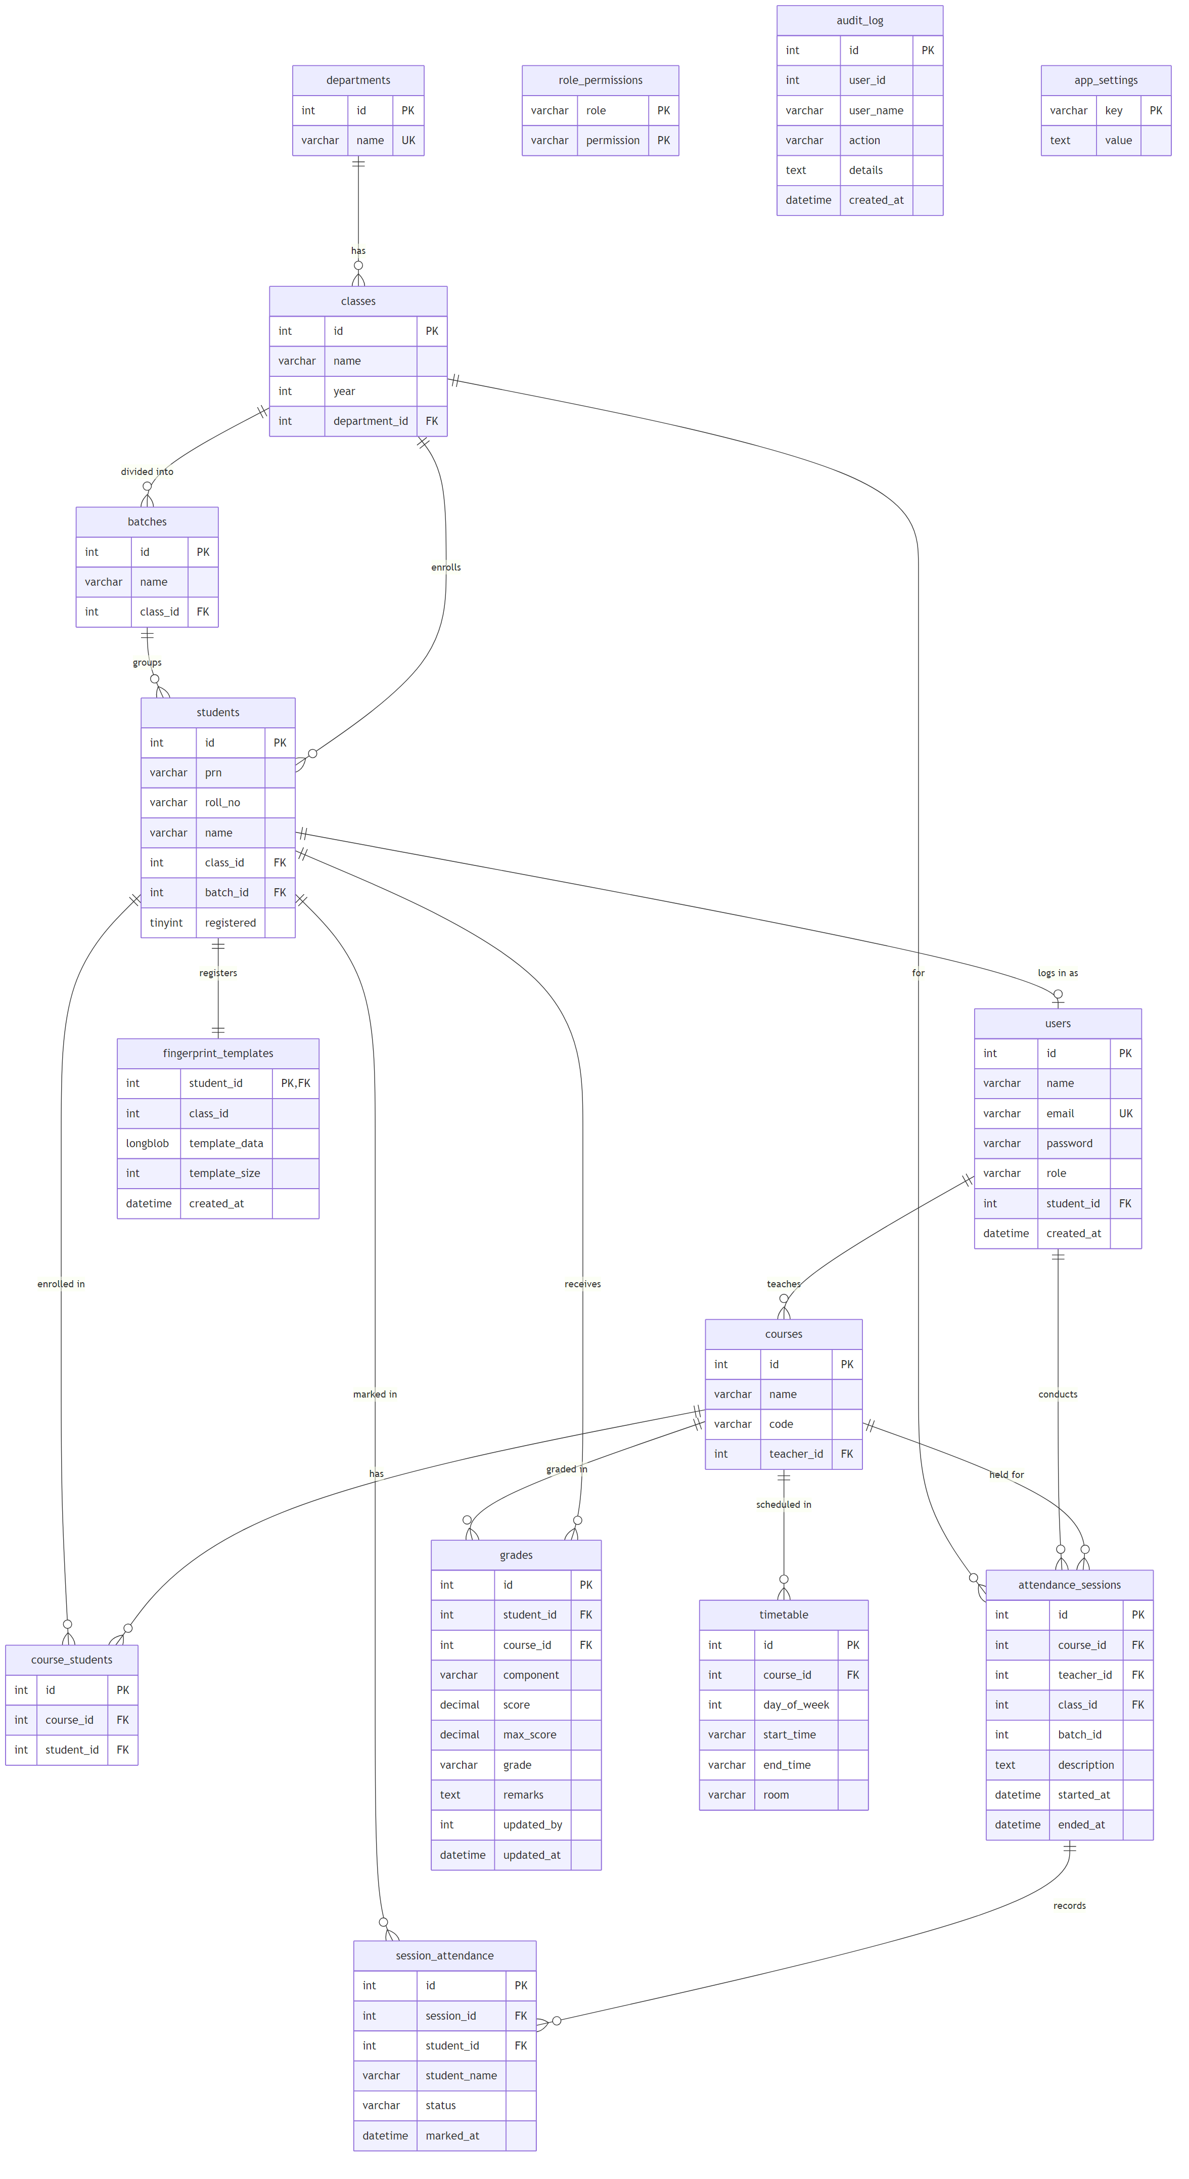
Fig. 4.1 ER diagram of the gwasoat database (14 tables, crow's-foot notation)
Database objects implemented
Object | Count / name
Tables | 14 (users, departments, classes, batches, students, courses, course_students, fingerprint_templates, attendance_sessions, session_attendance, grades, timetable, role_permissions, audit_log)
Views | 3 (v_student_directory, v_student_attendance_summary, v_course_defaulters)
Indexes | 5 secondary indexes plus PK/UNIQUE/FK indexes
Stored procedures / functions | sp_course_attendance_pct, sp_attendance_grade, sp_recompute_enrollment_percentages (cursor), fn_attendance_pct
Triggers | 4 (template sync register/unregister, grade validate, student delete audit)
Roles (RBAC) | 3 (Administrator, Teacher, Student) via role_permissions
Web pages | Login, Dashboard/Home, Course, Admin, Profile, Student home, Student course, plus CSV exports
Schema notes (recorded during development)
- fingerprint_templates stores the biometric template as a LONGBLOB in a one-to-one table keyed by student_id, keeping sensitive data isolated from the rest of the schema.
- students.id is the fingerprint-sensor slot id (not auto-increment), so the same number identifies a student in the database and on the device.
- A small SQLite store (attendance.db) holds only local device/network settings; all domain data lives in MySQL.

4.2 Performance Metrics
Since this is a DBMS project, the metrics are correctness and consistency rather than speed:
- Number of duplicate or invalid attendance rows accepted (target: 0).
- Consistency between attendance_sessions, session_attendance and students.registered after enrolment, marking and stopping a session.
- Role access blocked correctly (a teacher cannot open another teacher's course; a student cannot reach admin pages).
- Attendance totals on the dashboard, the report and the CSV export agree with each other.
- Correct attendance-percentage and defaulter calculation against a configurable threshold.

4.3 Comparison with Expected Results
Fill the Observed column after running each test on the live system.
Test | Expected | Observed
Log in as each role | Redirected to the correct dashboard (admin/home/student)
Enrol a fingerprint | Template stored, students.registered set to 1
Load a class and start a session | session_attendance rows created with status '--'
Scan an enrolled finger | Student marked Present, marked_at set
Scan the same finger again | No duplicate row; stays Present
Stop the session | Unmarked students set to Absent, ended_at set
View course report | Correct percentage; defaulters below 75% flagged
Export CSV | File with roll no, PRN, name, status, marked at
Teacher opens another teacher's course | Access denied (403)
Student opens /admin | Redirected / denied
Add an invalid grade (score > max) | Rejected by trigger (SQLSTATE 45000)
Delete a registered student | Login account removed first, then student row

4.4 Observations and Analysis
Paste the application screenshots into the boxes below; captions describe what each screen shows.
[ Paste screenshot here ]
Fig. 1 Login page (role tabs: Admin / Teacher / Student)

[ Paste screenshot here ]
Fig. 2 Dashboard (today's sessions, course and student counts, attendance rate)

[ Paste screenshot here ]
Fig. 3 Course page with batches and the Start / Stop attendance controls

[ Paste screenshot here ]
Fig. 4 Live attendance session (students being marked Present)

[ Paste screenshot here ]
Fig. 5 Course report with attendance percentages and flagged defaulters

[ Paste screenshot here ]
Fig. 6 Admin dashboard (departments, classes, courses, teachers, students)

[ Paste screenshot here ]
Fig. 7 Grades page (teacher editing per-component scores)

[ Paste screenshot here ]
Fig. 8 Student portal (own attendance and grades, read-only)

[ Paste screenshot here ]
Fig. 9 MySQL Workbench: session_attendance before and after a session

Observations
- The AFTER INSERT trigger on fingerprint_templates sets students.registered to 1 automatically, and the AFTER DELETE trigger resets it, so the registered flag always matches the presence of a template.
- The UNIQUE (session_id, student_id) key combined with the status check means a student scanning twice is never counted twice; the second scan is ignored.
- Because the trigger, the views and the transactions all work on the same tables, a start / mark / stop cycle leaves attendance_sessions, session_attendance and students.registered consistent.
- Left joins were needed for session_attendance and fingerprint_templates so that students with no attendance or no template still appear in reports.
- The grade-validation trigger rejects a score greater than max_score at the database level, mirroring the Python validation (defense in depth).
Useful demonstration queries
-- Latest attendance session and its marks
SELECT * FROM attendance_sessions ORDER BY id DESC LIMIT 1;
SELECT * FROM session_attendance WHERE session_id =
(SELECT MAX(id) FROM attendance_sessions);
-- Courses with more than one session and their present counts
SELECT c.name, COUNT(DISTINCT ses.id) AS sessions,
SUM(sa.status = 'Present') AS present
FROM courses c
JOIN attendance_sessions ses ON ses.course_id = c.id
LEFT JOIN session_attendance sa ON sa.session_id = ses.id
GROUP BY c.id HAVING COUNT(DISTINCT ses.id) > 1;
-- Students never marked present (nested query)
SELECT name FROM students WHERE id NOT IN
(SELECT student_id FROM session_attendance WHERE status = 'Present');
-- Call a stored procedure
CALL sp_course_attendance_pct(1, 1, @pct); SELECT @pct;

4.5 Validation and Summary of Findings
- Data integrity: primary keys, foreign keys, UNIQUE and CHECK constraints prevent invalid or duplicate rows.
- Concurrency and consistency: the start / mark / stop workflow runs as transactions, so an error rolls everything back and the three attendance tables stay in step.
- Security: passwords are salted-hashed, queries are parameterized, roles and permissions are checked on the server from the role_permissions table, teachers are limited to their own courses, and students are contained to their own data.
- Biometrics: fingerprint templates live only in the one-to-one fingerprint_templates table and are re-loaded onto the device per session rather than being trusted from the sensor permanently.
- Roles: Administrator, Teacher and Student each open only their own dashboards and APIs.
- Limitations: the cloud sync is an optional local backup rather than a hosted service; the system runs over HTTP on a local machine with no CSRF tokens or rate limiting; and some legacy single-class utility scripts still use the older SQLite-style calls.

CHAPTER 5: FUTURE ENHANCEMENT
- Deploy the back end on a hosted server with HTTPS so multiple teachers can use it at once, and add CSRF protection and login rate limiting.
- Turn the optional cloud-sync layer into a real hosted service with authenticated template and attendance synchronisation across devices.
- Add a mobile companion app for teachers to start and monitor sessions.
- Encrypt fingerprint templates at rest and add an explicit consent / retention policy for biometric data.
- Add admin reports and charts for attendance trends and defaulter history across a semester.
- Support multiple simultaneous sessions and multiple devices in different classrooms.
- Replace the legacy single-class scripts with the course-based flow throughout and remove the older SQLite-style utilities.
- Add automated backups and a scheduled job that recomputes enrolment percentages using the cursor procedure.

CHAPTER 6: CONCLUSION AND RECOMMENDATIONS
This project designed and built GWASOAT, a biometric attendance management system on a MySQL database, connected to an ESP32 fingerprint device and a Flask desktop application. It demonstrates the main DBMS topics: relational design with constraints across fourteen tables, joins, subqueries, aggregates, views, indexes, stored procedures, a function, a cursor, triggers and transactions. It also shows how a database connects to an embedded device and a desktop front end through parameterized queries. Teachers can enrol fingerprints, run live attendance sessions, view defaulter reports, export CSV and record grades; administrators manage the whole institution; and students view their own attendance, grades and timetable behind table-driven role-based login. The start / mark / stop workflow keeps the attendance tables consistent, and UNIQUE keys prevent the same student being marked twice.
Recommendations:
- Use transactions whenever several tables must change together (start, mark and stop a session).
- Keep biometric data in its own one-to-one table and never trust a flag alone; derive status from the actual rows.
- Keep validation in three layers: the browser for convenience, the server for correctness, and the database (constraints and triggers) for last-line protection.
- Drive access control from a role_permissions table rather than hard-coded checks, so permissions can change without editing every route.
- Add HTTPS and a hosted database before any real deployment.

CHAPTER 7: REFERENCES / BIBLIOGRAPHY
- R. Elmasri and S. B. Navathe, Fundamentals of Database Systems. Pearson. (Add the edition and year used.)
- A. Silberschatz, H. F. Korth and S. Sudarshan, Database System Concepts. McGraw-Hill. (Add the edition and year used.)
- Oracle, “MySQL 8.0 Reference Manual.” Available: https://dev.mysql.com/doc/refman/8.0/en/
- Oracle, “MySQL Connector/Python Developer Guide.” Available: https://dev.mysql.com/doc/connector-python/en/
- Pallets Projects, “Flask Documentation.” Available: https://flask.palletsprojects.com/
- Bootstrap, “Bootstrap 5 Documentation.” Available: https://getbootstrap.com/docs/5.3/
- Espressif Systems, “ESP32 Technical Reference and Arduino-ESP32.” Available: https://docs.espressif.com/
- Python Software Foundation, “Python Documentation.” Available: https://docs.python.org/3/

