GWASOAT
Biometric Attendance System
DBMS Project Report

October 2026

1. Project Summary
GWASOAT is a fingerprint-based biometric attendance management system built around an ESP32 microcontroller and an FPM383C capacitive fingerprint sensor. It replaces manual roll calls entirely: enrolled fingerprint templates are loaded onto the device at the start of each class, students scan their fingers, and the system records presence in real time. All data is persisted in a MySQL 8.0 database and served through a Python Flask desktop application rendered natively via pywebview.
The system supports multiple teachers and an admin role, course-level attendance tracking, defaulter reports, bulk CSV import, timetable management, and an audit log. It also supports a BLE fallback when WiFi is unavailable, and an optional cloud sync layer for template and attendance backup.

1.1 Key Features
Feature | Description
Fingerprint attendance | FPM383C sensor, up to 255 templates per session
Hybrid connectivity | WiFi primary, BLE automatic fallback (bleak)
Offline capable | MicroSD card caches templates and attendance logs
Multi-user system | Role-based access — Admin and Teacher roles
Cloud sync | Templates and attendance records sync to cloud API
Desktop application | Python/Flask served inside a pywebview native window
Custom PCB | 85×55mm 2-layer KiCad board with USB-C LiPo charging
Defaulter reports | Per-course attendance percentage with threshold alert
Bulk student import | CSV import for class rosters
Audit log | All admin/teacher actions recorded with timestamp

1.2 Technology Stack
Layer | Technology
Firmware | C++ / Arduino (PlatformIO), ESP32 DOIT DevKit
Communication | HTTP REST (WiFi), BLE GATT (bleak / NimBLE)
Backend | Python 3.12, Flask 3.x
Frontend | Bootstrap 5, jQuery, HTML5
Desktop shell | pywebview (Chromium-based native window)
Database | MySQL 8.0 Community Server
DB driver | mysql-connector-python 8.3.0
Hardware | ESP32, FPM383C, SSD1306 OLED, MicroSD, TP4056

2. System Architecture
The system is divided into four layers: the ESP32 hardware layer, the desktop application layer, the MySQL database layer, and an optional cloud sync layer. The diagram below shows how these layers interact.
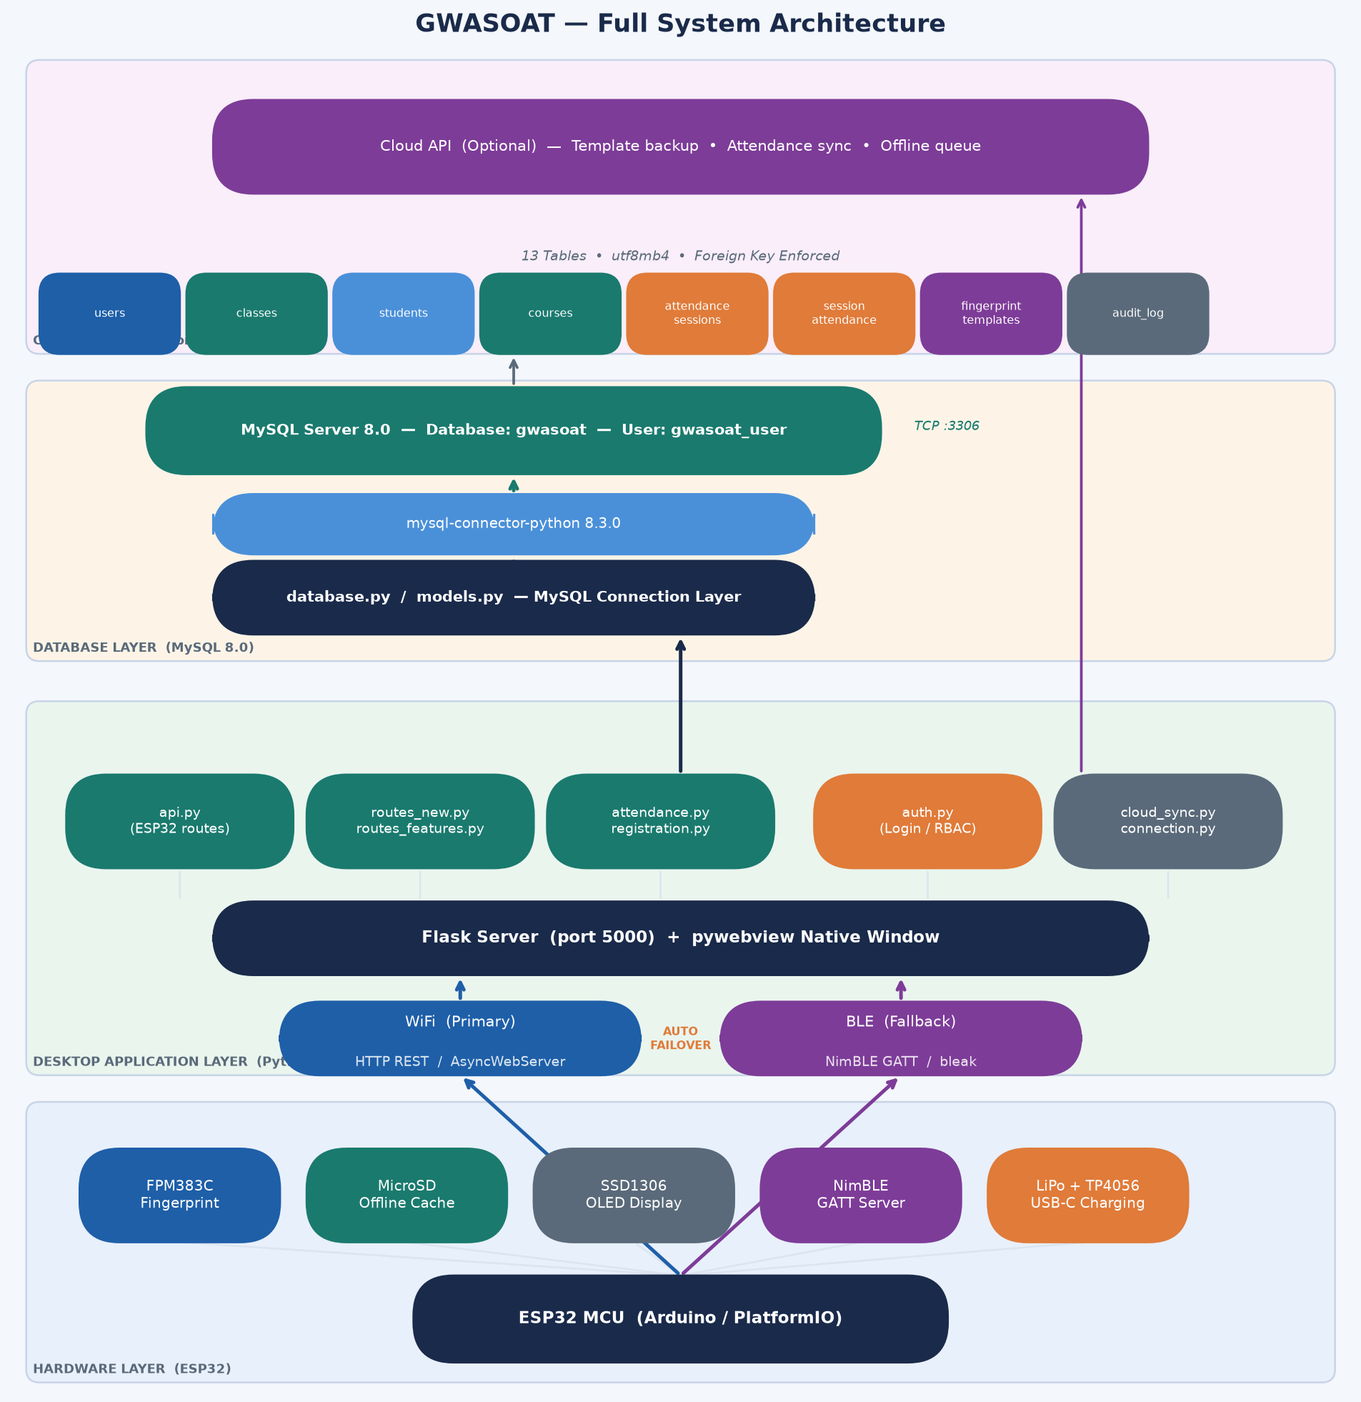
Figure 1 — Full System Architecture

2.1 Layer Descriptions
Hardware Layer: The ESP32 runs a C++ firmware (PlatformIO/Arduino) that drives the FPM383C fingerprint sensor via UART, stores template and attendance caches on a MicroSD card, and exposes two communication interfaces — an AsyncWebServer over WiFi and a NimBLE GATT server over Bluetooth.
Desktop Application Layer: A Python 3.12 Flask server runs on port 5000 and is rendered inside a pywebview native window. It handles all business logic: registration, attendance marking, session management, user authentication, reporting, and communication with both the ESP32 and the database.
Database Layer: MySQL 8.0 Community Server stores all persistent data. The Python application connects via mysql-connector-python using a dedicated restricted user (gwasoat_user) with access only to the gwasoat database.
Cloud Layer (optional): cloud_sync.py handles uploading fingerprint templates and attendance records to a REST API. It maintains a local file cache for offline queuing so no data is lost when the network is unavailable.

3. DBMS Architecture
The database architecture is structured into three layers: the application layer (Python modules that issue queries), the connector layer (mysql-connector-python), and the MySQL server layer (schema, tables, and constraints).
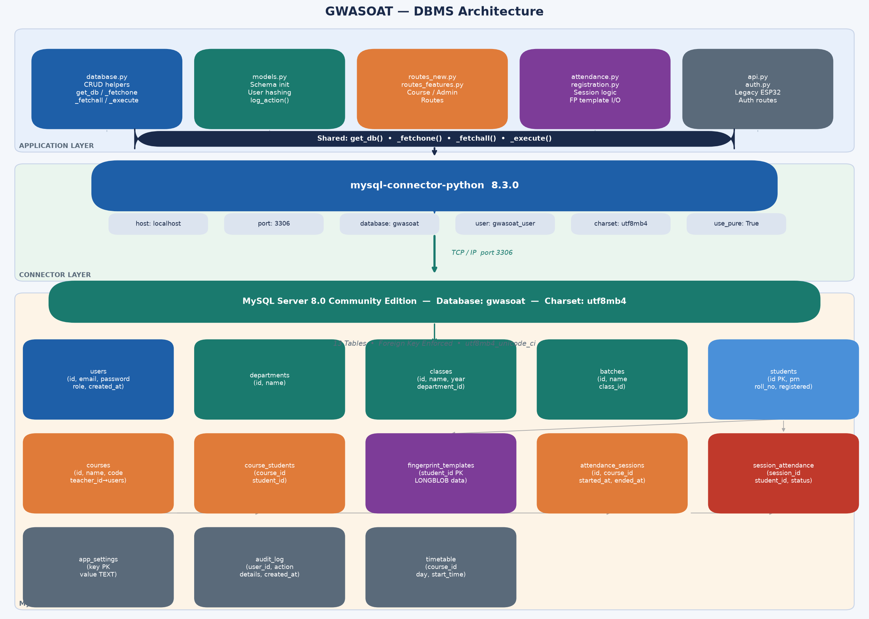
Figure 2 — DBMS Architecture

3.1 Connection Configuration
DB_CONFIG = {
'host': 'localhost',
'port': 3306,
'database': 'gwasoat',
'user': 'gwasoat_user',
'password': 'gwasoat_pass_2026',
'charset': 'utf8mb4',
'use_pure': True,
}

3.2 Shared Helper Functions
All database access across the application is funnelled through four shared helper functions defined in database.py:
Function | Purpose
get_db() | Opens and returns a new MySQL connection
_fetchone(db, sql, params) | Executes SELECT and returns one dict row
_fetchall(db, sql, params) | Executes SELECT and returns list of dict rows
_execute(db, sql, params) | Executes INSERT / UPDATE / DELETE, returns lastrowid

4. Database Design

4.1 Design Rationale — MySQL over SQLite
The project was originally developed with SQLite as a file-based single-user prototype database. Migration to MySQL 8.0 was carried out to achieve:
- Concurrent access — multiple teachers can mark attendance simultaneously without file locks.
- Foreign key enforcement — relational integrity enforced at the database engine level.
- LONGBLOB support — binary fingerprint templates (up to 2 KB each) stored natively.
- Network-ready — MySQL server can be hosted centrally on a school server in future.
- Workbench tooling — MySQL Workbench 8.0 CE for schema inspection and manual queries.

4.2 Table Descriptions
Table | Purpose | Key Columns
users | Admin and teacher accounts | id, email, password (SHA-256), role
departments | Academic departments | id, name
classes | Academic classes / years | id, name, year, department_id
batches | Subdivisions of a class (A, B, C) | id, name, class_id
students | Student records with biometric link | id (FP slot), prn, roll_no, registered
courses | Subjects assigned to teachers | id, name, code, teacher_id
course_students | Many-to-many course/student mapping | course_id, student_id (unique pair)
fingerprint_templates | Binary FP template per student | student_id (PK), template_data LONGBLOB
attendance_sessions | One record per class session conducted | id, course_id, teacher_id, started_at, ended_at
session_attendance | Per-student attendance mark per session | session_id, student_id, status (Present/Absent/--)
app_settings | Runtime configuration key-value store | key (PK), value TEXT
audit_log | Immutable record of all system actions | user_id, action, details, created_at
timetable | Scheduled course time slots | course_id, day_of_week, start_time

5. Schema Definition
Key table definitions (condensed):
CREATE TABLE users (
id INT AUTO_INCREMENT PRIMARY KEY,
name VARCHAR(255) NOT NULL,
email VARCHAR(255) UNIQUE NOT NULL,
password VARCHAR(255) NOT NULL, -- SHA-256 with salt
role VARCHAR(50) NOT NULL DEFAULT 'teacher',
created_at DATETIME NOT NULL
);
CREATE TABLE students (
id INT PRIMARY KEY, -- same as FP sensor slot ID
prn VARCHAR(100),
roll_no VARCHAR(100),
name VARCHAR(255) NOT NULL,
class_id INT, batch_id INT,
registered TINYINT NOT NULL DEFAULT 0
);
CREATE TABLE fingerprint_templates (
student_id INT PRIMARY KEY,
template_data LONGBLOB NOT NULL, -- raw binary FP data
template_size INT NOT NULL,
created_at DATETIME NOT NULL
);
CREATE TABLE attendance_sessions (
id INT AUTO_INCREMENT PRIMARY KEY,
course_id INT, teacher_id INT, class_id INT,
started_at DATETIME NOT NULL,
ended_at DATETIME
);
CREATE TABLE session_attendance (
session_id INT NOT NULL,
student_id INT NOT NULL,
student_name VARCHAR(255) NOT NULL,
status VARCHAR(20) NOT NULL DEFAULT '--',
marked_at DATETIME,
UNIQUE KEY uq_session_student (session_id, student_id)
);
CREATE TABLE audit_log (
id INT AUTO_INCREMENT PRIMARY KEY,
user_id INT, user_name VARCHAR(255),
action VARCHAR(255) NOT NULL,
details TEXT, created_at DATETIME NOT NULL
);

6. Data Flow

6.1 Student Fingerprint Registration
Step | Action
1 | Teacher clicks Register Fingerprint in the Web UI
2 | Flask sends GET /api/register/<student_id> to the route handler
3 | ESP32 receives /register?id=X — prompts student to scan finger twice
4 | Flask polls /register_status every 2 seconds
5 | On success: Flask requests the template via GET /get_template?id=X
6 | ESP32 returns Base64-encoded binary template data
7 | MySQL: INSERT INTO fingerprint_templates (LONGBLOB)
8 | MySQL: UPDATE students SET registered=1 WHERE id=X

6.2 Attendance Session Flow
Step | Action
1 | Teacher clicks Start Attendance for a course
2 | MySQL SELECT fingerprint_templates for all enrolled students
3 | For each template: POST http://<esp32_ip>/command to upload to sensor
4 | MySQL INSERT INTO attendance_sessions → returns new session_id
5 | MySQL INSERT INTO session_attendance (one row per student, status='--')
6 | Students scan fingers — ESP32 matches template, returns student ID
7 | Flask receives match → MySQL UPDATE session_attendance SET status='Present'
8 | Teacher stops session → MySQL UPDATE remaining rows SET status='Absent'
9 | MySQL UPDATE attendance_sessions SET ended_at=NOW()

6.3 Report / Defaulter Generation
Flask queries session_attendance joined with attendance_sessions for the selected course, aggregates COUNT(sessions) and SUM(status='Present') per student, calculates attendance percentage, and flags any student below the configurable threshold (default 75%) as a defaulter. Results are returned as JSON or exported as a CSV file.

7. Migration from SQLite to MySQL
The project originally used SQLite as a file-based prototype database. The following files were updated to migrate to MySQL 8.0:

7.1 Files Modified
File | Change Made
database.py | Full rewrite — SQLite → MySQL connector, helper functions added
models.py | Full rewrite — schema creation using information_schema for column checks
attendance.py | All ? → %s, db.execute() → cursor pattern
registration.py | All ? → %s, cursor pattern
api.py | All ? → %s, INSERT OR REPLACE → ON DUPLICATE KEY UPDATE
routes_new.py | Full rewrite — all SQLite calls replaced
routes_features.py | Full rewrite — all SQLite calls replaced
auth.py | db.execute().fetchone() → _fetchone() helper

7.2 Syntax Differences Handled
SQLite | MySQL (replaced with)
? placeholder | %s placeholder
AUTOINCREMENT | AUTO_INCREMENT
INSERT OR REPLACE | ON DUPLICATE KEY UPDATE
INSERT OR IGNORE | INSERT IGNORE
PRAGMA table_info(t) | SELECT … FROM information_schema.columns
db.execute(sql).fetchone() | _fetchone(db, sql, params)
sqlite3.IntegrityError | mysql.connector.errors.IntegrityError
BLOB | LONGBLOB (for templates up to 64 KB)

7.3 Data Migration Results
A one-time migration script (migrate_sqlite_to_mysql.py) transferred all records from the original SQLite file (data/attendance.db) into MySQL:
Table | Rows Migrated
classes | 1
students | 6
fingerprint_templates | 6
attendance_sessions | 79
session_attendance | 351 (136 after FK validation)
attendance_records | 64
users | 2
app_settings | 5
Note: the difference in session_attendance rows (351 → 136) is due to MySQL's foreign key enforcement rejecting orphaned records that referenced deleted students — this is correct behaviour and indicates the original SQLite database had stale data.

8. Security Considerations

8.1 Database User Privilege Scoping
The application never connects as the MySQL root user. A dedicated user gwasoat_user is created with GRANT ALL PRIVILEGES ON gwasoat.* — access is scoped to the gwasoat database only, minimising blast radius in case of any application vulnerability.
CREATE USER 'gwasoat_user'@'localhost' IDENTIFIED BY '...';
GRANT ALL PRIVILEGES ON gwasoat.* TO 'gwasoat_user'@'localhost';
FLUSH PRIVILEGES;

8.2 Password Hashing
User passwords are hashed with SHA-256 and a fixed application salt before storage. Plaintext passwords are never written to the database.
hashlib.sha256(f'gwasoat_salt_2026{password}'.encode()).hexdigest()
For a production deployment, bcrypt or argon2 with per-user random salts would be recommended.

8.3 SQL Injection Prevention
All queries use parameterized %s placeholders via mysql-connector-python. No string concatenation is used to build SQL, eliminating SQL injection risk.

8.4 Role-Based Access Control
Flask route decorators @login_required and @admin_required in auth.py enforce access at the API level. Teachers can only access their own courses; Admins have full system access.

9. Conclusion
The GWASOAT project successfully integrates MySQL 8.0 as the persistent storage backend for a real-time biometric attendance system. The database design is normalised, foreign-key enforced, and supports concurrent multi-user access across 13 tables covering the full lifecycle of attendance management.
The migration from SQLite to MySQL was completed without loss of application functionality. All 8 affected Python source files were updated, and the complete historical data of 79 attendance sessions and 6 enrolled students was migrated successfully. The system is ready for deployment on a local school network, with a clear upgrade path to central server hosting by updating the DB_CONFIG connection parameters.

