29.Randomized Block ANOVA With Excel

When you conduct a randomized block analysis of variance with Excel, the main output is an ANOVA summary table. As we've seen in previous lessons, an ANOVA summary table holds all the information we need to answer the research questions posed above.

Here is a step-by-step guide for producing an ANOVA summary table for a randomized block experiment with Excel:

* **Step 1.** Enter data from Table 1 in rows and columns of an Excel spreadsheet. Follow the layout from Table 1, with the independent variable (teaching method) in columns and the blocking variable (IQ) in rows. Include labels for rows and columns, as shown below:

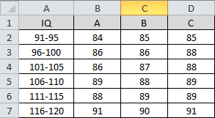

* **Step 2.** From Excel's main navigation menu, click **Data / Data Analysis** to display the Data Analysis dialog box.

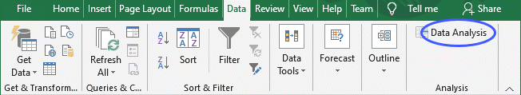

* **Step 3.** In the Data Analysis dialog box, select "Anova: Two-Factor Without Replication" and click the **OK** button to display the Anova: Two-Factor Without Replication dialog box.

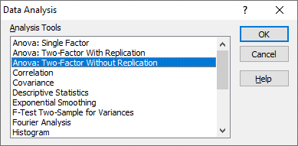

* **Step 4.** In the Anova: Two-Factor Without Replication dialog box, enter the input range. Click the Labels checkbox to indicate that you included labels for the rows and columns. And finally, enter a value for Alpha, the significance level. For this exercise, we'll use a significance level of 0.05, as shown below:

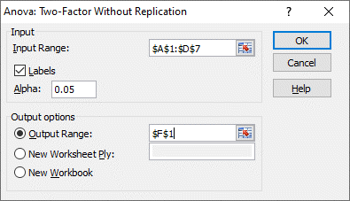

* **Step 5.** From the Anova: Two-Factor Without Replication dialog box, click the **OK** button to display the ANOVA summary table.

