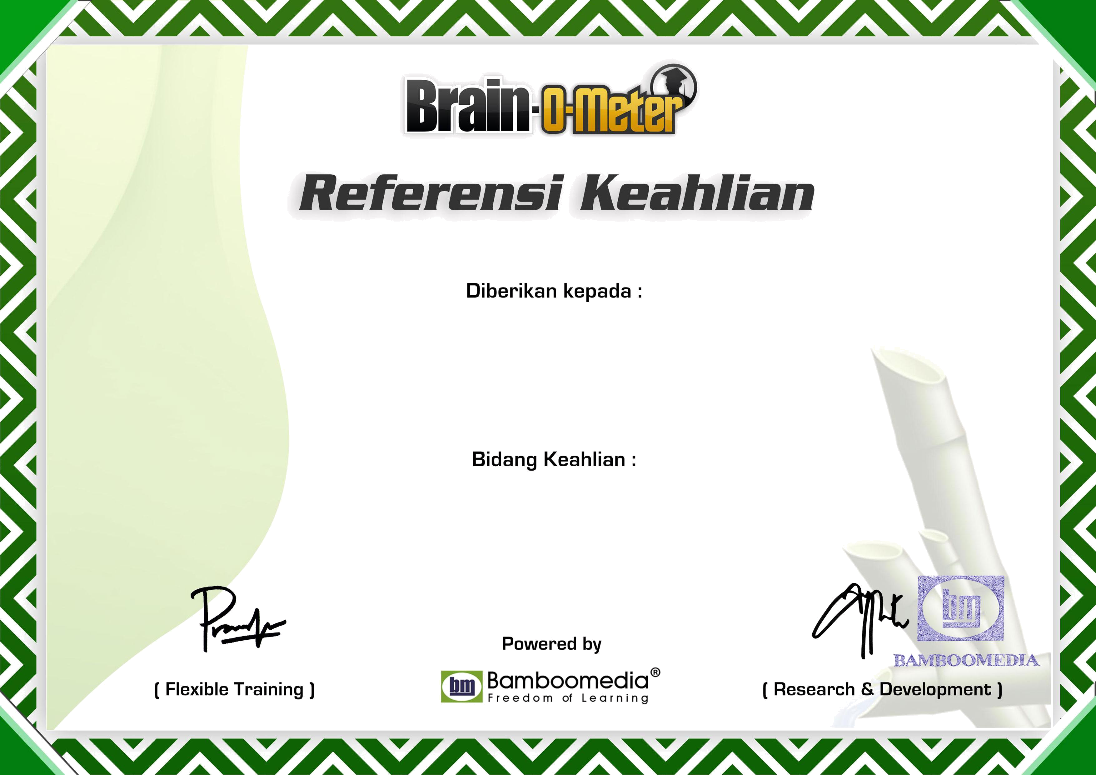
NO: 18052017/24296/3/14951173288237115941/N-85/BM-2017

RIKI SETIYO PAMBUDI

MICROSOFT WORD 2010

