WEEK-1
- Create a class Student with student ID, name and age. Create three student objects and display their details.
CODE:
class Student {
int studentId;
String name;
int age;
void display() {
System.out.println("Student ID: " + studentId);
System.out.println("Name: " + name);
System.out.println("Age: " + age);
System.out.println("-------------------");
}
public static void main(String[] args) {
Student s1 = new Student();
s1.studentId = 101;
s1.name = "Ravi";
s1.age = 20;
Student s2 = new Student();
s2.studentId = 102;
s2.name = "Priya";
s2.age = 21;
Student s3 = new Student();
s3.studentId = 103;
s3.name = "Rahul";
s3.age = 19;
s1.display();
s2.display();
s3.display();
}
}

OUTPUT:
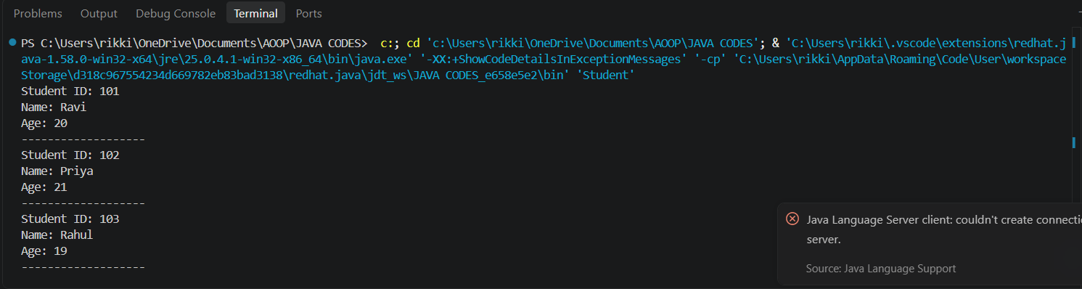

- Create an Employee class with employee ID, name and salary. Initialize the values using a constructor and display employee details.

CODE:

class Employee {
int employeeId;
String name;
double salary;

Employee(int id, String n, double s) {
employeeId = id;
name = n;
salary = s;
}

void display() {
System.out.println("Employee ID: " + employeeId);
System.out.println("Name: " + name);
System.out.println("Salary: " + salary);
}

public static void main(String[] args) {
Employee e1 = new Employee(101, "Ravi", 25000);
Employee e2 = new Employee(102, "Priya", 30000);

e1.display();
e2.display();
}
}

OUTPUT:
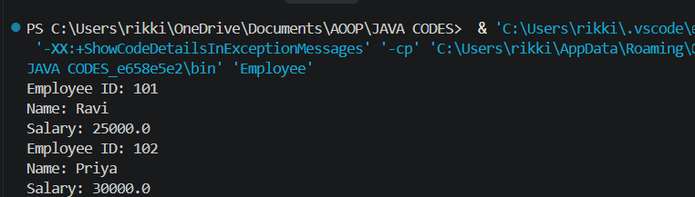

- Create a BankAccount class with account number and balance. Implement deposit and withdrawal methods.

CODE:
class BankAccount {
int accountNumber;
double balance;

void deposit(double amount) {
balance = balance + amount;
System.out.println("Deposited Amount: " + amount);
}

void withdraw(double amount) {
if (amount <= balance) {
balance = balance - amount;
System.out.println("Withdrawn Amount: " + amount);
} else {
System.out.println("Insufficient Balance");
}
}

void display() {
System.out.println("Account Number: " + accountNumber);
System.out.println("Available Balance: " + balance);
}

public static void main(String[] args) {
BankAccount b = new BankAccount();

b.accountNumber = 12345;
b.balance = 5000;

b.deposit(2000);
b.withdraw(1000);

b.display();
}
}

OUTPUT:
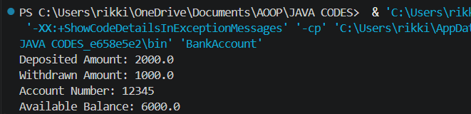

- Create a Rectangle class with length and width. Calculate and display its area and perimeter.

CODE:
class Rectangle {
double length;
double width;

void calculate() {
double area = length * width;
double perimeter = 2 * (length + width);

System.out.println("Length: " + length);
System.out.println("Width: " + width);
System.out.println("Area: " + area);
System.out.println("Perimeter: " + perimeter);
}

public static void main(String[] args) {
Rectangle r = new Rectangle();

r.length = 10;
r.width = 5;

r.calculate();
}
}

OUTPUT:
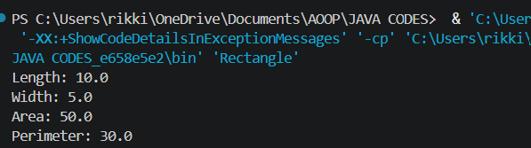

- Create a Book class with ISBN, title and price. Initialize the values using a parameterized constructor.

CODE:

class Book {
int ISBN;
String title;
double price;

Book(int i, String t, double p) {
ISBN = i;
title = t;
price = p;
}

void display() {
System.out.println("ISBN: " + ISBN);
System.out.println("Book Title: " + title);
System.out.println("Price: " + price);
}

public static void main(String[] args) {
Book b1 = new Book(12345, "Java Programming", 450);
Book b2 = new Book(67890, "Python Programming", 550);

b1.display();
b2.display();
}
}

OUTPUT:


