University of Southampton
Faculty of Engineering and Applied Science
Department of Electronics and Computer Science

COMP6005: Interactive Entertainment Systems
Game Project

Emma Lee-Choon
Rikki Prince

4th June 2007

Abstract

Contents

Abstract ii
1 Introduction 3
1.1 3
1.2 3
2 Design 3
3 Implementation 3
4 Testing 3
5 Evaluation 3
6 Team Dynamics 3
7 Future Work 3
8 Conclusion 3
References 3

Introduction
This project involves designing and implementing a game that:
- Demonstrates aspects of the game development process;
- Demonstrates background knowledge from lectures and labs;
- Contains an original element;
- Attempts to overcome a significant technical challenge.

We aim to develop a 3-dimensional (3D) maze puzzle game that is controlled through the use of the wireless Nintendo Wii controllers. The movement of the controller will control the movement of the player (in this case a ball) that will roll around a 3D maze, and move towards the goal. Various obstacles will be placed in the maze, and there will also be items to collect that increase the player’s score.

This game will follow a typical game development process, to ensure that it is produced to a good quality. Background research was carried out on game development, and the technical challenge of using the Wii controllers, and this is described in Section 2. The stages of the development process are described in Sections 4 to 6, with an evaluation of the final product given in Section 7. Section 8 gives an overview of the team dynamics during this project, Section 9 described future work and improvements to the game, and finally Section 10 concludes this report.

Background Research
Before game development began, it was important to recognise the stages of a process that should be followed to ensure a good quality product. Various development processes were researched, and the process followed is described in Section 2.1. The technical challenge of using Nintendo Wii controllers involves researching the technology and discovering how to integrate it with the hardware being used for game development. The research carried out for this technical challenge is described in Section 2.2. Finally, given our initial game concept, various similar games were researched, to obtain additional ideas and add further detail to our game plans. The existing games researched are outlined in Section 2.3.

Game Development Process
A game can be described as “software with art, audio and gameplay” (Bethke, 2003). In this respects, the game development process can follow a typical software engineering lifecycle, with requirements capture, analysis, design, implementation, testing and maintenance stages. However, game development is often considered differently to software development, with various processes being created by game designers and developers.

The use of a defined game development process in designing and implementation a game can enhance the quality of the product, and improve the likelihood of success. Bethke (2003) states that “games that have a poor development methodology (or none at all) take much longer than they should, run over budget, and tend to be unreasonably buggy”.

Of the many development processes and methodologies that can be considered, a suitable one for the particular task and for the development team in place needs to be found. The following sections describe the aspects of game development that were considered for this project, to ensure that a good quality game was produced within the required time.

Initially, a plan was made to set out the steps of the development process that would be considered, and to set milestones and deadlines to ensure the project would be completed by the deadline. It was ensured that the schedule allows enough time for each stage of the process, and also extra time for balancing, tuning and tweaking the features that can inevitably be improved at the end of development.

A brainstorming session between the two team members resulted in a game concept that was written up as a game treatment. This process is an extra stage to a typical software development process, as described by Dave Morris (Riddoch, 2007). This document consisted of ideas for the game, and did not consider any constraints, such as time and expertise available. The gameplay, and story behind the game, is explained, along with the feedback and balance that would be present in the game.

The next step was to formally describe the game requirements, through the use of Unified Modelling Language use case diagrams. These clearly show what functions we expected to develop within the game, and also ensured that the requirements were clear to all the team members. In capturing the requirements, it was important to consider the capabilities of the team, and the time constraints of the project, to ensure that the requirements were realistic and achievable. Bethke (2003) describes how many of the most successful games choose a narrow set of features, but polish them to a “superior degree”. This tactic was used in this game, with only a small number of features selected, but the implementation of these was concentrated on and perfected.

A game design document and a technical design document were produced, to outline the structure of the code, and the design decisions for the game. The game design document includes the design and purpose of items within the game, eg. the player, obstacles, goal, as well as level designs and how the game will increase in difficult through each level (to offer feedback to the player). The technical design document concentrates on the structure of the code, and the tools and editors that will be implemented to aid in constructing and loading levels within the game.

The test plan…

As good software development practice, the use of a subversion repository was used to ensure that, not only was the code backed up on a server, but any changes were logged and stored.

Since this project requires the team to demonstrate the knowledge obtained from the lab sessions for COMP6005, it was decided to loosely follow the structures of the labs. We knew that this was an effective way of ensuring that our game incorporates all the necessary features and also will be completed to schedule.

Initially, the 2D grid was developed into a 3D grid, with simple block textures and lighting. Then the basic rules for the game will be implemented: create platforms of blocks, and move a ball on the platforms. This was tested using the keyboard first, and then extended to implement the Wii controllers. 3D models as obstacles were created and imported and placed within the game. Finally audio is added to the game, and the gameplay is polished.

Create task visibility so everyone in the team knows what he or she needs to do and how far along the rest are in their tasks. With fewer people in this ‘team’ time must be managed and used even more efficiently than with a large 30-person team. Create achievable tasks, measure progress, control features are even more critical for small teams.

Nintendo Wii Controllers (RIKKI)

Existing Games
It was decided that our game would be based on the grid framework used in the lab sessions of the COMP6005 module (ECS, 2007). Our initial ideas involved using a 3D grid as a maze, with platforms that the player (a ball) would roll along to reach the goal. A similar game that was found was Kula World: a PlayStation One puzzle game (KulaWorld, 2007). The beach ball is moved along the platforms of the 3D maze to find and collect keys to exit the level. There is a range of obstacles and the level must be completed within a limited time. Screenshots of the game are shown in Figure 1.

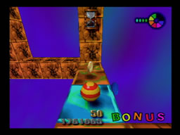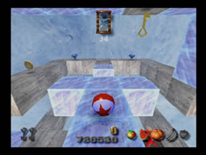
Figure 1. Screenshots of Kula World

Although this game was not available to us to play, we used videos and walkthroughs of the game (available on the Internet) to give us ideas for obstacles and determine the features of the game. The main difference with our game is the technical challenge and the control that the player will have over the ball within the 3D maze.

Requirements Capture
The team defined the requirements based on the results of a brainstorming session. The spider diagram created from this session is shown in Figure 2. The three main areas considered were the gameplay, the various block textures/obstacles that could be implemented within the game, and other ideas for …

[Insert Brainstorming Diagram]
Figure 2. Brainstorming diagram

Two UML use case diagrams were created to display the requirements of the player and the system for the game. The use cases in Figure 3 describe the functions the actor, in this case the Player, should be able to perform while interacting with the game.

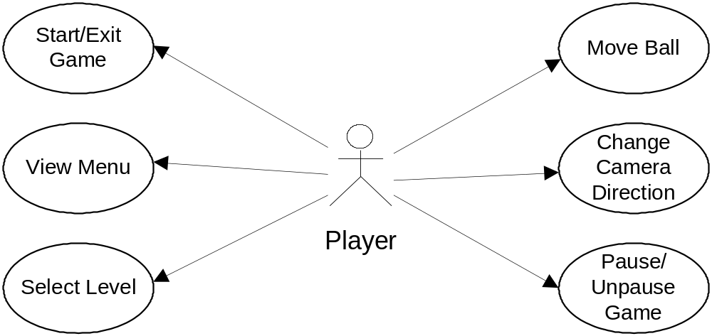
Figure 3. Player use case diagram

The use cases in Figure 4 demonstrate the functions that the system, or the game, should be able to perform, either automatically or as directed by the user. For example, the game should start and exit when the user selects to begin or end the game. However, the game should automatically load models and textures when a level is loaded.

The diagrams in Figure 3 and Figure 4 helped to clarify the capabilities of the game that need to be implemented, and also revealed issues and discussion points on areas not considered previously.
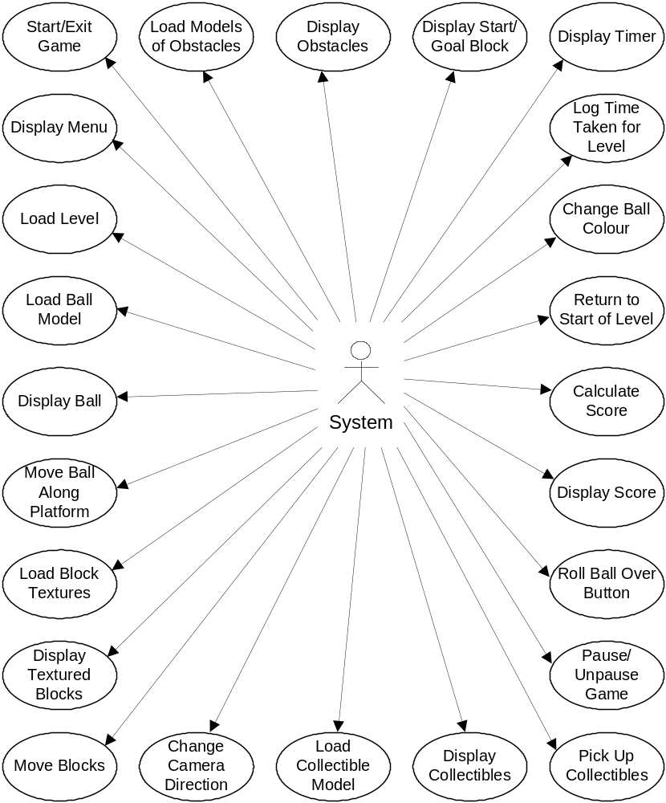
Figure 4. System use case diagram

Design
Given the results of the requirements capture stage, the design stage of the development process was begun. The design was split into two sections: the game design and the technical design. The game design focuses on the design of elements of the game, and the level design, while the technical design is regarding the structure of the code itself, to ensure it functions in an efficient way.

Game Design
The aim of the game is to

Technical Design (RIKKI)

Implementation
A description of the tools used to implement the game is described in this section, along with the problems and issues encountered during this stage of the development process.

Development Environment

Modelling Tools

Problems Encountered

Testing

Evaluation

Team Dynamics

Future Work

Conclusion

References

BETHKE, E. (2003) Game Development and Production. Texas, USA: Wordware Publishing, Inc.

ECS (2007) Interactive Entertainment Systems – Coursework. ECS, Southampton. Available from: https://secure.ecs.soton.ac.uk/notes/comp6005/coursework.html [Last accessed: 28 May 2007].

KULAWORLD (2007) A Kula World Walkthrough. Available from: http://www.kulaworld.com/ [Last accessed: 28 May 2007].

RIDDOCH, A. (2007) Interactive Entertainment Systems – Game Design. ECS, Southampton. Available from: https://secure.ecs.soton.ac.uk/notes/comp6005/lecture2.html [Last accessed: 28 May 2007].

