CSC422/522: Second Assignment Instructions
(70 points + 5 bonus points)

Due:
- Feb 26, 2026 (Thursday) before class

Topic:
- Object tracking refers to the task of continuously localizing the same object across a sequence of frames while maintaining its identity over time.
- In this assignment, tracking is performed using SIFT keypoints and descriptors: a bounding box is manually initialized in the first frame, local features are extracted, and the object’s location in subsequent frames is estimated by matching these features over time.
- Below is an example of tracking an otter at Bramble Park Zoo in Watertown, generated using the instructor’s own scripts:
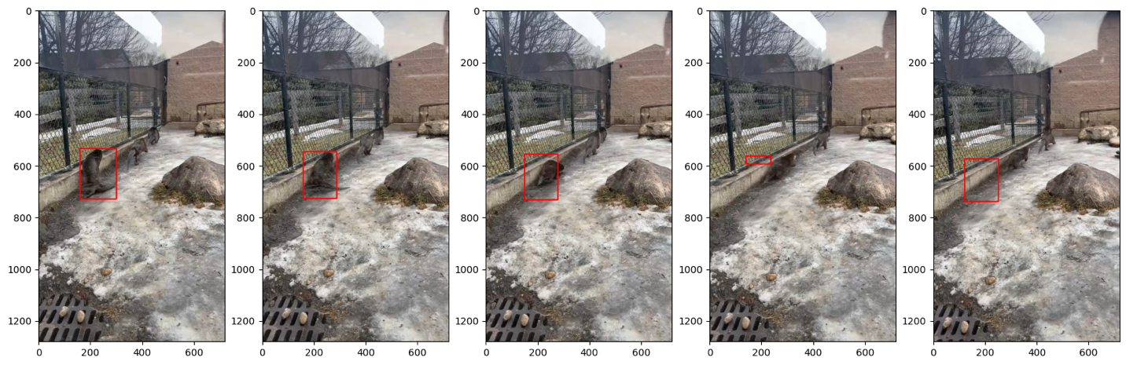

Important Notes:
- Your tracking does not need to be accurate to receive full credit. As long as you follow the instructions and clearly demonstrate your approach, you will be graded on correctness of your codes and effort—not performance of your object tracking. Even in the example above, tracking performance degrades when the otter moves dramatically.
- In this assignment, all frames are matched directly to the first frame rather than to the immediately preceding frame. Although frame-to-frame matching is conceptually common in tracking, in this assignment it can be less stable due to feature drift and accumulated matching errors.
- You can refer to official OpenCV documents or related tutorials to finish the assignment. The use of AI tools (e.g., ChatGPT, Gemini, etc.) to directly generate complete code or text cells is discouraged.

Submission File:
A single .ipynb file downloaded from your Google Colab Notebook, like assignment 1.

Requirements:

1 (5 points). Data Collection.
- Take multiple images or extract keyframes of a video for an object in interest.
- At least 5 frames should be provided.
- Put the frames in your Google Drive and read in Google Colab.
- You need also provide a short description of how you collect the data and what is the object you want to track [Text Cell].

2 (5 points). Manually annotate the bounding box of the object in the first frame (i.e., the initial bounding box).
  - To represent a bounding box, you just need the coordinates for its left-top corner (x_min, y_min) and right-bottom corner (x_max, y_max).
  - You can obtain (x_min, y_min), (x_max, y_max) in the first frame using any reasonable manual method. For example, you can open the first frame in an image editor and record the pixel coordinates shown when you move your cursor over the object of interest.
  - Please provide a short description of how you obtain this initial bounding box and write down your coordinates [Text Cell].

3 (5 points). Extract the Region of Interest (RoI) within the initial bounding box, and find its SIFT keypoints and descriptors.
  - SIFT is available in OpenCV. You do not need to implement from scratch.
  - You should run SIFT only on the region of interest (RoI) defined by the bounding box, not on the full image. 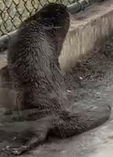
  - This RoI-based feature extraction will be used for tracking.
  - Visualize your detected SIFT keypoints. You are expected to get something like this: (note the grayscale version of the RoI is used to make the keypoint visualization clearer)
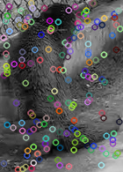

4 (25 points in total). For each remaining frame, obtain bounding box following steps 4.1-4.3:
- Step 4.1 (5 points): compute SIFT keypoints and descriptors in the frame.
- Step 4.1 (10 points): conduct matching with the initial bounding box using SIFT descriptors and ratio test.
- Step 4.3 (10 points): compute the bounding box based on the keypoints that find good matches.

5 (5 points). Write a short justification on how you solve Step 4.3. [Text Cell]

6. (10 points) Visualize your tracking results.
- Use OpenCV function to draw the bounding box of each frame.
- Feel free to refer to OpenCV official documents for this assignment.

7. (15 points) Summarize your findings on your tracking results, including but not limited to:
- possible reasons for good tracking performance
- possible reasons for poor tracking performance
- potential strategies to improve your tracking results

8. (Bonus, 5 points) Implement one or more of your proposed strategies in Step 7 and discuss your results.
- It is acceptable if your proposed strategies do not improve the results. If performance degrades, explain the possible failure modes and why the strategy may not work in this case.

