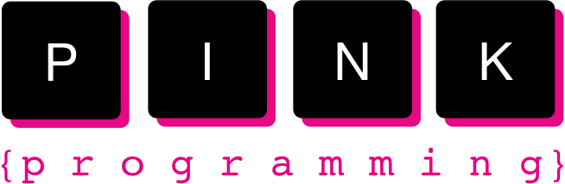

Installation guide

*Program to download and install:*

* Java Development Kit (JDK)
* Eclipse IDE for Java Development

*Download and install Java:*

1. Start with checking if you already have Java installed, and in that case what version you have. You can see this through terminal (Mac) or the command prompt (Windows). A terminal/command prompt is a window where you can write commands to the computer. With this it is possible to perform things without using a GUI (graphical user interface). Follow the instructions to find out if you have Java:
   1. **Start the command prompt in Windows 7/10**In Windows 7/10 you start the command prompt by pressing Start, write cmd in the field *Search programs and files* and then press enter.

You can also start the command prompt by choosing *Start -> All Programs -> Accessories -> Command Prompt*.

* 1. **Start the command prompt in Windows Vista**In Windows Vista you start the command prompt by pressing the *Start menu*, write *cmd*in the field *Start Search* and then press enter.  
     You can also start the command prompt by choosing *Start -> All programs -> Accessories -> Command Prompt*.
  2. **Mac**:   
     Press on the magnifier (Spotlight) and write *terminal.* Press on the first match that appears. You can also start terminal through *Finder* by *Program -> Utilities -> Terminal.*

1. When you have activated the terminal/command prompt according to the instructions above, a window will pop up. It is in this window you can write commands to the computer. To run a command press enter.
2. In the terminal or the command prompt type java -version. In the window you will see which Java version you have. If nothing pops up you do not have Java installed on your computer.

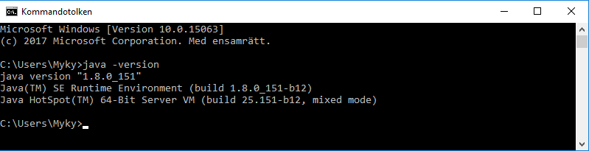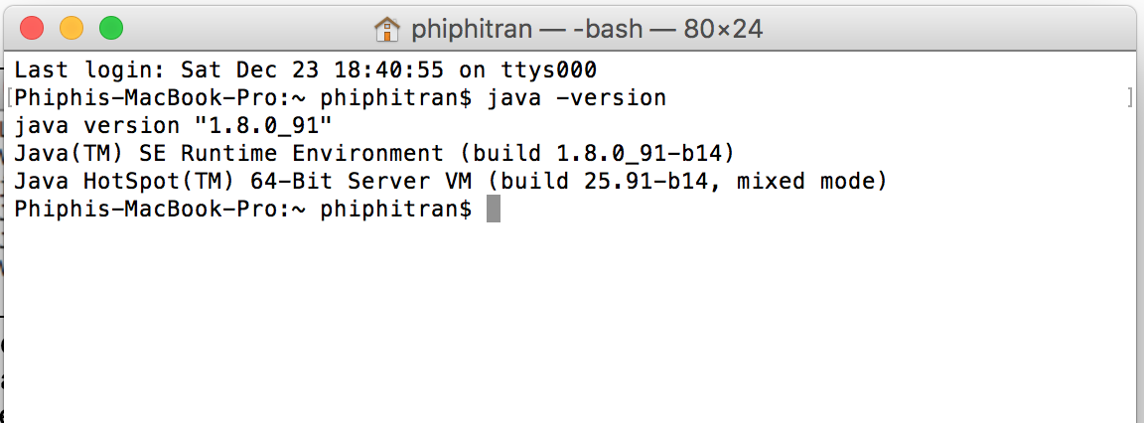

In this case Myky has version 8 in Windows 10 and Phiphi version 8 for Mac. If you have Java (version 8 or higher) installed on your computer you can move on to installing Eclipse. If you have a version lower than 8 you have to upgrade to a higher version, which we will do in the following step.

1. If you do *not* have Java you have to download it. You can do this from [Oracle](http://www.oracle.com/technetwork/java/javase/downloads/index.html). Press on Download.  
    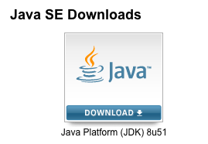
2. Accept the license by clicking on “Accept Licence Agreement”.
3. Click on the file in the column that corresponds to your operative system.
4. When the file has been downloaded, double click on the file.  
   Screen Shot 2016-08-10 at 16.30.57.png
5. Install Java by following the instructions that will pop up.
6. Control that Java is installed by typing java -version in the terminal as (3).

*Download and install Eclipse:*

1. Go to the website for downloading: [Eclipse Download](http://www.eclipse.org/downloads/packages/eclipse-ide-java-developers/marsr) 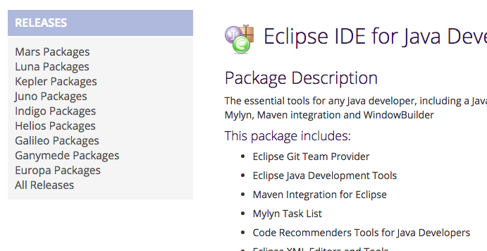
2. Choose the appropriate link to the right (depending on what computer you have) to download.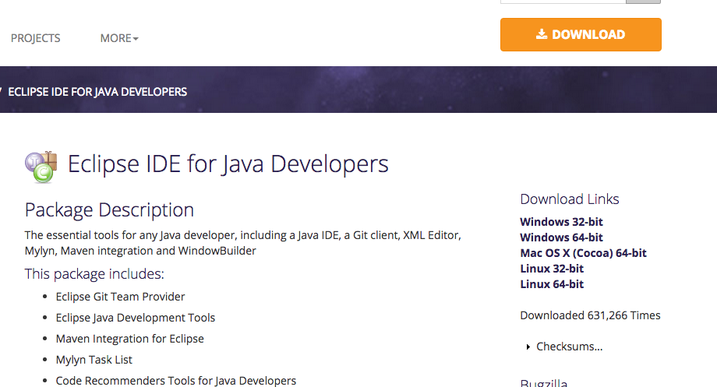
3. Press on Download.
4. When the download is done, double click on the downloaded file. Skärmavbild 2015-07-30 kl. 12.12.03.png
5. Move Eclipse to your programs
6. Done :)