

PROJECT REPORT

Design and Implementation of a Smart Parking Management System using Verilog HDL

Submitted by :
Name | Registration Number | Role
Divyam | 24BCT0125 | System Design: Problem statement, block diagram, flowchart
Nikunj Sinha | 24BCT0051 | Verilog Coding: Implements main smart parking module
Niveditha | 24BCT0140 | Testbench & Simulation: Writes testbench, simulates design, captures waveforms
Karthikeyan | 24BCT0228 | Documentation & Presentation: Prepares final report, diagrams, PPT, applications and Hardware.

Under the guidance of
Naveen Mishra
Department of Electronics and Communication Engineering
Vellore Institute of Technology
Overview / Brief of the Project
The Smart Parking Management System is designed to automate parking operations using Verilog HDL. It detects vehicle entry and exit, allocates or frees slots automatically, counts available spaces, and indicates when the parking is full. The design uses digital logic, counters, and control circuits to simulate real-time parking management efficiently.

Materials / Components Used
Since it’s a digital design project (Verilog-based), the main components include:
- FPGA Board / Simulator (e.g., Xilinx Vivado or ModelSim)
- Verilog HDL Code
- Digital Sensors (Entry/Exit Detection) – simulated inputs
- LED Indicators – for gate control and “FULL” signal
- Registers and Counters (in code) – for slot allocation logic
- Clock and Reset Inputs

Block Diagram
Inputs:
clk, rst, entry, exit
Outputs:
entry_gate, exit_gate, free_count, full
Processing Unit:
Slot allocation logic that:
- Decrements counter on entry
- Increments counter on exit
- Activates “FULL” signal when all slots are occupied
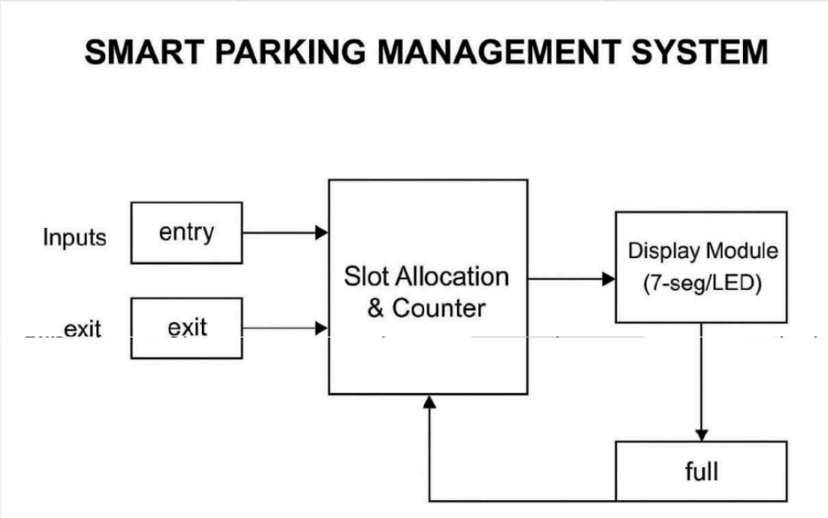

Future Scope
The project can evolve into a full smart-city–grade parking system:
- IoT Integration: View slot availability via mobile apps.
- Automated Billing: Time-based fare deduction and ticketing.
- ANPR System: Vehicle number plate recognition for security.
- Sensor-based Slot Detection: Using IR/Ultrasonic sensors for accuracy.
- Multi-Level Parking Support: Expand logic to handle multiple floors.
- Guidance System: LEDs or voice alerts to guide drivers to free slots.
- Priority/Emergency Parking: Reserved zones for specific vehicles.

