**RamakantVishwakarma**

**MCA**

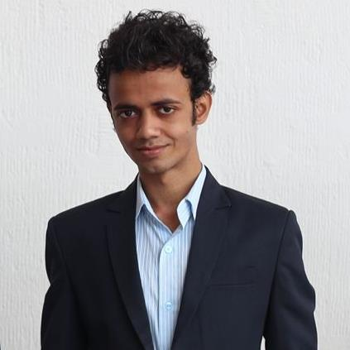

**Personal Details**

**Contact no:** 8286608983

**Email Id:**

r.k.vish456@gmail.com

**Address:**

Room no. 3,JagrupMauryaChawl,

Azad Lane, SionChunabhatti(E)

Mumbai – 400022

**Languages Known:**

English, Marathi and Hindi

**Hobbies & Interests:**

Reading novels

Blogging

Trekking

**Competencies:**

Analytical Thinking

Quick Learner

Team worker

Taking Initiatives

|  |
| --- |
| **Currently Working At** |

**Name of Organization** : Convergence IT Services.

**Position :** Web Developer.

**Current Project :**pce.blufysh.com, sstglobes.com, idfw.online

**Best project : pce.blufysh.com** -> project controlle expo has joomla based website , where user can register for particular event and book ticket . userrevice mail of event details .

**Software Requirement :**

1. Sublime Text Editor, xampp. Visual code.

|  |
| --- |
| **Education** |

|  |  |  |  |
| --- | --- | --- | --- |
| **Year** | **Examination** | **Institution** | **Percentage/CGPI**  **Obtained** |
| 2016-19 | MCA | SIES College of Management Studies, Navi Mumbai | 6.34 |
| 2015 | BSc IT | Guru Nanak College | 59.75 |
| 2013 | HSC | GauriDutta Mittal Jr. College | 48.00 |
| 2011 | SSC | Swami Vivekanand High School | 72.00 |

|  |
| --- |
| **Projects In Intership** |

* Fasih perfumes using PHP( Laravel Framework), domain(fasihperfumes.com)
* Cable Application using PHP &MySql(Laravel Framework) (March 2019).
* Get On Door (E-Commerce Website )usingPHP &MySql (April 2019).
* Towncart (E-Commerce Website )usingPHP &MySql (April 2019).
* Marketviewx.com (Cryptocurrency Exchange) using PHP (May2019)

|  |
| --- |
| **Latest Project** |

* Bulk product buying on wholesale PHP Laravel (July 2021).( idfw.online)

In this project have multiple authentication, made using middle ware of laravel. User can register account book bulk product and get invoice of order details. Admin have all right to perform a task on order , user , products managements and all .

|  |
| --- |
| **Work Experience** |

* Worked in adigos as web developer (2 Jan 2019 – 16 aug 2019 )
* Worked in stemrx as web developer (17 aug 2019 – 31 oct 2020)
* Worked in Convergence IT Services (2 feb 2021 – till date)

|  |
| --- |
| **Technical Skills** |

|  |  |
| --- | --- |
| Programming Languages | C++,Core Java, Advanced Java Programming |
| Web Technologies/ Scripting Languages | HTML, CSS, PHP(Laravel,codeigniter), [JavaScript](https://www.google.com/search?rlz=1C1CHBF_enIN816IN816&q=JavaScript&stick=H4sIAAAAAAAAAOOQU-LQz9U3MCqwNI-SKU4uyiwoycxLV8hJzEsvTUxPLVZIrUjMLchJLT7FCFcIZRoaVuZBmWYG2WVQpmlVEUzUPK3cCC5qGP-I0Zdb4OWPe8JSLpPWnLzGaMfFFZ6a5JhXXJ5aVCxkwMUVWJpaVOmck1hcLKTEJSDF4-MZHBIf7Orq7ennrsEoxceFIsLzi1HKMTk5vygF5OCSfIXy1KT8gtSUzES95PzcX0wc8a5-IZ4hkfGTmC0ySkoKiq309cvLy_VQlOmHuAb56gfrw30eD_O5XkZJbs4iVi6vxLLEYLAsAGELkQQsAQAA&sa=X&ved=2ahUKEwilpo69iJniAhXh7XMBHYZoA5EQxA0wAHoECA0QBQ" \o "JavaScript)  JQuery |
| Application Software | Microsoft Word |
| Platform | PHP Storm.Sublime 3 |
| Database | MYSQL |
| Designing Software | Adobe xd, Lunacy, Corel Draw, Photoshop. |
| Operating Systems | Ubantu16.04, windows 10. |

_

**Project In Laravel** : idfw.online, sstglobes.com, emeric.world. stemmetics.com, bedatawise.in.

**Codeigniter** :Fasih Perfumes-> Built in CI , In this from admin panel admin can create category and products. Each product belongs to some category. Products have name, description , price, purchase link(amzon,fliplart), multiple images.

**Core PHPProject :**stemrxworld**.com ->**In this website it has an admin panel, where admin can handle Events, Media, Enquiries and setting reflects on website. In Setting admin can enable or disable the pages and turn on website under construction page.

**Project In PHP:** indiataekwondo.com/register/, techstom.com, stemrx.in.

**WordpressProject** : thotpotdesigns.com**->**Built using woocommerce plugins, piazzanapoli.in, drpvmahajan.com.

__________________________

RamakantVishwakarma