# Download MYSQL

<https://dev.mysql.com/downloads/windows/installer/8.0.html>



**Defaults and download any dependency that is missing**

**You want to remember your root password**

**Start my workbench**

# 



Select open SQL after you go into the localhost connection. Looks like SQL with folder icon



Browse to the first SQL and run it then run the second one to set up the DB

Select the lightning bolt to run the sql

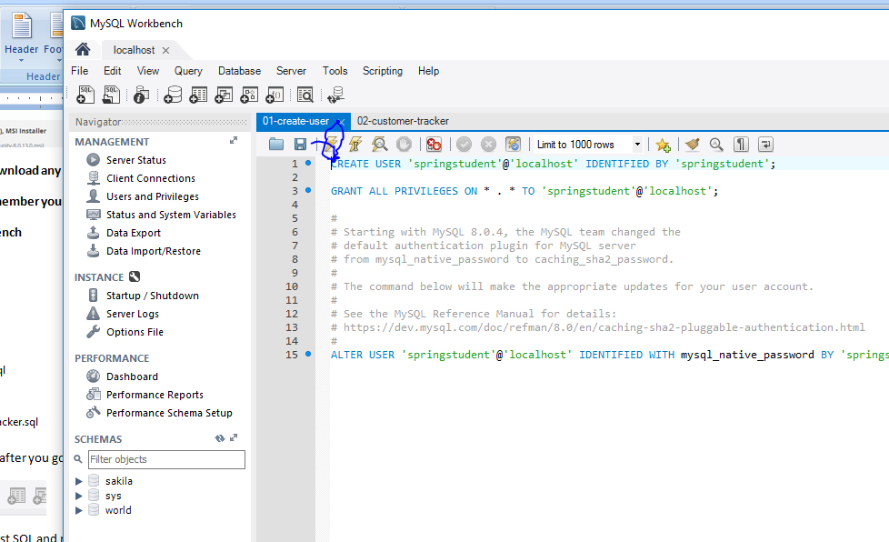

# Download Eclipse

<https://www.eclipse.org/downloads/packages/release/2018-09/r/eclipse-ide-java-ee-developers>

# Download Tomcat

<https://tomcat.apache.org/download-90.cgi>



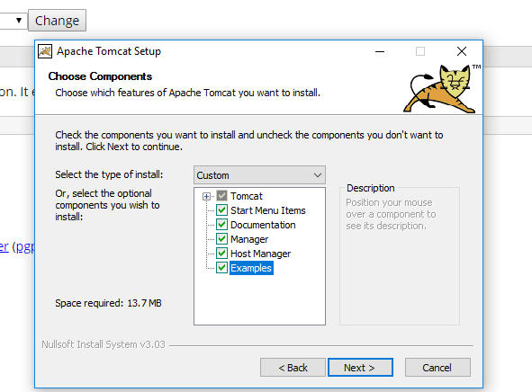

Everything else can leave as defaults install Tomcat. Don’t need to run Tom cat after install Eclispe will automatically start Tomcat up

# Setting up Tomcat with Eclispe

Run eclipse

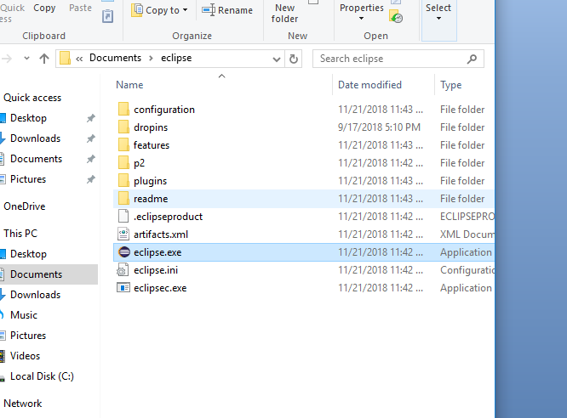

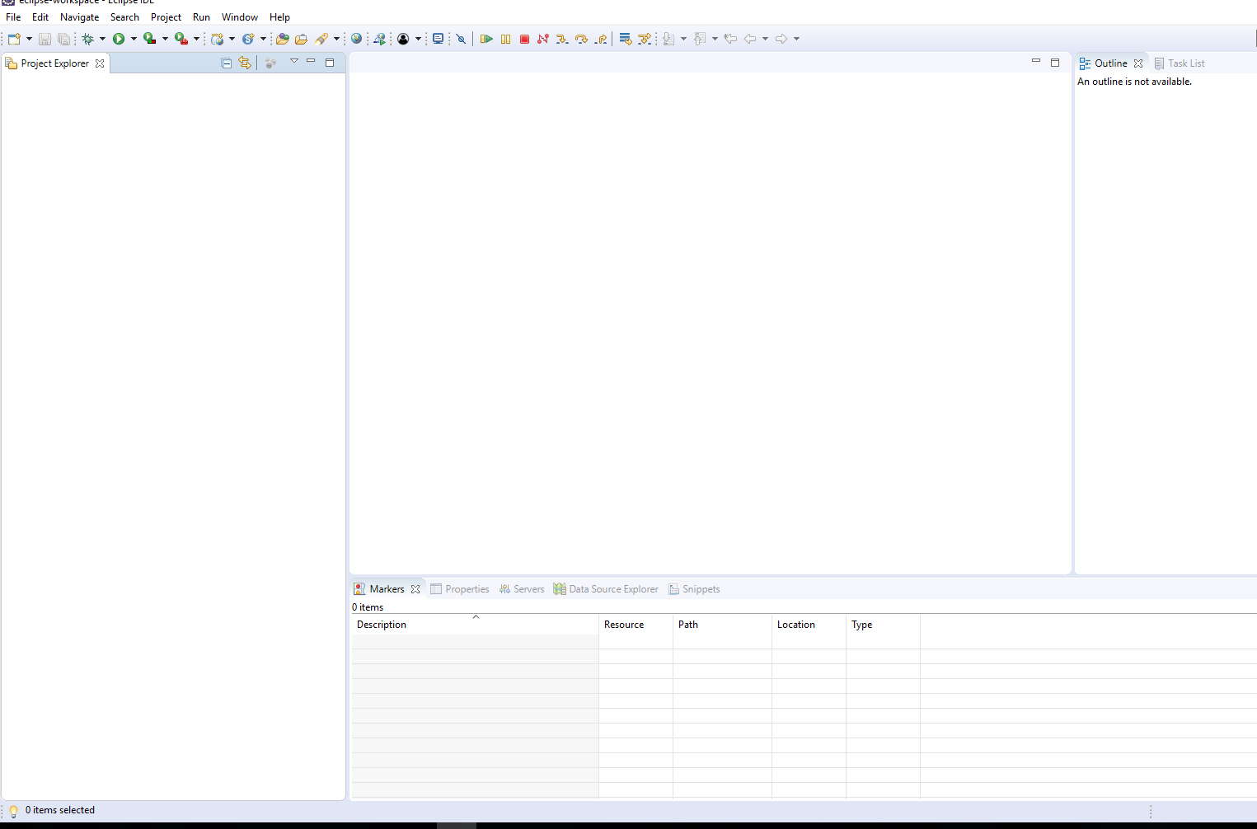

Select servers tab

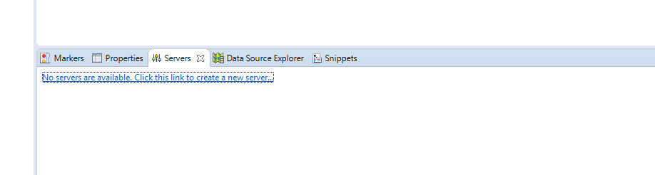

If you don’t see it On the top window / show view / other and search Server

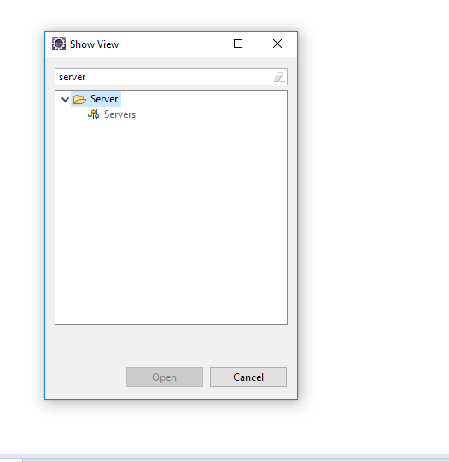

Select the no servers link

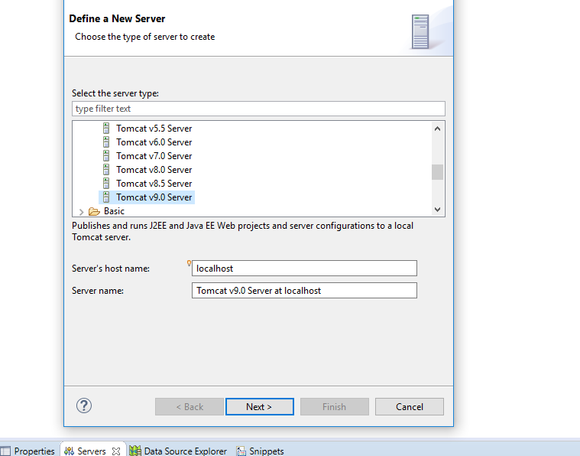

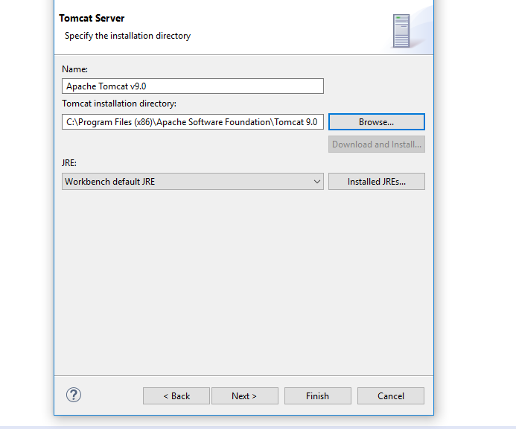

Everything else as default

Right click project explorer and select import

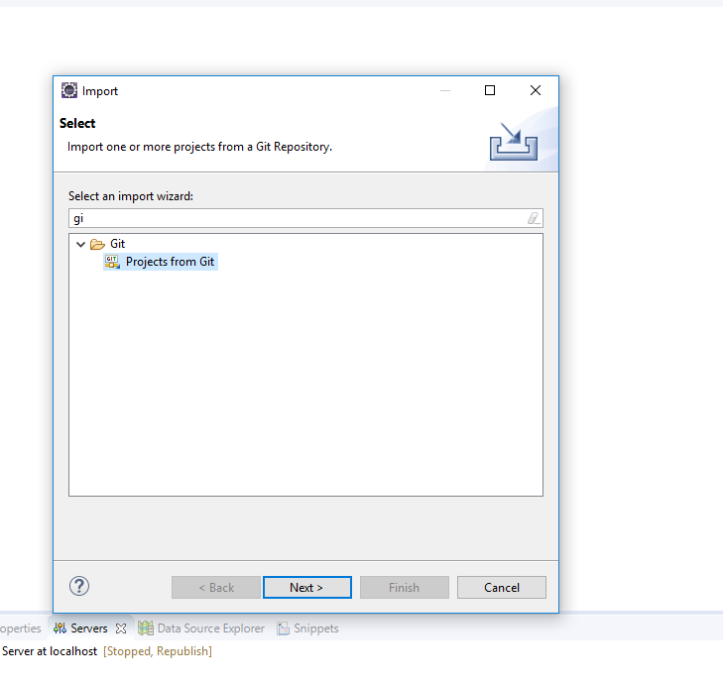

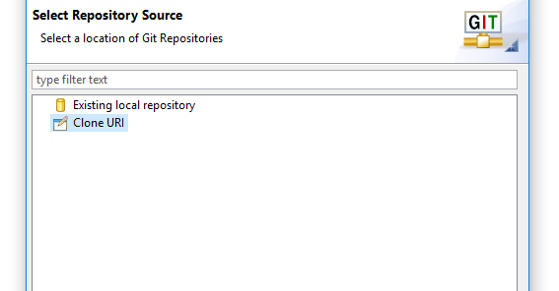

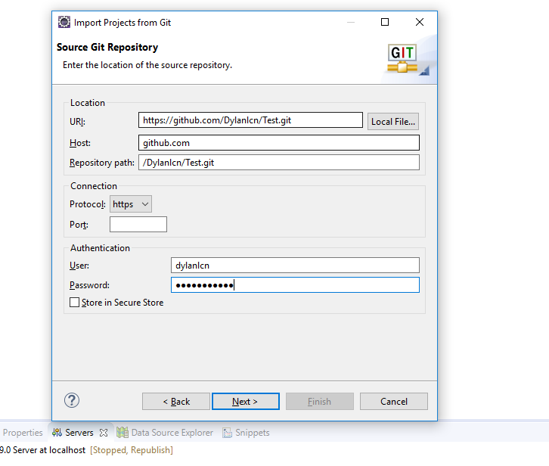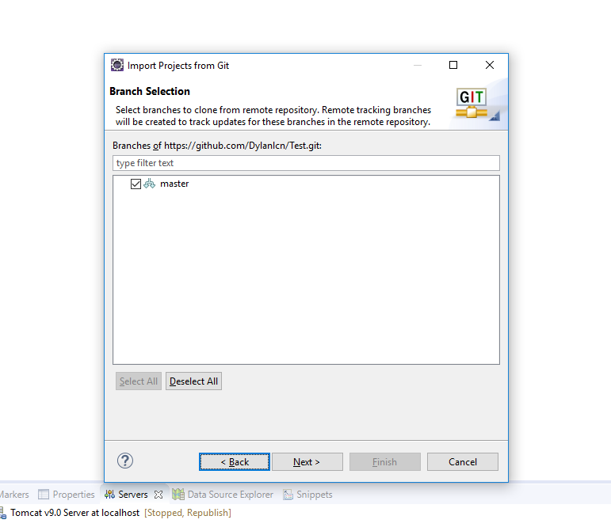

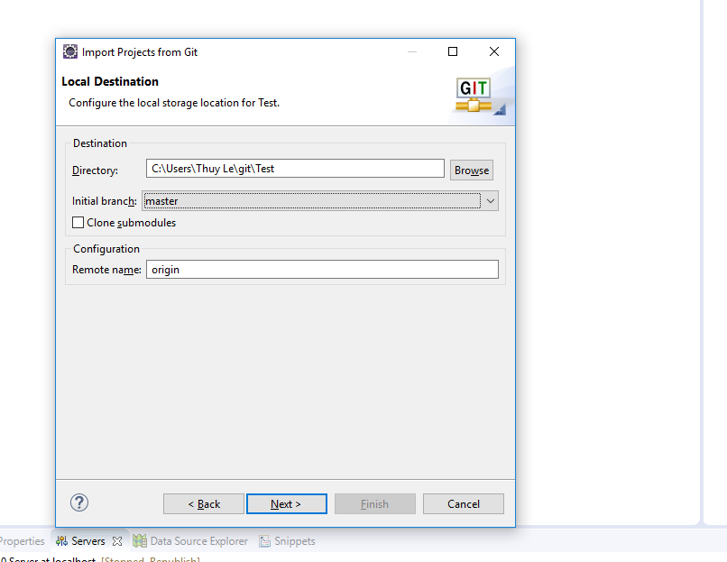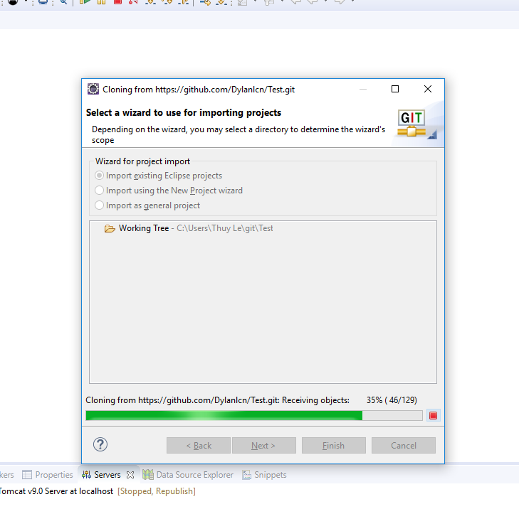

Right click web sudent tracker and run on server

