Description of Results (ONE paragraph)
Fig. 7 shows the small-angle X-ray scattering (SAXS) results for suspensions of aSyn and unilamellar lipid vesicles (LVs). The lipid composition resembles that of physiological synaptic vesicles (DOPC : DOPS : DOPE : cholesterol in the molar ratios 11 : 4 : 3 : 2, see supplementary materials). The one-dimensional intensity curves I(q) are shown after azimuthal averaging of the radially symmetric scattering patterns, as a function of the momentum transfer q (modulus of the scattering vector). On a qualitative level, the most prominent effect of increasing aSyn concentrations is the filling of the minimum at ca. q = 0.3 nm⁻¹ (see Fig. 7A). To analyze the acquired data, we have implemented an approximative analytical model by Brzustowicz and Brunger¹³. In this model, the radial electron density profile (EDP) of the vesicle lipid bilayer is parameterized as a sum of three Gaussians representing the headgroup maxima and the midplane minimum (the model function is detailed in the supplementary materials). On the larger scale, the vesicles are considered as perfect spheres with radius R and a Gaussian polydispersity function with the width $σ_{R}$. During the fitting, we experienced a certain ambiguity. By varying the initial guess and the bounds of the fitting algorithm, a number of equally precise fits with significantly different EDPs can be obtained. This ambiguity can be attributed to an over-parameterization. It can also be rationalized when considering the resolution limit resulting from the q-value, where the background exceeds the vesicle signal. However, we noted that the areas of the three EDP Gaussians show consistency among numerous fits of the same curve. For this reason, we introduce the quantities $Ω_{1,2,3}$ for the characterization of the vesicle EDP under influence of aSyn. As illustrated in Fig. 7B, $Ω_{1,2,3}$ are defined as the integrated EDP areas of the inner head group, the central tail groups and the outer head group respectively. In this way, the parameters describing the structure of the EDP are effectively reduced by a factor of two. By placing $Ω_{1,2,3}$ in different relations, we obtain reliable measures of relevant properties such as the total EDP integral, the EDP asymmetry and the ratio of head groups to tail groups. In Fig. 7C, we compare these measures between aSyn WT and aSyn A124T. For each sample, multiple equally precise fits were found and the average values of these fits were used for linear fitting. Statistical parameters (e.g. $χ_{\text{red}}^{2}$, coefficient of determination R², F test) are shown in Tab. S2 and Tab. S3 in the supplementary materials. According to these parameters, the most confidence can be placed in the increase of the total EDP integral and the EDP asymmetry. Moreover, the width of the polydispersity distribution is rising and the total head group integral grows in relation to the tail group integral. All of these findings indicate protein adhesion and maybe insertion at the vesicle surface. As the linear fits visualize, aSyn WT and aSyn A124T behave quite similarly. One could speculate that aSyn A124T is slightly less active in binding to lipids, for example based upon the less pronounced EDP asymmetry. There is definitely no dramatic change of the vesicle shape, neither for WT aSyn nor for aSyn A124T.

Legend
Figure 7. Structure of lipid vesicles in the presence of aSyn. (A) SAXS data and fits for 15 mM LVs at increasing concentrations of aSyn (shifted for clarity, aSyn WT data in blue, aSyn A124T data in red). The SAXS curve of the 15 mM LV solution without aSyn (dark grey) is plotted below each LVs + aSyn sample as a reference. (B) Illustration of the parameters derived from the electron density profiles (EDPs) corresponding to the least-squares fits in (A). The EDP of the 15 mM LVs (no protein) is shown as a reference. $Ω_{1,2,3}$ are the EDP integrals of the inner head group, the central tail groups and the outer head group, respectively. (C) Different parameters of fits with the spherical vesicle model with asymmetric EDP depending on the aSyn concentration from 0 μM to 100 μM. In order to reduce the ambiguity, average values of multiple fits of the same sample were used for the linear fitting. See Tab. S2 and Tab. S3 in the supplementary materials for statistical parameters of the fits.

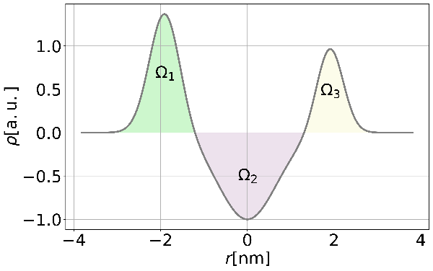
A
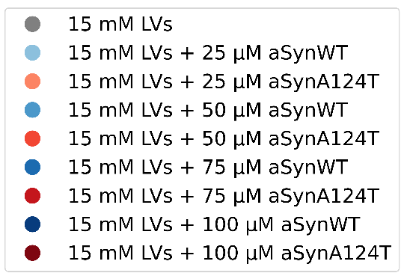
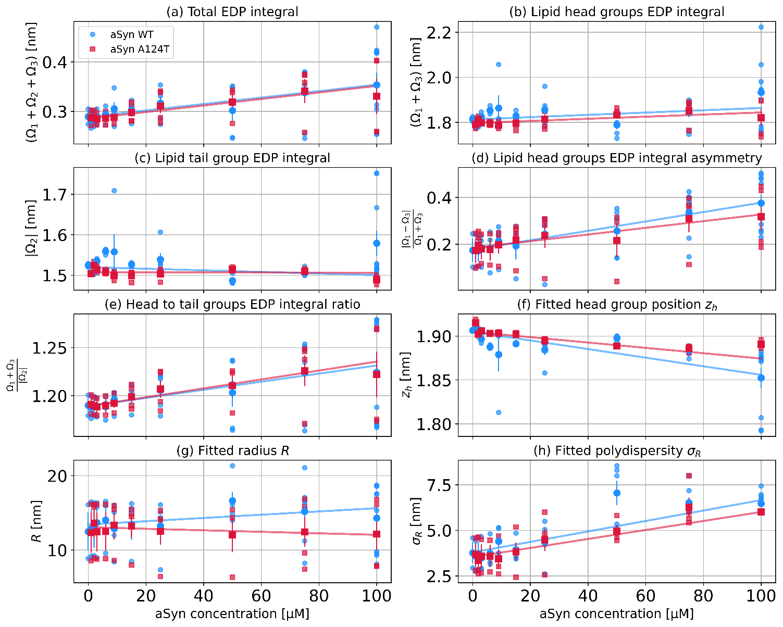
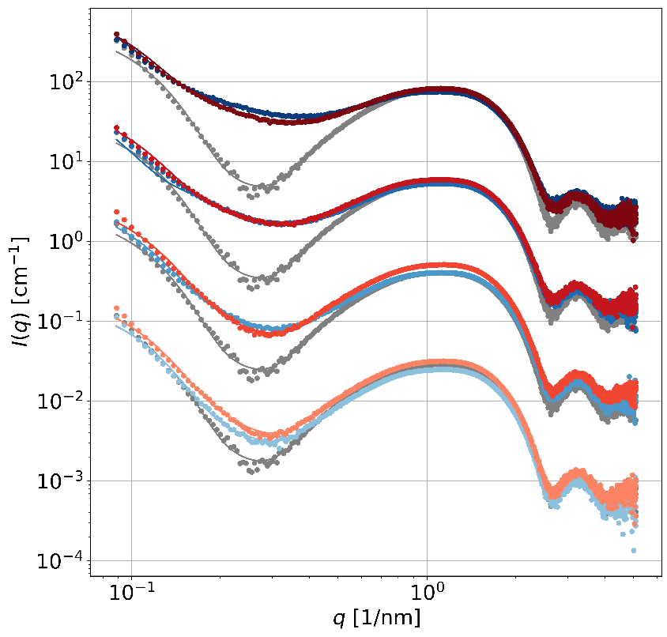
C
B

