# SVR

# Importing the dataset

dataset = read.csv('Position_Salaries.csv')  
dataset = dataset[2:3]

# Fitting SVR to the dataset

*install.packages(‘e1071’)*

library(e1071)  
regressor = svm(formula = Salary ~ .,  
 data = dataset,  
 type = 'eps-regression',  
 kernel = 'radial')

# Predicting a new result

y_pred = predict(regressor, data.frame(Level = 6.5))

# Visualising the SVR results

*install.packages(‘ggplot2’)*

library(ggplot2)  
ggplot() +  
 geom_point(aes(x = dataset$Level, y = dataset$Salary),  
 colour = 'red') +  
 geom_line(aes(x = dataset$Level, y = predict(regressor, newdata = dataset)),  
 colour = 'blue') +  
 ggtitle('Truth or Bluff (SVR)') +  
 xlab('Level') +  
 ylab('Salary')

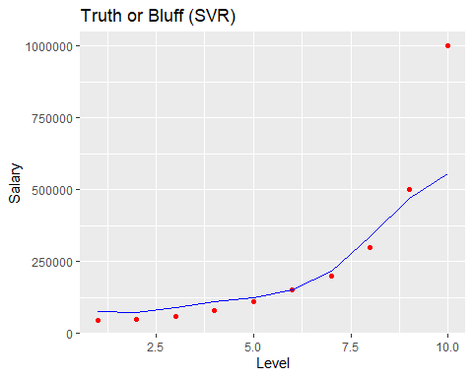

# Visualising the SVR results (for higher resolution and smoother curve)

*install.packages(‘ggplot2’)*

library(ggplot2)  
x_grid = seq(min(dataset$Level), max(dataset$Level), 0.1)  
ggplot() +  
 geom_point(aes(x = dataset$Level, y = dataset$Salary),  
 colour = 'red') +  
 geom_line(aes(x = x_grid, y = predict(regressor, newdata = data.frame(Level = x_grid))),  
 colour = 'blue') +  
 ggtitle('Truth or Bluff (SVR)') +  
 xlab('Level') +  
 ylab('Salary')

