Creatin Presentations and Report Writing: *Dynamically!*

Justin Falardeau

2017-03-22

Table of Contents

## Learning Goals

* Static documents: what options are out there?
  + A focus on markdown.
* Dynamic documents: produce documents that integrate text with code for the analysis that the text presents.
* Produce documents in a variety of output formats (HTML/PDF/Word)

## Part 1: Static Documents

In this section, we'll look at:

* The types of static documents
* Reproducibility of static documents

## List

1. Item 1
2. Item 2

But here is a trick

1. Item 3

## We built a linear regression model.

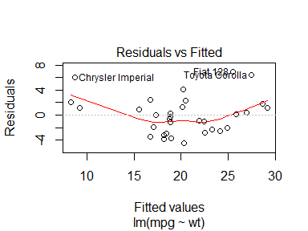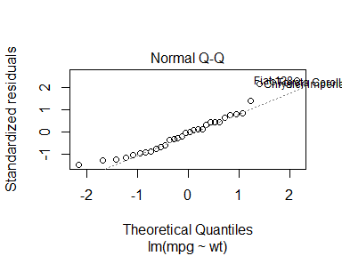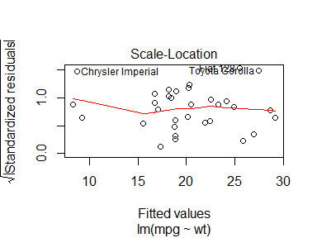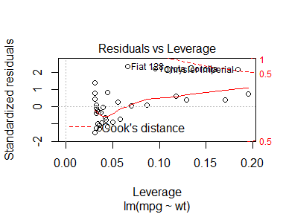

The slope of the regression is 37.2851262.