Creating Presentations and Report Writing: *Dynamically!*

Hanna Eriksson

March 22, 2017

# Start of my presentation

## Learning Goals

* Static documents: what options are out there?
  + A focus on markdown.
* Dynamic documents: produce documents that integrate text with the code for the analysis that the text presents.
* Produce documents in a variety of output formats (HTML/PDF/Word)

# Intermediate slide

## Part 1: Static Documents

In this section, weâ€™ll look at:

* The types of static documents
* Reproducibility of static documents

## Two Tasks of Writing

Two distinguishable tasks involved in writing a document:

* Write/insert the content. -Indicate how the content appears on the document.
* These two features are bundled together in a markup language.
  + â€œMarkupâ€ because authors would â€œmark upâ€ their publication with instructions on how to display the various parts of the publication â€“ title size, indentations, justification, etc.
  + Note: MS products combine these two steps into one editor.
* â€œView sourceâ€ of this document.

Part 2:

We built a linear regression model.

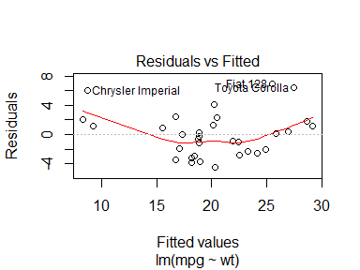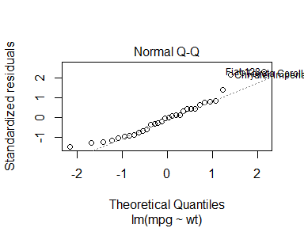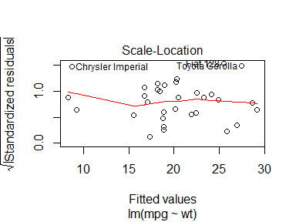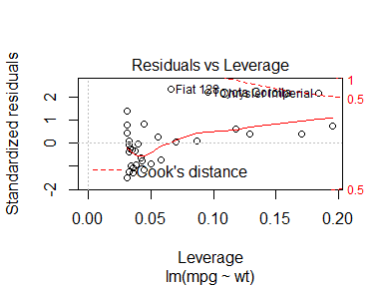

The slope of the regression is 37.