Global inference from community science requires careful statistics and interpretation
Karthik Thrikkadeeri^{1,2,✉}, Ashwin Viswanathan^{3,2}, and K L Vinay¹
¹ Department of Biological Sciences, Louisiana State University, Baton Rouge 70803, Louisiana, USA
² The State of India’s Birds Partnership, India
³ Bird Monitoring Team, Nature Conservation Foundation, Mysuru 570017, Karnataka, India
✉ Correspondence: Karthik Thrikkadeeri <rikudoukarthik@gmail.com>

1. Introduction
The COVID-19 pandemic had a significant impact on humanity, including widespread deaths and a sharp disruption in “normal” human activities (i.e., Anthropause). In order to understand how this influenced biodiversity data collection across the world, Roilo et al.¹ analysed large-scale biodiversity datasets. Here, we illustrate that several of their inferences about the pandemic and biodiversity monitoring do not directly follow from their results, and are therefore unfounded, thus highlighting the dangers of oversimplifying complex phenomena.

2. Socioeconomic analysis does not support inferences
Our primary concern lies with the headline inference, that a country’s economic status explains its community science (CS) data generation during the pandemic. This conclusion is drawn primarily from modelling the change in GBIF records (compared to a pre-pandemic baseline) against “economic class” (Fig. 2, Fig. S2 in ref.¹). Despite this variable being clearly directional (most to least developed; e.g., labelled 1–4 in Table S4¹), it has not been treated as such in the model. Given this implicit directionality, and the fact that only one pairwise comparison of classes (developed vs developing) showed a significant difference, we disagree with the conclusion that economic class affected data collection during the pandemic. In fact, the authors do not find any evidence that the “least developed” countries behaved any differently from developed and emerging countries. The presented inference is therefore not only statistically unsupported, but is also misleading. A reasonable inference here is that there is no evidence of an impact of economic class, but that the “developing” countries behaved differently from the rest, likely due to other unaccounted differences.
A vital nuance that is lacking in both the analysis and its interpretation is the history of CS in countries, often independent of economic class. Many countries, developed and otherwise, have large networks of community scientists built over many years with the help of dedicated regional programmes (see https://ebird.org/about/portals/). Such countries likely responded in a complex manner to the pandemic, like those that in fact saw increases in data^{2,3}. Roilo et al.¹ themselves acknowledge some previous studies that showed highly variable results⁴, some showing no effect of the lockdown⁵ or a positive one^{6,7}. But without factoring in the presence of active resident birding communities and other sociocultural factors affecting CS participation, the discourse is reductionist and the question becomes trivial: how dependent are countries on foreign (primarily birding) tourists for data collection? If the tourist inflow stopped in such countries, there would obviously be an inevitable drop in data collection (see also Section 4). Nevertheless, a likely reason for the inconclusive statistical link with economic class is that a number of less-developed countries have strong resident communities of naturalists today—a function of other sociocultural realities, and a feature that was restricted to developed countries in the past.
The authors extensively discuss the change in GBIF records in relation to the “stringency index” of government regulations, even though this variable was uninformative in their regression model. The “change in park visits” (derived from Google’s COVID-19 Community Mobility data) was the most important predictor here, but this actually represents a comparison with the five-week period of 3 January–6 February 2020, which is inconsistent with most other analyses in the study that compare changes in the first lockdown relative to the same period in 2019. Human mobility is driven by many annual and seasonal realities such as weather, natural phenology, holidays, and sociocultural calendars (Figure 1). Equating the periods of January–February and March–May in this context is therefore logically flawed. For instance, visits to parks and outdoor areas are much higher in the summer in temperate regions (“Developed region” panel in Figure 1), whereas many countries like India may show the opposite pattern³ due to seasonal challenges such as the monsoon rains.
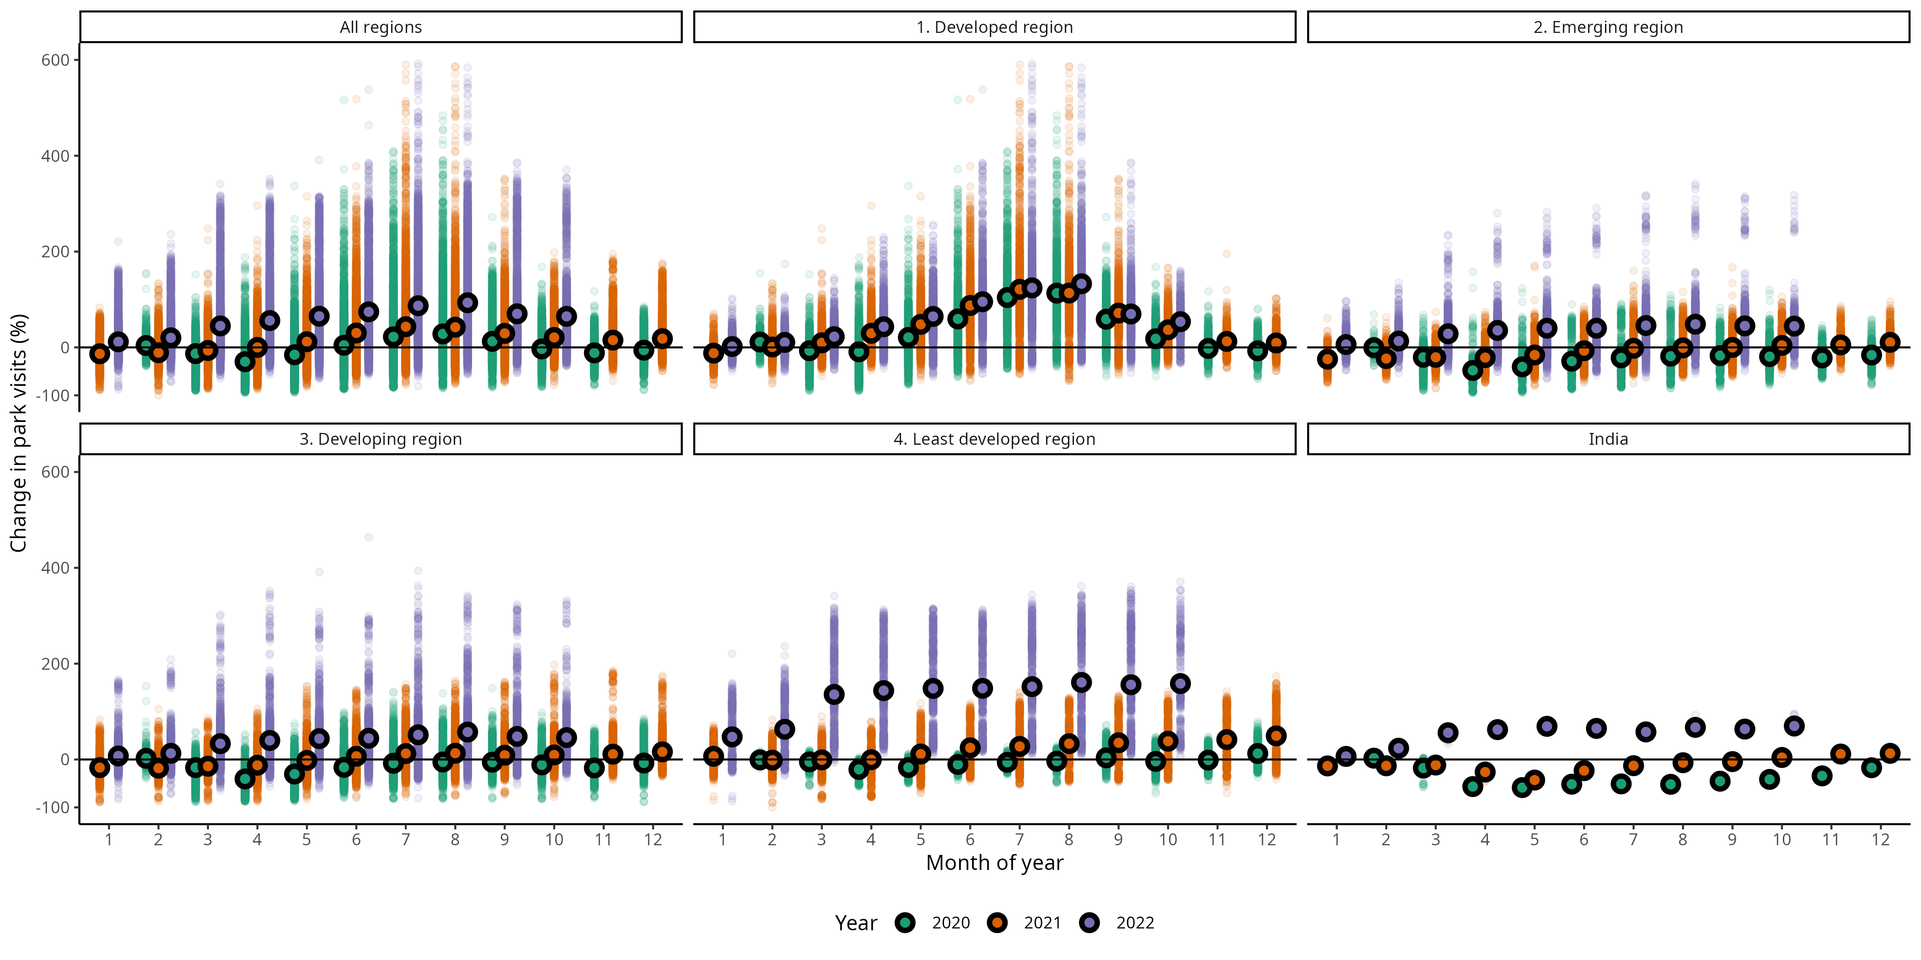
Figure 1: Google’s COVID-19 Community Mobility data showing change in park visits for all 12 months across the years 2020, 2021 and 2022 (in three different colours). Points with black stroke represent monthly average values, while smaller translucent points show individual daily values. Black horizontal lines represent baseline park visits during 3 January–6 February of 2020 (medians for corresponding days of the week). Facets show this data aggregated for all regions, regions of each of four economic classes, and India separately. Note the especially high variability—unrelated to economic class—within months, across months of a year, and across the three years.
Moreover, in an urban planning context as well as in the context of park visits, this variable may not mean the same in all parts of the world. In this dataset, “parks” are defined as “local parks, national parks, public beaches, marinas, dog parks, plazas, and public gardens” (see Mobility data documentation), and a measure of such visits is arguably more meaningful in western countries. For instance, national parks are much more accessible to the general public in the Global North than elsewhere in the world. The accuracy and robustness of this measure is also contingent on the local status of mapping and GIS technology, which might not be comparable across the globe (see 2022 data for the “Least developed” panel in Figure 1). Even in developed countries, these Mobility data were highly variable, suggesting that they must be treated with caution, but the authors instead reduced everything down to singular mean values for the entire six-week period.

3. Only six weeks of a two-year pandemic analysed
With their title, Roilo et al.¹ position their study as a comprehensive, global assessment of the impact of the COVID-19 pandemic. Globally, the pandemic was a public health emergency lasting more than two years, with several countries facing the greatest impact (death tolls) in 2021 rather than 2020⁸. Despite this, the authors restrict their study to just the first six weeks of the first lockdown (15 March–1 May 2020), which they call “the COVID-19 lockdown”. The study therefore not only completely misses the second year of lockdowns (2021) as well as the other pandemic months between major lockdowns, but also fails to account for differences around the world in the timing of first wave lockdowns⁹. For instance, the first lockdown in India started on 25 March 2020¹⁰ and extended until 31 May 2020¹¹, meaning the analysis misrepresents >29% of the actual 2020 lockdown in India. In fact, the same analyses implemented just with broader temporal scope yields drastically different, sometimes contradictory results (Figure 2, Figure 3). But the authors’ discussions lack the critical nuance of how narrow their scope actually is, and the title is therefore misleading at best. (Note: The interactive Anthropause app allows full-year visualisation but not any actual analyses at the annual level.)
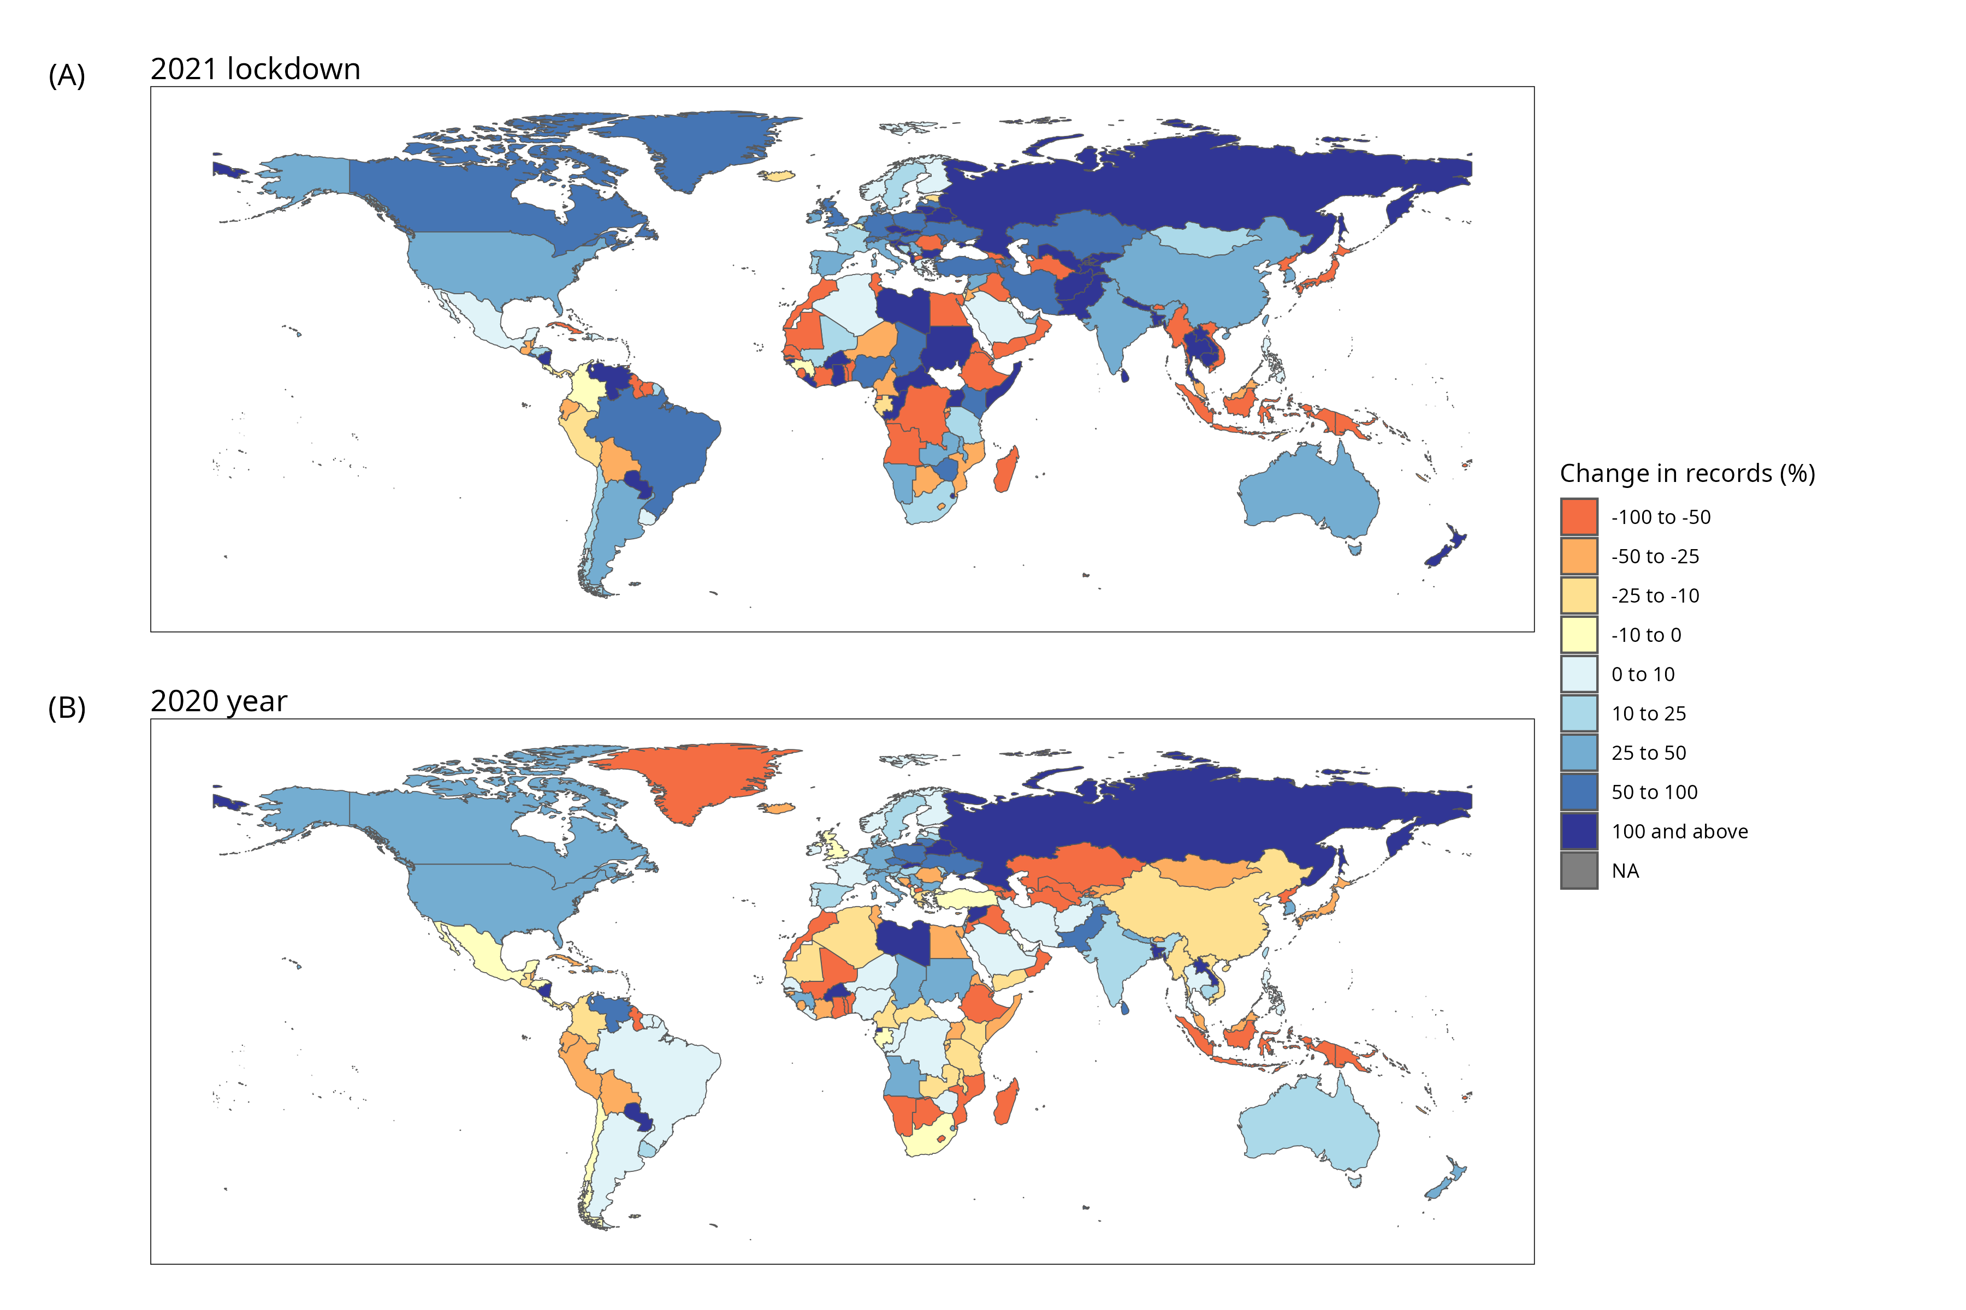
Figure 2: Maps of countries of the world, showing the percent change in mean daily number of GBIF records collected between: (A) March 15th and May 1st 2021 relative to the same period in 2019; (B) All 12 months of 2020 relative to all 12 months of 2019. (Compare with Fig. 1 in ref.¹.)

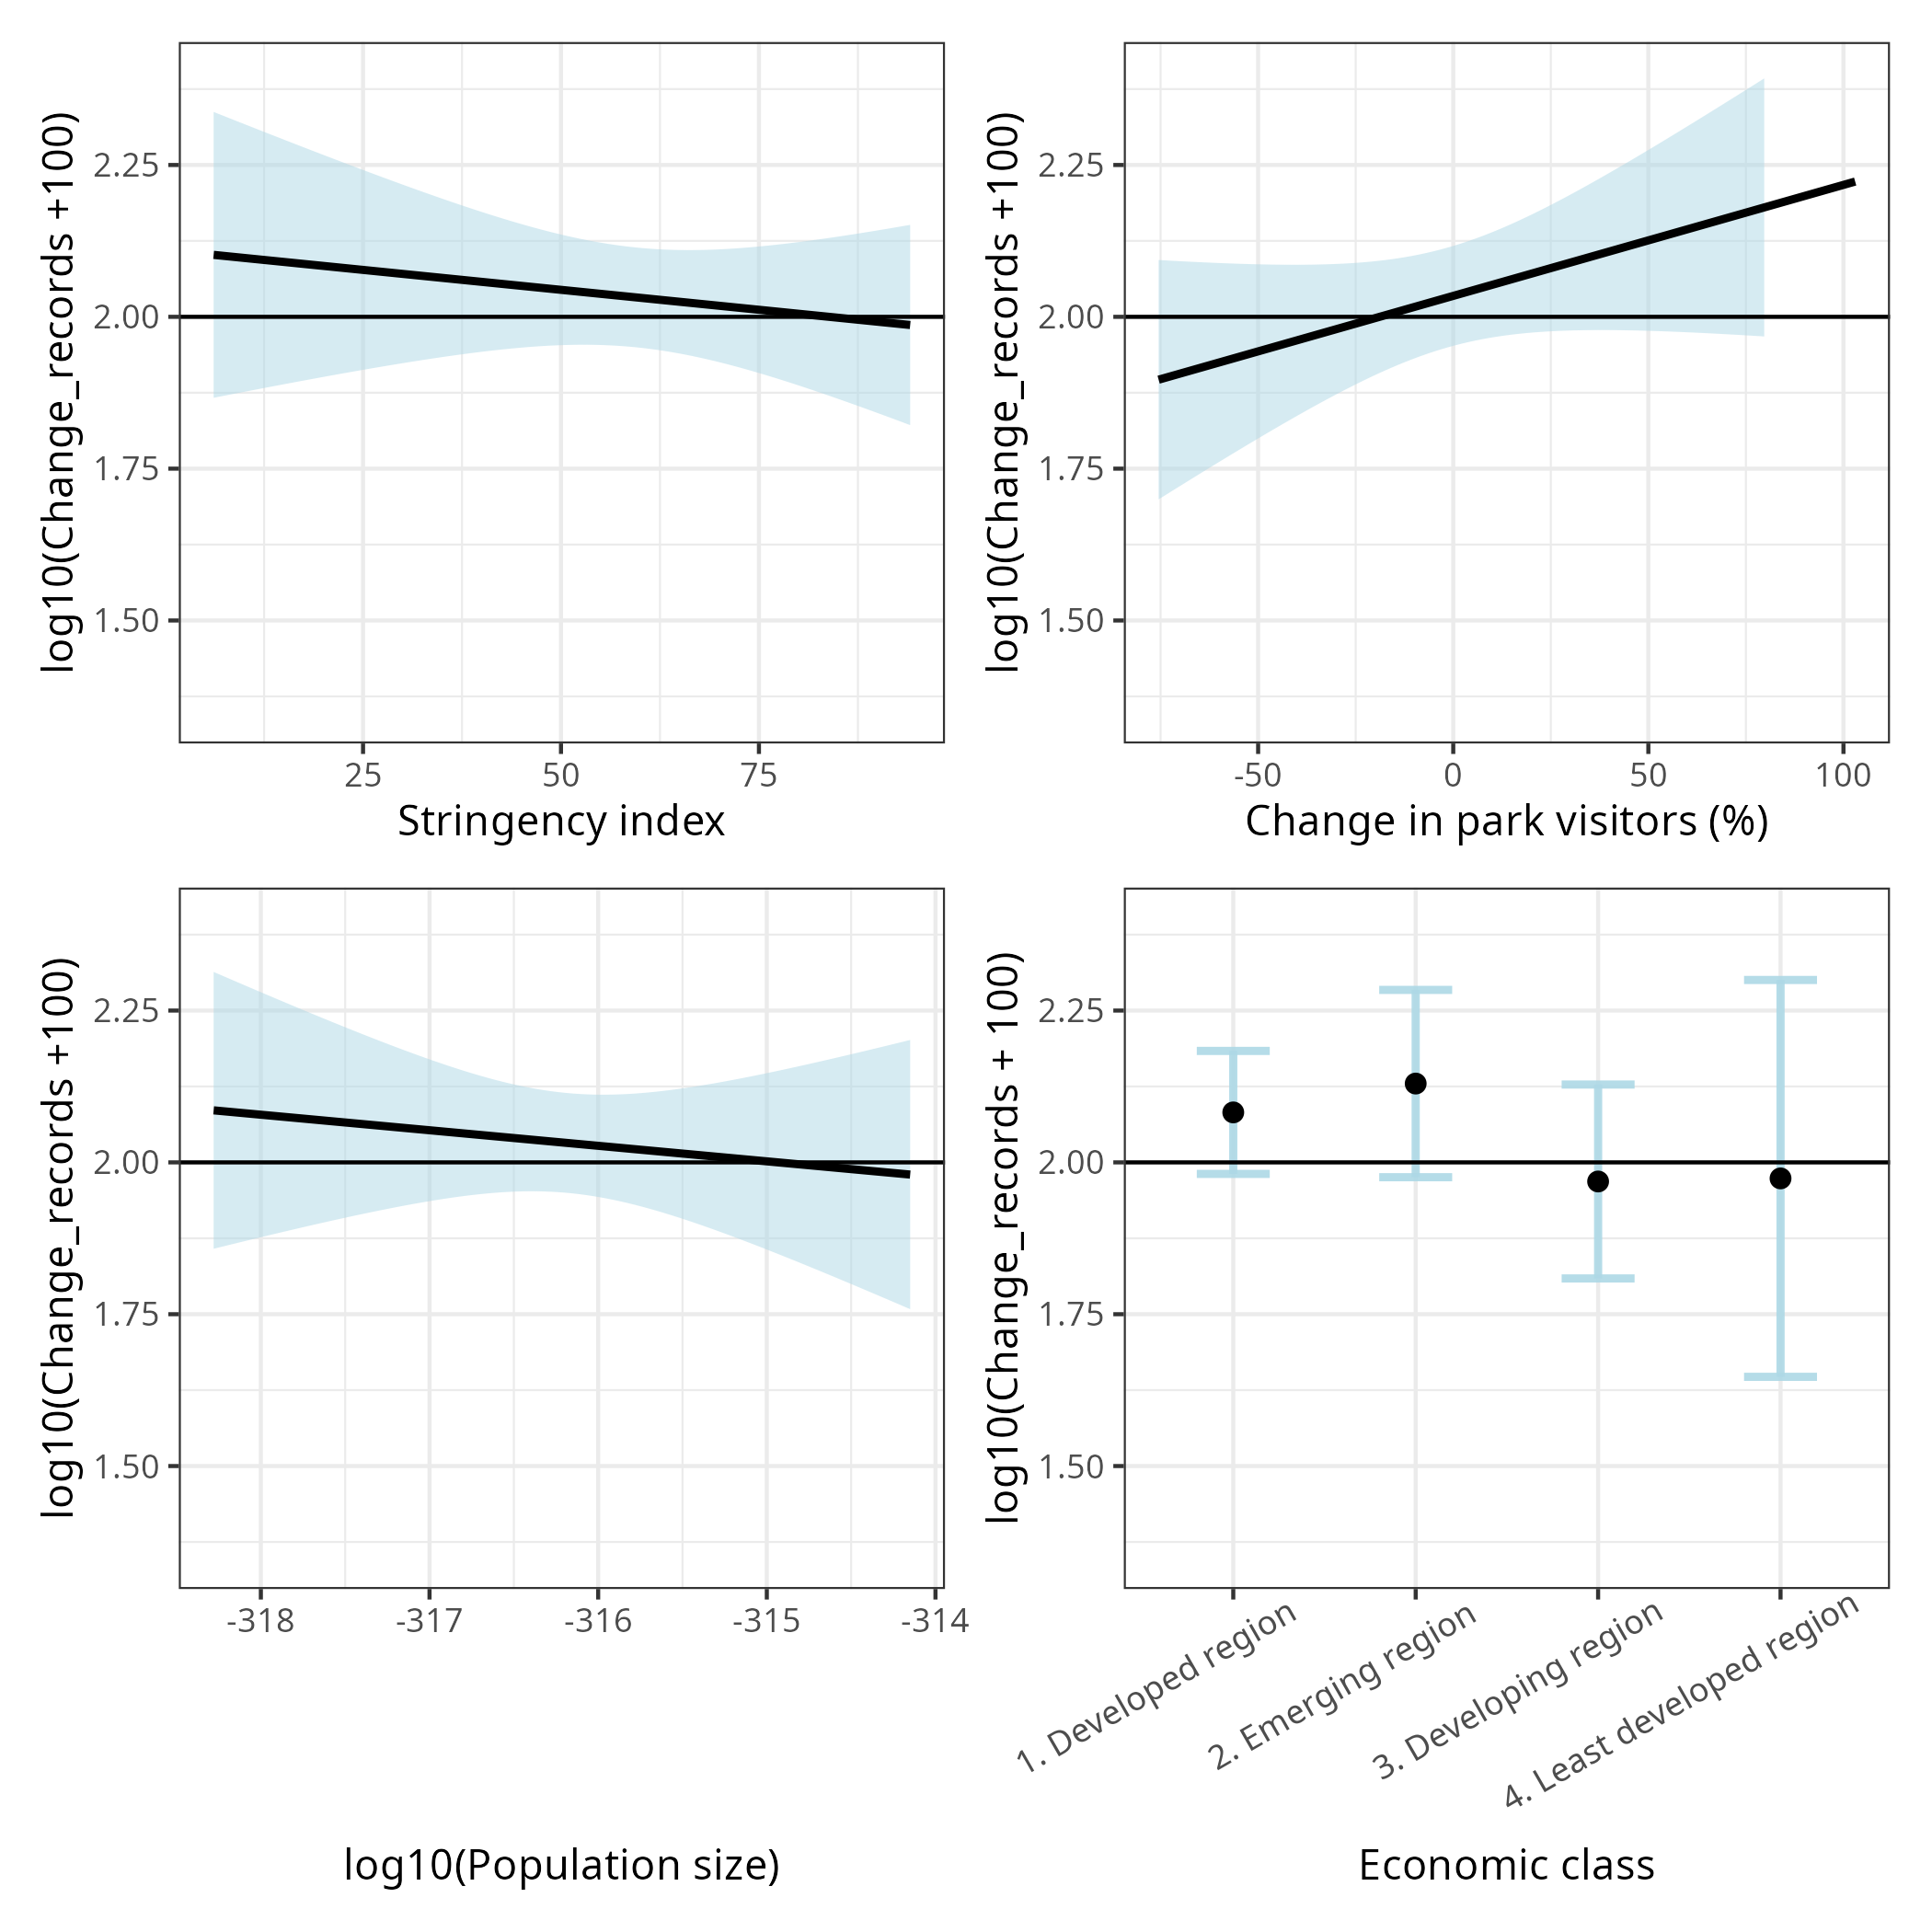
Figure 3: Conditional plots showing the predictors of the generalised least squares regression of percent change in GBIF records between six-week periods in 2021 and 2019. Relationships were graphed for each predictor with all other continuous covariates held at their means, or by weighting levels of the categorical covariate in proportion to sample size. Black horizontal lines at y = 2 represent the baseline of 0% change on the transformed scale of the y-axis. The light blue shading and error bars show 95% confidence intervals, which notably overlap the zero-change baseline for all variables. (Compare with Fig. 2 in ref.¹.)

4. Data curation, statistics and interpretation lack rigour
CS data are characteristically noisy and uneven, therefore requiring careful curation of data prior to analyses^{12,13}, and rendering simple statistical methods and conventional significance tests inappropriate¹⁴. Because this study includes several countries that have very little available CS data (most “least developed” countries analysed), an absolutely vital consideration^{12,13} would be whether these countries have enough data to be analysed at all (i.e., minimum data thresholds). Another important statistical step would be to include explicit effort correction¹⁴.
Such best practices appear to be completely absent in this study: the analyses do not correct for effort nor involve curated data; they do not utilise effect sizes or confidence estimates, and instead rely on either p-values (inappropriate for large, noisy datasets^{15,16}), or simple numerical or visual comparisons of percent change and counts. For example, their headline metric is a simple percent change in number of occurrence records (Figure 2; Fig. 1 in ref.¹). Notably, many countries show a positive or negative change of 0%–25%, which could very likely be simple stochastic artefacts of multiple comparisons, such as the phenomenon of “regression to the mean”^{17,18}.
Another inappropriate statistical choice is to assess significance of the 2020 lockdown deviation in data collection, by comparing predicted values for 2020 (from a smooth-splined growth curve for 2010–2023) with the observed values. Despite the misleading reference in Table S2¹ to “linear regressions”, smoothing splines are not appropriate in this context due to their following properties¹⁹: (1) The width of their confidence interval depends on the smoothing parameter, which the authors limited to 0.4–0.6 without justification. (2) They do not produce simultaneous confidence intervals, thereby underestimating uncertainty and risking false positives. (3) They ignore residual noise, rendering comparisons of observed and predicted values meaningless. We also found some unaddressed contradictions in these and similar results. Fig. 1¹ shows percent change between 2019 and 2020, whereas Table S2¹ shows percent change between predicted and observed values for 2020—and these two have several contradictory patterns. For example, Canada, the United States, New Zealand, Zimbabwe and Papua New Guinea all show non-significant changes in Table S2 but decreases (Papua New Guinea) or increases (others) in Fig. 1. Further, Australia shows a decrease in Table S2 but an increase in Fig. 1.
The authors found that eBirders covered smaller areas than expected during the first COVID-19 lockdown (Fig. 3 in ref.¹). While this is one of few unanimous, consistent patterns across studies exploring the pandemic impact^{2–4,20,21}, the statistical method used to arrive at the result is inappropriate. They used a two-sample Kolmogorov-Smirnov test to check for a significant difference between the 2019 and 2020 values, but this test focuses on the distribution of data (rather than their means as in previous analyses)—effectively comparing whether areas of eBirder activity in 2019 and 2020 followed the same distribution²². This test is thus sensitive to differences in shape in addition to mean or variance, and is therefore not robust to unequal sample sizes or noisy data²³. For instance, it would detect a “significant” difference if just birders covering the largest areas (outliers) increased or decreased their area of activity, even if the overall mean value remained similar.

5. Change in number of eBird records is a flawed response variable
The main response variable in this analysis is the total number of records uploaded to eBird (= “observations”) and GBIF—where eBird is the primary source, contributing 68% of “human” observations in the full dataset, and 76% in the lockdown data analysed here. Given that eBird data were not removed for the GBIF analysis, we argue that this choice of variable is a fundamental flaw of the analysis, and hence also of much of the interpretation (Fig. 3 and Fig. 4 in ref.¹; see also Section 6).
eBird follows a semi-structured framework^{24,25}, with data organised at the level of checklists and not as individual observations. Further, all checklists are not created equal: “complete” checklists are the gold standard indicators of data generation effort, whereas “incomplete” checklists show much more variability and a much weaker relationship with effort. An appropriate indication of data generation is therefore the number of (complete) checklists rather than the number of observations. Aside from the eBird data not having been curated for complete checklists (see Section 4), several pandemic-associated changes (as well as many unrelated factors) are likely to have influenced the number of observations per checklist, two of which we discuss as especially important below.
- Reduced mobility. People moved around less during the pandemic and also potentially visited fewer national parks and “interesting” areas, instead spending more time in urban areas closer to home^{2–4,20,21}. This very likely resulted in a reduction in the number of species observed per checklist due to lower species diversity in urban areas. Therefore, even if the number of checklists (i.e., data generation effort) did not change during the pandemic, the number of observations will inherently have decreased, creating the false impression of lowered participation in CS.
- Reduced group birding. People also avoided groups during the lockdowns^{3,20}, which likely reflected in eBird data as fewer “group birding” events³. Roilo et al.¹ summarised observations without removing “duplicates” (another obvious data curation step that was missed; Section 4), which are multiple copies of the same observations created for every eBirder involved in a group birding event. Birding in groups typically also increases species detection rates, so irrespective of how the number of “unique” checklists (i.e., independent birding effort) changed, the number of observations during 2020 likely decreased.

6. Analysis of top eBirder activity is uninformative
The authors compared the countries where each eBirder recorded observations in 2019 and 2020. However, they only considered 30 eBirders per country for this analysis, and these 30 were selected from the eBirders with observations on the most days during the six-week period in 2019. They introduce the premise of transboundary migrations of eBirders, suggesting that in less developed countries (which are generally also more biodiverse) higher proportions of data contribution come from tourists, i.e., foreign eBirders. While this is undeniably true for regions without resident eBirding communities (see Section 2), the analysis itself is questionable because it considers the 2019 top 30 eBirder list as the benchmark. This is misleading especially for such short timeframes, since many factors unrelated to the pandemic or the economic class of a country could result in a top 30 list that does not represent local consistent birding. In other words, short-term visitors or tourists may lead in “most activity” for a given six-week period, even while many resident birders continue to contribute regularly but remain underrepresented.
It is obvious and intuitive that countries without resident eBirding communities would have greater tourist contribution. The authors’ concept of top 30 “returning birders” does not make sense in the context of how tourism typically functions—most tourists would not return to the same country in the following year. Moreover, the authors interpret Fig. 4¹ with statements about developing and least developed countries together; the actual results only hold true for the least developed countries, whereas developing countries, notably, showed patterns similar to emerging and developed countries. This reiterates the importance of threshold minima for data quantity (Section 4). Nevertheless, in order to claim an effect of the pandemic, the pattern seen during the six-week periods of 2019 and 2020 must be compared against those in other months of the year as well as other pairs of years. Without such contextualization, it is difficult to infer about birders who “stopped collecting data”, and to isolate the impact of the global pandemic on biodiversity data collection.

7. Conclusion
The main takeaway from Roilo et al.¹ was that local, community-based biodiversity monitoring programmes are vital, especially in less-developed countries, to sustain and improve the quality of global biodiversity monitoring. This is certainly true, and we agree that it is worth emphasising and working towards. However, we stress that our fundamental concern discussed here is about oversimplified analyses of complex datasets and broad sweeping inferences that do not directly follow from results—which give rise to bold, and perhaps misleading, claims, often about issues that might operate differently between the Global North and South.
In general, there seems to have been high variability across geographical units in the impact of the pandemic on CS data^{3,4}. As a result, the larger the spatial or temporal scale, the less evidence there seems to be for any strong consistent trend. This is a clear suggestion of multicausal contingency not just in CS data, but more broadly also in the behavioural and sociocultural aspects of biodiversity monitoring today. Importantly, our intent is not to discourage attempts at analysing complex CS data and making large-scale inferences, but rather to caution that such work demands greater care and nuance in its implementation and interpretation.

References
1. Roilo, S., Engler, J. O. & Cord, A. F. Global impact of the COVID-19 lockdown on biodiversity data collection. Sci Rep 15, 8767 (2025).
2. Basile, M., Russo, L. F., Russo, V. G., Senese, A. & Bernardo, N. Birds seen and not seen during the COVID-19 pandemic: The impact of lockdown measures on citizen science bird observations. Biological Conservation 256, 109079 (2021).
3. Thrikkadeeri, K. & Viswanathan, A. Despite short-lived changes, COVID-19 pandemic had minimal large-scale impact on citizen science participation in India. Ornithological Applications 126, duae024 (2024).
4. Hochachka, W. M., Alonso, H., Gutiérrez-Expósito, C., Miller, E. & Johnston, A. Regional variation in the impacts of the COVID-19 pandemic on the quantity and quality of data collected by the project eBird. Biological Conservation 254, 108974 (2021).
5. Stenhouse, A. et al. COVID restrictions impact wildlife monitoring in Australia. Biological Conservation 267, 109470 (2022).
6. Sweet, F. S. T., Rödl, T. & Weisser, W. W. COVID-19 lockdown measures impacted citizen science hedgehog observation numbers in Bavaria, Germany. Ecology and Evolution 12, e8989 (2022).
7. Crimmins, T. M., Posthumus, E., Schaffer, S. & Prudic, K. L. COVID-19 impacts on participation in large scale biodiversity-themed community science projects in the United States. Biological Conservation 256, 109017 (2021).
8. Worldometer. COVID Live - Coronavirus Statistics - Worldometer. https://www.worldometers.info/coronavirus/ (2023).
9. Hale, T. et al. Variation in government responses to COVID-19. (2020).
10. BBC News. Coronavirus: India enters ‘total lockdown’ after spike in cases. BBC News (2020).
11. Banerjea, A. Coronavirus lockdown extended till 31 May, says NDMA. mint (2020).
12. Johnston, A. et al. Analytical guidelines to increase the value of community science data: An example using eBird data to estimate species distributions. Diversity and Distributions 27, 1265–1277 (2021).
13. Viswanathan, A. et al. State of India’s Birds 2023: A framework to leverage semi-structured citizen science for bird conservation. 2024.09.05.611348 Preprint at https://doi.org/10.1101/2024.09.05.611348 (2024).
14. Isaac, N. J., van Strien, A. J., August, T. A., de Zeeuw, M. P. & Roy, D. B. Statistics for citizen science: extracting signals of change from noisy ecological data. Methods in Ecology and Evolution 5, 1052–1060 (2014).
15. Gotelli, N. J. & Ellison, A. M. A primer of ecological statistics. vol. 1 (Sinauer Associates Sunderland, 2004).
16. Wasserstein, R. L. & and Lazar, N. A. The ASA Statement on p-Values: Context, Process, and Purpose. The American Statistician 70, 129–133 (2016).
17. Mazalla, L. & Diekmann, M. Regression to the mean in vegetation science. Journal of Vegetation Science 33, e13117 (2022).
18. Barnett, A. G., van der Pols, J. C. & Dobson, A. J. Regression to the mean: what it is and how to deal with it. International Journal of Epidemiology 34, 215–220 (2005).
19. Helwig, N. E. Package ‘npreg’. (2024).
20. Randler, C., Tryjanowski, P., Jokimäki, J., Kaisanlahti-Jokimäki, M.-L. & Staller, N. SARS-CoV2 (COVID-19) Pandemic Lockdown Influences Nature-Based Recreational Activity: The Case of Birders. International Journal of Environmental Research and Public Health 17, 7310 (2020).
21. Vardi, R., Berger-Tal, O. & Roll, U. iNaturalist insights illuminate COVID-19 effects on large mammals in urban centers. Biological Conservation 254, 108953 (2021).
22. Berger, V. W. & Zhou, Y. Kolmogorov–Smirnov Test: Overview. in Wiley StatsRef: Statistics Reference Online (John Wiley & Sons, Ltd, 2014). doi:10.1002/9781118445112.stat06558.
23. Bubelíny, P. Some notes on biasedness and unbiasedness of two-sample Kolmogorov-Smirnov test. Preprint at https://doi.org/10.48550/arXiv.1106.5598 (2011).
24. Kelling, S. et al. Using Semistructured Surveys to Improve Citizen Science Data for Monitoring Biodiversity. BioScience 69, 170–179 (2019).
25. Sullivan, B. L. et al. The eBird enterprise: An integrated approach to development and application of citizen science. Biological Conservation 169, 31–40 (2014).

Author contributions
KT and AV conceived the manuscript; KT wrote the first draft; KT and KLV assembled and explored Original Article data and results; KT, AV and KLV designed the analyses; KT performed the analyses; KT, AV and KLV revised and edited the manuscript.

Competing interests
We (KT and AV) conducted a similar analysis for India³ which found results that do not match those in the Original Article. Roilo et al.¹ do not cite or discuss our study, but we maintain that this was not a factor motivating our commentary. Our motivation is borne of a shared research interest and is as detailed in the Introduction and Conclusion.

