Report Mandelbrot OpenMP

**Authors:**

*Riccardo Isola - S4943369*

*Gabriele Dellepere - S4944557*

*Kevin Cattaneo - S4944382*

# Index

**Index 1**

**Head of analysis 1**

**Hotspot identification 2**

**Vectorization issues 3**

**Best sequential time 4**

**OpenMP Parallelization 6**

**Speedup and efficiency 7**

**Conclusions 10**

# Head of analysis

**Algorithm:** the code provided has quadratic N^3 (cubical) complexity.

**Tools:** we used the *icpx* compiler, the Intel one, and Intel Advisor GUI to perform the most of the analysis.

**Machine:** the machine on which we run the code has 20 processors:

* 12 core
  + 8 core with hyperthreading up to 2
  + 4 performance core

For the current analysis we decided to fix the RESOLUTION that is WIDTHxHEIGHT and to iterate different runs over different ITERATIONS.

We also changed the original time function with the OpenMP library one to be more precise (the original one was rounding on seconds).

# 

# Hotspot identification

In first place we compiled the program:

- **compiling line**: icpx -g -fopenmp mandelbrot.cpp

- **data size**: RESOLUTION=1000, ITERATIONS=700

- **time taken**: 49.70 seconds

Then we put the executable into intel advisor to perform a detailed analysis, where we identified the following hotspots.

What we discovered is that the hotspot is the main loop at line 44, contained in the one at line 34, so the one that performs the mandelbrot computation. So the main objective will be trying to parallelize the external one, since the inner one has the dependence on the previous value of z at each iteration.

| **Name** | **Time taken (seconds)** |
| --- | --- |
| Overall program | 49.70 |
| _libm_hypot | 20.45 |
| operator+<double> | 7.67 |
| complex<double> | 3.79 |
| loop in main - line 60 | 3.78 |

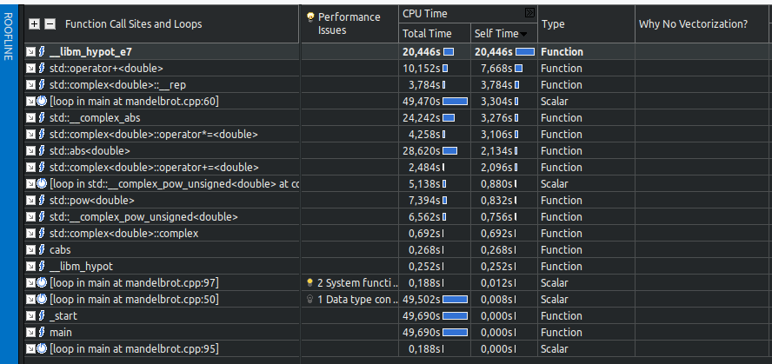

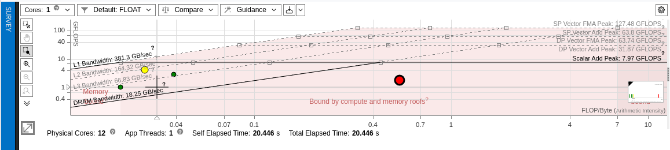

As we can see from the survey section, the main hotspots are the math operations of _libm_hypot that performs the Euclidean distance, the override of the operator + for double in the library std, the conversion into complex from double, then the main loop that we can optimize, that performs the power operation. The remaining most taken times are taken again by other math operations like abs on double and operator + on complex type.

As we can see on the roofline, the point that we can optimize is the third from the left, that is the green one representing the main loop.

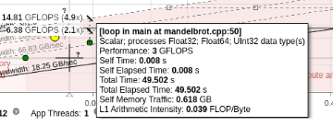

# Vectorization issues

To obtain the report about vectorization infos, we specified the level 3:

**First**

- **compiling line**: icpx -O3 -xHost -qopt-report=3 mandelbrot.cpp

- **data size**: RESOLUTION=1000, ITERATIONS=700

- **time taken**: 2.27 seconds

The mandelbrot.optrpt report told us the following:

* LOOP BEGIN at mandelbrot.cpp (50, 5)
  + **remark** #15541: loop was not vectorized: outer loop is not an auto-vectorization candidate.
  + That may be caused by the fact that z is probably not a number but a pointer so the compiler can’t put it in a vector; since z can’t be transformed the outer loop fails to be vectorized
  + A possible solution, difficult to implement, could be to transform the coordinates from cartesian to polar, perform the exponential as a rotation and then transform from polar to cartesian again to allow an easier sum computation. We verified that this kind of transformation is vectorizable by the compiler, still we have a break that breaks the possibility of vectorization, since some z indexes should stop the for loop and should prevent the other indexes from being computed.  
    Indeed by removing the break we observed that the LOOP WAS VECTORIZED in the report. Still that cannot be safely removed, so no vectorization obtained.
* LOOP BEGIN at mandelbrot.cpp (60, 9)
  + **remark** #15344: Loop was not vectorized: vector dependence prevents vectorization
  + that is the dependence on the z we pointed out previously

# Best sequential time

Now we perform different runs to find the best sequential time, to be used as reference for the further parallel application, by passing several arguments and flags to the intel compiler.

Original without optimizations

- **compiling line**: icpx -O0 -fopenmp mandelbrot.cpp

- **data size**: RESOLUTION=1000, ITERATIONS=700

- **time taken**: 50.488 seconds

Compared to the one with the flag optimizations:

- **compiling line**: icpx -g -fopenmp -O3 -xHost -ffast-math mandelbrot.cpp

- **data size**: RESOLUTION=1000, ITERATIONS=700

- **time taken**: 2.422 seconds

Then we tried different combinations of flags to find the best combination in terms of time, to make this difference more visible, we also increased the data size. With that we identified the best sequential case with data size equal to 10000 iterations.

- **compiling line**: icpx -fopenmp -O3 -xHost mandelbrot.cpp

- **data size**: RESOLUTION=1000, ITERATIONS=10000

- **time taken**: 31.3712 seconds

- **compiling line**: icpx -fopenmp -O3 -xHost -ffast-math mandelbrot.cpp

- **data size**: RESOLUTION=1000, ITERATIONS=10000

- **time taken**: 31.2874 seconds

- **compiling line**: icpx -fopenmp -O3 -xHost -ipo mandelbrot.cpp

- **data size**: RESOLUTION=1000, ITERATIONS=10000

- **time taken**: 31.4665 seconds

- **compiling line**: icpx -fopenmp -O3 -xHost -ipo -ffast-math mandelbrot.cpp

- **data size**: RESOLUTION=1000, ITERATIONS=10000

- **time taken**: 31.3204 seconds

We see a little difference, so there is no best combination.

Overall we are applying the best optimizations arguments:

* **O3**: to allow the compiler to optimize the code, so that it can reorder the operations in the most efficient way
* **xHost**: to achieve the best assembly instructions specifically on the current machine architecture
* **ipo**: to enable interprocedural optimizations; we observed that with this flag the program didn’t achieve better performances
* **fast-math**: to reduce the time needed for mathematical operations, although reducing the precision of our calculations.

We also check on the roofline the result obtained so far with the combination of flags, also decreasing the data size for a matter of time spent by Intel Advisor:

- **compiling line**: icpx -fopenmp -O3 -xHost -ffast-math mandelbrot.cpp

- **data size**: RESOLUTION=1000, ITERATIONS=700

- **time taken**: 2.23492 seconds

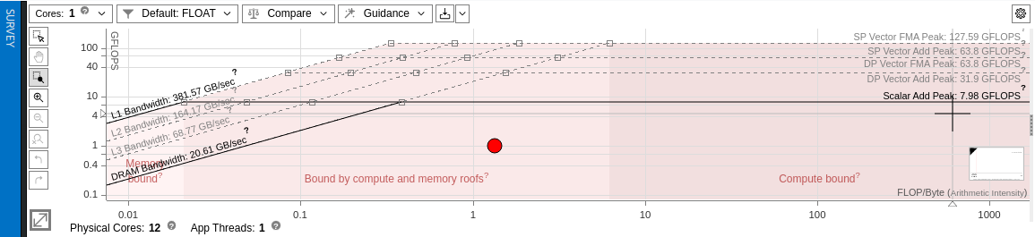

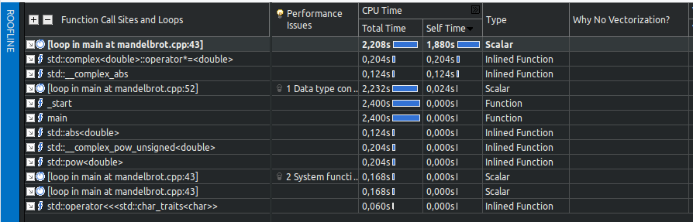

By exploiting the optimization flags we achieved the reduction in time of the hotspots, so the math computations on double and complex numbers.

Also the advisor suggests that we have some data type conversion between two different widths, that’s because of the conversion from complex to real and vice versa, that can’t be avoided because of the algorithm implementation.

Also there are some notifications about 2 system calls used and also a reduction suggested, but those can’t apply actually to the algorithm, so it’s an hallucination of Advisor.

# OpenMP Parallelization

To compare we fix the same data size of before and we run the parallelization.

On line 49 we put the following line:

*# pragma omp parallel for default(none) shared(image)*

We compare the original best sequential run without pragma:

- **compiling line**: icpx -fopenmp -O3 -xHost -ffast-math mandelbrot.cpp

- **data size**: RESOLUTION=1000, ITERATIONS=10000

- **time taken**: 31.2413 seconds

With pragma enabled:

- **compiling line**: icpx -fopenmp -O3 -xHost -ffast-math mandelbrot.cpp

- **data size**: RESOLUTION=1000, ITERATIONS=10000

- **number of threads**: 20 (decided by scheduler)

- **time taken**: 4.10494 seconds

We reduced the time needed by 8 times, also exploiting the maximum power of our machine in terms of threads.

Now we increase the data size to test the limits by trying different combinations of the usage of the *pragma* instructions.

- **compiling line**: icpx -fopenmp -O3 -xHost -ipo -ffast-math mandelbrot.cpp

- **data size**: RESOLUTION=1000, ITERATIONS=80000

- **number of threads**: 20 (decided by scheduler)

- **time taken**: 30.3726 seconds

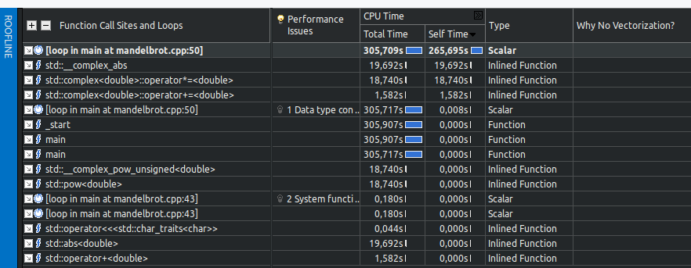

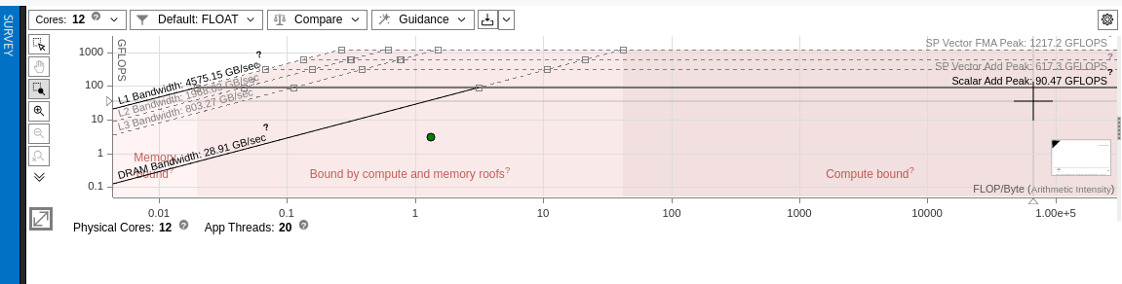

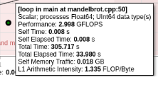

We increased our data size and our arithmetic intensity achieving great results with respect to the non-parallel one. For some reason Advisor hallucinates and gives some 300s of runtime even if the program is correctly recognized to have ~30s of runtime.

# Speedup and efficiency

As possible number of processors, we chose:

* 1: sequential run
* 2: enable parallelization
* 4: equal to the number of performance cores
* 12: equal to the number of all cores without considering hyperthreading
* 20: the maximum value of processors considering hyperthreading up to 2
* 30: to observe any overhead

**compiling line**: icpx -g -fopenmp -O3 -xHost -ipo -ffast-math mandelbrot.cpp

| **Data size** | RESOLUTION=1000 | ITERATIONS=10000 |  |
| --- | --- | --- | --- |
|  |  |  |  |
| N processors | Time spent | Speedup T1/Tp | Efficiency |
| 1 | 31,05 | 1 | 1,00 |
| 2 | 15,53 | 2 | 1,00 |
| 4 | 12,93 | 2 | 0,60 |
| 12 | 5,66 | 5 | 0,46 |
| 20 | 3,71 | 8 | 0,42 |
| 30 | 3,33 | 9 | 0,31 |

# Grafico

We observe that after enabling the parallelization with 2 processors, the time spent drastically decreases, while remaining more or less stable after 12 processors.

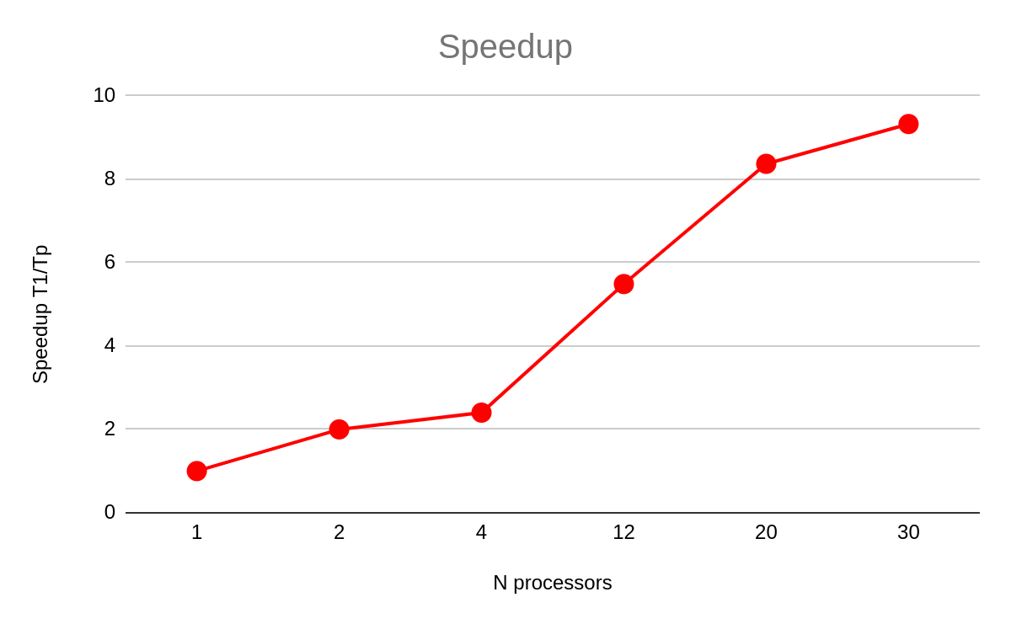

Here we see that the speedup increases in different sections, in particular after enabling the parallelization with 2 processors, then a huge peak after 4.

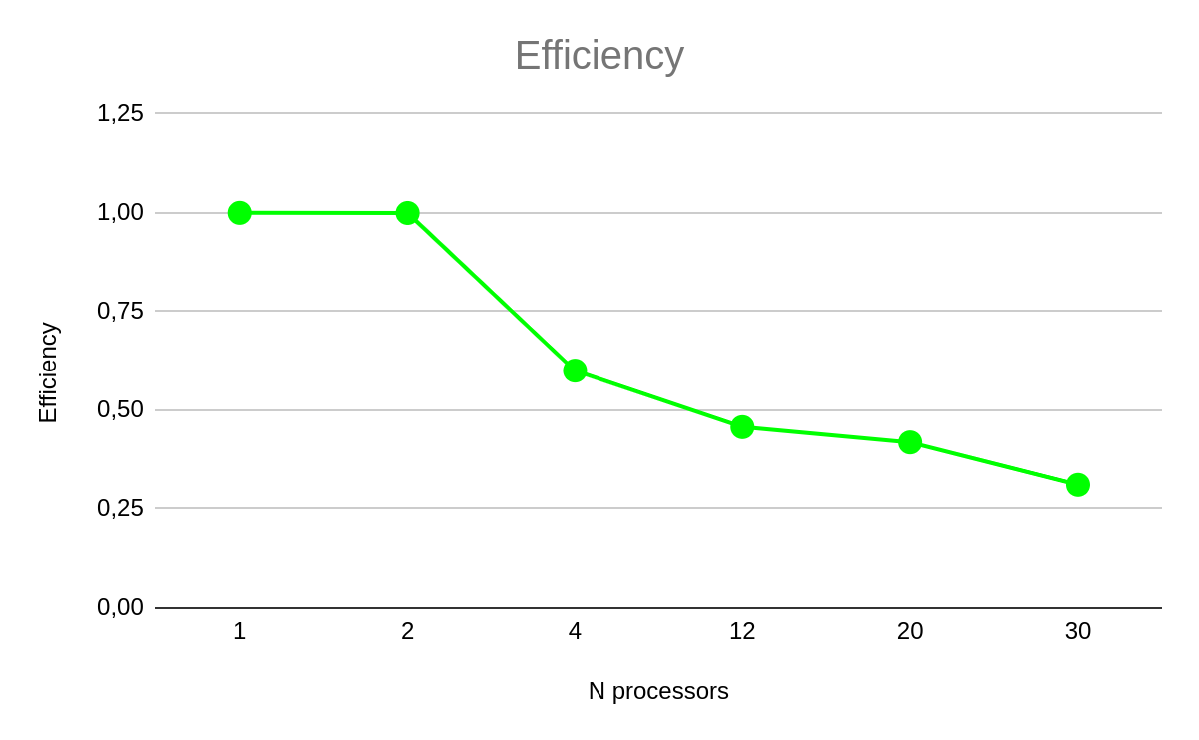

On the other hand, the efficiency remains more or less stable up to 4 processors, then starts decreasing, but the most decreased distance is from 2 processors.

# CUDA Parallelization

As first thing we explored some specifications of the machine on which we are running on via *devicequery:*

Device 0: "Tesla T4"

CUDA Driver Version / Runtime Version 12.2 / 12.2

CUDA Capability Major/Minor version number: 7.5

Total amount of global memory: 15102 MBytes (15835660288 bytes)

(040) Multiprocessors, (064) CUDA Cores/MP: 2560 CUDA Cores

GPU Max Clock rate: 1590 MHz (1.59 GHz)

Memory Clock rate: 5001 Mhz

Memory Bus Width: 256-bit

L2 Cache Size: 4194304 bytes

Maximum Texture Dimension Size (x,y,z) 1D=(131072), 2D=(131072, 65536), 3D=(16384, 16384, 16384)

Maximum Layered 1D Texture Size, (num) layers 1D=(32768), 2048 layers

Maximum Layered 2D Texture Size, (num) layers 2D=(32768, 32768), 2048 layers

Total amount of constant memory: 65536 bytes

Total amount of shared memory per block: 49152 bytes

Total shared memory per multiprocessor: 65536 bytes

Total number of registers available per block: 65536

Warp size: 32

Maximum number of threads per multiprocessor: 1024

Maximum number of threads per block: 1024

Max dimension size of a thread block (x,y,z): (1024, 1024, 64)

Max dimension size of a grid size (x,y,z): (2147483647, 65535, 65535)

[...]

So the maximum number of threads that we can use per block is 1024, scheduled in warps of 32 threads. Also we have available 40 Streaming Multiprocessors (each with 2 warp schedulers), for a total available maximum of 2560 concurrent threads scheduled at each clock cycle.

## First version

The main idea was to unroll the for loop inside the function *main* that generates the mandelbrot matrix via indexes, and so we parallelize each pos, so pixels.

So our kernel is implemented as follows:

__global__ void kernel(int* image)

{

int pos = threadIdx.x + blockIdx.x * blockDim.x;

if(pos > WIDTH*HEIGHT) return;

// evaluate derivatives

image[pos] = 0;

const int row = pos / WIDTH;

const int col = pos % WIDTH;

const cuda::std::complex<double> c(col * STEP + MIN_X, row * STEP + MIN_Y);

// z = z^2 + c

cuda::std::complex<double> z(0, 0);

for (int i = 1; i <= ITERATIONS; i++)

{

z = cuda::std::pow(z, DEGREE) + c;

// If it is convergent

if (cuda::std::abs(z) >= 2)

{

image[pos] = i;

break;

}

}

}

And in the main:

const int size=WIDTH*HEIGHT;

int *image_dev;

cudaMalloc((void**) &image_dev, size);

cudaMemcpy(image_dev, image, size, cudaMemcpyHostToDevice);

dim3 block_size(BLOCK_SIZE);

dim3 grid_size = dim3((size - 1) / BLOCK_SIZE + 1);

// Execute the modified version using same data

kernel<<<grid_size, block_size>>>(image_dev);

cudaMemcpy(image, image_dev, size, cudaMemcpyDeviceToHost);

cudaDeviceSynchronize();

cudaFree(image_dev);

The original run, in the remote Colab machine:

- **compiling line**: g++ -O3 -ffast-math mandelbrot.cpp

- **data size**: RESOLUTION=1000, ITERATIONS=10000

- **time taken**: 73.682 seconds

The run with the parallelization:

- **compiling line**: nvcc mandelbrot.cpp

- **data size**: RESOLUTION=1000, ITERATIONS=10000

- **time taken**: 5.32149 seconds

- **note:** with a BLOCK_SIZE of 256 (we obtain similar result also with 32 since we schedule the entire warp), in this case to exploit multiple scheduling of the warps

In the lab machine with OpenMP we obtained:

- **compiling line**: icpx -fopenmp -O3 -xHost -ffast-math mandelbrot.cpp

- **data size**: RESOLUTION=1000, ITERATIONS=10000

- **number of threads**: 20 (decided by scheduler)

- **time taken**: 4.10494 seconds

It seems that at this time the computation with the accelerator didn’t win over the OpenMP implementation, even if for just a second. On the other hand we expect that if we increase the resolution we increase the number of same operations that need to be applied just on a larger scale (matrix). Given that the accelerator should perform better than the OpenMP implementation, since we scaled on the iterations.

The run with the parallelization:

- **compiling line**: nvcc mandelbrot.cpp

- **data size**: RESOLUTION=3000, ITERATIONS=5000

- **time taken**: 11.0791 seconds

- **note:** with a BLOCK_SIZE of 256

In the lab machine with OpenMP we obtained:

- **compiling line**: icpx -fopenmp -O3 -xHost -ffast-math mandelbrot.cpp

- **data size**: RESOLUTION=3000, ITERATIONS=5000

- **number of threads**: 20 (decided by scheduler)

- **time taken**: 20.171 seconds

As expected we obtained a better result from the GPU when scaling over resolutions.

# Speedup with accelerator

For this computation we used different combinations of block size and by doing so also of grid size, that is computed starting from the block width and height, observing the time spent. We start from a block_size that is above the warp size of 32 threads.

Respectively in the following <<<grid_size, block_size>>>

| **Data size** | RESOLUTION=1000 | ITERATIONS=70000 |
| --- | --- | --- |
|  |  |  |
| N processors | Time spent | Speedup T1/Tp |
| 187500, 32 | 35,83 | 1 |
| 93750, 64 | 34,87 | 1 |
| 46875, 128 | 34,86 | 1 |
| 23438, 256 | 35,00 | 1 |
| 11719, 512 | 35,27 | 1 |
| 5860, 1024 | 35,89 | 1 |

# Grafico

# Since the gridSize and the blockSize are inverse proportional dependent, the number of threads scheduled is the same. The time achieved is almost the same in each run.

# Grafico

# The same applies also for speedup, not achieving great difference.

# Conclusions

We observed that, in the best sequential case, our code performs the run in about 30 seconds, on an amount of data that from the original unoptimized sequential run is 8 times more.

By applying the *pragma* instructions to achieve better performance exploiting our processors via the OpenMP library, we observed an improvement that follows the increase of the number of threads. By just using 2 processors, we halved the time run, and we halved again at 12 processors usage.

The optimal number of threads to be used, without losing too much in terms of efficiency is 12. We can get better performance by increasing that number to the maximum number of processors, that is 20, but the gain is of just a few seconds, not so relevant.

Finally, by applying a number of processors greater than the one owned in the machine, we don’t observe any major overhead that significantly delays the time run of our code.

Regarding the accelerator we saw the difference from the OpenMP version when scaling over the resolution, that is the applying the same operation on a larger scale.

Also since we have the same amount of threads computed with the difference block size and grid size, we didn’t achieve significant differences in terms of speedup on several combinations of <<<gridSize, blockSize>>>.