10 CREATIVE SOLUTIONS SDN BHD (10CS)
Consultant, Solution & Innovation (CSI) Department

CSI DIGITAL OPERATING PLATFORM

Database Design Specification
ERD, Entity Data Dictionary, Relationships, Indexes and Audit Log Design
Companion to the PRD v1.1 (Approved) and the UI/UX Wireframe Specification v1.0
Document Type | Database Design Specification
Reference Documents | CSI Digital Operating Platform PRD v1.1 (Approved); UI/UX Wireframe Specification v1.0
Target Platform | PostgreSQL (per PRD §16.1 platform direction)
Department | Consultant, Solution & Innovation (CSI)
Version | 1.0
Status | Draft — For Solution Architect, Developer and Management Review and Approval
Date Prepared | 19 June 2026
Prepared By | Farhan Nordin, Head of Department, CSI
Classification | Internal — 10CS Confidential

Document Control

Revision History
Version | Date | Author | Description
1.0 | 19 Jun 2026 | Farhan Nordin | Initial Database Design Specification, derived from the approved PRD v1.1 logical data model (§11) and the UI/UX Wireframe Specification's screen-level data and filter requirements

Approval Sign-Off
This specification turns the PRD's logical data model into a physical schema ready for build: surrogate keys, data types, constraints, indexes and the audit mechanism. Approval here authorises schema creation and migration scripting to proceed; it does not reopen scope already approved in the PRD.
Role | Name | Signature | Date
Prepared by — Solution Architect / HOD, CSI | Farhan Nordin
Reviewed by — Developer / Database Engineer
Approved by — Management / Chairman's Office

Distribution List
- Head of Department, CSI (Document Owner)
- Solution Architect / Enterprise Architecture function
- Assigned Developer(s) / Database Engineer
- 10CS Management and Chairman's Office

Table of Contents

1. Introduction & Design Conventions
This specification translates the logical data model approved in PRD v1.1 §11 into a physical PostgreSQL schema: every table, column, data type, key, index and the audit mechanism needed before the Developer begins migration scripting. It assumes the platform direction confirmed in PRD §16.1 (PostgreSQL database, Next.js/FastAPI application layer) and the screen-level data and filter requirements set out in the UI/UX Wireframe Specification v1.0.

1.1 Purpose & Scope
In scope: the complete physical schema for all 25 tables required to support the 19 screens specified in the Wireframe Specification and the functional requirements approved in PRD §7, expressed as an Entity Relationship Diagram, a full entity data dictionary, a relationship/cardinality matrix, an index plan, and the design of the platform-wide AUDIT_LOG. Out of scope: actual DDL scripts, migration tooling, and physical storage/partitioning implementation detail beyond the recommendations in Section 7 — these are Developer-stage artefacts that follow from, rather than belong in, this specification.

1.2 Naming Conventions
- Table names are UPPER_SNAKE_CASE and match the entity names already used in PRD §11, so every table in this document is traceable to the PRD without translation
- Column names are PascalCase, also carried forward from the PRD's field names where the PRD already named a field (e.g. CSI_WO_No, ExtWO_Id, TenderOwnerId)
- Foreign key columns are named <ReferencedConcept>Id (e.g. RoleId, DeptId, AssignedTo) rather than always repeating the referenced table name, matching how the PRD already referred to these fields
- Index names follow IDX_<TABLE>_<COLUMN(S)> for non-unique indexes and UQ_<TABLE>_<COLUMN(S)> for unique constraints/indexes

1.3 Data Type Conventions
Logical Type | PostgreSQL Type | Usage
Surrogate Key | UUID, default gen_random_uuid() | Primary key on every table except AUDIT_LOG
Sequential Key | BIGSERIAL | AUDIT_LOG only — append-only, high write volume, sequential read patterns favour a serial key over UUID
Short Code | VARCHAR(10–40) | Business/natural keys such as DeptCode, CSI_WO_No, TenderNo
Name / Title | VARCHAR(100–200) | Display names, titles
Long Text | TEXT | Notes, reasons, justifications — unbounded length
Whole Number | SMALLINT / INTEGER | Counts, scores on a 0–5 scale, type codes
Money / Value | NUMERIC(15,2) | All monetary fields — never FLOAT/DOUBLE, to avoid rounding drift on tender and commission values
Hours / Factor | NUMERIC(4,2) – NUMERIC(8,2) | Effort hours, productivity factor, baseline hours
Date | DATE | Calendar dates with no time component (ClosingDate, DueDate, IssueDate)
Timestamp | TIMESTAMP (with time zone) | Event-time fields (PerformedAt, UploadedDate, ScoredAt)
Flag | BOOLEAN | Two-state flags (IsCurrent, SystemConfigFlag, the six complexity-multiplier flags)

1.4 Key Design Decisions
Four decisions in this physical design go beyond what PRD §11 specified at the logical level. Each is called out here so the Solution Architect can confirm them explicitly rather than discover them inside the data dictionary.
- Surrogate primary keys. Every table carries a UUID Id as its true primary key, even where the PRD marked a business field as "(PK)" — for example CSI_WO_No. Those business fields are retained as NOT NULL UNIQUE columns (natural/alternate keys) rather than primary keys, so that joins and foreign keys are stable UUIDs while the human-facing reference numbers staff already use (CSI_WO_No, TenderNo, ExtWO_No) remain exactly as defined in the PRD.
- Standard audit columns, omitted from the dictionary for brevity. Every table includes CreatedAt (TIMESTAMP, default now(), not null) and UpdatedAt (TIMESTAMP, nullable, set by application or trigger on update). These two columns show only the last touch on a row; full row-level history is the job of AUDIT_LOG (Section 6), so CreatedAt/UpdatedAt are not repeated in every table's field list below.
- MASTER_DATA normalised into six lookup tables. PRD §11 described a single "MASTER_DATA (Config)" entity covering request types, complexity tiers, multiplier factors, SLA targets and role-split percentages. Because these have materially different shapes, they are normalised here into REQUEST_TYPE, COMPLEXITY_TIER, BASELINE_TIER, MULTIPLIER_FACTOR, ROLE_SPLIT and a generic SYSTEM_SETTING table for everything else configurable (utilization thresholds, the certification expiry window, the Go/No-Go planning horizon default) — still all reachable from the single Admin & Master Data screen (Wireframe Spec, Screen 19), just properly shaped underneath it.
- STAFF rows are never hard-deleted. Because STAFF is referenced by foreign key from nineteen of the other twenty-four tables, deactivation is handled entirely through the Status column (Active/Inactive/OnLeave). This avoids cascading deletes ever reaching effort logs, KPI records or audit history tied to a former staff member.

2. Entity Relationship Diagrams
The model is presented as two diagrams rather than one, purely for legibility — twenty-five tables in a single diagram stops being readable on a printed page. Each diagram shows only primary keys, foreign keys and natural/unique keys; the full attribute list for every table is in Section 3. Relationship lines carry PRD-style cardinality labels (1 / *) rather than crow's-foot notation, to keep the diagrams readable at the resolution a Word document allows.

2.1 ERD 1 — Core Operational Model
Covers identity and organisation (DEPARTMENT, ROLE, STAFF), the Tender → WO → Task → Effort hierarchy (TENDER, EXTERNAL_WO, CSI_WO, ASSIGNMENT, EFFORT_LOG, EVIDENCE_DELIVERABLE, APPROVAL_RECORD), the two lookup tables CSI_WO depends on directly (REQUEST_TYPE, COMPLEXITY_TIER), the Go/No-Go evaluation chain (TENDER_SCORING, GONOGO_EVALUATION), KPI/OI tracking, and AUDIT_LOG.
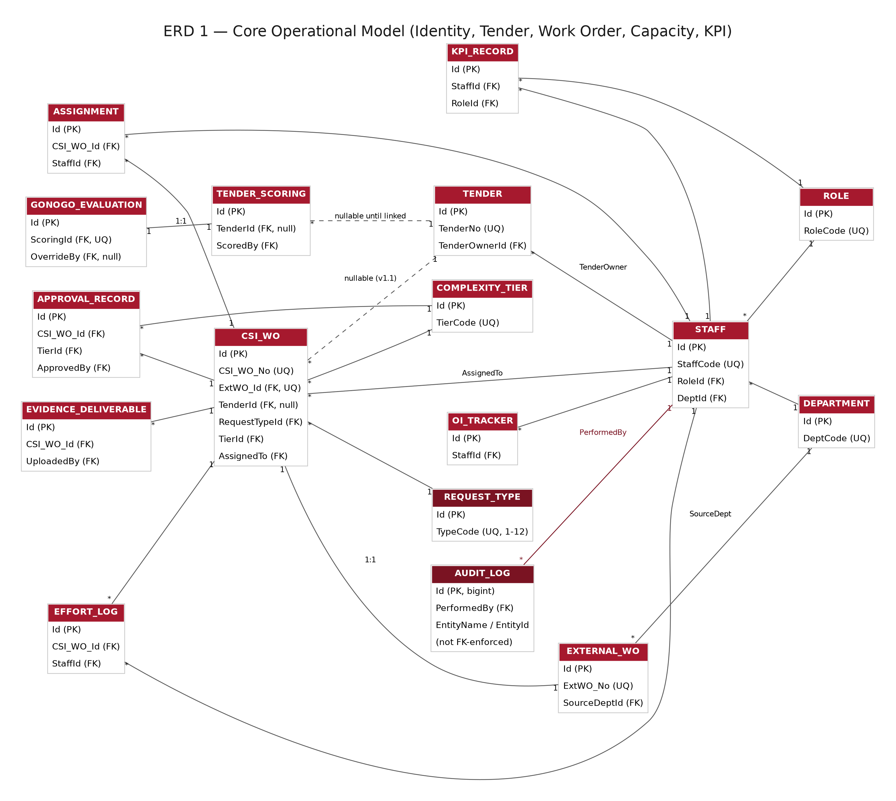
Figure 1 — ERD 1: Core Operational Model. Dashed edges denote a nullable foreign key (v1.1 additions). AUDIT_LOG's EntityName/EntityId pair is shown without an arrowhead because it is intentionally not FK-enforced (Section 6).

2.2 ERD 2 — Capability & Configuration Model
Covers the v1.1 Skills, Competency & Certification module (SKILL, STAFF_SKILL, CERTIFICATION, TRAINING_PLAN) and the remaining master-data lookup tables (REQUEST_TYPE is shown in ERD 1 since CSI_WO depends on it directly; MULTIPLIER_FACTOR, BASELINE_TIER, ROLE_SPLIT and SYSTEM_SETTING appear here). STAFF, ROLE and DEPARTMENT are repeated as anchor nodes, shown at reduced detail with a pointer back to ERD 1 for their full attribute list.
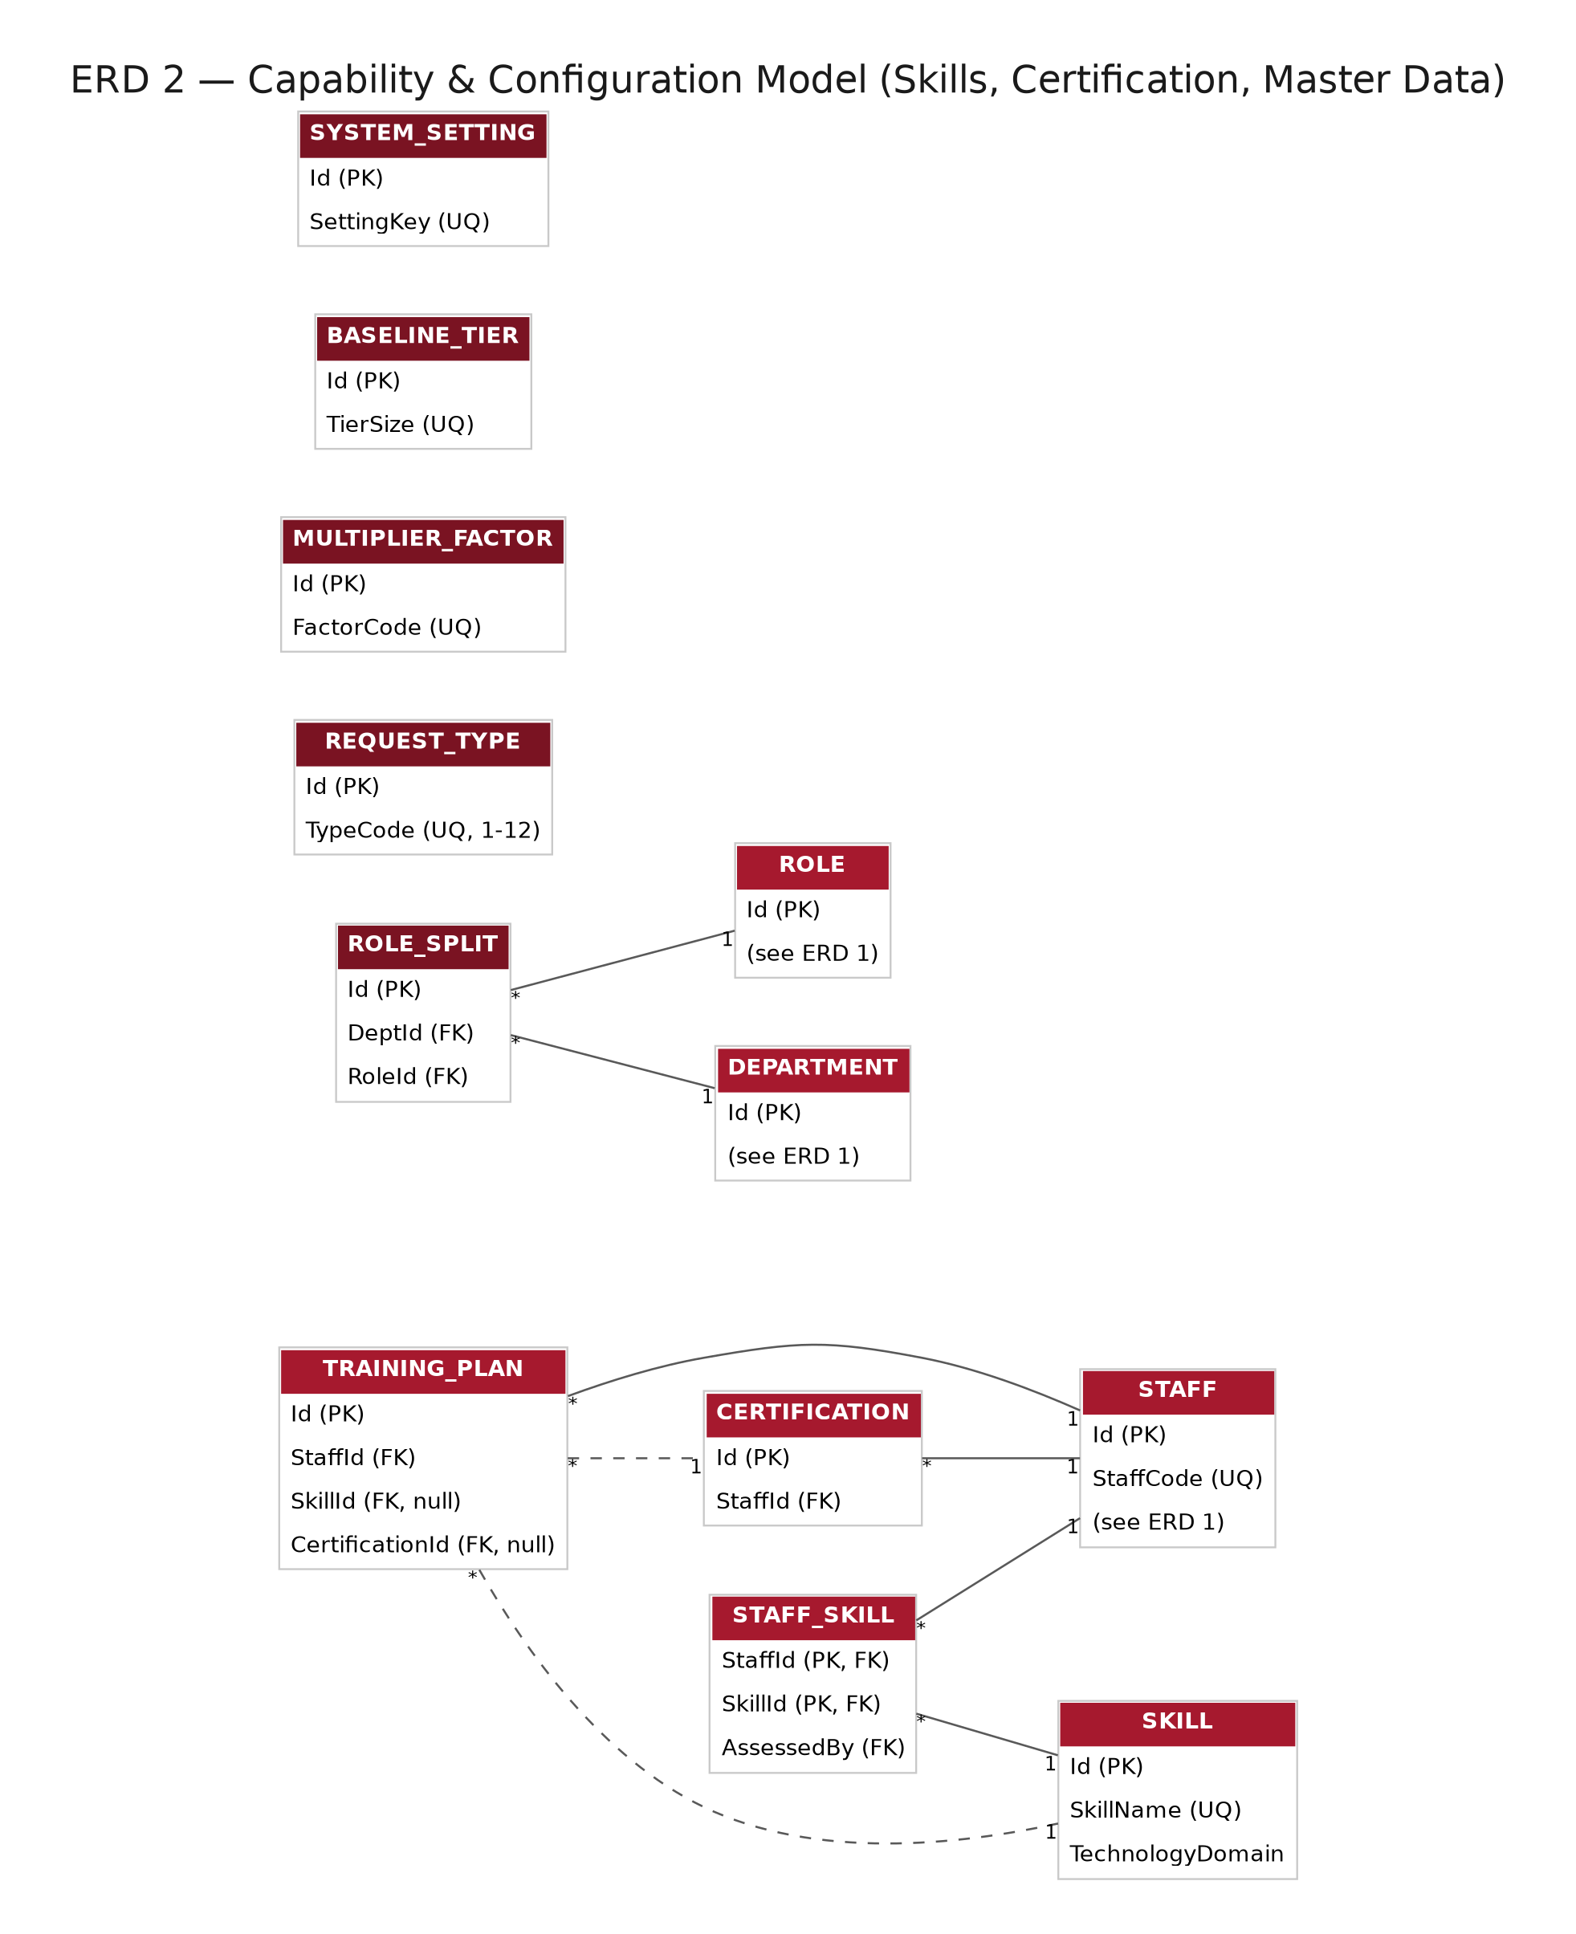
Figure 2 — ERD 2: Capability & Configuration Model. Dashed edges from TRAINING_PLAN denote the nullable either/or relationship to SKILL or CERTIFICATION (Section 3.22).

3. Entity Data Dictionary
Twenty-five tables, presented in the same logical order as the ERDs: identity and organisation; external WO and Tender; the work order core; Go/No-Go scoring; KPI and OI tracking; Skills, Competency and Certification; master-data lookups; and finally AUDIT_LOG. Per §1.4, every table additionally carries CreatedAt and UpdatedAt columns not repeated below.

DEPARTMENT
Reference table for the six departments the platform is aware of today (PRD §11). Source of DeptCode values shown throughout the platform's filters.
Column | Data Type | Null | Key | Default | Description
Id | UUID | No | PK | gen_random_uuid() | Surrogate primary key
DeptCode | VARCHAR(10) | No | UQ | — | CSI, CMT, CPO, CGI, CSA or CBA
DeptName | VARCHAR(100) | No | — | — | Full department name

ROLE
The six system roles defined in PRD §6, plus capacity scope used to drive row-level visibility throughout the application layer.
Column | Data Type | Null | Key | Default | Description
Id | UUID | No | PK | gen_random_uuid() | Surrogate primary key
RoleCode | VARCHAR(20) | No | UQ | — | HOD, SM, TL, TM, BIM_TL, BIM_MOD
RoleName | VARCHAR(50) | No | — | — | Display name shown in the UI
CapacityScope | VARCHAR(20) | No | — | 'Self' | Department / Stream / Pod / Self (PRD §6)

STAFF
Every CSI and CMT staff member known to the platform. Referenced by foreign key from the majority of other tables — see §1.4 on why rows here are never hard-deleted.
Column | Data Type | Null | Key | Default | Description
Id | UUID | No | PK | gen_random_uuid() | Surrogate primary key
StaffCode | VARCHAR(20) | No | UQ | — | Human-readable employee code
Name | VARCHAR(150) | No | — | — | Full name
Email | VARCHAR(150) | No | UQ | — | Maps to the Entra ID / Google Workspace identity used at sign-in
RoleId | UUID | No | FK → ROLE.Id | — | Current system role
DeptId | UUID | No | FK → DEPARTMENT.Id | — | CSI or CMT today
SubTeam | VARCHAR(20) | Yes | — | NULL | Pod grouping (A/B/C/D)
ProductivityFactor | NUMERIC(3,2) | No | — | 0.80 | Used in DailyUsableHours (§13.1 of the PRD)
DailyUsableHours | NUMERIC(4,2) | No | — | computed | WorkingHoursPerDay × ProductivityFactor
Status | VARCHAR(20) | No | — | 'Active' | Active / Inactive / OnLeave — never hard-deleted
SystemConfigFlag | BOOLEAN | No | — | false | Grants Admin & Master Data access (FR-48)

EXTERNAL_WO
The corporate system's reference record for external intake. System of record for everything upstream of CSI's own classification.
Column | Data Type | Null | Key | Default | Description
Id | UUID | No | PK | gen_random_uuid() | Surrogate primary key
ExtWO_No | VARCHAR(30) | No | UQ | — | Corporate reference, e.g. 200-DDMMYYYY-NNN
ProjectCode | VARCHAR(30) | Yes | — | NULL | Corporate project code, where issued
SourceDeptId | UUID | No | FK → DEPARTMENT.Id | — | Originating department
EndUser | VARCHAR(150) | Yes | — | NULL | Named end client/user, where applicable
ReceivedDate | DATE | No | — | — | Date the external WO was received
Status | VARCHAR(20) | No | — | 'Open' | Mirror of the external system's status

TENDER
The v1.1 top-level business object (PRD §4.3). Sits above CSI_WO in the Tender → WO → Task → Effort hierarchy.
Column | Data Type | Null | Key | Default | Description
Id | UUID | No | PK | gen_random_uuid() | Surrogate primary key
TenderNo | VARCHAR(30) | No | UQ | system-generated | Auto-generated, never entered manually (FR-57)
TenderName | VARCHAR(200) | No | — | —
Client | VARCHAR(150) | No | — | —
TenderCategory | VARCHAR(50) | Yes | — | NULL
ClosingDate | DATE | No | — | — | Must be a future date at creation (app rule)
EstimatedValue | NUMERIC(15,2) | No | — | — | Must be greater than zero
SubmittedValue | NUMERIC(15,2) | Yes | — | NULL
WinValue | NUMERIC(15,2) | Yes | — | NULL | Editable only once Status = Won
Status | VARCHAR(20) | No | — | 'Prospect' | Prospect/Qualified/InProgress/Submitted/Clarification/Won/Lost/Cancelled (FR-58)
TenderOwnerId | UUID | No | FK → STAFF.Id | —

REQUEST_TYPE
The 12-type request taxonomy from PRD §4.1, with the SLA targets each type carries.
Column | Data Type | Null | Key | Default | Description
Id | UUID | No | PK | gen_random_uuid() | Surrogate primary key
TypeCode | SMALLINT | No | UQ | — | 1 through 12
TypeName | VARCHAR(80) | No | — | — | e.g. Leads/Opportunity, Tender/RFP, Documentation
Domain | VARCHAR(50) | No | — | — | Solution Design / Consultancy / BIM / Project Monitoring
SlaAckDays | SMALLINT | No | — | 1 | Acknowledgement SLA (FR-32)
SlaClassifyDays | SMALLINT | No | — | 2 | Classification SLA
SlaRouteDays | SMALLINT | No | — | 3 | Routing/assignment SLA

COMPLEXITY_TIER
The three complexity tiers and the approver role each routes to (FR-33).
Column | Data Type | Null | Key | Default | Description
Id | UUID | No | PK | gen_random_uuid() | Surrogate primary key
TierCode | SMALLINT | No | UQ | — | 1, 2 or 3
TierName | VARCHAR(30) | No | — | —
ApproverRoleId | UUID | No | FK → ROLE.Id | — | Team Lead (1) / Solution Manager (2) / HOD (3)

CSI_WO
The internal work order — the platform's central operational record (PRD §7.2). The busiest table in the schema by both read and write volume.
Column | Data Type | Null | Key | Default | Description
Id | UUID | No | PK | gen_random_uuid() | Surrogate primary key
CSI_WO_No | VARCHAR(40) | No | UQ | system-generated | 300-DDMMYYYY-NNN (CSI) format
ExtWO_Id | UUID | No | FK → EXTERNAL_WO.Id, UQ | — | Unique to enforce the 1:1 relationship (FR-05)
TenderId | UUID | Yes | FK → TENDER.Id | NULL | v1.1 addition — see PRD §4.3
RequestTypeId | UUID | No | FK → REQUEST_TYPE.Id | —
Title | VARCHAR(200) | No | — | —
Priority | VARCHAR(10) | No | — | 'Normal' | Low/Normal/High/Urgent
IndicativeValue | NUMERIC(15,2) | Yes | — | NULL
ComplexityValue | NUMERIC(10,2) | Yes | — | NULL
TaskScore | NUMERIC(6,2) | Yes | — | computed | System-derived, not directly editable (FR-04)
TierId | UUID | No | FK → COMPLEXITY_TIER.Id | —
CreatedBy | UUID | No | FK → STAFF.Id | —
AssignedTo | UUID | Yes | FK → STAFF.Id | NULL | Denormalised current assignee; full history in ASSIGNMENT
DueDate | DATE | Yes | — | NULL
Status | VARCHAR(20) | No | — | 'Open' | Open/InProgress/PendingApproval/Closed/OnHold

ASSIGNMENT
Full assignment chain per WO, including Team Lead to Team Member cascades (FR-10–12).
Column | Data Type | Null | Key | Default | Description
Id | UUID | No | PK | gen_random_uuid() | Surrogate primary key
CSI_WO_Id | UUID | No | FK → CSI_WO.Id | —
StaffId | UUID | No | FK → STAFF.Id | — | The assignee
AssignedHours | NUMERIC(6,2) | No | — | — | Must be greater than zero
AssignedDate | DATE | No | — | —
AssignedBy | UUID | No | FK → STAFF.Id | —
IsCurrent | BOOLEAN | No | — | true | Distinguishes the active row from historical reassignment rows
ReassignReason | TEXT | Yes | — | NULL | Mandatory at the application layer when reassigning an existing WO

EFFORT_LOG
Daily effort entries, replacing the manual Daily_Log spreadsheet (FR-29).
Column | Data Type | Null | Key | Default | Description
Id | UUID | No | PK | gen_random_uuid() | Surrogate primary key
CSI_WO_Id | UUID | No | FK → CSI_WO.Id | —
StaffId | UUID | No | FK → STAFF.Id | —
LogDate | DATE | No | — | —
Hours | NUMERIC(4,2) | No | — | — | Greater than zero, at most 8 per single entry
Notes | TEXT | Yes | — | NULL

EVIDENCE_DELIVERABLE
Evidence and deliverable repository tied to the WO closure checklist (FR-30).
Column | Data Type | Null | Key | Default | Description
Id | UUID | No | PK | gen_random_uuid() | Surrogate primary key
CSI_WO_Id | UUID | No | FK → CSI_WO.Id | —
FileRef | VARCHAR(500) | No | — | — | Storage path or URL
EvidenceType | VARCHAR(50) | No | — | — | Mandatory tag — untagged files are rejected
UploadedBy | UUID | No | FK → STAFF.Id | —
UploadedDate | TIMESTAMP | No | — | now()
RemovedAt | TIMESTAMP | Yes | — | NULL | Soft delete only — rows are never hard-deleted
RemovedBy | UUID | Yes | FK → STAFF.Id | NULL

APPROVAL_RECORD
Approval trail by complexity tier, including rework returns (FR-33).
Column | Data Type | Null | Key | Default | Description
Id | UUID | No | PK | gen_random_uuid() | Surrogate primary key
CSI_WO_Id | UUID | No | FK → CSI_WO.Id | —
TierId | UUID | No | FK → COMPLEXITY_TIER.Id | — | Tier this decision was routed under
ApprovedBy | UUID | No | FK → STAFF.Id | —
Decision | VARCHAR(20) | No | — | — | Approved / Returned
Reason | TEXT | Yes | — | NULL | Mandatory at the application layer when Decision = Returned
DecisionDate | TIMESTAMP | No | — | now()

BASELINE_TIER
Baseline hour allocation per tender size tier (PRD §13.3).
Column | Data Type | Null | Key | Default | Description
Id | UUID | No | PK | gen_random_uuid() | Surrogate primary key
TierSize | VARCHAR(10) | No | UQ | — | Small / Medium / Large / Mega
BaselineCSIHours | NUMERIC(8,2) | No | — | — | 65 / 100 / 200 / 320 by default
BaselineCMTHours | NUMERIC(8,2) | No | — | —

MULTIPLIER_FACTOR
Configurable multiplier values for the six complexity flags (FR-38). Joined to TENDER_SCORING by FactorCode at calculation time, not by foreign key, since several flags can apply simultaneously.
Column | Data Type | Null | Key | Default | Description
Id | UUID | No | PK | gen_random_uuid() | Surrogate primary key
FactorCode | VARCHAR(30) | No | UQ | — | Rush / Consortium / SecurityHeavy / CustomDev / ManyQA / Onsite
MultiplierValue | NUMERIC(4,2) | No | — | — | e.g. 1.15 for a 15% uplift

TENDER_SCORING
New-commitment scoring inputs and resulting size tier (PRD §13.3, FR-37).
Column | Data Type | Null | Key | Default | Description
Id | UUID | No | PK | gen_random_uuid() | Surrogate primary key
ReferenceNo | VARCHAR(30) | No | UQ | system-generated
TenderId | UUID | Yes | FK → TENDER.Id | NULL | Populated once the evaluation is linked to a Tender
FunctionalBreadth | SMALLINT | No | — | — | 0–5
IntegrationCount | SMALLINT | No | — | — | 0–5
ComplianceDepth | SMALLINT | No | — | — | 0–5
SolutionNovelty | SMALLINT | No | — | — | 0–5
CommercialComplexity | SMALLINT | No | — | — | 0–5
StakeholderIntensity | SMALLINT | No | — | — | 0–5
IsRush / IsConsortium / IsSecurityHeavy / IsCustomDev / IsManyQA / IsOnsite | BOOLEAN (×6) | No | — | false | The six complexity-multiplier flags (FR-38)
WeightedScore | NUMERIC(5,2) | Yes | — | computed
BaselineTierId | UUID | Yes | FK → BASELINE_TIER.Id | NULL | Derived from WeightedScore
ScoredBy | UUID | No | FK → STAFF.Id | —
ScoredAt | TIMESTAMP | No | — | now()

GONOGO_EVALUATION
Capacity projection and decision log for new commitments (PRD §13.4, FR-39–40).
Column | Data Type | Null | Key | Default | Description
Id | UUID | No | PK | gen_random_uuid() | Surrogate primary key
ScoringId | UUID | No | FK → TENDER_SCORING.Id, UQ | — | 1:1 with TENDER_SCORING
PlanningHorizonDays | SMALLINT | No | — | 10
ProjectedCSIUtilization | NUMERIC(5,2) | Yes | — | NULL
ProjectedCMTUtilization | NUMERIC(5,2) | Yes | — | NULL
Recommendation | VARCHAR(10) | No | — | — | Go / NoGo
OverrideBy | UUID | Yes | FK → STAFF.Id | NULL | HOD only (FR-40)
OverrideReason | TEXT | Yes | — | NULL | Mandatory if OverrideBy is set
EvaluatedAt | TIMESTAMP | No | — | now()

KPI_RECORD
Live KPI scorecard data, replacing the static KPI cascade document (PRD §14). UNIQUE(StaffId, Period, MetricName).
Column | Data Type | Null | Key | Default | Description
Id | UUID | No | PK | gen_random_uuid() | Surrogate primary key
StaffId | UUID | No | FK → STAFF.Id | —
RoleId | UUID | No | FK → ROLE.Id | — | Role the metric is scored against
Period | VARCHAR(10) | No | — | — | e.g. 2026-Q2
MetricName | VARCHAR(100) | No | — | —
TargetValue | NUMERIC(10,2) | Yes | — | NULL
AchievedValue | NUMERIC(10,2) | Yes | — | NULL
CalculatedAt | TIMESTAMP | No | — | now()

OI_TRACKER
Opportunity of Interest counts against role-specific annual targets (PRD §14). UNIQUE(StaffId, Period).
Column | Data Type | Null | Key | Default | Description
Id | UUID | No | PK | gen_random_uuid() | Surrogate primary key
StaffId | UUID | No | FK → STAFF.Id | —
Period | VARCHAR(10) | No | — | — | e.g. 2026
Registered | INTEGER | No | — | 0
Won | INTEGER | No | — | 0

SKILL
Skills inventory tagged to one of the eight configured technology domains (PRD §7.15, FR-50). UNIQUE(SkillName, TechnologyDomain).
Column | Data Type | Null | Key | Default | Description
Id | UUID | No | PK | gen_random_uuid() | Surrogate primary key
SkillName | VARCHAR(100) | No | UQ* | —
TechnologyDomain | VARCHAR(50) | No | UQ* | — | Cloud / Cyber Security / Data Centre / Network / Enterprise Architecture / AI-HPC / BIM / Consultancy

STAFF_SKILL
Many-to-many link recording each staff member's assessed competency level per skill (FR-51). Composite primary key.
Column | Data Type | Null | Key | Default | Description
StaffId | UUID | No | PK1, FK → STAFF.Id | —
SkillId | UUID | No | PK2, FK → SKILL.Id | —
CompetencyLevel | VARCHAR(20) | No | — | — | Beginner / Intermediate / Advanced / Expert — no free text permitted
LastAssessmentDate | DATE | No | — | —
AssessedBy | UUID | No | FK → STAFF.Id | — | Auto-populated with the logged-in assessor

CERTIFICATION
Per-staff certification register (PRD §7.15, FR-52–53).
Column | Data Type | Null | Key | Default | Description
Id | UUID | No | PK | gen_random_uuid() | Surrogate primary key
StaffId | UUID | No | FK → STAFF.Id | —
CertificationName | VARCHAR(150) | No | — | —
Vendor | VARCHAR(100) | Yes | — | NULL
CertificationLevel | VARCHAR(50) | Yes | — | NULL
IssueDate | DATE | No | — | —
ExpiryDate | DATE | Yes | — | NULL | Must be after IssueDate
Status | VARCHAR(20) | No | — | 'Unverified' | Unverified / Verified / Expired
EvidenceFile | VARCHAR(500) | Yes | — | NULL | Required before Status can become Verified

TRAINING_PLAN
Training roadmap linking a planned activity to an identified skill or certification gap (FR-54).
Column | Data Type | Null | Key | Default | Description
Id | UUID | No | PK | gen_random_uuid() | Surrogate primary key
StaffId | UUID | No | FK → STAFF.Id | —
SkillId | UUID | Yes | FK → SKILL.Id | NULL | Exactly one of SkillId / CertificationId is set
CertificationId | UUID | Yes | FK → CERTIFICATION.Id | NULL
PlannedActivity | VARCHAR(200) | No | — | —
TargetDate | DATE | Yes | — | NULL
Status | VARCHAR(20) | No | — | 'Planned' | Planned / InProgress / Completed / Cancelled

ROLE_SPLIT
Percentage of adjusted department hours allocated per role (PRD §13.3, FR-49). UNIQUE(DeptId, RoleId); percentages must sum to 100% per DeptId, validated at the application layer.
Column | Data Type | Null | Key | Default | Description
Id | UUID | No | PK | gen_random_uuid() | Surrogate primary key
DeptId | UUID | No | FK → DEPARTMENT.Id, UQ* | —
RoleId | UUID | No | FK → ROLE.Id, UQ* | —
Percentage | NUMERIC(5,2) | No | — | —

SYSTEM_SETTING
Generic key-value configuration for everything else the HOD can tune without a code change — utilization thresholds, the certification expiry window, the Go/No-Go default planning horizon, and similar.
Column | Data Type | Null | Key | Default | Description
Id | UUID | No | PK | gen_random_uuid() | Surrogate primary key
SettingKey | VARCHAR(60) | No | UQ | — | e.g. CSI_UTILIZATION_THRESHOLD, CERT_EXPIRY_WINDOW_DAYS
SettingValue | VARCHAR(200) | No | — | —
Description | VARCHAR(300) | Yes | — | NULL

AUDIT_LOG
The platform-wide, immutable compliance ledger. Full design rationale, trigger events, retention and access control are covered in Section 6 — this entry lists only the schema.
Column | Data Type | Null | Key | Default | Description
Id | BIGINT | No | PK | auto-increment (BIGSERIAL) | Sequential, append-only
EntityName | VARCHAR(50) | No | — | — | Affected table, e.g. CSI_WO, TENDER
EntityId | UUID | No | — | — | PK of the affected row — intentionally not FK-enforced (polymorphic across 24 tables)
Action | VARCHAR(20) | No | — | — | Insert / Update / StatusChange / Approve / Return / Override / Export / Delete
FieldName | VARCHAR(100) | Yes | — | NULL | Populated for field-level change entries
OldValue | TEXT | Yes | — | NULL
NewValue | TEXT | Yes | — | NULL
Reason | TEXT | Yes | — | NULL | Captures mandatory reasons — override justification, return reason, reassignment reason
PerformedBy | UUID | No | FK → STAFF.Id | —
PerformedAt | TIMESTAMP | No | — | now()
ChecksumHash | VARCHAR(64) | No | — | computed | SHA-256 of PreviousHash + row content — see §6.3

4. Relationships
Every foreign-key relationship in the schema, with its cardinality and ON DELETE behaviour. CASCADE is used only for child records that are meaningless without their parent (effort logs, evidence, approvals on a WO; KPI/OI/skills/certifications on a staff member); RESTRICT protects reference data and any record that should force an explicit unlink before deletion; SET NULL is used for the two genuinely optional v1.1 links (Tender on a WO, the staff-assignee fields).
# | From → To | Cardinality | FK Column | On Delete | Notes
1 | STAFF → ROLE | M:1 | RoleId | RESTRICT
2 | STAFF → DEPARTMENT | M:1 | DeptId | RESTRICT
3 | EXTERNAL_WO → DEPARTMENT | M:1 | SourceDeptId | RESTRICT
4 | TENDER → STAFF | M:1 | TenderOwnerId | RESTRICT
5 | CSI_WO → EXTERNAL_WO | 1:1 | ExtWO_Id (UQ) | RESTRICT | Enforced by the UNIQUE constraint (FR-05)
6 | CSI_WO → TENDER | M:1, nullable | TenderId | SET NULL | v1.1 addition, PRD §4.3
7 | CSI_WO → REQUEST_TYPE | M:1 | RequestTypeId | RESTRICT
8 | CSI_WO → COMPLEXITY_TIER | M:1 | TierId | RESTRICT
9 | CSI_WO → STAFF (creator) | M:1 | CreatedBy | RESTRICT
10 | CSI_WO → STAFF (assignee) | M:1, nullable | AssignedTo | SET NULL | Denormalised pointer; ASSIGNMENT holds full history
11 | ASSIGNMENT → CSI_WO | M:1 | CSI_WO_Id | CASCADE
12 | ASSIGNMENT → STAFF | M:1 | StaffId | RESTRICT
13 | EFFORT_LOG → CSI_WO | M:1 | CSI_WO_Id | CASCADE
14 | EFFORT_LOG → STAFF | M:1 | StaffId | RESTRICT
15 | EVIDENCE_DELIVERABLE → CSI_WO | M:1 | CSI_WO_Id | CASCADE
16 | APPROVAL_RECORD → CSI_WO | M:1 | CSI_WO_Id | CASCADE
17 | APPROVAL_RECORD → COMPLEXITY_TIER | M:1 | TierId | RESTRICT
18 | TENDER_SCORING → TENDER | M:1, nullable | TenderId | SET NULL | Populated once linked
19 | TENDER_SCORING → BASELINE_TIER | M:1, nullable | BaselineTierId | RESTRICT
20 | GONOGO_EVALUATION → TENDER_SCORING | 1:1 | ScoringId (UQ) | CASCADE
21 | KPI_RECORD → STAFF | M:1 | StaffId | CASCADE
22 | KPI_RECORD → ROLE | M:1 | RoleId | RESTRICT
23 | OI_TRACKER → STAFF | M:1 | StaffId | CASCADE
24 | STAFF_SKILL → STAFF | M:1 | StaffId | CASCADE
25 | STAFF_SKILL → SKILL | M:1 | SkillId | CASCADE
26 | CERTIFICATION → STAFF | M:1 | StaffId | CASCADE
27 | TRAINING_PLAN → STAFF | M:1 | StaffId | CASCADE
28 | TRAINING_PLAN → SKILL | M:1, nullable | SkillId | SET NULL
29 | TRAINING_PLAN → CERTIFICATION | M:1, nullable | CertificationId | SET NULL
30 | ROLE_SPLIT → DEPARTMENT | M:1 | DeptId | RESTRICT
31 | ROLE_SPLIT → ROLE | M:1 | RoleId | RESTRICT
32 | AUDIT_LOG → STAFF | M:1 | PerformedBy | RESTRICT | The only true FK on AUDIT_LOG — see Section 6

5. Indexes
Every index beyond the automatic primary-key index, each justified by a specific query pattern from the approved Wireframe Specification's filters, sorts and dashboards — so the Developer can see why each index exists rather than treating the list as boilerplate.
Index | Table | Column(s) | Type | Supports
UQ_DEPARTMENT_DEPTCODE | DEPARTMENT | DeptCode | Unique | Lookup by code
UQ_ROLE_ROLECODE | ROLE | RoleCode | Unique | Lookup by code
UQ_STAFF_STAFFCODE | STAFF | StaffCode | Unique | Lookup by code
UQ_STAFF_EMAIL | STAFF | Email | Unique | SSO identity match at sign-in (Screen 1)
IDX_STAFF_ROLE_DEPT | STAFF | RoleId, DeptId | Composite | Department Dashboard role/department filters
UQ_EXTERNALWO_NO | EXTERNAL_WO | ExtWO_No | Unique | Create Internal WO lookup (FR-01)
UQ_TENDER_NO | TENDER | TenderNo | Unique | Tender Registry lookup
IDX_TENDER_STATUS_CLOSING | TENDER | Status, ClosingDate | Composite | Tender Registry filter bar; Executive Dashboard upcoming closings
IDX_TENDER_OWNER | TENDER | TenderOwnerId | Non-unique | KPI Dashboard OI drill-down
UQ_CSIWO_NO | CSI_WO | CSI_WO_No | Unique | WO Detail lookup
UQ_CSIWO_EXTWOID | CSI_WO | ExtWO_Id | Unique | Enforces the 1:1 relationship with EXTERNAL_WO
IDX_CSIWO_STATUS | CSI_WO | Status | Non-unique | Internal WO List status filter; Department Dashboard board
IDX_CSIWO_ASSIGNEDTO | CSI_WO | AssignedTo | Non-unique | My Tasks
IDX_CSIWO_DUEDATE | CSI_WO | DueDate | Non-unique | SLA countdown sort across multiple screens
IDX_CSIWO_TENDERID | CSI_WO | TenderId | Non-unique | Tender Detail's linked-WO rollup (FR-60)
IDX_CSIWO_REQTYPE | CSI_WO | RequestTypeId | Non-unique | Scope-domain filters (Internal WO List)
IDX_ASSIGNMENT_STAFF_CURRENT | ASSIGNMENT | StaffId, IsCurrent | Composite | Capacity Dashboard utilization calculation
IDX_ASSIGNMENT_WO | ASSIGNMENT | CSI_WO_Id | Non-unique | WO Detail assignment history tab
IDX_EFFORTLOG_STAFF_DATE | EFFORT_LOG | StaffId, LogDate | Composite | Daily Effort Log "today's entries" and running total
IDX_EFFORTLOG_WO | EFFORT_LOG | CSI_WO_Id | Non-unique | WO Detail effort log tab
IDX_EVIDENCE_WO | EVIDENCE_DELIVERABLE | CSI_WO_Id | Non-unique | WO Detail evidence tab; closure-eligibility check
IDX_APPROVAL_WO | APPROVAL_RECORD | CSI_WO_Id | Non-unique | WO Detail approval trail tab
IDX_SCORING_TENDER | TENDER_SCORING | TenderId | Non-unique | Tender Detail Go/No-Go history
UQ_GONOGO_SCORINGID | GONOGO_EVALUATION | ScoringId | Unique | Enforces the 1:1 with TENDER_SCORING
IDX_KPI_STAFF_PERIOD | KPI_RECORD | StaffId, Period | Composite | KPI Dashboard personal scorecard and period selector
UQ_OITRACKER_STAFF_PERIOD | OI_TRACKER | StaffId, Period | Unique | OI & Commission Tracker
UQ_SKILL_NAME_DOMAIN | SKILL | SkillName, TechnologyDomain | Unique | Prevents duplicate skill entries
IDX_STAFFSKILL_SKILL | STAFF_SKILL | SkillId | Non-unique | Skills & Competency "By Domain" heatmap
IDX_CERTIFICATION_EXPIRY | CERTIFICATION | ExpiryDate | Non-unique | Expiry alert job (FR-53); Certification Tracker KPI strip
IDX_CERTIFICATION_STAFF | CERTIFICATION | StaffId | Non-unique | Certification Tracker staff filter
UQ_ROLESPLIT_DEPT_ROLE | ROLE_SPLIT | DeptId, RoleId | Unique | Admin & Master Data 100%-sum validation (FR-49)
UQ_SYSSETTING_KEY | SYSTEM_SETTING | SettingKey | Unique | Admin & Master Data configuration lookup
IDX_AUDITLOG_ENTITY | AUDIT_LOG | EntityName, EntityId | Composite | Pulling the full history for one record (e.g. a WO's complete trail)
IDX_AUDITLOG_PERFORMEDAT | AUDIT_LOG | PerformedAt | Non-unique | Date-range compliance export; monthly partition key (§7)
IDX_AUDITLOG_PERFORMEDBY | AUDIT_LOG | PerformedBy | Non-unique | "Who changed this" queries

6. Audit Log Design
ASSIGNMENT, APPROVAL_RECORD and the Effort/Evidence tables already give fast, domain-specific history for in-app display — an HOD opening WO Detail does not need to query AUDIT_LOG to see who approved a WO. AUDIT_LOG exists underneath all of that as the single, immutable, compliance-grade ledger: it duplicates what those domain tables capture for completeness, and additionally captures the things that have no dedicated history table at all — Admin & Master Data changes, evidence removals, report exports, and Go/No-Go overrides. This is the platform's answer to the Auditability non-functional requirement (PRD §8) and the ISO 9001/PDPA/MAMPU-KRISA evidence trail referenced throughout the PRD.

6.1 What Writes an Audit Entry
- Every INSERT, UPDATE and status change on CSI_WO, TENDER, ASSIGNMENT, APPROVAL_RECORD and GONOGO_EVALUATION
- Every evidence removal on EVIDENCE_DELIVERABLE (the soft-delete itself, via RemovedAt/RemovedBy, plus the corresponding AUDIT_LOG entry)
- Every Go/No-Go override (FR-40) — written with Action = 'Override' and the mandatory OverrideReason copied into the Reason column
- Every Admin & Master Data change across the six configuration tables (FR-47–49) — including who attempted a Save that failed the 100%-sum validation, for governance completeness
- Every report export from the Reports screen (Action = 'Export'), recording who exported what report, with which parameters, and when
- Every certification verification status change and competency assessment recorded in Skills & Competency or Certification Tracker

6.2 Table Schema
Repeated here from Section 3.25 for convenient reference alongside the design rationale in this section.
Column | Data Type | Null | Key | Default | Description
Id | BIGINT | No | PK | auto-increment (BIGSERIAL) | Sequential, append-only
EntityName | VARCHAR(50) | No | — | — | Affected table, e.g. CSI_WO, TENDER
EntityId | UUID | No | — | — | PK of the affected row — intentionally not FK-enforced (polymorphic across 24 tables)
Action | VARCHAR(20) | No | — | — | Insert / Update / StatusChange / Approve / Return / Override / Export / Delete
FieldName | VARCHAR(100) | Yes | — | NULL | Populated for field-level change entries
OldValue | TEXT | Yes | — | NULL
NewValue | TEXT | Yes | — | NULL
Reason | TEXT | Yes | — | NULL | Captures mandatory reasons — override justification, return reason, reassignment reason
PerformedBy | UUID | No | FK → STAFF.Id | —
PerformedAt | TIMESTAMP | No | — | now()
ChecksumHash | VARCHAR(64) | No | — | computed | SHA-256 of PreviousHash + row content — see §6.3

6.3 Immutability & Tamper-Evidence
AUDIT_LOG permits INSERT only — the application's database role has no UPDATE or DELETE grant on this table, enforced at the database level, not merely by application convention. Each row's ChecksumHash is a SHA-256 hash computed over the previous row's hash concatenated with the current row's content, forming a hash chain identical in principle to the technique used in tamper-evident ledgers: altering any historical row, or deleting one, breaks the chain for every row written after it, and a periodic integrity check can detect this without needing to trust the database administrator's good faith. The first row in the chain uses a fixed seed value in place of a "previous hash".

6.4 Retention & Partitioning
AUDIT_LOG is range-partitioned by PerformedAt at the calendar-month boundary. This keeps each partition's index small for fast recent-history queries (the common case — most lookups are "what happened to this WO in the last few weeks") while allowing older partitions to be moved to cheaper storage or archived wholesale once they exceed 10CS's document retention policy, without an expensive row-by-row delete. Retention period is a SYSTEM_SETTING value (e.g. AUDIT_LOG_RETENTION_YEARS), not hard-coded, so the HOD can align it to whatever ISO 9001/PDPA retention period 10CS's compliance function specifies, without a schema change.

6.5 Access Control & Query Patterns
Read access to AUDIT_LOG is restricted to the HOD and any Compliance/Audit-scoped user, consistent with the Governance & Compliance Audit Trail Export's role gating defined in the Wireframe Specification (Screen 18). Three query patterns cover the overwhelming majority of real use: pulling every entry for one record (filter on EntityName and EntityId, ordered by PerformedAt, using IDX_AUDITLOG_ENTITY); pulling everything one staff member did in a period (filter on PerformedBy and a PerformedAt range, using IDX_AUDITLOG_PERFORMEDBY); and a full compliance export for a date range (filter on PerformedAt alone, using IDX_AUDITLOG_PERFORMEDAT, which also aligns with the partition boundary so the export only touches the partitions it needs).

7. Data Retention & Storage Considerations
Two tables are high-volume by nature and warrant the same partitioning treatment recommended for AUDIT_LOG in Section 6.4: EFFORT_LOG, which receives at least one write per staff member per work order per day across the full CSI/CMT headcount, and AUDIT_LOG itself. Both should be range-partitioned by date from day one rather than retrofitted later, since partitioning an already-large table in production is materially more disruptive than partitioning an empty one.
- CSI_WO and its child records (ASSIGNMENT, EFFORT_LOG, EVIDENCE_DELIVERABLE, APPROVAL_RECORD) are never hard-deleted once Closed; a closed WO older than a configurable threshold (SYSTEM_SETTING) becomes a candidate for read-only archival storage rather than deletion, preserving the governance evidence trail PRD §2 identified as a current gap
- EVIDENCE_DELIVERABLE's FileRef points to object storage (not a database BLOB column), keeping the relational database itself comparatively small and fast to back up; the file storage tier follows 10CS's standard backup/DR policy independently
- Backup and disaster recovery follow the recovery point and recovery time objectives to be agreed at technical design stage, per the Backup & DR non-functional requirement in PRD §8 — this specification defines the schema those objectives apply to, not the objectives themselves

This Database Design Specification is submitted for review and sign-off by the Solution Architect, Developer/Database Engineer and Management. Approval authorises schema creation and migration scripting against the model defined above.

