10 CREATIVE SOLUTIONS SDN BHD (10CS)
Consultant, Solution & Innovation (CSI) Department

CSI DIGITAL OPERATING PLATFORM

System Architecture Design (SAD)
Architecture Overview · Application · Technology Stack · Authentication · Authorisation · Data Flow · Database · API · Audit Trail · Reporting · Integration · Security · Backup & Recovery · Deployment · High Availability · Future AI Integration
Companion to PRD v1.1 (Approved) · UI/UX Wireframe Specification v1.0 · Database Design Specification v1.0
Document Type | System Architecture Design (SAD)
Reference Documents | CSI Digital Operating Platform PRD v1.1 (Approved); UI/UX Wireframe Specification v1.0; Database Design Specification v1.0
Architecture Pattern | Three-Tier Web Application (Next.js + FastAPI + PostgreSQL)
Department | Consultant, Solution & Innovation (CSI)
Version | 1.0
Status | Draft — For Solution Architect, Developer and Management Review and Approval
Date Prepared | 19 June 2026
Prepared By | Farhan Nordin, Head of Department, CSI
Classification | Internal — 10CS Confidential

Document Control

Revision History
Version | Date | Author | Description
1.0 | 19 Jun 2026 | Farhan Nordin | Initial System Architecture Design issued following approval of the PRD v1.1, UI/UX Wireframe Specification v1.0 and Database Design Specification v1.0, covering all 16 architecture domains and 16 Mermaid diagrams

Approval Sign-Off
This document translates the approved platform scope and database schema into architecture decisions across all 16 domains. Approval here authorises build-phase technical design to proceed against this architecture; it does not reopen PRD scope.
Role | Name | Signature | Date
Prepared by — Solution Architect / HOD, CSI | Farhan Nordin
Reviewed by — Developer / Technical Lead
Approved by — Management / Chairman's Office

Distribution List
- Head of Department, CSI (Document Owner)
- Solution Architect / Enterprise Architecture function
- Assigned Developer(s) / Technical Lead and DevOps Engineer
- 10CS Management and Chairman's Office

Table of Contents
Document Control 2
Table of Contents 3
1. Architecture Overview 4
2. Application Architecture 6
3. Technology Stack 8
4. Authentication Architecture 10
5. Authorization Model 12
6. Data Flow 15
7. Database Architecture 17
8. API Architecture 19
9. Audit Trail Architecture 20
10. Reporting Architecture 22
11. Integration Architecture 24
12. Security Architecture 27
13. Backup and Recovery 30
14. Deployment Architecture 32
15. High Availability Considerations 34
16. Future AI Integration Architecture 36

1. Architecture Overview
The CSI Digital Operating Platform is a three-tier web application built on a modern, cloud-native stack established in PRD v1.1 §16.1 — Next.js (frontend), Next.js API Routes with a FastAPI compute worker (backend), and PostgreSQL (database). This architecture is chosen over the v1.0 Power Apps/SharePoint recommendation because the platform must carry load-bearing business logic at scale: the Tender → WO → Task → Effort hierarchy, multi-criteria capacity and Go/No-Go calculations, role-scoped row-level data enforcement across 25 tables, and Phase 4 AI/ML workloads. A SharePoint Lists model cannot host that logic reliably.
The platform serves six system roles across two departments (CSI and CMT) with a current headcount of 26 staff, and is designed from day one to expand to additional departments without schema or architecture rework. Every architectural decision in this document is traceable to a PRD §8 non-functional requirement, a functional requirement in PRD §7, or a schema decision in the Database Design Specification.

1.1 System Context Diagram
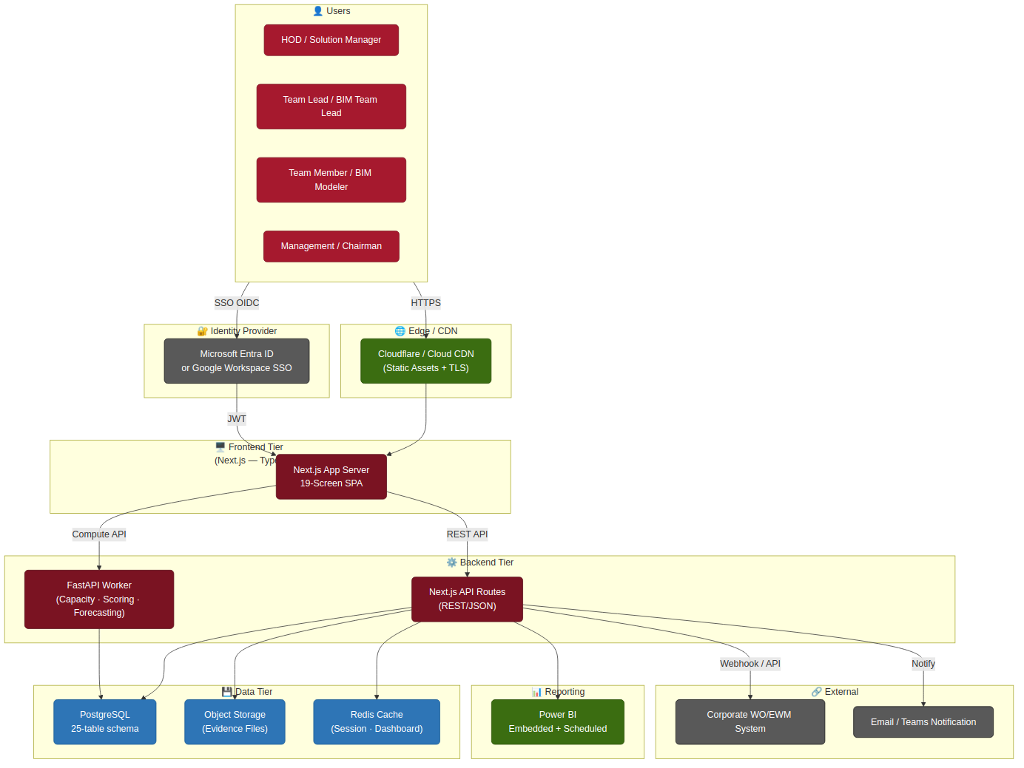
Figure 1 — System Context. Dashed-border nodes are external. All connections are HTTPS/TLS 1.3.

1.2 Key Architecture Principles
Principle | Decision | PRD Reference
Separation of concerns | Frontend rendering, business API, and compute-heavy capacity/scoring run as separate deployable units | §16.1
Server-enforced security | Role scope and row-level visibility enforced in the API middleware layer, not only in the UI | §6, §8
Immutable audit | AUDIT_LOG is INSERT-only with a SHA-256 hash chain; no UPDATE/DELETE grants at the DB role level | §8, DB Spec §6
Soft-delete only | No hard deletes on STAFF or closed WO records — deactivation via Status column | DB Spec §1.4
Config-driven behaviour | Utilization thresholds, SLA targets, scoring weights — all in SYSTEM_SETTING, not hard-coded | FR-47–49
AI-ready schema | EFFORT_LOG, STAFF_SKILL, TENDER partitioned and structured for nightly ETL to feature store from day one | PRD §16, Phase 4
Graceful scalability | Kubernetes HPA scales stateless pods horizontally; PostgreSQL scales vertically first, read replica for reporting | §8 NFR
No vendor lock-in at data layer | PostgreSQL is fully open-source and portable across AWS RDS, Azure Database, GCP Cloud SQL, or self-hosted | §16.1

2. Application Architecture
The application is structured as a Backend-for-Frontend (BFF) pattern: the Next.js API layer acts as the single API gateway visible to the browser, handling authentication, RBAC, scope-filtering and audit interception before delegating to module-specific repository functions. Heavy computation (capacity projections, tender scoring, future AI inference) is offloaded to a dedicated FastAPI worker process to keep the BFF responsive under concurrent load.

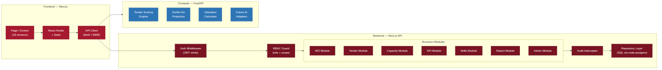
Figure 2 — Application Architecture. The Frontend never calls the database directly; all data access flows through the API middleware stack.

2.1 Frontend Tier — Next.js
The frontend is a Next.js 14 application using the App Router, TypeScript for type safety, and Tailwind CSS for utility-first styling consistent with the 10CS design system defined in the UI/UX Wireframe Specification §0.1. The 19 screen specifications in the Wireframe Spec map to 19 route groups within the Next.js App Router. Server Components handle initial data fetch on page load, reducing client-side JavaScript and improving time-to-first-content; interactive widgets (Kanban board, Go/No-Go wizard, competency heatmap) are Client Components with local state managed via Zustand. SWR handles all data fetching, caching and background revalidation on the client — the 5-minute dashboard cache target in PRD §8 is satisfied by SWR's revalidation interval combined with Redis-cached API responses.

2.2 Backend API Tier — Next.js API Routes
Every API route passes through a consistent seven-layer middleware stack: rate limiter, CORS guard, JWT verification, RBAC guard, row-level scope filter, audit interceptor, and error handler. The order is deliberate — a request rejected by the rate limiter or CORS guard never reaches the JWT verification step, minimising CPU cost on malicious traffic. Business logic is grouped into modules (WO, Tender, Capacity, KPI, Skills, Reports, Admin) each of which exposes a thin repository layer over node-postgres. No raw SQL strings exist outside repository files — all queries use parameterised statements, eliminating SQL injection risk.

2.3 Compute Worker Tier — FastAPI
The FastAPI worker exposes four endpoint groups on an internal port (:8001, not externally reachable): /score for tender scoring, /gonogo for capacity projection, /utilization for live utilization calculation, and /ai/* as the future AI adapter surface. It is written in Python because the capacity and forecasting logic in PRD §13 maps naturally to NumPy/pandas, and the Phase 4 AI/ML models will use Python-native libraries (scikit-learn, Prophet, PyTorch). Celery with Redis as the broker handles async jobs — KPI rollup, scheduled report generation, expiry alert scanning — so long-running operations do not block the API request thread.

3. Technology Stack
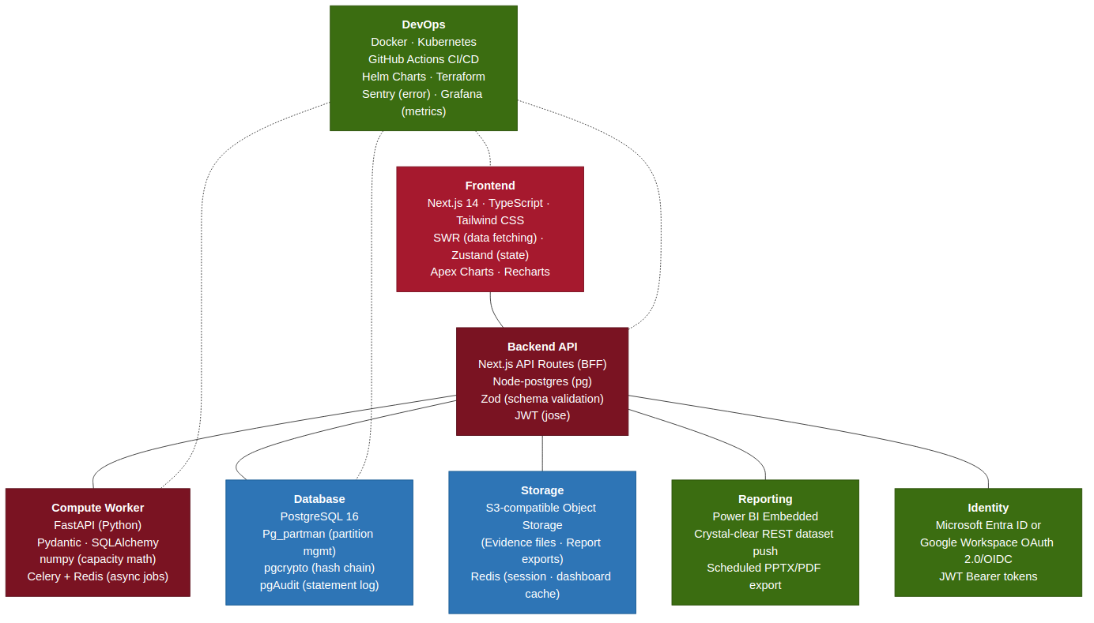
Figure 3 — Technology Stack. All choices are open-source or have permissive enterprise licensing; no proprietary vendor lock-in at the application or database tier.

Layer | Technology | Version / Notes | Rationale
Frontend framework | Next.js | 14 (App Router) | SSR + CSR hybrid; built-in API routes for BFF pattern
UI language | TypeScript | 5.x | Type safety across 25-entity schema; caught at compile time, not runtime
Styling | Tailwind CSS | 3.x | Utility-first; PRD design tokens map directly to Tailwind config
State management | Zustand | 4.x | Lightweight; no Redux boilerplate for a department-scale app
Data fetching | SWR | 2.x | Stale-while-revalidate matches the ≤5 min dashboard staleness NFR (PRD §8)
Charts | Recharts + ApexCharts | Latest | Recharts for time-series (capacity trend); ApexCharts for radar (competency) and gauge (utilization)
Backend API | Next.js API Routes | 14 | BFF; co-located with frontend; shared TypeScript types
DB client | node-postgres (pg) | 8.x | Mature, production-proven PostgreSQL driver; no ORM to preserve query control
Input validation | Zod | 3.x | Schema validation on every API request; shared with frontend form validation
Compute worker | FastAPI | 0.111+ | Python async; numerical compute; Pydantic models align with Zod schemas
Async jobs | Celery + Redis | 5.x + 7.x | KPI rollup, report scheduling, expiry alerts (FR-53)
Database | PostgreSQL | 16 | 25-table schema (DB Spec §3); pg_partman, pgcrypto, pgAudit extensions
Connection pool | PgBouncer | 1.22 | Transaction-mode pooling; max 100 PostgreSQL connections regardless of pod count
Cache / broker | Redis | 7.x | Dashboard cache (TTL 5 min), session store (TTL 8 h), Celery broker
Object storage | S3-compatible | AWS S3 / Minio | Evidence files, report exports; FileRef stored in DB, binary never in DB
Reporting | Power BI Embedded | Premium Per User | Dashboard widgets + PPTX/PDF report generation; REST dataset push from replica
Report export | python-pptx + WeasyPrint | Latest | PPTX: 10CS corporate template; PDF: faithful to PPTX layout
Identity | Entra ID / Google OIDC | — | SSO-only; no local credentials (PRD §16.1)
Containers | Docker | 26+ | Multi-stage build; distroless production image
Orchestration | Kubernetes | 1.29+ | HPA, PDB, namespaced isolation, Helm chart packaging
CI/CD | GitHub Actions | — | Lint → test → scan → build → push → Helm upgrade pipeline
Observability | Prometheus + Grafana + Loki | — | Metrics, dashboards, log aggregation; Alertmanager for SLA breach alerts
Error tracking | Sentry | — | Frontend + backend error tracking with source maps
IaC | Terraform | 1.7+ | Cloud infra (networking, managed DB, object storage, DNS)

4. Authentication Architecture
Authentication is delegated entirely to the configured Identity Provider (Microsoft Entra ID or Google Workspace) via OIDC/OAuth 2.0 with PKCE. There are no local username/password credentials anywhere in the platform, eliminating the largest class of credential-related vulnerabilities and offloading MFA enforcement to the identity provider where 10CS's IT policy already controls it. This aligns with PRD §8 (Security NFR: SSO-only auth) and Wireframe Specification Screen 1 (Login / Landing Page, validation rule 1).

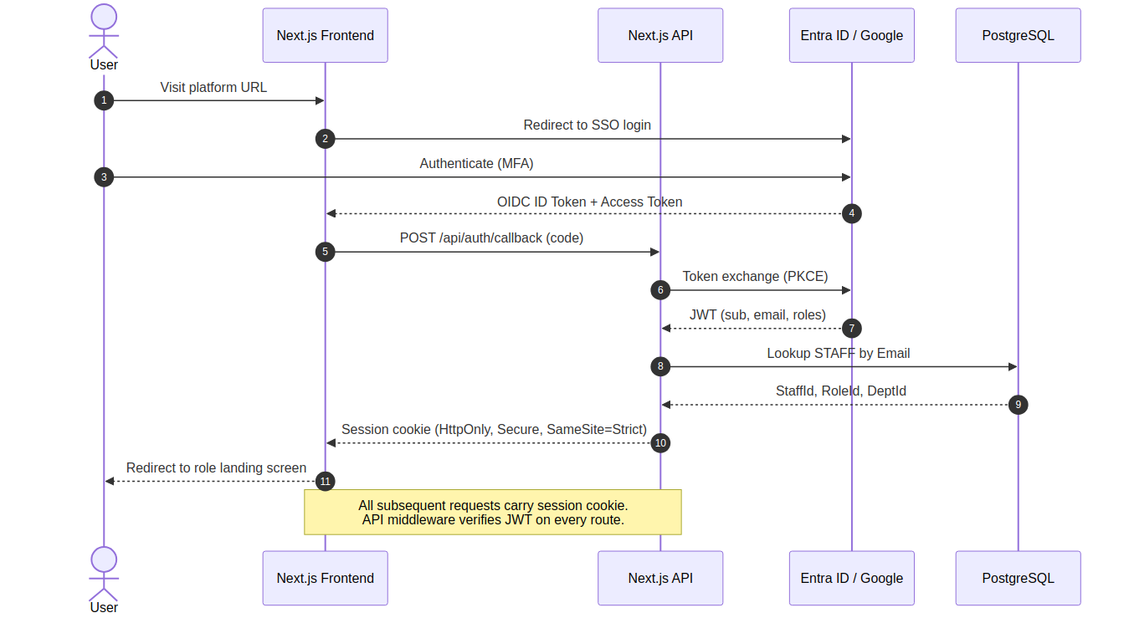
Figure 4 — Authentication Sequence. Steps 1–10 complete before any business data is returned to the client.

Component | Design Decision | Rationale
Token format | JWT (RS256), issued by IdP | Standard OIDC; public key verification at API with no IdP round-trip on every request
Session storage | HttpOnly + Secure + SameSite=Strict cookie (8 h TTL) | Prevents XSS token theft; SameSite=Strict prevents CSRF; session also stored in Redis for revocation
Session revocation | Redis session store; sign-out deletes the Redis key immediately | Ensures a compromised session can be revoked without waiting for JWT expiry
Staff lookup | Email from JWT sub → STAFF.Email (unique index) → StaffId, RoleId, DeptId | Single round-trip; result cached in session for the request lifetime
No-access state | STAFF record missing → distinct 'no access' page, not a generic error (Wireframe Spec §1) | Guides the user to the HOD for provisioning rather than leaving them with a cryptic error
Token refresh | Silent refresh via IdP /token endpoint before JWT expiry; re-authentication on failure | Transparent to the user; expired sessions surface as a sign-in redirect, not a failed API call
MFA | Enforced at the IdP level; platform does not implement its own MFA | Single point of MFA policy; changes to MFA strength do not require a platform update

5. Authorization Model
Authorization is a two-stage, server-enforced process: route-level role gating (can this role call this endpoint at all?) followed by row-level scope filtering (which rows can this staff member see?). Both stages execute in the API middleware, not in the frontend, so they cannot be bypassed by URL manipulation or by intercepting and modifying API responses. This is the explicit architecture commitment behind PRD §6's role-capacity-scope matrix and the Wireframe Specification's server-side enforcement notes across all 19 screens.

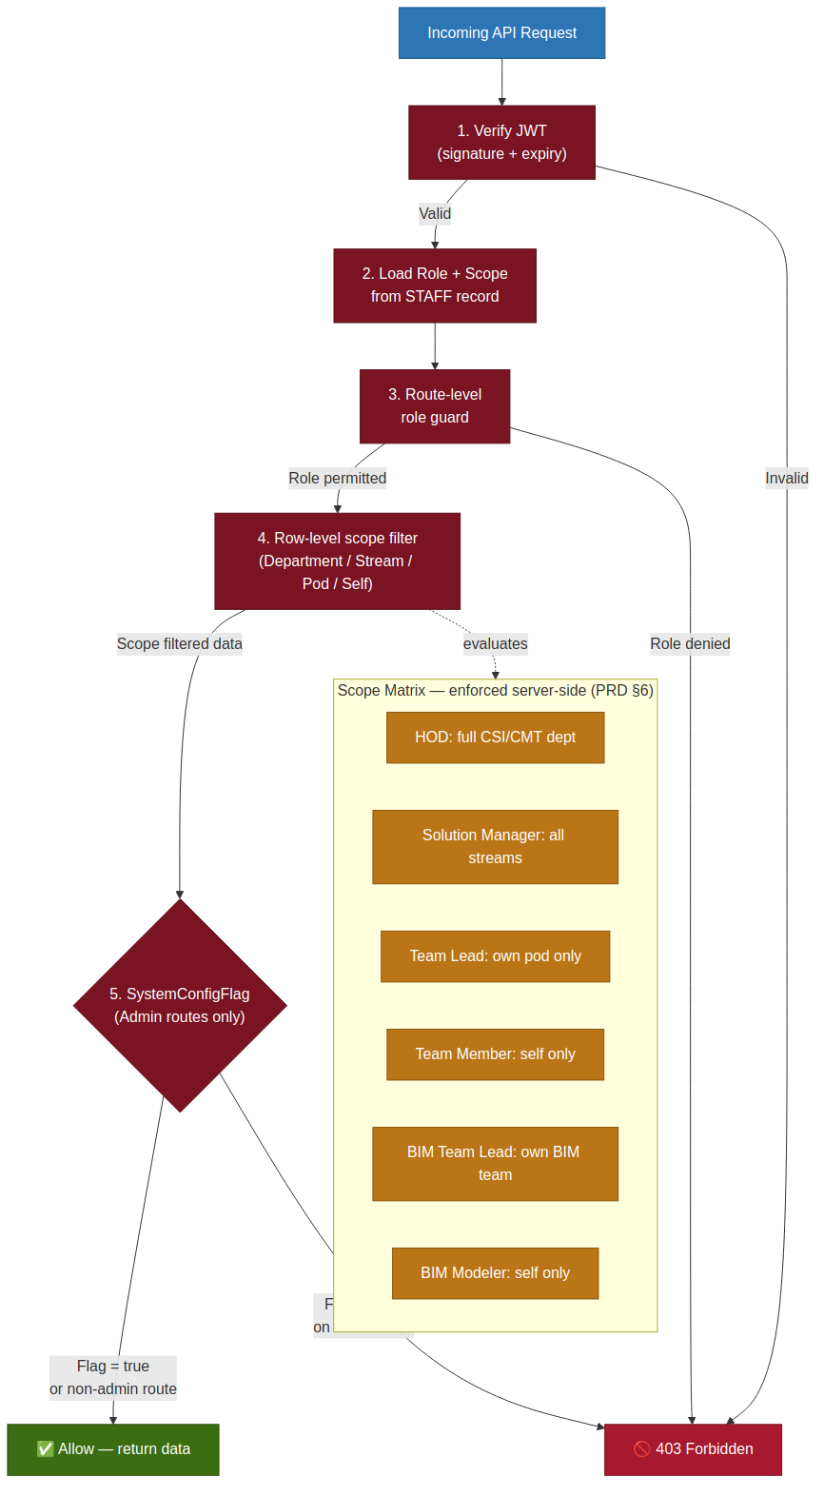
Figure 5 — Authorization Flow. All five checks execute in the middleware stack before any repository query runs.

5.1 Role-to-Route Mapping
Route Group | HOD | Sol. Mgr | Team Lead / BIM TL | Team Member | BIM Modeler
/api/wo/* (all) | ✅ Full | ✅ Full | ✅ Pod / BIM team | ✅ Own | ✅ Own
/api/tender/* | ✅ Full | ✅ Full | ✅ Read only | ✗ | ✗
/api/capacity/* | ✅ Full | ✅ Full | ✗ | ✗ | ✗
/api/kpi/* | ✅ Full | ✅ Stream | ✅ Pod / Own | ✅ Own | ✅ Own
/api/skills/* | ✅ Full | ✅ Full | ✅ Assess pod/team | ✅ View own | ✅ View own
/api/reports/* | ✅ Full | ✅ Scoped | ✅ Scoped | ✅ Own | ✅ Own
/api/admin/* | ✅ (SysConfig) | ✅ (if delegated) | ✗ | ✗ | ✗

5.2 Row-Level Scope Filter
After route-level gating, a scope filter appends a WHERE clause to every repository query based on the calling user's CapacityScope field (Department / Stream / Pod / Self). The filter is applied in the repository layer as a required parameter, not as an optional guard — a repository function that can return data without a scope filter cannot exist in the codebase. This architectural constraint, enforced via code review and automated tests, is the technical guarantee behind PRD §6's capacity-scope column.

6. Data Flow
The platform has five primary data flows corresponding to its five core operational cycles: work-order lifecycle, effort and evidence capture, capacity and Go/No-Go evaluation, KPI rollup, and reporting. Each flow is described below and illustrated in the consolidated data-flow diagram.

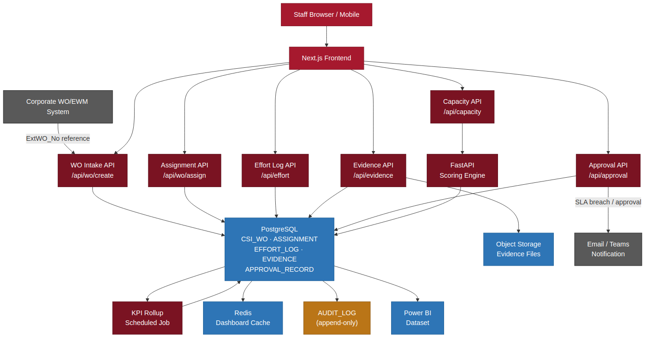
Figure 6 — Platform Data Flow. The AUDIT_LOG receives an entry from every mutating action across all five flows.

Flow | Trigger | Primary Path | Output
WO Lifecycle | External WO received from corporate system | CorpSys → /api/wo/create → CSI_WO + ASSIGNMENT → PG → AUDIT_LOG | Internal CSI_WO record; SLA clock started; assignee notified
Effort & Evidence | Team Member logs hours or uploads file | Browser → /api/effort or /api/evidence → PG (EFFORT_LOG) or Object Storage → AUDIT_LOG | Utilization figures updated in Redis cache; WO closure eligibility re-evaluated
Capacity & Go/No-Go | HOD evaluates a new tender commitment | Browser → /api/capacity → FastAPI /gonogo → PG (live EFFORT_LOG aggregation) → GONOGO_EVALUATION | Go/No-Go recommendation; persisted with optional HOD override and justification
KPI Rollup | Nightly Celery job (or on-demand) | Celery → /api/kpi/rollup → PG aggregation across EFFORT_LOG, OI_TRACKER, APPROVAL_RECORD → KPI_RECORD update | Role-cascaded KPI dashboard reflects achievement-to-date without manual entry
Reporting | User requests report or scheduled job fires | /api/reports → PG Read Replica → python-pptx / WeasyPrint / openpyxl → Object Storage → pre-signed download URL | PDF, Excel or PPTX file; Power BI dataset push for embedded widgets

7. Database Architecture
The database tier runs PostgreSQL 16 with three companion components: PgBouncer as a transaction-mode connection pool, a streaming read replica for reporting query isolation, and Redis for session and dashboard caching. The physical schema — 25 tables, 35 indexes, hash-chain audit log, monthly range partitions on EFFORT_LOG and AUDIT_LOG — is defined in full in the Database Design Specification. This section addresses the runtime topology, not the schema.

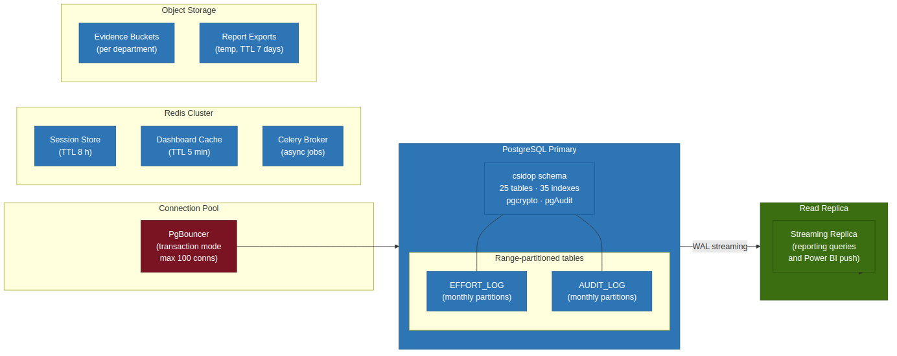
Figure 7 — Database Architecture. The primary handles all writes; the replica is read-only, used by reporting and Power BI push.

Component | Decision | Rationale
Primary PostgreSQL | Single primary; all writes land here | Schema integrity and FK enforcement require a single write point; current headcount (26 staff) does not warrant multi-primary sharding
Read replica | Streaming WAL replica; replica hosts reporting queries and Power BI nightly push | Isolates expensive report queries from OLTP workload; Power BI push does not compete with live dashboard requests
PgBouncer | Transaction-mode; max 100 PostgreSQL server connections | Next.js pods create many short-lived connections; PgBouncer keeps PostgreSQL connections stable; FastAPI uses its own named pool
Monthly partitions | EFFORT_LOG and AUDIT_LOG range-partitioned by LogDate / PerformedAt | High write volume, date-range query pattern; partition pruning makes SLA-breach reports and KPI rollups fast; old partitions archive cleanly
pgcrypto | SHA-256 hash chain on AUDIT_LOG.ChecksumHash | Tamper-evidence without a separate ledger service; no extra infrastructure
pgAudit | Statement-level audit logging at the PostgreSQL engine level | Catches any direct DB access that bypasses the application layer, satisfying the MAMPU/KRISA audit requirement
Redis cache | Dashboard data cached TTL 5 min; sessions TTL 8 h | PRD §8 NFR: dashboard staleness ≤5 min; session cache avoids DB lookup on every request
Object storage | Evidence files and report exports — FileRef stored in DB, binary in S3-compatible bucket | Keeps DB lean; binary search and versioning are object-storage strengths, not relational-DB strengths

8. API Architecture
The platform exposes a REST/JSON API across ten route groups, all fronted by the seven-layer middleware stack described in Section 2.2. The FastAPI worker exposes an internal-only API on a separate port for compute-heavy endpoints. There is no public API for external clients in Phase 1–3; external integration is handled through scheduled webhook/polling patterns (Section 11).

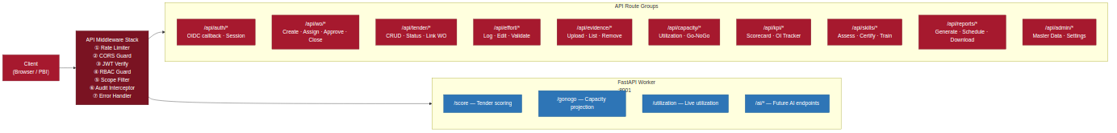
Figure 8 — API Architecture. All routes pass through the full middleware stack; the FastAPI worker is reachable from the API tier only, not from the public internet.

Design Decision | Detail
REST/JSON over GraphQL | The 19-screen data requirements are well-defined and screen-specific; REST avoids the over-fetch/under-fetch complexity and the N+1 query risk that GraphQL brings without a DataLoader layer
BFF pattern | The Next.js API layer is the only public-facing API; it aggregates data from PostgreSQL and FastAPI worker into screen-specific responses, reducing frontend complexity and hiding DB topology
Parameterised queries only | All SQL in repository files uses node-postgres parameterised statements ($1, $2…); no string concatenation; enforced via linting rule
Idempotency keys | POST endpoints for WO creation, effort log and evidence upload accept an optional Idempotency-Key header; duplicate submissions within a 24 h window return the original response without a double-write
Pagination | All list endpoints return cursor-based pagination (before/after UUID) rather than offset pagination, for stable results on high-velocity tables like EFFORT_LOG
HTTP status discipline | 200 data, 201 created, 204 no-content on delete; 400 validation error (Zod message), 401 unauthenticated, 403 forbidden (role/scope), 409 conflict (duplicate WO), 429 rate-limited, 500 internal
API versioning | Routes are not versioned in Phase 1–3 (single consumer: the platform's own frontend); versioning (/api/v2/) deferred to Phase 4 when external integrations may require stable contracts
FastAPI internal API | Port :8001, bound to the pod's internal network interface only; Next.js API connects via K8s service DNS (fastapi-worker:8001); no Ingress rule exposes this port externally

9. Audit Trail Architecture
The audit trail is a two-layer design: domain-specific history tables (ASSIGNMENT, APPROVAL_RECORD, EFFORT_LOG) for fast in-app display, and a single AUDIT_LOG as the immutable, compliance-grade ledger. The two layers are complementary, not redundant — an HOD opening WO Detail should not query the full AUDIT_LOG to see assignment history; the ASSIGNMENT table handles that. AUDIT_LOG exists to capture events that have no dedicated history table (master-data changes, report exports, Go/No-Go overrides, evidence removals) and to provide a single tamper-evident record spanning every table for compliance export (PRD §15, Governance & Compliance Audit Trail Export).

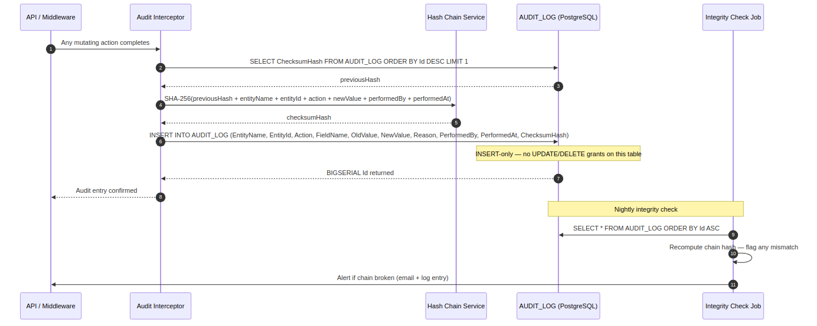
Figure 9 — Audit Trail Architecture. ChecksumHash forms a hash chain: any modification of a historical row breaks the chain and is detected by the nightly integrity check.

Design Decision | Detail | Rationale
Hash chain | SHA-256(prevHash + entityName + entityId + action + newValue + performedBy + performedAt); first row uses a fixed seed | Tamper-evidence without a hardware HSM or separate ledger; detects both row modification and row deletion
INSERT-only DB grant | The application's PostgreSQL role has INSERT + SELECT on AUDIT_LOG; no UPDATE or DELETE | Even a compromised application credential cannot alter audit history; only a DBA with superuser can, and pgAudit logs that
BIGSERIAL PK | Sequential integer, not UUID | Append-only access pattern; sequential key gives ordered reads for chain verification without a separate ORDER BY index
Monthly partitions | Range on PerformedAt; pg_partman manages creation | Fast date-range compliance exports; older partitions detach without touching recent data
Polymorphic entity reference | EntityName (VARCHAR) + EntityId (UUID) pair; no FK constraint | Avoids 24 separate FK columns; the nightly integrity check validates entity existence separately
Nightly integrity check | Celery job replays the hash chain from the oldest unverified row | Alerts on any chain break; also confirms that no rows have been deleted from a partition
Compliance export | /api/reports → Governance & Compliance Audit Trail Export generates a date-range extract of AUDIT_LOG | ISO 9001, PDPA and MAMPU/KRISA export on demand; role-gated to HOD and Compliance/Audit scope

10. Reporting Architecture
Reporting is built on two complementary engines: Power BI Embedded for interactive, always-current dashboard widgets (Executive Dashboard, Capacity Dashboard, KPI Dashboard) and a programmatic document-generation stack (python-pptx, WeasyPrint, openpyxl) for the 11 named report types in PRD §15. The two engines share a single data source — the PostgreSQL read replica — so there is no separate reporting database to keep in sync.

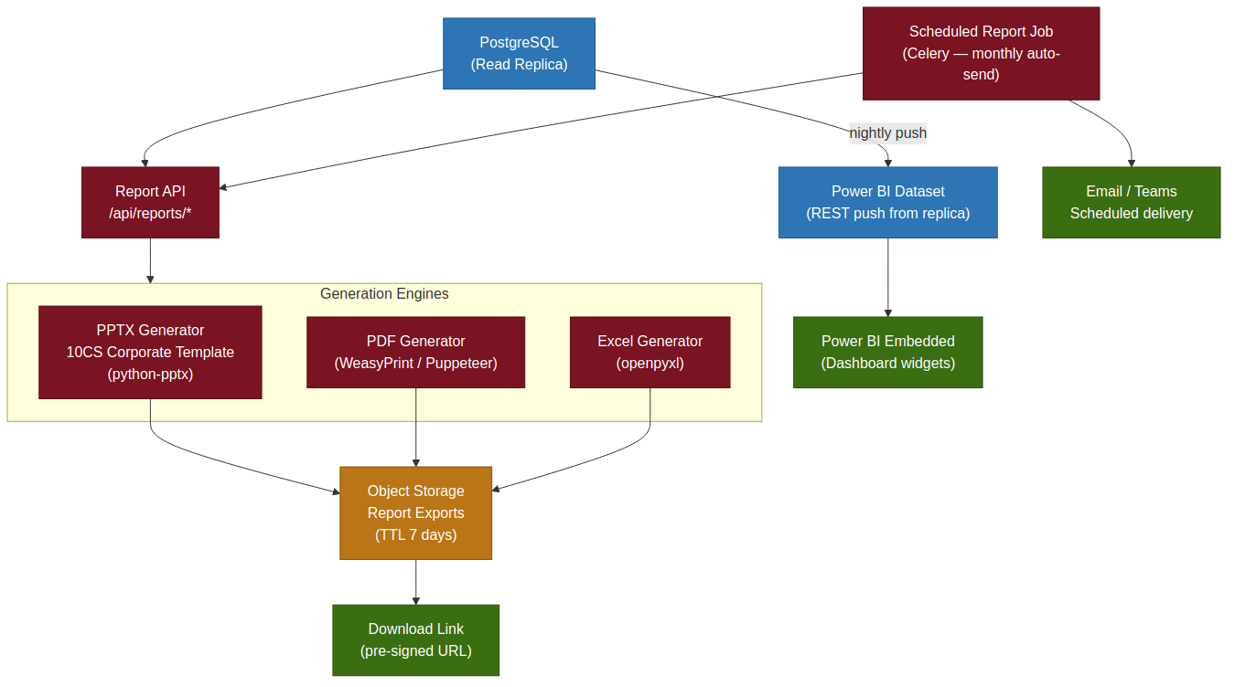
Figure 10 — Reporting Architecture. Power BI widgets are embedded directly in the Next.js dashboard screens; document generation runs async via Celery and is downloaded via pre-signed Object Storage URL.

Report Type | Engine | Format(s) | Schedule | PRD Reference
Monthly WO Trend | python-pptx / Excel | PPTX, Excel | Monthly auto | §15
Capacity & Utilization | Power BI + python-pptx | PBI widget, PPTX | On-demand + monthly | §15
CMT-to-CSI WO Linkage | Excel + python-pptx | Excel, PPTX | On-demand | §15
Governance & Compliance Audit Trail | WeasyPrint / Excel | PDF, Excel | On-demand | §15
KPI Achievement | Power BI + Excel | PBI widget, Excel | Monthly auto | §15
OI & Commission | Excel | Excel | On-demand | §15
Resource Capacity (v1.1) | Excel | Excel | On-demand | §15
Competency Gap Analysis (v1.1) | WeasyPrint / Excel | PDF, Excel | On-demand | §15
Certification Compliance (v1.1) | WeasyPrint / Excel | PDF, Excel | On-demand | §15
Tender Pipeline (v1.1) | Power BI + Excel | PBI widget, Excel | On-demand | §15
Chairman Executive Summary (v1.1) | python-pptx (10CS template) | PPTX, PDF | Monthly auto | §15

All PPTX exports use the 10CS corporate template (red, white and dark colour scheme with batik motifs) as confirmed in PRD §15.1 — the same template already used in the CSI Department Review deck, the most recent Chairman briefing deliverable. The python-pptx engine populates the template's placeholder shapes from live query results, so the HOD's review effort is editorial (checking narrative) rather than data reconstruction.

11. Integration Architecture
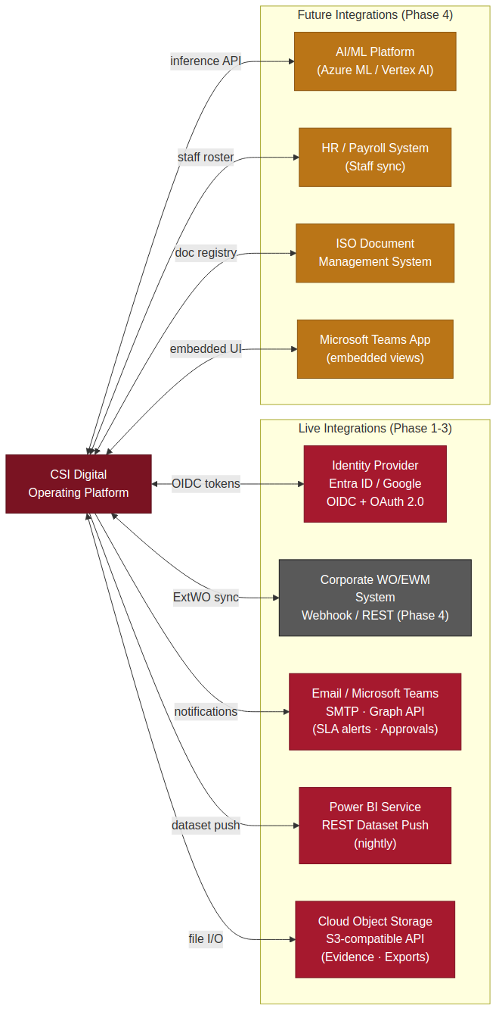
Figure 11 — Integration Architecture. Solid lines are live Phase 1–3 integrations; dashed lines are Phase 4 future integrations.

Integration | Direction | Protocol | Phase | Design Notes
Microsoft Entra ID / Google Workspace | Inbound (auth) | OIDC / OAuth 2.0 (PKCE) | Phase 1 | SSO-only; no local credentials; MFA enforced at IdP
Cloud Object Storage | Bidirectional | S3 API (HTTPS) | Phase 1 | Evidence file upload and download; report export storage; pre-signed URLs expire after 24 h
Power BI Service | Outbound (data push) | Power BI REST API (HTTPS) | Phase 1 | Nightly dataset push from read replica; embedded token issued per user session for embedded widgets
Email / Microsoft Teams | Outbound (notify) | SMTP / MS Graph API | Phase 2 | SLA breach alerts, approval request notifications, certification expiry warnings (FR-53); templated messages, not free-form
Corporate WO/EWM System | Bidirectional (sync) | REST webhook or polling | Phase 4 | ExtWO_No lookup at WO creation is manual-entry in Phase 1–3; Phase 4 adds a webhook so the corporate system pushes new WOs and the platform confirms internal classification. Schema already carries ExtWO_No (UQ); no schema change required
AI/ML Platform (Azure ML / Vertex AI) | Bidirectional | REST inference API | Phase 4 | Feature store fed by nightly ETL from EFFORT_LOG, STAFF_SKILL, TENDER; model inference called from FastAPI /ai/* endpoints; results are advisory, not auto-acted
HR / Payroll System | Inbound (staff sync) | REST / CSV | Phase 4 | New-starter / leaver sync to STAFF table; removes manual provisioning; STAFF.Status deactivation on leaver signal
Microsoft Teams App | Bidirectional (embedded UI) | Teams App SDK | Phase 4 | Select screens (My Tasks, Daily Effort Log, Approval requests) embedded in Teams channel as a tab app, with deep-link notifications from the Teams notification integration

12. Security Architecture
Security controls are layered across four domains — perimeter, application, data, and infrastructure — following a defence-in-depth model. No single control is relied on exclusively; compromise of any one layer is assumed and the remaining layers continue to enforce protection. The architecture satisfies the Security and Compliance NFRs in PRD §8 (PDPA, ISO 9001, MAMPU/KRISA) without requiring a dedicated security appliance.

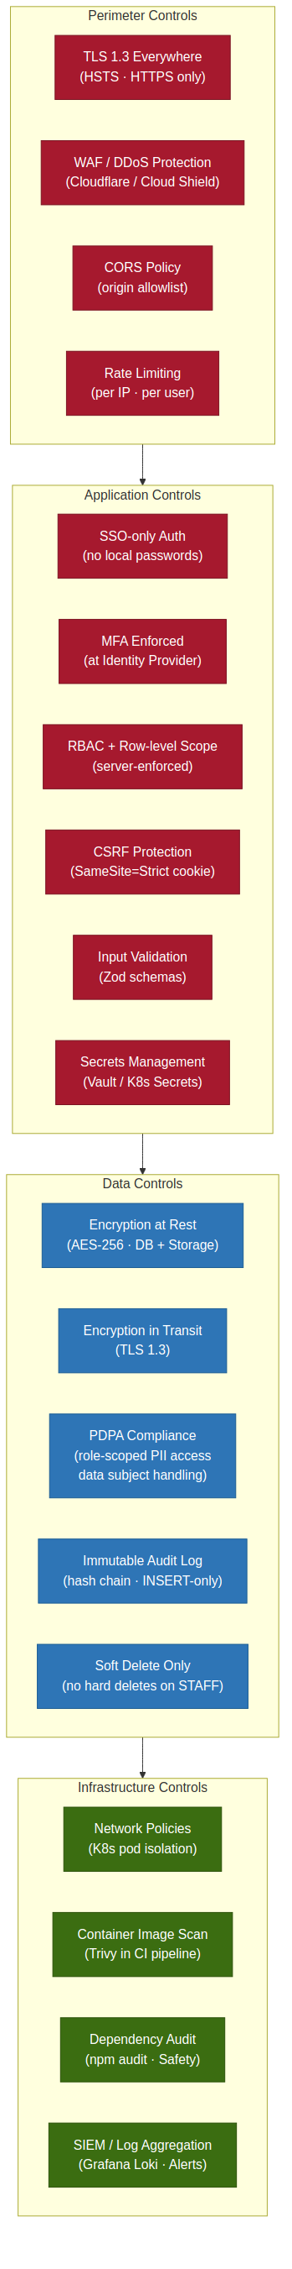
Figure 12 — Security Architecture: four concentric defence layers. Controls in each layer are independent; a failure in one layer does not cascade to the next.

Domain | Control | Implementation
Perimeter | TLS 1.3 everywhere | All traffic HTTPS; HSTS header; TLS certificate auto-renewed via cert-manager (Let's Encrypt or cloud CA)
Perimeter | WAF / DDoS | Cloudflare WAF or cloud-native equivalent; rate limiting at edge before traffic reaches the cluster
Perimeter | CORS policy | Origin allowlist in Next.js config; browser rejects cross-origin requests from unlisted origins
Perimeter | Rate limiting | Per-IP and per-authenticated-user rate limits in API middleware; 429 response with Retry-After header
Application | SSO-only auth | No local credentials; credential stuffing and brute force are irrelevant when there is no password to guess
Application | MFA | Enforced at IdP level; platform inherits the strength of 10CS's IdP MFA policy without implementing its own
Application | RBAC + row-level scope | Server-enforced in middleware (Section 5); cannot be bypassed from the frontend
Application | CSRF protection | SameSite=Strict cookie; no Bearer token in localStorage or URL parameters
Application | Input validation | Zod schema on every API request; rejects malformed input before it reaches repository layer
Application | Secrets management | All secrets (DB credentials, IdP client secret, Object Storage keys) in Kubernetes Secrets or HashiCorp Vault; never in environment files committed to git
Data | Encryption at rest | AES-256 at the cloud storage and managed DB level; object storage bucket encryption enabled by default
Data | Encryption in transit | TLS 1.3 for all client connections; TLS also on internal DB and Redis connections within the cluster
Data | PDPA compliance | Role-scoped PII access; individual KPI and utilization data visible only to the staff member, their direct line and HOD (PRD §8); data-subject export handled via /api/admin/data-subject
Data | Immutable audit log | SHA-256 hash chain; INSERT-only DB grant; pgAudit catches direct DB access (DB Spec §6)
Infrastructure | K8s network policies | Pods in csidop namespace can only connect to csidop-data namespace; FastAPI worker not reachable from outside the cluster
Infrastructure | Container image scan | Trivy scans every image in the CI pipeline; HIGH/CRITICAL vulnerabilities block the merge
Infrastructure | Dependency audit | npm audit (frontend/backend) and Safety (Python worker) run on every pull request
Infrastructure | SIEM / log aggregation | Grafana Loki aggregates container logs; Alertmanager fires on error-rate spikes, auth failures, and audit chain breaks

13. Backup and Recovery
The backup strategy follows a 3-2-1 principle: three copies of data (primary, replica, cold backup), on two different media types (live database and object storage backup), with one copy off-site (cross-region object replication). Recovery objectives are defined against the two most critical data types: the PostgreSQL relational data and the evidence file binary objects.

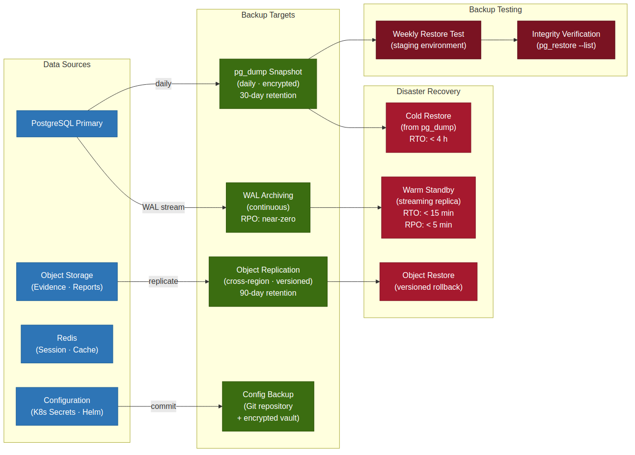
Figure 13 — Backup and Recovery. RPO and RTO targets are for the relational DB; object storage has independent versioning-based recovery.

Tier | Mechanism | RPO | RTO | Retention
Warm standby (primary DR) | Streaming WAL replica in a separate availability zone; auto-promote on primary failure | < 5 minutes | < 15 minutes | Continuous
Daily snapshot | pg_dump (compressed, encrypted); stored in object storage | 24 hours | < 4 hours | 30 days rolling
Evidence files | S3 versioning + cross-region replication; soft delete retains previous versions | Near-zero (versioned) | Minutes (version restore) | 90 days versioned; indefinite for closed WOs
Configuration | Helm charts and Terraform IaC committed to git; secrets in Vault with its own replication | Commit-time | < 30 minutes (re-apply) | Git history
Audit log | AUDIT_LOG partitions included in pg_dump; older partitions archived to cold object storage before detachment | 24 hours | < 4 hours | Configurable via SYSTEM_SETTING (AUDIT_LOG_RETENTION_YEARS)

Activity | Frequency | Owner | Notes
WAL replica health check | Continuous monitoring (Prometheus alert if replica lag > 30 s) | Platform ops | Auto-alert via Alertmanager
pg_dump snapshot test (restore to staging) | Weekly | DevOps | Confirms backup integrity; staging restore documented in runbook
Full DR simulation (promote replica, re-attach primary) | Quarterly | DevOps + HOD | Tests the full RTO; results recorded for ISO 9001 evidence
Audit log integrity check | Nightly (Celery job) | Automated | Replays hash chain; alerts on any break

14. Deployment Architecture
The platform is deployed on Kubernetes, using Helm charts for packaging and GitHub Actions for CI/CD. Two namespaces enforce network isolation: csidop (application pods) and csidop-data (stateful components). A three-stage pipeline — staging, UAT, production — gates every release, with staging and UAT running on smaller node pools but otherwise identical configuration to production.

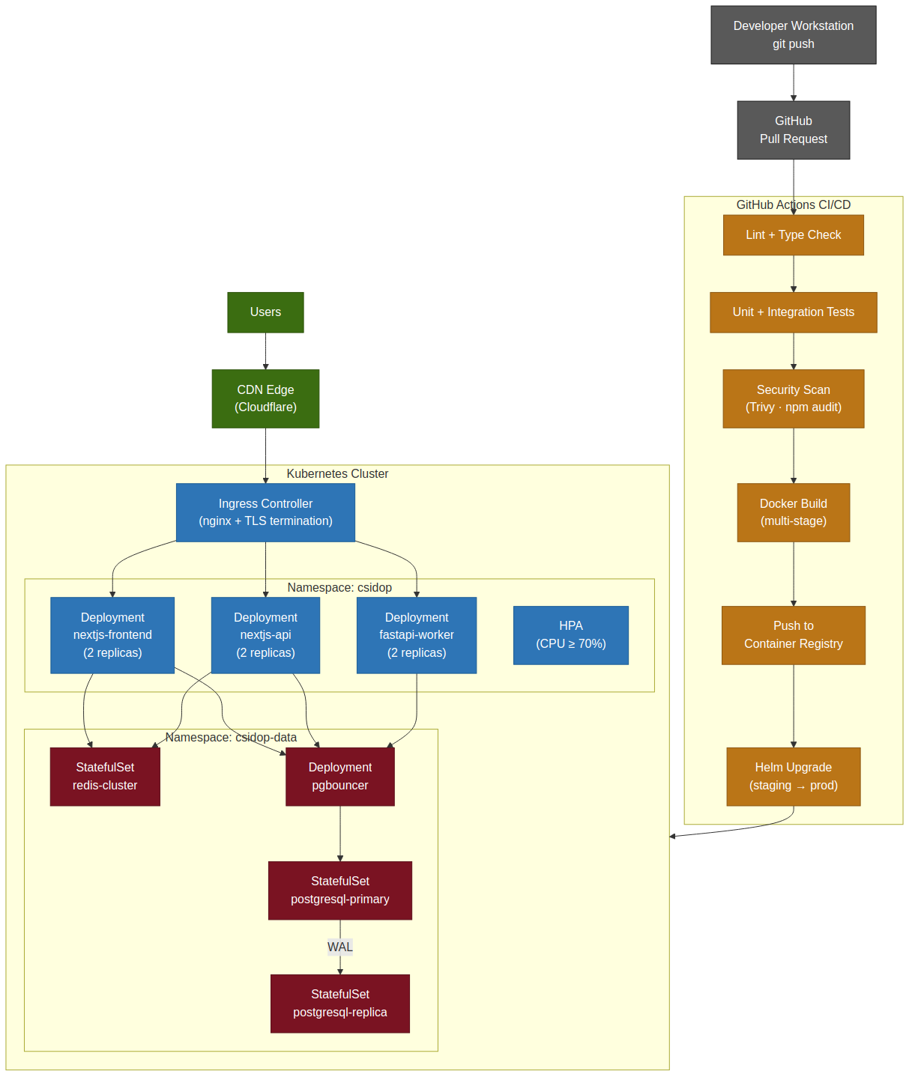
Figure 14 — Deployment Architecture. The CI/CD pipeline runs from developer commit to production Helm upgrade without manual intervention after the UAT sign-off gate.

Component | Replicas (Prod) | CPU / Memory Request | Notes
nextjs-frontend | 2 (HPA up to 6) | 250m / 256Mi | Static assets served from CDN; pod handles SSR only
nextjs-api | 2 (HPA up to 8) | 500m / 512Mi | BFF; stateless; session state in Redis
fastapi-worker | 2 (HPA up to 4) | 1000m / 1Gi | CPU-bound scoring; HPA on CPU ≥ 70%
celery-worker | 2 | 500m / 512Mi | Async jobs; one queue for reports, one for KPI rollup
postgresql-primary | 1 (StatefulSet) | 2000m / 4Gi | Vertical scale first; NVMe-backed PVC
postgresql-replica | 1 (StatefulSet) | 1000m / 2Gi | Read-only; reporting queries and PBI push
pgbouncer | 1 (Deployment) | 100m / 128Mi | Transaction-mode; max 100 PG connections
redis-cluster | 3 (StatefulSet) | 200m / 512Mi | Redis Sentinel for HA; one primary + two replicas

14.1 Environment Strategy
Environment | Purpose | Approval Gate
Development | Local developer workstation; docker-compose mirroring production services | Pull request peer review
Staging | Auto-deployed on merge to main branch; runs full test suite | Automated test pass
UAT | Manual sign-off environment; seeded with anonymised production data | HOD / SA sign-off
Production | Helm upgrade triggered after UAT sign-off; blue/green rollout via K8s deployment strategy | UAT gate + DevOps approval

15. High Availability Considerations
The platform targets 99.5% availability during business hours, as specified in PRD §8. This is achieved through multi-replica stateless pods, a PostgreSQL warm standby in a separate availability zone, Redis Sentinel failover, and Kubernetes Pod Disruption Budgets that prevent all replicas of any deployment from being terminated simultaneously during a node drain or cluster upgrade.

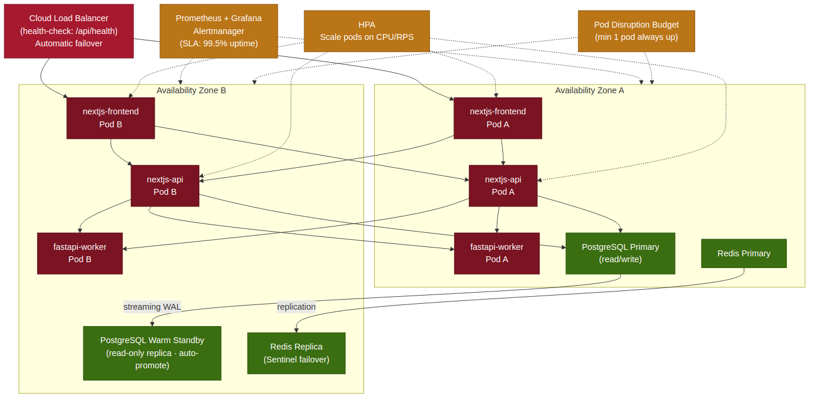
Figure 15 — High Availability Topology across two availability zones. Zone B can serve all traffic within the RTO window if Zone A fails entirely.

Component | HA Mechanism | Failover Behaviour
nextjs-frontend | 2+ replicas across AZs; HPA on CPU ≥ 70% | Load balancer health check detects a failed pod within 10 s; traffic re-routed to surviving replica automatically
nextjs-api | 2+ replicas across AZs; HPA | As above; stateless — no request state lost on pod termination (session in Redis)
fastapi-worker | 2+ replicas; HPA on CPU | Scoring requests re-routed; in-flight compute requests fail-fast with a 503; the frontend retries on the next user action
PostgreSQL primary | Warm standby in AZ-B via streaming WAL replication | If primary fails: promote standby (automated via Patroni / cloud-managed failover); reconnect PgBouncer to new primary — RTO < 15 min
Redis | Redis Sentinel with 1 primary + 2 replicas across AZs | Sentinel elects a new primary within 30 s; application Redis client reconnects automatically via Sentinel endpoint
PgBouncer | Single deployment; fast restart (< 5 s); connections re-pool on reconnect | In practice stateless; a pod restart does not lose data; connection pool rebuilds in seconds
Object storage | Cloud-managed; multi-AZ by default | No application-layer action required; cloud provider SLA handles availability

SLA Target | Mechanism | Monitoring
99.5% uptime (business hours) | Multi-replica pods + managed cloud services | Prometheus uptime probe; Alertmanager fires if uptime drops below threshold
Dashboard staleness ≤ 5 min (PRD §8) | Redis cache TTL 5 min; SWR revalidation interval 5 min | Grafana dashboard showing cache hit rate and last-refresh timestamp
API p95 latency < 500 ms | PgBouncer connection pooling; read-replica for reporting; Redis cache for repeated queries | Prometheus histogram on API middleware; Grafana alert on p95 > 500 ms
RTO < 15 min (DB failover) | Warm standby + Patroni / managed failover; pre-tested quarterly | DR simulation results; runbook with step-by-step failover procedure

16. Future AI Integration Architecture
Phase 4 of the platform roadmap (PRD §16, Months 7–12) introduces AI-assisted capabilities across five domains: resource assignment recommendation, tender scoring assistance, predictive workload forecasting, skills gap prediction, and succession planning analytics. The architecture for these capabilities is designed and documented now — not because they will be built in Phase 1–3, but because the Phase 1–3 schema and ETL pipeline decisions determine whether Phase 4 is a clean extension or an expensive retrofit. Every AI-readiness decision in Phase 1–3 is called out in this section.

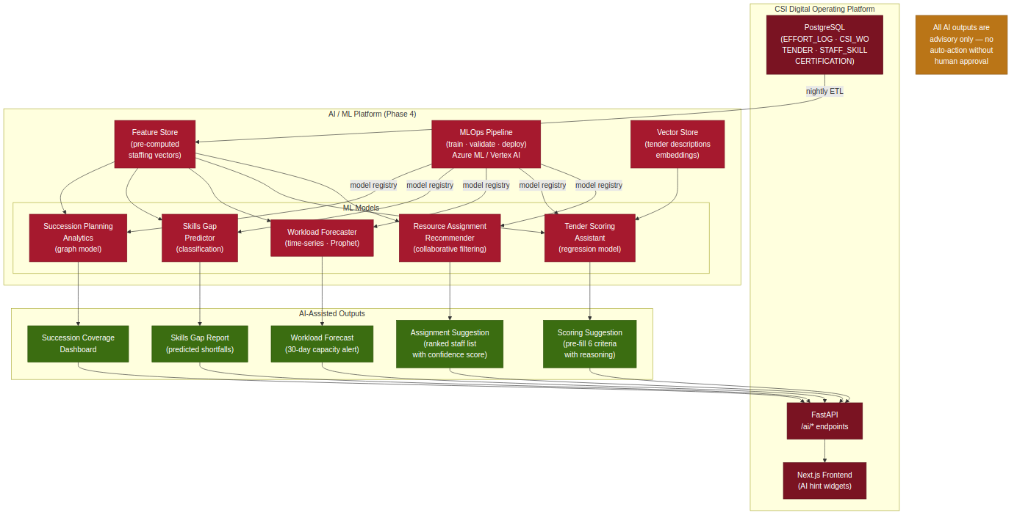
Figure 16 — Future AI Integration Architecture. The Phase 1–3 platform provides the data foundation; the AI/ML Platform layer is added in Phase 4 without schema changes.

16.1 Phase 1–3 AI Readiness Decisions
Decision | Implementation | Why It Matters for Phase 4
EFFORT_LOG monthly partitions | Range partition by LogDate from day one | Nightly ETL to feature store can scan only the relevant monthly partition rather than a full table scan on 100k+ rows
STAFF_SKILL composite PK with AssessedBy and LastAssessmentDate | Rich assessment history retained, not just current level | Competency trend over time is a feature for the skills-gap prediction model; without history it can only predict current state
TENDER entity as top-level object with explicit status lifecycle | Tender status transitions and value fields structured from day one | Win/loss labels and value outcomes are the target variables for the tender scoring assistant; they must be clean and structured, not inferred from WO text
CERTIFICATION with ExpiryDate and Status | Structured certification timeline per staff | Skills gap predictor can combine certification expiry with assignment load to forecast future capability shortfalls
FastAPI worker with /ai/* endpoint group | Placeholder endpoint group stubbed in Phase 1 | No routing change needed in Phase 4; AI inference calls drop in to existing endpoints; frontend already knows the URL
Feature store ETL slot in nightly Celery schedule | Celery beat scheduler configured from Phase 1 | Adding the feature-store push job in Phase 4 requires one new Celery task definition, not a scheduler architecture change
PostgreSQL + SQLAlchemy in FastAPI worker | FastAPI already reads directly from PG | Phase 4 adds a feature-store write path alongside the existing read path; no new DB connectivity pattern

16.2 AI Model Architecture (Phase 4)
Model | Input Features | Output | Advisory or Auto-Action
Resource Assignment Recommender | STAFF utilization history, role, SubTeam, current load, STAFF_SKILL competency level for the WO's domain | Ranked list of assignees with confidence score | Advisory — HOD/Solution Manager selects from suggestions; no auto-assignment
Tender Scoring Assistant | TenderName, Client, TenderCategory (text embedding via vector store), historical similar tenders and their outcome | Pre-filled scores for 6 criteria with a brief reasoning note | Advisory — user reviews and may override any pre-filled score
Workload Forecaster | EFFORT_LOG time series per staff per WO type, TENDER pipeline closing dates, historical tender→WO effort patterns | 30-day forward capacity utilization band (Free/Safe/Warning/Overloaded) per staff | Advisory — surfaced on Capacity Dashboard as a forecast band alongside actual utilization
Skills Gap Predictor | STAFF_SKILL competency levels, CERTIFICATION expiry dates, TENDER pipeline technology domains, assignment history | Predicted skill shortfalls by technology domain in the next 90 days | Advisory — feeds Competency Gap Analysis report; no auto-training enrollment
Succession Planning Analytics | STAFF role, STAFF_SKILL Expert/Advanced coverage per domain, OI_TRACKER history, years-in-role proxy from ASSIGNMENT history | Succession coverage score per critical role/domain pair; single-point-dependency risk rating | Advisory — displayed on Skills & Competency screen succession-planning view

All five models return advisory output only — the architecture has no pathway for an AI model to write directly to any operational table (CSI_WO, ASSIGNMENT, TENDER_SCORING or KPI_RECORD). Every AI suggestion requires a human action to take effect, and that action writes its own AUDIT_LOG entry in the normal way, so the audit trail for every AI-influenced decision captures both the AI suggestion and the human who accepted or overrode it.

This System Architecture Design document is submitted for review and sign-off by the Solution Architect, Developer/Technical Lead and Management. Approval authorises Phase 1 build-phase technical design to proceed against the architecture defined above.

