PHASE 1 - Introduction

Written Component
We created a hands-free cookbook prototype that tracks hand gestures and allows users to progress through the steps without touching their laptop. We utilized Python and Claude to make this first iteration of our prototype. Now young adults who are learning how to cook can get their hands dirty and fully immerse themselves in the kitchen experience without having to worry about getting their laptop dirty or lost in the confusing instructions.

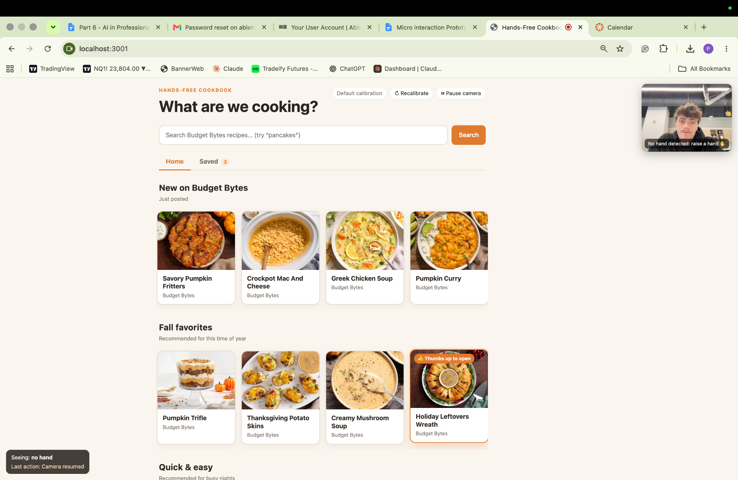
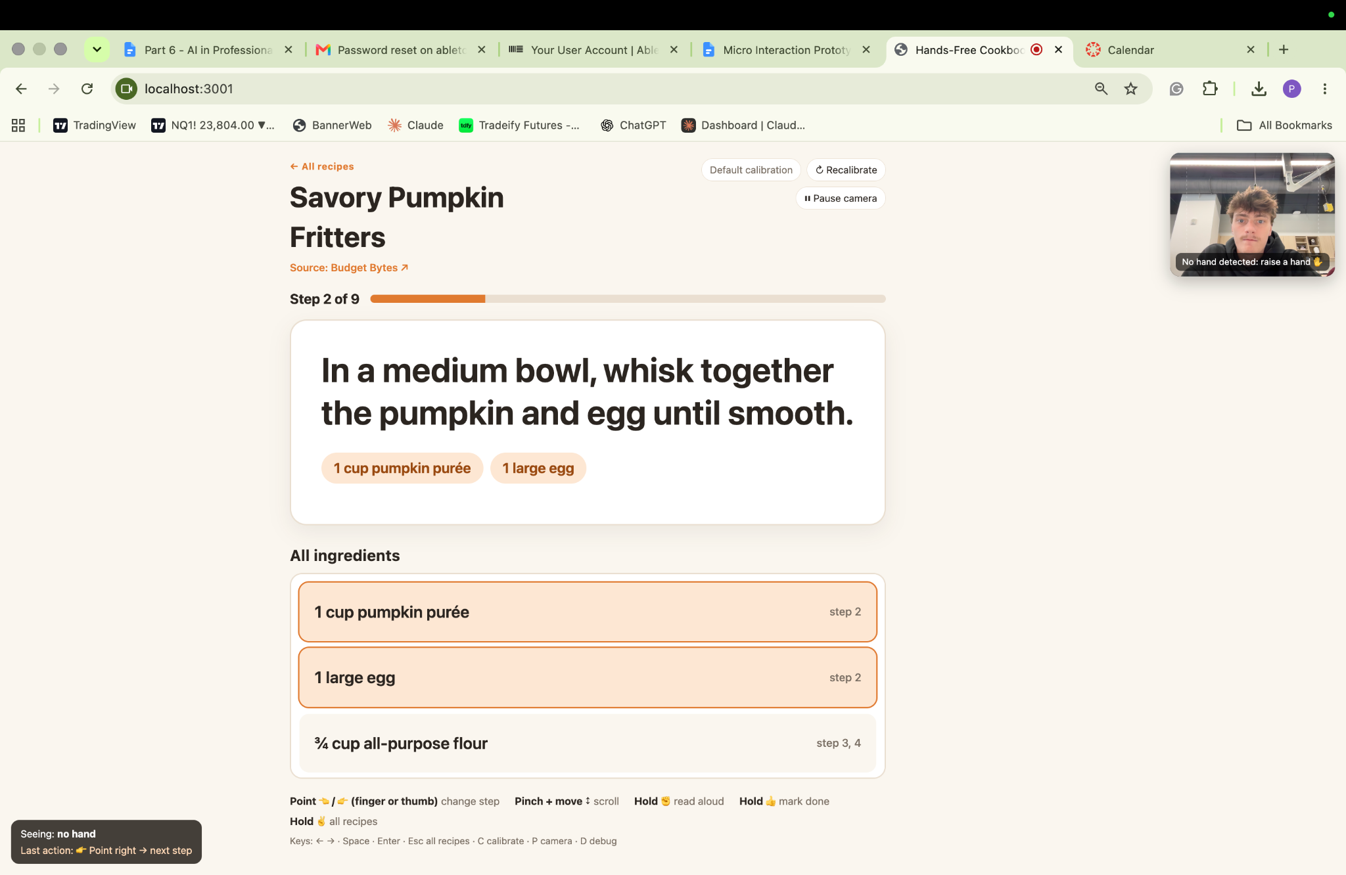

Skills & Strengths
Riley | Malia | Payton
- Coding  - Documentation  - Visual content  - Wireframes | - Documentation  - Visual content  - AI application  - wireframes | - Coding  - Ai Application  - Visuals

PHASE 2 - Brainstorming and Conceptualizing
Summary
At the beginning of this project, our team made a list of different goals that we felt would be interesting and doable. After further brainstorming and feedback we wanted to create a project that was meaningful or completed a meaningful task. Some of which were making music with a music player or teaching ASL. We also made a list of possible gestures that we wanted to use and what they would translate to in the software. This looked like using a thumps up to mark complete or select and point left or right for next or forward. After getting feedback from the class we decided to focus on the Cookbook idea because they gave the most applicable suggestions like using gestures that you actually use with a physical cookbook.
PHASE 3 - Prototyping & Iteration
Project Topic: Hands-Free Cookbook

Written Component
We finalized how we wanted the prototype to look and function. Below are the hand gestures that the cookbook will recognize. For the coding, the required inputs we think we will need are data tracking the hand location on the screen using x and y coordinates, velocity of the swiping motion, and the distance between the 2 points, as well as the distance of the user from the laptop. As we have tried to implement these things, we had to adjust how some of the gestures are recognized. Currently, there is a timer feature so that the software is picking up intention. Below are also 2 figma prototype designs that could work well for our layout. We did get some feedback about some of the gestures and that we should change the wave movement to use a pointer finger and thumb. Our professor suggested taking the distance between the pointing tip and knuckle and measuring the angle of that distance (between 80-90), meaning forward or backwards.

Next Adds: add more recipes + more navigation gestures
Refinement: eliminate errors, have it detect only one hand

Gestures
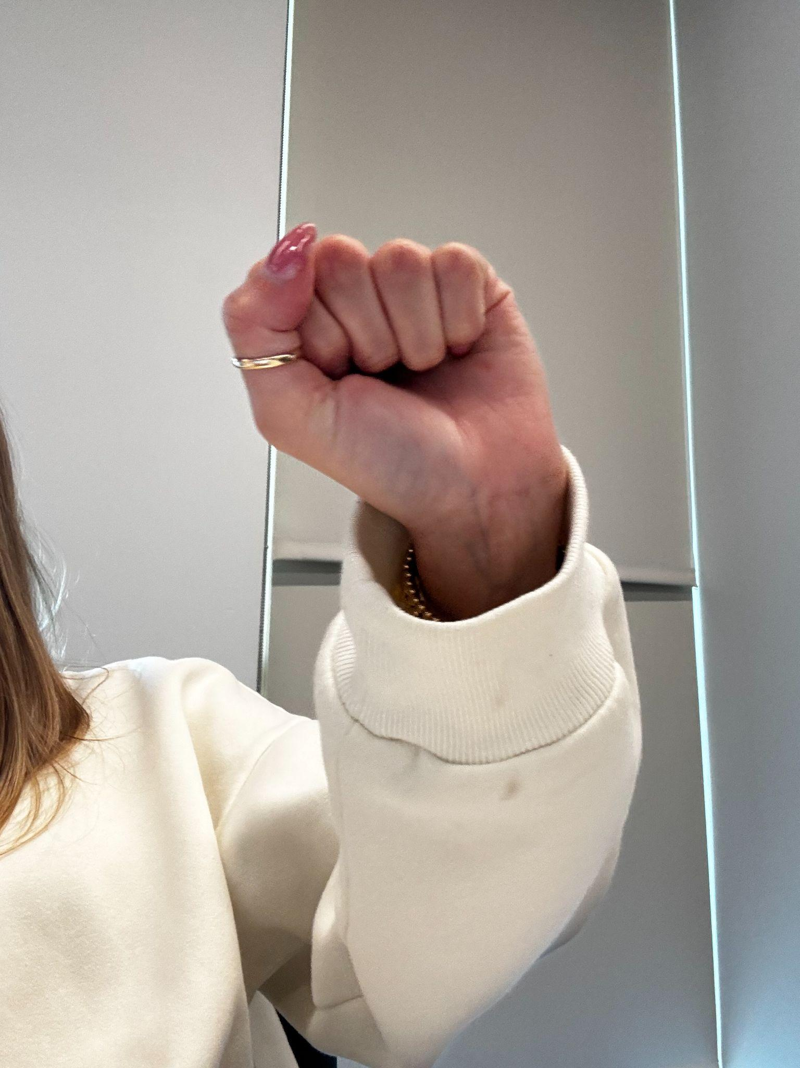  Fist  - Initial Recipe Selection  - Next & Previous Step | 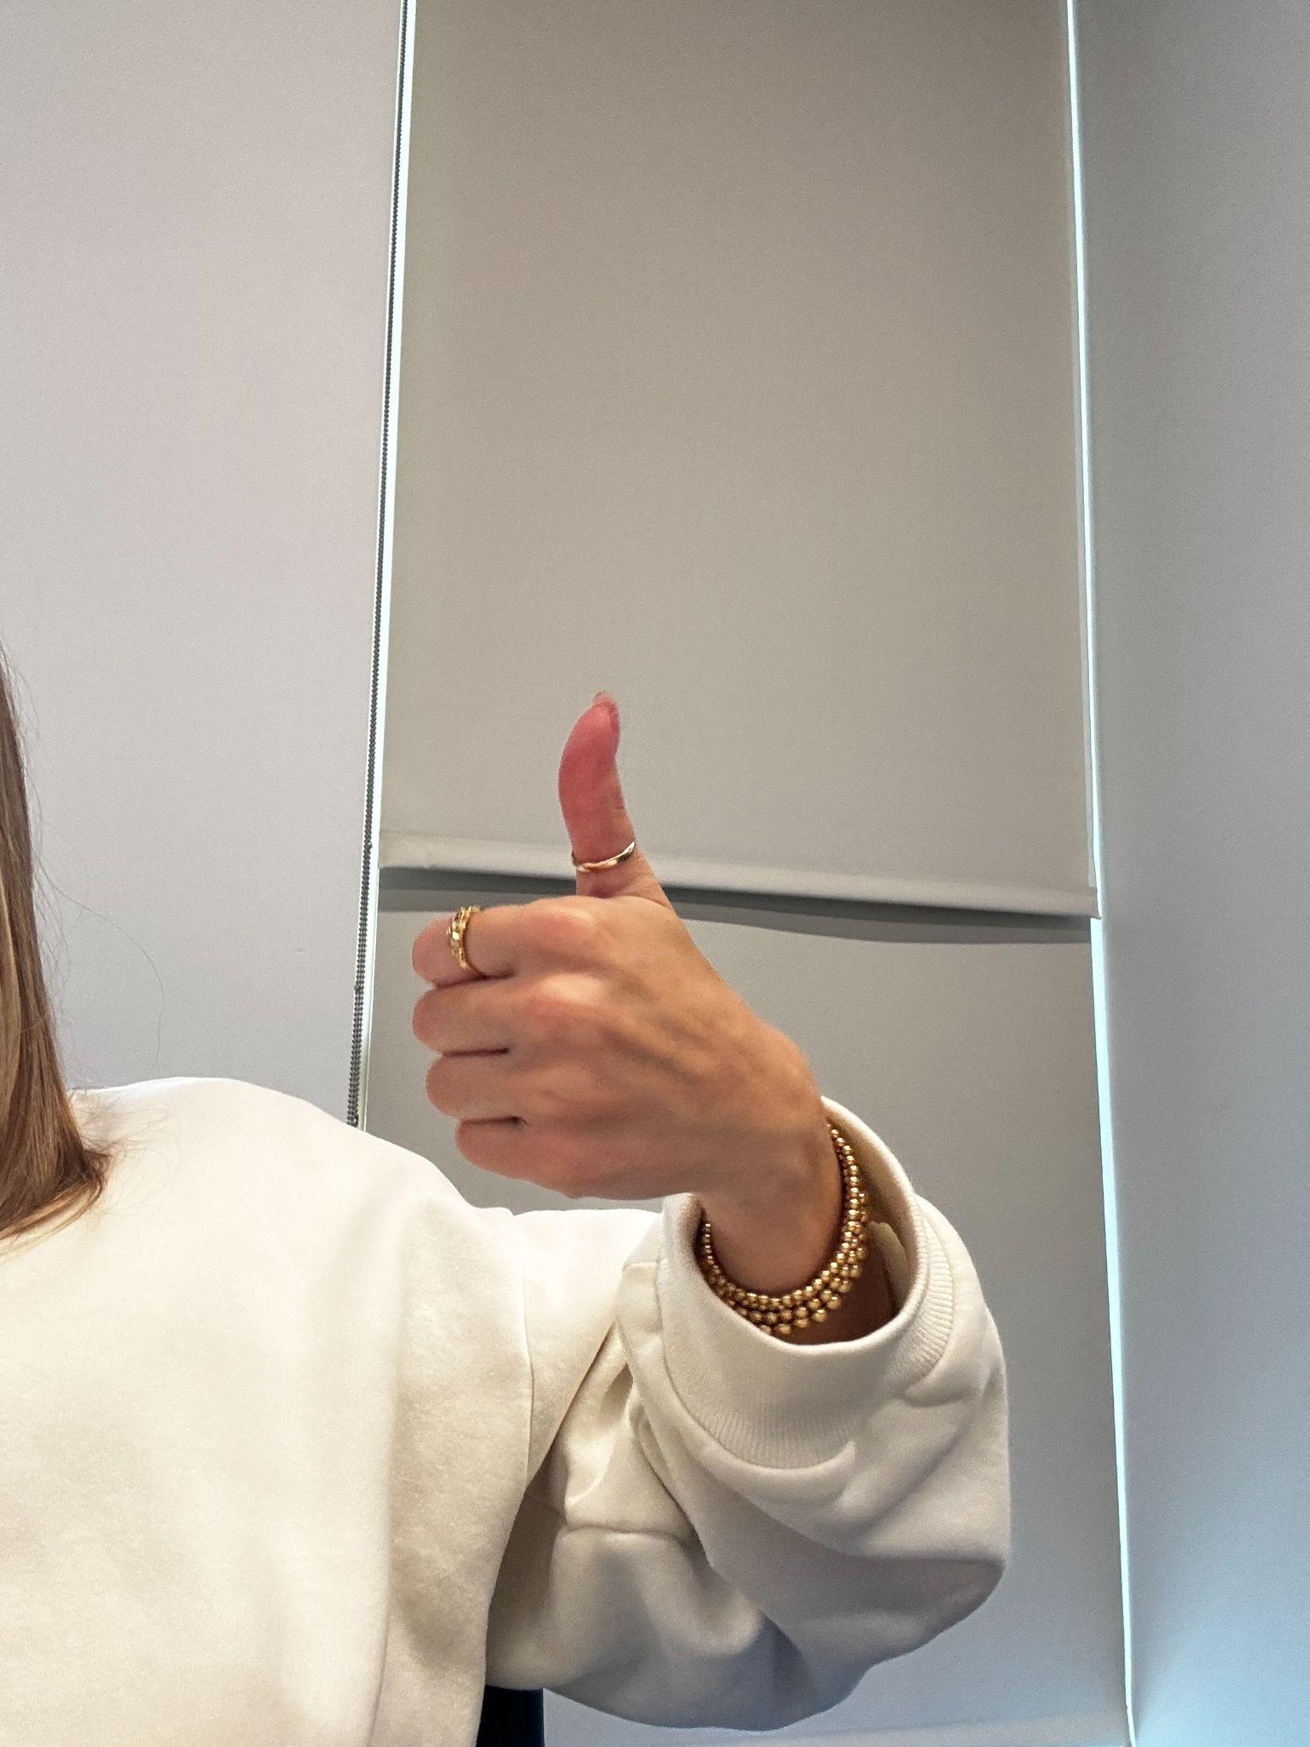  Thumbs up - Mark complete (step)
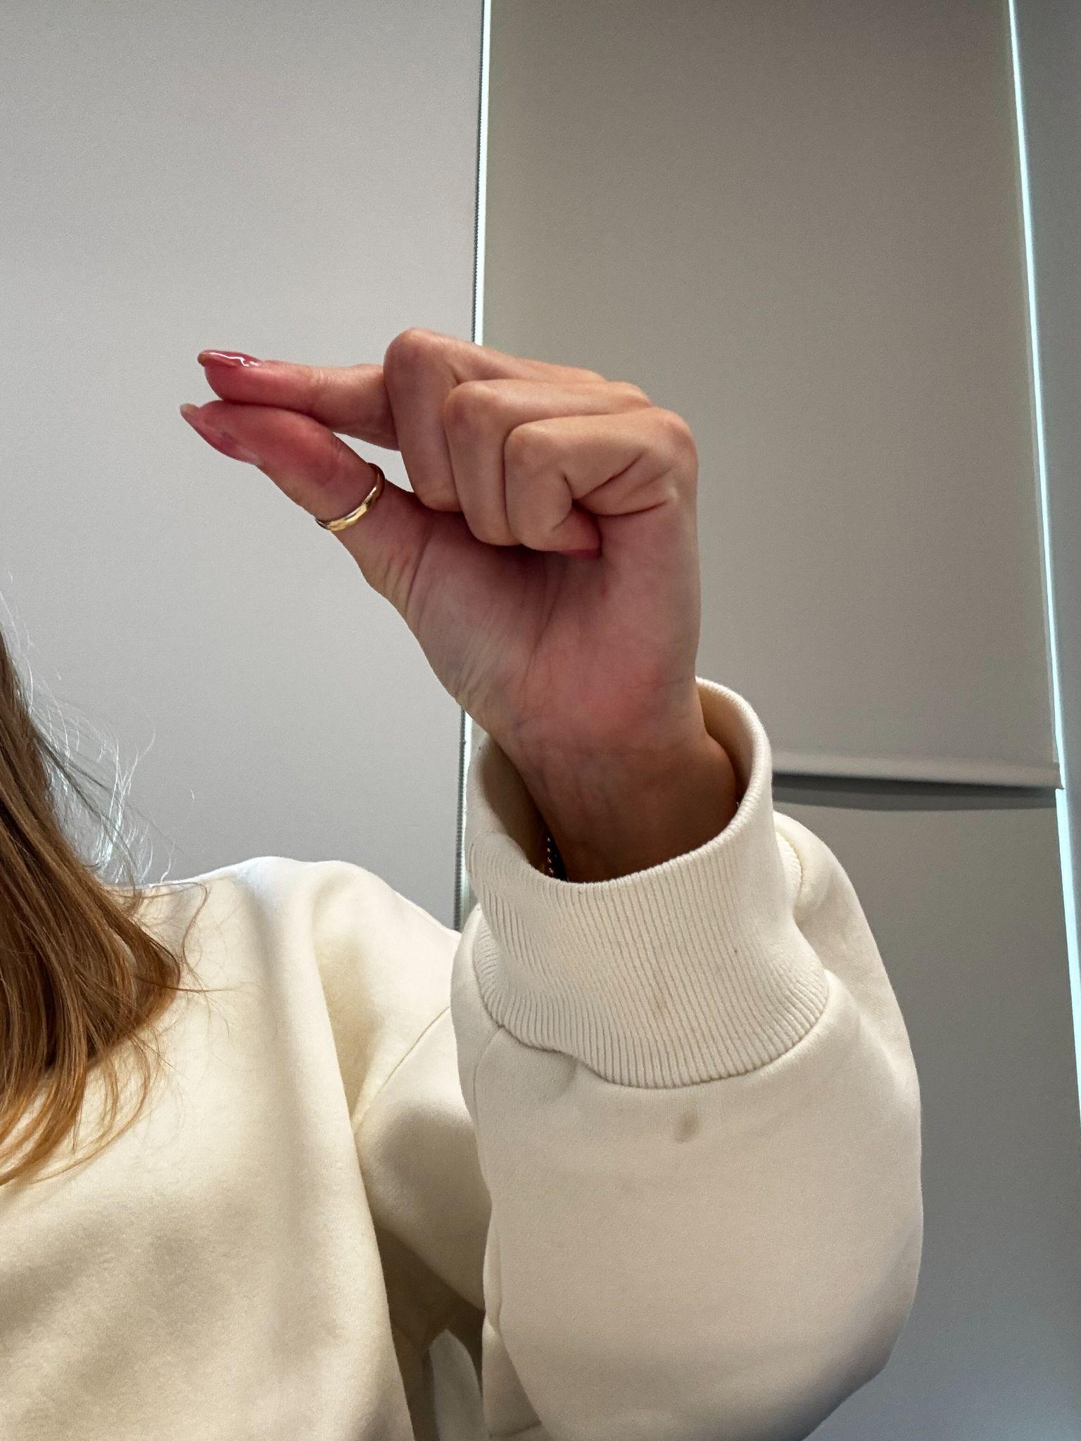  Scroll - pinch Up/down | 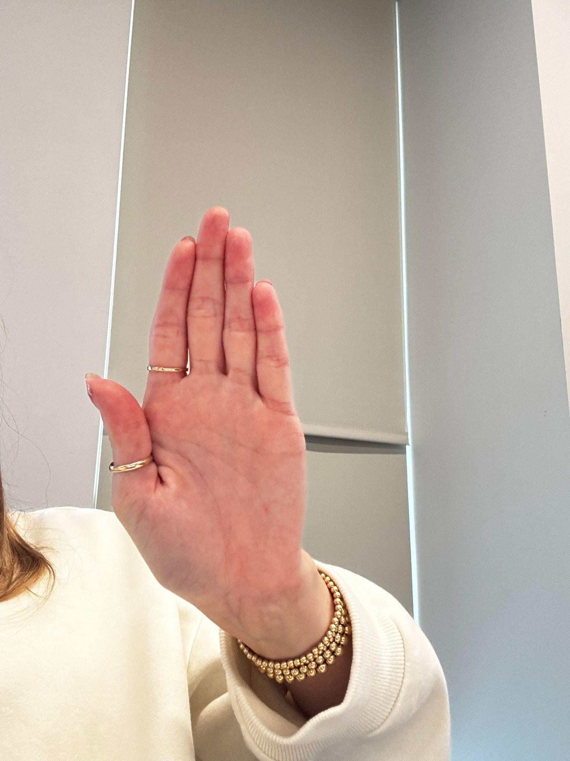  Palm - Start/stop reading

Mockups
Variation One - checks off the instructions on the website itself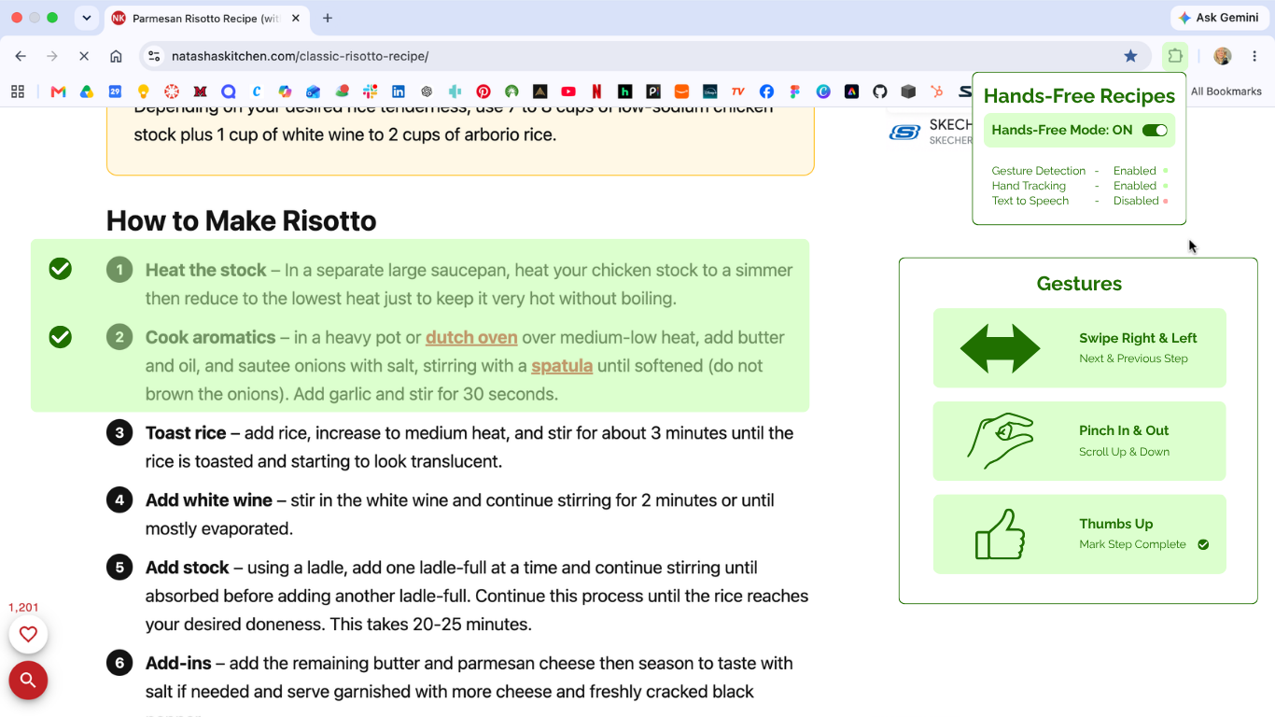

Variation Two - summarizes the sections for “flashcard” setup by headings
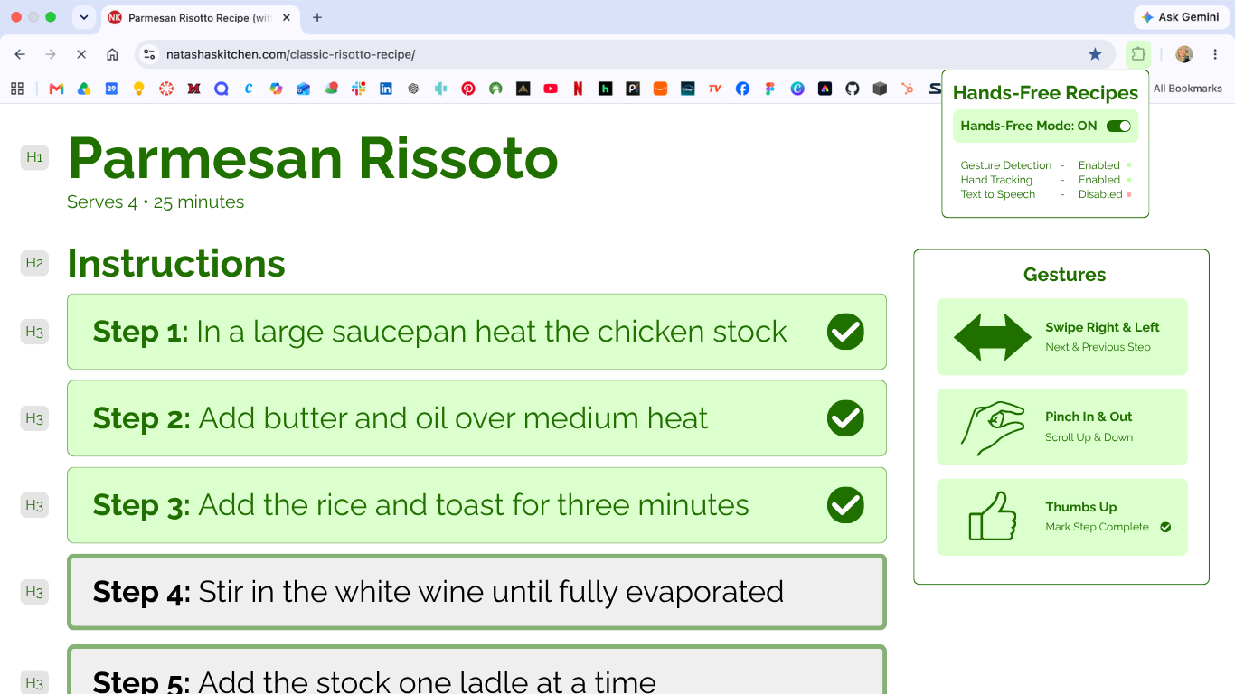

User Testing
Next Step | Previous Step
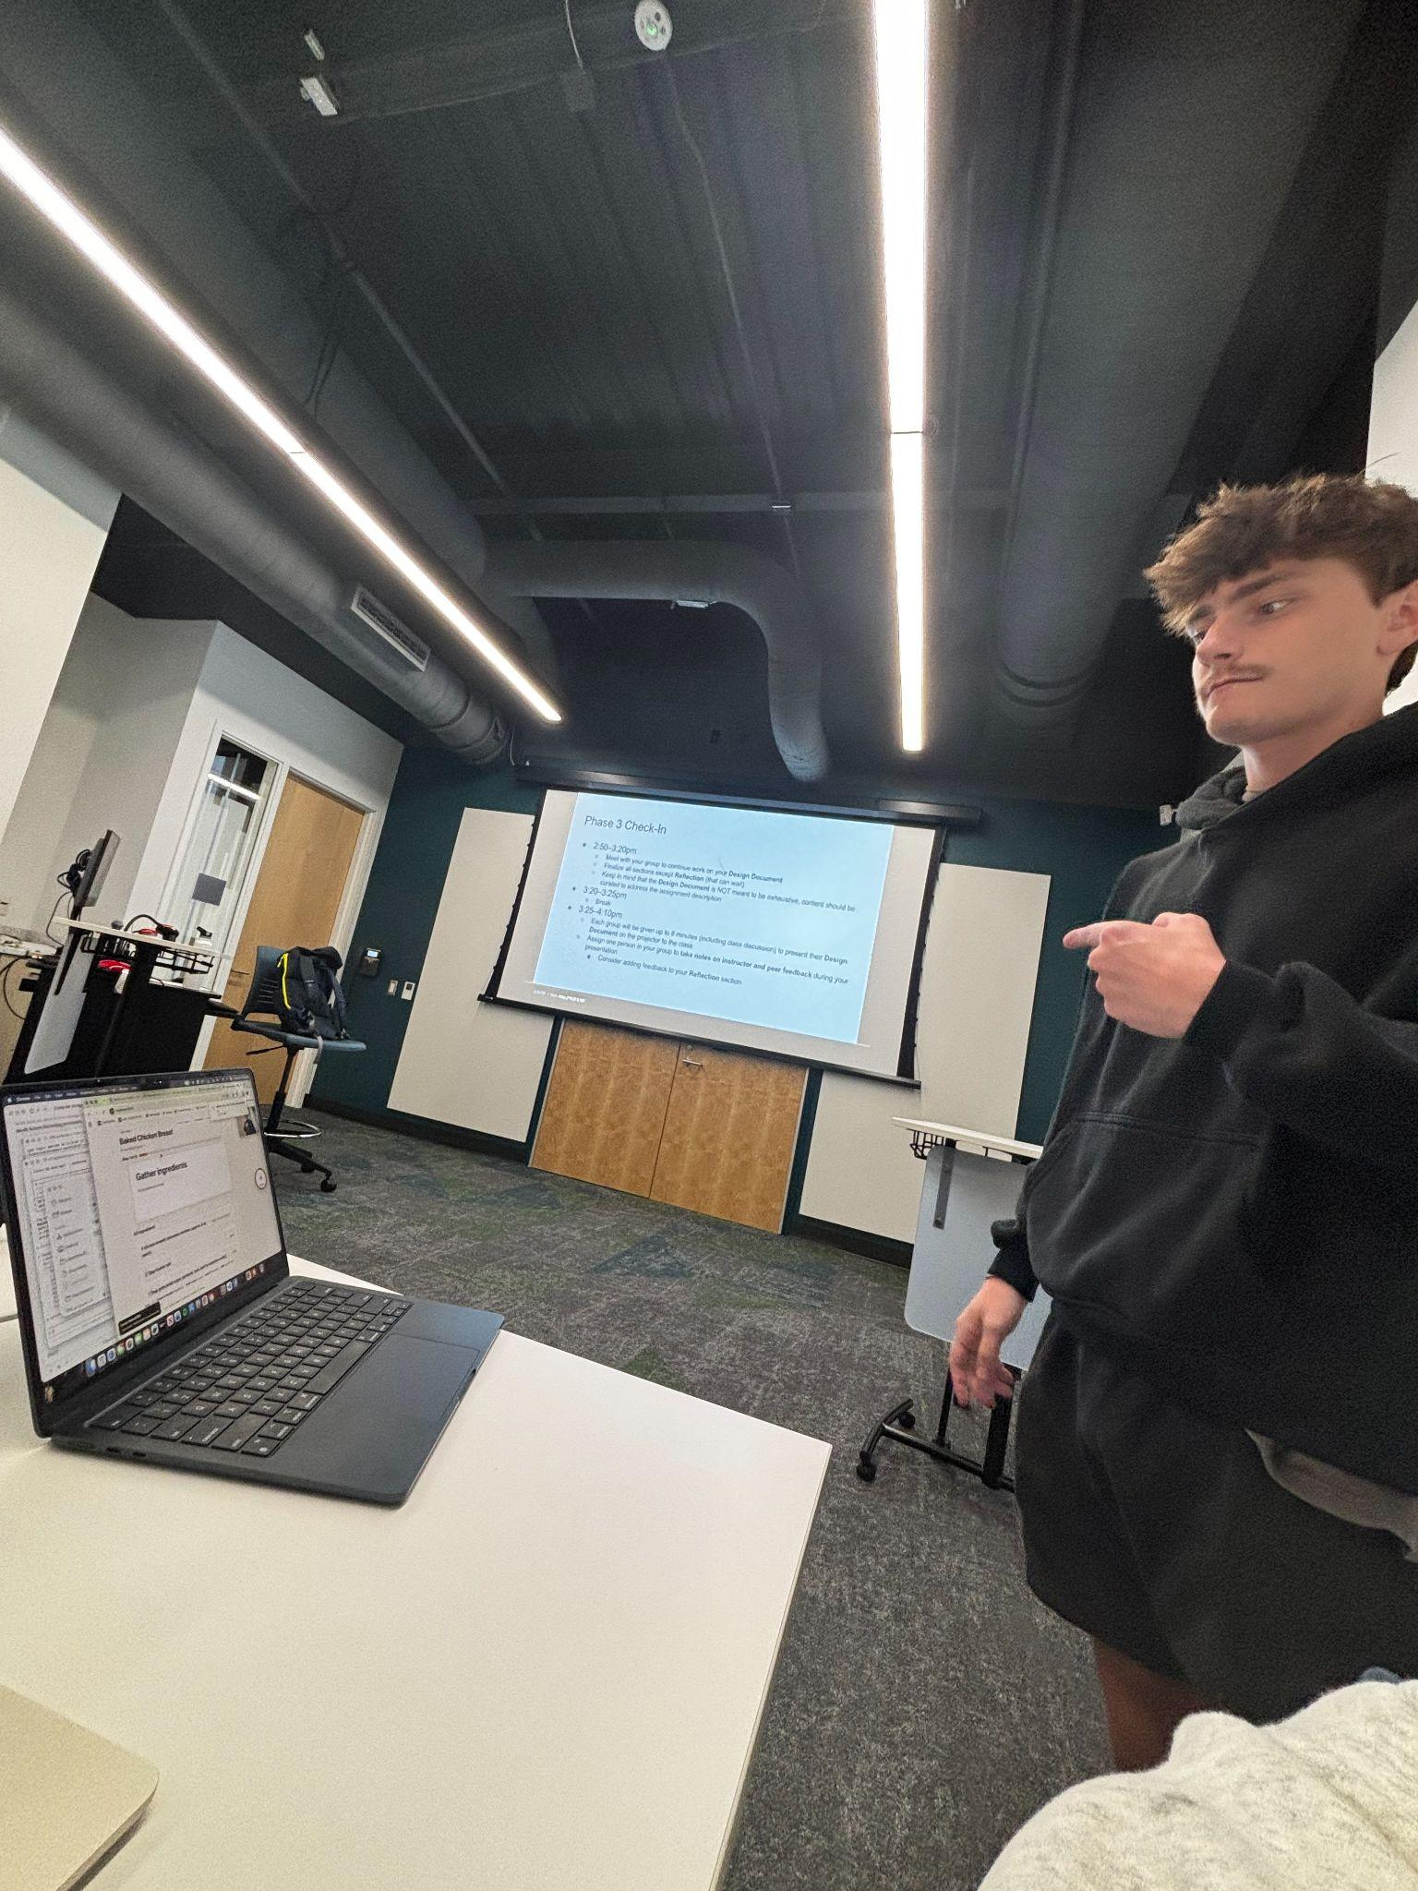 | 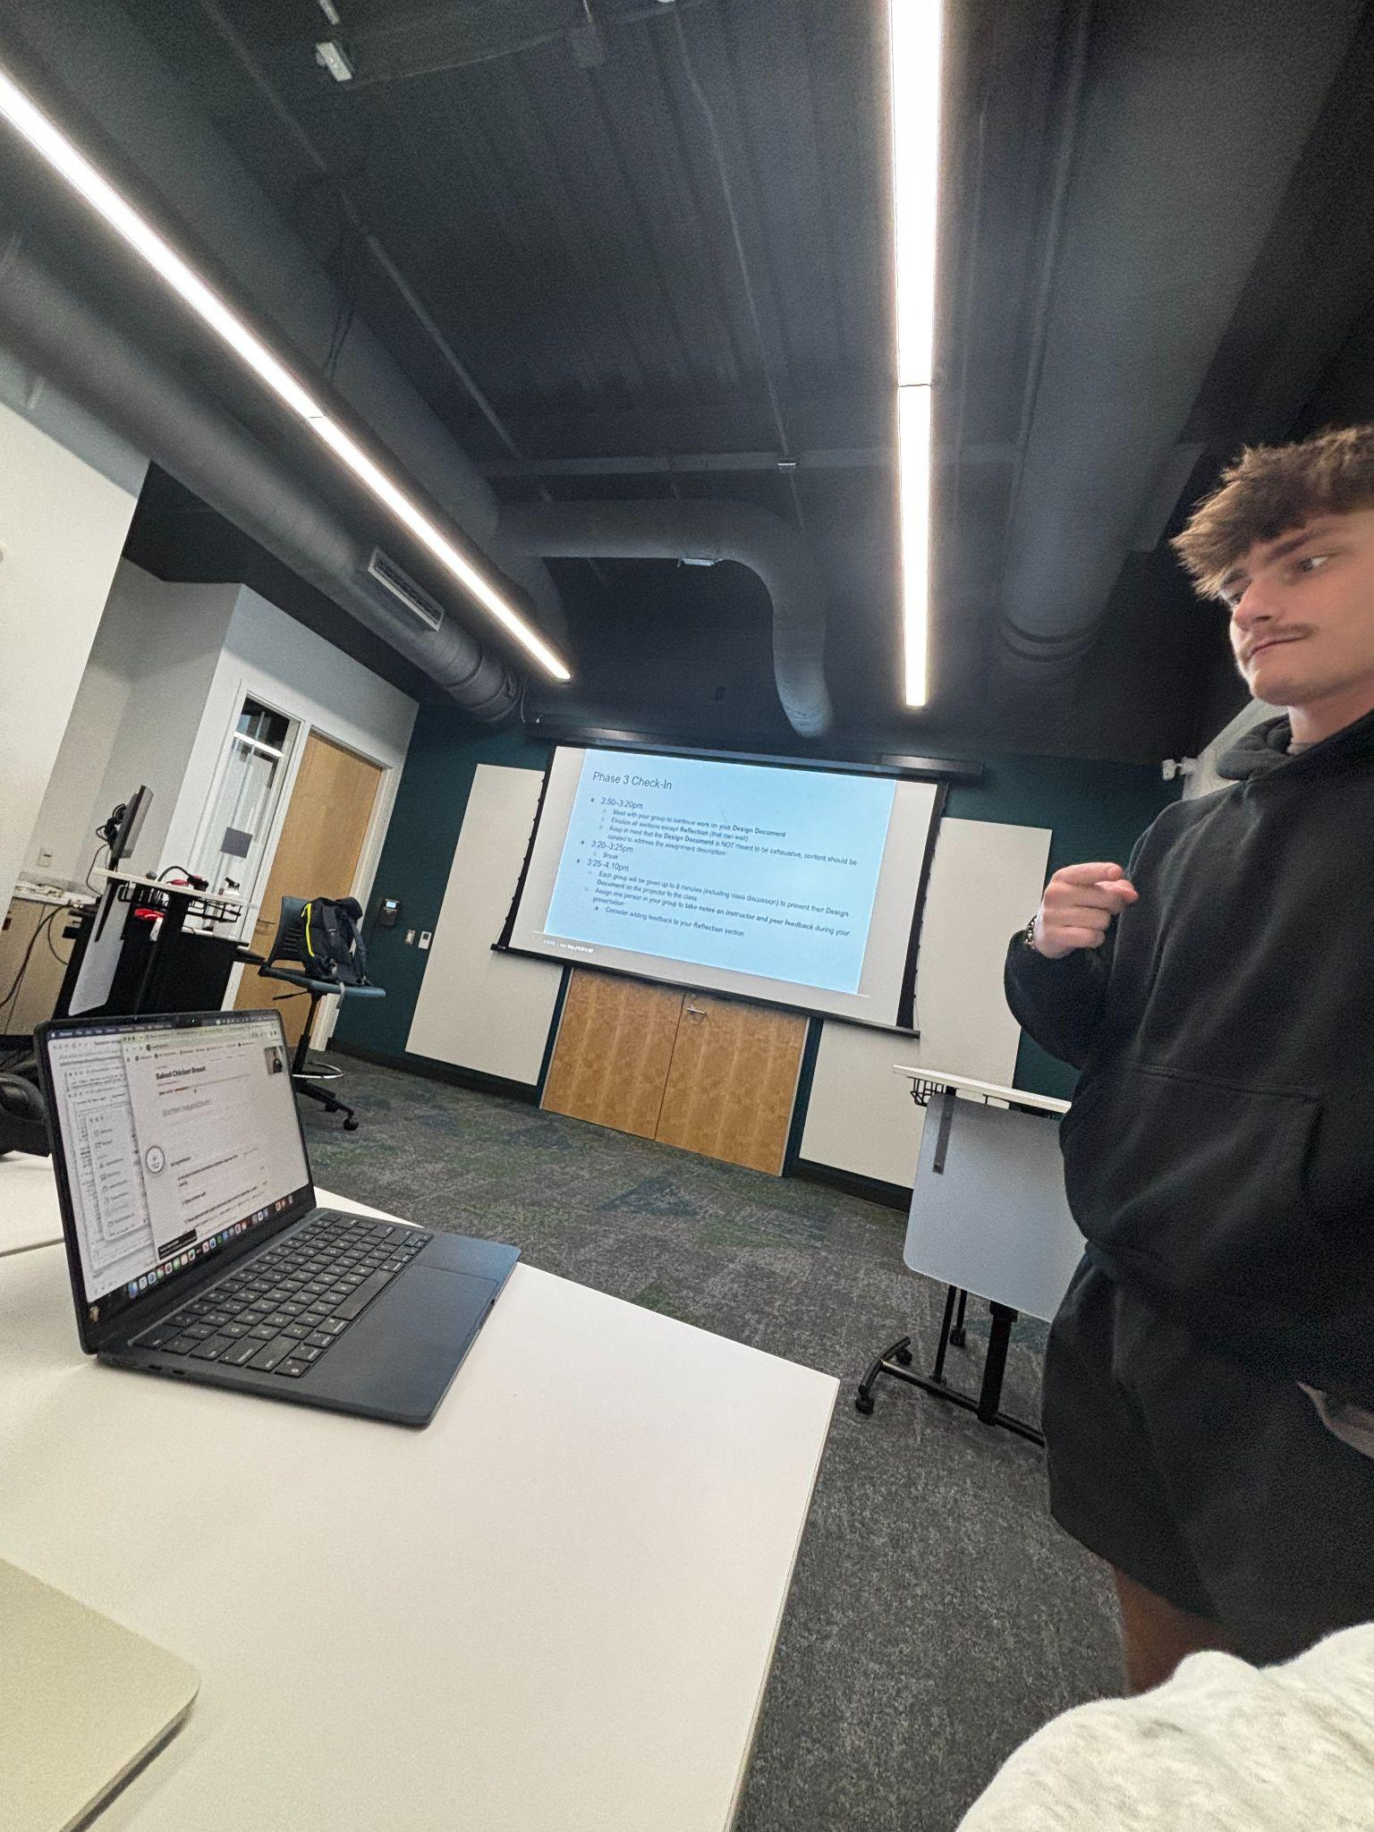

Class Feedback
- Neat project; for the sake of the project, it makes sense
- Extension idea is cool
- Work on when specifically
- Good how it gives the user feedback on if it's working
- Detect one hand
- Focus only on the left or right hand
  - Then will only listen to one hand
- Tried to scroll while we were making food (problematic for larger recipes)
- Work on intentionality - try to determine intentionality (cooking vs gesturing to navigate the setup)
- Display all the functionalities and gestures more
- Longer list of ingredients to show off the scrolling gesture more (can barely see with a short list)
- Gesture refinement

PHASE 4 - Refinement
Final Prototype
For our final prototype, we created a hands-free cookbook that allows users to navigate and progress through recipes through different hand gestures. It is very common to get your hands dirty with different ingredients while cooking. It can be aggravating and waste time to constantly wash your hands to navigate a recipe. Our goal for this project was to solve this by letting users navigate recipes hands-free.

In this phase, the team implemented recipes from WordPress through APIs. This expanded the usability by giving users a multitude of recipes, as opposed to the few previously coded in the prototype. Additionally, we refined the code to pick up one hand at a time. Previously, the prototype was reading both hands at the same time. This lead to unprompted navigation and confusion over a few gestures. The code has now been fixed to detect one hand at a time, even if both hands are on screen. Additionally, users can use either hand, accommodating both left- and right-handed people. Our last edit was changing the gestures from holding a fist on the left and right side, which represented next and previous steps. The gestures now are to point forward for the next step and backwards to navigate to the previous step. This made the gestures more intuitive to users and will allow them to memorize the gestures faster and easier.

Movement Catalog
 | 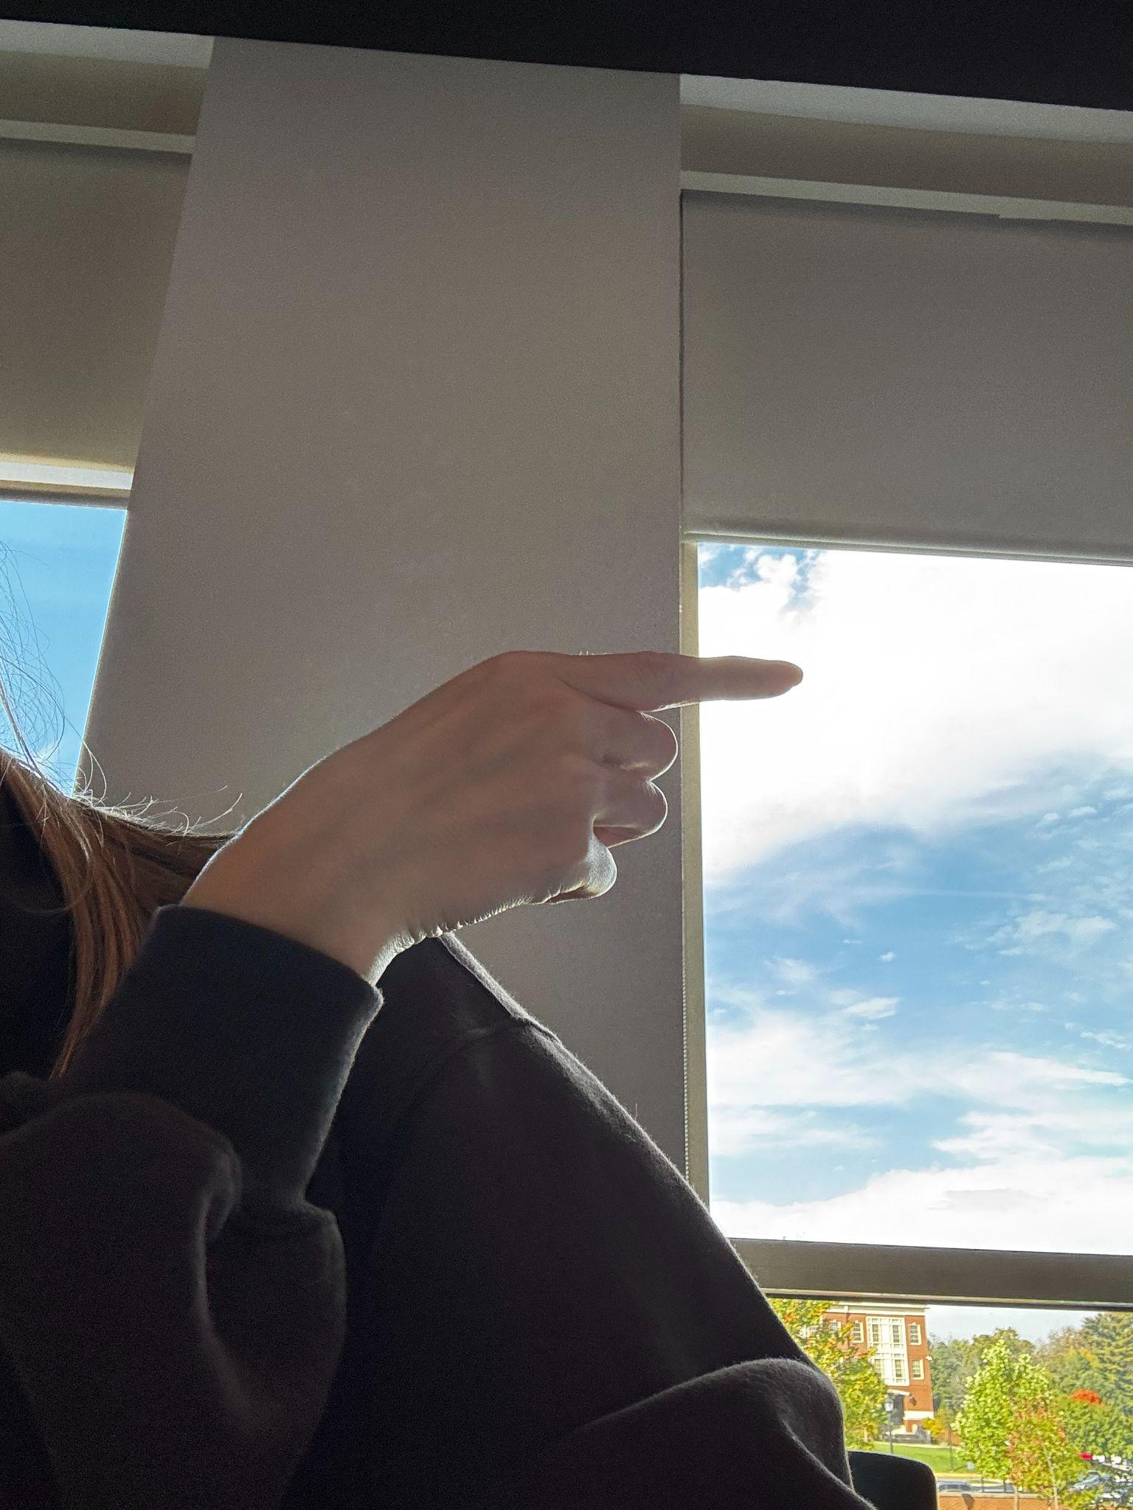 | 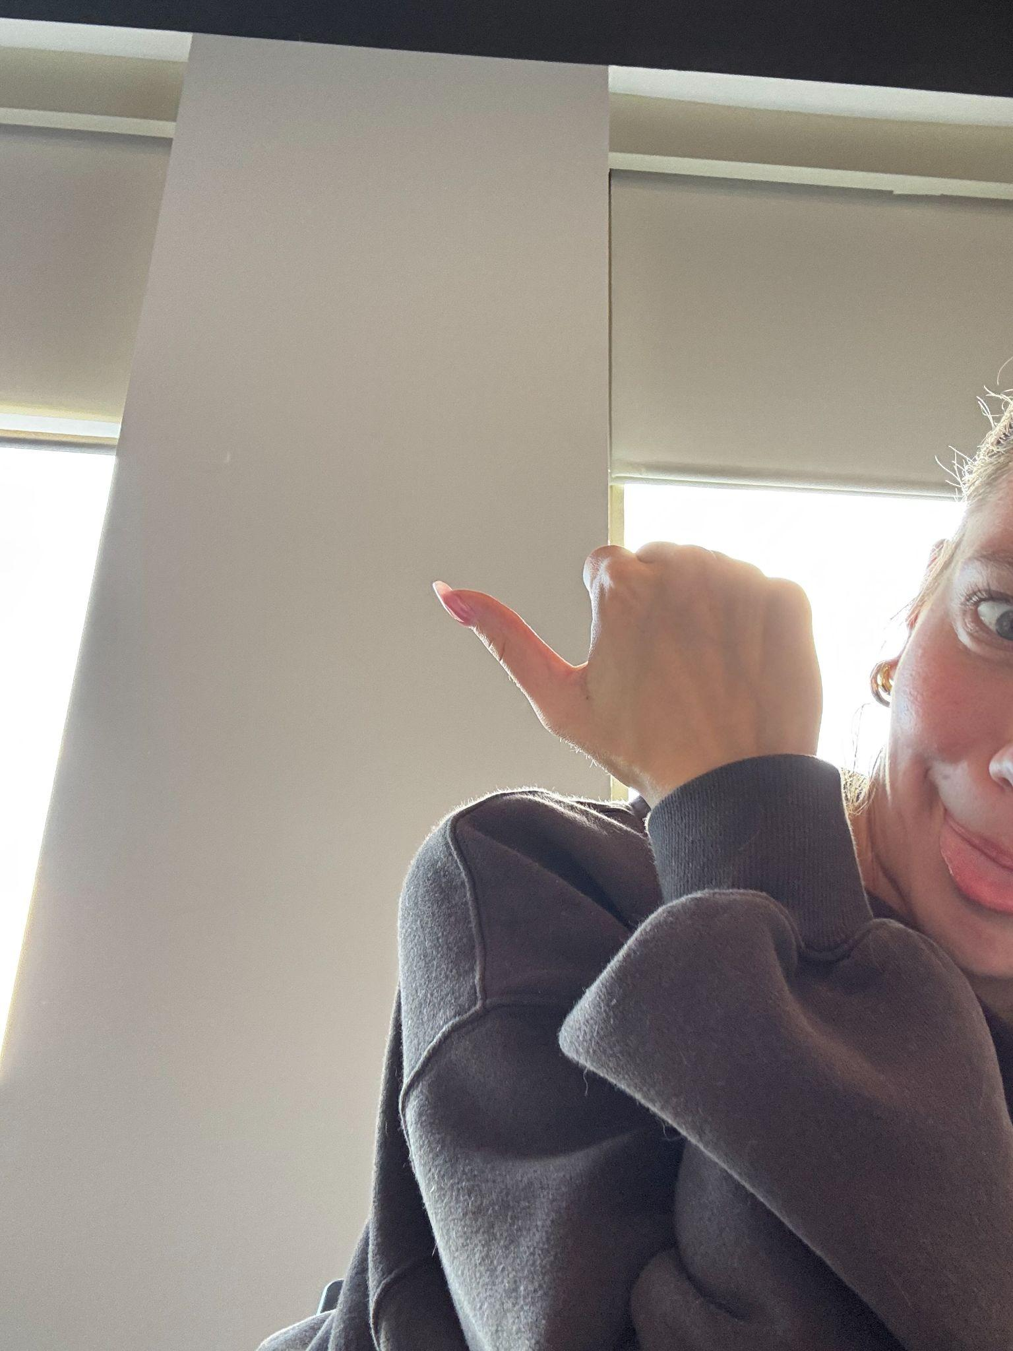
Fist  Holding up a fist in front of the camera will select the recipe. | Pointing Right  Pointing to the right will navigate the user to the next step. | Pointing Backwards  Pointing behind the user will navigate them to the previous step.
Thumbs Up  Holding a thumbs up will mark the step complete and move the user to the next step. | Palm  Making a palm will start and stop the screen reader for the user. | Pinch  Pinching two fingers together will allow the user to scroll through the website without touching the computer.

User Interface
Recipe Selection | Recipe Instructions

V2 Adds
Pulls from - https://www.budgetbytes.com/
- Runs on WordPress for easy browser pulling

Node Fetch - downloads the data from the site
Sends to WordPress API - gets the images, ingredients and steps.
Cheerio - Opens each recipe and condensed and reads steps
Parse - divides long steps and ingredients

Added dashboard of recipes + search
Dashboard nav needs improved
Changed holding hand gestures to a point
Added camera pause

Class Feedback
- Gestures at the bottom are hard to read; possibly make them a bit bigger
  - Legible but also out of the way, not distracting (people would learn the gestures over time)
- Holding hands transition to point forward and backward
  - Good change; it is more intuitive
  - Pointing has universal meaning behind it
- Marking the step done is a good feature, especially for new recipes
- Eric wants it to communicate with only one hand
  - Works fine that way already
- Using WordPress API is cool

PHASE 5 - Reflection
Written Component

