How Medications and Medication Regimens relate to Patient Mortality
Rebecca Basta and Riley Herber
The structure below is one possible setup for a manuscript stemming from a data analysis project. It loosely follows the structure of a standard scientific manuscript. Adjust as needed. You don’t need to have exactly these sections, but the content covering those sections should be addressed.
This uses MS Word as output format. See the Quarto documentation for instructions on how to use other formats.
Warning: package 'here' was built under R version 4.4.3
Warning: package 'knitr' was built under R version 4.4.3
Authors
- Rebecca Basta and Riley Herber These authors contributed equally to this work.
Author affiliations
- University of Georgia, Athens, GA, USA.

1. Summary/Abstract
Write a summary of your project.
It is recommended to use a structured abstract with Background/Methods/Results/Discussion sections.

2. Introduction
This information is important because it can help healthcare providers better understand the effects of commonly prescribed medications on patient survival. Identifying medications that are associated with improved or worsened outcomes may guide clinical decision-making, optimize treatment strategies, and ultimately improve patient care and safety.

2.1 General Background Information
Provide enough background on your topic that others can understand the why and how of your analysis

2.2 Description of data and data source
We are interested in using the MIMIC-IV dataset to explore the relationships between patient medication use, health outcomes, and mortality at Beth Israel Deaconess Medical Center in Boston, MA. MIMIC-IV contains data for over 65,000 patients admitted to an ICU and over 200,000 patients admitted to the emergency department. Variables within this database include, but are not limited to, hospital admissions, intra-hospital transfers, laboratory measurements, microbiology cultures, provider orders, medication administration records, medication prescriptions, hospital billing information, and mortality outcomes.

2.3 Questions/Hypotheses to be addressed
Our primary objective is to examine how different medications and medication regimens relate to patient mortality. This may include analyzing whether certain medications or combinations of medications are associated with higher or lower mortality rates. To analyze the relationship between medication, use and mortality in the MIMIC-IV dataset, we would first clean and organize medication and outcome data. We would then explore general patterns by comparing mortality rates across patients who received different medications or groups of medications. Simple summaries and visualizations could be used to identify trends or potential associations. This exploratory analysis would help generate initial insights and guide more detailed analyses later on.

3. Methods
This study uses the MIMIC-IV (Medical Information Mart for Intensive Care, version IV) database to examine the relationship between medication use and 30-day mortality in hospitalized patients. All data processing and analysis was conducted in R. Full cleaning and wrangling code is documented in code/processing-code/mimic-processing.qmd and exploratory analysis code is in code/eda-code/mimic-eda.qmd.

3.1 Data acquisition
Data were obtained from the MIMIC-IV database (v3.1), an available de-identified electronic health records database from Beth Israel Deaconess Medical Center, available via PhysioNet. Please see README file in the raw-data folder to get more information on how to gain access to the database. Access requires completion of a data use agreement and credentialing through PhysioNet. The following tables from the hosp module were used:
- patients.csv — patient demographics including gender, age, and date of death
- admissions.csv — hospital admission and discharge records
- prescriptions.csv — medication orders per admission

3.2 Data import and cleaning
Raw CSV files were loaded into R and cleaned as follows. Admissions with a length of stay less than 0 or greater than 365 days were removed as likely data entry errors. Medication drug names were standardized to uppercase and stripped of extra whitespace. Drugs were then assigned to one of 13 broad pharmacological classes (e.g. antibiotics, opioids, vasopressors) using keyword matching. For each admission, a binary indicator was created for each medication class indicating whether at least one drug from that class was prescribed during the stay. Full details of all cleaning steps are documented in code/processing-code/mimic-processing.qmd.

3.3 Statistical analysis
This report presents unadjusted exploratory analyses. Mortality rates are compared across medication classes, age groups, and gender using summary tables and visualizations.

4. Results

4.1 Exploratory/Descriptive analysis
library(here)
knitr::include_graphics(here("results", "figures", "day-30-mortality.png"))
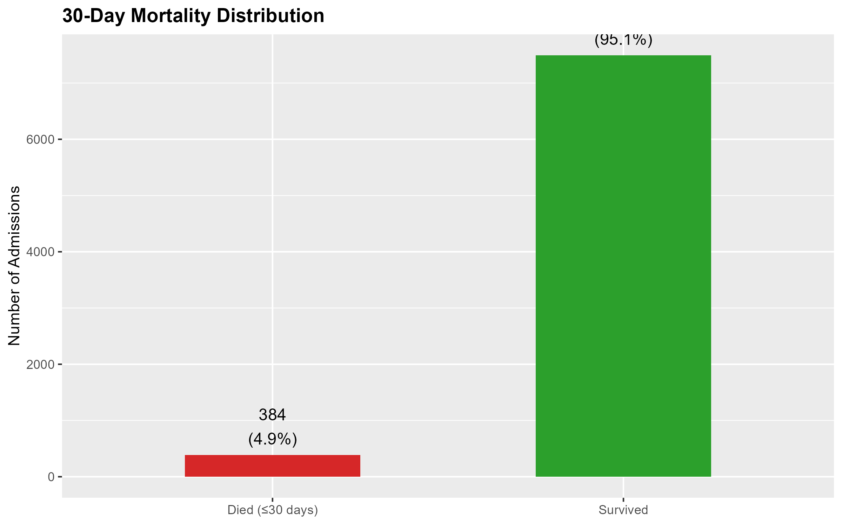
Figure 1: 30-Day Mortality Distribution
Figure 1 shows that 30-day mortality is low in this cohort, there are about 1 in 20 admissions that resulted in death within 30 days.
knitr::include_graphics(here("results", "figures", "age-distribution-mortality.png"))
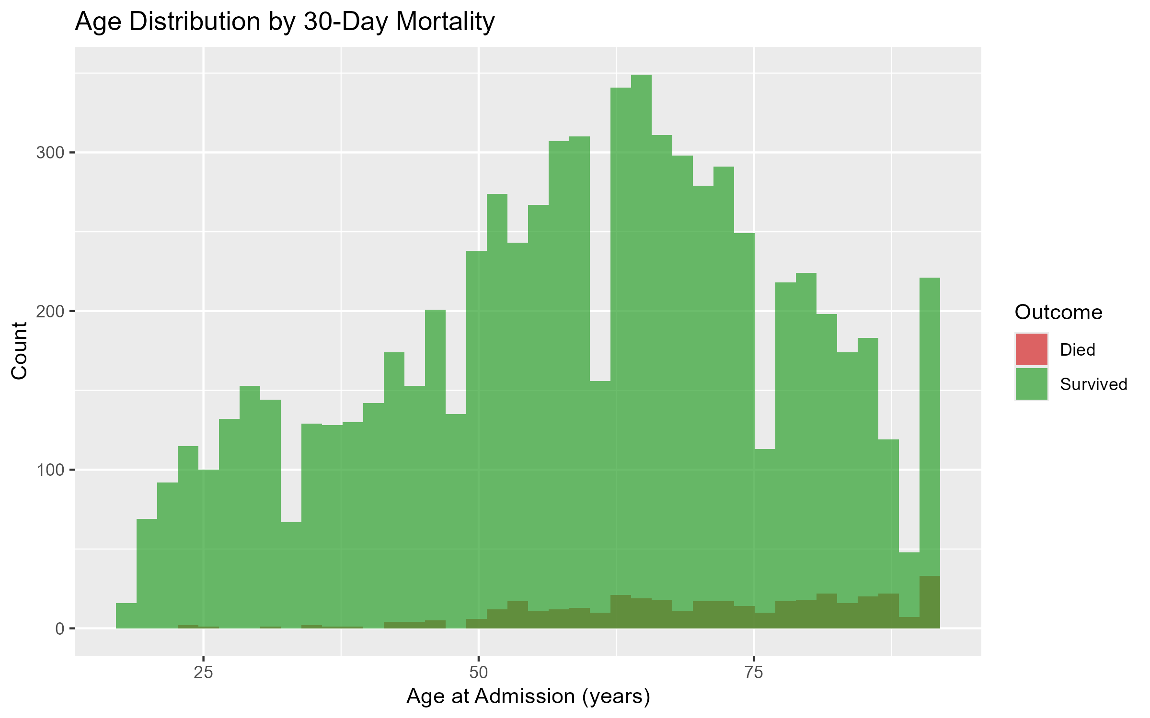
Figure 2: Age distribution by 30-day mortality
Figure 2 shows that most people in this study are in the age range of 50-75.
knitr::include_graphics(here("results", "figures", "mortality_by_age.png"))
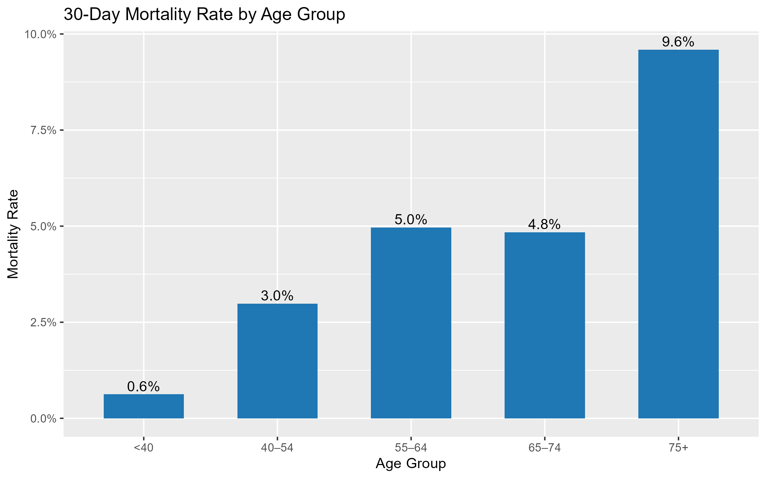
Figure 3: 30-day mortality rate by age group
Figure 3 shows that 30 day mortality increased as the age group increased, with the highest mortality rate in the 75+ group.
Table 1: 30-day mortality rate by gender
gender | n | deaths | mort_rate
F | 4057 | 173 | 0.0426423
M | 3818 | 211 | 0.0552645

?@fig-med-frequency shows hows that many particpants used cardiovascular and anticoagulations medicine. The highest used medications were anticoagulants and opioids.
knitr::include_graphics(here("results", "figures", "unadjusted-perscriptoin-frequency.png"))
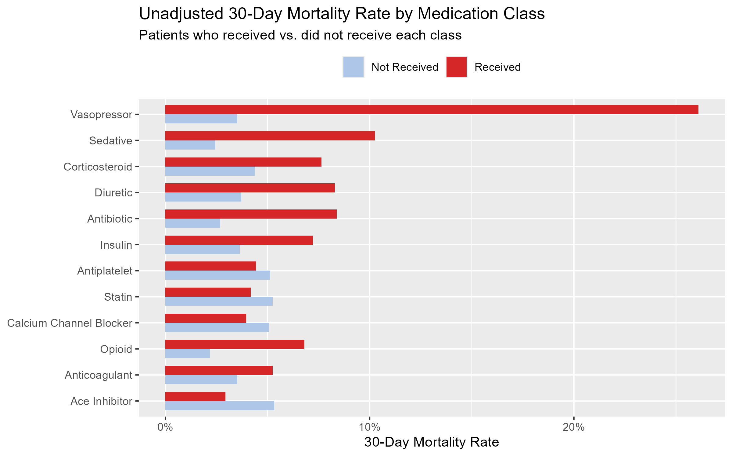
Figure 4: 30-day mortality rate by medication class (unadjusted)
Figure 4 suggests that patients who received vasopressors had the highest 30-day mortality rate, followed by opioids. In contrast, patients receiving ACE inhibitors, statins, and calcium channel blockers had lower mortality rates than those who did not receive them, likely reflecting their use in more stable patients. These associations are unadjusted and largely reflect disease severity rather than direct drug effects. Sicker patients tend to receive more aggressive medications and have worse outcomes.
Table 2
received | n | deaths | med_class | mort_rate
Not Received | 4984 | 256 | Antiplatelet | 0.0513644
Received | 2891 | 128 | Antiplatelet | 0.0442753
Not Received | 1714 | 60 | Anticoagulant | 0.0350058
Received | 6161 | 324 | Anticoagulant | 0.0525889
Not Received | 6408 | 341 | Ace Inhibitor | 0.0532147
Received | 1467 | 43 | Ace Inhibitor | 0.0293115
Not Received | 6510 | 330 | Calcium Channel Blocker | 0.0506912
Received | 1365 | 54 | Calcium Channel Blocker | 0.0395604
Not Received | 5873 | 218 | Diuretic | 0.0371190
Received | 2002 | 166 | Diuretic | 0.0829171
Not Received | 4845 | 130 | Antibiotic | 0.0268318
Received | 3030 | 254 | Antibiotic | 0.0838284
Not Received | 5159 | 188 | Insulin | 0.0364412
Received | 2716 | 196 | Insulin | 0.0721649
Not Received | 3271 | 71 | Opioid | 0.0217059
Received | 4604 | 313 | Opioid | 0.0679844
Not Received | 7396 | 259 | Vasopressor | 0.0350189
Received | 479 | 125 | Vasopressor | 0.2609603
Not Received | 5427 | 133 | Sedative | 0.0245071
Received | 2448 | 251 | Sedative | 0.1025327
Not Received | 6659 | 291 | Corticosteroid | 0.0437003
Received | 1216 | 93 | Corticosteroid | 0.0764803
Not Received | 5077 | 267 | Statin | 0.0525901
Received | 2798 | 117 | Statin | 0.0418156

tbl-med-mortality-summary shows mortality rates were higher with patients taking vasopressors, sedatives, and diruetics; this could be because the severity of their illness.
knitr::include_graphics(here("results", "figures", "polypharmacy-frequency.png"))
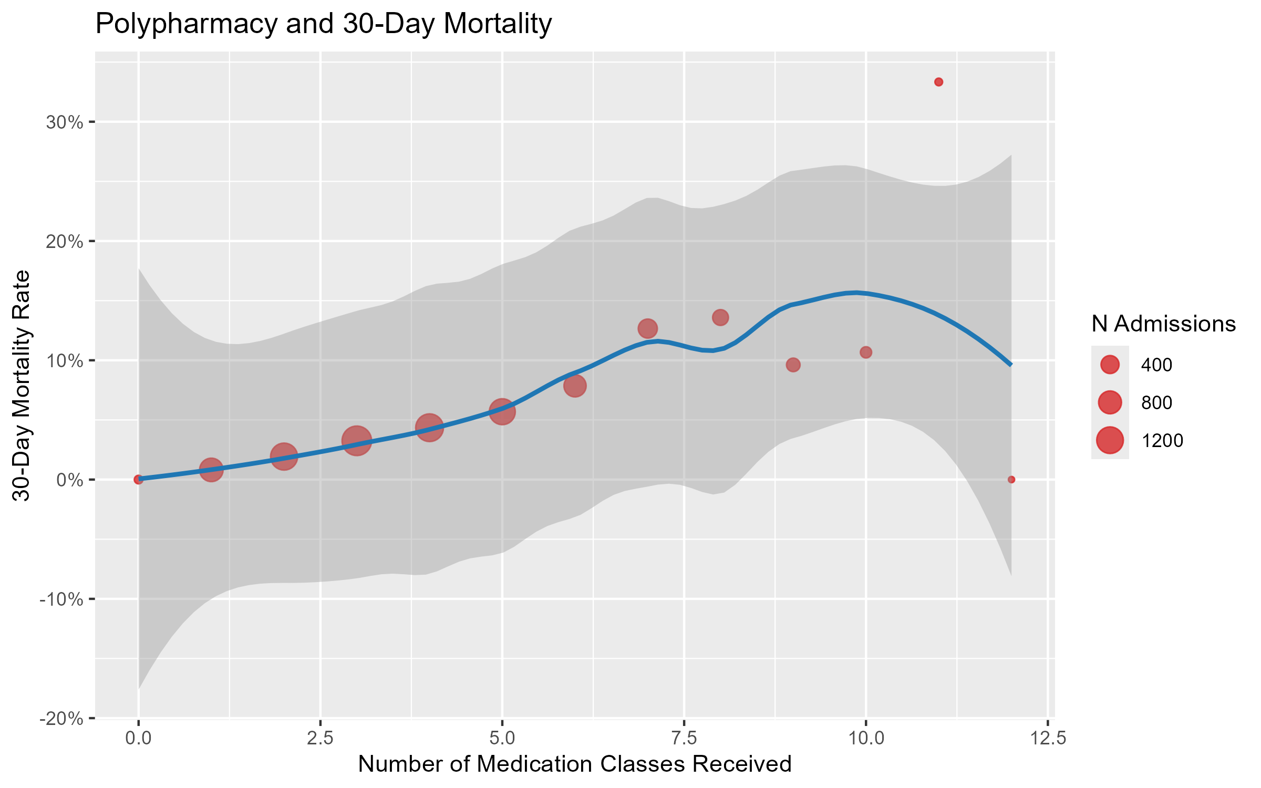
Figure 5: Number of medication classes received vs. 30-day mortality
Figure 5 shows mortality increased as the number of medications increased, this also could be explained by the increasing severity of illness as more medications were needed.

4.2 Basic statistical analysis
To get some further insight into your data, if reasonable you could compute simple statistics (e.g. simple models with 1 predictor) to look for associations between your outcome(s) and each individual predictor variable. Though note that unless you pre-specified the outcome and main exposure, any “p<0.05 means statistical significance” interpretation is not valid.
?@fig-result shows a scatterplot figure produced by one of the R scripts.

4.3 Full analysis
Use one or several suitable statistical/machine learning methods to analyze your data and to produce meaningful figures, tables, etc. This might again be code that is best placed in one or several separate R scripts that need to be well documented. You want the code to produce figures and data ready for display as tables, and save those. Then you load them here.

5. Discussion

5.1 Summary and Interpretation
Summarize what you did, what you found and what it means.

5.2 Strengths and Limitations
Discuss what you perceive as strengths and limitations of your analysis.

5.3 Conclusions
What are the main take-home messages?
Include citations in your Qmd file using BibTeX, the list of references will automatically be placed at the end
This paper (1) discusses types of analyses.
These papers (2,3) are good examples of papers published using a fully reproducible setup similar to the one shown in this template.
Note that this cited reference will show up at the end of the document, the reference formatting is determined by the CSL file specified in the YAML header. Many more style files for almost any journal are available. You also specify the location of your BibTeX reference file in the YAML. You can call your reference file anything you like.

6. References
1. Leek JT, Peng RD. Statistics. What is the question? Science (New York, N.Y.). 2015;347(6228):1314–1315.
2. McKay B, Ebell M, Billings WZ, et al. Associations Between Relative Viral Load at Diagnosis and Influenza A Symptoms and Recovery. Open forum infectious diseases. 2020;7(11):ofaa494.
3. McKay B, Ebell M, Dale AP, et al. Virulence-mediated infectiousness and activity trade-offs and their impact on transmission potential of influenza patients. Proceedings. Biological sciences. 2020;287(1927):20200496.

