Jace Riley

Randal Root

IT FDN 100 A

11/12/19

**To Do List 2 Script**

**Introduction**

This week’s assignment was the most fun by far. It was fun for multiple reasons. It required a bit of skill and understanding of the order of code as well as organization. Additionally, it required me to think outside of the box that I am normally in when I code. I had to take what I know and apply it to existing code and update functions.

**Creating and Running the Code**

The first step I took was to become familiar with the code. I knew that it was going to be similar to last weeks assignment but to update a more robust code and add it into functions. Functions are a part of coding that I have kind of avoided thus far in my professional coding. One reason for this is because I haven’t really needed to create functions, but also because they were a little confusing for me. While becoming familiar with this code, it helped me improve my knowledge by essentially grabbing what code was already there to update the To Do File, and place it into functions. Once I figured this out it was a pretty quick job getting through each of the functions.

Once I was done going through the code and adding the new functions, I organized the code though notes and descriptions of what the functions were doing. This is helpful when utilizing a program like PyCharm that reads through your class and gives hints.

A couple things that I changed in the original code was instead of lstTable, I changed it to list_of_rows. I also change FileProcessor to Processor.

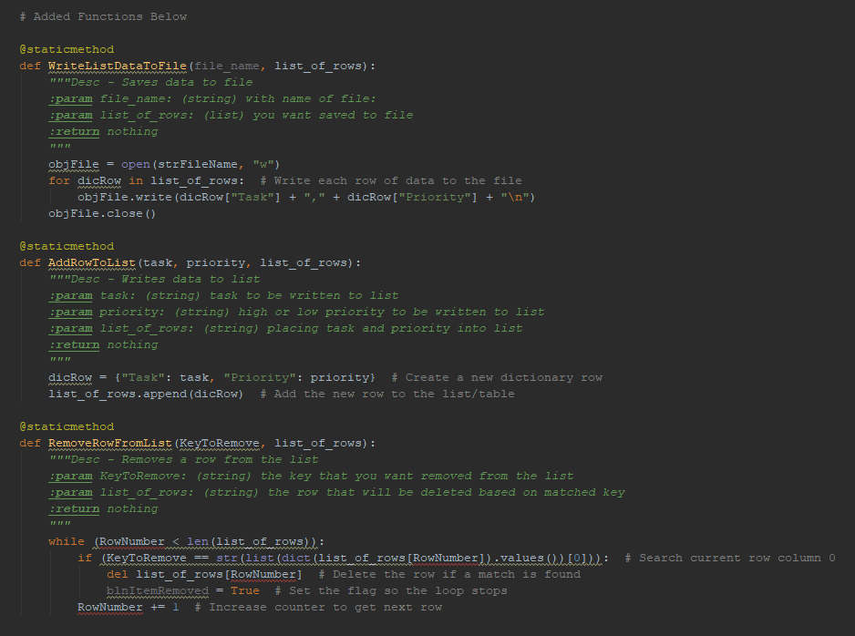

Figure 1: Added Processing Functions

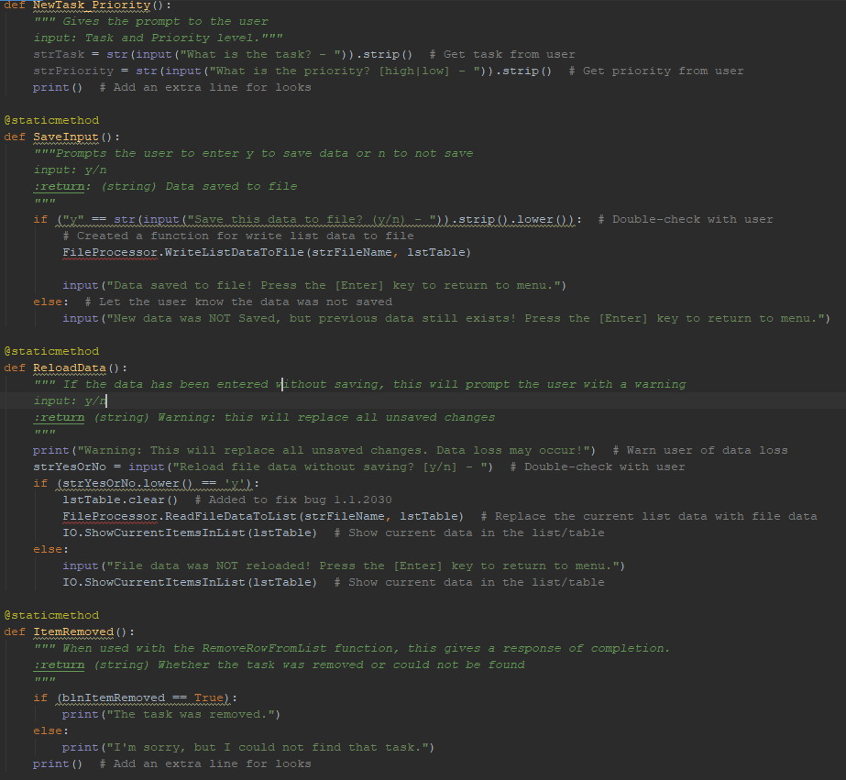

Figure 2: Added IO Functions

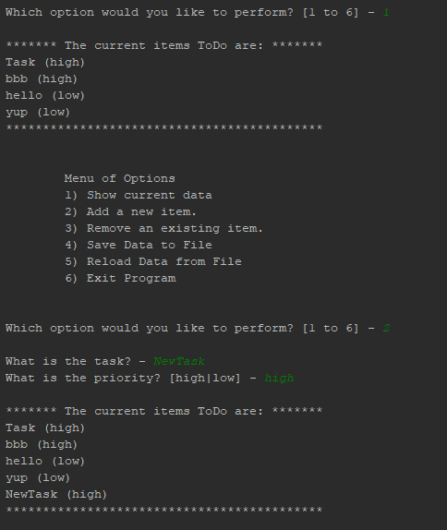

Figure 3: Options one and two - listing current items and adding an item.

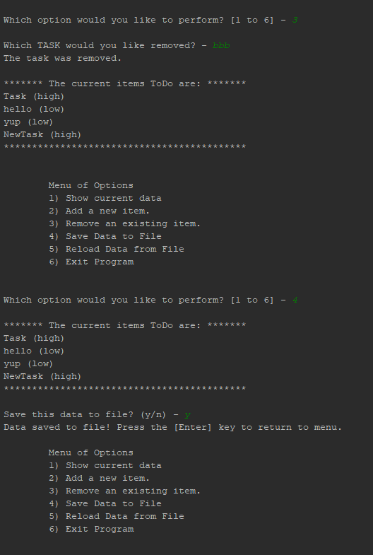

Figure 4: Options three and four - Removing bbb and saving data to file with prompt.

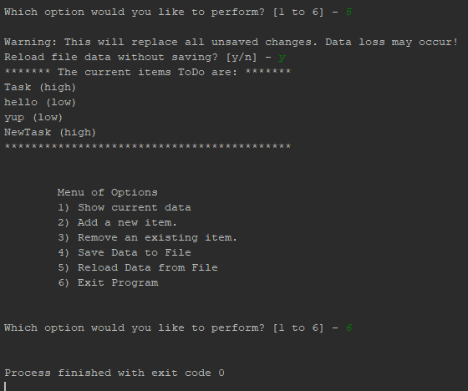

Figure 5: Options five and six

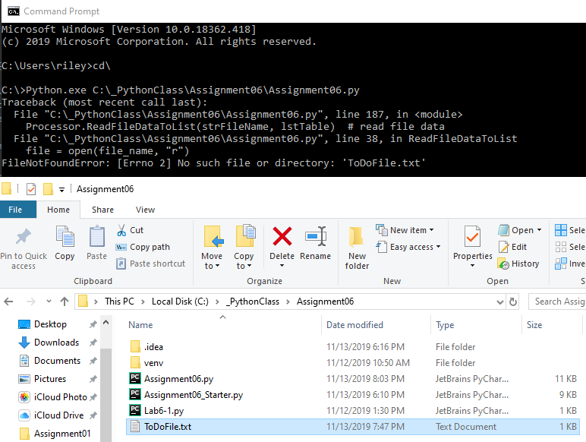

Figure 6. would not run in Command Prompt because it could not find ToDoList.txt file in directory, this is the result of being a relative path within PyCharm. If I made ToDoList an actual file path it would work instead of in a project within PyCharm.

**Summary**

This was my favorite assignment thus far due to the requirement to handle organization in the main body of the code in relation to the functions that were being created. This was a great exercise for learning how to create functions and to utilize them in future scripts. It brings a new addition to what coding can do for you in the terms of automation.