Jace Riley

Randal Root

IT FDN 100 A

11/6/19

**To Do List Script**

**Introduction**

This week proved to be a little more difficult than previous assignments. I found it difficult due to the utilizing of a starter script. Had I done it from scratch it would have fit my style a little more. This however allowed for me to learn things that I would not have otherwise. It taught me a little more on how to handle the organization of a program. In addition to this I did not have to focus on the notes as much as that task was pretty well taken care of.

**Creating and Running the Code**

The first step I took was to become familiar with the code. I had not in the past declared all variables as blank variables before. I have done that with an individual list that I was going to fill, but not all the variables to be used. This was also probably put into the script to challenge us to utilize a specific set and learn how to make it all fit, because that is exactly what it did to me. The steps in the code were already listed for us it was just determining how to go about accomplishing those tasks. The first thing I debated with the processing step was to print a new blank line after ever row in dictionary, I ultimately decided on not doing that as I did not like the formatting.

The part that I struggled with the most was the delete portion. I was contemplating having the script print out all the keys and items and let them choose which key to delete. I then felt as if that was going above what was being asked because of the utilization of the word “New” in the step 5 note. It proved to be a little more difficult to accomplish that task anyways, maybe one for the future.

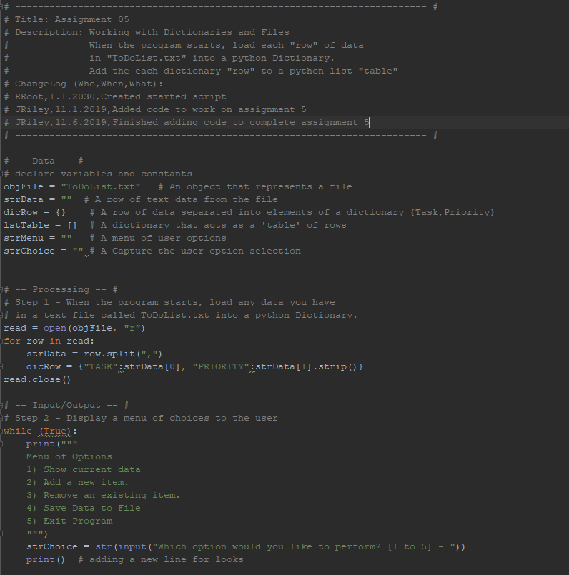

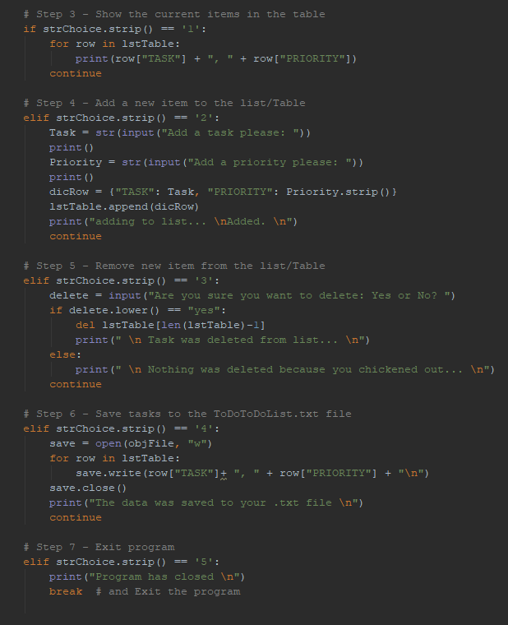

Figure 1: Code

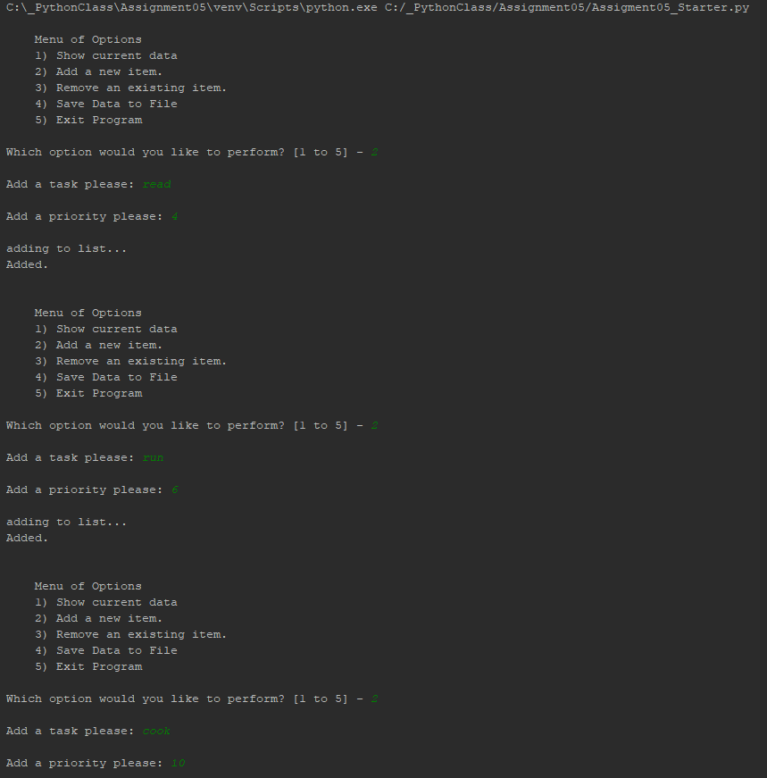

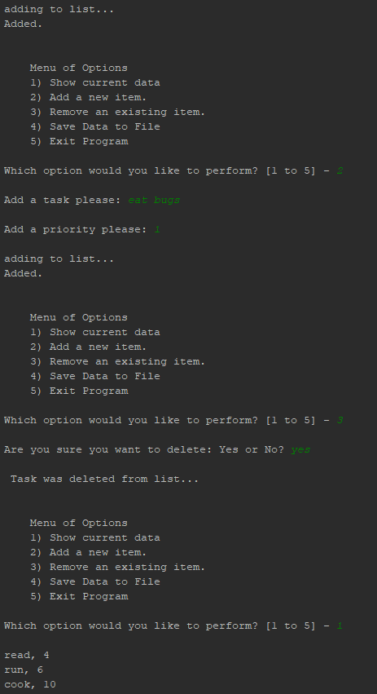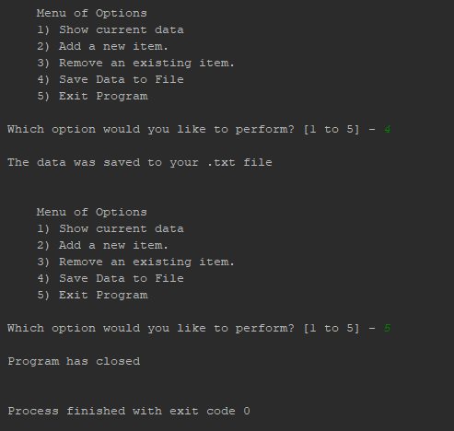

Figure 2. Code running

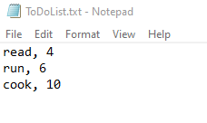

Figure 3. Txt File – notice no eating bugs, because it was deleted.

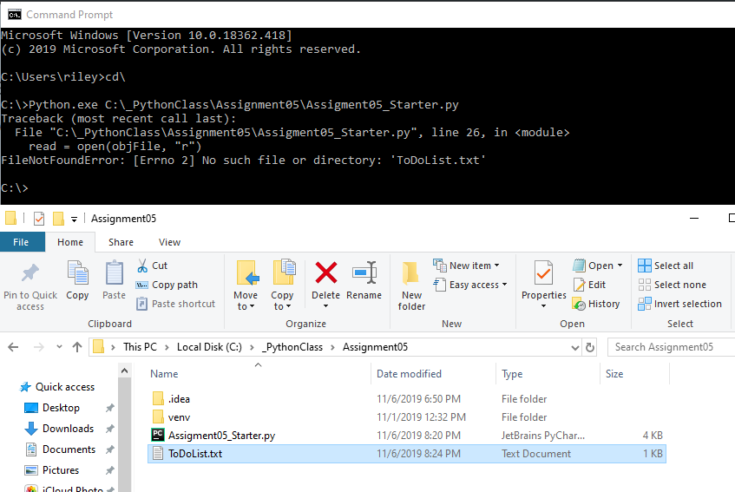

Figure 4. would not run in Command Prompt because it could not find ToDoList.txt file in directory. As you can see it exists. If I made ToDoList an actual file path it would work instead of in a project within PyCharm.

**Summary**

This was a great exercise to test my skills and knowledge. By making me fit within the confines of a pre made script I was required to test my knowledge in areas that I would not have if I made it from scratch. This is also similar to how it may be with working in a coding group. It teaches how to interact with that group by making changes to each other’s scripts.