Cody Esmeier Kyle Riley

Roster Manager

This project is made for sports teams to be able to view and edit their rosters. Currently, there are two teams that are within the database. This is to show how everything works. Users can visit the website to see the roster of whatever team they are interested in. From there, they can see detailed information about a specific player, and “become a fan” of the player (similar to liking a post). Players are added to the database by a site admin to ensure everything is accurate.

To get the code to work on your machine:

Import the database to phpMyAdmin.

Edit the settings.php file to match up with your configuration.

Files are all within the RosterManage folder, just make sure that folder is directly in htdocs when using xampp. From there, you can load <http://localhost/RosterManage/home.php> and everything should be working as intended. Files are directly within the RosterManage folder for simplicity, this way we do not have to mess with path, rather we can just call the file name.

An image of the database is on the Github, it is called db.png.

Screenshots:

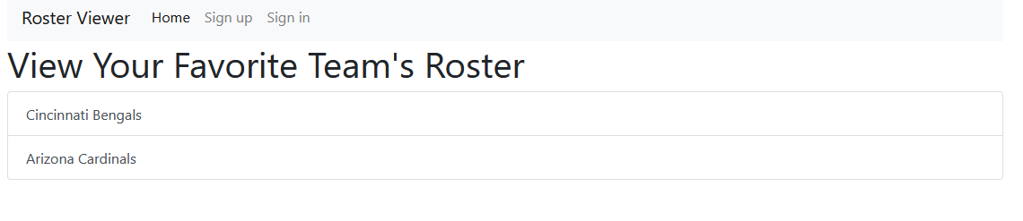

Home.php This is the homepage for the site. Users can then log in or create their accounts, or go directly to a look at a roster.

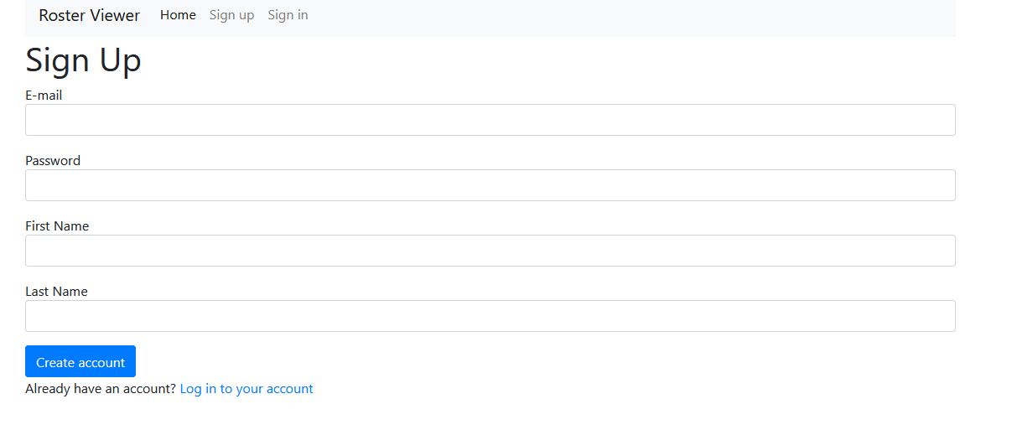

Users can create their account, when they are not signed in the navbar shows sing up / sign in. Data is stored in the database. Password must be at least 8 characters.

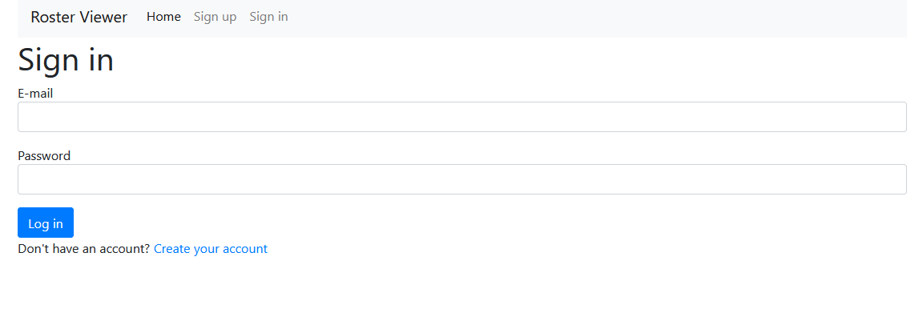Simple sign in page

After signing in:

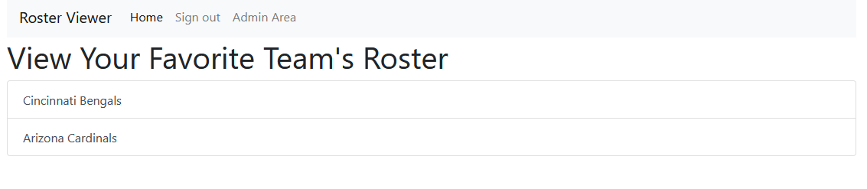You are redirected to the home page, notice that the sign up and in buttons have shifted because of the session being populated. The admin area is only accessible by “elevated” users-- general manager, coach, or admin (su). A normal user will not be able to see any content of the pages contained in the admin area.

Admin area:

su account used here: [esmeier@rostermanager.com](mailto:esmeier@rostermanager.com) password 12345678

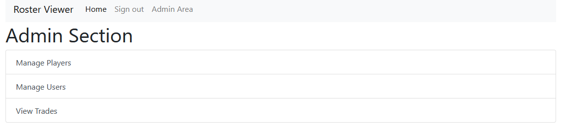Once in the admin section, you can choose to manage players stored in the database, manage users, or to view the pending trades.

Manage players:

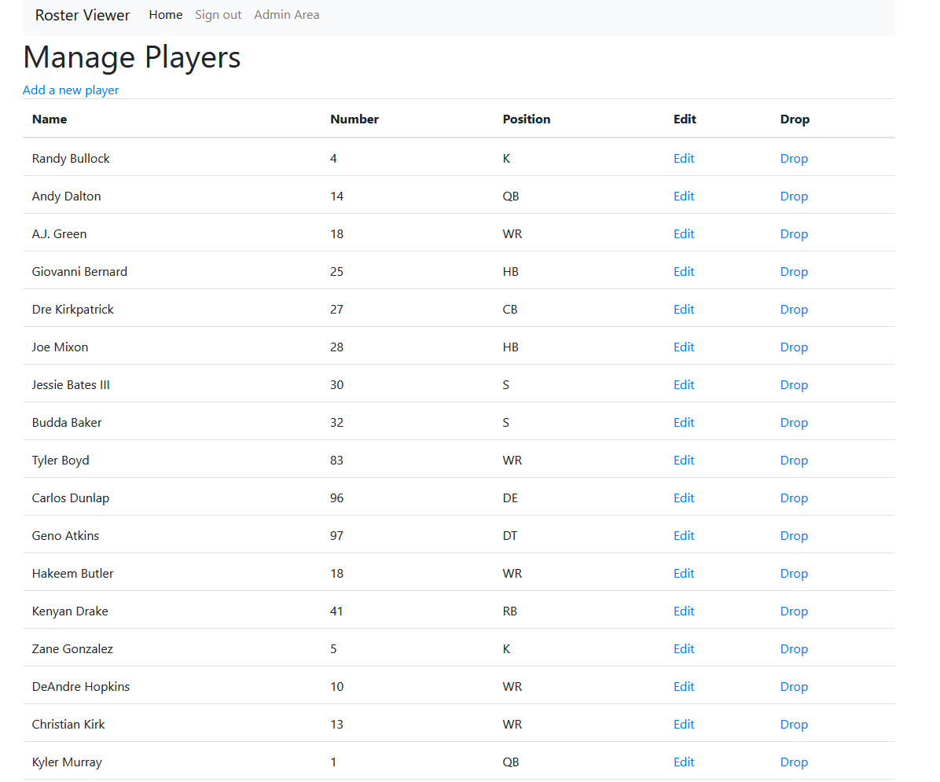Shows a table of all the players in the database. Only su can add new players. A general manager or coach can view their own players, but not those of other teams. If an unauthorized user tries to manage a player that is not theirs, they will not be allowed to do so (referencing if the teamid of the user matches the teamid of a player). SU and users do not have teamids, as su can edit whatever they want, and users will not even be allowed to access the page that allows a player to be changed.

When an su adds a player: 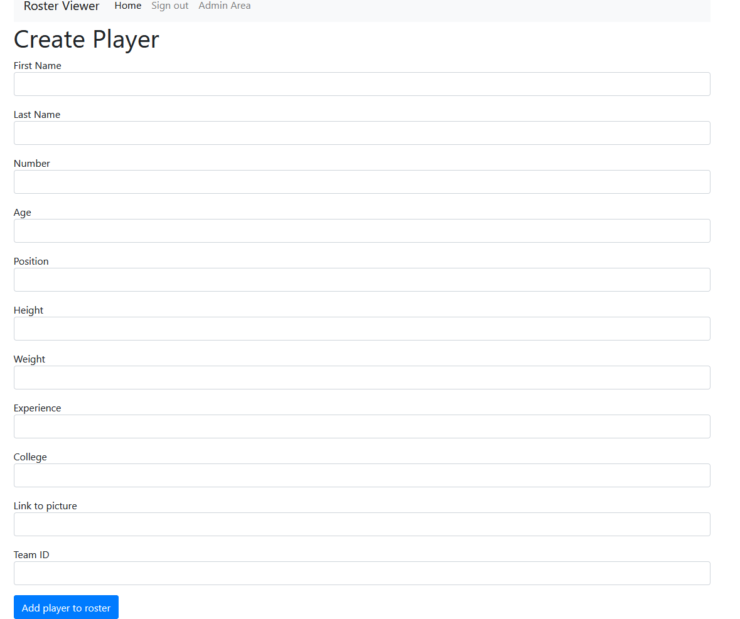We can assume they will know the teamID and put in the correct info. The page makes sure we do not create a duplicate number for a given team, as players can never have the same number on the same team. Only su can add players. There is no reason for users to be able to.

When editing a player: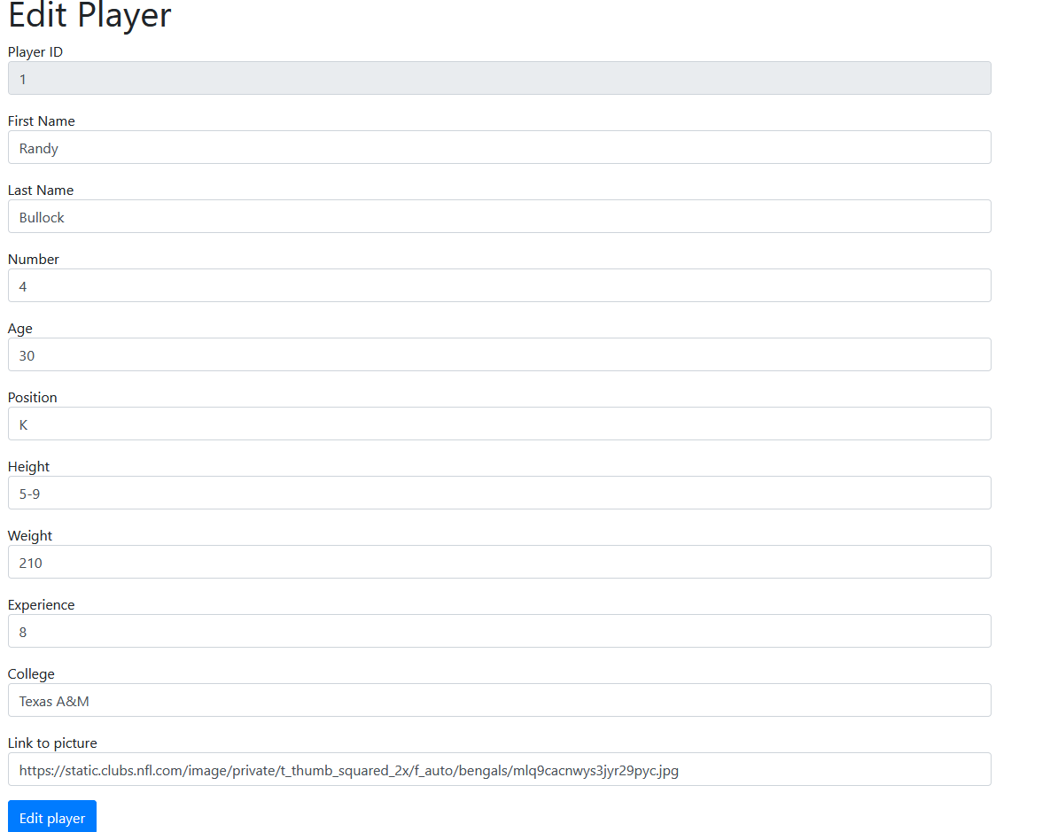The currently stored information is loaded. PlayerID cannot be edited, but everything else can. Again, the page makes sure that the player does not get a duplicate number as another player on the team.

When dropping a player: 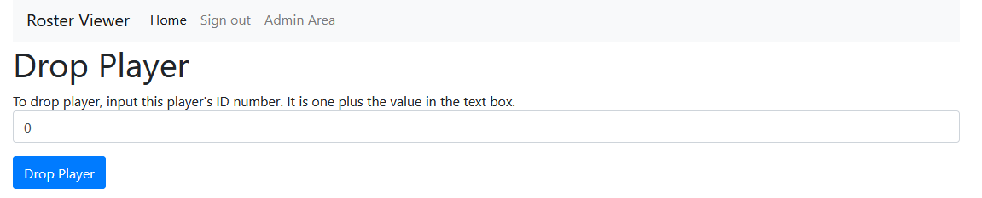Rather than letting the operation just be automatically confirmed, there is a confirmation system in place. Since players are deleted via their playerID, we use it as confirmation. The value in the textbox is automatically 1 less than the player’s id.

Users: In the interest of saving space in this document, users work similar to players. The difference is that coaches cannot manage users at all. GMs can only manage their staff (coaches for their team). SU can edit, delete, create any user.

Trades:

* 1. player trades are supported. 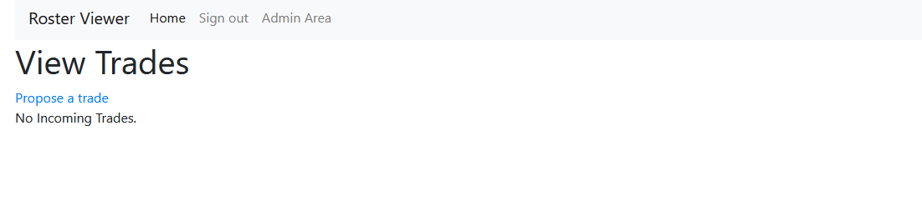A coach/gm be able to propose a trade to any team, and any incoming trades they have will be shown here. An su can view ALL trades. When proposing a trade:

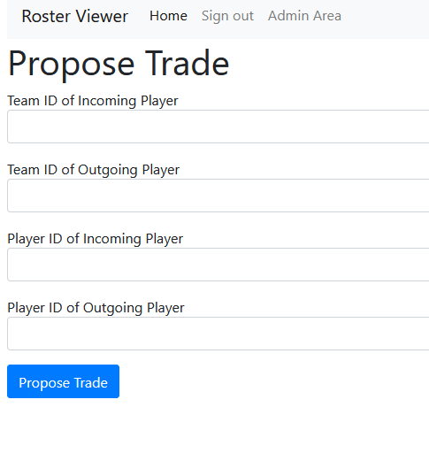If a coach/gm is proposing the trade, they must send a player from their own team to another. Incoming player is the player the proposer want to receive, while the outgoing player is the player that they are sending to the specified team (by id number).

Accepting/Declining

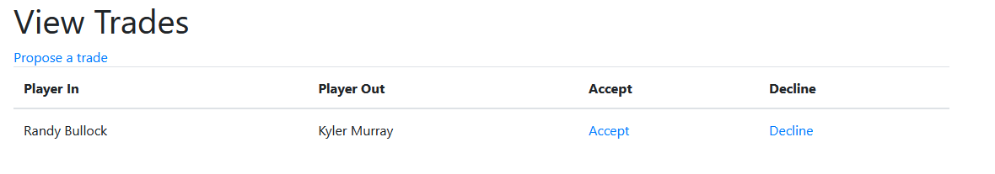When a trade is proposed to a team, this is what they will see on the admin_trade.php page. If they choose to decline, the trade is removed from the database and they will no longer see it. If a trade is accepted:

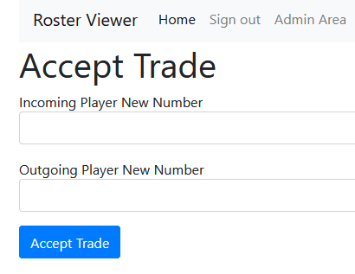The user must put in the number that the player will have on the team. This acts as a confirmation system as well as ensuring that no two players will have the same number on the same team. If the user tries to make a player have a duplicate number appear on the team via trade, the trade will not be completed and they are told to try accepting the trade again without using numbers that will result in duplicates. When a trade is accepted, the players are immediately put on the specific rosters.

Index page: 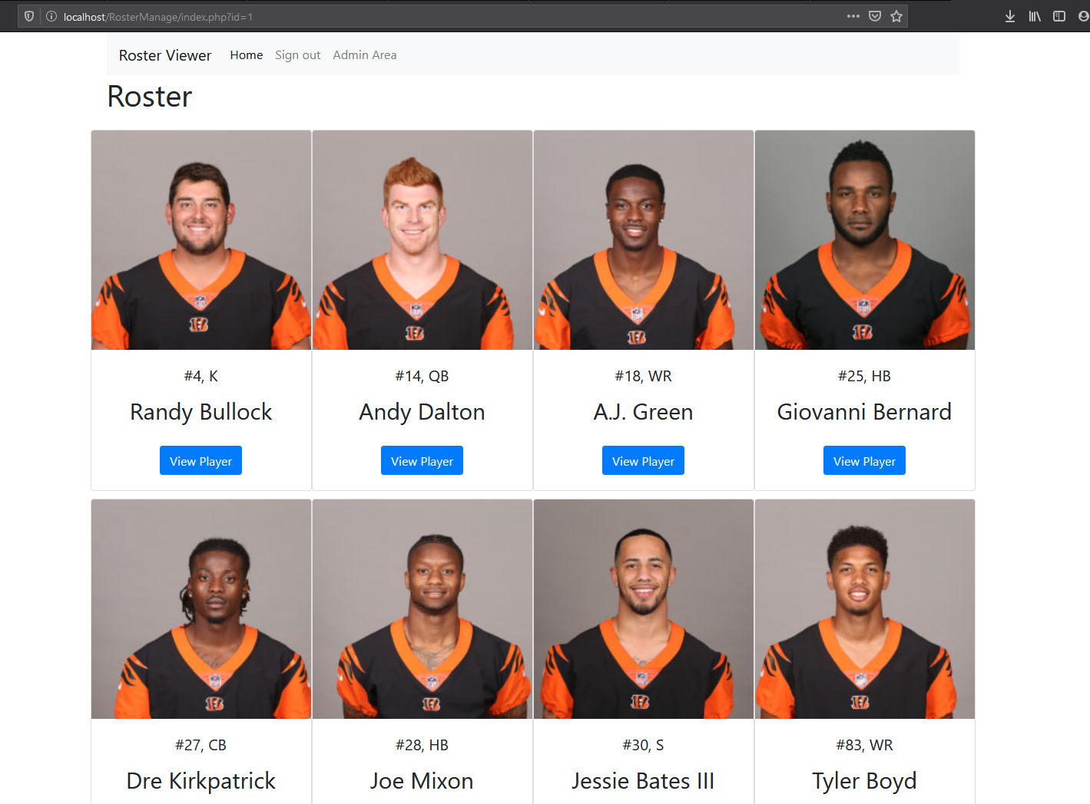Even if you are not signed in, you can view the rosters of the teams. When clicking view player you are redirected to the detailed view about a player. If you are not signed in, you will not be allowed to see the detailed view. Think of the detail page about each player as a “user area”.

Detail view: 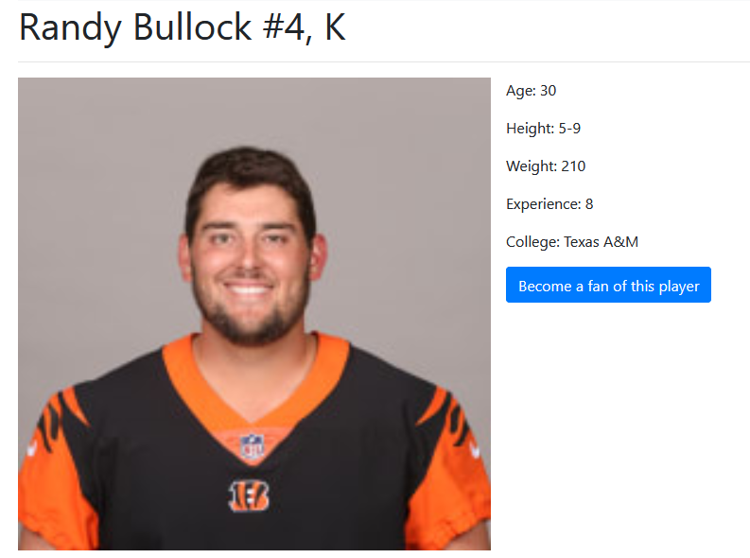Must be signed in. If you are not signed in, you are prompted to do so or to register. When on the page you are given the option of becoming a fan of the player. If the user chooses to do so, the action is performed asynchronously. The button is changed to prompt the user to stop being a fan if they select it. These actions also update the database. Button when you are a fan: 