1. File Size Performance

1.1 test_10mb

Command
Step 1: On server side, create 10mb test file (test_10mb)
% dd if=/dev/urandom of=test_10mb bs=1M count=10
Step 2: Start the server on server side
% sudo python3 server.py --server-ip 172.31.45.124 --client-ip 172.31.38.90 --server-port 9090 --client-port 9091
Step 3: Start the client on client side
% sudo python3 client.py test_10mb 172.31.45.124 172.31.38.90 --server-port 9090 --client-port 9091

1.2 test_100mb

Command
Step 1: On server side, create 100mb test file (test_100mb)
% dd if=/dev/urandom of=test_100mb bs=1M count=100
Step 2: Start the server on server side
% sudo python3 server.py --server-ip 172.31.45.124 --client-ip 172.31.38.90 –server- port 9090 --client-port 9091
Step 3: Start the client on client side
% sudo python3 client.py test_100mb 172.31.45.124 172.31.38.90 --server-port 9090 --client-port 9091

1.3 test_500mb

Command
Step 1: On server side, create 500mb test file (test_500mb)
% dd if=/dev/urandom of=test_500mb bs=1M count=500
Step 2: Start the server on server side
% sudo python3 server.py --server-ip 172.31.45.124 --client-ip 172.31.38.90 --server-port 9090 --client-port 9091
Step 3: Start the client on client side
% sudo python3 client.py test_500mb 172.31.45.124 172.31.38.90 --server-port 9090 --client-port 9091

1.4 test_800mb

Command to run server
Step 1: On server side, create 800mb test file (test_800mb)
% dd if=/dev/urandom of=test_800mb bs=1M count=800
Step 2: Start the server on server side
% sudo python3 server.py --server-ip 172.31.45.124 --client-ip 172.31.38.90 -- server-port 9090 --client-port 9091
Step 3: Start the client on client side
% sudo python3 client.py test_800mb 172.31.45.124 172.31.38.90 --server-port 9090 --client-port 9091

1.5 test_1gb
Command
Step 1: On server side, create 1gb test file (test_1gb)
% dd if=/dev/urandom of=test_1gb bs=1M count=1024
Step 2: Start the server on server side
% sudo python3 server.py --server-ip 172.31.45.124 --client-ip 172.31.38.90 -- server-port 9090 --client-port 9091
Step 3: Start the client on client side
%sudo python3 client.py test_1gb 172.31.45.124 172.31.38.90 --server-port 9090 -- client-port 9091

FileName | SERVER Report Screenshot | CLIENT Report Screenshot
test_10mb | 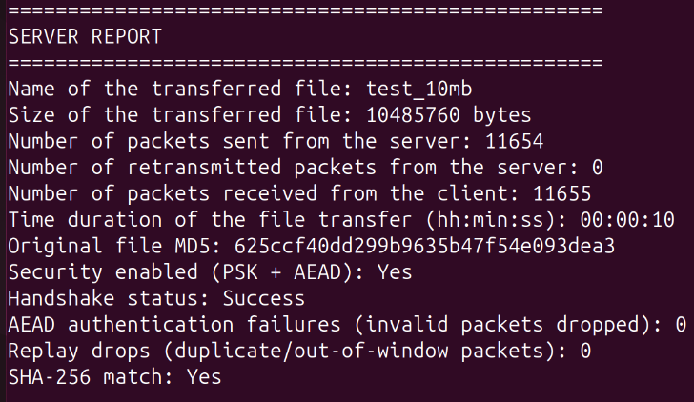 | 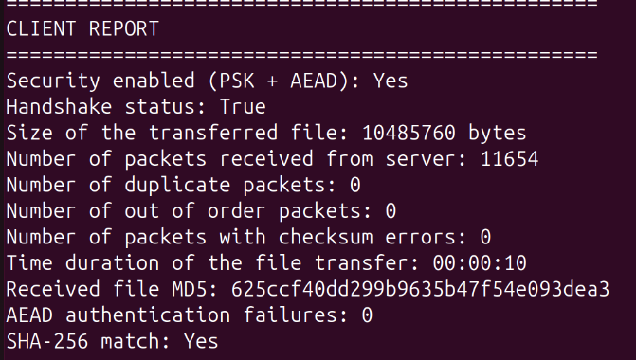
test_100mb | 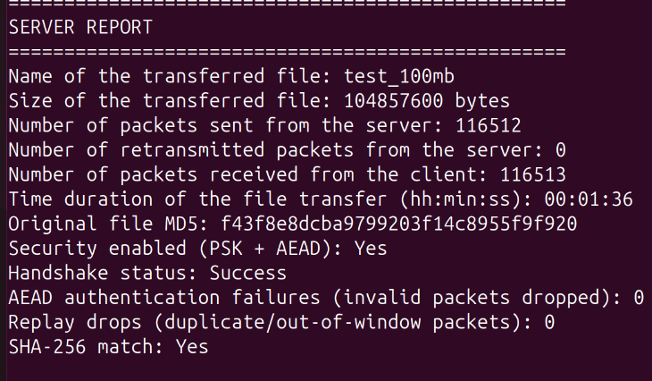 | 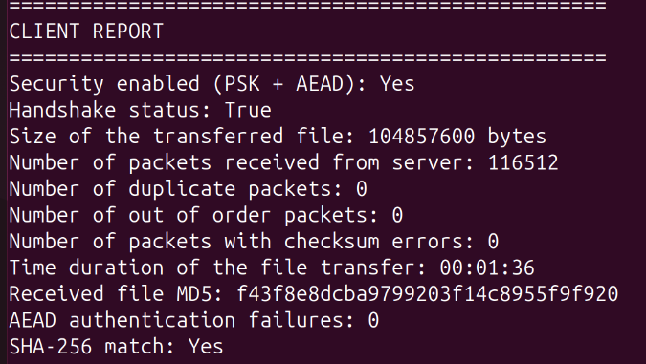
test_500mb | 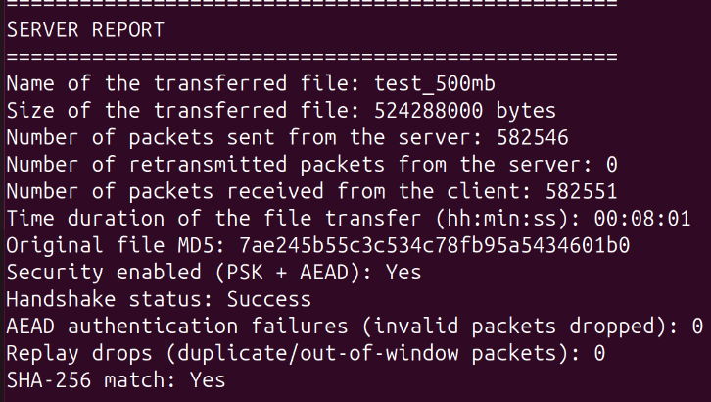 | 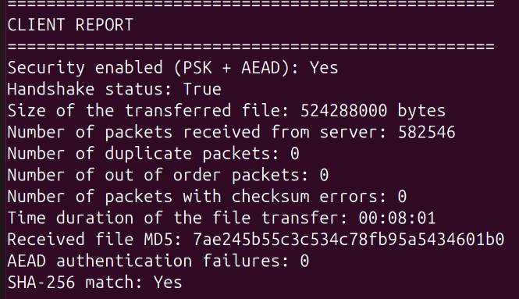
test_800mb | 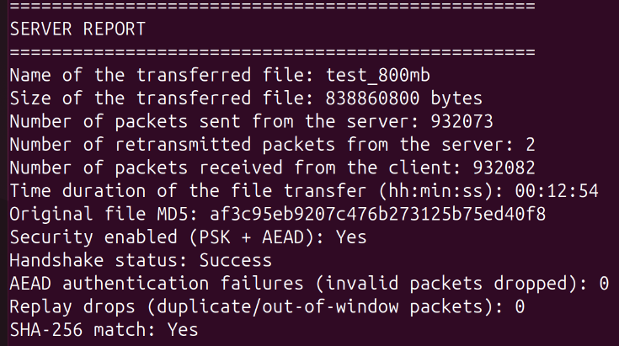 | 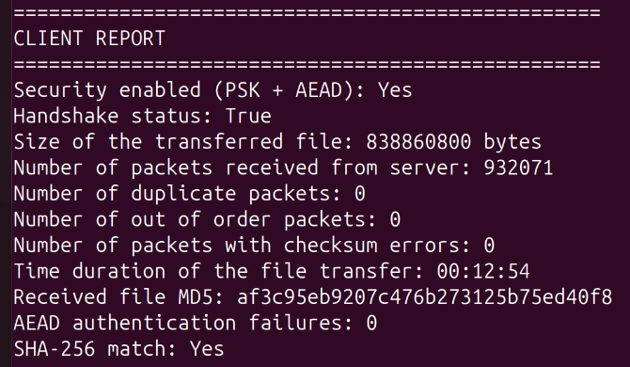
test_1gb | 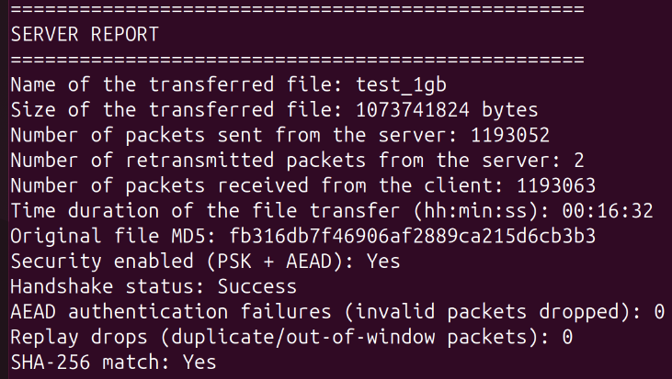 | 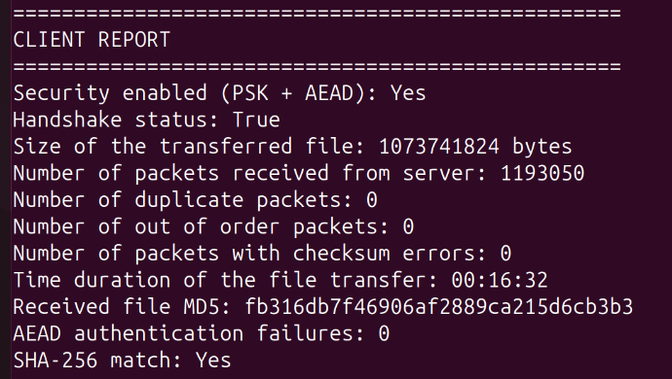

2. Packet Loss Performance

2.1 0% Packet Loss Rate
Command
step 1: Server EC2, Terminal 1:
sudo python3 server.py --server-ip 172.31.45.124 --client-ip 172.31.38.90 -- server-port 9090 --client-port 9091
Step 2 : Client EC2, Terminal 2:
sudo python3 client.py test_100mb 172.31.45.124 172.31.38.90 --server-port 9090 --client-port 9091
Step 3: Client EC2, Terminal 2:
sudo python3 client.py test_100mb 172.31.45.124 172.31.38.90 --server-port 9090 --client-port 9091
Step 4: After transfer finishes, remove netem rule:
sudo tc qdisc del dev ens5 root

2.2 2% Packet Loss Rate
command
Step 1: Server EC2, apply 2% loss:
sudo tc qdisc add dev ens5 root netem loss 2%
Step 2: Server EC2, Terminal 1:
sudo python3 server.py --server-ip 172.31.45.124 --client-ip 172.31.38.90 -- server-port 9090 --client-port 9091
Step 3: Client EC2, Terminal 2:
sudo python3 client.py test_100mb 172.31.45.124 172.31.38.90 --server-port 9090 --client-port 9091
Step 4: After transfer finishes, remove netem rule on server EC2:
sudo tc qdisc del dev ens5 root

2.3 4% Packet Loss Rate
command
Step 1: Server EC2, apply 4% loss:
sudo tc qdisc add dev ens5 root netem loss 4%
Step 2: Server EC2, Terminal 1:

Packet Loss Rate | SERVER Report Screenshot
0% | 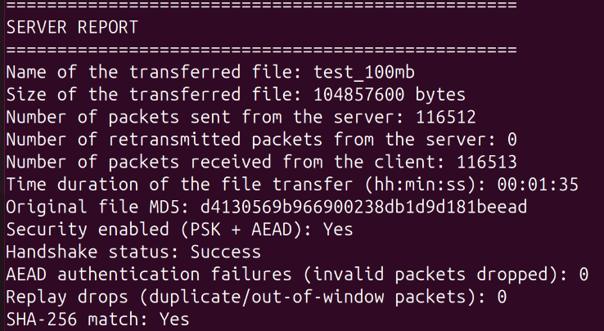
2% | 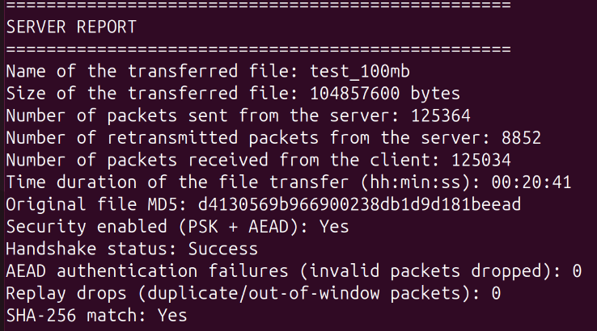
4% | 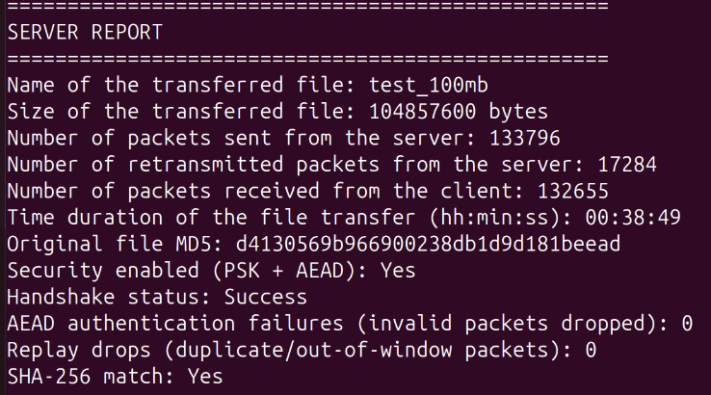

3. Security Test Plan

3.1 Test 1 Secure Transfer (Baseline)
3.1.a Transfer a small text file with security enabled
command:
Step 1: Create a small text file on server EC2:
echo "This is a secure transfer test file. Hello SRFT!" > test_text.txt
Step 2 : Server EC2
sudo python3 server.py --server-ip 172.31.45.124 --client-ip 172.31.38.90 -- server-port 9090 --client-port 9091
Step3: Client EC2
sudo python3 client.py test_text.txt 172.31.45.124 172.31.38.90 --server-port 9090 --client-port 9091

3.1.b Transfer a binary file with security enabled
command:
Step 1: Get a small binary file (png or zip) on server EC2
dd if=/dev/urandom of=test_binary.bin bs=1K count=100
Step 2 : Server EC2
sudo python3 server.py --server-ip 172.31.45.124 --client-ip 172.31.38.90 -- server-port 9090 --client-port 9091
Step3: Client EC2
sudo python3 client.py test_binary.bin 172.31.45.124 172.31.38.90 –server- port 9090 --client-port 9091
●

Type | SERVER Report Screenshot | CLIENT Report Screenshot
text | 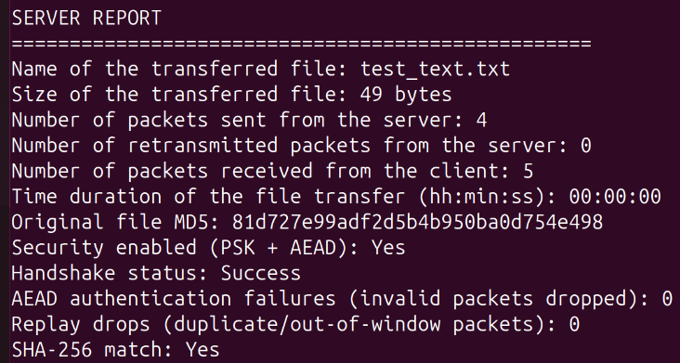 | 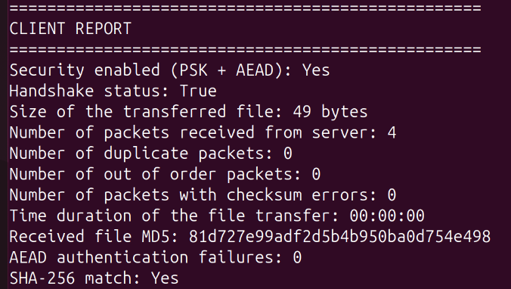
binary | 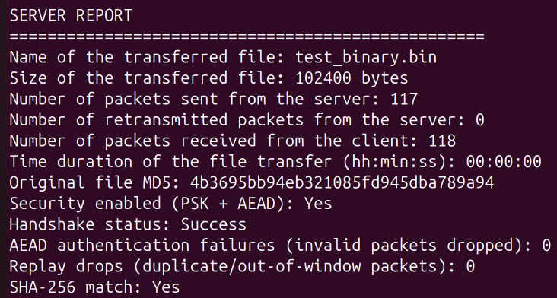 | 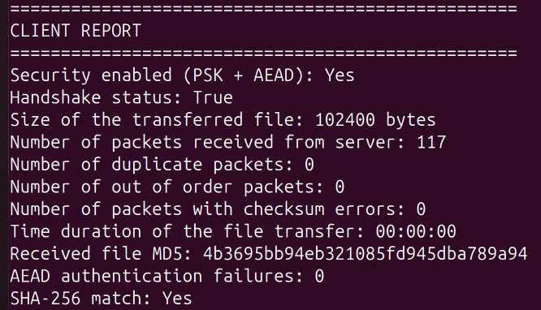

In the screenshot can be seen the expected result:
Handshake status: Success
AEAD authentication failures: 0
Replay drops: 0
SHA-256 match: Yes

3.2 Test 2 Wrong PSK (Authentication Failure)
Configure the client PSK different from the server PSK and attempt a transfer.
Command:
Step 1: Create a wrong PSK file on client EC2:
echo -n "this-is-a-wrong-psk-key-12345678" > wrong_psk.txt
while Server EC2 (runs with default correct PSK):
sudo python3 server.py --server-ip 172.31.45.124 --client-ip 172.31.38.90 --server-port 9090 --client-port 9091
Step 2: Server EC2:
sudo python3 server.py --server-ip 172.31.45.124 --client-ip 172.31.38.90 --server-port 9090 --client-port 9091
Step 3: Client EC2:
sudo python3 client.py test_text.txt 172.31.45.124 172.31.38.90 -- server-port 9090 --client-port 9091 --psk-file wrong_psk.txt

SERVER Report Screenshot | CLIENT Side Screenshot
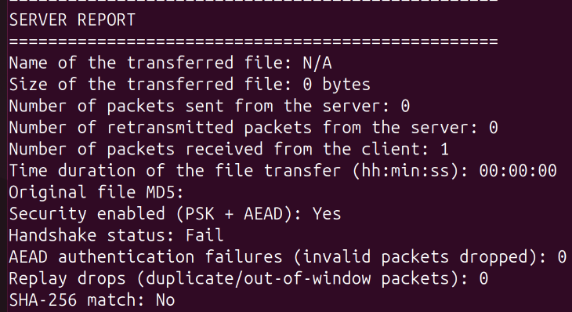 | 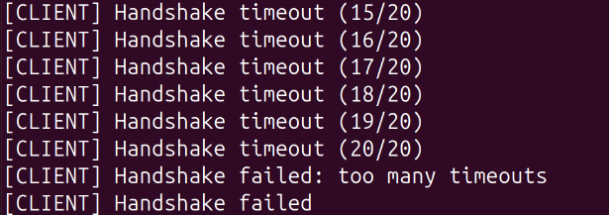

The expected result can be seen from screenshot:
On server side it reports “Handshake failed” and on client side no report generated because connection failed.

3.3 Test 3 Tamper Detection (Integrity)
command:
Step1: Server EC2 (with tamper attack mode):
sudo python3 server.py --server-ip 172.31.45.124 --client-ip 172.31.38.90 -- server-port 9090 --client-port 9091 --attack tamper
Step2: Client EC2: (use 100mb size to test)
sudo python3 client.py test_100mb 172.31.45.124 172.31.38.90 --server-port 9090 --client-port 9091

SERVER Report Screenshot | CLIENT Report Screenshot
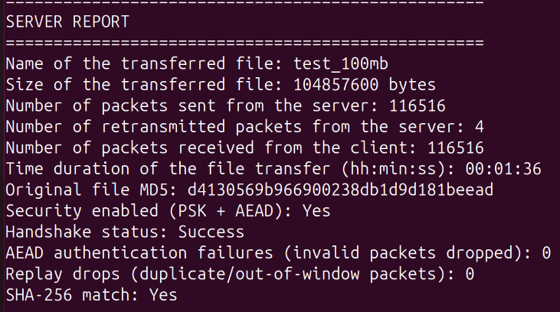 | 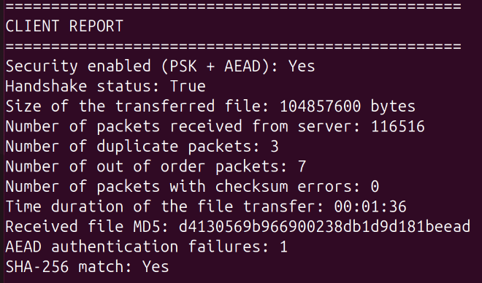

The expected result can be seen from the screenshot. From client side, handshake status is True, AEAD authentication failures increase to 1. Number of duplicate packets are 3, which means the server retransmitted the packet after a tamper detection. SHA-256 match is Yes, indicating transfer still completed correctly via retransmission.

From server side, number of retransmitted packets is 4, server retransmitted after no ACK for tampered. AEAD authentication failure is 0 because tamper detection happens on client. SHA-256 match is yes.

This demonstrates integrity protection — the tampered packet was caught by AEAD, then dropped, retransmitted, and the final file is still intact.

3.4 Test 4 Replay Protection
command:
Step 1: Server EC2:
sudo python3 server.py --server-ip 172.31.45.124 --client-ip 172.31.38.90 -- server-port 9090 --client-port 9091 --attack replay
Step2: Client EC2
sudo python3 client.py test_100mb 172.31.45.124 172.31.38.90 --server-port 9090 --client-port 9091

SERVER Report Screenshot | CLIENT Report Screenshot
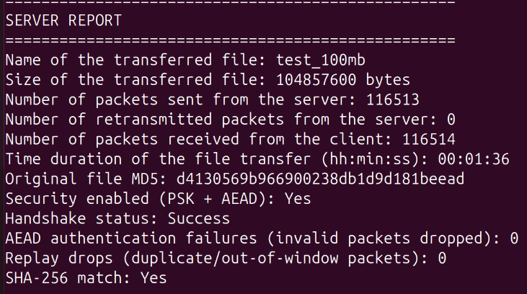 | 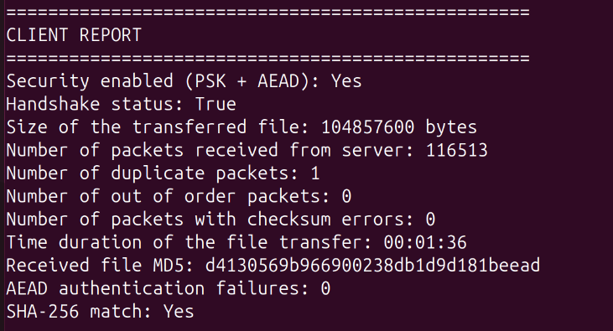

From the client report screenshot, the number of duplicate packets is shown to be 1. The SHA-256 match is Yes. The replay is tracked under "Number of duplicate packets: 1”, but the "Replay drops" counter shows 0 in the server report. This is because in the current code, the client tracks replays as duplicate_packets, not as a separate replay_drops counter. The replay_drops field exists in the server report but is never actually incremented in the code.

For now, the “Number of duplicate packets: 1” proves the replay was detected, The SHA-256 match is Yes proves no retransmission needed. This demonstrates that replay protection — the duplicate packet was detected and dropped, and the final file is still intact.

To fix the code matching the server report requirement, in client.py, could add a self.replay_drops counter and increment it when a duplicate is detected, then display it in the report.

3.5 Test 5 Forged Injection
Command
Step 1: Server EC2:
sudo python3 server.py --server-ip 172.31.45.124 --client-ip 172.31.38.90 -- server-port 9090 --client-port 9091 --attack inject
Step2: Client EC2
sudo python3 client.py test_100mb 172.31.45.124 172.31.38.90 --server-port 9090 --client-port 9091

SERVER Report Screenshot | CLIENT Report Screenshot
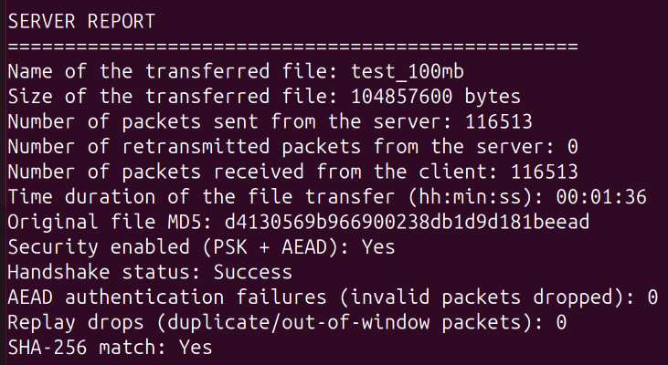 | 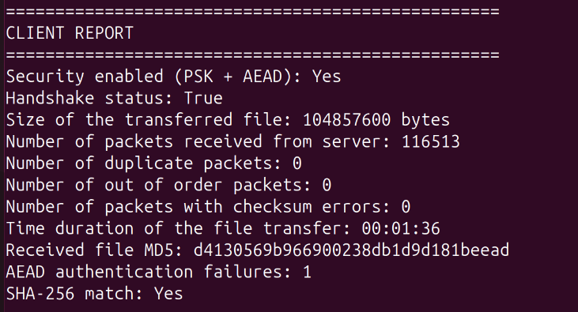

From the client side, the report shows AEAD authenticataion failures is 1, meaning forged packet was detected and rejected. But ransfer still completed correctly, because SHA-256 match is yes. The number of duplicate packets is 0 because this is a forged packet not a replay. So this is correct.

From the server side, handshake is successful and SHA-256 match is yes.

This perfectly demonstrates injection protection — the forged packet with random bytes was caught by AEAD decryption, dropped, and the final file is still intact.

