**Riley Worstell**

**ECE 542**

**HW 2**

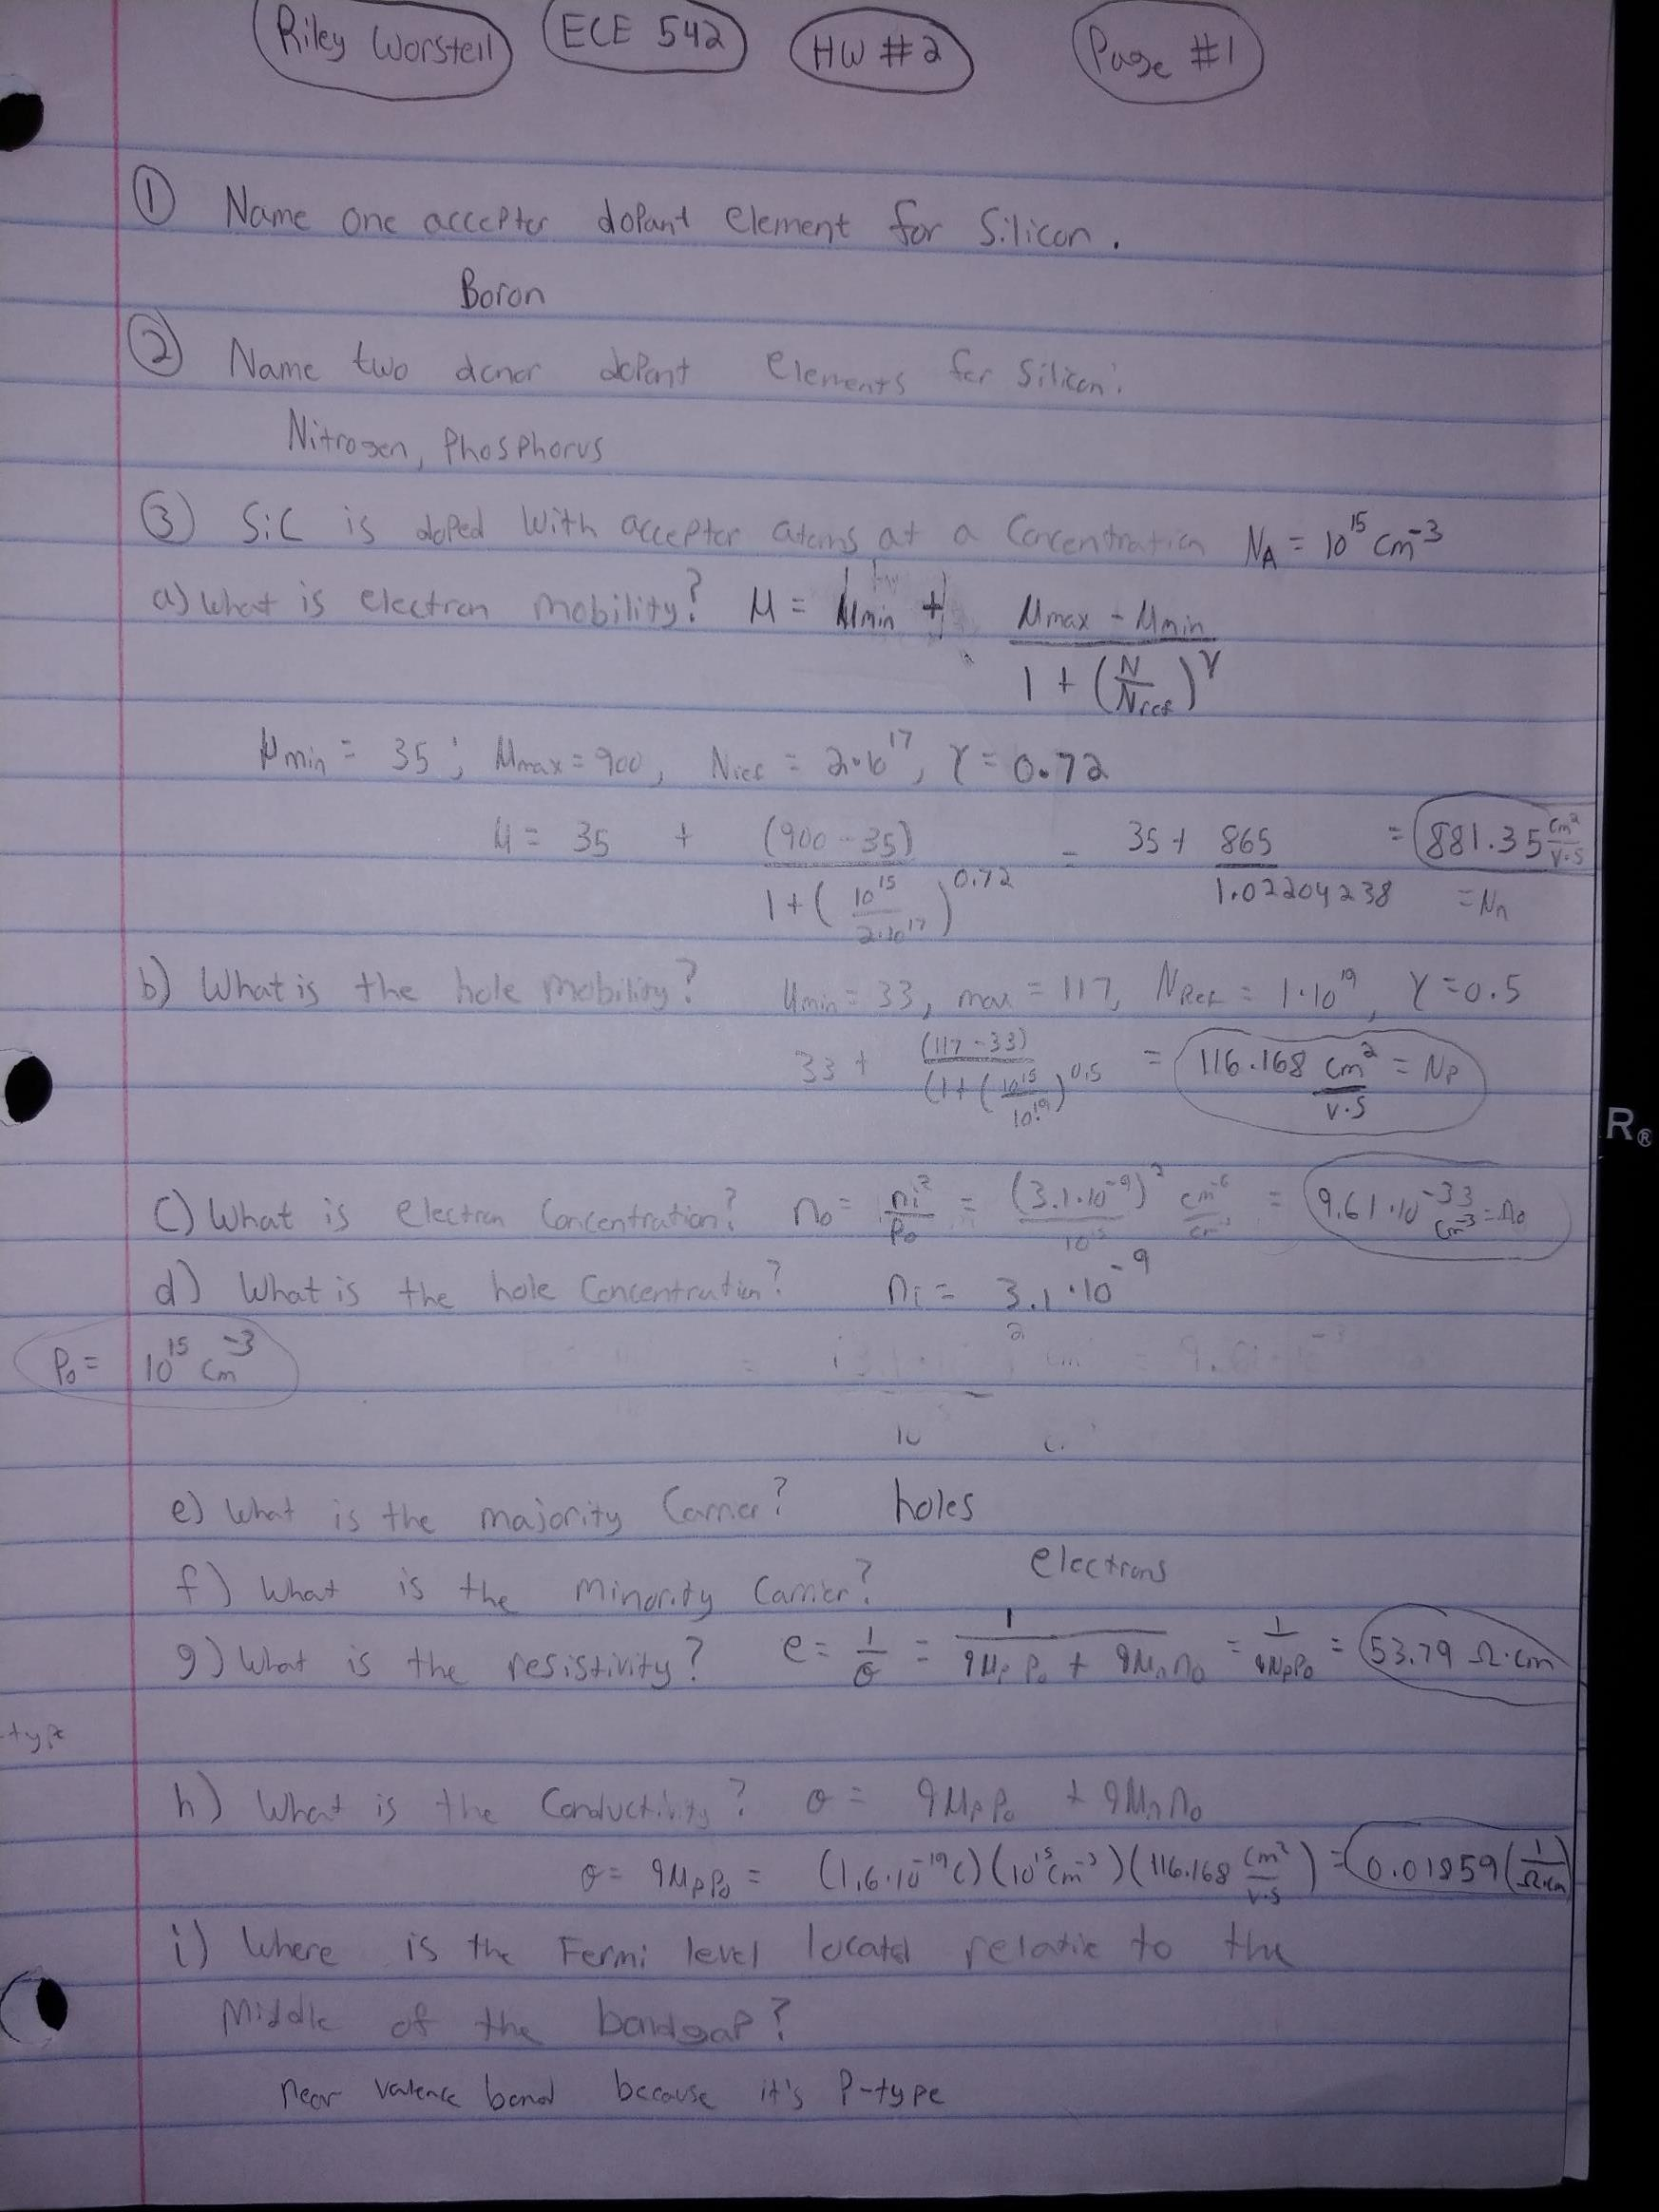

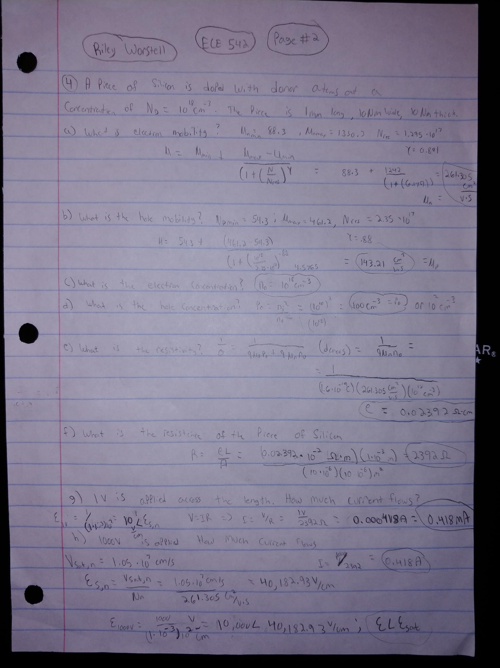

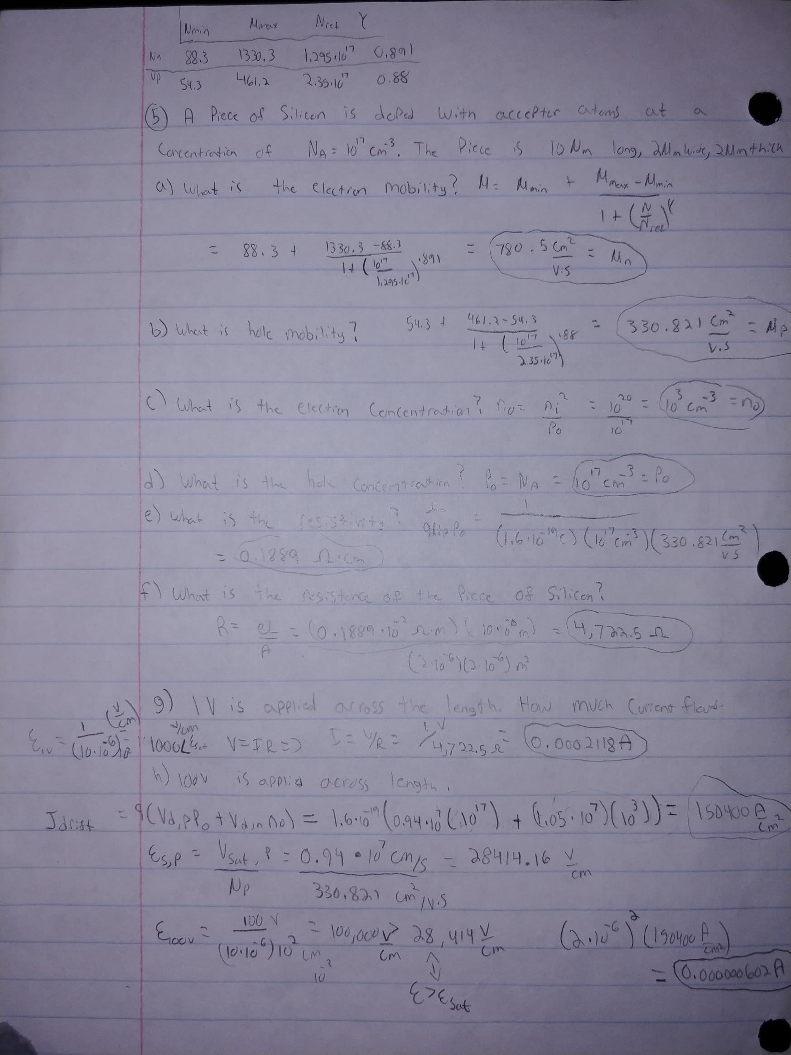

6)

CODE:

import pylab  
import matplotlib.pyplot as plt  
import math  
  
Si_NC = (3.51*(10**19))  
Si_NV = (1.87*(10**19))  
Si_BG = 1.12  
K_b = 0.00008617  
  
  
my_temps = []  
some_temp = 200  
for i in range(401):  
 my_temps.append(some_temp)  
 some_temp = some_temp + 1  
  
  
Ni_Si = []  
  
for i in my_temps:  
 x = Si_NC * ((i/300)**1.5)  
 y = Si_NV * ((i / 300) ** 1.5)  
 z = ((x*y*(math.exp(-(Si_BG/(i * K_b)))))**.5)  
 print(z)  
 Ni_Si.append(z)  
  
  
plt.plot(my_temps, Ni_Si)  
plt.yscale('log')  
plt.xlabel("Temperature")  
plt.ylabel("Intrinsic Carrier Concentration")  
plt.show()

PLOT:

