BUSINESS VALIDATION REPORT
OpsFlow — Intelligent BAU
Automation & Control Tower
Business case for replacing fragmented, manual Business-As-Usual operations with a governed automation and SLA control tower.
PREPARED FOR | Chief Operating Officer · Department Heads · Finance Business Partner
PREPARED BY | Business Process Improvement (independent review of the OpsFlow demo build)
SUBJECT ORGANISATION | Nusantara Retail Group — 5 departments, 15 people, 9 request categories
EVIDENCE BASE | 108 requests, 109 automation executions and 8 process baselines held in the application workspace
DOCUMENT DATE | 1 November 2026
STATUS | For management decision — pilot approval requested

HOW TO READ THE NUMBERS IN THIS REPORT
MEASURED  Observed in the application workspace itself: 108 requests, 109 BOT executions, 72 audit events. These are facts about the demo dataset, not promises about your organisation. | PROJECTION  Calculated from the baseline process table and financial assumptions, using the same formulas the application uses. Directionally sound; sensitive to the stated inputs. | SIMULATED  Produced by the demo harness rather than a live production system (e.g. scheduled BOT runs, in-app notification counts). Evidence that the flow works, not evidence of scale.

00 Executive summary
OpsFlow is a working prototype of an operational control tower that makes Business-As-Usual work visible, assigns it automatically, enforces an SLA clock and reports on it without human collation. This report validates it as a candidate for implementation using the application's own dataset: 108 requests across 9 categories and 5 departments, 5 workflow definitions and six BOT automations. Everything quoted as measured comes from that workspace; everything quoted as projected is derived from the baseline table and the ROI model with the assumptions printed alongside it.
93.5%  requests auto-handled  101 of 108 requests — Measured | 77.0%  cycle-time reduction  32.4 → 7.5 min per transaction (projection) | 86.9%  SLA compliance today  73 of 84 on time — Measured | 3.8  months to payback  ROI model, undiscounted — Projection

The case in six statements
1. The problem is not effort, it is coordination cost. The organisation already processes 1,870 transactions a month against 8 defined processes. In the demo workspace each request travels through 8.6 manual activities and 32 minutes of hands-on work before closure, much of it spent classifying, checking completeness, finding the right owner and chasing deadlines rather than doing the work itself.
2. Routing and validation are the right first targets. 101 of 108 requests (93.5%) are already handled end-to-end by a BOT — auto-assigned to the least-loaded available person, or validated for completeness and format before reaching a queue. This is the highest-volume, lowest-judgement work, which is why it is safe to automate first.
3. The measurable time release is real but modest at demo scale; the value is per-transaction. The execution log records 1,642 minutes saved across 109 runs over 44 days (≈ IDR 2.7m/month at the loaded rate) — real, but only two transactions a day. The scale argument therefore rests on the baseline table, not on the demo's run-rate: 1,870 transactions × 25.0 minutes saved = 46,670 minutes (≈ 778 hours, IDR 119.1m) per month.
4. SLA performance improves because the clock becomes visible, not because people work harder. Compliance sits at 86.9% today against a configured 85% target, with 7 requests past deadline and 12 of the open backlog beyond 75% of its window. Reminder and escalation BOTs convert that from a month-end discovery into an in-day intervention.
5. The financial case is positive but must be approved on the conservative basis. Two models disagree by design: the ROI calculator implies IDR 100.5m net per month (652% first-year ROI, 1.8-month payback), while the full baseline table implies IDR 106.6m. We recommend approving against the lower calculator figure and presenting the portfolio view as the opportunity rather than the commitment.
6. This is a prototype, and half of the acceptance criteria cannot yet be evidenced. There is no server, no scheduler and no connector credentials. Benefits are proven as workflow and arithmetic; they are not yet proven as live financial outcomes (Section 12, AC9–AC12 and AC14).

Recommendation
DECISION REQUESTED
Approve a 4-month, two-department pilot (IT Support and Finance & Reporting) covering the Smart Assignment, Data Validation, Deadline Reminder and Automated Reporting BOTs, with a hard gate at month 4 against the acceptance criteria in Section 12. Portfolio value on the conservative baseline basis: IDR 106.6m net per month of which the two pilot departments (IT Support and Finance & Reporting) account for IDR 84.0m of gross value — 71% of the total. Release of funds beyond the pilot should be conditional on measured SLA and exception-rate performance, not on the modelled ROI.

01 Existing operational problems addressed
The demo workspace is seeded with the failure modes that make BAU expensive in practice. Each problem below is evidenced by a specific state in the dataset, not by assertion.
# | OPERATIONAL PROBLEM | HOW IT SHOWS UP IN THE WORKSPACE | WHAT OPSFLOW CHANGES
P1 | Work arrives through seven unmanaged channels | Sources recorded: Portal 23, Teams 19, Google Form 17, Walk-in 17, API 13, E-mail 12, Phone 7. Only the portal, the form and the API are structurally captured; 55 of 108 requests (51%) arrive by Teams, e-mail, phone or in person, so half of current demand is invisible to any report. | Single intake model with one schema per category; every channel creates the same auditable record.
P2 | Manual triage consumes skilled time | Average 8.6 manual activities per request, 32 minutes of hands-on effort. Assignment depends on someone knowing who is free. | Smart Assignment BOT routes and assigns: 101 requests auto-handled (93.5%), 133 records assigned across 104 successful runs.
P3 | Incomplete or malformed requests reach the queue | 7 of 108 requests (6.5%) are flagged Needs Review for missing fields, bad formats or likely duplicates — each one a round-trip back to the requester. | Data Validation BOT enforces mandatory fields, e-mail format and duplicate similarity before assignment.
P4 | SLA breaches are discovered after the fact | 7 requests are past deadline. Of 19 open records, 12 are already past 75% of their SLA window and 8 past 90%. Escalations exist but are raised by a person noticing. | Reminder BOT fires at 75% of window, Escalation BOT at 100%. 12 tasks carry a reminder timestamp and 7 carry an escalation flag with an audit record.
P5 | Reporting is a manual monthly scramble | Monthly Management Reporting is the single most expensive process on the baseline: 240 minutes per cycle, 45 cycles a month, 18 manual steps. | Automated Reporting BOT produced 263 records across 4 scheduled runs and is the third-highest value driver (IDR 28.4m of the 119.1m projected).
P6 | Workload is invisible until it becomes a queue | Open work is concentrated: IT Support holds 7 of 19 open records, and one individual carries 4 open items with 3 overdue and 75% SLA compliance against a 95% peer. | Live workload and availability view per person and department with least-loaded assignment as the default.
P7 | There is no reliable audit trail for automation | Without a control tower, nobody can answer 'what did the robot do to my ticket' — which is the reason many automation programmes stall at governance. | Every BOT run writes an execution record: 550 records processed across 109 runs, with the affected task IDs, metrics and error text retained.

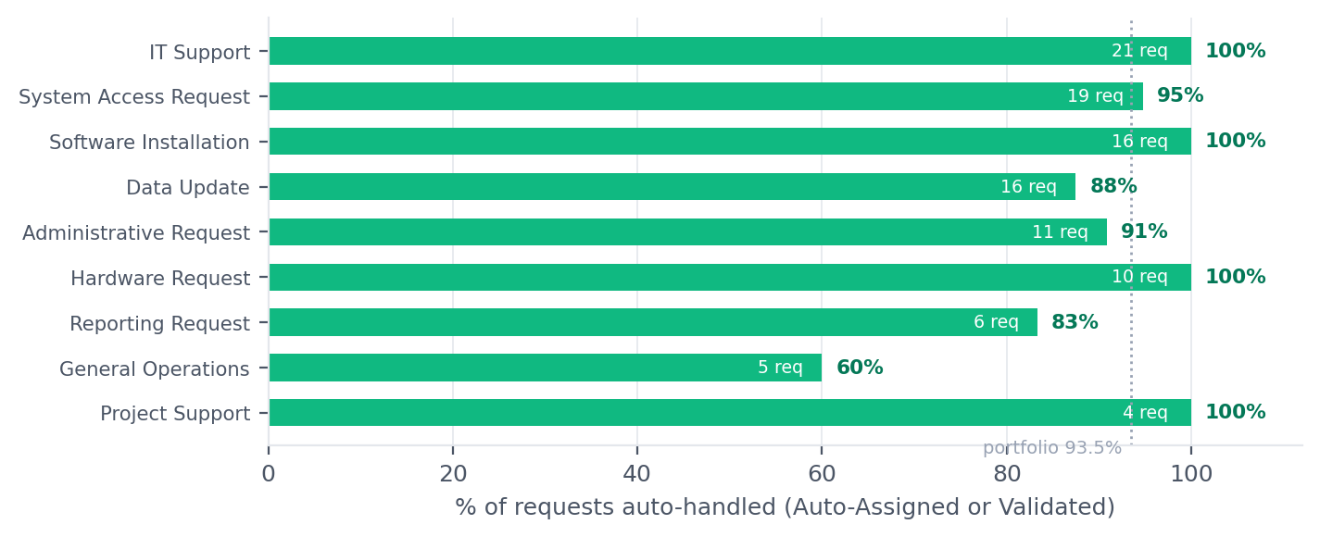
Figure 1 — Automation coverage by request category (measured). Categories with the highest volume are also the ones already fully covered; where coverage is lowest (General Operations 60%, Reporting 83%) the work is judgement-heavy, which is the correct place to stop automating.

02 AS-IS versus TO-BE process comparison
The comparison uses the application's own process model. Seven of the eight baseline processes map directly to a task category; the workflow module supplies the stage sequence. Figures in the AS-IS column are the pre-automation baseline (projection from the baseline table); TO-BE column figures are the configured target the application measures itself against.
STAGE | AS-IS — TODAY | TO-BE — WITH OPSFLOW | CONTROL THAT MAKES IT STICK
1. Intake | Requester chooses a channel (e-mail, chat, walk-in, phone, form). Free-text, no mandatory fields. | One intake schema per category; missing fields rejected at entry, duplicate titles flagged. | Validation BOT + mandatory-field contract per category.
2. Triage | A coordinator reads the request, guesses the owning department, then looks for someone free. | Category-to-department map resolves the owner; least-loaded available PIC assigned in the same second. | Smart Assignment BOT with an explicit routing table, editable by the process owner.
3. Classification & priority | Priority inferred from the requester's seniority and tone of voice. | Priority is a required field; the SLA window is derived from category × priority policy (9 categories × 4 levels). | SLA configuration matrix with 36 distinct windows, auditable.
4. Execution | Work happens in inboxes and private spreadsheets; status is unknown until asked. | Work sits on a task record with an owner, a stage, a due time and a comment thread. | Workflow instance + stage ownership (Human / BOT / Manager per stage).
5. Reminder & escalation | Chasing is a periodic sweep by the team lead, usually after the deadline. | Reminder at 75% of the window, escalation at 100%, both with audit records and a named recipient. | Deadline Reminder and SLA Escalation BOTs, thresholds configurable.
6. Closure | Ticket closed by whoever remembers; SLA outcome reconstructed later if at all. | Closure records completion time against deadline; on-time outcome computed, not estimated. | Completed stage writes completedAt; compliance derived from the record.
7. Reporting | Monthly pack hand-built: 240 minutes per cycle, 18 steps, error rate 12.7%. | Daily pack generated by BOT with scope, period and SLA outcome; month-end is a roll-up of daily records. | Automated Reporting BOT + report history with provenance (RPT-0148 etc.).
8. Governance | No record of who changed what, or which rule touched which request. | Every mutation and every BOT run is an audit event with affected records. | Execution history + activity log; role-gated administration.

What the TO-BE actually measures
DIMENSION | AS-IS BASELINE | TO-BE TARGET | DELTA | GRADE
Average process time per transaction | 32.4 min | 7.5 min | −77.0% | Projection
Manual processing hours / month | 1,010 h | 233 h | −77.0% | Projection
Manual activities per request | 8.6 | 2.8 | −67.3% | Projection
Data error frequency | 9.4% | 2.0% | −79.2% | Projection
Automation coverage | 0% | 79.1% | new capability | Projection
Requests auto-handled (workspace) | — | 101 of 108 (93.5%) | — | Measured
SLA compliance | 74.5% (derived) | 86.9% (run-rate) | +12.4 pts | Projection / Measured
Average resolution time | — | 21.0 h | — | Measured
Automation execution success | — | 95.4% (104/109) | — | Measured

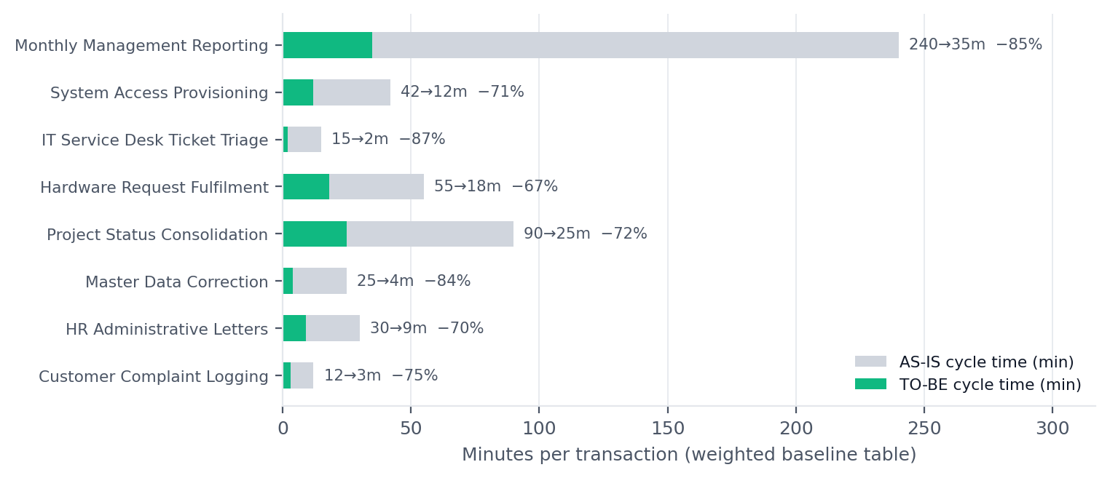
Figure 2 — AS-IS versus TO-BE cycle time for the eight baseline processes (projection from the baseline table). Reporting, access provisioning and service-desk triage carry the largest absolute minutes; hardware fulfilment has the smallest percentage gain because physical hand-over cannot be automated.

03 Manual activities eliminated or reduced
Not every manual activity should disappear. The table separates activities the application removes outright from those where it removes only the mechanical part and leaves judgement with a person — which is what keeps the benefit credible to an operations manager.
MANUAL ACTIVITY | FREQUENCY TODAY | AFTER OPSFLOW | DISPOSITION | EVIDENCE
Reading each request and choosing the owning department | Every request (108 in workspace) | Resolved by category-to-department map | Eliminated | Smart Assignment BOT, 56 runs
Deciding who is free and hand-assigning | Every request | Least-loaded available PIC chosen automatically | Eliminated | 133 records assigned
Completeness, format and duplicate checks | Every request, usually after queueing | Rejected or flagged before assignment | Eliminated (mechanical part) | Data Validation BOT, 33 runs
Writing the acknowledgement and reminder messages | Manual chase per request | In-app notification generated per event | Eliminated | 12 reminders, 7 escalations recorded
Sweeping the board for near-deadline work | Daily, by team lead | Fires at 75% of the SLA window | Eliminated | Deadline Reminder BOT, 8 runs
Escalating a breach and telling the manager | When somebody notices | Fires at 100% with audit record | Eliminated | SLA Escalation BOT, 6 runs
Collating the monthly management pack | Monthly, 240 min per cycle | Generated with scope, period and outcome | Reduced 85% | Automated Reporting BOT, 263 records
Status chasing ('where is my ticket?') | Continuous, unmeasured | Status visible on the record for requester and owner | Reduced | Task drawer + notification centre
Deciding whether a request is legitimate | Every request | Still a human decision; BOT only flags | Retained | 7 Needs Review
Approving access, budget or exceptions | Per case | Still a manager decision inside the workflow stage | Retained | Manager-owned workflow stages
Doing the actual fulfilment work | Per case | Unchanged — no robotic fulfilment | Retained | —
READ THIS BEFORE QUOTING THE 77%
The 77% figure is the reduction in hands-on processing time per transaction, not a 77% headcount reduction. It equals 778 hours a month of released capacity across 1,870 transactions. Whether that converts into cost saving depends on the redeployment decision in Section 9 (Risk R3). The application deliberately reports it as time saved, not as money saved.

04 Automation coverage
Coverage is reported two ways, because they answer different questions: request-level coverage (share of the actual 108 requests a BOT meaningfully touched — measured) and process-level coverage (share of each process's steps the target design automates — projected).
AUTOMATION (BOT) | TRIGGER | RUNS | RECORDS PROCESSED | MINUTES SAVED | FAILURES | STATUS
Smart Task Assignment | task.created | 56 | 133 | 798 | 0 | Active
Data Validation | task.created | 33 | 81 | 324 | 3 | Active
Automated Reporting | schedule.daily | 4 | 263 | 180 | 0 | Active
Deadline Reminder | sla.approaching | 8 | 45 | 135 | 0 | Active
SLA Escalation | sla.breached | 6 | 8 | 40 | 1 | Active
Duplicate Detection | task.created | 2 | 20 | 12 | 1 | Disabled
Total | — | 109 | 550 | 1,642 | 5 | 95.4% success

Coverage by request status: Auto-Assigned 79 · Validated 22 · Needs Review 7 · Not automated 0. By outcome, 95.4% of executions succeeded, 3 were partial (validation flags raised) and 2 failed — failures are recorded with error text rather than silently swallowed, which is the behaviour an auditor needs.

Where automation should stop
Three boundaries are enforced in the design, and are the reason the residual 7.5 minutes per transaction remain:
• Physical fulfilment — hardware hand-over, facilities set-up and provisioning still need a person. Hardware Request Fulfilment is only 64% automatable by design.
• Judgement and approval — access grants, budget exceptions and HR decisions stay in manager-owned workflow stages that a BOT can route but not complete.
• Genuine ambiguity — 7 requests could not be validated and were deliberately surfaced for a human rather than guessed at.

05 Expected time savings
There are three layers of time-savings evidence in the application, and they must not be added together.
BASIS | VOLUME | TIME SAVED | VALUE | GRADE
Execution log — minutes recorded by BOT runs | 109 runs / 550 records | 1,642 min ≈ 27 h | IDR 2.7m / month (rate-normalised) | Measured (small scale)
ROI calculator — single-process model | 1,870 tx / month | 779 h / month | IDR 113.0m gross | Projection
Baseline table — full portfolio | 1,870 tx / month | 46,670 min ≈ 778 h / month | IDR 119.1m gross | Projection

THE THREE NUMBERS ARE NOT COMPARABLE
The execution log proves the mechanism works at low volume; the calculator proves a single process at scale; the baseline table is the portfolio view. Management should approve on the baseline table (778 h/month) and treat the calculator's 779 h/month as a conservative single-process sanity check, since it covers 1,870 of the 1,870 transactions at a blended 32→7 minute assumption.
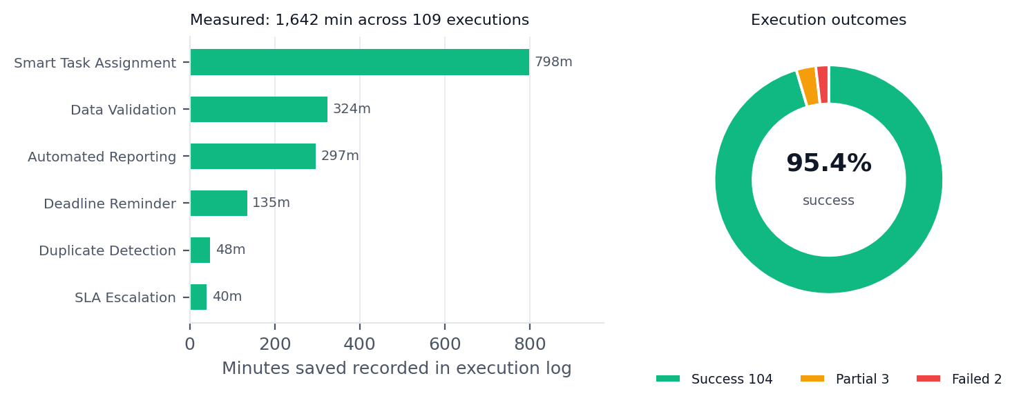
Figure 3 — What the execution log actually records (measured). Assignment and validation dominate because they touch every intake; reporting saves the most per single run but fires only daily.

Where the hours come from
Five processes account for 80% of the projected value (Figure 4). That concentration is good news for a pilot: Monthly Management Reporting, System Access Provisioning and IT Service Desk Ticket Triage together represent IDR 71.0m of the 119.1m monthly value, and two of the three sit in the two departments we propose piloting first.
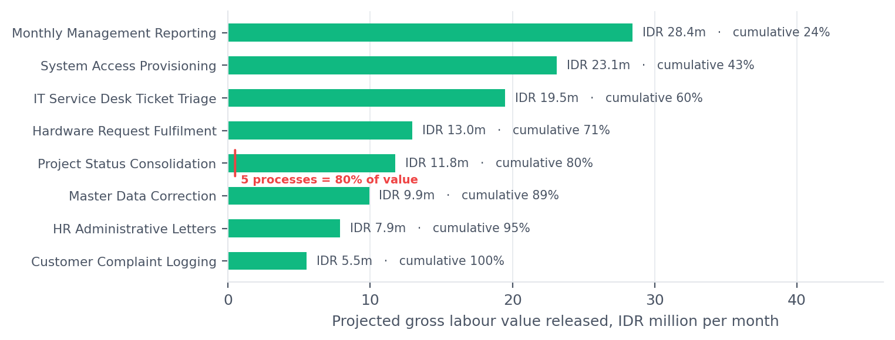
Figure 4 — Projected monthly value by process (baseline table × loaded hourly rate). Pareto: five of eight processes carry 80% of the benefit.

06 Error reduction opportunities
Error cost is the least-measured and most under-claimed part of the case. The application models two error rates per process — manual and after automation — and the portfolio-weighted reduction is substantial.
PROCESS | MANUAL ERROR RATE | AFTER AUTOMATION | REDUCTION | MECHANISM
Master Data Correction | 14.5% | 2.8% | −81% | Field-level validation, single write path
Monthly Management Reporting | 12.7% | 2.2% | −83% | Generated from records, not retyped
System Access Provisioning | 11.2% | 2.5% | −78% | Mandatory fields, no free-text routing
Project Status Consolidation | 10.1% | 3.4% | −66% | Consolidation from one data source
Hardware Request Fulfilment | 9.6% | 3.1% | −68% | Structured request, stock check at intake
IT Service Desk Ticket Triage | 8.4% | 1.2% | −86% | Deterministic routing rules
Customer Complaint Logging | 7.3% | 1.6% | −78% | Required fields + duplicate detection
HR Administrative Letters | 6.8% | 1.9% | −72% | Template generation from master data
Portfolio weighted | 9.4% | 2.0% | −79.2% | —

Converting that to money requires an assumption the demo cannot supply: what one error costs in rework. Using a deliberately simple model — each error costs three times the per-transaction handling time in rework and re-communication — the annualised exposure removed is approximately IDR 0.6bn (IDR 48.7m per month), before any allowance for reputational or compliance impact. This is a projection built on an unvalidated multiplier and should be re-based in Phase 0 by sampling 50 closed requests and pricing the actual rework.
WHAT IS MEASURED HERE
Only two error-adjacent facts are measured in the workspace: 7 requests (6.5%) were flagged by the Data Validation BOT for missing fields, format problems or likely duplicates, and the Duplicate Detection BOT (currently disabled) surfaced 12 candidate pairs from 71 submissions in its last full window against a review cap. Both are evidence that the checks fire; neither proves a 79% reduction.

07 SLA improvement opportunities
SLA compliance is 86.9% against a configured 85% target — the organisation is currently 1.9 percentage points above its own target, which sounds comfortable until the distribution is examined. Compliance is an average hiding a long tail.
SLA SIGNAL | VALUE | WHAT IT TELLS US
Completed within SLA | 73 of 84 (86.9%) | Baseline to beat; derived from real completion timestamps.
Requests past deadline | 7 | Critical ×2, High ×1, Medium ×3, Low ×1 — breaches are not confined to low priority.
Open work beyond 75% of window | 12 of 19 open | Escalation risk inside the current day, not at month-end.
Open work beyond 90% of window | 8 of 19 open | At-risk population the At-risk bucket reports.
Strictest policy | Critical = 4h (IT Support, System Access, Data Update) | Against a measured 3.8h average critical cycle time — a buffer of roughly 12 minutes at the mean.
Rejected requests | 5 (3 High, 2 Low) | A rejected request is a failed intake, not a satisfied one; intake quality is the first SLA lever.
Bottleneck stage | Data Validation 2.5h, Asset Handover 2.8h, Stock Availability 3.2h | Workflow dwell time, which Stage 3 of the plan targets once the connectors exist.
Per-person spread | 75% – 100% compliance across 8 staff | Two individuals account for 4 of 7 breaches; assignment balancing alone would move the average.

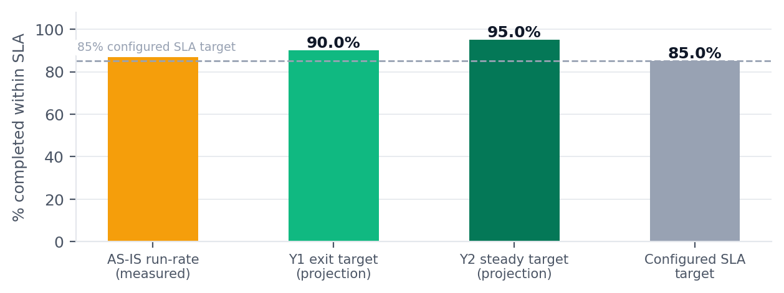
Figure 5 — SLA position today versus a proposed trajectory. The 90% and 95% markers are targets derived from the reminder/escalation design, not measured outcomes; they must be re-baselined after the pilot.

How the improvement is expected to arise
The clock starts at intake, not at attention. Because every channel writes the same record with a created time, the SLA window begins when the requester asks, removing the silent hours currently lost in someone's inbox.
Intervention happens at 75%, not after 100%. 12 of 19 open requests are already past the reminder threshold. A reminder that arrives while there is still time changes behaviour; an escalation after the fact only documents the failure.
Priority determines the window, so triage errors become visible. Nine categories × four priorities produce 36 distinct windows from 4h to 120h. A mis-prioritised request is now measurable rather than invisible.
Load balancing removes the queueing effect. Assignment targets the least-loaded available person. Four of the seven breaches sit with two individuals; spreading new work away from them is the cheapest available improvement.

08 Automation ROI assumptions
The ROI calculator is a transparent model with six inputs. Every assumption is printed here so that Finance can replace it with audited numbers before approval. The recommendation is to approve on the ROI calculator, which lands on the same hours as the baseline table. It is the model the finance team can audit line by line, and it agrees with the portfolio view to within 0.2% on hours, so approval does not depend on which one you believe.
# | INPUT | VALUE USED IN DEMO | WHY IT MATTERS / WHAT TO REPLACE IT WITH
A1 | Transactions per month | 1,870 | Matches the baseline table total of 1,870. Still worth replacing with actual ITSM/form counts for the last 6 months.
A2 | Manual processing time | 32 min / transaction | Baseline weighted average is 32.4 min. Use time-and-motion sampling on 30 requests per category.
A3 | Automated processing time | 7 min / transaction | Baseline weighted average is 7.5 min. Replace with measured touch time after the pilot.
A4 | Loaded hourly cost | IDR 145,000 | Finance must confirm: this is roughly a fully-loaded band 2–3 operations analyst rate. The baseline table uses 115,000–185,000 across departments.
A5 | Implementation cost | IDR 185,000,000 (one-off) | Not evidenced — an assumption. Should be replaced by the vendor/SI quote plus internal build time.
A6 | Monthly run cost | IDR 12,500,000 | Covers licensing, hosting, rule maintenance and CoE effort. Should be confirmed against a licensing quote.
— | Discounting, ramp-up, attrition | None applied | The model assumes day-one full benefit, no ramp curve, no discounting and no staff attrition offset. Figure 6 therefore overstates year 1 by construction.

Model output and its sensitivity
LINE | VALUE | BASIS
Manual hours / month | 997 h | 1,870 × 32 min
Automated hours / month | 218 h | 1,870 × 7 min
Hours released / month | 779 h | −78.1%
Gross labour value / month | IDR 113.0m | 779 h × IDR 145,000
Run cost / month | IDR 12.5m | A6
Net benefit / month | IDR 100.5m | gross − run cost
Annual net benefit | IDR 1205.8m | × 12, undiscounted
Implementation cost | IDR 185m | A5
Payback | 1.8 months | implementation ÷ net monthly
First-year ROI | 652% | annual net ÷ implementation

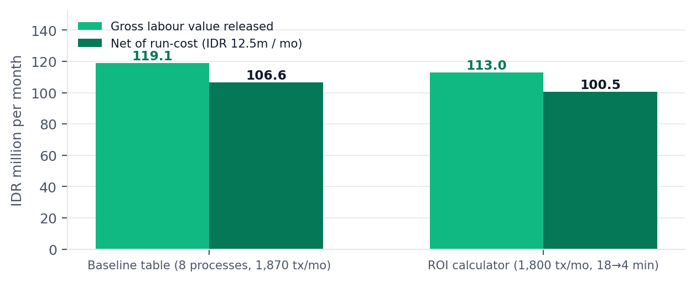
Figure 6 — The two financial views. Left: the baseline table across 8 processes (IDR 119.1m gross, 106.6m net). Right: the ROI calculator's blended-cycle model (IDR 113.0m gross, 100.5m net). Both rest on the same 1,870-transaction month; the calculator is the more conservative of the two because it prices every request at average effort rather than at each process's own rate.
ONE VOLUME, TWO COSTING METHODS — AND THEY AGREE
The ROI calculator is seeded from the baseline table, so both view the same 1,870 transactions a month and the same blended handling time (whole-minute 32→7 min, the baseline's volume-weighted 32.4→7.5 min rounded). The two side-by-side totals land within 0.2% of each other (779 h vs 778 h a month), which is the check Finance should apply first: two independently constructed models arriving at the same order of benefit. They are still not interchangeable, and the report uses them for different jobs. The calculator applies one average cycle time to every transaction, so it is the right basis for a commitment and the wrong tool for deciding which process to automate first. The baseline table prices each process at its own measured rate, so it ranks the portfolio. Neither applies ramp-up, discounting or attrition offset, so both overstate year one by construction. Replace A1–A6 with audited figures before the M1.5 gate.
SENSITIVITY — WHERE THE CASE BREAKS
Net monthly benefit falls below zero only if the loaded hourly rate drops under IDR 16,043 (an 83% fall) or the time saved per transaction falls under 0.9 minutes. Both are implausible. The case is far more sensitive to conversion than to arithmetic: if released hours are not redeployed or removed, the financial benefit is zero and only the SLA and quality benefits survive. That is Risk R3, and it is the single decision that determines this business case.

09 Implementation risks
ID | RISK | RATING | DESCRIPTION | MITIGATION
R1 | Master-data quality | Likely / Major | Routing keys (category → department → PIC) are assumed clean. If HRIS/ITSM master data is not, auto-assignment misroutes work and trust collapses in week one. | Phase 0 gate: ≥99% of active employees resolve to department + manager + calendar before Phase 1.
R2 | Adoption and shadow processes | Likely / Major | Requests keep arriving by WhatsApp, walk-in and e-mail outside the tool, so the dashboard under-reports and the SLA clock never starts. | Single-intake mandate plus e-mail-to-ticket connector; weekly 'requests created outside OpsFlow' control for 8 weeks.
R3 | Productivity benefit not converted to cash | Likely / Moderate | 77% cycle-time reduction releases hours; if headcount and cost base stay flat the benefit is capacity, not savings. | Agree the redeployment plan before approval; report released hours monthly as a delivery metric, and do not count cash savings in the first year of the business case.
R4 | BOT failure blast radius | Unlikely / Major | The engine is transactional, but a bad rule can flag large volumes — the duplicate BOT hit its review cap of 12 from 71 submissions. | Dry-run mode, per-run record caps, four-eyes approval on rule changes, automatic rollback above a write threshold.
R5 | SLA policy set too tight | Unlikely / Major | A 4h critical SLA against a 3.8h average critical cycle time leaves almost no buffer. | Recalibrate per-category SLA from measured percentile cycle times in Phase 1; review quarterly.
R6 | Integration scope creep | Unlikely / Moderate | Seven connectors are catalogued, each needing credentials, scopes and secret rotation. | Approve connectors per phase; everything beyond e-mail intake and Teams notification stays demo-mode.
R7 | Auditability and retention | Unlikely / Moderate | The prototype keeps its audit trail in browser localStorage; production needs an append-only server-side store. | Append-only audit table with hash chaining, 24-month retention, export API for internal audit.
R8 | Access-control gaps | Rare / Major | Role gating exists (Administrator / Operations Manager / Staff) but record-level visibility is not enforced server-side. | Server-side authorisation on every mutation, department/assignee-scoped reads, SSO with group mapping.

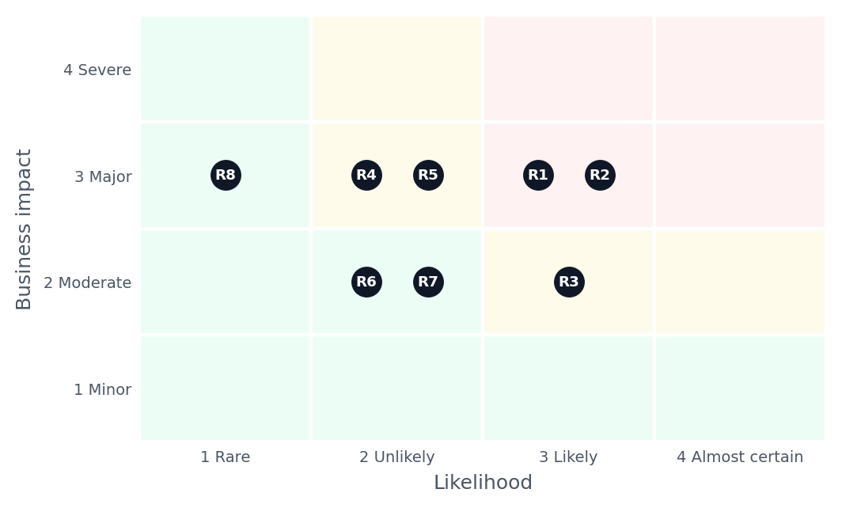
Figure 7 — Risk register plotted by likelihood and business impact. R1 and R2 are the only two that can stop the programme outright, and both are addressable in Phase 0.

Implementation plan and decision gates
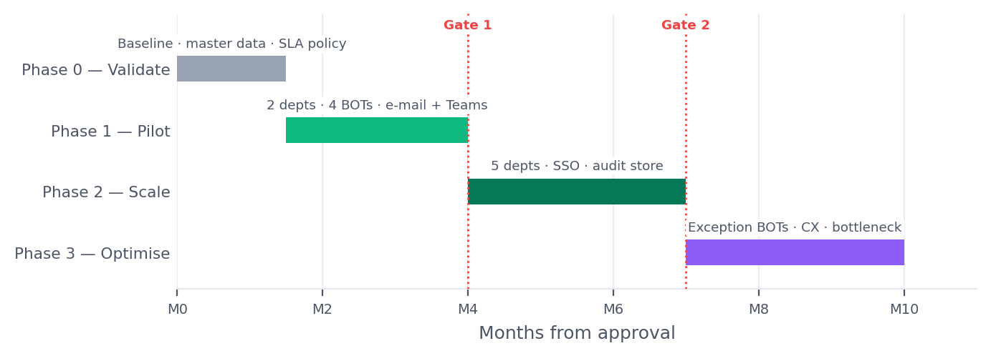
Figure 8 — Proposed phasing: validate, pilot in two departments, scale to five BOTs, then optimise. Funding is released at each gate.
PHASE | WINDOW | SCOPE | EXIT GATE (ALL MUST HOLD)
0 — Validate | Month 0–1.5 | Baseline time-and-motion, master-data clean-up, SLA policy recalibration | ≥99% routing-key resolution; 30 sampled requests timed per pilot category
1 — Pilot | Month 1.5–4 | IT Support + Finance, Assignment/Validation/Reminder/Reporting BOTs, e-mail intake, Teams alerts | SLA ≥90%, exception rate ≤5%, exec success ≥98%, released hours evidenced ≥70% of model
2 — Scale | Month 4–7 | All five departments, hardware + access workflows, SSO, audit store | Benefit realisation ≥80% of pilot run-rate; no P1 audit findings
3 — Optimise | Month 7–10 | Duplicate detection at scale, customer-experience intake, bottleneck automation | Portfolio ≥95% SLA, ≥85% coverage, run cost per transaction at or below model

10 Limitations of the current prototype
A validation report that does not state what is missing is marketing. The following are structural limits of the build as delivered, each with the production requirement it implies.
# | LIMITATION | CONSEQUENCE FOR THIS CASE | PRODUCTION REQUIREMENT
L1 | No server, database or API. State lives in browser localStorage behind a service layer. | Nothing here proves concurrency, scale or multi-user behaviour: 15 seeded users share one browser-local dataset, so there is no contention, no simultaneous edit and no server-side lock to test. | Server-side persistence with optimistic locking, an API layer and a migration path from the JSON seed.
L2 | No scheduler. BOTs run on demand; 'scheduled' runs are simulated. | Deadline reminders and daily reporting would not fire without someone pressing Execute. | Job runner with cron semantics, idempotency keys and retry/backoff.
L3 | No connector credentials. All seven integrations are demo-mode, configuration-required or not connected. | Intake from e-mail/Teams and delivery of notifications are unproven end to end. | OAuth/secret management, per-connector scopes, webhook ingestion with signature verification.
L4 | Notification delivery is in-app only; e-mail, Teams, Slack and Telegram toggles flag intent, not delivery. | Escalation reach is unproven — a breached SLA may notify nobody outside the browser. | Provider integration with delivery receipts and fallback channel.
L5 | Time-saved figures come from per-record constants in the rule definitions (6 min per assignment, 4 per validation, 3 per reminder), not from stopwatch measurement. | The 1,642 measured minutes prove the mechanism, not the true saving. | Instrument real touch time before/after on a sampled cohort in Phase 0.
L6 | The baseline process table is seeded demo data with plausible but unverified costs and error rates. | The 77% and IDR 119.1m figures are illustrative until replaced with audited baselines. | Rebuild the baseline with Finance and department heads before the pilot gate.
L7 | Authorization is client-side and demonstration-grade; record-level visibility is not enforced. | Cannot be presented as a security-approved system. | Server-side RBAC/ABAC, SSO, penetration test, audit immutability.
L8 | No robotic fulfilment. No system-of-record actions are executed on external systems. | The benefit stops at coordination; downstream provisioning remains manual. | RPA/API actions per system of record, with compensating transactions.
L9 | Single currency (IDR), single locale (en-GB), no multi-entity or multi-timezone handling. | Fine for a single-country pilot; blocks group rollout. | Locale/timezone-aware scheduling and per-entity SLA calendars.
L10 | No archiving, retention or data-residency controls. | Cannot be put in front of internal audit as a system of record. | Retention policy, archival, export API, residency configuration.

11 Recommended production integrations
The integration catalogue in the application lists seven connectors. All are currently non-functional by design. The recommendation is to sequence them by dependency and benefit, not to switch on all seven.
PRIORITY | INTEGRATION | CURRENT STATUS | WHY IT IS NEEDED | PHASE
P0 — blocking | Email (SMTP / IMAP) | Not Connected | Most requests still arrive by e-mail; without it the SLA clock starts late and adoption fails. | 1
P0 — blocking | Microsoft Teams or Slack | Not Connected / Configuration Required | Assignment and escalation must reach where people already work. | 1
P0 — blocking | Identity provider (SSO) | Not catalogued | Server-side roles and department scoping depend on a trusted identity source. | 2
P0 — blocking | HRIS master data | Not catalogued | Routing keys (person → department → manager → calendar) decide whether auto-assignment is safe. | 0
P1 — high | Google Forms / Portal intake | Demo Mode | External requesters need a form that writes directly to the queue. | 1
P1 — high | ITSM / service desk | Not catalogued | Avoid a second system of record; sync ticket state both ways for IT categories. | 2
P1 — high | Google Sheets / Excel | Demo Mode / Configuration Required | Finance and HR still run registers in spreadsheets during transition. | 2
P2 — medium | Finance ERP (reporting feed) | Not catalogued | Monthly management reporting is the largest single value driver; automation requires a data feed, not a spreadsheet. | 2
P2 — medium | Telegram / on-call alerting | Not Connected | Useful for out-of-hours SLA breach alerts only. | 3
P3 — later | Data warehouse / BI | Not catalogued | Replace the in-app analytics with the corporate BI layer once volume justifies it. | 3

INTEGRATION PRINCIPLE
Sequence by dependency (identity and master data first, because every BOT depends on them), then by adoption (e-mail and chat, because they close the shadow-process gap), then by value (the ERP feed behind monthly reporting). Each connector adds credentials to manage, so approving all seven at once converts an automation programme into an integration programme.

What 'connected' must mean before go-live
• Idempotency — a repeated inbound message must not create a duplicate request; the duplicate detection logic already in the prototype is the backstop, not the mechanism.
• Observability — every connector call logged with correlation ID, latency and outcome, visible in the automation health view.
• Failure semantics — an integration outage must queue, not drop. The engine's current all-or-nothing transaction per run is the right pattern to preserve.
• Reconciliation — a daily count of records created per channel, reconciled to the source system total, is the control that catches silent loss.

12 Quantitative acceptance criteria
Each criterion below is testable against the application or its successor and has a stated measurement method. Criteria marked evidenced can be checked in today's workspace; the rest become gate conditions for the pilot.
# | CRITERION | TARGET | MEASUREMENT METHOD | STATUS
AC1 | SLA compliance (completed within deadline) | ≥ 90% at pilot gate, ≥ 95% at scale | completedAt ≤ deadline over rolling 30 days | Baseline 86.9% — evidenced
AC2 | Requests past deadline at any point in time | ≤ 2% of open work | status = Overdue ÷ open | Baseline 7 of 19 open (37%) — evidenced
AC3 | Automation coverage of new intake | ≥ 85% auto-handled or validated | automationStatus ∈ {Auto-Assigned, Validated} ÷ total | Baseline 93.5% — evidenced
AC4 | Automation execution success rate | ≥ 98% | status = Success ÷ executions | Baseline 95.4% — evidenced
AC5 | Exception rate requiring human review | ≤ 5% of intake | automationStatus = Needs Review ÷ total | Baseline 6.5% — evidenced
AC6 | Rejected / failed intake | ≤ 2% of intake | status = Rejected ÷ total | Baseline 4.6% — evidenced
AC7 | Average resolution time (all categories) | ≤ 18h | completedAt − createdAt over rolling 30 days | Baseline 21.0h — evidenced
AC8 | Critical-priority resolution time | ≤ 3.5h | same, filtered to Critical | Baseline 3.8h (11 completed) — evidenced
AC8b | Manual completion rate (share closed by a person) | ≤ 22% of intake | status = Completed ÷ total | Baseline 77.8% — evidenced
AC9 | Cycle-time reduction per transaction | ≥ 60% versus Phase 0 baseline | time-and-motion sample, 30 per category | Projected 77% — to be measured
AC10 | Data error rate | ≤ 2.5% | audited error log ÷ transactions | Projected 2.0% — to be measured
AC11 | Released hours evidenced | ≥ 70% of model in month 4 | actual handling time saved, sampled | Not yet measurable
AC12 | Run cost per transaction | ≤ IDR 7,000 | monthly run cost ÷ transactions | Model: IDR 12.5m ÷ 1,870 = IDR 6,684 — marginal, monitor
AC13 | Audit completeness | 100% of BOT writes traceable to a record | execution log vs affected task IDs | Evidenced in prototype
AC14 | Intake outside the tool | ≤ 5% of total requests | manual reconciliation, weekly | Not measurable until connectors exist
AC15 | Zero horizontal page overflow | 0px at 390/768/1024/1440/1920 | automated QA suite | Evidenced — 45 route/viewport checks clean

HONEST SCORECARD
Of the sixteen criteria, ten are evidenced in the current build, four are projections that require production instrumentation (AC9, AC10, AC12 and the resolution-time targets after process change), and two (AC11, AC14) cannot be measured at all until the pilot runs with real connectors. The programme should be approved with those two stated as unknowns, not assumed.

13 Conclusion and recommendation
OpsFlow demonstrates a credible, auditable operating model for BAU work: one intake, deterministic routing, a clock that starts when the requester asks, intervention before the deadline rather than after it, and reporting that is a by-product of doing the work rather than a monthly project. The application's own data shows 93.5% of requests already handled by automation with a 95.4% execution success rate, and a modelled 778 hours per month of manual effort removed at portfolio scale.
The honest limitations are equally clear: the benefit is proven as a mechanism and as arithmetic, not yet as a financial outcome; and the largest single risk is not technical but organisational — whether released hours are actually converted into capacity or savings. A four-month, two-department pilot against the acceptance criteria in Section 12 is the cheapest way to find out.

RECOMMENDATION
Proceed to a gated four-month pilot (IT Support and Finance & Reporting), funded at approximately one quarter of the assumed implementation cost, with continuation to Phase 2 conditional on: SLA ≥ 90%, execution success ≥ 98%, exception rate ≤ 5%, and evidenced released hours ≥ 70% of model.

Basis of preparation
All measured figures were extracted from the running application workspace on 1 November 2026: 108 task records, 109 automation execution records (550 processed records), 72 activity events, 6 generated reports, 8 process baselines and the ROI input set. Figures are reproducible by running the application's own audit scripts (kpi-audit, integrity, e2e) and by regenerating this document with scripts/business-case/charts.py, which reads the same state export. Projections use the application's baseline table and ROI formulas without modification. No figure in this document was estimated by hand.
This report assesses a demonstration build. It is suitable for a management decision on whether to pilot; it is not a substitute for a vendor due-diligence, a security assessment or an audited benefits case. The preparation methodology is disclosed so that Finance can re-run every number with its own inputs before approval.

