Vista Apps User Manual
Role based operating guide for Vista Operations Vista POS and Vista Recovery
Last updated 14 September 2026
Use the section for your assigned account. Each procedure starts at the application navigation and ends after the record is saved, posted, completed, or reviewed.

Applications
Application | Address | Purpose
Vista Operations | https://vista-ops.whym.eu/login | ERP, CRM, Service, Logistics, Finance, Warehouse, Reports, and Security
Vista POS | https://vista-pos.whym.eu/login | Cashier shifts, sales, returns, checkout recovery, and POS reports
Vista Recovery | https://vista-recovery.whym.eu/login | Backup and recovery review

Training accounts
The staging demo accounts below use demo123.
Account | Role
admin@vista.com | Initial administrator
manager@vista.local | Operations manager
platform.manager@vista.local | Platform and business structure manager
crm@vista.local | CRM coordinator
warehouse@vista.local | Warehouse operator
procurement@vista.local | Procurement buyer
sales@vista.local | Sales coordinator
finance@vista.local | Finance officer
dispatcher@vista.local | Service dispatcher
technician@vista.local | Service technician
pos.operator@vista.local | POS operator
backup.operator@vista.local | Backup operator
viewer@vista.local | Read only reviewer

Current operating limits
1. Use the POS only in Test receipt mode until the approved fiscal device and PIN pad are connected and accepted.
2. Econt and Speedy pages show connection status; live booking is unavailable until approved provider credentials are added.
3. Vista Recovery is currently a review workspace. Creating policies, running backups, approving restores, and recording DR tests remain unavailable until Vista's infrastructure and hardware are connected.

1. All users
Account: Every account

Sign in
1. Open the login address for the required application.
2. Enter the email assigned to your role and the account password.
3. If an Authentication code field appears, enter the current six digit code from the enrolled authenticator app.
4. Select Sign in. Confirm that the first page belongs to the signed in role.
Fig. 1.1: application sign in page
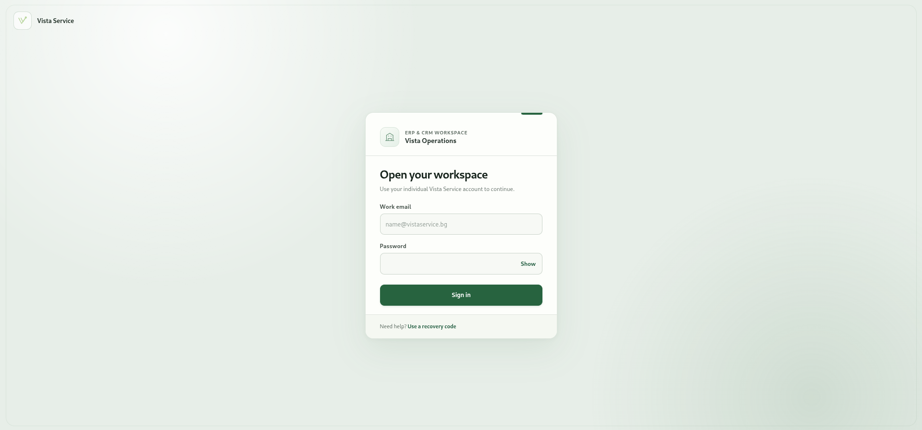

Set up an authenticator
1. Sign in to Vista Operations.
2. Open the account menu in the top right and select My access and security.
3. Under Authenticator app, select Set up authenticator.
4. Enter the current password and continue.
5. Scan the QR code with the authenticator app. If scanning is unavailable, enter the displayed setup key in the app.
6. Enter the current six digit code and select Confirm.
7. Sign out and sign in again to confirm the code is accepted.
Fig. 1.2: My access authenticator setup panel
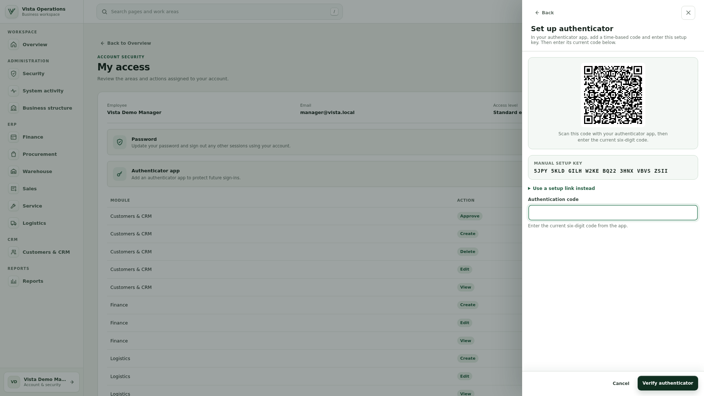

Use the workspace overview
1. Select Overview in the sidebar.
2. Review the KPI cards shown for the account.
3. Use the date and warranty filters when they are displayed, then select Apply.
4. Under Your work areas, select a card to open that module.
Fig. 1.3: Vista Operations overview and work areas
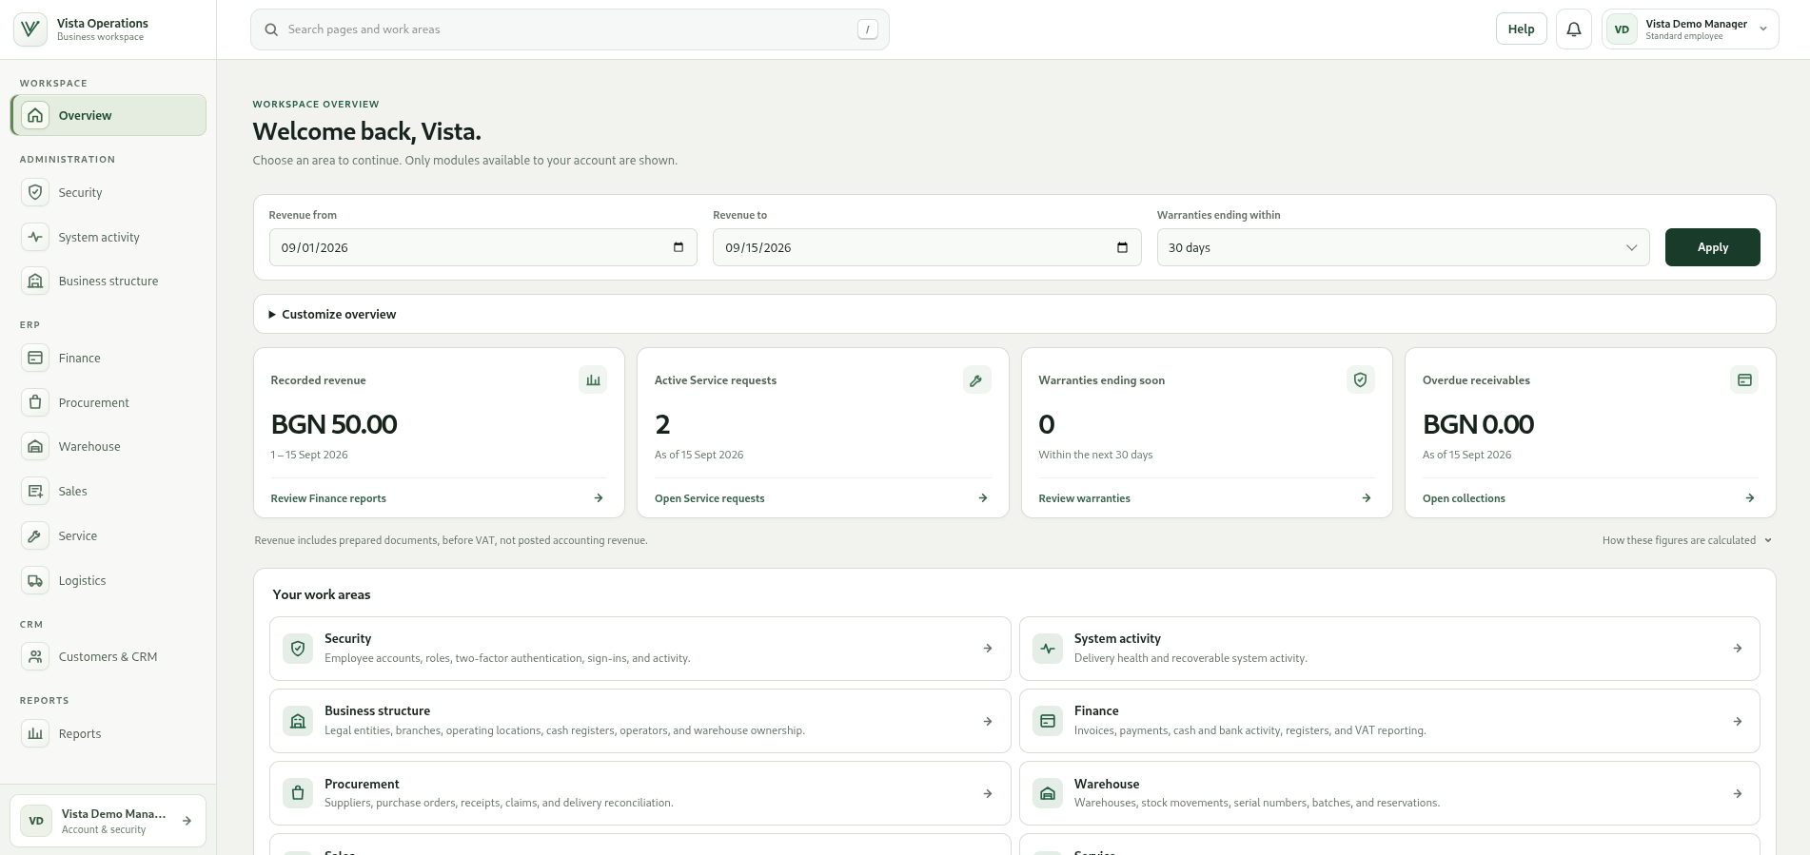

Find any available page
1. Select the global search box in the top bar.
2. Type a page or work area name, such as Purchase orders or Tickets.
3. Select the required result. Only pages available to the account are shown.
4. Use Back in the page or side panel to return without losing the workspace position.
Fig. 1.4: global page search results
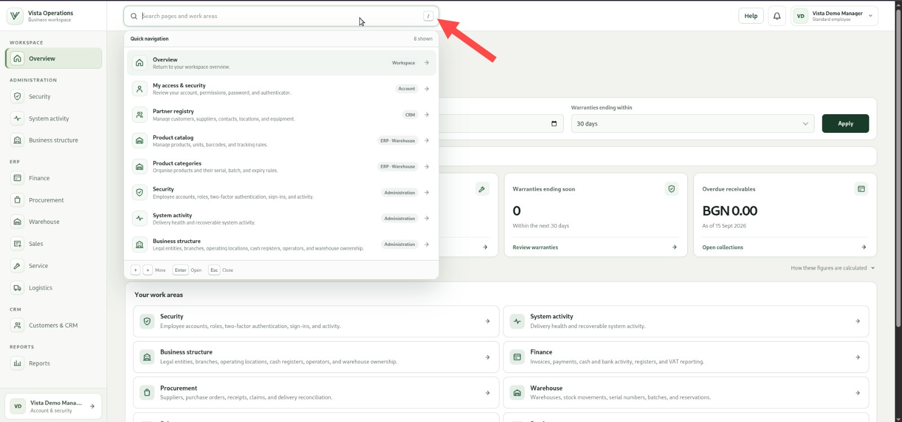

Review notifications
1. Select the notification bell in the top bar.
2. Open an unread notification to review its record and mark it as read.
3. Use the related page link when shown.
4. Close the notification panel to return to the current page.
Fig. 1.5: notification centre
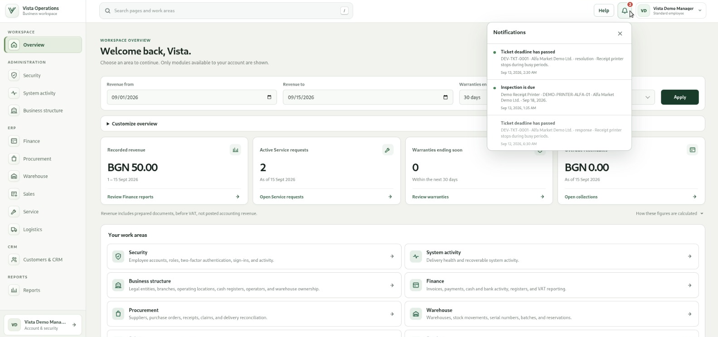

Change the password
1. Open the account menu and select My access and security.
2. Under Password, select Change password.
3. Enter the current password, the new password, and the new password again.
4. Meet every password rule displayed on the page, then select Update password.
5. Sign in with the new password on the next session.
Fig. 1.6: Change password panel
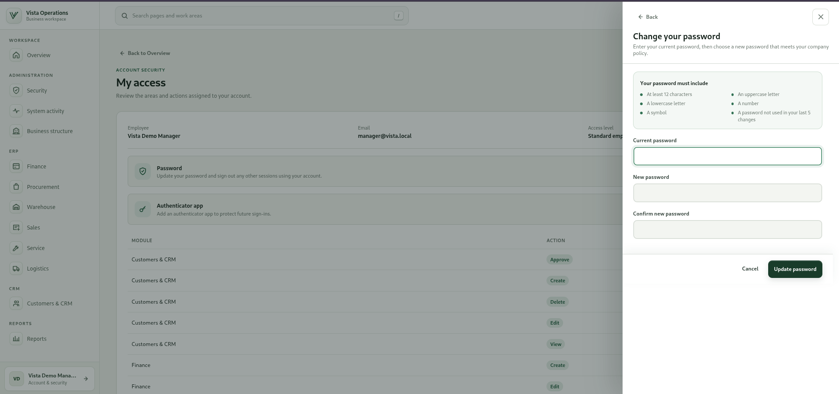

Check access and sign out
1. Open My access and security to review the account's modules and actions.
2. Open Help from the top bar when a page instruction is needed.
3. Open the account menu and select Sign out when work is complete.
Fig. 1.7: account menu and My access page
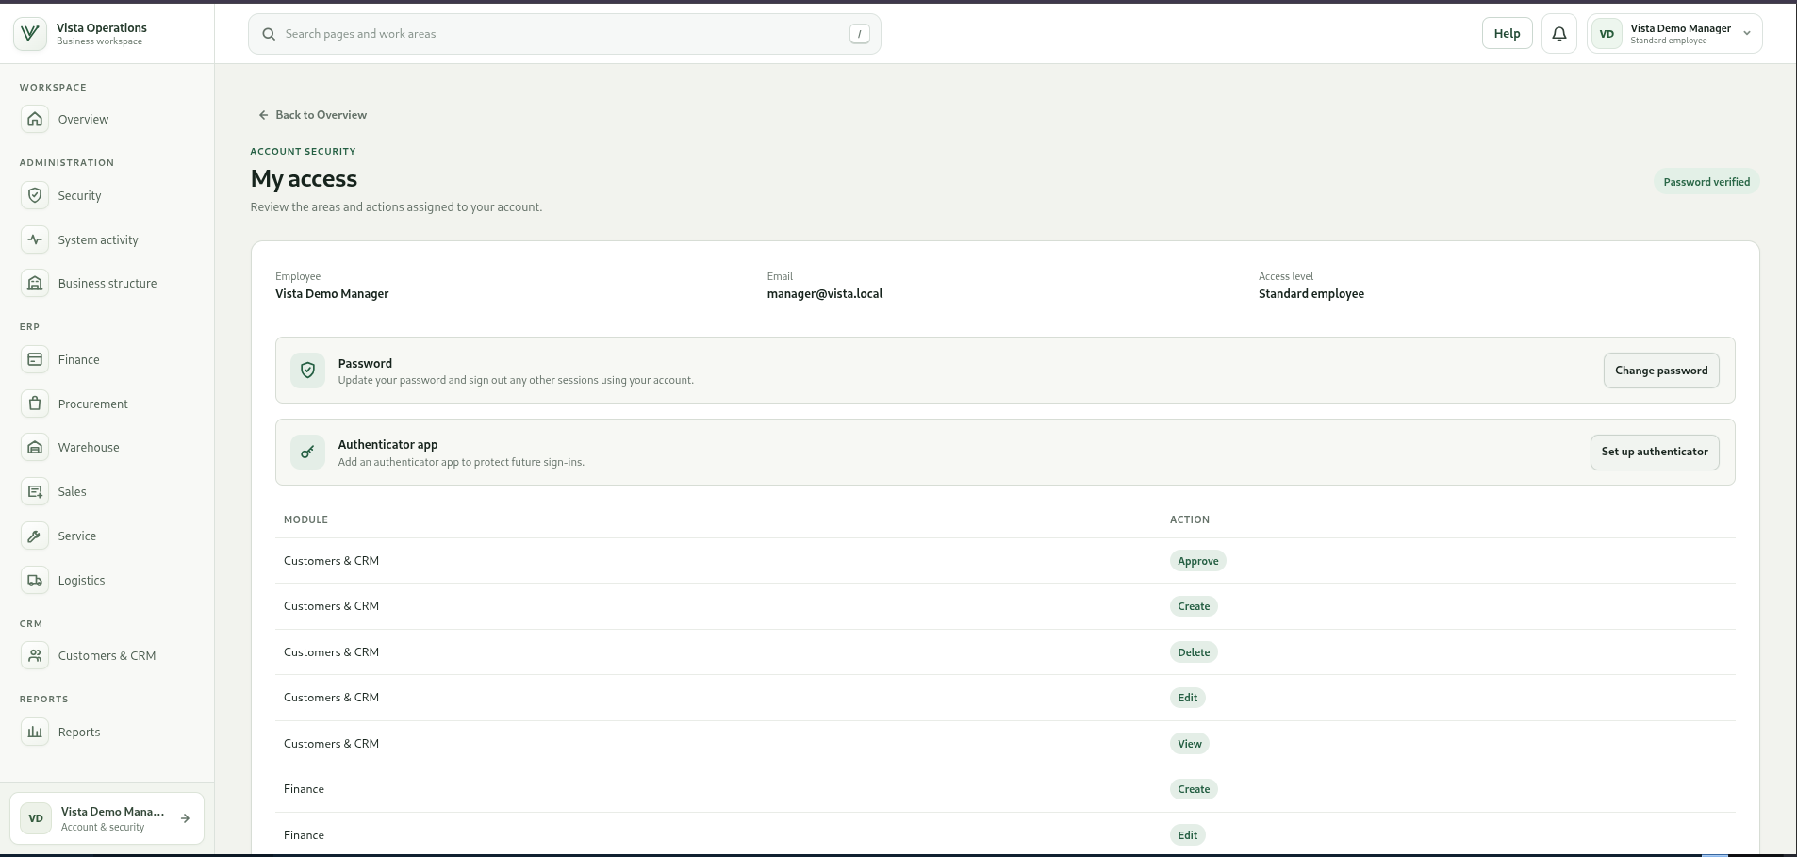

2. Initial administrator guide
Account: admin@vista.com
Use this account for employee access, roles, sessions, audit review, and configuration that requires administrative approval. It can also open every operational module.

Add an employee account
1. Open Administration, then Security.
2. Select Employees, then Add employee.
3. Enter the employee number, display name, email, and initial password required by the form.
4. Select Create employee.
5. Open the new employee, assign the approved role, and save the access change.
Fig. 2.1: [Insert screenshot - Security Employees page and Add employee panel]

Create a role
1. Open Administration, then Security, then Roles.
2. Select Add role.
3. Enter the role name, code, and description.
4. Enable only the approved module actions: View, Create, Edit, Delete, and Approve.
5. Mark the role administrative only when 2FA must be enforced for it.
6. Select Create role.
Fig. 2.2: [Insert screenshot - Security Roles page and Add role panel]

Assign roles or change an account status
1. Open Security, then Employees.
2. Search by employee name, email, or employee number.
3. Select Manage for the employee.
4. Select the approved roles and set the account to Active or Disabled as required.
5. Save the employee access change.
Fig. 2.3: [Insert screenshot - employee access management panel]

Issue an account recovery handoff
1. Sign in with the administrator account and complete 2FA.
2. Open Security, then Employees, and select Manage for the locked employee.
3. Select the recovery action and confirm the employee identity before continuing.
4. Generate the recovery handoff once and give it directly to the employee.
5. Ask the employee to open the Vista Operations Recover page, use the handoff, and set a new password.
Fig. 2.4: [Insert screenshot - employee recovery handoff panel]

Revoke an active login
1. Open Security, then Sessions.
2. Find the employee and confirm the browser, address, last activity, and session state.
3. Select Revoke for the session that must be closed.
4. Confirm that the session changes to Revoked.
Fig. 2.5: [Insert screenshot - Security Sessions page]

Review the activity log
1. Open Security, then Activity log.
2. Confirm that the Activity log checked indicator is shown.
3. Review the actor, action, target, time, and result for relevant events.
4. Use the account, module, and date details to investigate any unexpected action.
Fig. 2.6: [Insert screenshot - Security Activity log page]

Create the business structure
1. Open Administration, then Business structure.
2. Select Legal entity, enter the code, legal name, UIC, and VAT number, then select Add legal entity.
3. Select Branch, choose the legal entity, enter the branch code and name, then save.
4. Select Location, choose the branch, enter the location type and address, then save.
5. Select Operator, choose the location and employee account, enter the operator code, then save.
6. Select Cash register, choose the location, enter the code and name, assign allowed operators, then save.
Fig. 2.7: [Insert screenshot - Business structure page]

Review and retry system activity
1. Open Administration, then System activity.
2. Filter by status and open an item that needs attention.
3. Review the delivery steps, attempts, and recorded error.
4. Select Retry delivery only after the cause has been corrected, then confirm the retry.
5. Refresh and confirm that the same activity completes without creating a duplicate business record.
Fig. 2.8: [Insert screenshot - System activity details panel]

Operational pages available to the administrator
Use the specialist procedures in Sections 5 to 12 for CRM, Warehouse, Procurement, Sales, Finance, Service, Logistics, POS, and reporting. Do not use the administrator account to demonstrate restricted role behavior.

3. Operations manager guide
Account: manager@vista.local
Use this account to supervise ERP, CRM, Service, Logistics, POS approvals, reports, business structure, and read only Security activity.

Review daily operations
1. Open Overview.
2. Set the revenue period and warranty window, then select Apply.
3. Review revenue, active service requests, warranties ending soon, and overdue receivables.
4. Select a KPI or work area to open the related records.
5. Return to Overview and repeat for any item that needs attention.
Fig. 3.1: [Insert screenshot - manager Overview with KPI filters]

Approve operational work
1. Open the module that contains the pending record.
2. Open Preview and review the source, totals, status history, user, and date.
3. Select the available approval or completion action only when the record matches its source documents.
4. Return to the register and confirm the new status.
Fig. 3.2: [Insert screenshot - manager record preview with approval action]

Use the report library
1. Open Reports, then Report library.
2. Use Search reports to find the required module or standard report.
3. Select Open reports to work in that module's report page.
4. In the module report, choose the filters, columns, and format, select Save view, enter a clear name, and save.
5. Return to Report library. Under Saved views, open the saved report to review its module, report, dates, fields, and output format.
6. Select Export when it is available, then download the file when processing is complete.
Fig. 3.3: [Insert screenshot - Reports Report library]

Review scheduled exports
1. Open Reports, then Scheduled exports.
2. Open a schedule to review its saved view, cadence, reporting period, first run, timezone, state, and execution history.
3. Enable or disable a schedule only when the control is available and the delivery requirement is approved.
4. Open the related report view to correct filters before the next run when required.
Fig. 3.4: [Insert screenshot - Reports Scheduled exports]

Use the dashboard directory
1. Open Reports, then Dashboards.
2. Select Finance, Service, CRM, or POS to open its dashboard or reporting page.
3. Apply the available period and status filters.
4. Return to Dashboards to open another area.
Fig. 3.5: [Insert screenshot - Reports Dashboards page]

Manager page guide
Work area | Use these procedures
Security and Business structure | Sections 2.6 to 2.8 and 4.2. Security is read only for this account.
Customers and CRM | Section 5
Warehouse | Section 6
Procurement | Section 7
Sales | Section 8
Finance | Section 9
Service and Logistics | Sections 10 and 11
Reports | Sections 5.11, 6.8, 7.7, 8.7, 9.9, 10.7, and 11.6
POS approvals | Use a POS operator for the sale. Enter the manager's current six digit code only when the discount approval panel requests it.

4. Platform manager guide
Account: platform.manager@vista.local
Use this account to review Security and System activity and to create the approved business structure. It cannot add employees, create roles, revoke sessions, or approve account changes.

Review security
1. Open Administration, then Security.
2. Use Employees to review account status, assigned roles, 2FA state, and active-session count.
3. Use Roles to review permission sets.
4. Use Sessions to review active and expired sign-ins.
5. Use Activity log to review recorded actions and the integrity result.
Fig. 4.1: [Insert screenshot - read only Security tabs]

Add the approved organization records
1. Open Administration, then Business structure.
2. Create records in this order: Legal entity, Branch, Location, Operator, Cash register.
3. For each record, select its action, complete every required field, and save.
4. For an operator, select an existing employee account and the correct business location.
5. For a cash register, assign only the operators approved for that location.
6. Review the structure tree and confirm every child appears under the correct parent.
Fig. 4.2: [Insert screenshot - Business structure hierarchy]

Review system activity
1. Open Administration, then System activity.
2. Choose a status filter.
3. Open an activity row and review its delivery history and attempts.
4. Report items that need attention to an administrator if retry controls are not available to this account.
Fig. 4.3: [Insert screenshot - System activity register]

5. CRM coordinator guide
Account: crm@vista.local
Use this account for partners, locations, contacts, equipment, communications, leads, opportunities, tickets, warranties, feedback, referrals, and CRM analytics. It may create a Service request from a CRM ticket.

Create a partner
1. Open Customers and CRM, then Partners.
2. Select New partner.
3. Choose Legal entity or Individual and complete the required identity and contact fields.
4. For a legal entity, enter the UIC and VAT number when available.
5. Review any duplicate warning. Open the existing partner if it is the same party; do not create a duplicate.
6. Select Save partner.
Fig. 5.1: [Insert screenshot - New partner panel]

Update a partner profile
1. Open Customers and CRM, then Partners.
2. Search by name, UIC, VAT number, email, or telephone.
3. Select Preview for the partner.
4. Select Edit, change only the required details, then select Save changes.
5. Use the status action only when the partner must be activated or deactivated.
Fig. 5.2: [Insert screenshot - partner Preview panel]

Add an address contact or bank account
1. Open the partner Preview panel.
2. In Profile, select Add under Addresses, Contacts, or Bank accounts.
3. Complete the fields and select the correct address or contact role.
4. Select Save.
5. Confirm the new entry appears in the partner profile.
Fig. 5.3: [Insert screenshot - partner profile related record form]

Add a customer location and equipment
1. Open Partners and Preview the customer.
2. Select Customer overview.
3. Select Add location, enter the location name, type, address, and responsible contact, then save.
4. Open the new location and select Add equipment.
5. Choose the product or device, enter the serial number, purchase date, warranty period, and status, then save.
6. Use Customers and CRM, then Locations and equipment to review the shared register. Its page action is currently review only; create records through the customer Preview flow above.
Fig. 5.4: [Insert screenshot - Customer overview location and equipment panels]

Upload and replace a partner document
1. Open the partner Preview panel and select Documents.
2. Select Upload document, choose the file, enter its document details, and save.
3. Open the saved document to download it or show its versions.
4. Select Replace, choose the new file, and upload it.
5. Confirm that the new version is current and the earlier version remains listed.
Fig. 5.5: [Insert screenshot - partner Documents and versions panel]

Log a customer interaction
1. Open Customers and CRM, then Timeline.
2. Choose the customer and optional location. Set From and To dates only when filtering existing activity.
3. Select Log interaction.
4. Choose Incoming call, Outgoing call, Email, Chat, or On site visit.
5. Enter the subject, date, notes, contact, and location, then select Save interaction.
6. Open the saved interaction to add or review attachments.
Fig. 5.6: [Insert screenshot - Log interaction panel and customer timeline]

Create and complete a CRM task
1. Open Customers and CRM, then Timeline, and choose the customer.
2. Select New task.
3. Enter the task title, assignee, priority, due date, and notes, then save.
4. Open the task from Open tasks or the timeline.
5. Select the available completion action and confirm the task no longer appears as open.
Fig. 5.7: [Insert screenshot - New task and task detail panels]

Create qualify and convert a lead
1. Open Customers and CRM, then Leads and pipeline.
2. Select Leads, then New lead.
3. Choose Telephone, Referral, Website, or Trade exhibition as the source. Enter the prospect, contact details, interest, owner, and notes, then select Save lead.
4. Open the lead and select Mark as qualified.
5. Select Convert, choose whether to create the customer and opportunity, complete the required fields, and confirm conversion.
Fig. 5.8: [Insert screenshot - lead details and Convert panel]

Create and manage an opportunity
1. Open Leads and pipeline, then Sales pipeline.
2. Select New opportunity.
3. Choose the customer and owner. Enter the title, estimated revenue, probability, and stage, then save.
4. Drag the opportunity to New, Qualified, Quotation sent, Negotiation, Won, or Lost.
5. Open the opportunity to review history or link an existing Sales quotation.
Fig. 5.9: [Insert screenshot - Sales pipeline and opportunity panel]

Create and process a ticket
1. Open Customers and CRM, then Tickets.
2. Select New ticket.
3. Choose the customer, location, submission channel, priority, category, assignee, SLA policy when available, and enter the subject and description.
4. Select Create ticket.
5. Open the ticket, record the first response, update its status, and review its response and resolution deadlines.
6. For technical work, select Create service request and complete the Service details.
Fig. 5.10: [Insert screenshot - CRM ticket detail panel]

Open the linked Service request
1. After creating a Service request from a ticket, open Service, then Service requests.
2. Find the request by its number, customer, or linked ticket.
3. Open it and confirm the customer, location, equipment, serial, problem, source, and ticket link.
4. Create another request only when it represents separate work. Scheduling and completion belong to the dispatcher and technician roles.
Fig. 5.10A: [Insert screenshot - CRM linked Service request]

Manage warranty customer care feedback and referrals
1. Open Customers and CRM, then Customer care.
2. Use Warranties to open a warranty card, update the follow up status, or create a warranty claim.
3. For a claim, choose the device, describe the issue, attach evidence, and save. Open it again to move it through Received, Under review, Approved or Rejected, and Closed.
4. Use Feedback and NPS to record a completed survey and score after service or delivery.
5. Use Referrals to record the referring customer and prospect, then open the linked lead when it is created.
Fig. 5.11: [Insert screenshot - Customer care tabs and warranty claim panel]

Use CRM analytics
1. Open Customers and CRM, then Analytics.
2. Choose 30 days, 90 days, or This year.
3. Review purchase frequency, transaction value, retention, churn, lifetime value, pipeline, employee performance, and revenue views.
4. Use the revenue grouping to switch among product, service, customer, region, and responsible employee.
5. Apply available filters, then export or save the report view when those actions are shown.
Fig. 5.12: [Insert screenshot - CRM Analytics filters and report results]

6. Warehouse operator guide
Account: warehouse@vista.local
Use this account for product master data, categories, warehouses, receipts, issues, transfers, stocktakes, reservations, serial traceability, and Warehouse reports.

Review warehouse ownership
1. Open Administration, then Business structure.
2. Open the legal entity and branch that own the operating location.
3. Confirm the warehouse location, cash registers, and operators shown for that location.
4. Use the platform manager or administrator account if the business structure must be changed.
Fig. 6.0: [Insert screenshot - Business structure warehouse location]

Create a product category
1. Open Warehouse, then Product catalog, then Product categories.
2. Select Add category.
3. Enter the category name and code and choose its parent when it is a subcategory.
4. Choose Serial, Batch, or Standard tracking. Enable expiry tracking only where required.
5. Select Save category.
Fig. 6.1: [Insert screenshot - Product categories page and category form]

Create a unit and product
1. Open Warehouse, then Product catalog. If you open the Products and units summary page, use Back to Warehouse and choose Product catalog because the summary action is currently unavailable.
2. Open Units, select Add unit, enter the code, name, and decimal precision, then save.
3. Open Products and select Add product.
4. Enter the product code and name, then choose the category and unit.
5. Enter one or more barcodes and their types. Enter warranty months for a serial tracked device.
6. Select Save product.
Fig. 6.2: [Insert screenshot - Product catalog product and unit forms]

Add a warehouse
1. Open Warehouse, then Warehouses.
2. Select Add warehouse.
3. Enter the code and name, choose the owning business location, and choose Central, Service, or Technician warehouse as applicable.
4. Assign the technician for a mobile warehouse when requested.
5. Select Save warehouse.
Fig. 6.3: [Insert screenshot - Add warehouse panel]

Receive stock
1. Open Warehouse, then Movements.
2. Select New movement, then Receipt.
3. Choose the product and receiving warehouse.
4. Enter the quantity, source reference, and BGN unit cost.
5. For serial tracked products, enter exactly one unique serial per unit. For batch tracked products, enter the batch and expiry date when required.
6. Select Post receipt and confirm the movement appears in the register and Stock page.
Fig. 6.4: [Insert screenshot - Warehouse receipt movement panel]

Issue write off or transfer stock
1. Open Warehouse, then Movements, and select New movement.
2. Choose Issue, Write off, or Transfer.
3. Choose the product and source warehouse. For a transfer, also choose the destination warehouse.
4. Enter the quantity, source reference, reason, and required serials or batch.
5. Review availability, then post the movement.
6. Open Stock to confirm the source and destination balances changed once.
Fig. 6.5: [Insert screenshot - warehouse issue transfer and write off controls]

Review stock and low stock
1. Open Warehouse, then Stock.
2. Filter by warehouse, product, or stock status.
3. Review On hand, Reserved, Available, In transit, average cost, and minimum stock.
4. Open a low stock line to review the purchase recommendation.
5. Use Movements when a correcting receipt, issue, or transfer is required.
Fig. 6.6: [Insert screenshot - Stock overview and low stock recommendation]

Run a stocktake
1. Open Warehouse, then Stocktakes.
2. Select Start stocktake and choose the warehouse.
3. Open the stocktake and enter the counted quantity for each product and tracking identity.
4. Review each variance and correct any counting mistake before submission.
5. Submit the stocktake, then use the approval action available to this account.
6. Confirm that approved adjustments appear once in Stock movements.
Fig. 6.7: [Insert screenshot - stocktake count and variance review]

Create or release a reservation and trace a serial
1. Open Warehouse, then Reservations and trace.
2. Select New reservation.
3. Choose the warehouse, product, source type, source reference, and quantity. Choose exact serials when required.
4. Select Create reservation.
5. Use Release when the source work is cancelled.
6. Search a serial number to review supplier receipt, warehouse movement, sale, customer, Service, repair, and technician history.
Fig. 6.8: [Insert screenshot - reservation panel and serial trace]

Run a Warehouse report
1. Open Warehouse, then Reports.
2. Choose the report, date range, warehouse, status, grouping, and columns.
3. Select Apply.
4. Review totals and rows, then select XLSX, CSV, or PDF.
5. Open Recent exports to download a completed file or retry one that needs attention.
Fig. 6.9: [Insert screenshot - Warehouse report workspace and Recent exports]

7. Procurement buyer guide
Account: procurement@vista.local
Use this account for suppliers, purchase orders, receipts from purchase orders, supplier invoices, supplier claims, and Procurement reports.

Review a supplier and record an evaluation
1. Open Procurement, then Suppliers.
2. Search for the supplier and select Preview.
3. Review contact details, payment terms, and delivery terms.
4. Select the evaluation action, enter a score from 1 to 5 and a clear note, then save.
5. Confirm the new evaluation appears in the supplier history.
Fig. 7.1: [Insert screenshot - supplier Preview and evaluation form]

Create a purchase order
1. Open Procurement, then Purchase orders.
2. Select Create purchase order.
3. Choose TechSupply Demo Ltd. and the receiving warehouse.
4. Enter currency, delivery terms, payment terms, and an expected delivery date in the future.
5. Add each product, quantity, and unit price.
6. Select Save order, then open Preview and confirm the totals and delivery date.
Fig. 7.2: [Insert screenshot - Create purchase order and Preview panels]

Receive a purchase order
1. Open Procurement, then Purchase orders, and Preview the open order.
2. Select Receive delivery.
3. Enter only the quantity received now and the supplier delivery reference.
4. For a serial tracked product, enter one unique serial per received unit. For a batch tracked product, enter the batch and expiry date when required.
5. Enter the BGN unit cost and select Receive delivery.
6. Confirm the order shows Part received or Received and the Goods receipts tab contains the new receipt.
Fig. 7.3: [Insert screenshot - Receive purchase order panel]

Review a goods receipt
1. Open Procurement, then Goods receipts.
2. Find the receipt by purchase order or delivery reference.
3. Open the receipt and compare the supplier, warehouse, products, quantities, serials or batches, and cost with the delivery.
4. Open Warehouse, then Stock only if the receiving balance needs confirmation.
Fig. 7.4: [Insert screenshot - Goods receipt details]

Record a supplier invoice
1. Open Procurement, then Supplier invoices.
2. Select Record supplier invoice.
3. Choose the supplier and purchase order, then enter the supplier invoice number, invoice date, due date, and currency.
4. Include the delivered lines that appear on the invoice. Enter each invoiced quantity, unit price, VAT treatment, and VAT rate when required.
5. Review the ordered, delivered, and invoiced comparison, then select Record invoice.
6. Preview the invoice and confirm VAT details are complete or correct the missing line.
Fig. 7.5: [Insert screenshot - Record supplier invoice and invoice Preview panels]

Create and progress a supplier claim
1. Open Procurement, then Supplier claims.
2. Select New supplier claim.
3. Choose the supplier, purchase order, goods receipt, and affected product.
4. Choose Damaged or Non conforming, enter the quantity and description, attach supporting files, and save.
5. Open the claim and move it through Open, Submitted, Resolved, and Closed as the supplier responds.
6. Confirm the complete status history remains visible.
Fig. 7.6: [Insert screenshot - supplier claim form and status history]

Run a Procurement report
1. Open Procurement, then Reports.
2. Choose the report and set the date, supplier, status, grouping, and column filters.
3. Select Apply and review the results.
4. Select XLSX, CSV, or PDF.
5. Open Recent exports to download the completed file.
Fig. 7.7: [Insert screenshot - Procurement report workspace]

8. Sales coordinator guide
Account: sales@vista.local
Use this account for quotations, order confirmation, reservation, shipment, handover, invoice draft preparation, prices, promotions, service subscriptions, and Sales reports.

Create a quotation
1. Open Sales, then Quotations.
2. Select New quotation.
3. Choose Alfa Market Demo Ltd., Demo Central Warehouse, BGN, and a validity date at least seven days ahead.
4. Add the product or service. Enter quantity, unit price, line discount, VAT treatment, and any overall discount.
5. Select Save quotation, then select Preview.
Fig. 8.1: [Insert screenshot - New quotation and Preview panels]

Confirm the order and reserve stock
1. Open the quotation Preview panel.
2. Review the customer, warehouse, validity, lines, discounts, VAT, and total.
3. For every serial tracked line, select the exact number of available serials requested by the line quantity.
4. Select Confirm order and reserve stock.
5. If stock is insufficient, open Warehouse, receive stock into the quotation warehouse, then return and retry.
6. Confirm that the timeline shows a Confirmed order number.
Fig. 8.2: [Insert screenshot - quotation serial selection and confirmation]

Create the shipment handover and invoice draft
1. Continue in the confirmed quotation Preview panel.
2. Choose batches for batch tracked lines when the page requests them.
3. Select Create shipment.
4. Complete the handover or acceptance action and enter the customer acceptance details requested by the panel.
5. Select Prepare invoice draft.
6. Confirm that the timeline contains Quotation, Confirmed order, Shipment, Handover, and Invoice draft.
Fig. 8.3: [Insert screenshot - completed Sales timeline]

Review orders and shipments
1. Open Sales, then Sales orders.
2. Open the order created from the quotation and verify its customer, reservation, serials, status, and shipment link.
3. Open Shipments and handover.
4. Open the shipment and verify the warehouse release, delivery link, handover, and invoice draft link.
Fig. 8.4: [Insert screenshot - Sales order and Shipment registers]

Create customer pricing
1. Open Sales, then Prices and promotions.
2. Use Customer groups to create a group when group pricing is needed.
3. Use Price lists to create a list for all customers, one group, or one customer. Enter its period, priority, currency, products, and prices, then save.
4. Use Campaigns to create a promotional period and connect it to the relevant pricing.
5. Use Check price to choose a customer, product, and date and confirm the applied price list.
Fig. 8.5: [Insert screenshot - Prices and promotions tabs]

Create a service subscription
1. Open Sales, then Service subscriptions.
2. Select New contract.
3. Choose the customer location and covered equipment.
4. Enter visit frequency, included services, contract period, price, currency, and billing cycle.
5. Set the contract Active when it is approved, then save.
6. Open Preview to confirm coverage and recurring billing details. Use Edit when a permitted change is required.
Fig. 8.6: [Insert screenshot - New service contract and subscription Preview]

Run a Sales report
1. Open Sales, then Reports.
2. Choose the report and apply the date, status, customer, product, grouping, and column filters.
3. Select Apply and review the totals and rows.
4. Select XLSX, CSV, or PDF and download the completed file from Recent exports.
Fig. 8.7: [Insert screenshot - Sales reports and export history]

9. Finance officer guide
Account: finance@vista.local
Use this account for financial document drafts, collections, payments, customer credit and advances, supplier payables, cash vouchers, bank reconciliation, journals, VAT, and Finance reports.

Create a financial document
1. Open Finance, then Financial documents.
2. Select New financial document.
3. Choose Invoice, Proforma invoice, Credit note, or Debit note.
4. Choose the source, issuing location, customer, cash register and operator when applicable.
5. Enter document date, tax event date, due date, currency, and the exchange rate details when the currency is not BGN.
6. Add the lines and choose the VAT treatment for each line. Link the original document for a credit or debit note.
7. Enter notes, then select Prepare draft and open Preview.
Fig. 9.1: [Insert screenshot - New financial document and Preview panels]

Cancel a financial document draft
1. Open Finance, then Financial documents.
2. Preview the Draft that should not be used.
3. Verify that no later workflow depends on it.
4. Select Cancel, enter the reason when requested, and confirm.
5. Confirm the register shows Cancelled and retains the document history.
Fig. 9.2: [Insert screenshot - cancelled financial document Preview]

Add an invoice draft to collections
1. Confirm that Sales has completed the shipment and selected Prepare invoice draft.
2. Open Finance, then Collections and payments.
3. Select Add to collections.
4. Choose the prepared Sales invoice draft and enter its due date.
5. Select Add collection record.
6. Open the new row and verify the original amount, paid amount, outstanding balance, and status.
Fig. 9.3: [Insert screenshot - Add to collections and collection record]

Record a customer payment
1. Open Finance, then Collections and payments.
2. Open the unpaid or partly paid collection and select Record payment.
3. Choose Cash, Bank transfer, POS terminal, Card payment, or Compensation.
4. Enter the amount, paid date, reference, and note, then save.
5. Confirm the outstanding balance and status change to Partially paid or Paid.
Fig. 9.4: [Insert screenshot - Record payment panel]

Set POS credit terms or record a customer advance
1. Open Finance, then Customer payment accounts.
2. Choose the customer.
3. To allow on account POS sales, enter the credit limit, due period, start date, and end date, then save the terms.
4. To record an advance, select Record advance, enter amount, date, method, reference, and note, then save.
5. Confirm the available credit and unused advance balance shown for the customer.
Fig. 9.5: [Insert screenshot - Customer payment account and advance panel]

Record and pay a supplier payable
1. First record the matched supplier invoice under Procurement, then Supplier invoices.
2. Open Finance, then Supplier payables.
3. Open the supplier invoice and verify its gross amount, due date, paid amount, and balance.
4. Select Record payment, enter the payment method, amount, date, reference, and note, then save.
5. Confirm the payable status and balance update.
Fig. 9.6: [Insert screenshot - Supplier payable Preview and payment panel]

Record and allocate a supplier advance or offset
1. Open Finance, then Supplier payables.
2. Select Record advance, choose the supplier, and enter amount, date, method, reference, and note.
3. Open the saved advance and allocate the required amount to an open supplier invoice.
4. To settle customer and supplier balances by compensation, select the offset action, choose the partner records, enter the amount and date, and save.
5. Confirm that both balances and the allocation history changed once.
Fig. 9.7: [Insert screenshot - supplier advance allocation or offset panel]

Create a cash voucher and review the daily cash report
1. Open Finance, then Cash operations.
2. Select New cash voucher and choose Receipt or Payment.
3. Choose the location, cash register, operator, counterparty, and linked collection when applicable.
4. Enter the amount, date, reason, reference, and note, then save.
5. Use the daily report filters to choose the date, location, and cash register.
6. Review opening cash, receipts, payments, and closing cash.
Fig. 9.8: [Insert screenshot - Cash voucher and daily cash report]

Enter and reconcile a bank statement
1. Open Finance, then Bank reconciliation.
2. Select New statement.
3. Choose the bank account and enter statement reference, statement date, opening balance, and closing balance.
4. Add each transaction with date, direction, amount, currency, reference, counterparty, and description. Ensure opening plus incoming minus outgoing equals closing.
5. Save the statement and open it.
6. Accept an automatic match only when the reference and amount agree. Otherwise select Review match, choose the correct invoice or advance, and confirm.
Fig. 9.9: [Insert screenshot - bank statement entry and matching panel]

Run Finance registers journals and VAT reports
1. Open Finance, then Finance reports.
2. Choose Receivables, Supplier payables, Turnover, Document journals, or VAT.
3. Choose the report subtype, such as Sales or Purchases, and set the date range and available filters.
4. Select Apply.
5. Review aging buckets, balances, gross amounts, allocated amounts, VAT bases, and VAT amounts as relevant.
6. Select XLSX, CSV, or PDF and download the completed file from Recent exports.
Fig. 9.10: [Insert screenshot - Finance report tabs and results]

10. Service dispatcher guide
Account: dispatcher@vista.local
Use this account for Service intake, work order creation, scheduling, assignments, workload, warranty and inspection records, Service completion review, and Service reports.

Create a service request
1. Open Service, then Service requests.
2. Select New service request.
3. Choose the customer, business location, device and serial number.
4. Choose Telephone, Email, Customer portal, or On site visit as the source.
5. Choose Warranty, Out of warranty, or Subscription as the service type. Enter priority, problem description, appointment date, start time, and duration.
6. Select Save request.
Fig. 10.1: [Insert screenshot - New service request panel]

Schedule and assign a work order
1. Open the saved Service request.
2. Select the work order or scheduling action.
3. Choose technician@vista.local, the technician warehouse, appointment date, start time, and duration.
4. Keep the appointment time consistent when the same stop will be used in Logistics.
5. Save the assignment and confirm it appears in Work orders and Schedule.
Fig. 10.2: [Insert screenshot - Service assignment and schedule panel]

Reschedule or cancel Service work
1. Open Service, then Service requests or Work orders.
2. Open the required record.
3. Use Reschedule to choose a new date, time, duration, and reason, then save.
4. Use Cancel only when approved, enter the cancellation reason, and confirm.
5. Open Schedule and verify that the calendar reflects the latest status.
Fig. 10.3: [Insert screenshot - Service reschedule or cancel action]

Review technician workload
1. Open Service, then Schedule.
2. Choose the date or period and technician.
3. Review assigned visits, start times, durations, overlaps, and completed work.
4. Open a scheduled item to review the request and work order.
5. Reassign or reschedule only when capacity or priority requires it.
Fig. 10.4: [Insert screenshot - Technician schedule and workload]

Review equipment Service history
1. Open Service, then Equipment history.
2. Search by customer, device, or serial number.
3. Open the device.
4. Review sale, visits, repairs, services, parts, assigned technician, dates, warranty, and current status.
Fig. 10.5: [Insert screenshot - Equipment history by serial number]

Manage warranties claims and inspections
1. Open Service, then Warranty and inspections.
2. Use Warranties to review remaining coverage and claim history.
3. Create or open a claim, review evidence, and record its decision and status.
4. Use Inspections to schedule a technical or metrological inspection with type, due date, assigned technician, and notes.
5. Open a completed inspection and record the result, next due date, and evidence.
Fig. 10.6: [Insert screenshot - Service care warranty and inspection panels]

Run a Service report
1. Open Service, then Reports.
2. Choose Service request register, Technician performance, or Service cost summary.
3. Set the date range and available customer, technician, status, and service type filters.
4. Select Apply, review totals and rows, then select XLSX, CSV, or PDF.
5. Download the completed file from Recent exports.
Fig. 10.7: [Insert screenshot - Service reports and export history]

11. Service technician guide
Account: technician@vista.local
Use this account to review assigned Service work, record work performed, consume parts, upload photos, capture a customer signature, and complete the work order. Service report approval is not assigned.

Find assigned work
1. Open Service, then Schedule or Work orders.
2. Choose the current date and open the work order assigned to the signed in technician.
3. Review the customer, location, device, serial number, problem, service type, appointment time, and technician warehouse.
4. Select the start or in progress action when work begins.
Fig. 11.1: [Insert screenshot - technician assigned work order]

Record time parts photos and signature
1. Open the assigned work order.
2. Add working time with the date, duration, labor rate or value when displayed, and work note.
3. Add each used spare part from the technician warehouse and enter the quantity and tracking identity required by the product.
4. Upload clear photos or supporting files in the evidence section.
5. Capture the customer's signature and signer name.
6. Review labor, parts, transport, and total repair cost.
Fig. 11.2: [Insert screenshot - technician work entry and evidence panel]

Complete a work order
1. Confirm that time, parts, work description, photos, and signature are complete.
2. Select Complete work order.
3. Confirm the completion action.
4. Open Completed work or the work order history and verify the completion date, costs, evidence, and parts used.
5. Open Warehouse stock only through an authorized account if the technician warehouse deduction must be checked.
Fig. 11.3: [Insert screenshot - completed Service work order]

Review device history
1. Open Service, then Equipment history.
2. Search the serial number serviced.
3. Open the device and confirm that the completed visit, technician, date, services, and parts appear in its history.
Fig. 11.4: [Insert screenshot - device Service history]

Review requests schedule and customer care
1. Open Service, then Service requests to review the source request for assigned work.
2. Open Schedule to review current and completed appointments.
3. Open Warranty and inspections to review coverage, claims, and inspection dates for the device.
4. Use the dispatcher account when a new request, assignment, inspection, or report must be created or approved.
Fig. 11.5: [Insert screenshot - technician Service request schedule and care pages]

12. Logistics operating guide
Account: manager@vista.local
Use the manager account for Logistics because the current demo does not include a separate Logistics account. The account can create and update deliveries, returns, and routes.

Plan and complete a delivery
1. Open Logistics, then Deliveries.
2. Select Plan delivery.
3. Choose the Sales shipment, customer location, delivery method, scheduled date, delivery window, and driver notes, then save.
4. Open the delivery and select Dispatch when it leaves.
5. Select Complete delivery, enter the recipient name and receipt notes, and confirm receipt.
6. If delivery cannot continue, record an Exception with the reason. Resume or cancel it after review.
Fig. 12.1: [Insert screenshot - Delivery Preview and completion panel]

Review courier connections
1. Open Logistics, then Couriers.
2. Review Econt and Speedy connection status.
3. Do not attempt live shipment creation until the approved provider account and credentials are connected.
4. After connection, use the linked delivery to create, track, and reconcile the courier shipment.
Fig. 12.2: [Insert screenshot - Courier connections page]

Register and receive a return
1. Open Logistics, then Returns and reverse logistics.
2. Select Register return.
3. Choose the original shipment, customer location, returned line, quantity, serials where required, collection method, and reason.
4. Choose Send to Service for a repairable device or Return to stock for an eligible product.
5. For Service, choose the customer equipment and service type, then save.
6. Open the return and select Receive return. Confirm the stock or Service request link after receipt.
Fig. 12.3: [Insert screenshot - Register return and Receive return panels]

Plan a route
1. Open Logistics, then Routes.
2. Select Plan route.
3. Enter the route title, date, assignee, start location, and end location.
4. Add Delivery or Service visit stops in the required order.
5. For a Service stop, keep the scheduled appointment time and duration shown by the Service record.
6. Enter notes, save the route, and open it to verify the stop order.
Fig. 12.4: [Insert screenshot - Plan route panel and route calendar]

Run a Logistics report
1. Open Logistics, then Reports.
2. Choose the report and apply date, method, status, route, location, and available column filters.
3. Select Apply and review totals and records.
4. Select XLSX, CSV, or PDF and download the completed file from Recent exports.
Fig. 12.5: [Insert screenshot - Logistics report workspace]

13. POS operator guide
Account: pos.operator@vista.local
Use this account only in Vista POS for shifts, sales, returns, saved checkout recovery, and POS reports.

Open a shift
1. Sign in to Vista POS.
2. Select Shifts in the left navigation or Open shift in the top bar.
3. Choose Demo POS terminal.
4. Enter the counted opening cash amount.
5. Select Open shift and confirm the shift number appears in the top bar.
Fig. 13.1: [Insert screenshot - POS Open shift page]

Complete a cash sale
1. Open Sell.
2. Scan the barcode, enter the product code, search by name, or use Quick access.
3. Select the product to add it to the basket and adjust quantity with the minus and plus controls.
4. For a serial tracked product, select exactly one available serial for each unit.
5. Choose Cash, enter Cash received, and confirm the calculated change.
6. Select Complete sale and keep the receipt panel open until the receipt information is confirmed.
Fig. 13.2: [Insert screenshot - POS sale basket and Cash payment]

Choose a customer and use customer pricing
1. Open Sell and select Customer or press F4.
2. Search by company, UIC, or VAT number.
3. Select Alfa Market Demo Ltd. and confirm the customer appears above the basket.
4. Add the product and confirm that any individual, group, or campaign price is shown before payment.
Fig. 13.3: [Insert screenshot - POS customer picker and applied pricing]

Apply an authorized manual discount
1. Add a product to the sale and choose the customer when required.
2. Open Offers and rewards, then select Manual discount.
3. Choose Percentage or Fixed amount, enter the value and reason.
4. When manager approval is required, enter the approving manager account and its current six digit authenticator code.
5. Select Approve and confirm the discount and approver appear in the sale summary.
Fig. 13.4: [Insert screenshot - POS manual discount approval]

Use loyalty points
1. Choose a customer with a loyalty account.
2. Open Offers and rewards, then select the reward points entry.
3. Review available points and points activity.
4. Enter Points to use without exceeding the available balance, then apply.
5. Complete the sale and confirm earned or redeemed points in the receipt and later loyalty activity.
Fig. 13.5: [Insert screenshot - POS loyalty points panel]

Use card split on account or advance payment
1. Prepare the basket and choose the customer when the method requires customer credit or advance.
2. Choose Bank card to use the current test card flow, or Split to enter cash and card amounts that equal the total due.
3. Choose On account only when the customer has active terms and enough available credit.
4. Choose Advance when the customer has an unused advance; enter the advance amount and choose the remaining payment method when needed.
5. Select Complete sale and verify every payment component in the receipt.
Fig. 13.6: [Insert screenshot - POS payment methods]

Use the receipt and warranty cards
1. After a successful sale, review the fiscal receipt number, customer, items, serials, VAT, payments, and totals.
2. Review the receipt details and retain the receipt number for Sale history.
3. For a serial tracked device, open each generated warranty card and confirm the customer, product, serial, sale date, and warranty period.
4. Use the invoice action only when it is available for the completed sale.
5. Close the receipt panel after the records have been checked.
Fig. 13.7: [Insert screenshot - POS receipt and warranty cards]

Process a linked return
1. Open Returns.
2. Find the original receipt under Receipts with returnable items and select Return.
3. Choose the products and quantities, then enter the reason and refund method.
4. Select Complete return.
5. Review the return receipt and confirm the original sale, payment reversal, serial, and stock result are linked.
Fig. 13.8: [Insert screenshot - POS return panel and return receipt]

Review sale history
1. Open Sale history.
2. Use the available search or period controls to find the sale.
3. Open the sale and review the receipt, customer, products, serials, payments, returns, and warranty cards.
Fig. 13.9: [Insert screenshot - POS Sale history]

Recover an interrupted checkout
1. If completion is interrupted, do not click Complete sale repeatedly.
2. Open Checkout recovery from the left navigation or the footer status.
3. Review the pending checkout and Recent activity.
4. Reconnect the network when required and allow the application to retry the same checkout.
5. Open the recovered receipt and confirm that No second sale was created.
Fig. 13.10: [Insert screenshot - POS Checkout recovery]

Close a shift
1. Confirm that no checkout is pending and all receipts and returns are complete.
2. Open Shifts and select the current shift.
3. Review opening cash and transaction totals.
4. Enter the counted closing cash and select Close shift.
5. Review the completed shift and its cash difference.
Fig. 13.11: [Insert screenshot - POS Close shift and completed shift]

Run a POS report
1. Open Reports.
2. Choose Shifts, Cashiers, Products, Categories, Payments, Locations, or Compare locations.
3. Set the period, location, register, cashier, grouping, and available columns, then select Apply.
4. Open a shift row when X or Z report details are required.
5. Select XLSX, CSV, or PDF and download the completed file from Recent exports.
Fig. 13.12: [Insert screenshot - POS Reports and shift report detail]

Turn POS sounds on or off
1. Open the account menu in the top right.
2. Use the Sale sounds switch to enable or disable completed sale and error sounds.
3. Close the menu. The choice remains stored for this account in the browser.
Fig. 13.13: [Insert screenshot - POS account and sound settings]

14. Backup operator guide
Account: backup.operator@vista.local
Use this account in Vista Recovery after enrolling 2FA in Vista Operations. Current Recovery pages are review only until the approved backup infrastructure is connected.

Open Vista Recovery
1. Sign in to Vista Operations with backup.operator@vista.local.
2. Open My access and security and complete Set up authenticator.
3. Sign out, open Vista Recovery, and sign in with the same account, password, and current six digit code.
4. Confirm the Overview page opens.
Fig. 14.1: [Insert screenshot - Vista Recovery login and Overview]

Review backup readiness
1. Open Overview.
2. Review Source inventory, Backup policy, and Restore test status.
3. Record any item shown as Not set up, Not approved, or Not completed for the implementation owner.
Fig. 14.2: [Insert screenshot - Recovery readiness overview]

Review jobs and restore points
1. Open Jobs and restore points.
2. Review the record reference, protected source, status, owner, updated time, restore point, verification state, and error details when records are available.
3. The Run verification action remains unavailable until backup execution is connected.
Fig. 14.3: [Insert screenshot - Recovery Jobs and restore points]

Review sources and inventory
1. Open Sources and inventory.
2. Review each approved server, workstation, mobile device, database, file share, email service, cloud service, and configuration source when records are available.
3. Check its Critical, Important, or Standard classification and protection status.
4. The Add source action remains unavailable until the approved inventory is connected.
Fig. 14.4: [Insert screenshot - Recovery Sources and inventory]

Review policies and schedules
1. Open Policies and schedules.
2. Review backup type, frequency, retention, RPO, RTO, verification, encryption, and storage target when records are available.
3. The Create policy action remains unavailable until the Information Backup Plan is approved.
Fig. 14.5: [Insert screenshot - Recovery Policies and schedules]

Review restores and approvals
1. Open Restores and approvals.
2. Review request type, source, requested restore point, requester, approver, status, and result when records are available.
3. Do not attempt a destructive restore during a demonstration.
4. The Request restore action remains unavailable until four eyes approval and restore execution are connected.
Fig. 14.6: [Insert screenshot - Recovery Restores and approvals]

Review DR tests alerts and audit
1. Open DR tests and review planned date, scope, RPO, RTO, evidence, nonconformities, and corrective actions when records are available.
2. Open Alerts and audit and review success, failure, missed backup, restore, policy, and security events.
3. The Plan DR test and Configure notification actions remain unavailable until the approved backup service and notification providers are connected.
Fig. 14.7: [Insert screenshot - Recovery DR tests and Alerts and audit]

15. Read only reviewer guide
Account: viewer@vista.local
Use this account to inspect CRM, Warehouse, Procurement, Sales, Finance, Logistics, and Reports without changing records.

Review operational registers
1. Sign in to Vista Operations and open a work area from Overview.
2. Use the module tabs, search, date, and status filters to find a record.
3. Open Preview to review details, source links, totals, status, and history.
4. Use Back to return. Create, Edit, Delete, Approve, Post, Complete, and Cancel actions are not available to this account.
Fig. 15.1: [Insert screenshot - read only register and Preview]

Review and export reports
1. Open Reports, then Report library or a module report page.
2. Choose the report and apply the available filters.
3. Review totals and rows.
4. Use an available export action only when it is permitted for the selected report and account.
Fig. 15.2: [Insert screenshot - read only Reports page]

Review dashboards and scheduled exports
1. Open Reports, then Dashboards, and select an available reporting area.
2. Return to Reports and open Scheduled exports.
3. Open a schedule to review its cadence, reporting period, state, and execution history.
4. Do not change schedule state when an action is not available to this account.
Fig. 15.3: [Insert screenshot - read only Dashboards and Scheduled exports]

16. Complete cross application workflows
Account: Use the accounts named in each procedure
Use these sequences for staff training after the individual role pages are understood.

Supplier purchase to available stock
1. Sign in as procurement@vista.local and create a purchase order under Procurement, then Purchase orders.
2. Preview the order and receive the delivery with the required serials or batch information.
3. Open Goods receipts and confirm the receipt.
4. Sign in as warehouse@vista.local, open Stock, and confirm the received quantity in the receiving warehouse.
5. Sign in as procurement@vista.local, record the supplier invoice and confirm the ordered, delivered, and invoiced quantities.
6. Sign in as finance@vista.local, open Supplier payables, and record the supplier payment.
Fig. 16.1: [Insert screenshot - purchase to stock and payable result]

Quotation to customer payment
1. Sign in as sales@vista.local and create the quotation.
2. Preview it, select required serials, confirm the order, create the shipment, complete handover, and prepare the invoice draft.
3. Sign in as finance@vista.local, add the draft to Collections and payments, then record payment.
4. Open Finance reports and confirm the remaining balance and status.
5. Sign in as crm@vista.local, open the customer overview or timeline, and confirm the related sale and document activity.
Fig. 16.2: [Insert screenshot - completed Sales and Finance records]

CRM ticket to completed Service visit
1. Sign in as crm@vista.local and create a customer ticket.
2. Open it, record a response, and create the linked Service request.
3. Sign in as dispatcher@vista.local, schedule the visit and assign technician@vista.local.
4. Sign in as technician@vista.local, record work, time, parts, photos, and signature, then complete the work order.
5. Sign in as crm@vista.local, open the ticket and customer timeline, and verify the linked Service result.
6. Record customer feedback in Customer care.
Fig. 16.3: [Insert screenshot - linked CRM ticket and completed Service work]

POS sale return and customer history
1. Sign in as pos.operator@vista.local and open a shift.
2. Choose the customer, sell a product, select a serial when required, and complete payment.
3. Open Sale history and confirm the receipt and warranty card.
4. Process a linked return from Returns.
5. Sign in as crm@vista.local and confirm the purchase or return appears in the customer history where available.
6. Sign in as warehouse@vista.local and confirm the eligible stock or serial movement.
Fig. 16.4: [Insert screenshot - POS receipt return and linked customer history]

17. Common messages
Message | What to do
There is not enough available stock | Receive the product into the same warehouse used by the quotation or POS shift, then retry.
No Sales invoice draft is ready | Complete the Sales shipment and select Prepare invoice draft, then return to Collections and payments.
Request validation failed | Choose a value from each searchable list, complete every required field, and use a valid date. Do not paste or invent record identifiers.
This record conflicts with an existing record | Close the panel, refresh the register, and check whether the first action already succeeded before trying again.
Recovery asks for an authenticator | Sign out, enroll the same backup account under Vista Operations, My access and security, then sign in to Recovery again.
This page is unavailable to your account | Return to Overview and use the account assigned to that work area.
A page looks outdated after deployment | Refresh the browser without cache, then confirm the deployed version with the system administrator.
POS checkout is pending | Open Checkout recovery and let the existing checkout resume. Do not create a second sale.

18. Staff training sign off
The trainer should tick each item after the staff member completes it with the assigned account.
Check | Training item
[ ] | Sign in, use 2FA when required, navigate, and sign out
[ ] | Create, preview, update, and find a record allowed by the role
[ ] | Complete the role's main end to end workflow
[ ] | Use Back and close a side panel without losing work
[ ] | Read notifications and respond to a validation message
[ ] | Apply report filters and download an available export
[ ] | Explain which actions are unavailable to the role

Staff member: ______________________________
Trainer: ___________________________________
Date: ______________________________________

