Chapter 1 assignment

* A print screen of the Git-it desktop App indicating that you have done all the challenges:

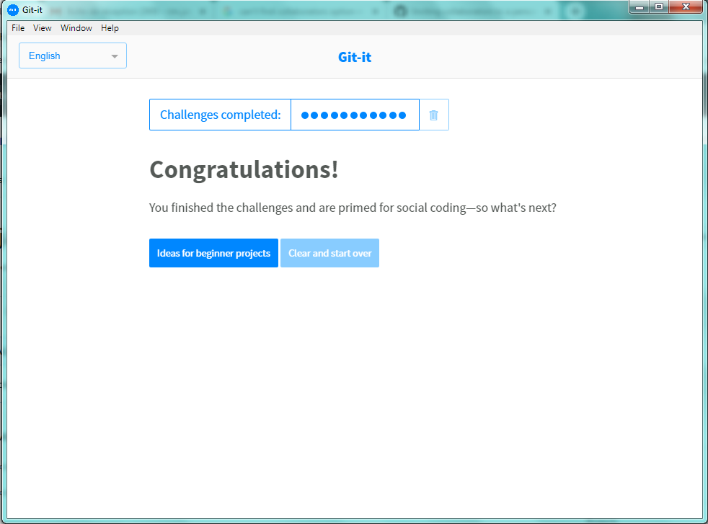

* A print screen of your GitHub created repository:

