King Abdulaziz University

Faculty of Computing and Information Technology

Computer Science Department

Fall 2023

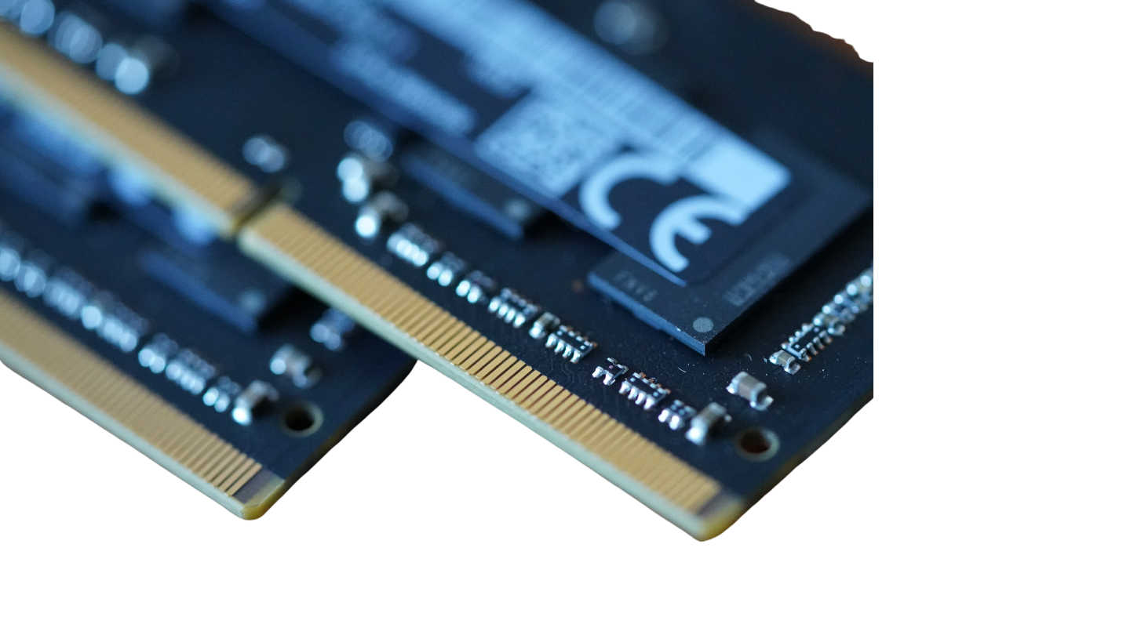CPCS361 – Operating Systems

Final Project

>> Memory management

Group members:

Rima Ali Alghamdi [2005617]

Wajd Bandar Alharbi [2007057]

Arwa Mohammed Kulib [2019574]

Ghaida Ahmed Aleryani [1906952]

Course Instructor:

Dr. May Fadel

Table of Contents

>> Work Distribution 2

>> Introduction 2

>> Tools 2

>> Source Code 2

>> Test Output 2

# >> Work Distribution

|  |  |
| --- | --- |
| Name | Tasks |
| Rima Ali Alghamdi | *All Team Members contributed equally in the project. |
| Wajd Bandar Alharbi | *All Team Members contributed equally in the project. |
| Arwa Mohammed Kulib | *All Team Members contributed equally in the project. |
| Ghaida Ahmed Aleryani | *All Team Members contributed equally in the project. |

# >> Introduction

# >> Tools

# >> Source Code

# >> Test Output