COMPUTER NETWORKING & CYBER SECURITY
FINAL CASE STUDY REPORT
Case Study No. 44
Falkirk Shipyard
Campus LAN Segmentation, Trunking & Spanning Tree

Student Details | Information
Name | Rima Maji
Roll No. | 150096725215
Program | B.Tech in Computer Science & Engineering
University | ITM Skills University
Semester | III
Academic Session | 2025–29
Course | Computer Networking & Cyber Security

Submitted as the final practical/case-study implementation report

Student Declaration
I hereby submit this report as documentation of the Cisco Packet Tracer implementation completed for the Falkirk Shipyard campus LAN case study. The report records the implemented VLAN segmentation, 802.1Q trunking, router-on-a-stick inter-VLAN routing, STP root configuration, LACP EtherChannel, Contractor-WiFi port security, ACL-based isolation, and link-failure verification demonstrated in the supplied Packet Tracer evidence.
The screenshots embedded in this report are taken from the supplied project evidence archive and the final topology images provided for this submission.

Table of Contents
1. Case Study Overview
2. Objectives
3. Proposed Network Architecture
4. VLAN Design and Port Assignment
5. 802.1Q Trunking
6. Router-on-a-Stick Inter-VLAN Routing
7. Spanning Tree Protocol
8. LACP EtherChannel
9. Contractor-WiFi Port Security
10. ACL-Based Network Segmentation
11. Connectivity and Security Testing
12. STP Link-Failure / Convergence Analysis
13. VTP Mode Recommendation
14. Results and Verification Summary
15. Conclusion
Appendix A – Screenshot Evidence Index
Note: Page numbers can be refreshed automatically in Microsoft Word if the Table of Contents field is inserted/updated.

1. Case Study Overview
The supplied case-study brief describes the Falkirk Shipyard campus as a three-building LAN consisting of the Administration Building, Fabrication Hall, and Dry Dock Control Tower. The three access-layer switches are connected in a triangle for redundancy. The design requirement is to segment traffic with VLANs, use secure trunk links, prevent the Layer-2 loop from creating a broadcast storm, and protect Dry Dock control traffic from the Contractor-WiFi segment.
The case-study brief defines VLANs 18, 28, 38, 48, 990 and 999. VLAN 38 is the DryDock-Control network, while VLAN 990 is Contractor-WiFi. VLAN 999 is deliberately unused and is intended as the native VLAN on trunk links. The supplied brief also explicitly requires inter-VLAN routing, STP with SW-DRYDOCK as the root bridge, an EtherChannel between SW-ADMIN and SW-DRYDOCK, port security on Contractor-WiFi ports, a VTP recommendation, and a simulated link-failure/convergence report.
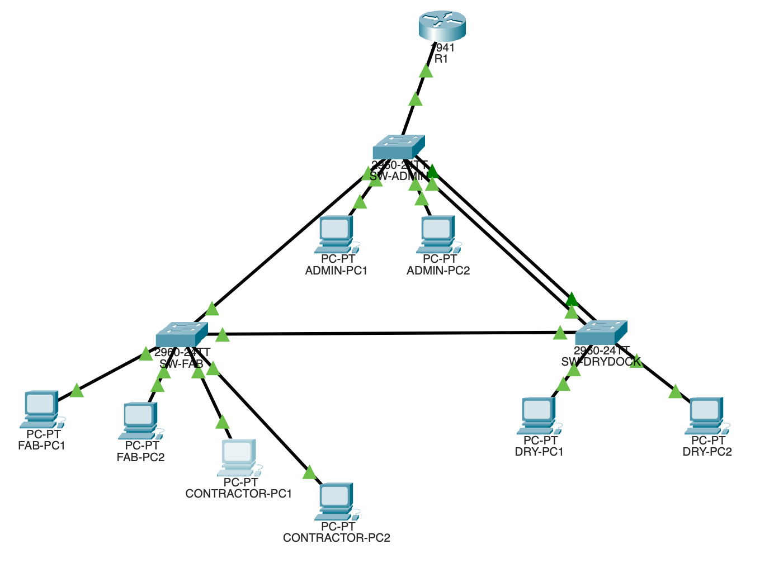
Figure 1. Final Packet Tracer topology supplied for the completed implementation.

2. Objectives
- Finalize the VLAN scheme and assign the VLANs to the correct switch ports.
- Configure 802.1Q trunk links between the three switches and the router-facing link, using VLAN 999 as the unused native VLAN.
- Provide inter-VLAN routing using router-on-a-stick and ensure Contractor-WiFi cannot reach DryDock-Control.
- Configure Spanning Tree so that SW-DRYDOCK is the root bridge for the required VLANs.
- Bundle the SW-ADMIN ↔ SW-DRYDOCK links into an LACP EtherChannel and explain its effect on STP.
- Apply port security to the Contractor-WiFi access ports with a maximum of two learned MAC addresses and restrict-mode violation handling.
- Recommend a VTP mode appropriate for the three-building shipyard and justify the choice.
- Simulate a SW-FAB ↔ SW-DRYDOCK link failure and document the STP response, port-state change, and possible traffic impact.

3. Proposed Network Architecture
The implemented topology uses R1 as the Layer-3 gateway and three Cisco 2960 switches as the access/distribution switching layer. SW-ADMIN is connected to R1 and also provides the redundant triangle links to SW-FAB and SW-DRYDOCK. SW-DRYDOCK is deliberately selected as the STP root so that the Dry Dock control building hosts the root bridge for the safety-critical VLAN.
The final topology contains end devices for Administration, Fabrication, Contractor-WiFi, and Dry Dock Control. The redundant Layer-2 triangle is controlled by STP, while the two SW-ADMIN ↔ SW-DRYDOCK physical links are bundled into Port-channel 1 using LACP.
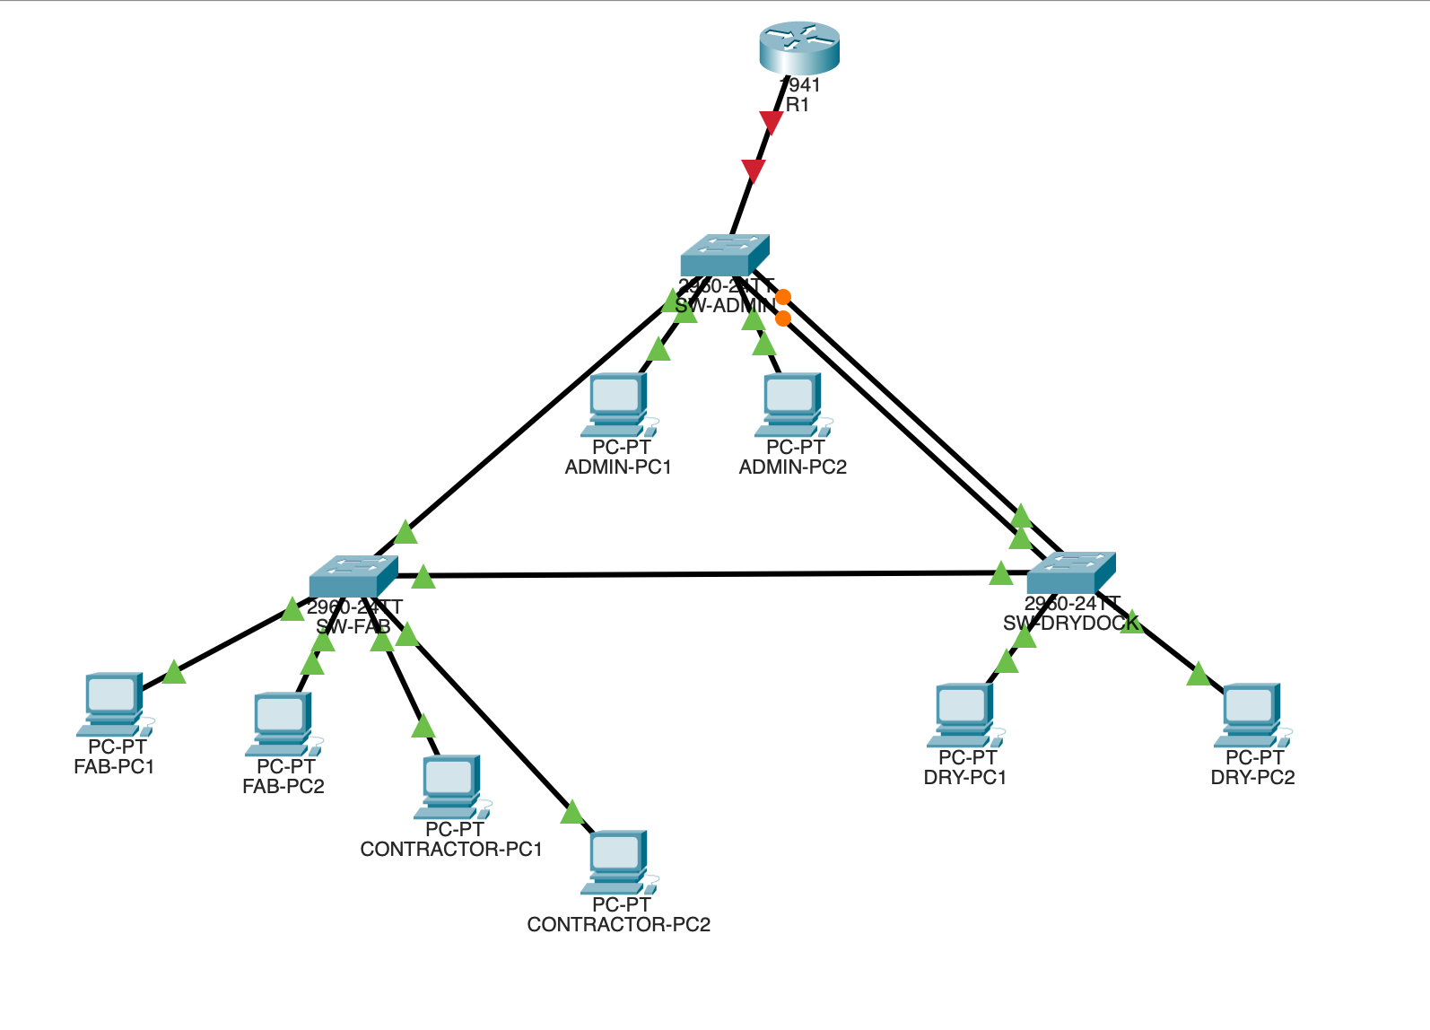
Figure 2. Earlier topology state retained as project evidence; the final report uses Figure 1 as the final-state topology.
The final-state topology is the authoritative visual for the completed design. The earlier image is retained only as evidence of the topology during implementation.

4. VLAN Design and Port Assignment
The VLAN plan follows the case-study table and the final switch verification screenshots. The same VLAN IDs are carried on the trunk links, while access ports are assigned according to the building/function they serve.
VLAN | Name | Purpose / Location | Verified Access Ports
18 | Admin-Ops | Administration Building / office and management endpoints | SW-ADMIN Fa0/1–Fa0/2
28 | Fabrication-Floor | Fabrication Hall / welding and CNC devices | SW-FAB Fa0/1–Fa0/2
38 | DryDock-Control | Dry Dock Control Tower / dry-dock control systems | SW-DRYDOCK Fa0/1–Fa0/2
48 | IT-Mgmt | Switch/AP management interfaces across buildings | No endpoint access ports shown in supplied evidence
990 | Contractor-WiFi | Third-party contractor devices in Fabrication Hall | SW-FAB Fa0/11–Fa0/12
999 | Native-unused | Unused native VLAN for trunks; reduces exposure to VLAN-hopping attacks | Trunk native VLAN

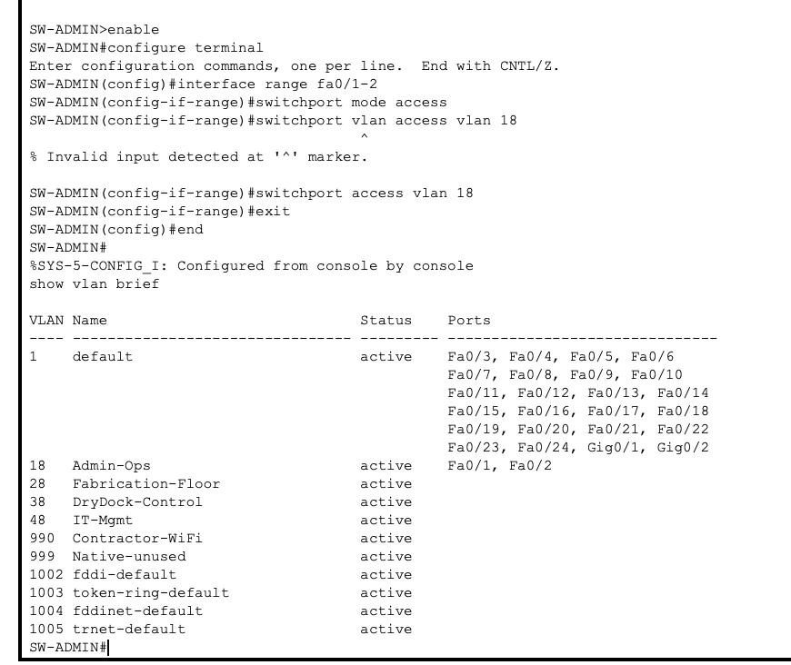
Figure 3. SW-ADMIN access-port assignment and VLAN verification.
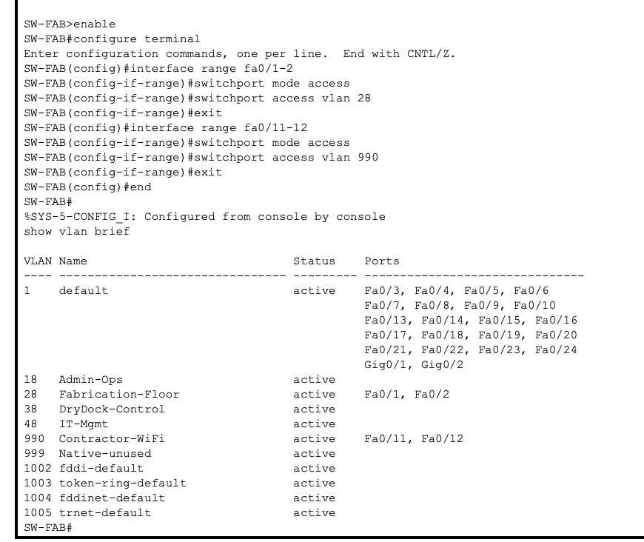
Figure 4. SW-FAB access-port assignment for Fabrication and Contractor-WiFi VLANs.
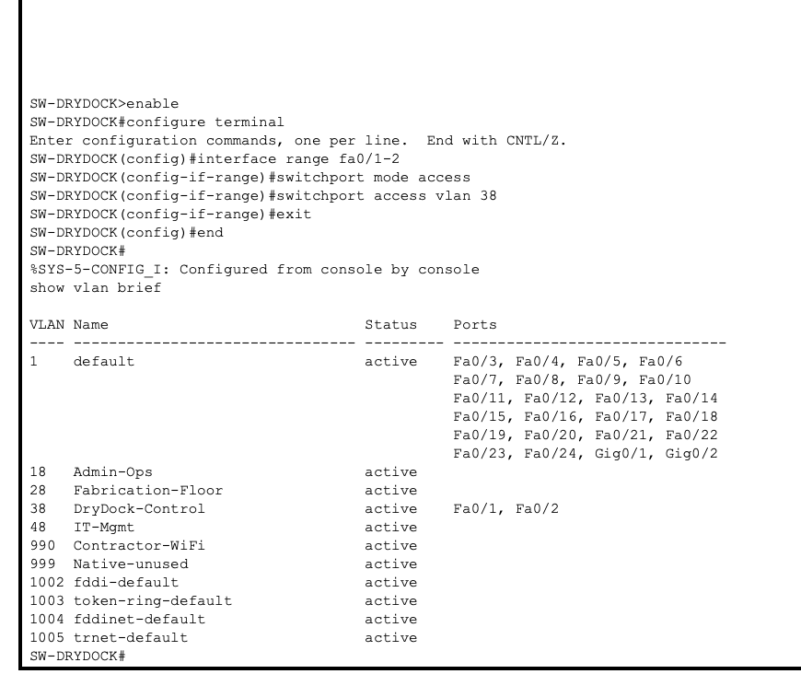
Figure 5. SW-DRYDOCK access-port assignment to VLAN 38.
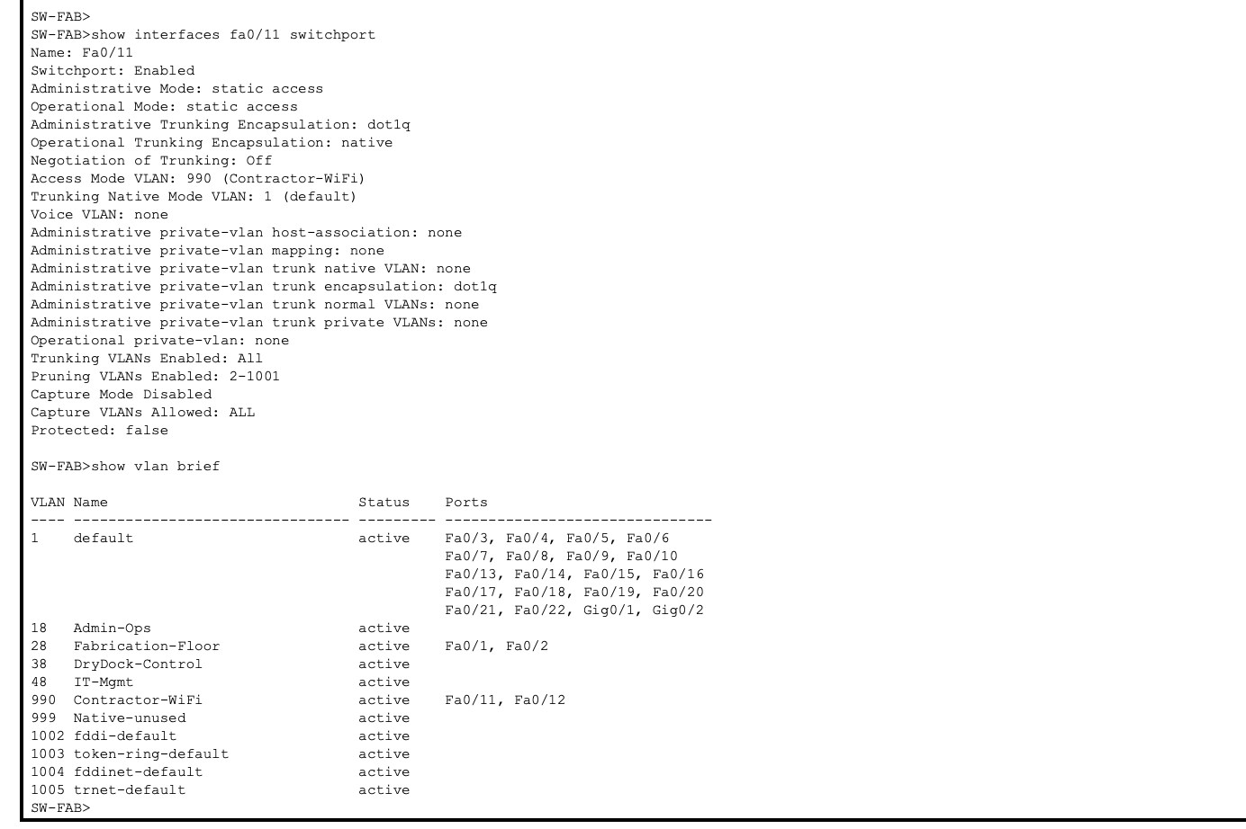
Figure 6. Final SW-FAB verification showing Fa0/11 and Fa0/12 in Contractor-WiFi VLAN 990.

5. 802.1Q Trunking
802.1Q trunks were configured on the inter-switch links and on the router-facing link. The native VLAN was set to VLAN 999 and the required VLANs 18, 28, 38, 48, 990 and 999 were explicitly allowed. The supplied verification screenshots show trunking with 802.1Q encapsulation, native VLAN 999, and the required VLAN list.
Device | Trunk Interface(s) | Native VLAN | Allowed VLANs
SW-ADMIN | Po1, Fa0/23, Gi0/1 | 999 | 18, 28, 38, 48, 990, 999
SW-FAB | Fa0/23, Fa0/24 | 999 | 18, 28, 38, 48, 990, 999
SW-DRYDOCK | Po1, Fa0/24 | 999 | 18, 28, 38, 48, 990, 999

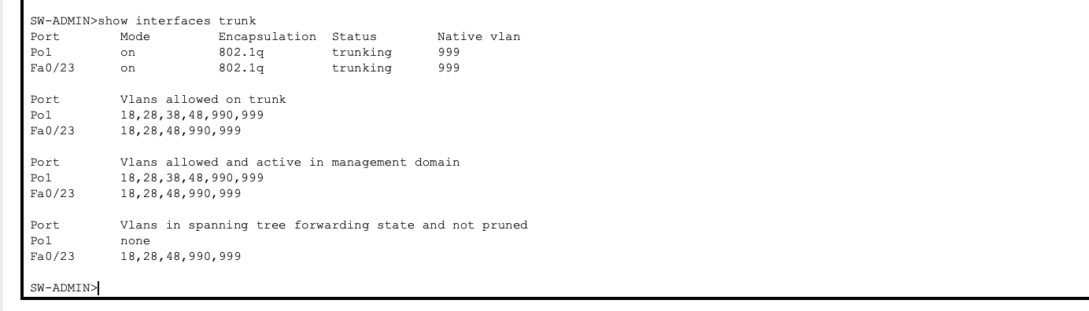
Figure 7. SW-ADMIN trunk verification.
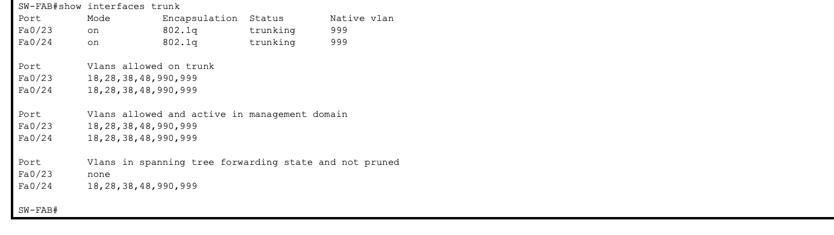
Figure 8. SW-FAB trunk verification.
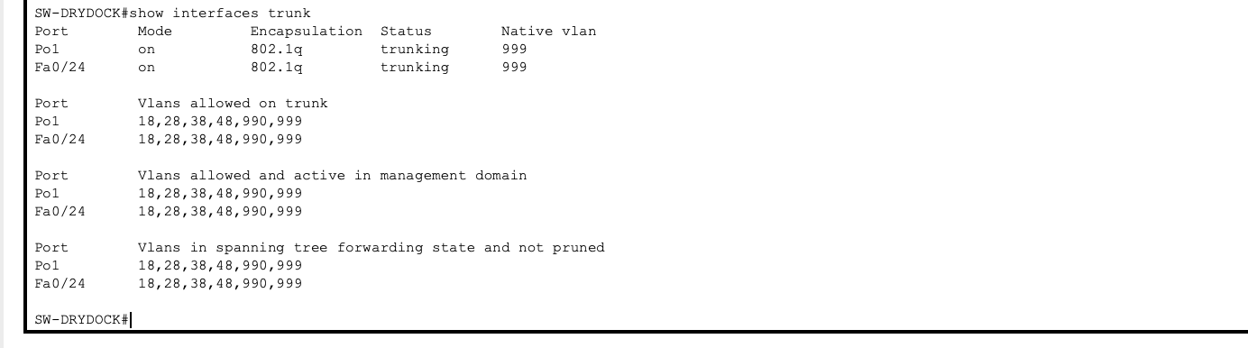
Figure 9. SW-DRYDOCK trunk verification.
Security rationale for VLAN 999: using a dedicated unused VLAN as the native VLAN avoids carrying normal user traffic on the native VLAN and reduces the opportunity for native-VLAN/VLAN-hopping abuse. The VLAN is intentionally not assigned to endpoint devices.

6. Router-on-a-Stick Inter-VLAN Routing
R1 performs inter-VLAN routing through 802.1Q subinterfaces on GigabitEthernet0/0. Each required VLAN receives a gateway address in its own /24 network. The final interface-status evidence shows all five subinterfaces as up/up.
Subinterface | VLAN | Gateway IP | Network
Gi0/0.18 | 18 | 192.168.18.1 | 192.168.18.0/24
Gi0/0.28 | 28 | 192.168.28.1 | 192.168.28.0/24
Gi0/0.38 | 38 | 192.168.38.1 | 192.168.38.0/24
Gi0/0.48 | 48 | 192.168.48.1 | 192.168.48.0/24
Gi0/0.990 | 990 | 192.168.99.1 | 192.168.99.0/24

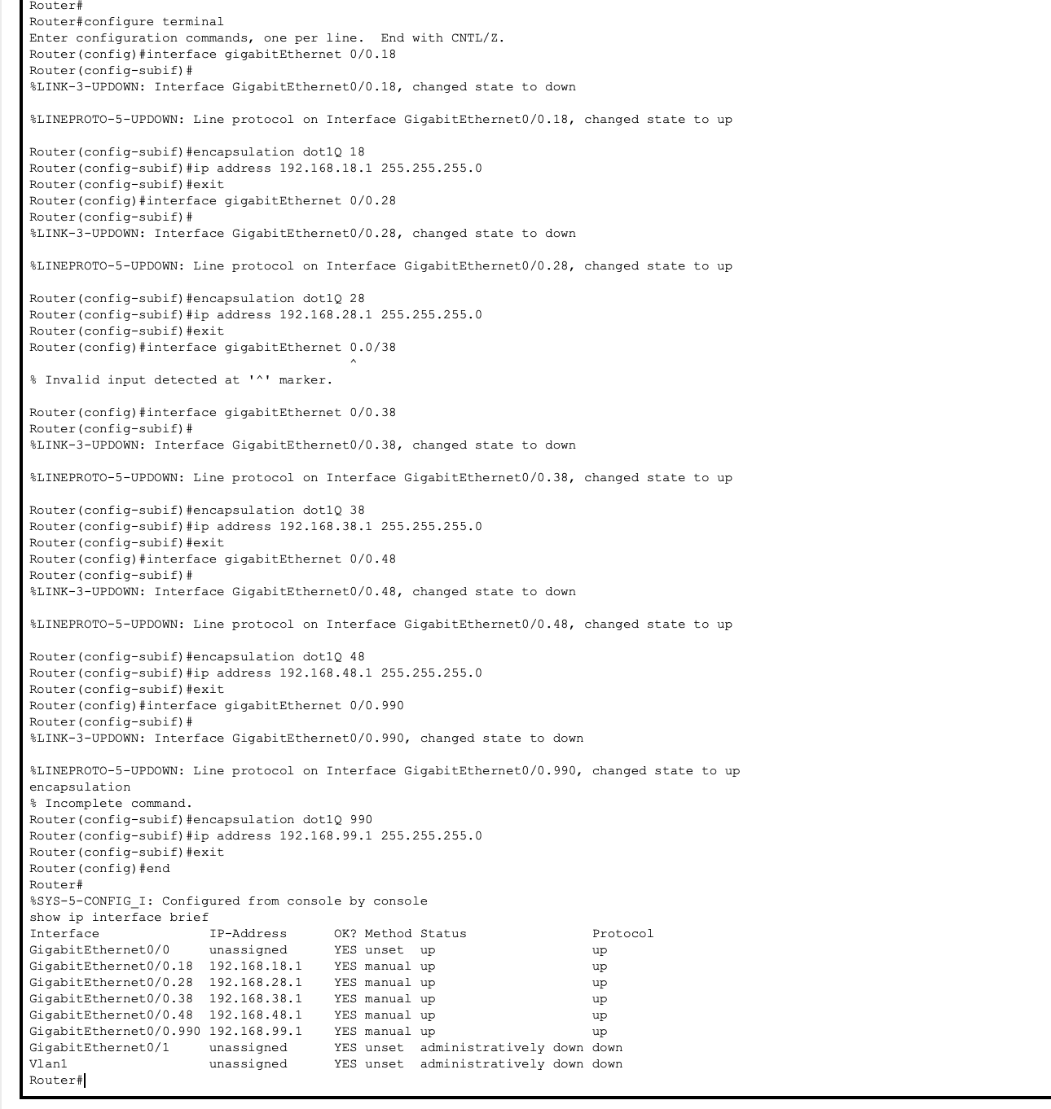
Figure 10. Router-on-a-stick subinterface configuration for the VLAN gateways.
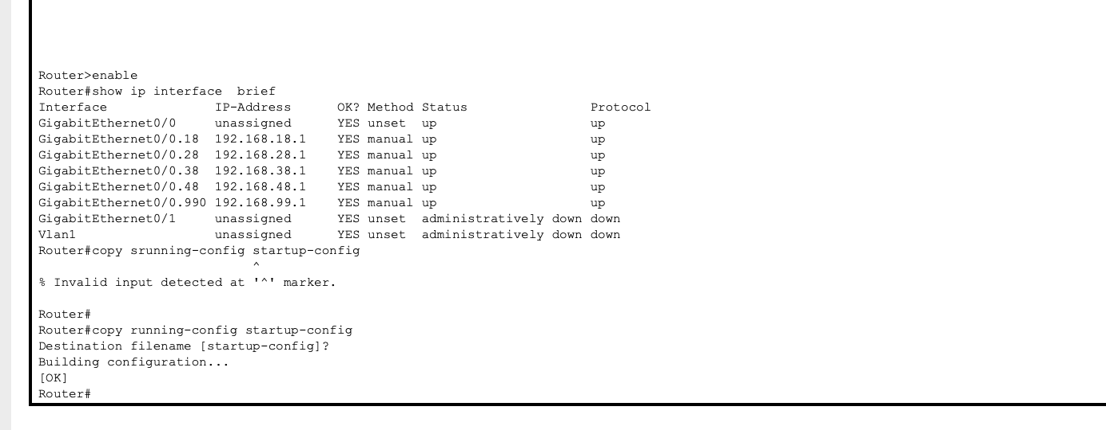
Figure 11. Final R1 interface status showing all required subinterfaces up/up and configuration saved.

7. Spanning Tree Protocol
The triangle topology introduces a Layer-2 loop risk. STP is therefore used to maintain a loop-free forwarding topology while preserving redundancy. The final configuration sets SW-DRYDOCK to priority 24576 for VLANs 18, 28, 38, 48, 990 and 999. The verification for VLAN 38 reports SW-DRYDOCK as the root bridge with priority 24614 after the system-ID extension is added.
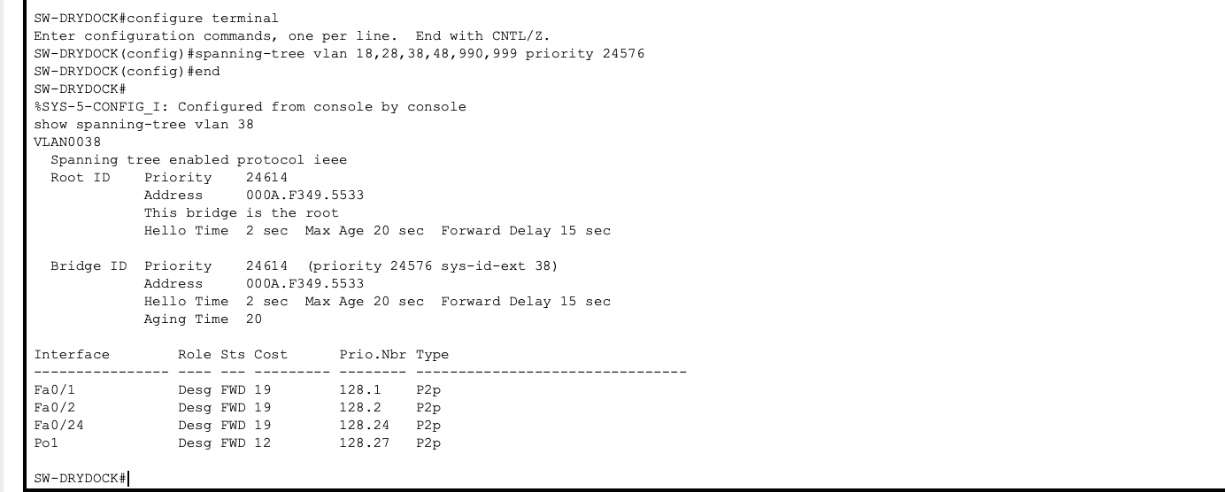
Figure 12. Final STP root verification: SW-DRYDOCK is the root bridge for VLAN 38.
Observed on SW-DRYDOCK | Role | State | Cost
Fa0/1 | Designated | Forwarding | 19
Fa0/2 | Designated | Forwarding | 19
Fa0/24 | Designated | Forwarding | 19
Port-channel 1 | Designated | Forwarding | 12

The captured final STP evidence directly verifies the root and the local port roles on SW-DRYDOCK. The report does not invent additional per-port roles on SW-ADMIN or SW-FAB because equivalent final `show spanning-tree vlan 38` screenshots for those switches were not present in the supplied archive.

8. LACP EtherChannel
The two physical links between SW-ADMIN and SW-DRYDOCK were bundled into Port-channel 1 using LACP. Once active, STP treats the EtherChannel as one logical connection instead of calculating the two member links as separate parallel links. This preserves bandwidth and redundancy while simplifying STP's view of the triangle.
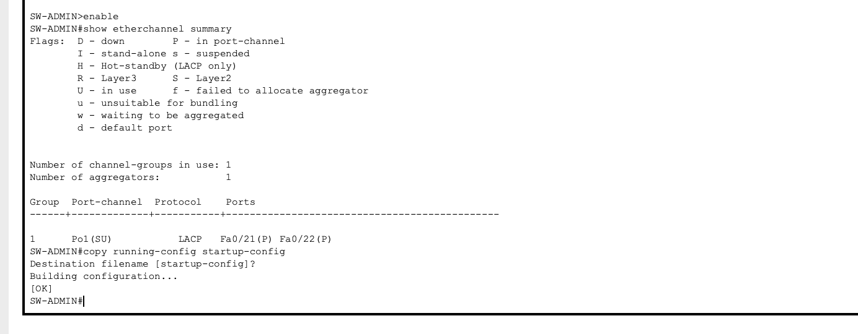
Figure 13. SW-ADMIN final EtherChannel summary: Port-channel 1 is up using LACP with Fa0/21 and Fa0/22 as members.
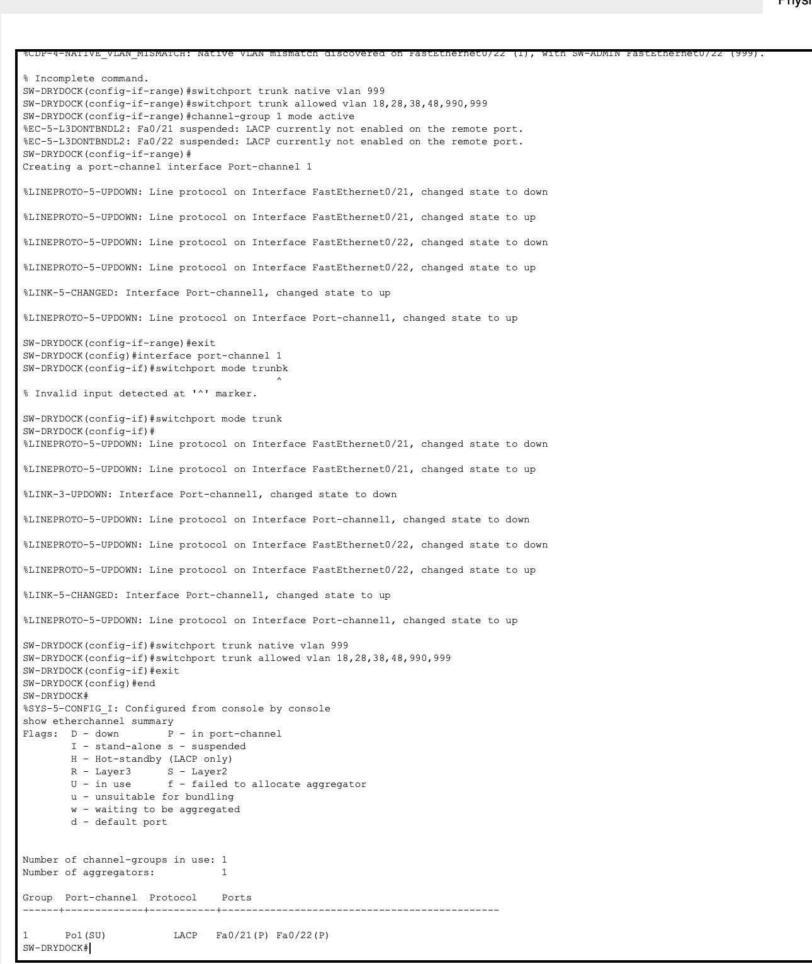
Figure 14. SW-DRYDOCK EtherChannel configuration and final LACP summary.
The final summaries show Port-channel 1 in the SU state, using LACP, with Fa0/21(P) and Fa0/22(P) bundled. This is the final operational state used by the project.

9. Contractor-WiFi Port Security
The case study requires Layer-2 port security on the Fabrication Hall Contractor-WiFi access ports. Fa0/11 and Fa0/12 were configured as access ports in VLAN 990 with port security enabled, a maximum of two secure MAC addresses, sticky learning, and violation mode set to restrict.
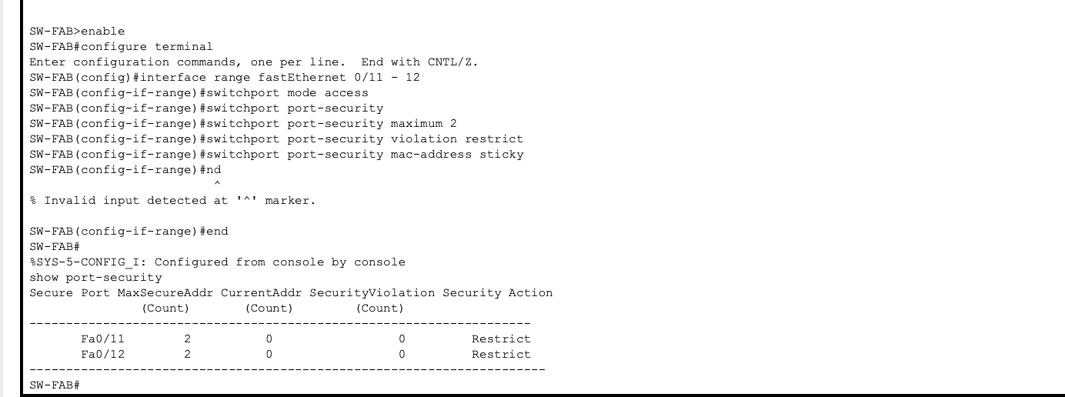
Figure 15. Final port-security configuration and verification on SW-FAB Fa0/11–Fa0/12.
The `show port-security` evidence reports a maximum secure-address count of 2 for both ports and a Restrict security action. Restrict mode is appropriate for the stated requirement because violating traffic is prevented while the switch can continue forwarding legitimate traffic and record the violation rather than administratively shutting the port.

10. ACL-Based Network Segmentation
The central security requirement is that Contractor-WiFi VLAN 990 must not be able to reach the DryDock-Control VLAN 38. The final implementation uses extended ACL 101 with a deny rule for traffic from 192.168.99.0/24 to 192.168.38.0/24 followed by a permit-any rule for other IP traffic. ACL 101 is applied inbound on R1 subinterface Gi0/0.990, so the source segment is filtered as traffic enters the router.
ACL 101 entry | Action | Source | Destination
10 | deny ip | 192.168.99.0/24 | 192.168.38.0/24
20 | permit ip | any | any

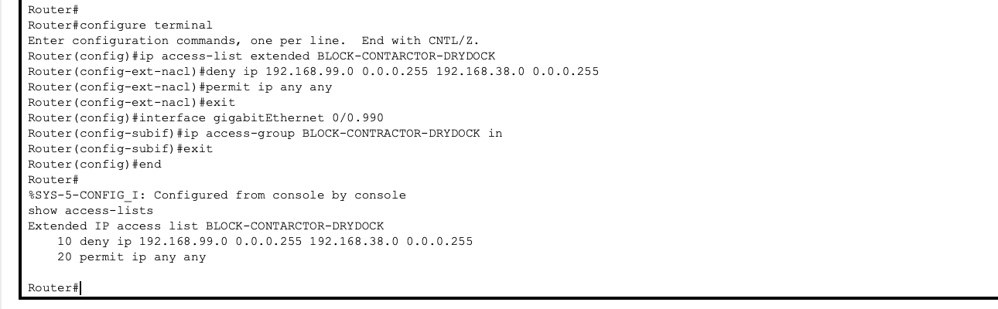
Figure 16. ACL rule creation and application to Gi0/0.990.
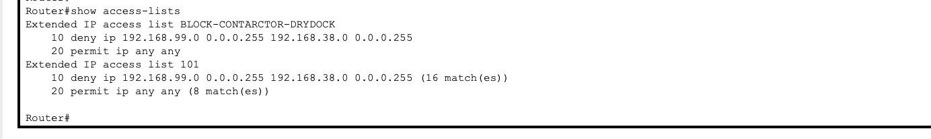
Figure 17. ACL verification showing the deny rule and packet match counters for ACL 101.
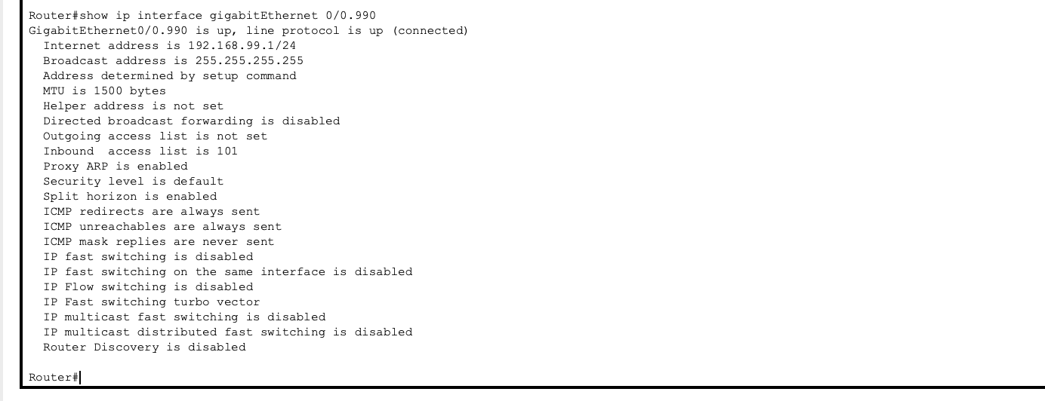
Figure 18. Final verification that ACL 101 is applied inbound on Gi0/0.990.
The evidence archive shows ACL 101 recording 16 matches on the deny entry and 8 matches on the permit-any entry. This demonstrates that the ACL was actively processing traffic during testing.

11. Connectivity and Security Testing
Testing was performed from the Contractor-PC1 and DryDock-PC1 endpoints. The final results demonstrate the intended security boundary: Contractor-WiFi traffic can reach the Fabrication gateway while access to the DryDock endpoint is blocked.
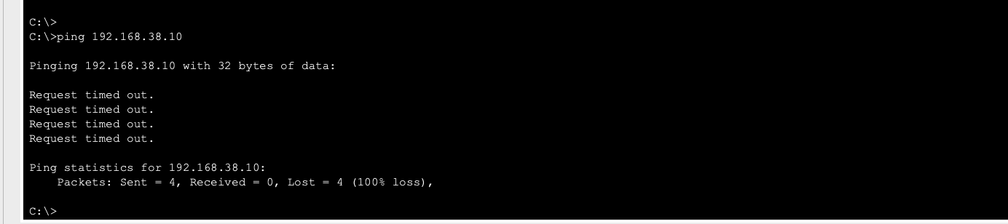
Figure 19. Final security test: Contractor-PC1 → DryDock-PC1 (192.168.38.10) is blocked with 100% packet loss.
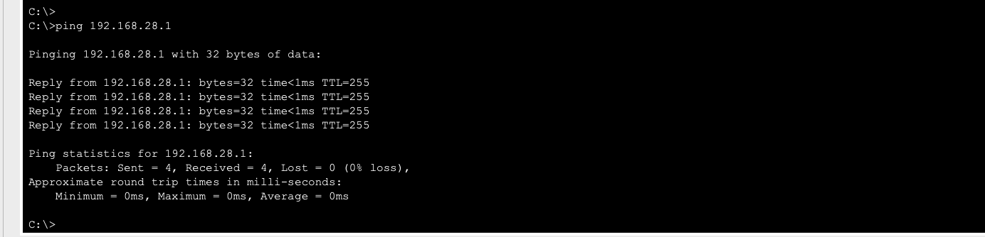
Figure 20. Final connectivity test: Contractor-PC1 → Fabrication gateway (192.168.28.1) succeeds with 0% loss.
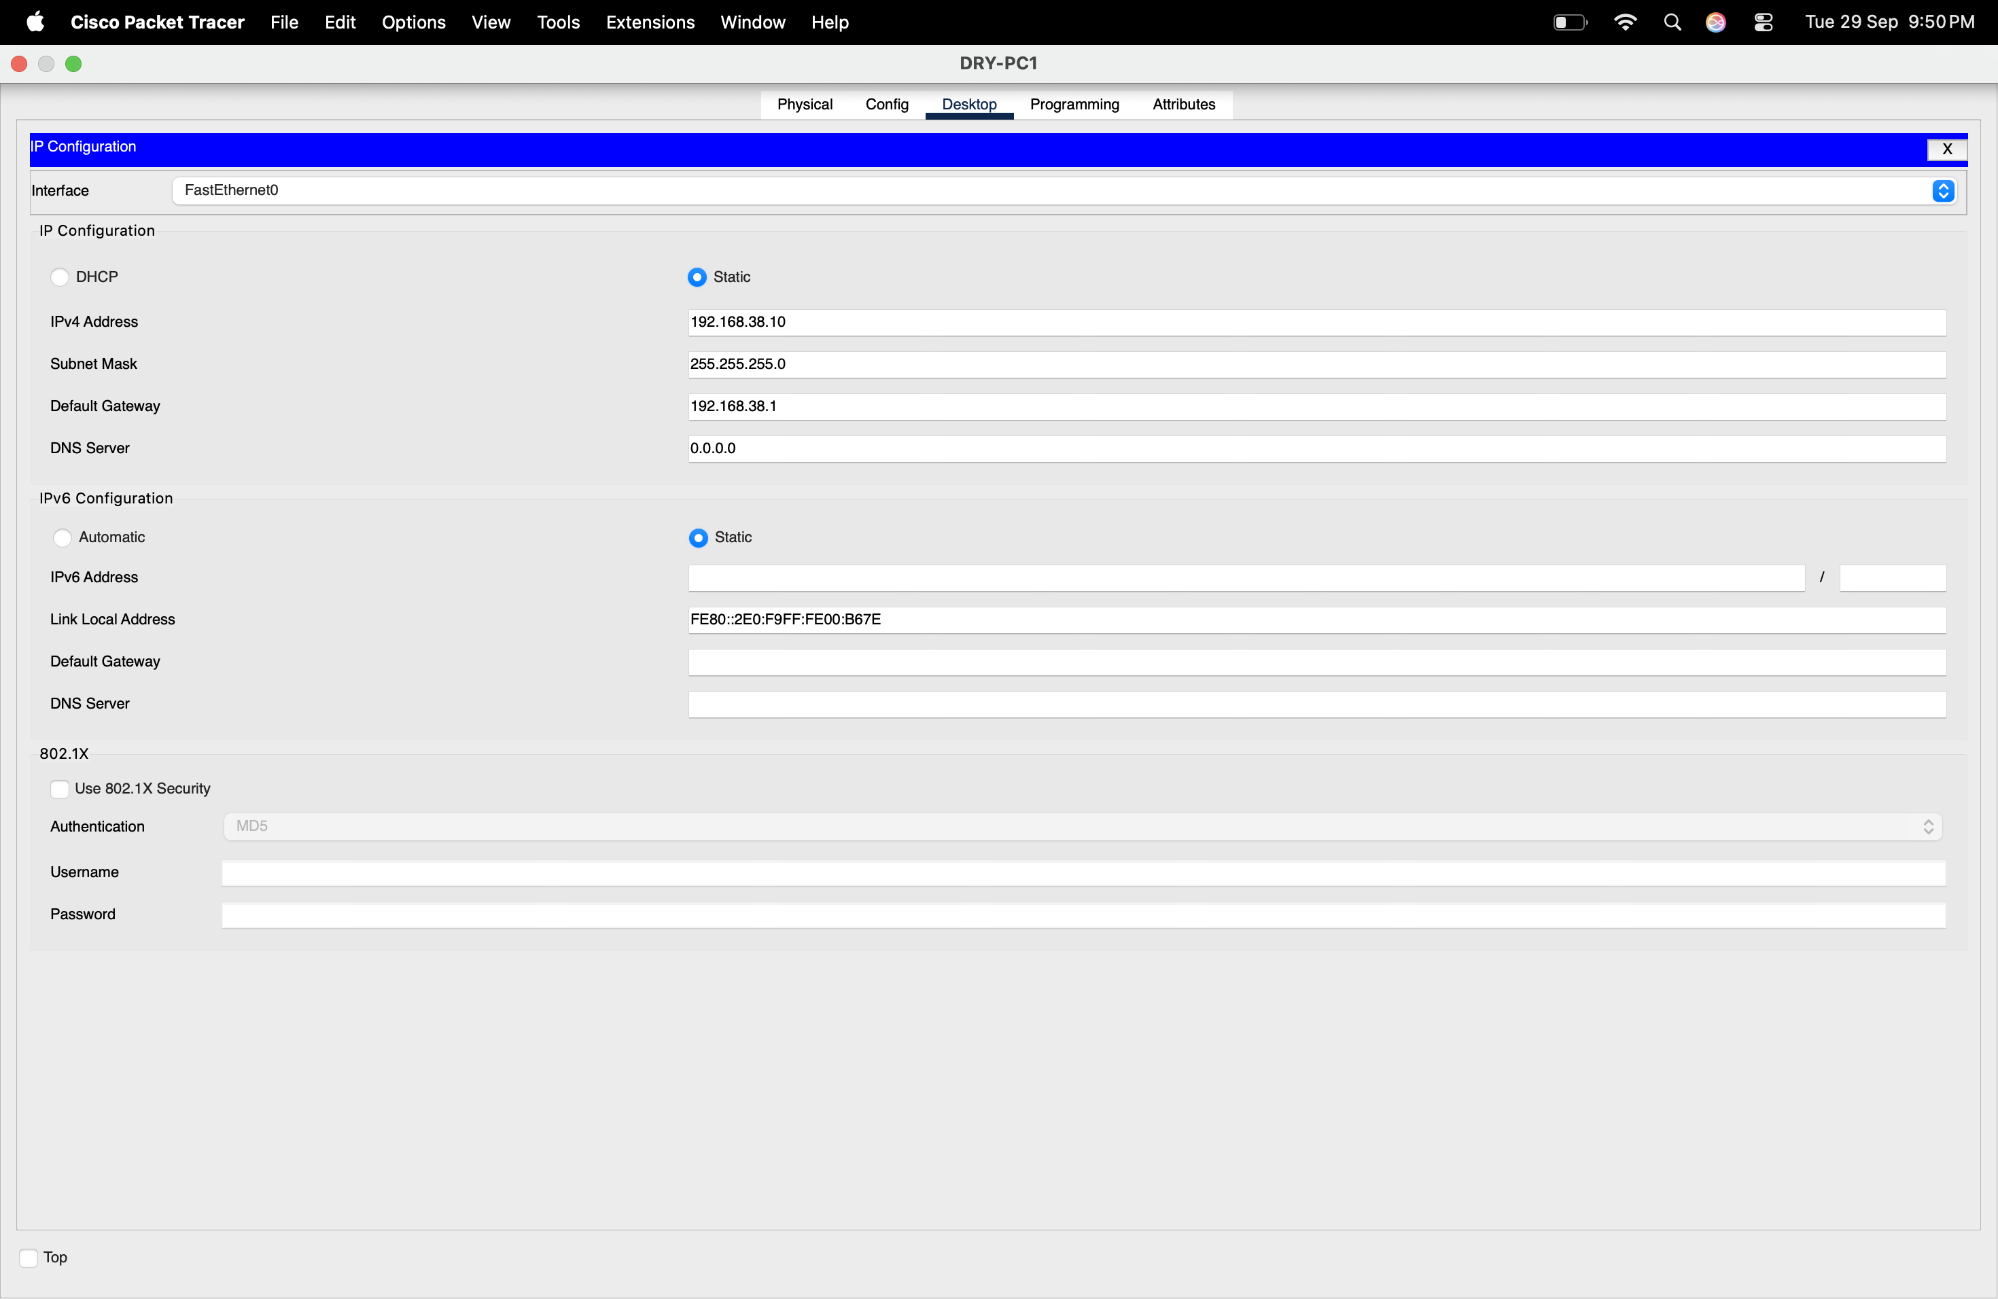
Figure 21. DryDock-PC1 IP configuration: 192.168.38.10/24 with gateway 192.168.38.1.
Together, these tests verify that the ACL is selective rather than a blanket isolation rule: the Contractor segment is denied specifically from the DryDock-Control subnet while normal IP connectivity to the Fabrication gateway remains available.

12. STP Link-Failure / Convergence Analysis
The case study requires a simulated failure of the SW-FAB ↔ SW-DRYDOCK link. The supplied evidence uses SW-DRYDOCK FastEthernet0/24 as the failed link. Before the failure, Fa0/24 is a designated forwarding port on the root bridge. The link is then administratively shut down and later restored.
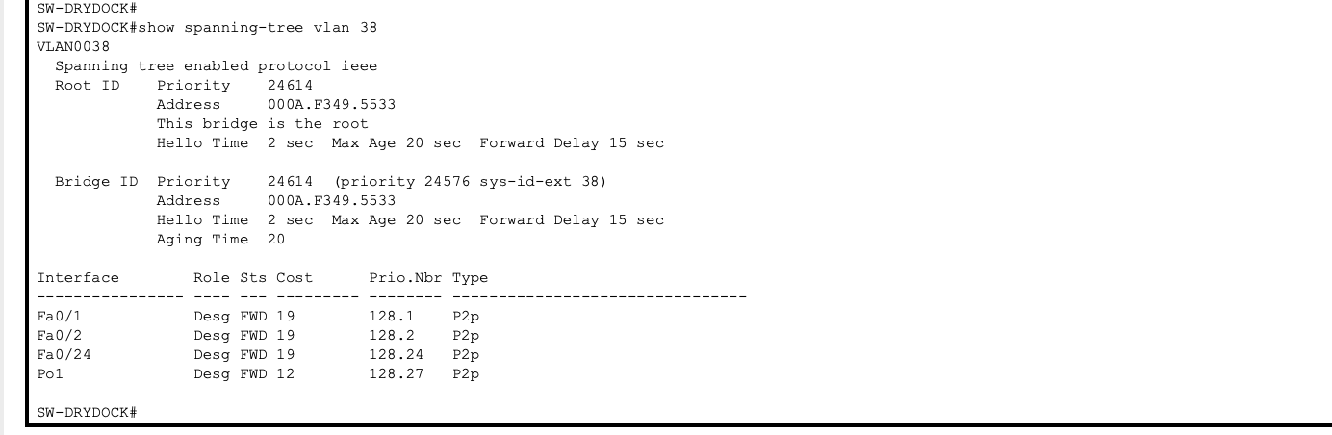
Figure 22. STP state immediately before the simulated link failure.
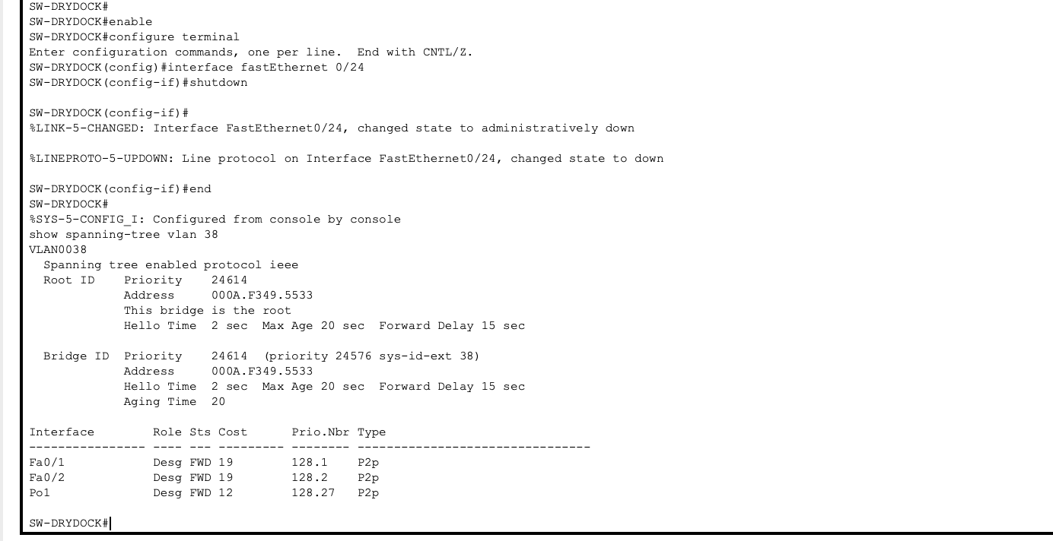
Figure 23. Simulated failure: SW-DRYDOCK Fa0/24 is administratively shut down; STP continues through the remaining topology.
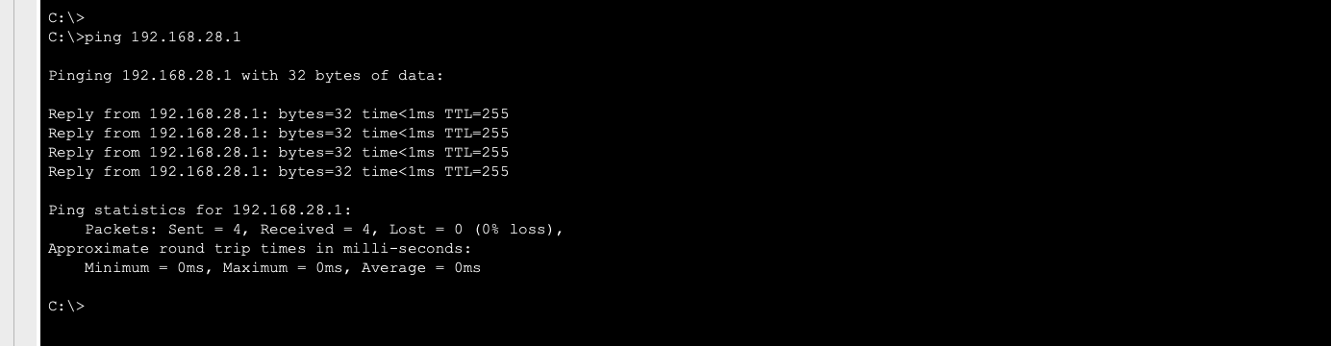
Figure 24. Connectivity test during the failure scenario; DryDock-PC1 still reaches the Fabrication gateway.
During the failure window, the physical Fa0/24 link is taken out of service. Because the network has a redundant path through SW-ADMIN and the active EtherChannel, the Dry Dock segment can continue to communicate through the remaining topology. The supplied connectivity screenshot shows a successful ping to 192.168.28.1 during the failure scenario.
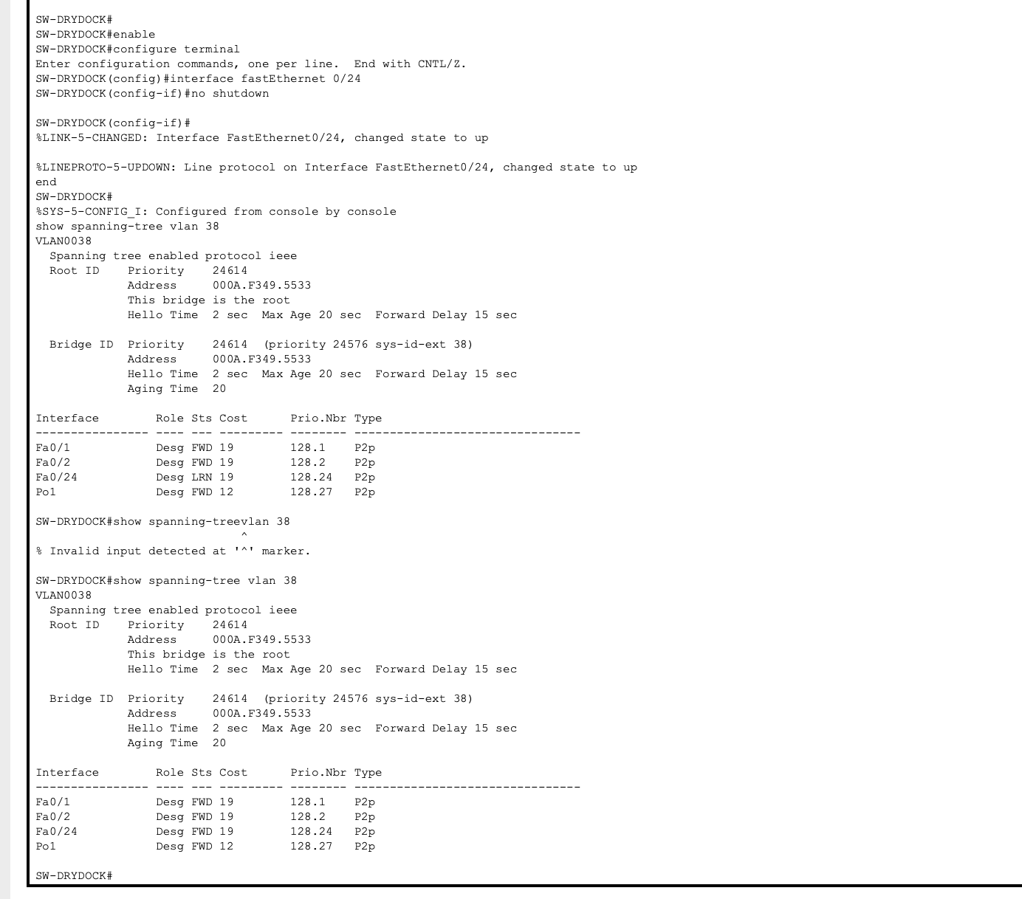
Figure 25. Link restoration: Fa0/24 returns to forwarding after the STP state transitions through learning.
After the link is restored, the evidence shows Fa0/24 moving through the learning state and then returning to forwarding. This demonstrates the STP convergence process and the preservation of a loop-free topology. During the transition, packets associated with the reconverging path can experience temporary delay or loss; the exact duration depends on the simulated STP timers and topology state.

13. VTP Mode Recommendation
Recommended mode: VTP Transparent.
For this small three-building shipyard network, VTP Transparent is a defensible choice because it avoids making the VLAN database of the whole campus dependent on a single VTP server/client propagation domain. VLANs can be created and controlled explicitly on the switches, which makes the configuration more deliberate and reduces the risk that an unintended VTP update changes the VLAN database across the network.
Trade-off: Transparent mode requires administrators to keep VLAN definitions synchronized manually on the switches. That is additional operational work, but for a three-switch topology the administrative burden is limited. In a larger environment, centralized VLAN management could provide stronger operational consistency, but the case study's small scale makes the transparent approach practical.

14. Results and Verification Summary
Requirement | Implementation / Evidence | Result
VLAN segmentation | VLANs 18, 28, 38, 48, 990, 999 created and endpoint ports assigned | Verified
802.1Q trunking | Trunks use 802.1Q, native VLAN 999, required VLANs allowed | Verified
Inter-VLAN routing | R1 Gi0/0.18/.28/.38/.48/.990 are up/up | Verified
DryDock isolation | ACL 101 denies 192.168.99.0/24 → 192.168.38.0/24 | Verified
STP root | SW-DRYDOCK priority 24576; root ID confirms it as root for VLAN 38 | Verified
EtherChannel | Po1 using LACP with Fa0/21 and Fa0/22 bundled | Verified
Port security | Fa0/11–Fa0/12: maximum 2, Restrict mode | Verified
Link-failure test | SW-DRYDOCK Fa0/24 shut/no-shut; STP and connectivity observed | Verified
VTP recommendation | VTP Transparent recommended with explicit justification | Documented

The supplied evidence supports completion of the major implementation and verification requirements in the case-study brief. The final topology and command-output screenshots demonstrate the configured design and its key security/redundancy behaviors.

15. Conclusion
The Falkirk Shipyard campus LAN was redesigned as a segmented, redundant and security-aware network. VLANs separate administrative, fabrication, Dry Dock control, management and contractor traffic. 802.1Q trunking carries the required VLANs between the switches, while VLAN 999 is reserved as an unused native VLAN.
R1 provides router-on-a-stick inter-VLAN routing, allowing normal communication between permitted segments. The extended ACL applied to the Contractor-WiFi gateway specifically blocks access from 192.168.99.0/24 to the DryDock-Control subnet 192.168.38.0/24. Final endpoint testing confirms that Contractor-PC1 cannot reach DryDock-PC1 while it can still reach the Fabrication gateway.
STP is configured with SW-DRYDOCK as the root bridge, protecting the triangular topology from Layer-2 loops. LACP combines the two SW-ADMIN ↔ SW-DRYDOCK links into Port-channel 1, giving the network a resilient logical path. The link-failure exercise further demonstrates that the redundant topology can continue carrying traffic while STP handles the failed link and later restores it.
Overall, the completed Packet Tracer implementation addresses the major functional, security, redundancy and documentation requirements stated in the case-study brief.

Appendix A – Screenshot Evidence Index
The following evidence files were selected from the supplied Archive.zip. Debug/error-only screenshots were not included in the main report so that the submitted document reflects the final verified state rather than intermediate typing mistakes.
Figure | Evidence file | Purpose
Figure 1 | Final_Network_Topology.png | Final topology
Figure 3 | sw-admin/SW-ADMIN_PC_VLAN.png | SW-ADMIN VLAN assignment
Figure 4 | sw-fab/SW-FAB_PC_VLAN.png | SW-FAB VLAN assignment
Figure 5 | sw-drydock/SW-DRYDOCK_PC_VLAN.png | SW-DRYDOCK VLAN assignment
Figure 6 | sw-fab/SW-FAB_VLAN990_Verification.png | Contractor-WiFi VLAN 990 verification
Figure 7 | sw-admin/SW-ADMIN_Trunk_VLAN990_Verification.png | SW-ADMIN trunk verification
Figure 8 | sw-fab/SW-FAB_Trunk_Verification.png | SW-FAB trunk verification
Figure 9 | sw-drydock/SW-DRYDOCK_Trunk_Verification.png | SW-DRYDOCK trunk verification
Figure 10 | R1/R1_Router_on_a_Stick.png | Router-on-a-stick configuration
Figure 11 | R1/R1_Interface_Status_Config_Saved.png | R1 interface status and save
Figure 12 | sw-drydock/FINAL_STP_DRYDOCK_ROOT.png | STP root verification
Figure 13 | sw-admin/EtherChannel_SW-ADMIN_Saved.png | SW-ADMIN LACP verification
Figure 14 | sw-drydock/EtherChannel_LACP_SW-DRYDOCK.png | SW-DRYDOCK LACP verification
Figure 15 | sw-fab/FINAL_PORT_SECURITY.png | Contractor port security
Figure 16 | R1/R1_ACL_Contractor_DryDock.png | ACL creation/application
Figure 17 | R1/R1_ACL_Block_Contractor_DryDock.png | ACL match counters
Figure 18 | R1/R1_ACL101_Applied_VLAN990.png | ACL 101 inbound on VLAN 990
Figure 19 | contractor pc-1/FINAL_ACL_CONTRACTOR_TO_DRYPC1_BLOCKED.png | Contractor → DryDock blocked
Figure 20 | contractor pc-1/FINAL_ACL_CONTRACTOR_TO_FABRICATION_ALLOWED.png | Contractor → Fabrication allowed
Figure 21 | drydock pc 1/DRY_PC1_IP_Config.png | DryDock-PC1 addressing
Figure 22 | sw-drydock/STP_BEFORE_LINK_FAILURE.png | STP before link failure
Figure 23 | sw-drydock/STP_Link_Failure_Verification_SW-DRYDOCK.png | Link failure simulation
Figure 24 | drydock pc 1/STP_Link_Failure_Connectivity_Test.png | Connectivity during failure
Figure 25 | sw-drydock/STP_Link_Restored_FWD.png | STP restoration

Source Material
Primary case-study brief: Computer Networking & Cyber Security, Case Study No. 44, “Falkirk Shipyard – Campus LAN Segmentation, Trunking & Spanning Tree,” ITM Skills University, Semester II, B.Tech CSE 2025–29. The supplied brief contains the problem statement, VLAN table, eight objectives, expected outcomes and deliverables.
Project evidence: Archive.zip and the topology/screenshot files supplied with the final submission materials.

