ASSIGNMENT 4
ER Modeling & Relational Model – Digital ER Diagram Design
Name | Rima Maji
Roll No. | 150096725215
Business / Clinic Visited | Sanjeevani Clinic
Digital Tool | dbdiagram.io

1. Introduction
A clinic needs to maintain and connect information about patients, doctors, appointments, prescriptions, medicines and billing. An Entity–Relationship (ER) model provides a structured way to represent these entities, their attributes and their relationships before the design is converted into relational tables.

2. Entities Identified
The model uses the following entities as the working structure for the clinic patient-intake process:
Entity | Purpose
Patient | Stores patient information
Doctor | Stores doctor details and specialization
Appointment | Stores appointment details between patients and doctors
Prescription | Stores diagnosis and prescription information
Medicine | Stores medicine details
Prescription_Medicine | Connects prescriptions with medicines and resolves the many-to-many relationship
Billing | Stores payment and billing details

3. Entity and Attribute Description

Patient
- Patient_ID — Primary Key
- Patient_Name
- Age
- Gender
- Contact_No.

Doctor
- Doctor_ID — Primary Key
- Doctor_Name
- Specialization
- Contact_No.

Appointment
- Appointment_ID — Primary Key
- Appointment_Date
- Appointment_Time
- Patient_ID — Foreign Key
- Doctor_ID — Foreign Key

Prescription
- Prescription_ID — Primary Key
- Prescription_Date
- Diagnosis
- Patient_ID — Foreign Key
- Doctor_ID — Foreign Key
- Appointment_ID — Foreign Key

Medicine
- Medicine_ID — Primary Key
- Medicine_Name

Prescription_Medicine
- Prescription_ID — Primary Key + Foreign Key
- Medicine_ID — Primary Key + Foreign Key
- Dosage
- Frequency
- Duration
- Composite Primary Key: (Prescription_ID, Medicine_ID)

Billing
- Bill_ID — Primary Key
- Appointment_ID — Foreign Key
- Bill_Date
- Consultation_Fee
- Amount_Mode
- Payment_Status

4. Primary Keys and Foreign Keys
A primary key uniquely identifies a record in a table. A foreign key refers to a primary key in another table and establishes a relationship between the tables.
Table | Primary Key | Foreign Key(s)
Patient | Patient_ID | —
Doctor | Doctor_ID | —
Appointment | Appointment_ID | Patient_ID, Doctor_ID
Prescription | Prescription_ID | Patient_ID, Doctor_ID, Appointment_ID
Medicine | Medicine_ID | —
Prescription_Medicine | (Prescription_ID, Medicine_ID) | Prescription_ID, Medicine_ID
Billing | Bill_ID | Appointment_ID

5. Relationships and Cardinality
Relationship | Cardinality | Meaning
Patient → Appointment | 1:N | One patient can have multiple appointments; each appointment belongs to one patient.
Doctor → Appointment | 1:N | One doctor can attend multiple appointments; each appointment is associated with one doctor.
Appointment → Prescription | 1:N | An appointment can result in prescription record(s).
Prescription → Medicine | M:N | A prescription can contain multiple medicines and a medicine can occur in multiple prescriptions; Prescription_Medicine resolves this relationship.
Appointment → Billing | 1:1 | The working model associates billing information with an appointment.

6. Digital ER Diagram
Create the ER diagram using one of the approved tools in the assignment (for example, dbdiagram.io or diagrams.net). Mark primary keys and foreign keys clearly and show the cardinality of the relationships. Export the completed diagram as PNG or PDF.
ER diagram structure to reproduce digitally:
- PATIENT 1:N APPOINTMENT
- DOCTOR 1:N APPOINTMENT
- PATIENT 1:N PRESCRIPTION
- DOCTOR 1:N PRESCRIPTION
- APPOINTMENT 1:N PRESCRIBTION
- PRESCERIPTION M:N MEDICINE
- APPOINTMENT 1:1 BILLING

7. Physical Relational Model / Index Cards
Prepare one index card for each of the seven tables below. Clearly mark PKs and FKs on the cards. Use yarn/string to connect each foreign key to the referenced primary key and label each connection.
- Card 1: Patient
Patient_ID — Primary Key; Patient_Name; Age; Gender; Contact_No.
- Card 2: Doctor
Doctor_ID — Primary Key; Doctor_Name; Specialization; Contact_No.
- Card 3: Appointment
Appointment_ID — Primary Key; Appointment_Date; Appointment_Time; Patient_ID — Foreign Key; Doctor_ID — Foreign Key
- Card 4: Prescription
Prescription_ID — Primary Key; Prescription_Date; Diagnosis; Patient_ID — Foreign Key; Doctor_ID — Foreign Key; Appointment_ID — Foreign Key
- Card 5: Medicine
Medicine_ID — Primary Key; Medicine_Name
- Card 6: Prescription_Medicine
Prescription_ID — Primary Key + Foreign Key; Medicine_ID — Primary Key + Foreign Key; Dosage; Frequency; Duration; Composite Primary Key: (Prescription_ID, Medicine_ID)
- Card 7: Billing
Bill_ID — Primary Key; Appointment_ID — Foreign Key; Bill_Date; Consultation_Fee; Amount_Mode; Payment_Status

8. Submission
- Digital ER diagram

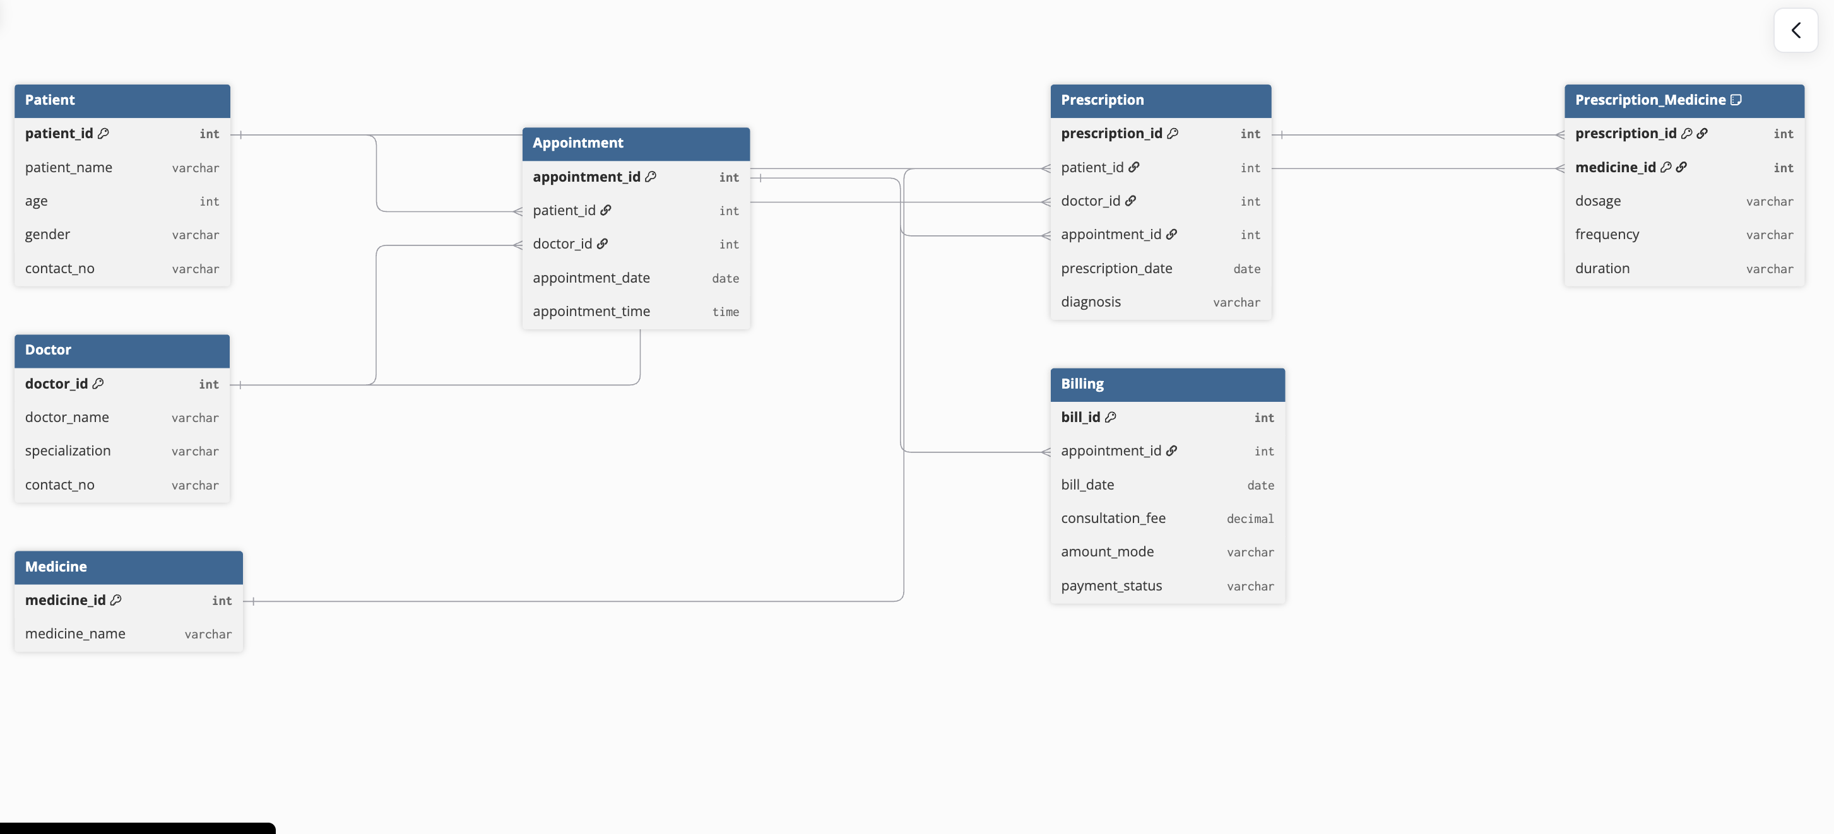

- Physical Relational Model (Seven index cards prepared: Patient, Doctor, Appointment, Prescription, Medicine, Prescription_Medicine, Billing.)


