
School of Future Tech

Case Study Report
on

LocalKart – Hyperlocal Marketplace

Case Study No- 66

by

Rima Maji
150096725215
HTML 5 | CSS 3 | JavaScript

Index

- Introduction to the Case Study
- Problem Statement / Case Background (Abstract)
- Case Study Design
- Methods & Technology Applied
- Implementation Details and Snapshots
- Results and Conclusion
- References

1. Introduction to the Case Study

India has millions of small local shops — grocery stores, pharmacies, bakeries — that have no digital presence. Customers nearby often remain unaware of what is available or whether same-day delivery is possible. LocalKart is a hyperlocal marketplace web application designed to bridge this gap by connecting customers with verified nearby shops through a responsive, multi-page website.

Built entirely with HTML 5, CSS 3, and JavaScript, LocalKart lets users discover shops by pincode, browse categorised products, manage a shopping cart, complete checkout, and view a seller commission model. A Node.js + Express backend handles seller registration by persisting data to a JSON file.

This report documents the design, technology, and implementation of all eight pages — Landing, Login/Register, Home, Shops, Products, Cart, Checkout, and Pricing — along with the shared stylesheet, script, and server.

2. Problem Statement / Case Background (Abstract)

Background
India has over 12 million small retail stores, yet the vast majority have no online presence. Existing e-commerce platforms are national in scale and cannot surface a shop 0.5 km away from a customer. They also charge high commissions (15–30%) and require complex on-boarding that is inaccessible to non-technical shop owners.

Abstract
LocalKart is an 8-page hyperlocal marketplace built with HTML 5, CSS 3, JavaScript, and a lightweight Node.js backend. It addresses three core pain points: lack of neighbourhood shop discovery, absence of digital product listings for local shops, and no integrated cart-and-checkout flow for hyperlocal purchases. Key features include a pincode availability checker, real-time shop filtering, a 62-product catalogue with localStorage cart, a checkout form with payment method toggle, seller registration connected to a Node.js backend, and a transparent 5% commission model. The frontend is fully responsive across desktop, tablet, and mobile.

3. Case Study Design

LocalKart is a multi-page web application where each HTML file shares a common stylesheet (css/style.css) and JavaScript file (js/script.js). No frontend framework is used.

3.1 Application Architecture
- Frontend: Eight HTML pages linked through a shared navigation bar. All styling in style.css, all behaviour in script.js.
- Backend: Node.js + Express (server.js) serves static files and handles one POST route (/register-seller), appending shop data to shops.json.

3.2 Page-by-Page Design

Page | File | Purpose & Key Design Decisions
Landing | index.html | Hero banner, tagline and a single 'Get Started' CTA linking to login.html.
Login/Register | login.html | Split-screen layout — form on the left, looping video on the right. In-memory login/register.
Home | home.html | Bootstrap 5 auto-carousel, pincode checker, Best Seller cards, stats section and contact form.
Shops | shops.html | 22 shop cards in CSS Grid. Real-time search + rating + delivery-type filters. Hover distance tooltip.
Products | products.html | 62 products across 6 categories. Add-to-cart via localStorage. Live product name search.
Cart | cart.html | Dynamic table from localStorage. Quantity controls, item removal and live grand total.
Checkout | checkout.html | Delivery form with payment toggle (Cash / UPI / Card). Confirmation popup on submit.
Pricing | pricing.html | 5% commission table, seller benefit cards and form that POSTs to /register-seller.

3.3 Data Flow
- User adds a product → addToCart() writes to localStorage.
- Cart page loads → loadCart() reads localStorage and renders the table.
- Quantity changed / item removed → localStorage updated, table re-rendered.
- Checkout submitted → confirmation popup displayed.
- Seller form submitted → POST /register-seller → server.js appends to shops.json.

4. Methods & Technology Applied

4.1 HTML 5

Semantic elements (<header>, <nav>, <section>, <footer>) are used throughout all pages. Forms use HTML 5 input types (text, email, tel, password, radio). The <table> element renders the cart. <video autoplay muted loop> provides background visuals on Home, Shops, and Pricing pages. Bootstrap 5 is integrated on home.html for the carousel component only.

4.2 CSS 3

- Flexbox — navigation bar, login split-screen, benefit cards, stat boxes.
- CSS Grid — products grid (.product-grid), shops grid (.shops-grid).
- Responsive design — media queries at 1024px, 768px, and 480px breakpoints.
- Animations — @keyframes fadeIn on hero sections; transform: scale(1.04) hover effect on cards.
- Background video — position: fixed; z-index: -1 keeps video behind all content.
- Sticky navbar — position: sticky; top: 0 keeps navigation visible while scrolling.

4.3 JavaScript — Key Functions

4.3.1 Cart System (localStorage)
addToCart(button, name, price) reads the cart array from localStorage, increments quantity if the item exists or pushes a new entry, then writes back. loadCart() reads the array on DOMContentLoaded and dynamically builds the cart table. changeQty() and removeItem() update the array and re-render the table.

4.3.2 Shop Filtering
filterShops() runs on every input/change event across three controls — text search, rating dropdown, delivery-type dropdown. It evaluates all three values together and sets card.style.display to 'flex' or 'none' for each shop card instantly. Distance badges are positioned as floating tooltips using mousemove event coordinates.

4.3.3 Product Search & Checkout
A live input listener on the product search box compares the typed value against each .product-name text content, showing or hiding cards instantly across all 62 products. On the checkout page, radio change events toggle UPI ID / card detail fields. On form submit, e.preventDefault() stops default behaviour and shows the order confirmation popup.

4.4 Node.js Backend & Technology Stack
express.static(__dirname) serves all static files. The POST /register-seller handler reads shops.json, appends req.body, and writes back — persistent seller storage without a database.

Layer | Technology | Usage
Structure | HTML 5 | 8 pages, semantic elements, forms, tables, video
Styling | CSS 3 | Flexbox, Grid, animations, responsive breakpoints
Interactivity | JavaScript (ES6+) | Cart, filters, validation, localStorage, DOM events
UI Library | Bootstrap 5.3 | Carousel on home.html only
Backend | Node.js + Express | Static server + POST /register-seller route
Data Store | localStorage / JSON | Cart persistence; seller data in shops.json

5. Implementation Details and Snapshots

5.1 Landing Page (index.html)
Minimal hero page with the LocalKart logo, tagline 'Your Local Market, One Click Away', and a single 'Get Started' button linking to login.html. Creates a strong first impression before routing users into the login flow.

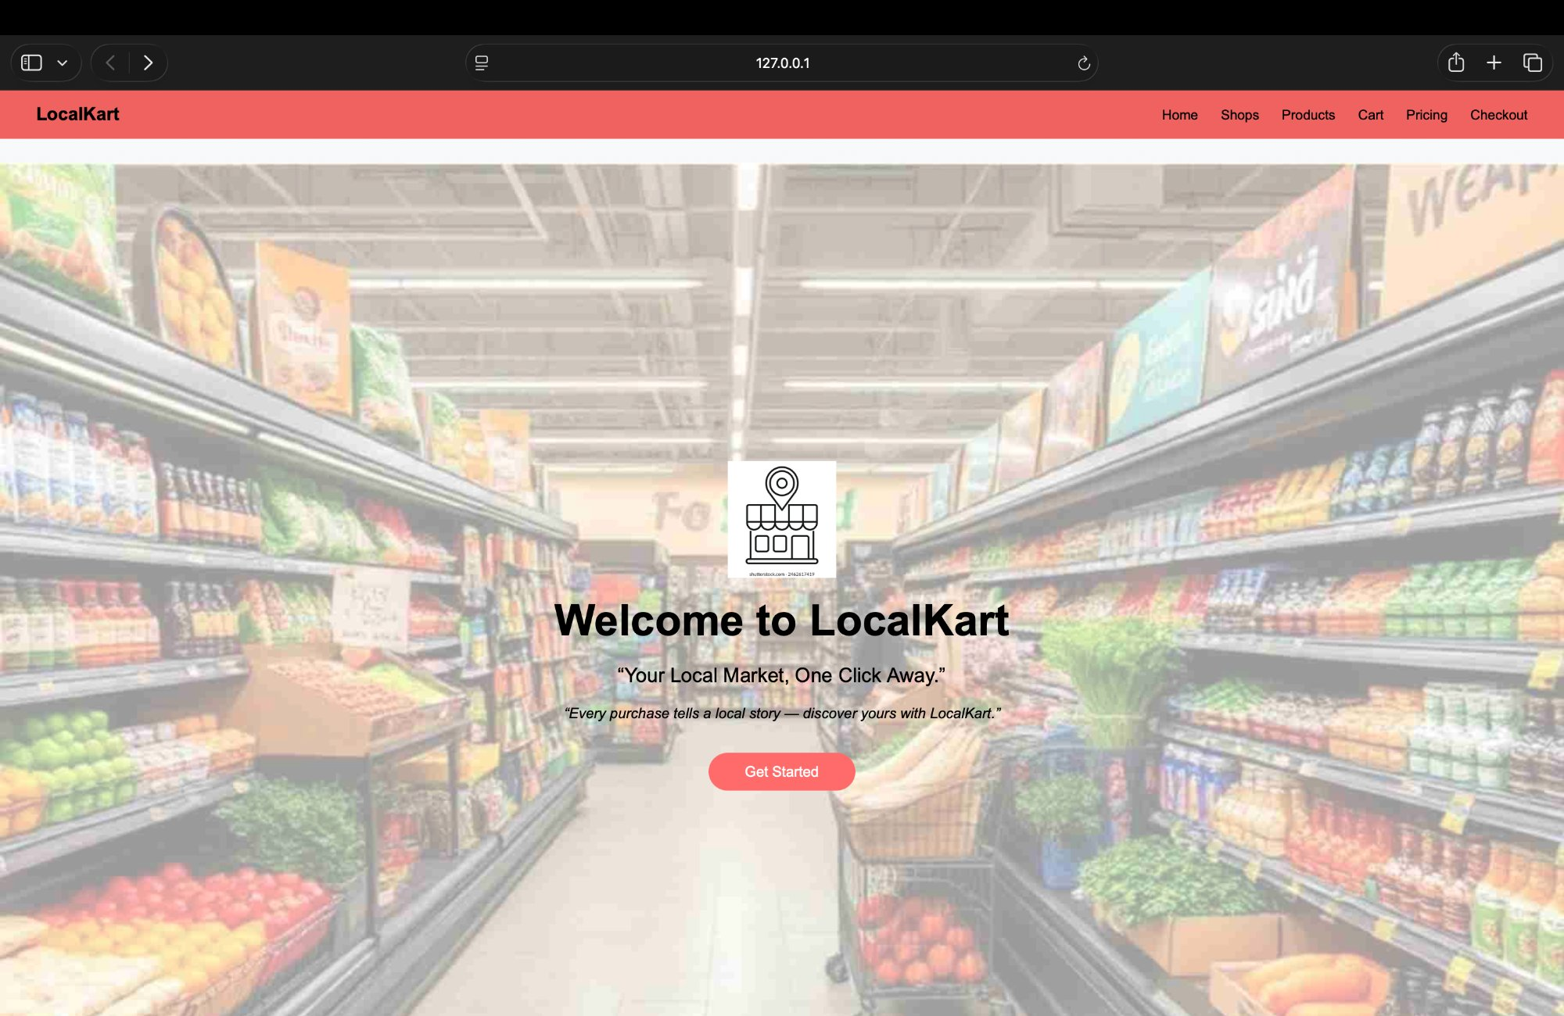

5.2 Login / Register (login.html)
Split-screen Flexbox layout with the login form on the left and a looping background video on the right. JS variables store credentials in-memory; the view toggles between Login and Sign-Up without a page reload.

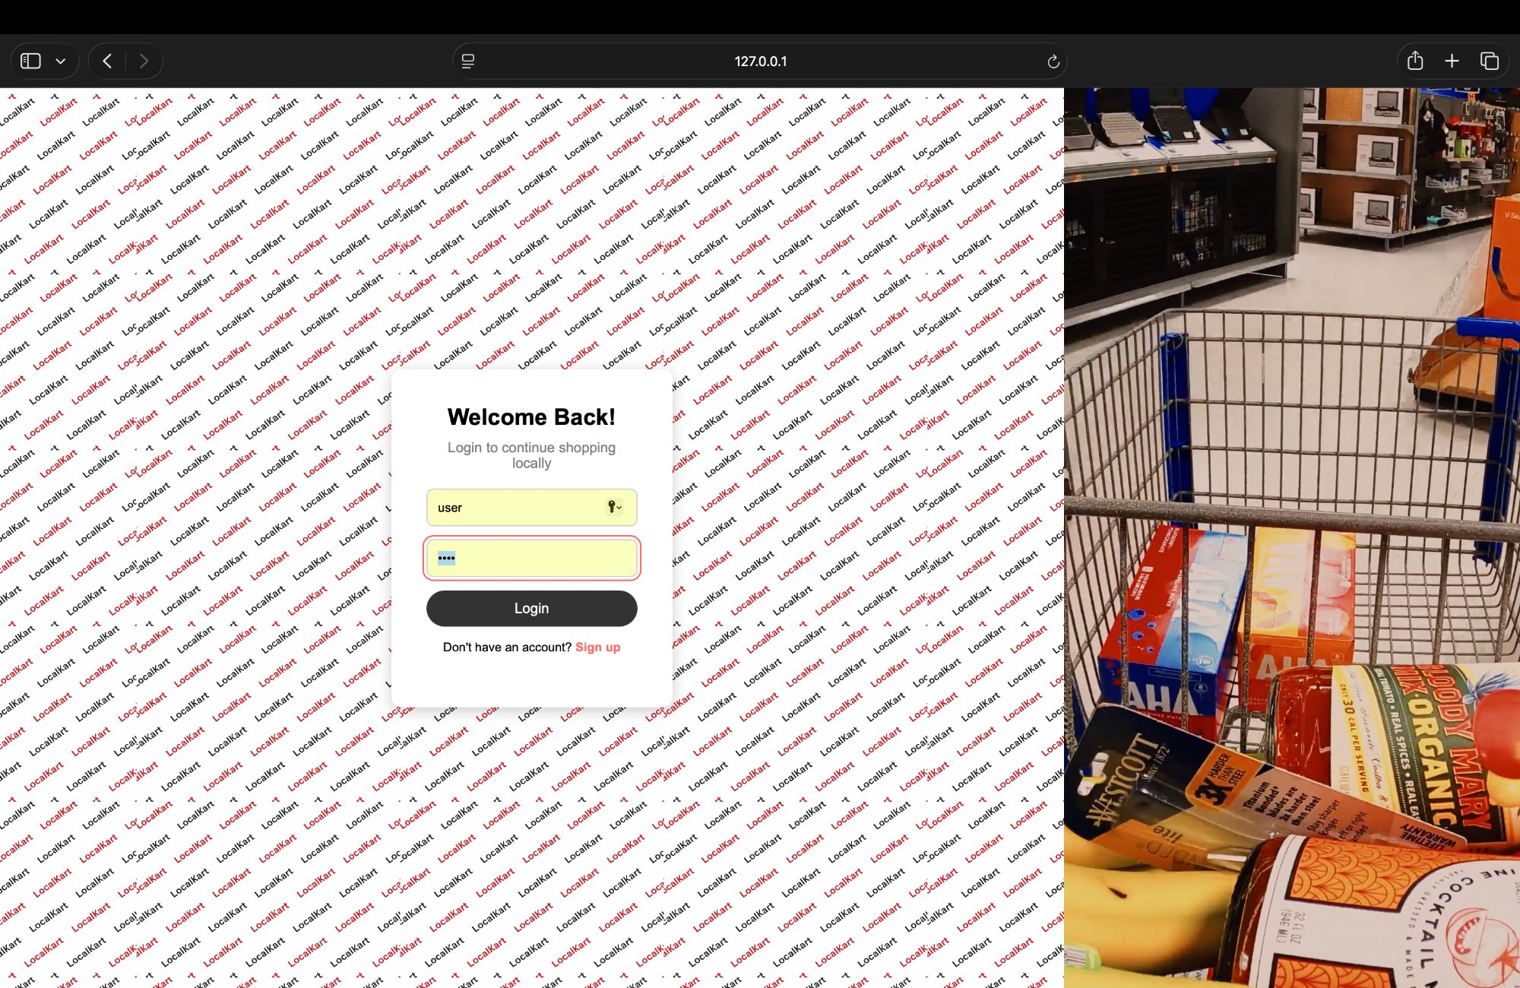

5.3 Home Page (home.html)
Bootstrap 5 carousel auto-advances through three hero slides. Below it, a pincode checker validates 6-digit input and shows a delivery availability badge. A Best Seller shops grid, About stats section (4.8 rating, 5000+ customers, 50+ shops, same-day delivery), and a Contact form complete the page.

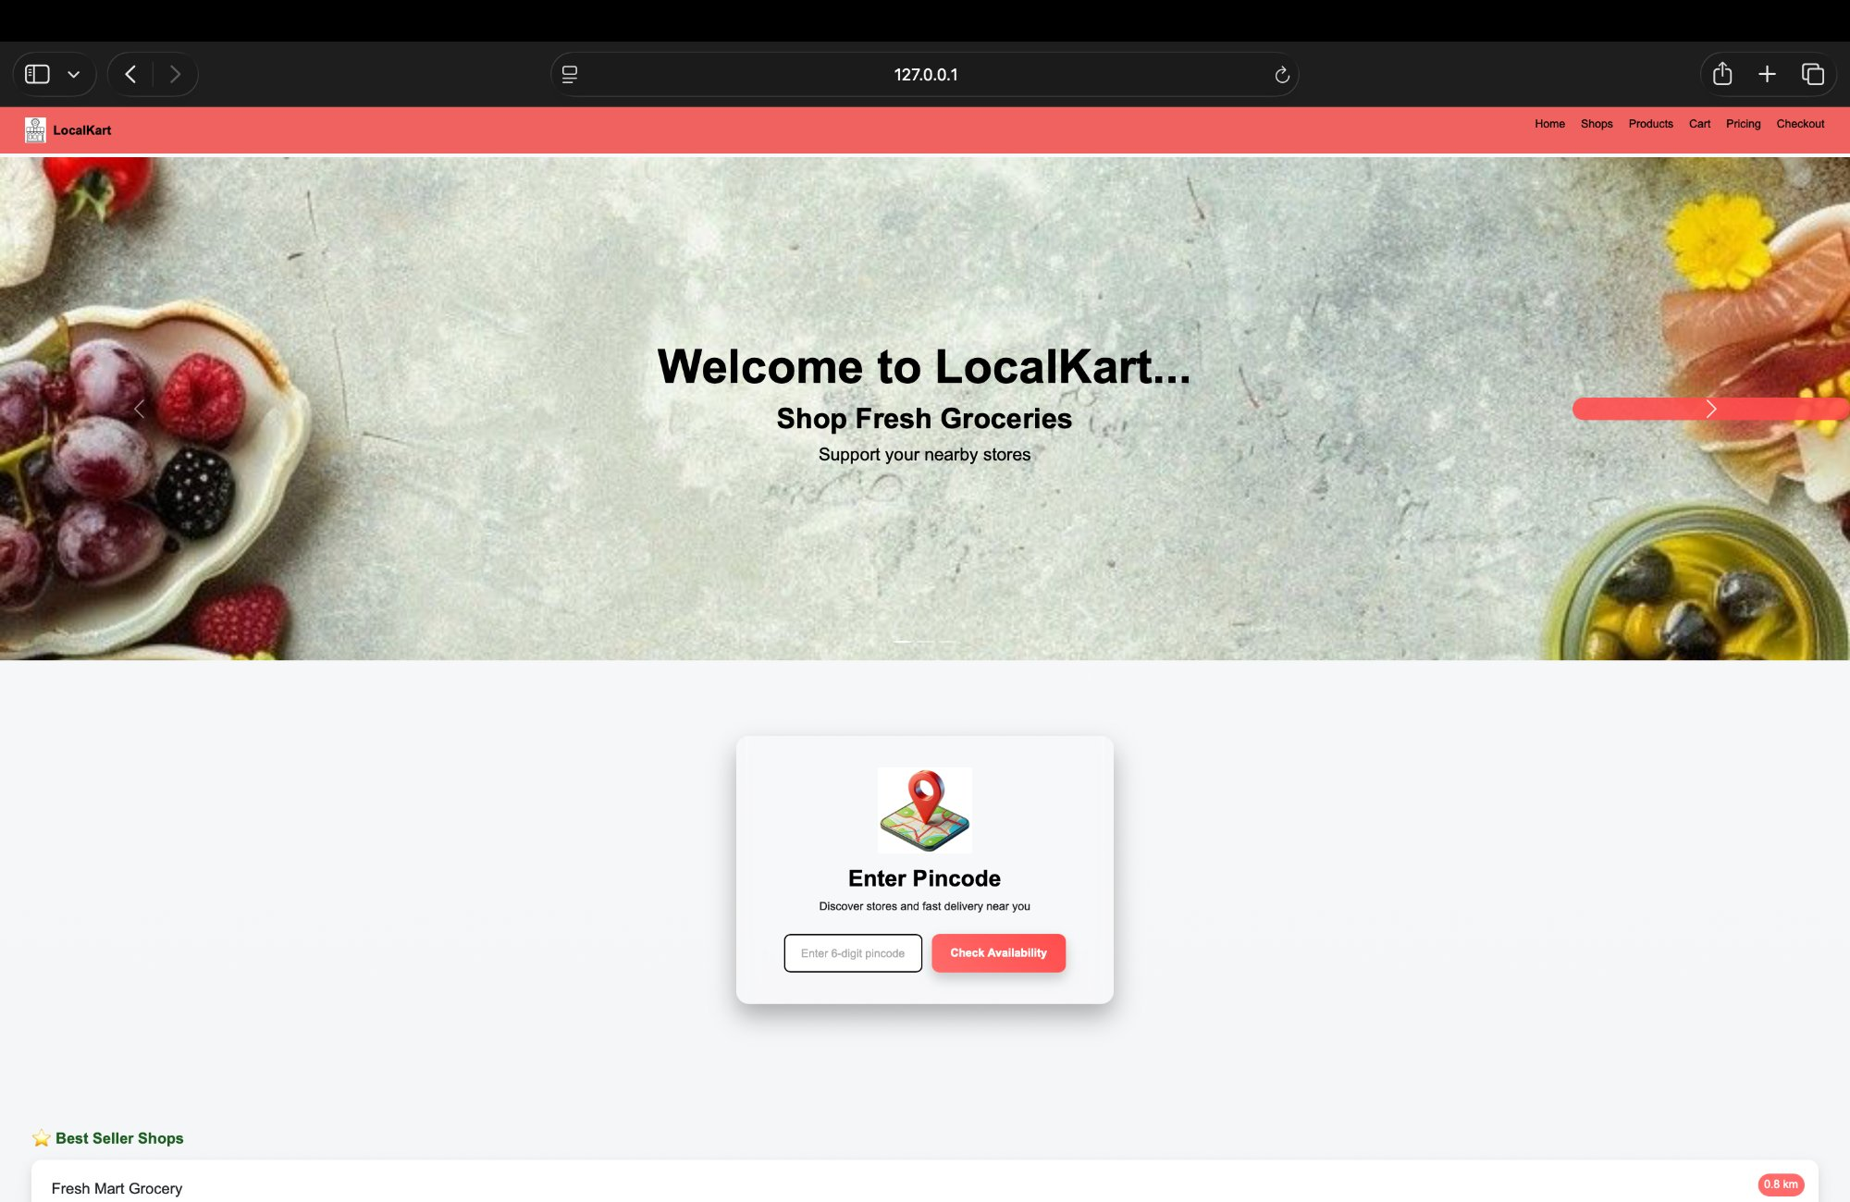

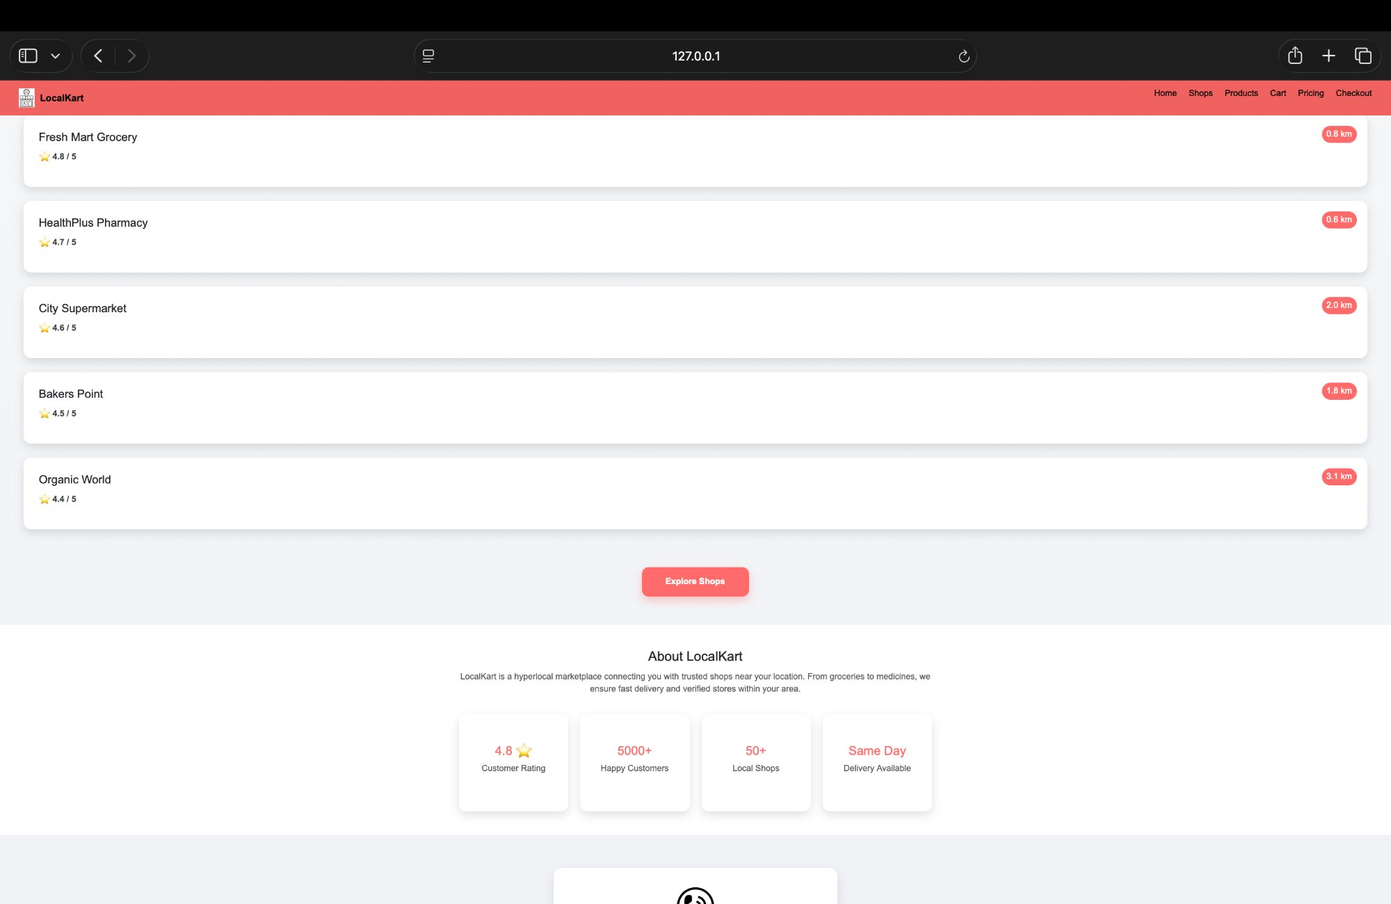

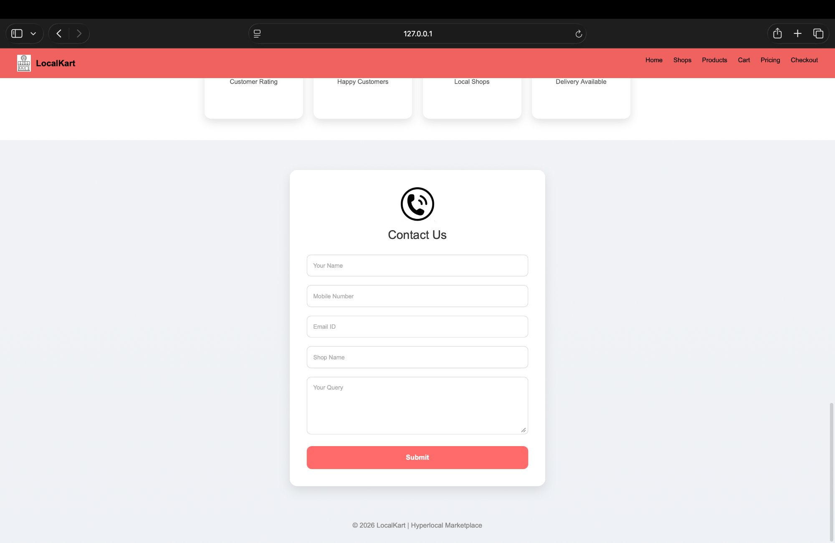

5.4 Shops Page (shops.html)
22 shop cards in a CSS Grid over a background video. A combined search + rating + delivery-type filter bar updates visible cards in real time on every keystroke or dropdown change. Distance badges appear as floating tooltips on mouse hover using mousemove coordinates.

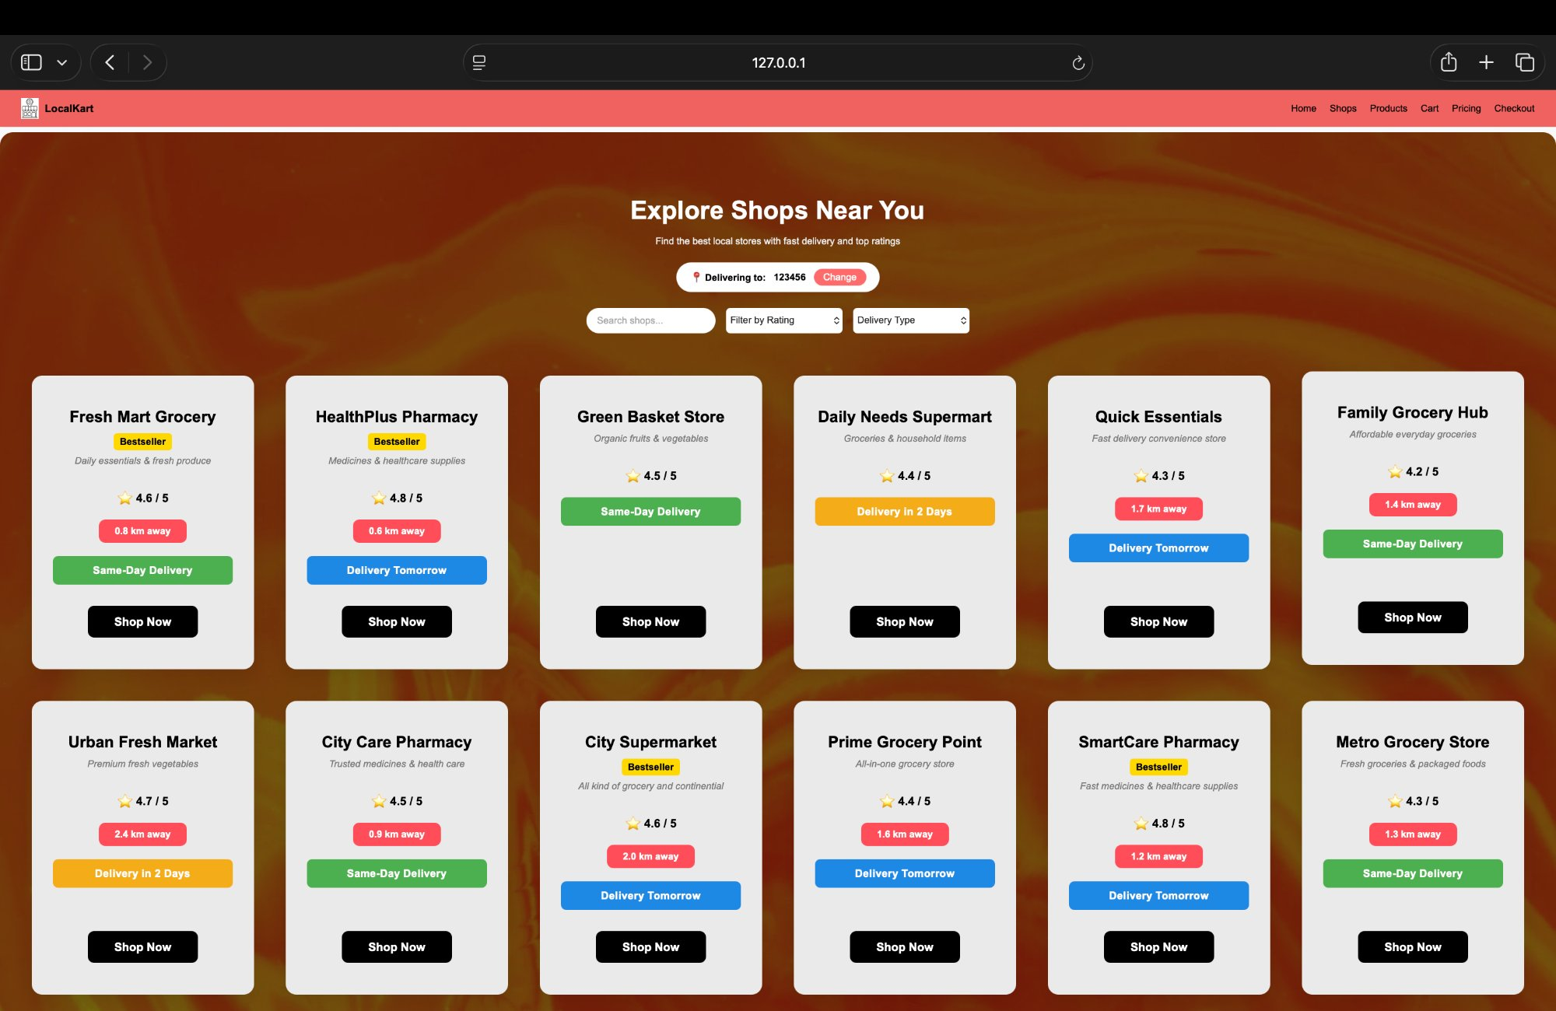

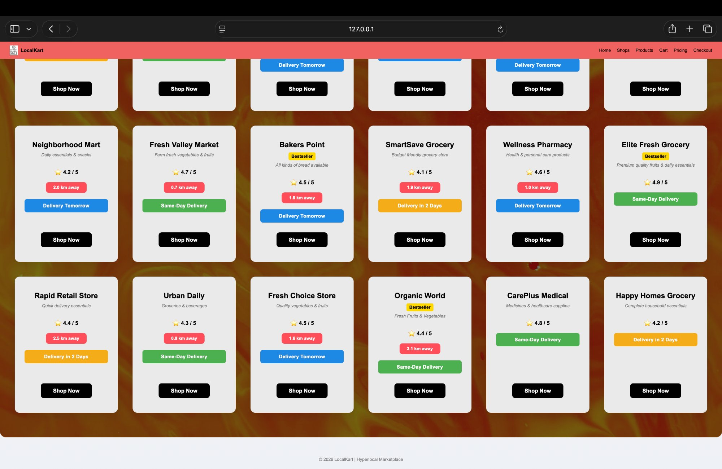

5.5 Products Page (products.html)
62 products across six categories: Vegetables, Fruits, Dairy & Bread, Lentils & Grains, Oil & Spices, and Medicines. Each card has a product image, name, price, and Add to Cart button that writes to localStorage. A live search input filters all cards as the user types.

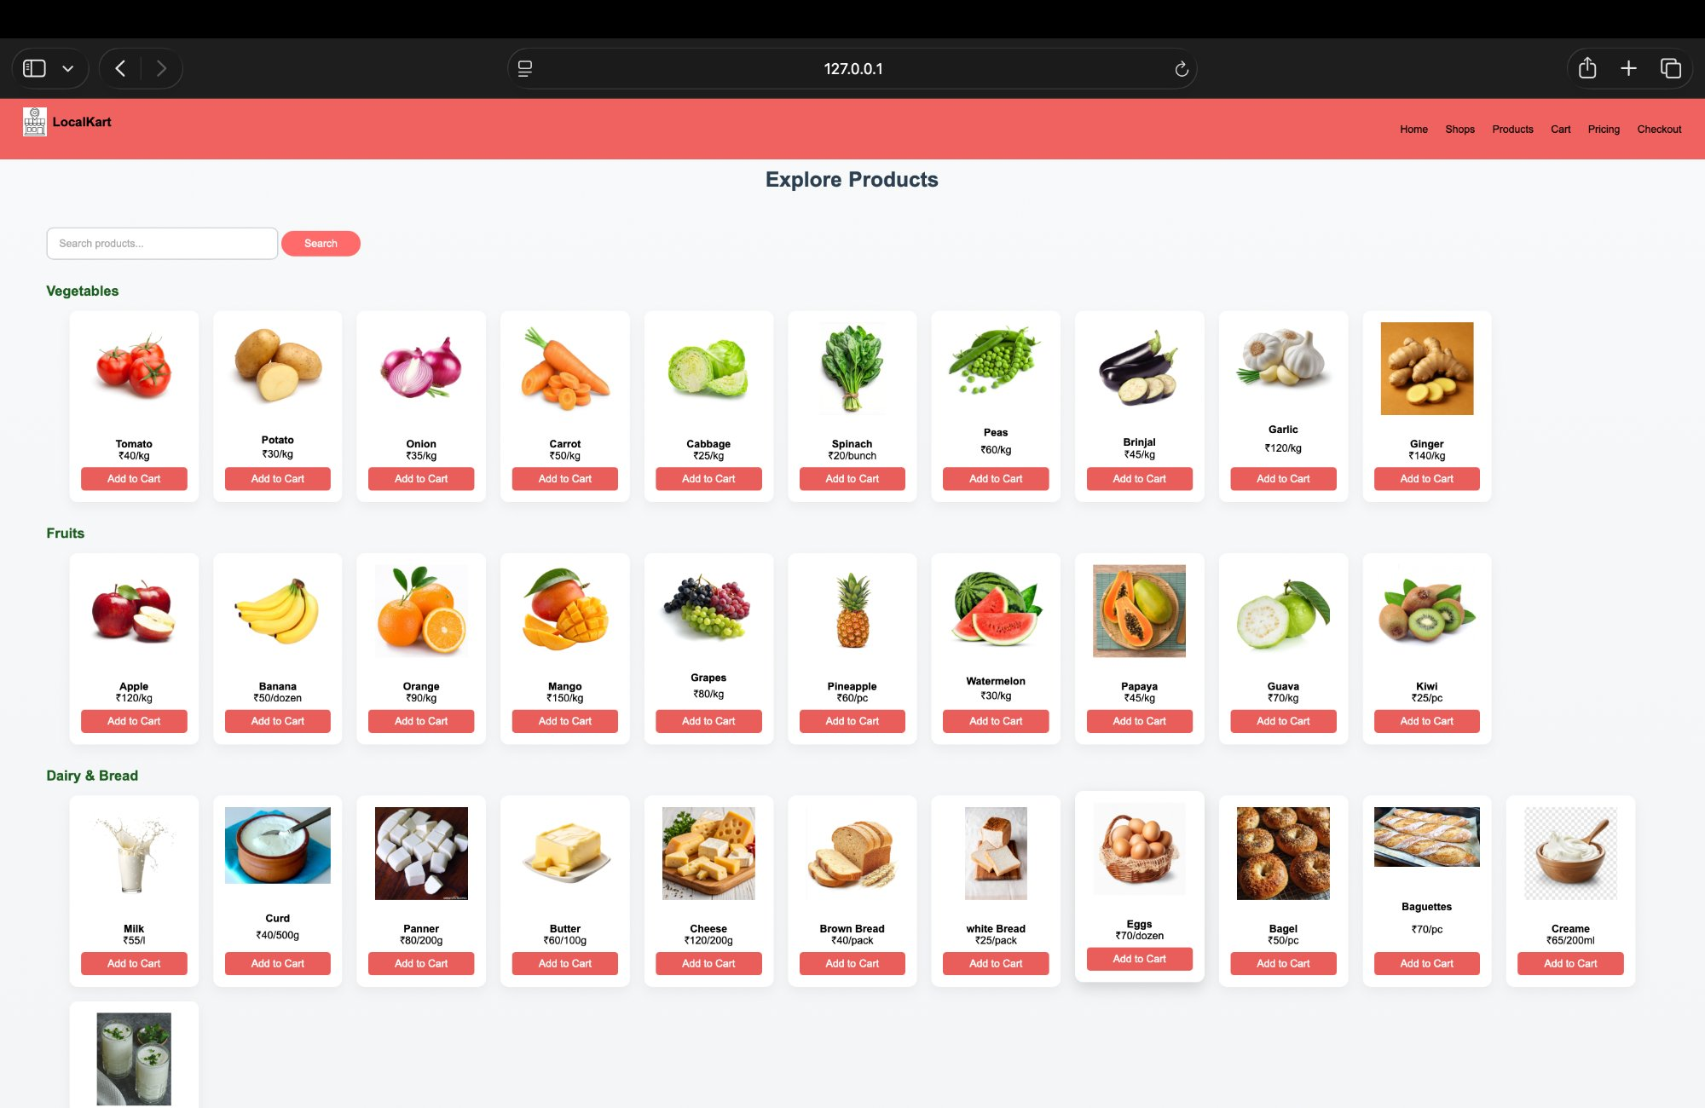

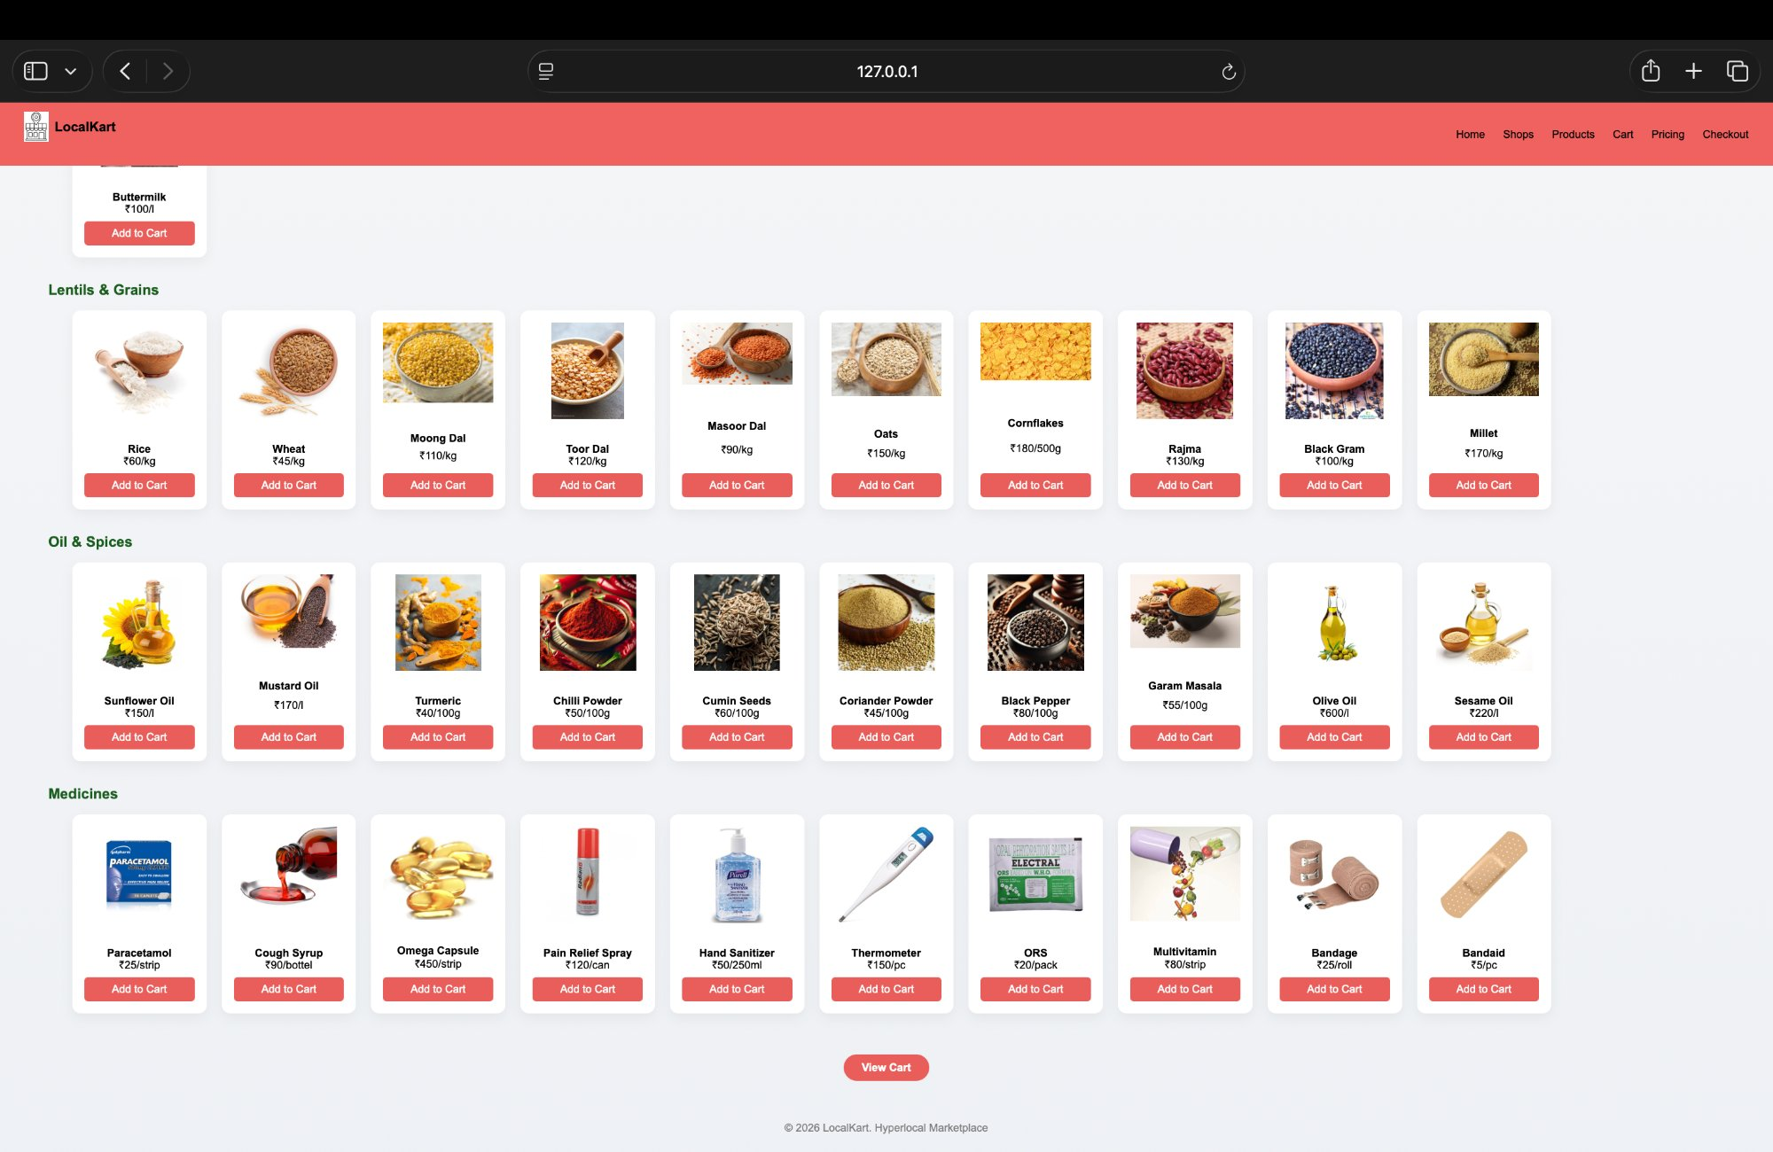

5.6 Cart Page (cart.html)
loadCart() reads localStorage on DOMContentLoaded and builds a dynamic HTML table. Each row has quantity input (changeQty()) and a remove button (removeItem()). Grand total updates live. Continue button redirects to checkout.

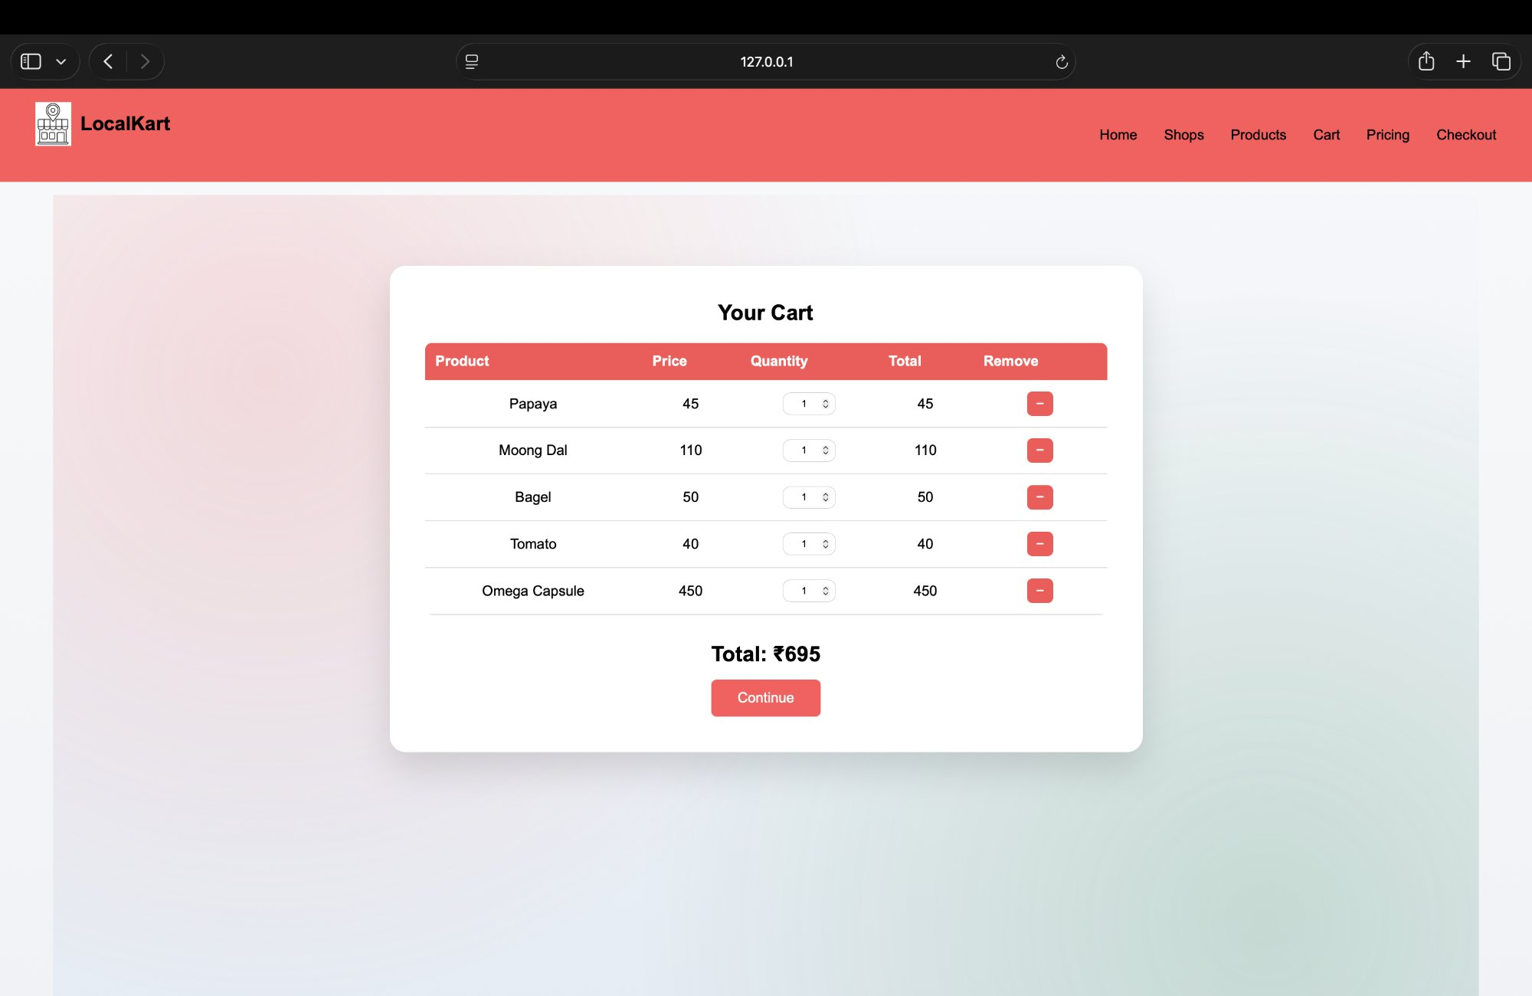

5.7 Pricing / Seller Page (pricing.html)
Hero CTA scrolls to the seller registration form via scrollIntoView. A 5% commission table, four seller benefit cards, and the registration form (POSTs to /register-seller) are displayed over a background video.

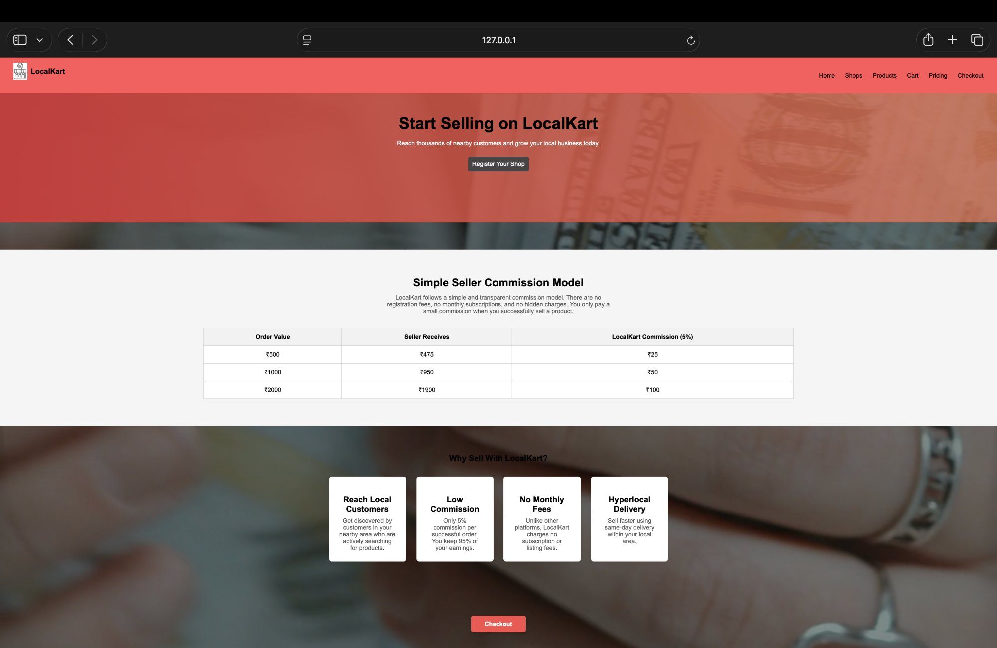

5.8 Checkout Page (checkout.html)
Delivery form collects name, phone, address, pincode, and shop name. Payment radio buttons toggle UPI ID or card detail fields. On valid submission a confirmation popup is shown with a Continue Shopping option.

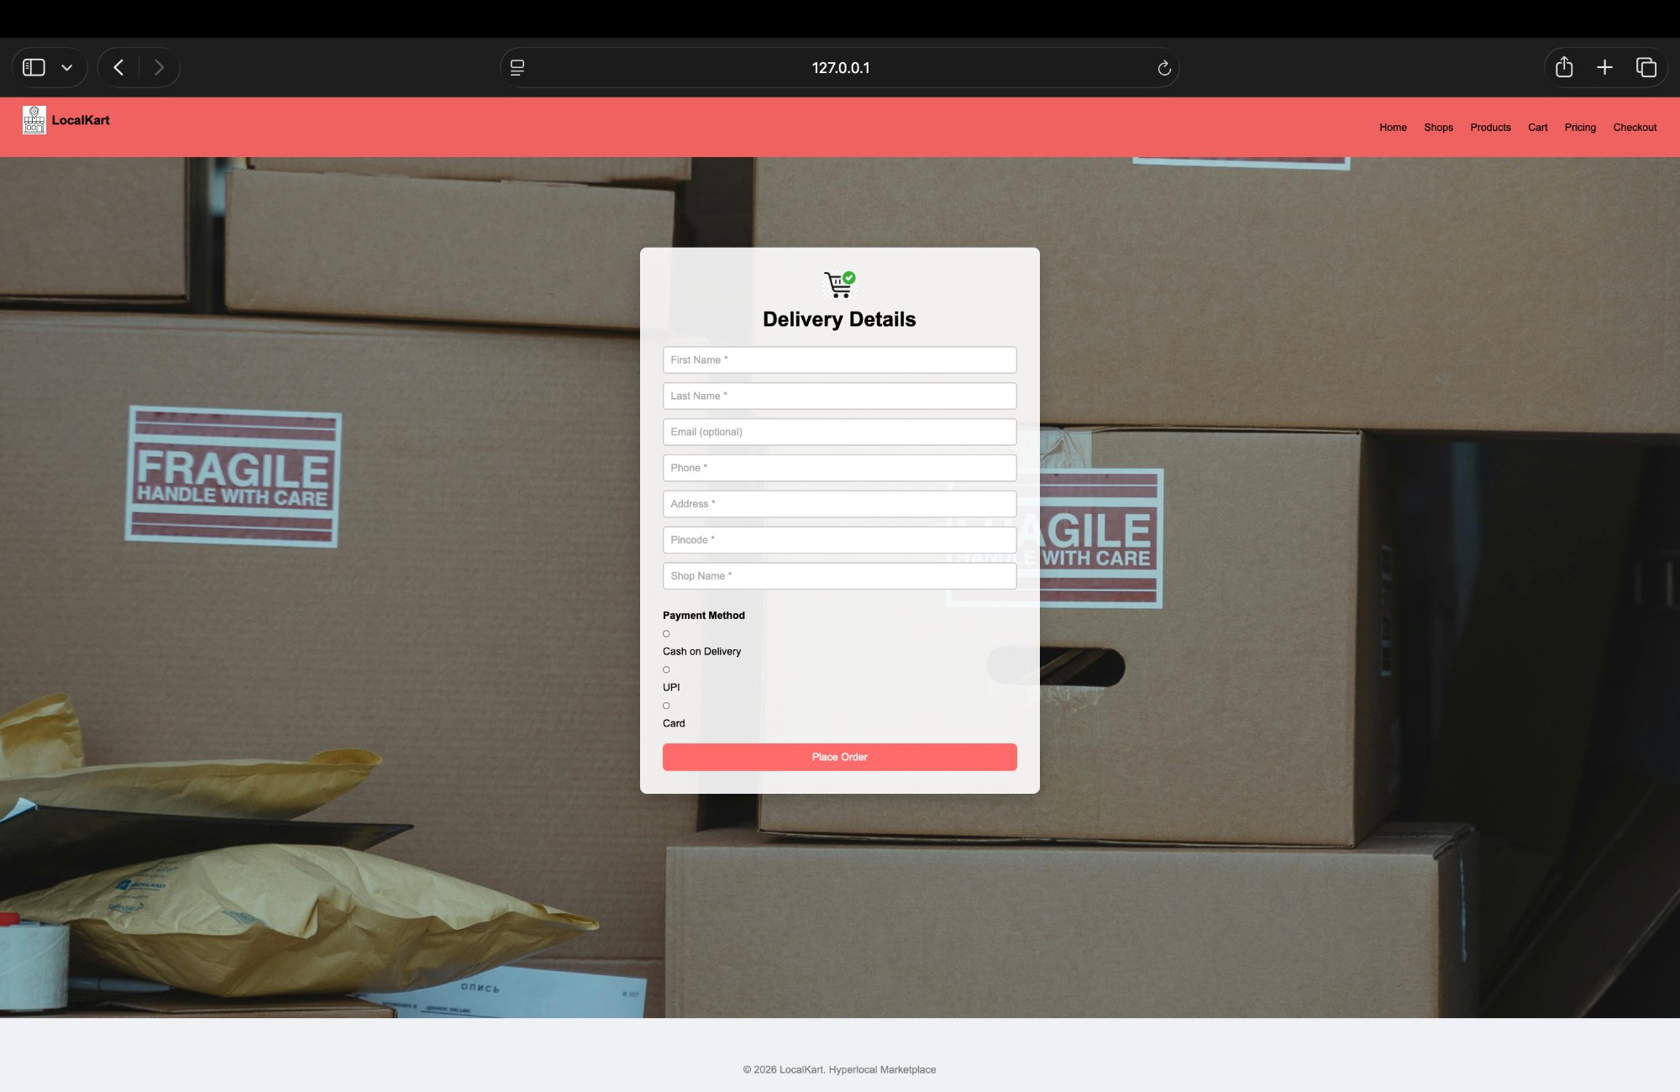

6. Results and Conclusion

Findings
- All 8 pages are functional and navigable through the shared navigation bar.
- localStorage cart persists correctly across Products, Cart, and Checkout pages.
- Shop filter applies search, rating, and delivery-type criteria simultaneously in real time.
- Product search filters all 62 cards live with no noticeable lag.
- Checkout payment toggle and order confirmation popup work as expected.
- Seller registration POSTs successfully to the Node.js backend, updating shops.json.
- Bootstrap 5 carousel auto-advances and supports manual navigation on home.html.
- All pages are responsive and usable at 480px mobile viewport width.

Conclusion
LocalKart demonstrates how a complete hyperlocal marketplace can be built using only HTML 5, CSS 3, JavaScript, and a minimal Node.js backend. The project covers the full user journey from landing and authentication through product discovery, cart management, and checkout, along with a seller onboarding flow backed by a real server endpoint. Future enhancements could include a real database, JWT authentication, a seller dashboard, and payment gateway integration.

Key Outcomes
- 8-page responsive hyperlocal marketplace successfully built and tested.
- 62 products across 6 categories with add-to-cart and localStorage persistence.
- 22 shop cards with combined real-time search, rating, and delivery-type filtering.
- Full checkout flow with dynamic payment toggle and popup confirmation.
- Seller registration connected to Node.js + Express backend, data written to shops.json.

7. References

- MDN Web Docs — HTML 5 Elements Reference. https://developer.mozilla.org/en-US/docs/Web/HTML/Element
- MDN Web Docs — CSS Reference (Flexbox, Grid, Animations). https://developer.mozilla.org/en-US/docs/Web/CSS
- MDN Web Docs — Web APIs: localStorage, DOM, EventListener. https://developer.mozilla.org/en-US/docs/Web/API
- Bootstrap 5.3 Documentation — Carousel Component. https://getbootstrap.com/docs/5.3/components/carousel/
- Node.js Official Documentation. https://nodejs.org/en/docs
- Express.js Official Documentation. https://expressjs.com/en/4x/api.html
- W3Schools — HTML 5, CSS 3, JavaScript Tutorials. https://www.w3schools.com
- ITM Skills University, School of Future Tech — Course Material: HTML 5, CSS 3, JavaScript (2025–26).

