School of Future Tech

Case Study Report
on
Case Study 168: Simple Calculator Application
by
Rima Maji
Roll Number: 150096725215
B.Tech in Computer Science Engineering
3rd Semester

Index
1. Introduction to the Case Study
2. Problem Statement / Case Background (Abstract)
3. Problem Statement / Case Study Design
4. Methods & Algorithms Technology Applied in the Problem Statement / Case Study
5. Problem Statement / Case Study Implementation Details and Snapshots
6. Problem Statement / Case Study Results and Conclusion
7. References

1. Introduction to the Case Study
A calculator is a basic application used to perform arithmetic operations on numerical values. This case study focuses on designing and implementing a Simple Calculator Application in Java. The application accepts two numbers from the user and performs addition, subtraction, multiplication, or division according to the operator selected by the user.
The case study demonstrates fundamental Java programming concepts including the Scanner class for user input, switch statements for operation selection, arithmetic operators for calculations, methods for handling individual operations, and if-else statements for validation. The application also handles the special condition of division by zero and displays an appropriate error message.
2. Problem Statement / Case Background (Abstract)
Background
Users often need a simple way to perform arithmetic calculations. A calculator application provides a direct interface for entering numerical values and selecting the required operation. In this case study, the calculator is implemented as a console-based Java application.
Abstract
This case study presents the design and implementation of a Simple Calculator Application using Java. The program accepts two numbers through Scanner and accepts an arithmetic operator from the user. A switch statement selects the corresponding calculation method. Addition, subtraction, multiplication, and division are implemented using separate methods. Before division, an if-else condition checks whether the second number is zero. The result is then displayed on the console. The implementation provides a clear demonstration of input handling, decision making, methods, operators, validation, and output.
3. Problem Statement / Case Study Design
The Simple Calculator is designed as a small modular console application with the following stages:
1. Number Input | Accept two numbers using Scanner.
2. Operation Selection | Accept an operator such as +, -, *, or /.
3. Calculation | Use the selected operation and call the corresponding method.
4. Validation | Check division by zero using an if-else condition.
5. Result Display | Display the calculated result or an error message.
Program flow: Start → Input first number → Input second number → Input operator → Select operation using switch → Validate division if required → Calculate → Display result → End.
4. Methods & Algorithms Technology Applied in the Problem Statement / Case Study
Key Java concepts and methods:
- Scanner: Used to accept numerical values and the operator from the keyboard.
- Switch statement: Selects the arithmetic operation based on the entered operator.
- Methods: Separate methods are used for add, subtract, multiply, and divide operations.
- Arithmetic operators: The program uses +, -, *, and / for calculations.
- If-else validation: Checks whether the divisor is zero before performing division.
- Default case: Displays an error message when an unsupported operator is entered.
Technology Stack Used for the Case
- Programming language: Java.
- Input library: java.util.Scanner.
- Development environment: Visual Studio Code / Java-enabled IDE.
- Execution: Java compiler (javac) and Java runtime (java).
- Application type: Console-based application.

5. Problem Statement / Case Study Implementation Details and Snapshots
The implementation consists of one Java class named SimpleCalculator. Four methods perform the individual arithmetic operations. The main method handles input, operator selection, validation, and result display.
import java.util.Scanner;
public class SimpleCalculator {
static double add(double a, double b) {
return a + b;
}
static double subtract(double a, double b) {
return a - b;
}
static double multiply(double a, double b) {
return a * b;
}
static double divide(double a, double b) {
return a / b;
}
public static void main(String[] args) {
Scanner sc = new Scanner(System.in);
System.out.print("Enter first number: ");
double num1 = sc.nextDouble();
System.out.print("Enter second number: ");
double num2 = sc.nextDouble();
System.out.print("Enter operator (+, -, *, /): ");
char operator = sc.next().charAt(0);
double result;
switch (operator) {
case '+':
result = add(num1, num2);
System.out.println("Result = " + result);
break;
case '-':
result = subtract(num1, num2);
System.out.println("Result = " + result);
break;
case '*':
result = multiply(num1, num2);
System.out.println("Result = " + result);
break;
case '/':
if (num2 == 0) {
System.out.println("Error: Cannot divide by zero.");
} else {
result = divide(num1, num2);
System.out.println("Result = " + result);
}
break;
default:
System.out.println("Invalid operator.");
}
sc.close();
}
}
Implementation Screenshots and Evidence
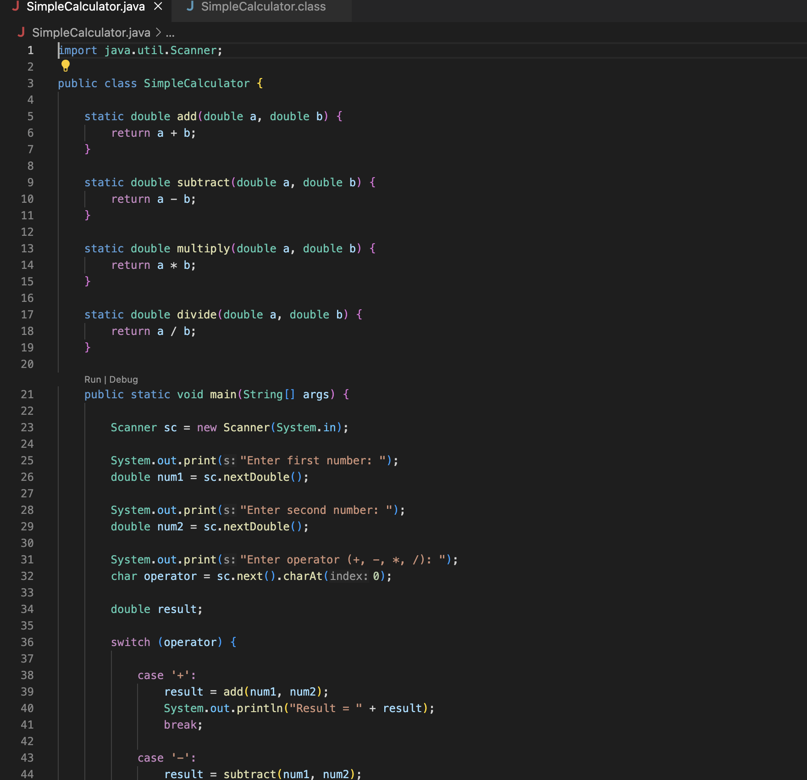
Figure 1. SimpleCalculator.java source code – Part 1
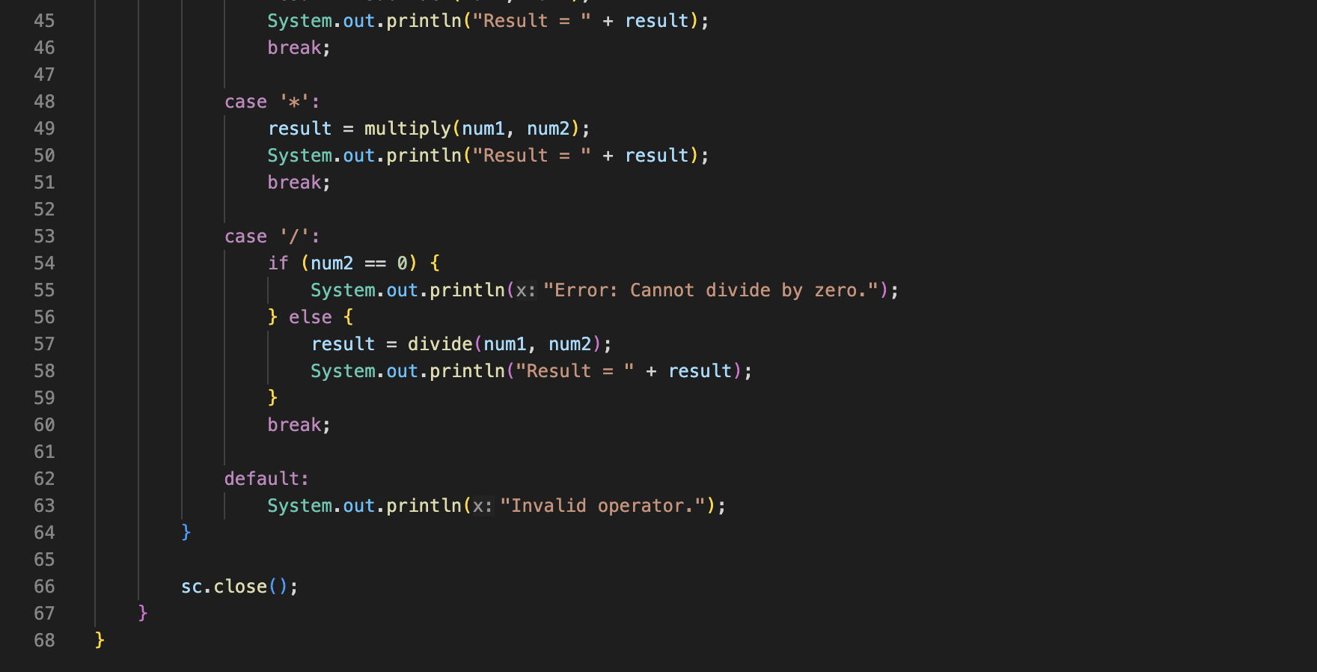
Figure 2. SimpleCalculator.java source code – Part 2
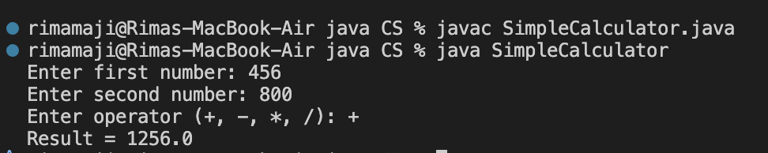
Figure 3. Successful compilation and addition operation
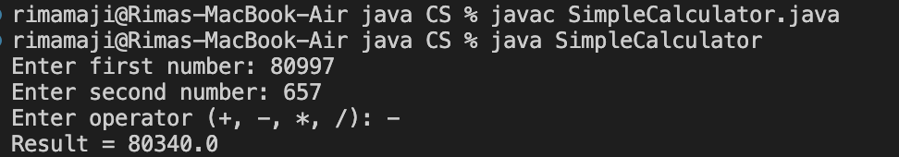
Figure 4. Subtraction operation output
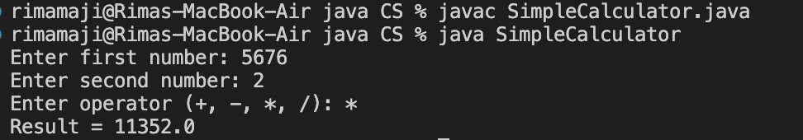
Figure 5. Multiplication operation output
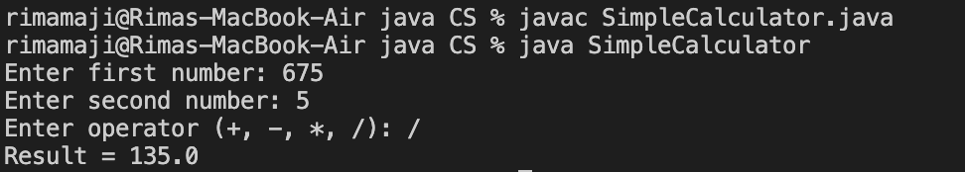
Figure 6. Division operation output
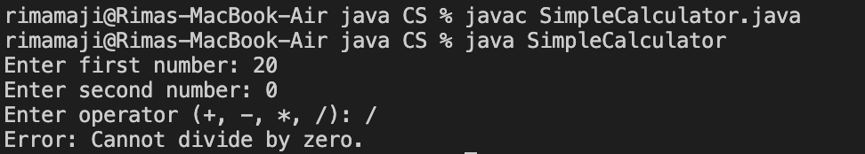
Figure 7. Division-by-zero validation output

6. Problem Statement / Case Study Results and Conclusion
Findings
- The application successfully accepts two numerical inputs from the user.
- The switch statement correctly selects addition, subtraction, multiplication, or division.
- Individual arithmetic operations are handled through separate methods.
- Division by zero is validated using an if-else condition and produces an error message instead of performing the calculation.
- The result of a valid operation is displayed clearly on the console.
- An invalid operator is handled through the default switch case.
Observed Results
Operation | Input | Output
Addition (+) | 456 + 800 | 1256.0
Subtraction (-) | 80997 - 657 | 80340.0
Multiplication (*) | 5676 * 2 | 11352.0
Division (/) | 675 / 5 | 135.0
Division by zero | 20 / 0 | Error: Cannot divide by zero.
Input | Operator | Output
20, 5 | + | Result = 25.0
20, 5 | - | Result = 15.0
20, 5 | * | Result = 100.0
20, 5 | / | Result = 4.0
20, 0 | / | Error: Cannot divide by zero.
Conclusion
This case study demonstrates the implementation of a simple calculator using core Java programming concepts. The application combines Scanner input, switch-based operation selection, methods for individual calculations, arithmetic operators, and if-else validation. The final program is modular, easy to understand, and satisfies the required objectives of the Simple Calculator Application.
7. References
- Java documentation for Scanner and core language constructs.
- Java documentation for switch statements, methods, operators, and conditional statements.
- Course material and laboratory notes on Java programming fundamentals.

