ITM SKILLS UNIVERSITY
SCHOOL OF FUTURE TECH

DATABASE MANAGEMENT SYSTEM
FINAL CASE STUDY REPORT
Case Study 6: Seed and Fertiliser Depot Stock

Student Name | Rima Maji
Roll Number | 150096725215
Programme | B.Tech in Computer Science & Engineering
University | ITM Skills University
Database System | PostgreSQL
Academic Year | 2026

DBMS case study.

TABLE OF CONTENTS
- 1. Case Study Overview
- 2. Objectives and Required Deliverables
- 3. System and Database Design
- 4. ER Diagram and Relational Structure
- 5. Schema Implementation
- 6. Sample Data / Database Seeding
- 7. SQL Query Implementation (Q1–Q18)
- 8. Query Results Summary
- 9. Practical Execution Evidence
- 10. Subquery vs Join Comparison
- 11. NULL Trap: NOT IN vs NOT EXISTS
- 12. Design Decisions and Alternatives Rejected
- 13. Testing and Validation
- 14. Conclusion
- Appendix A — Project Files
- Appendix B — Viva / Explanation Points

1. Case Study Overview
The supplied ITM Skills University case study is titled “Seed and Fertiliser Depot Stock Database Using SQL.” It describes a government depot that issues subsidised seed and fertiliser to registered farmers against seasonal quotas. The database is required to support day-to-day depot operations and produce end-of-season reports.

Business requirements
- Identify farmers who have used more than 80% of their quota.
- Identify products whose stock is below the average stock across products.
- Identify registered farmers who collected nothing during the selected season.
- Identify the latest issue of each product and the farmer who received it.
- Identify products that were issued to every registered farmer.
- Demonstrate scalar, multi-row and correlated subqueries using IN, NOT IN, EXISTS, NOT EXISTS, ANY and ALL.
- Rewrite at least two subqueries using joins and compare the approaches.
- Use PostgreSQL filtering, sorting, aggregation, GROUP BY, HAVING and subqueries.
- Use realistic sample data rather than only a few rows per table.
- Document design decisions and alternatives that were rejected.

2. Objectives and Required Deliverables
The case-study sheet specifies the following major objectives and deliverables.

Objectives addressed
- Model farmers, products, quotas, issues and stock receipts so that a farmer cannot be issued beyond the quota by design intent and reporting logic.
- Implement the required subquery categories and demonstrate their different uses.
- Explain correlated versus uncorrelated subqueries and the NULL behaviour of NOT IN.
- Compare subquery and join formulations for equivalent requirements.
- Populate the database with realistic volumes of farmers, products, seasons, quotas, issues and receipts.
- Record design decisions and rejected alternatives.

Deliverables included in the project
- ER_Diagram.png
- schema.sql
- seed.sql
- queries.sql
- README.md
- query_outputs.md
- subquery_vs_join.md
- Practical execution screenshots

3. System and Database Design
The database separates master data, seasonal quota data and transaction data. This keeps the model normalized and allows stock and quota utilisation to be calculated from transaction history.

Main entities
Entity | Purpose | Key | Important relationships
farmers | Registered farmers | farmer_id | Has many quotas and issues
products | Seed and fertiliser catalogue | product_id | Referenced by quotas, issues and receipts
seasons | Seasonal allocation periods | season_id | Referenced by quotas and issues
quotas | Allowed quantity by farmer/product/season | quota_id | FKs to farmer, product, season
issues | Actual issue transactions | issue_id | FKs to farmer, product, season
stock_receipts | Depot stock received from suppliers | receipt_id | FK to product

Derived stock model
Current stock is not stored as a manually maintained value. The project creates a product_stock view that calculates current stock as total receipts minus total issues. This avoids duplicating the same business fact in multiple places.
current_stock = SUM(stock_receipts.quantity) - SUM(issues.quantity)

4. ER Diagram and Relational Structure
The ER diagram connects farmers, products and seasons to the quota and issue transaction tables, while stock_receipts records inventory entering the depot. The diagram also identifies primary and foreign keys.
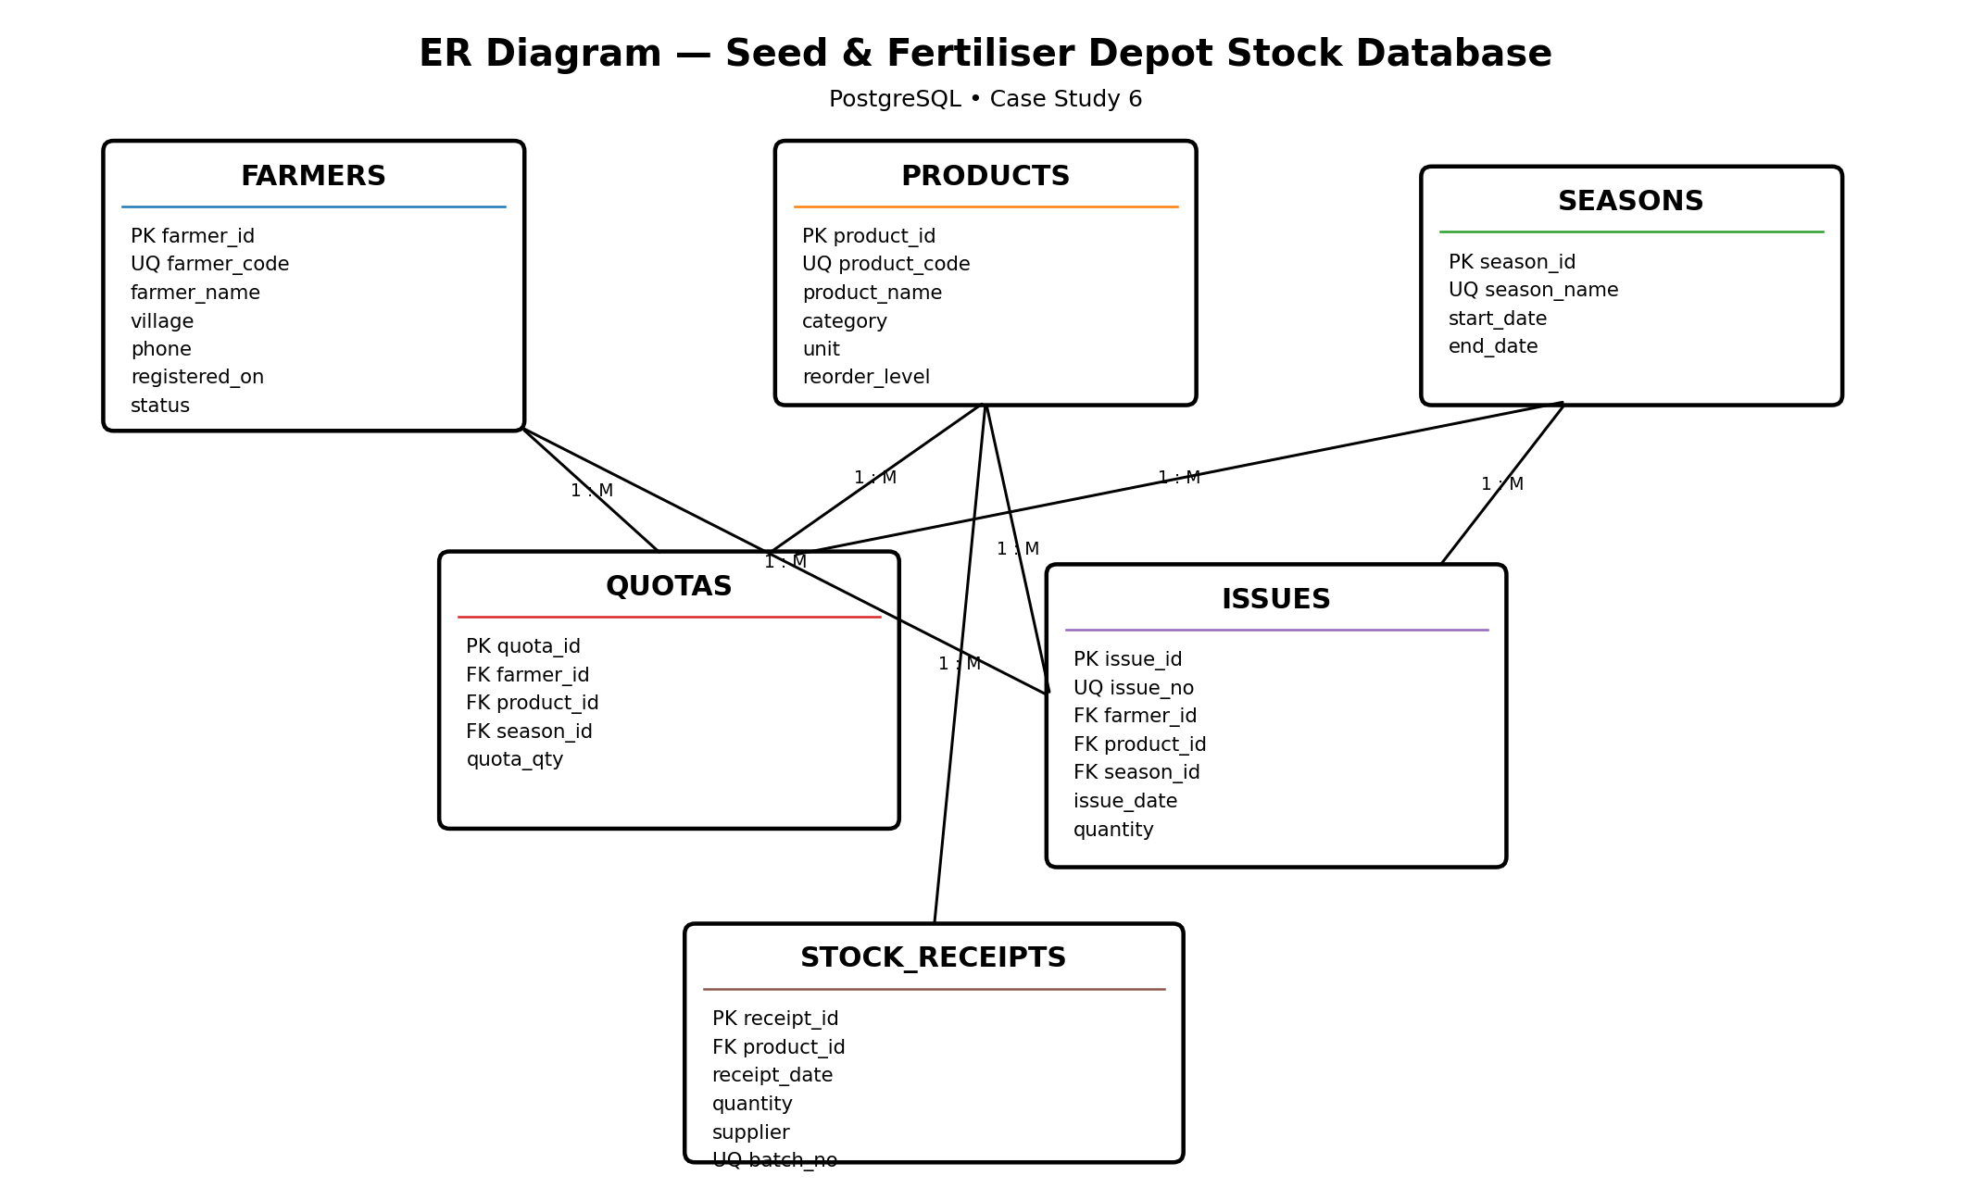
Figure 1. ER diagram supplied in the completed project.

Key constraints
- Primary keys uniquely identify rows.
- Foreign keys maintain valid references between related tables.
- UNIQUE constraints protect farmer_code, product_code, season_name, issue_no and batch_no.
- CHECK constraints restrict product category, positive quantities and valid season dates.
- A UNIQUE(farmer_id, product_id, season_id) constraint ensures one quota row per farmer/product/season combination.
- Indexes are created for frequently joined or filtered columns.

5. Schema Implementation
The completed schema.sql creates six base tables and a derived view:
- farmers
- products
- seasons
- quotas
- stock_receipts
- issues
- product_stock view

Schema execution evidence
The PostgreSQL session confirms that the six tables were created successfully. The following screenshot is the captured practical evidence.

6. Sample Data / Database Seeding
The completed seed.sql contains realistic data volumes: 15 farmers, 8 products, 3 seasons, 42 quota rows, 45 issue rows and 24 stock-receipt rows. This provides enough variation to produce meaningful subquery results.
The seed data also intentionally includes F015 (Yash Shinde) with a Kharif quota but no Kharif issue, allowing the NOT EXISTS requirement to produce a meaningful result.

Data verification
The practical evidence below shows row counts and sample-table verification after seeding.

7. SQL Query Implementation (Q1–Q18)
The final queries.sql contains eighteen numbered queries. Together they cover the required subquery types, case-study reports, aggregation, filtering and two join rewrites.
Query | Technique | Purpose | Recorded result
Q1 | Scalar subquery | Quota greater than average quota | 19 rows; average quota 114.76 kg
Q2 | IN | Farmers with a Kharif issue | 14 farmers
Q3 | NOT IN | Farmers who did not receive Urea in Kharif | 9 farmers
Q4 | EXISTS | Farmers with at least one Kharif issue | 14 farmers
Q5 | NOT EXISTS | Farmers who collected nothing in Kharif | F015 — Yash Shinde
Q6 | ANY | Products with stock greater than at least one seed stock | 7 rows
Q7 | ALL | Products with stock greater than every seed stock | P005 Urea; P006 DAP
Q8 | Correlated aggregate | Farmers using more than 80% of quota | 13 farmers
Q9 | Scalar aggregate | Products below average stock | 5 products
Q10 | Correlated MAX | Latest issue of each product | 8 rows
Q11 | Nested NOT EXISTS | Products issued to every active registered farmer | 0 rows
Q12 | GROUP BY + HAVING | Products issued >300 kg in Kharif | 4 products
Q13 | Filtering + sorting | Active farmers matching village pattern | 3 farmers
Q14 | Correlated quota check | Farmers with no product-level over-issue | 15 farmers
Q15 | Case-study report | Farmer-wise Kharif utilisation | 15 farmers; 0%–96.15%
Q16 | JOIN rewrite | Equivalent to Q4 | Same 14-farmer set
Q17 | JOIN rewrite | Equivalent to Q9 | Same 5-product set
Q18 | NULL-trap demonstration | NOT IN with NULL vs NOT EXISTS | NOT IN: 0 rows; safer form: F015

8. Query Results Summary
The project's query_outputs.md records the expected/verified result summary for all eighteen queries.

Important case-study findings
- Q8: 13 farmers are above 80% quota utilisation.
- Q9: five products are below the average stock of 2,110 kg: Cotton Seed, Maize Seed, Potash, Rice Seed and NPK 10-26-26.
- Q5: F015 (Yash Shinde) is the registered farmer with no Kharif collection.
- Q10: one latest issue is returned per product, producing eight rows.
- Q11: no product was issued to all 15 active registered farmers during Kharif 2026.
- Q12: Urea, DAP, Maize Seed and Wheat Seed exceed 300 kg of Kharif issues.
- Q15: all 15 farmers appear in the utilisation report, ranging from 0% to 96.15%.
- Q18 demonstrates the NULL trap: the intentionally constructed NOT IN query returns zero rows, while the NOT EXISTS alternative identifies F015.

9. Practical Execution Evidence
The uploaded project ZIP contains twenty PostgreSQL/terminal screenshots. They are embedded below as execution evidence and mapped to the corresponding project step or query. The screenshots are kept as evidence images rather than recreated tables.

Figure 2. PostgreSQL database creation and connection.
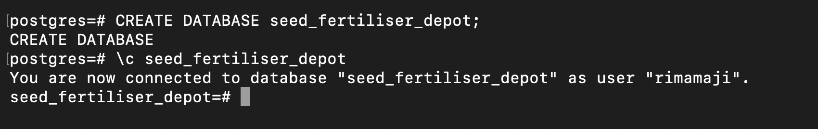
Figure 2. PostgreSQL database creation and connection.

Figure 3. Project files: ER diagram, SQL scripts, README and comparison note.
Figure 3. Project files: ER diagram, SQL scripts, README and comparison note.

Figure 4. Verification of the six database tables after schema execution.
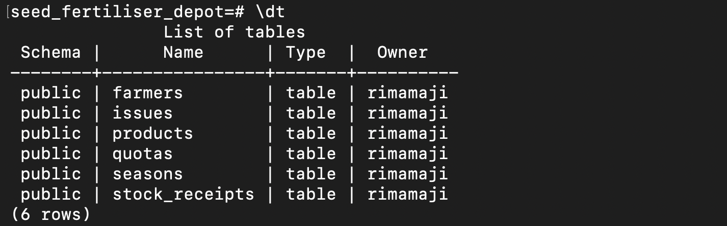
Figure 4. Verification of the six database tables after schema execution.

Figure 5. Seed-data verification and row counts.
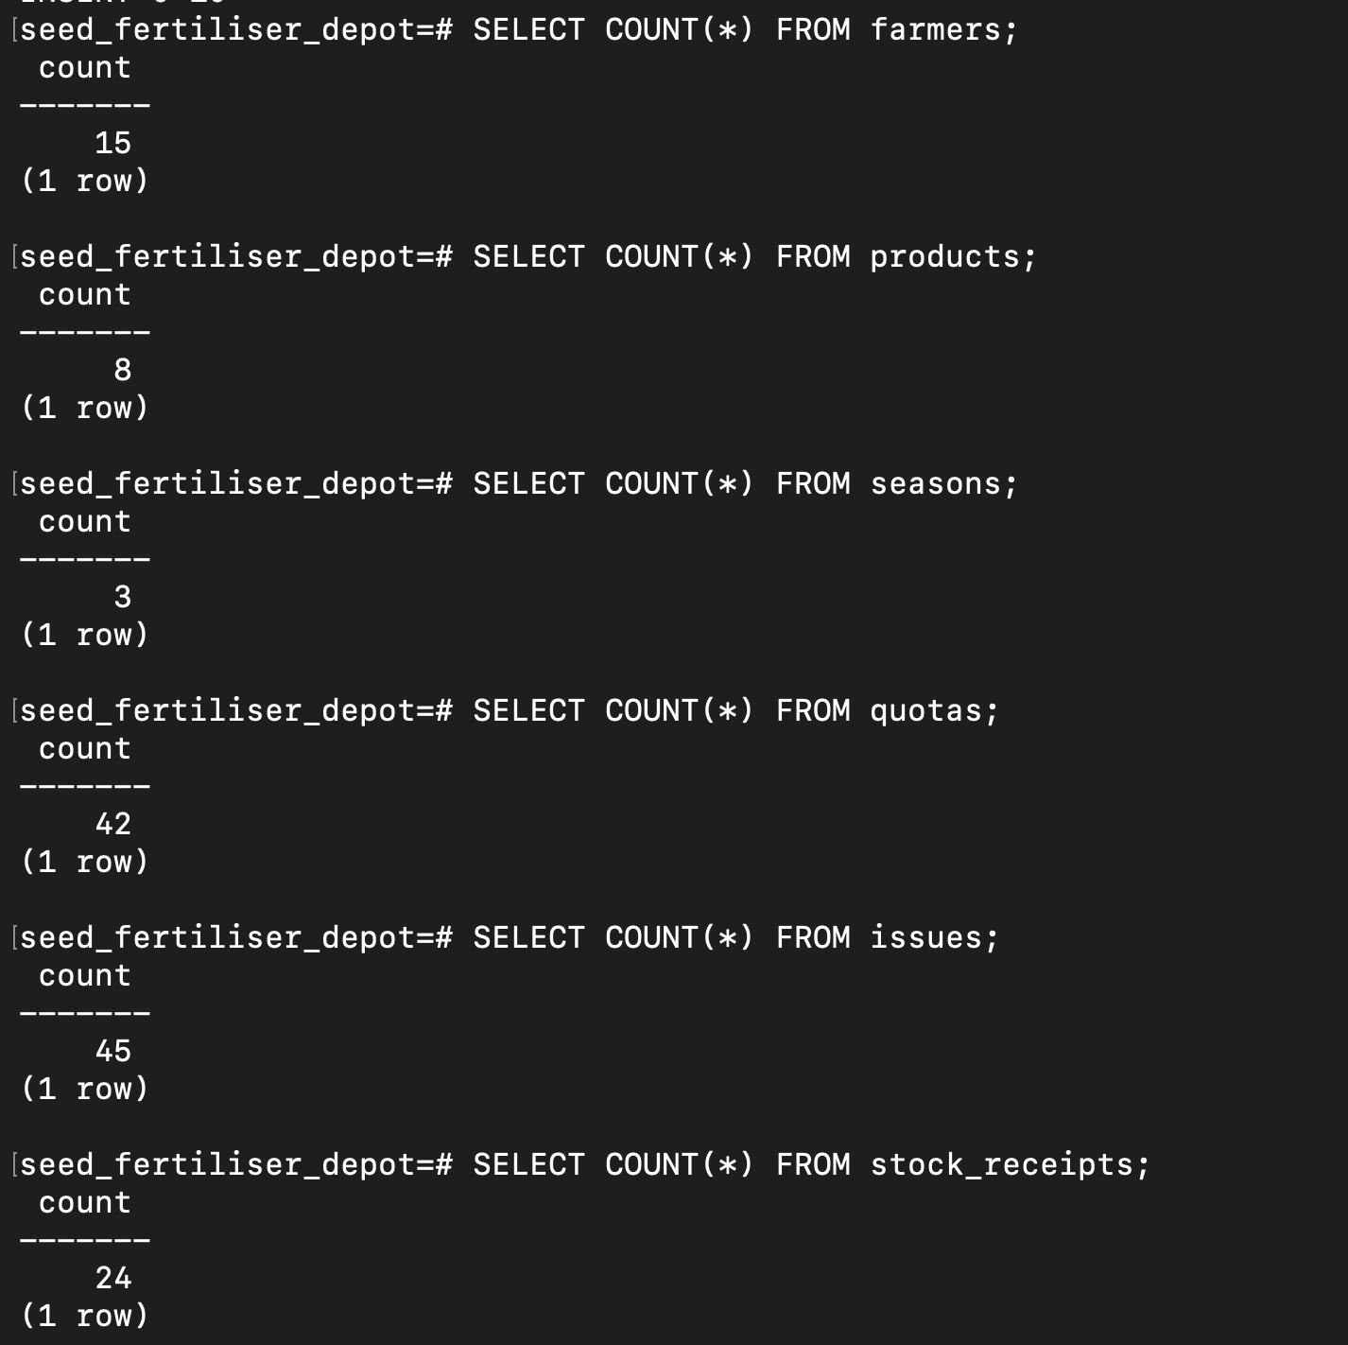
Figure 5. Seed-data verification and row counts.

Figure 6. Q1 — scalar subquery result.
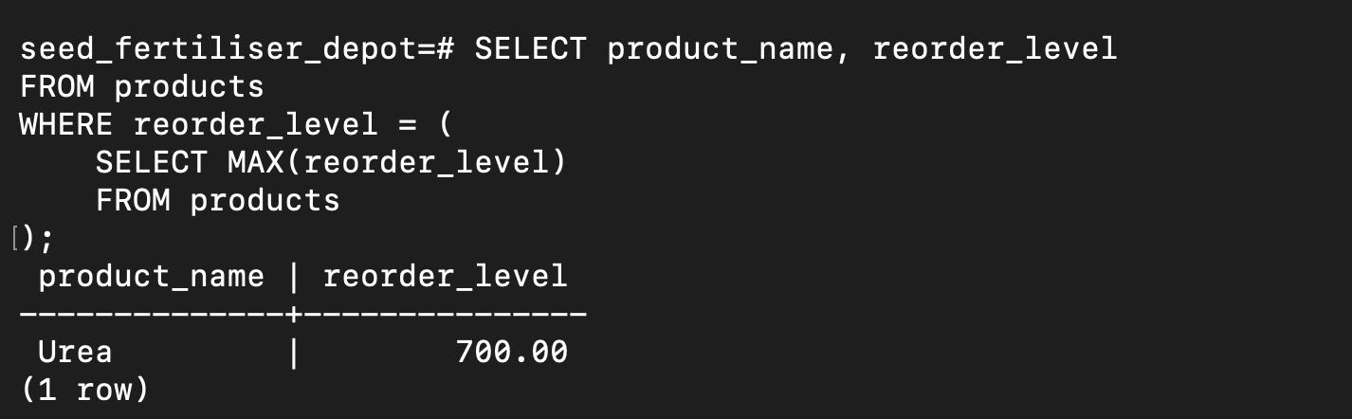
Figure 6. Q1 — scalar subquery result.

Figure 7. Q2 — IN subquery result.
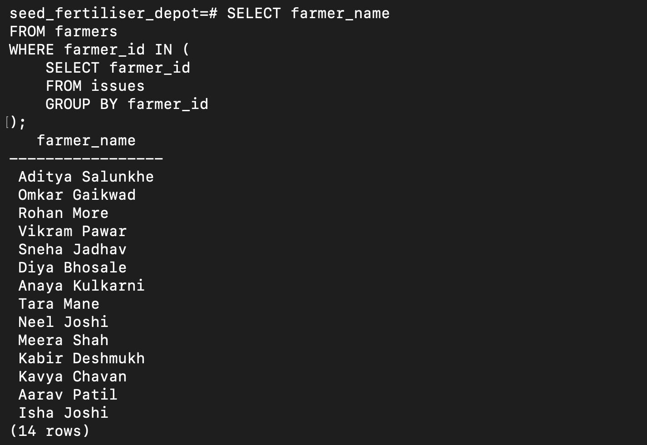
Figure 7. Q2 — IN subquery result.

Figure 8. Q3 — NOT IN subquery result.
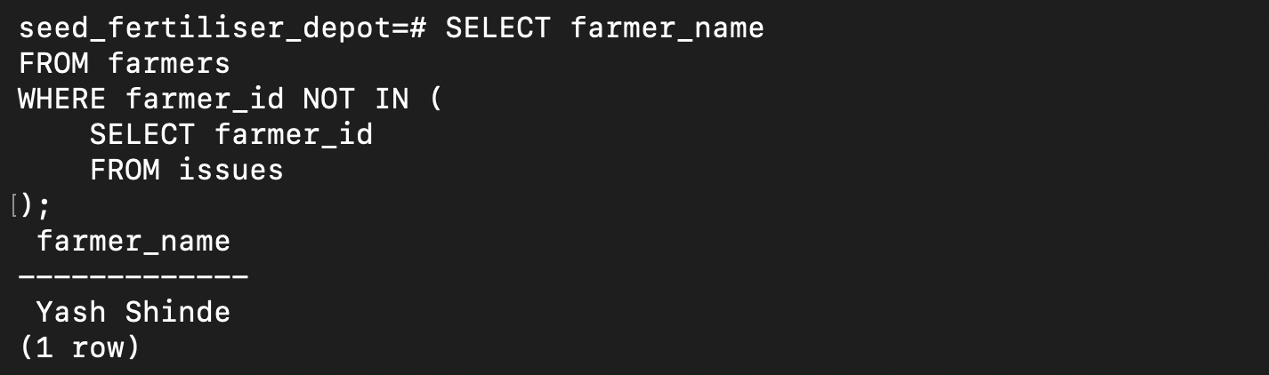
Figure 8. Q3 — NOT IN subquery result.

Figure 9. Q4 — EXISTS subquery result.
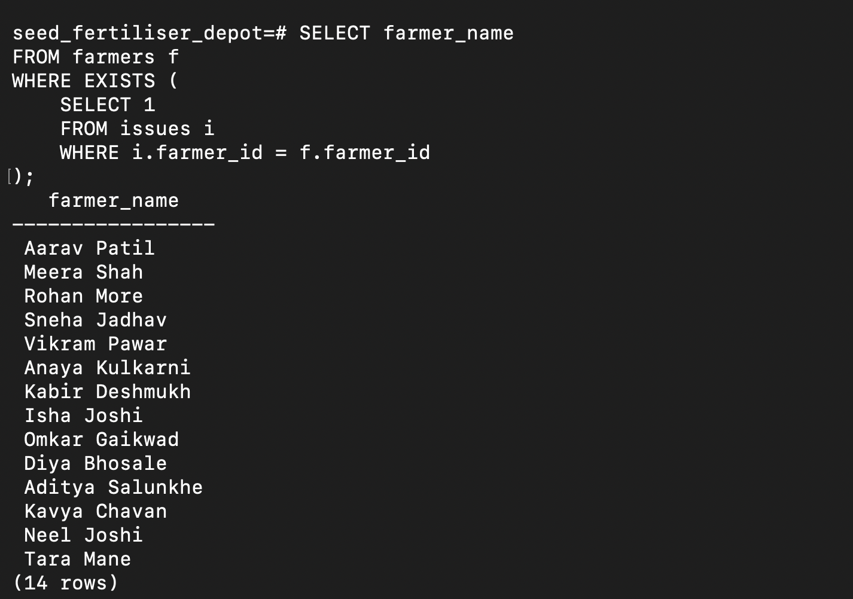
Figure 9. Q4 — EXISTS subquery result.

Figure 10. Q6 — ANY subquery result.
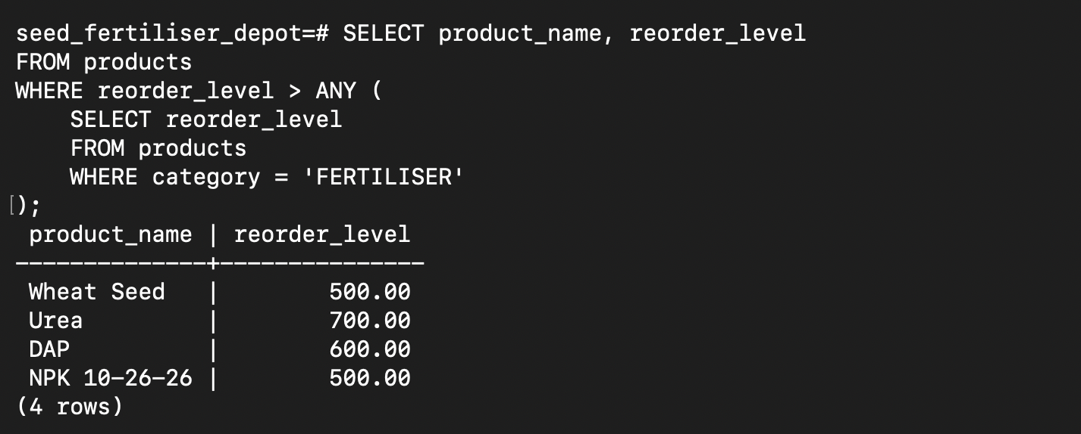
Figure 10. Q6 — ANY subquery result.

Figure 11. Derived product_stock view / current stock verification.
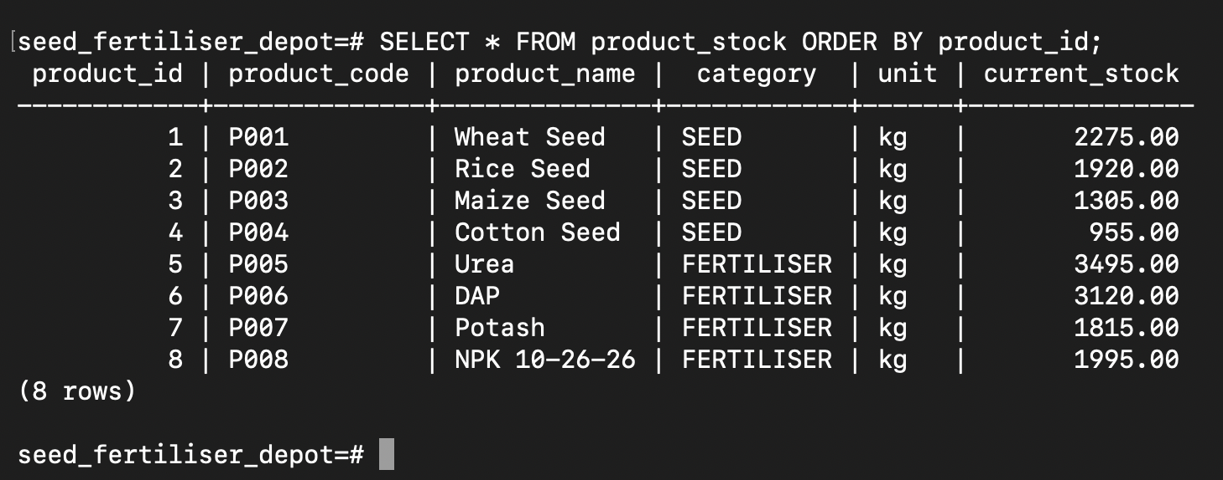
Figure 11. Derived product_stock view / current stock verification.

Figure 12. Q8 — farmers using more than 80% of quota.
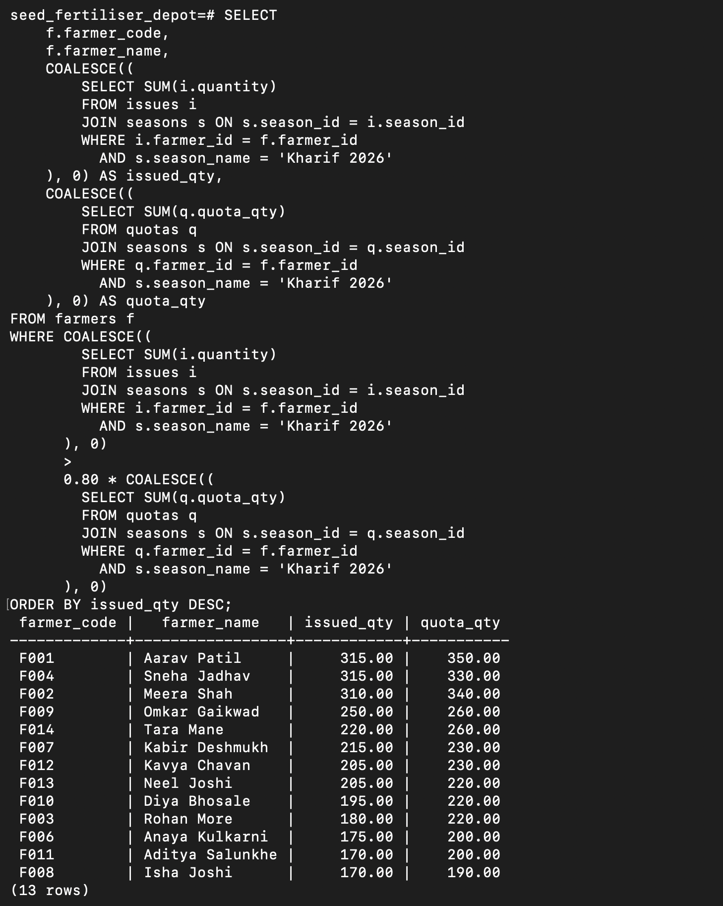
Figure 12. Q8 — farmers using more than 80% of quota.

Figure 13. Q9 — products below average stock.
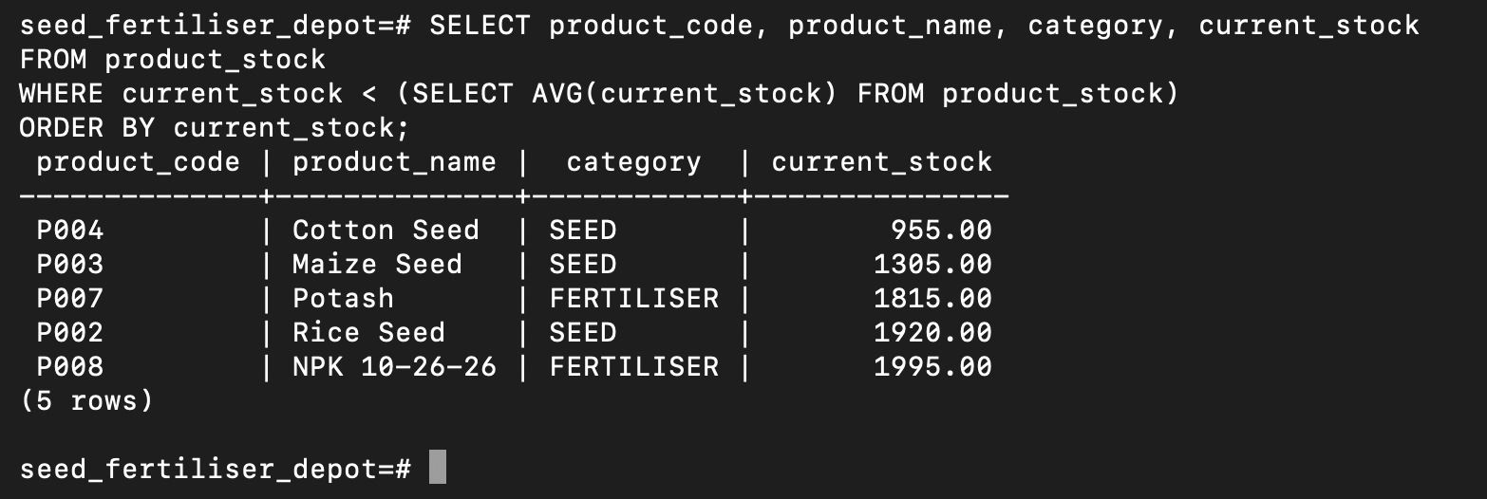
Figure 13. Q9 — products below average stock.

Figure 14. Q5 — farmer(s) who collected nothing in Kharif.
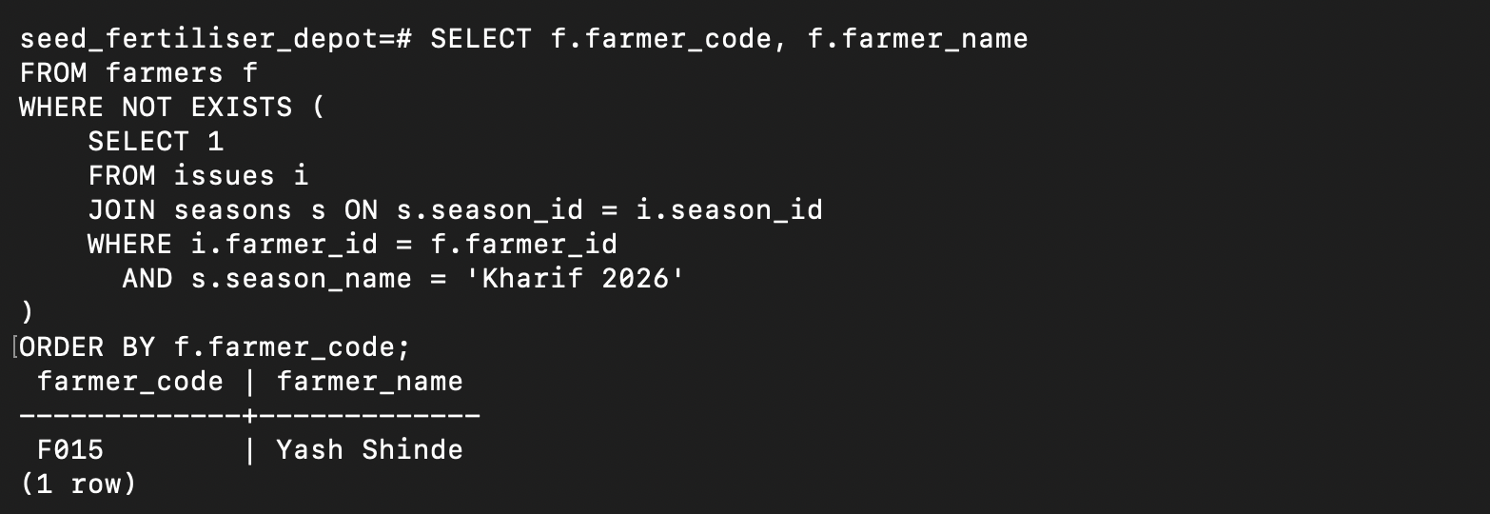
Figure 14. Q5 — farmer(s) who collected nothing in Kharif.

Figure 15. Q10 — latest issue of each product.
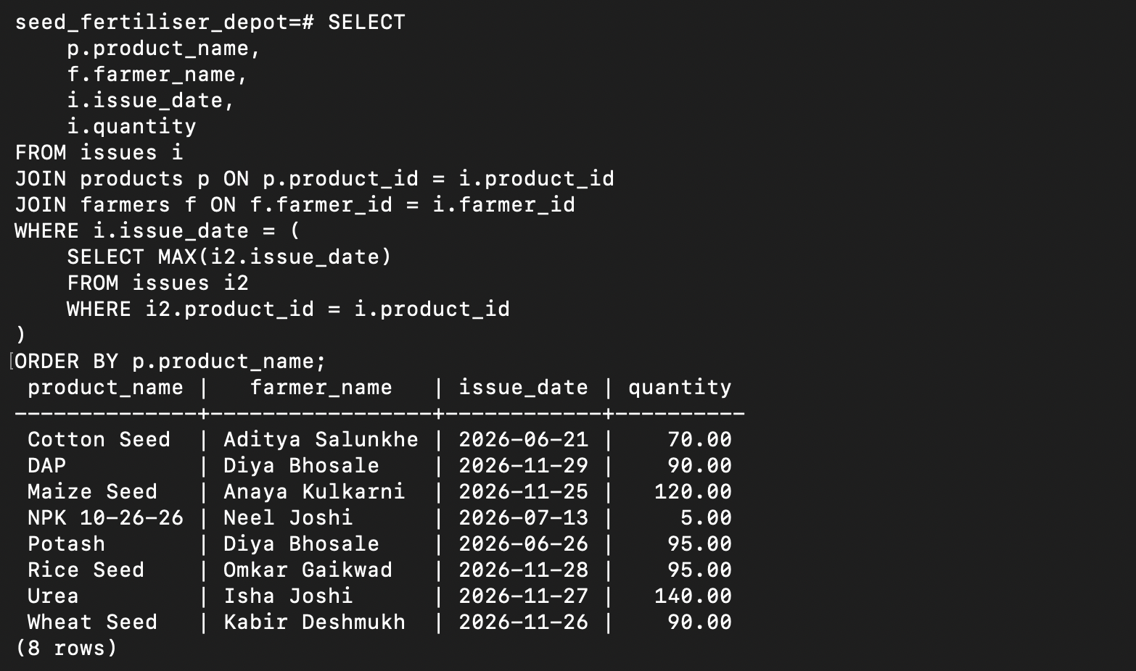
Figure 15. Q10 — latest issue of each product.

Figure 16. Q11 — products issued to every active registered farmer.
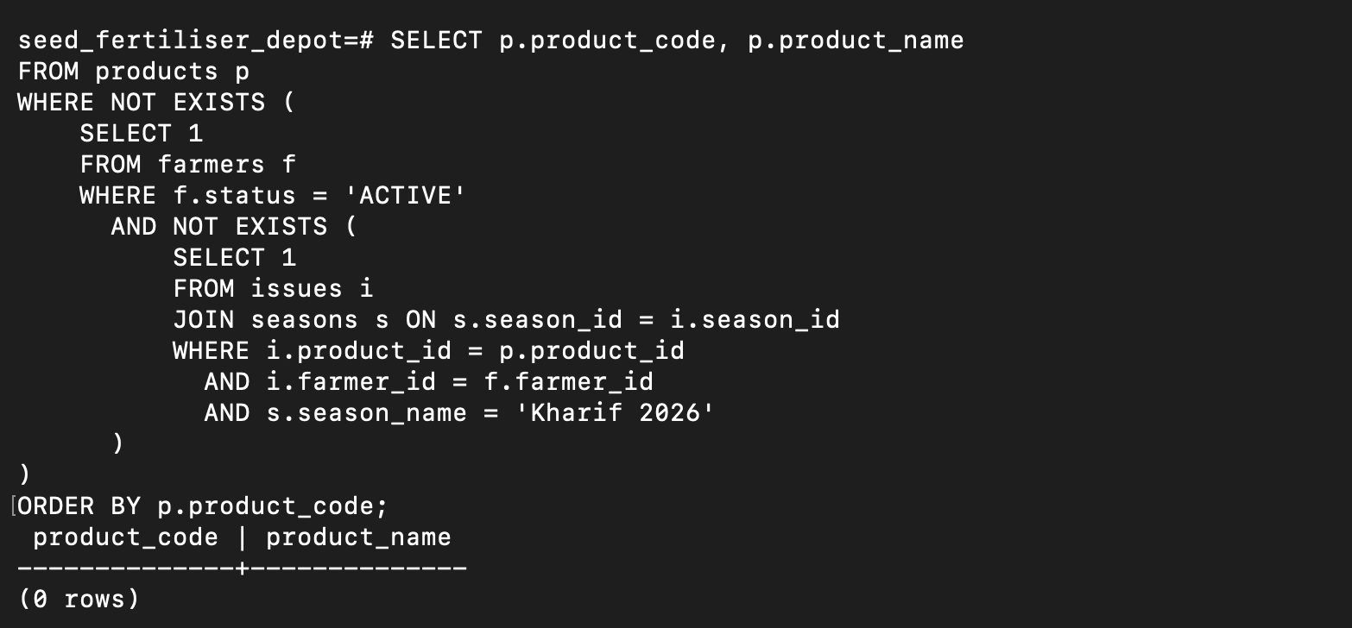
Figure 16. Q11 — products issued to every active registered farmer.

Figure 17. Q16 — JOIN rewrite of the Q4 requirement.
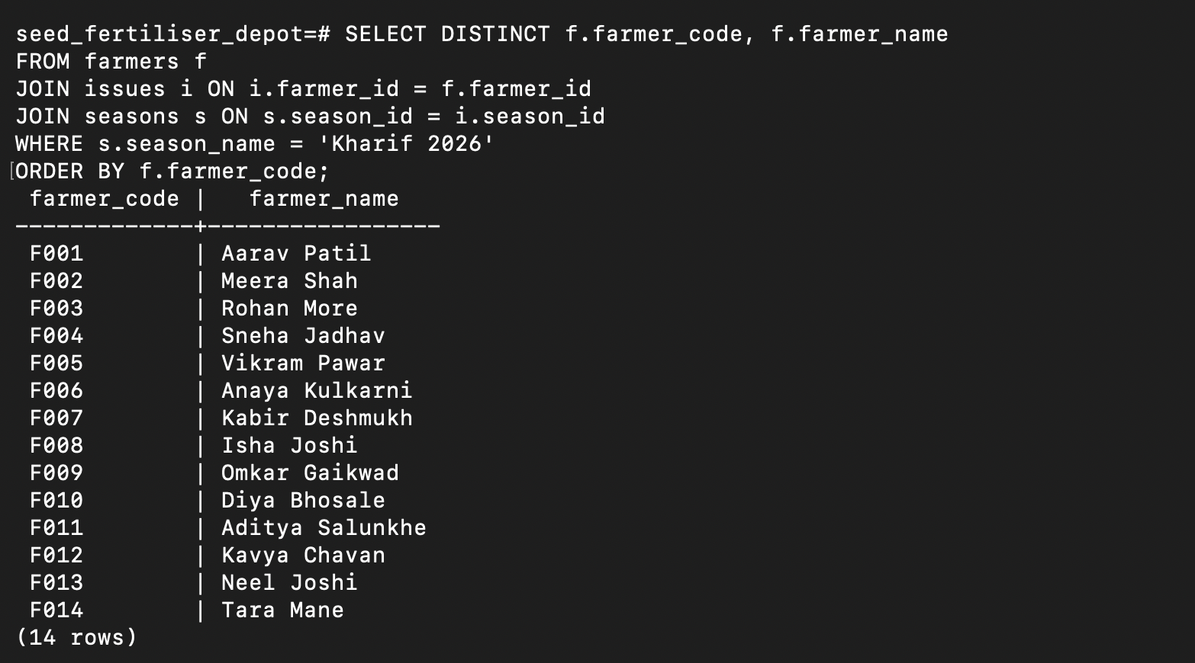
Figure 17. Q16 — JOIN rewrite of the Q4 requirement.

Figure 18. Q12 — GROUP BY + HAVING result.
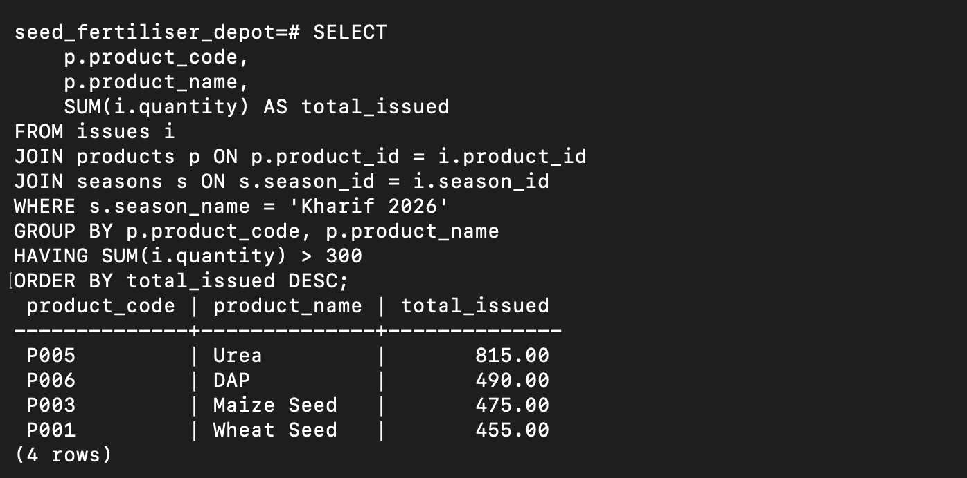
Figure 18. Q12 — GROUP BY + HAVING result.

Figure 19. Q13 — filtering and sorting of active farmers.
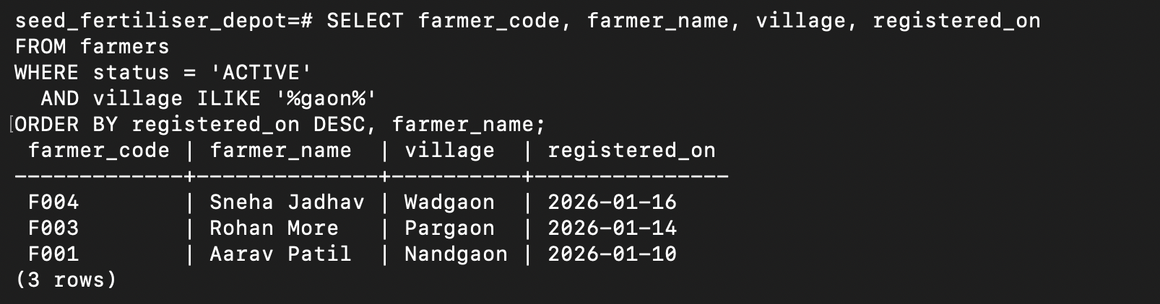
Figure 19. Q13 — filtering and sorting of active farmers.

Figure 20. Q14 — correlated quota-rule check.
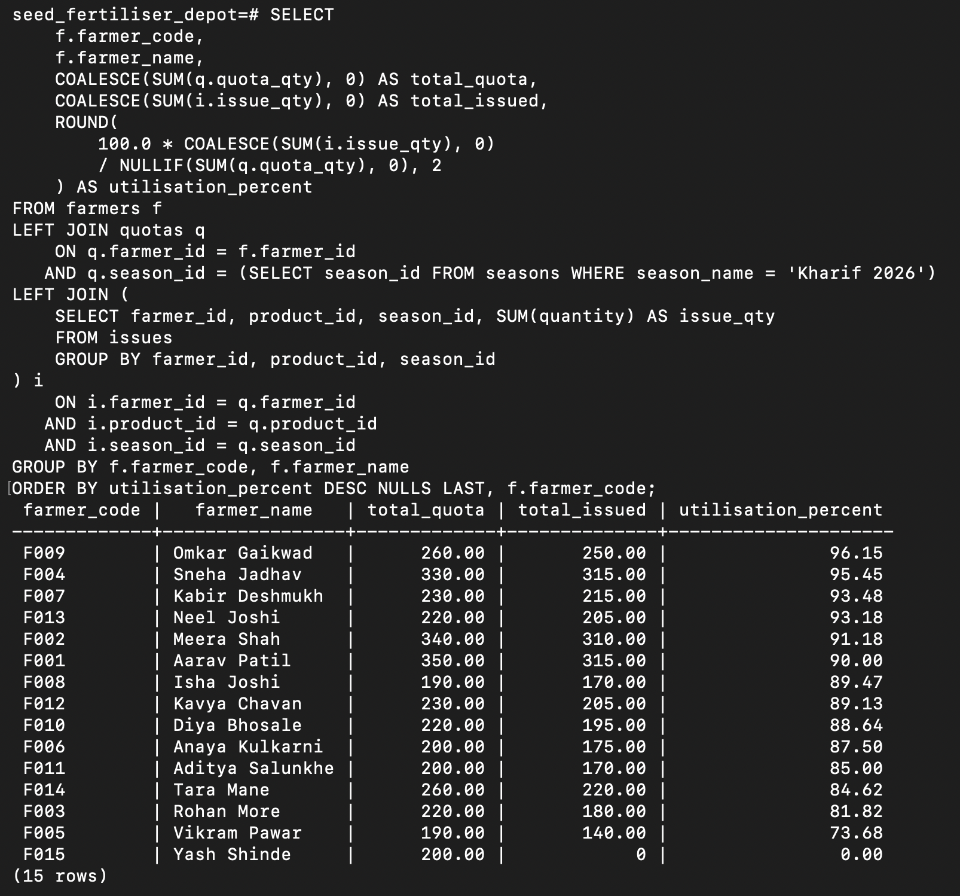
Figure 20. Q14 — correlated quota-rule check.

Figure 21. Q7 — ALL subquery result.
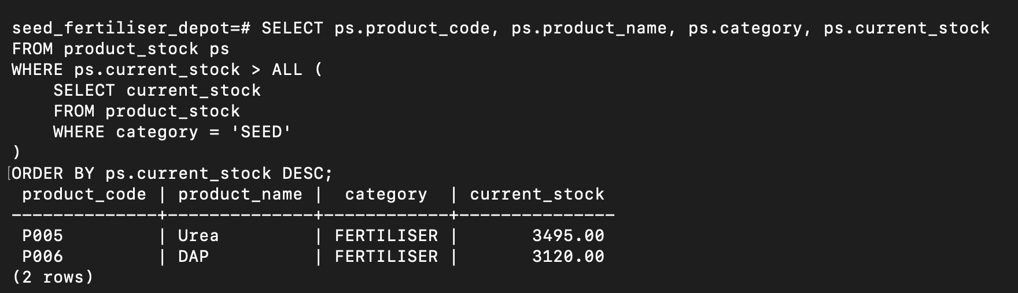
Figure 21. Q7 — ALL subquery result.

Evidence coverage note
The uploaded screenshot set contains direct image evidence for Q1–Q14, Q16 and Q7, plus database setup/verification. Q15, Q17 and Q18 are present in the completed SQL and result summary, and their outputs were verified during execution, but separate image files for those three query outputs were not present in the uploaded screenshot folder. No output has been invented for these queries; the report uses the result summary recorded in query_outputs.md.

10. Subquery vs Join Comparison
The case study explicitly requires at least two subqueries to be rewritten using joins and compared for result, readability and intent. The project implements this through Q16 and Q17.

Comparison 1 — Farmers who collected in Kharif
- Q4 uses EXISTS and asks whether a matching Kharif issue exists for each farmer.
- Q16 uses JOIN + DISTINCT to reach the same set of 14 farmers.
- DISTINCT is necessary in the join version because one farmer may have multiple issue rows.
- EXISTS expresses the existence condition directly, while JOIN expresses the relational combination.

Comparison 2 — Products below average stock
- Q9 uses a scalar AVG subquery and is concise for the requirement.
- Q17 creates a one-row average-stock relation and CROSS JOINs it with product_stock.
- The project does not claim that joins are always better; the appropriate form depends on the requirement and the columns needed.

11. NULL Trap: NOT IN vs NOT EXISTS
Q18 is an intentional demonstration of SQL three-valued logic. Its NOT IN subquery contains a NULL. Because comparison against a NULL can become UNKNOWN, the NOT IN condition does not produce the expected farmer rows and returns zero rows.
-- Q18 demonstration
WHERE f.farmer_id NOT IN (
SELECT NULL::INT
UNION ALL
SELECT farmer_id FROM issues WHERE season_id = 1
);
The safer alternative uses NOT EXISTS and checks for the absence of a matching issue row. In the supplied data, this identifies F015 — Yash Shinde.

12. Design Decisions and Alternatives Rejected
Decision | Alternative rejected | Reason
Derived current_stock view | Store current stock directly in products | Stock is derivable from receipts and issues; storing both creates a risk of inconsistent values.
Quota as a separate relationship table | Store quota columns directly in farmers | Quota varies by product and season, so it belongs to farmer/product/season.
Separate receipts and issues | Use one combined transaction table | Receipts and issues represent different business events with different attributes.
Normalized product table | Create one farmer row with many product columns | New products should not require schema changes; the normalized design scales better.

13. Testing and Validation
- Database creation was verified in PostgreSQL.
- Schema execution was verified through the list of six created tables.
- Seed data was verified through table row counts and SELECT queries.
- The product_stock view was checked to confirm current stock values are derived.
- Q1–Q14 and Q16 evidence is included as screenshots in this report.
- Q15, Q17 and Q18 are represented in queries.sql and query_outputs.md, with their outputs verified during execution.
- Q18 explicitly validates the NULL-trap behaviour and the NOT EXISTS alternative.
- Q16 and Q17 validate that the join rewrites return the same intended result sets as their subquery counterparts.

14. Conclusion
The Seed and Fertiliser Depot Stock database was implemented in PostgreSQL according to the supplied Case Study 6 requirements. The final solution includes a normalized relational design, primary/foreign-key constraints, realistic sample data, a derived stock view, eighteen SQL queries covering the required subquery forms and reporting requirements, two join rewrites, and a focused comparison of subqueries versus joins. The practical screenshots provide execution evidence for the main database setup and query requirements. The resulting project demonstrates how SQL subqueries, aggregation, filtering, joins and NULL-aware logic can be applied to a realistic depot-management scenario.

Appendix A — Project Files
File / Folder | Purpose
schema.sql | Creates tables, constraints, indexes and product_stock view.
seed.sql | Loads realistic farmers, products, seasons, quotas, receipts and issues.
queries.sql | Contains Q1–Q18 and all required SQL techniques.
query_outputs.md | Records the query result summary.
subquery_vs_join.md | Documents the two join rewrites and the NOT IN/NOT EXISTS comparison.
README.md | Documents design, reasoning, execution and viva points.
ER_Diagram.png | Visual relational/ER structure.
screenshots/ | Practical PostgreSQL evidence captured during execution.

Appendix B — Viva / Explanation Points
Concept | Short explanation
Primary key | Uniquely identifies each row.
Foreign key | Maintains a valid relationship with another table.
Scalar subquery | Returns one value, such as an average.
IN | Tests membership in a set returned by a subquery.
NOT IN | Tests non-membership, but must be handled carefully when NULL can appear.
EXISTS | Checks whether at least one matching row exists.
NOT EXISTS | Checks whether no matching row exists; useful for absence conditions.
ANY | The comparison is true if it succeeds for at least one returned value.
ALL | The comparison is true only if it succeeds for every returned value.
GROUP BY | Forms groups so aggregate functions can be calculated per group.
HAVING | Filters groups after aggregation.
Correlated subquery | References a column from the current outer query row.
Current stock | Total receipts minus total issues.
Why indexes | They can reduce lookup work for frequently joined or filtered columns as data grows.

END OF REPORT

