Codebook for tidy_data

Autogenerated data summary from dataMaid

2019-12-10 12:12:13

# Data report overview

The dataset examined has the following dimensions:

|  |  |
| --- | --- |
| Feature | Result |
| Number of observations | 180 |
| Number of variables | 68 |

# Codebook summary table

|  |  |  |  |  |  |
| --- | --- | --- | --- | --- | --- |
| Label | Variable | Class | # unique values | Missing | Description |
|  | **Activity** | factor | 6 | 0.00 % | Activity performed by the subjects. One of six possible factors. |
|  | **Subject** | factor | 30 | 0.00 % | Numeric factor denoting the 30 subjects that participated in this study. |
|  | **time-body-acceleration-mean()-X** | numeric | 180 | 0.00 % | Average of the X-axis data for the mean of the body acceleration in the time domain. |
|  | **time-body-acceleration-mean()-Y** | numeric | 180 | 0.00 % | Average of the Y-axis data for the mean of the body acceleration in the time domain. |
|  | **time-body-acceleration-mean()-Z** | numeric | 180 | 0.00 % | Average of the Z-axis data for the mean of the body acceleration in the time domain. |
|  | **time-body-acceleration-std()-X** | numeric | 180 | 0.00 % | Average of the X-axis data for the standard deviation of the body acceleration in the time domain. |
|  | **time-body-acceleration-std()-Y** | numeric | 180 | 0.00 % | Average of the Y-axis data for the standard deviation of the body acceleration in the time domain. |
|  | **time-body-acceleration-std()-Z** | numeric | 180 | 0.00 % | Average of the Z-axis data for the standard deviation of the body acceleration in the time domain. |
|  | **time-gravity-acceleration-mean()-X** | numeric | 180 | 0.00 % | Average of the X-axis data for the mean of the gravity acceleration in the time domain. |
|  | **time-gravity-acceleration-mean()-Y** | numeric | 180 | 0.00 % | Average of the Y-axis data for the mean of the gravity acceleration in the time domain. |
|  | **time-gravity-acceleration-mean()-Z** | numeric | 180 | 0.00 % | Average of the Z-axis data for the mean of the gravity acceleration in the time domain. |
|  | **time-gravity-acceleration-std()-X** | numeric | 180 | 0.00 % | Average of the X-axis data for the standard deviation of the gravity acceleration in the time domain. |
|  | **time-gravity-acceleration-std()-Y** | numeric | 180 | 0.00 % | Average of the Y-axis data for the standard deviation of the gravity acceleration in the time domain. |
|  | **time-gravity-acceleration-std()-Z** | numeric | 180 | 0.00 % | Average of the Z-axis data for the standard deviation of the gravity acceleration in the time domain. |
|  | **time-body-acceleration-Jerk-mean()-X** | numeric | 180 | 0.00 % | Average of the X-axis data for the mean of the body jerk acceleration in the time domain. |
|  | **time-body-acceleration-Jerk-mean()-Y** | numeric | 180 | 0.00 % | Average of the Y-axis data for the mean of the body jerk acceleration in the time domain. |
|  | **time-body-acceleration-Jerk-mean()-Z** | numeric | 180 | 0.00 % | Average of the Z-axis data for the mean of the body jerk acceleration in the time domain. |
|  | **time-body-acceleration-Jerk-std()-X** | numeric | 180 | 0.00 % | Average of the X-axis data for the standard deviaton of the body jerk acceleration in the time domain. |
|  | **time-body-acceleration-Jerk-std()-Y** | numeric | 180 | 0.00 % | Average of the Y-axis data for the standard deviaton of the body jerk acceleration in the time domain. |
|  | **time-body-acceleration-Jerk-std()-Z** | numeric | 180 | 0.00 % | Average of the Z-axis data for the standard deviaton of the body jerk acceleration in the time domain. |
|  | **time-body-gyroscope-mean()-X** | numeric | 180 | 0.00 % | Average of the X-axis data for the mean of the body gyroscope in the time domain. |
|  | **time-body-gyroscope-mean()-Y** | numeric | 180 | 0.00 % | Average of the Y-axis data for the mean of the body gyroscope in the time domain. |
|  | **time-body-gyroscope-mean()-Z** | numeric | 180 | 0.00 % | Average of the Z-axis data for the mean of the body gyroscope in the time domain. |
|  | **time-body-gyroscope-std()-X** | numeric | 180 | 0.00 % | Average of the X-axis data for the standard deviation of the body gyroscope in the time domain. |
|  | **time-body-gyroscope-std()-Y** | numeric | 180 | 0.00 % | Average of the Y-axis data for the standard deviation of the body gyroscope in the time domain. |
|  | **time-body-gyroscope-std()-Z** | numeric | 180 | 0.00 % | Average of the Z-axis data for the standard deviation of the body gyroscope in the time domain. |
|  | **time-body-gyroscope-Jerk-mean()-X** | numeric | 180 | 0.00 % | Average of the X-axis data for the mean of the body jerk gyroscope in the time domain. |
|  | **time-body-gyroscope-Jerk-mean()-Y** | numeric | 180 | 0.00 % | Average of the Y-axis data for the mean of the body jerk gyroscope in the time domain. |
|  | **time-body-gyroscope-Jerk-mean()-Z** | numeric | 180 | 0.00 % | Average of the Z-axis data for the mean of the body jerk gyroscope in the time domain. |
|  | **time-body-gyroscope-Jerk-std()-X** | numeric | 180 | 0.00 % | Average of the X-axis data for the standard deviation of the body jerk gyroscope in the time domain. |
|  | **time-body-gyroscope-Jerk-std()-Y** | numeric | 180 | 0.00 % | Average of the Y-axis data for the standard deviation of the body jerk gyroscope in the time domain. |
|  | **time-body-gyroscope-Jerk-std()-Z** | numeric | 180 | 0.00 % | Average of the Z-axis data for the standard deviation of the body jerk gyroscope in the time domain. |
|  | **time-body-acceleration-magnitude-mean()** | numeric | 180 | 0.00 % | Average of the mean of the body acceleration magnitude in the time domain. |
|  | **time-body-acceleration-magnitude-std()** | numeric | 180 | 0.00 % | Average of the standard deviation of the body acceleration magnitude in the time domain. |
|  | **time-gravity-acceleration-magnitude-mean()** | numeric | 180 | 0.00 % | Average of the mean of the gravity acceleration magnitude in the time domain. |
|  | **time-gravity-acceleration-magnitude-std()** | numeric | 180 | 0.00 % | Average of the standard deviation of the gravity acceleration magnitude in the time domain. |
|  | **time-body-acceleration-Jerkmagnitude-mean()** | numeric | 180 | 0.00 % | Average of the mean of the body jerk acceleration magnitude in the time domain. |
|  | **time-body-acceleration-Jerkmagnitude-std()** | numeric | 180 | 0.00 % | Average of the standard deviation of the body jerk acceleration magnitude in the time domain. |
|  | **time-body-gyroscope-magnitude-mean()** | numeric | 180 | 0.00 % | Average of the mean of the body gyroscope magnitude in the time domain. |
|  | **time-body-gyroscope-magnitude-std()** | numeric | 180 | 0.00 % | Average of the standard deviation of the body gyroscope magnitude in the time domain. |
|  | **time-body-gyroscope-Jerkmagnitude-mean()** | numeric | 180 | 0.00 % | Average of the mean of the body jerk gyroscope magnitude in the time domain. |
|  | **time-body-gyroscope-Jerkmagnitude-std()** | numeric | 180 | 0.00 % | Average of the standard deviation of the body jerk gyroscope magnitude in the time domain. |
|  | **frequency-body-acceleration-mean()-X** | numeric | 180 | 0.00 % | Average of the mean of the X-axis body acceleration in the frequency domain. |
|  | **frequency-body-acceleration-mean()-Y** | numeric | 180 | 0.00 % | Average of the mean of the Y-axis body acceleration in the frequency domain. |
|  | **frequency-body-acceleration-mean()-Z** | numeric | 180 | 0.00 % | Average of the mean of the Z-axis body acceleration in the frequency domain. |
|  | **frequency-body-acceleration-std()-X** | numeric | 180 | 0.00 % | Average of the standard deviation of the X-axis body acceleration in the frequency domain. |
|  | **frequency-body-acceleration-std()-Y** | numeric | 180 | 0.00 % | Average of the standard deviation of the Y-axis body acceleration in the frequency domain. |
|  | **frequency-body-acceleration-std()-Z** | numeric | 180 | 0.00 % | Average of the standard deviation of the Z-axis body acceleration in the frequency domain. |
|  | **frequency-body-acceleration-Jerk-mean()-X** | numeric | 180 | 0.00 % | Average of the mean of the X-axis body jerk acceleration in the frequency domain. |
|  | **frequency-body-acceleration-Jerk-mean()-Y** | numeric | 180 | 0.00 % | Average of the mean of the Y-axis body jerk acceleration in the frequency domain. |
|  | **frequency-body-acceleration-Jerk-mean()-Z** | numeric | 180 | 0.00 % | Average of the mean of the Z-axis body jerk acceleration in the frequency domain. |
|  | **frequency-body-acceleration-Jerk-std()-X** | numeric | 180 | 0.00 % | Average of the standard deviation of the X-axis body jerk acceleration in the frequency domain. |
|  | **frequency-body-acceleration-Jerk-std()-Y** | numeric | 180 | 0.00 % | Average of the standard deviation of the Y-axis body jerk acceleration in the frequency domain. |
|  | **frequency-body-acceleration-Jerk-std()-Z** | numeric | 180 | 0.00 % | Average of the standard deviation of the Z-axis body jerk acceleration in the frequency domain. |
|  | **frequency-body-gyroscope-mean()-X** | numeric | 180 | 0.00 % | Average of the mean of the X-axis body gyroscope in the frequency domain. |
|  | **frequency-body-gyroscope-mean()-Y** | numeric | 180 | 0.00 % | Average of the mean of the Y-axis body gyroscope in the frequency domain. |
|  | **frequency-body-gyroscope-mean()-Z** | numeric | 180 | 0.00 % | Average of the mean of the Z-axis body gyroscope in the frequency domain. |
|  | **frequency-body-gyroscope-std()-X** | numeric | 180 | 0.00 % | Average of the standard deviation of the X-axis body gyroscope in the frequency domain. |
|  | **frequency-body-gyroscope-std()-Y** | numeric | 180 | 0.00 % | Average of the standard deviation of the Y-axis body gyroscope in the frequency domain. |
|  | **frequency-body-gyroscope-std()-Z** | numeric | 180 | 0.00 % | Average of the standard deviation of the Z-axis body gyroscope in the frequency domain. |
|  | **frequency-body-acceleration-magnitude-mean()** | numeric | 180 | 0.00 % | Average of the mean of the body acceleration magnitude in the frequency domain. |
|  | **frequency-body-acceleration-magnitude-std()** | numeric | 180 | 0.00 % | Average of the standard deviation of the body acceleration magnitude in the frequency domain. |
|  | **frequency-body-body-acceleration-Jerkmagnitude-mean()** | numeric | 180 | 0.00 % | Average of the mean of the body jerk acceleration magnitude in the frequency domain. |
|  | **frequency-body-body-acceleration-Jerkmagnitude-std()** | numeric | 180 | 0.00 % | Average of the standard deviation of the body jerk acceleration magnitude in the frequency domain. |
|  | **frequency-body-body-gyroscope-magnitude-mean()** | numeric | 180 | 0.00 % | Average of the mean of the body gyroscope magnitude in the frequency domain. |
|  | **frequency-body-body-gyroscope-magnitude-std()** | numeric | 180 | 0.00 % | Average of the standard deviation of the body gyroscope magnitude in the frequency domain. |
|  | **frequency-body-body-gyroscope-Jerkmagnitude-mean()** | numeric | 180 | 0.00 % | Average of the mean of the body jerk gyroscope magnitude in the frequency domain. |
|  | **frequency-body-body-gyroscope-Jerkmagnitude-std()** | numeric | 180 | 0.00 % | Average of the standard deviation of the body gyroscope jerk magnitude in the frequency domain. |

# Variable list

## Activity

|  |  |
| --- | --- |
| Feature | Result |
| Variable type | factor |
| Number of missing obs. | 0 (0 %) |
| Number of unique values | 6 |
| Mode | “LAYING” |
| Reference category | LAYING |

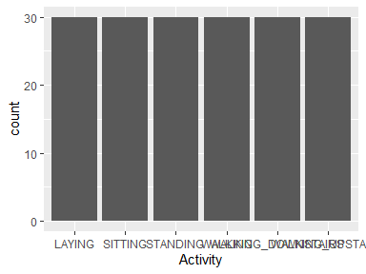

* Observed factor levels: "LAYING", "SITTING", "STANDING", "WALKING", "WALKING_DOWNSTAIRS", "WALKING_UPSTAIRS".

## Subject

|  |  |
| --- | --- |
| Feature | Result |
| Variable type | factor |
| Number of missing obs. | 0 (0 %) |
| Number of unique values | 30 |
| Mode | “1” |
| Reference category | 1 |

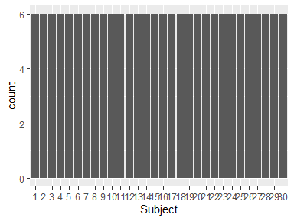

* Observed factor levels: "1", "10", "11", "12", "13", "14", "15", "16", "17", "18", "19", "2", "20", "21", "22", "23", "24", "25", "26", "27", "28", "29", "3", "30", "4", "5", "6", "7", "8", "9".

## time-body-acceleration-mean()-X

|  |  |
| --- | --- |
| Feature | Result |
| Variable type | numeric |
| Number of missing obs. | 0 (0 %) |
| Number of unique values | 180 |
| Median | 0.28 |
| 1st and 3rd quartiles | 0.27; 0.28 |
| Min. and max. | 0.22; 0.3 |

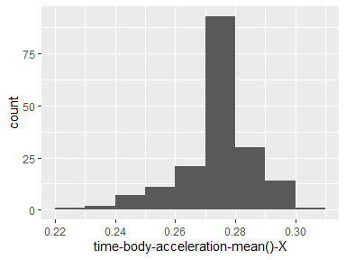

## time-body-acceleration-mean()-Y

|  |  |
| --- | --- |
| Feature | Result |
| Variable type | numeric |
| Number of missing obs. | 0 (0 %) |
| Number of unique values | 180 |
| Median | -0.02 |
| 1st and 3rd quartiles | -0.02; -0.01 |
| Min. and max. | -0.04; 0 |

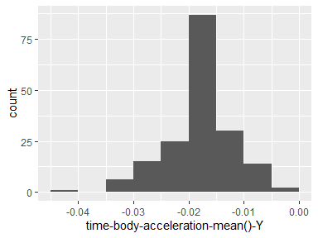

## time-body-acceleration-mean()-Z

|  |  |
| --- | --- |
| Feature | Result |
| Variable type | numeric |
| Number of missing obs. | 0 (0 %) |
| Number of unique values | 180 |
| Median | -0.11 |
| 1st and 3rd quartiles | -0.11; -0.1 |
| Min. and max. | -0.15; -0.08 |

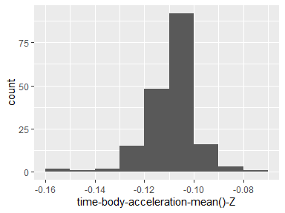

## time-body-acceleration-std()-X

|  |  |
| --- | --- |
| Feature | Result |
| Variable type | numeric |
| Number of missing obs. | 0 (0 %) |
| Number of unique values | 180 |
| Median | -0.75 |
| 1st and 3rd quartiles | -0.98; -0.2 |
| Min. and max. | -1; 0.63 |

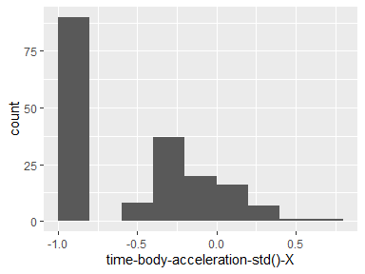

## time-body-acceleration-std()-Y

|  |  |
| --- | --- |
| Feature | Result |
| Variable type | numeric |
| Number of missing obs. | 0 (0 %) |
| Number of unique values | 180 |
| Median | -0.51 |
| 1st and 3rd quartiles | -0.94; -0.03 |
| Min. and max. | -0.99; 0.62 |

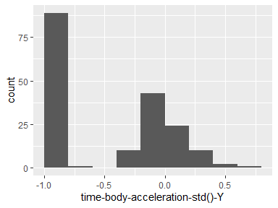

## time-body-acceleration-std()-Z

|  |  |
| --- | --- |
| Feature | Result |
| Variable type | numeric |
| Number of missing obs. | 0 (0 %) |
| Number of unique values | 180 |
| Median | -0.65 |
| 1st and 3rd quartiles | -0.95; -0.23 |
| Min. and max. | -0.99; 0.61 |

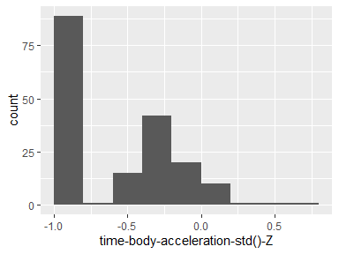

## time-gravity-acceleration-mean()-X

|  |  |
| --- | --- |
| Feature | Result |
| Variable type | numeric |
| Number of missing obs. | 0 (0 %) |
| Number of unique values | 180 |
| Median | 0.92 |
| 1st and 3rd quartiles | 0.84; 0.94 |
| Min. and max. | -0.68; 0.97 |

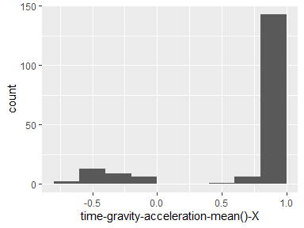

## time-gravity-acceleration-mean()-Y

|  |  |
| --- | --- |
| Feature | Result |
| Variable type | numeric |
| Number of missing obs. | 0 (0 %) |
| Number of unique values | 180 |
| Median | -0.13 |
| 1st and 3rd quartiles | -0.23; 0.09 |
| Min. and max. | -0.48; 0.96 |

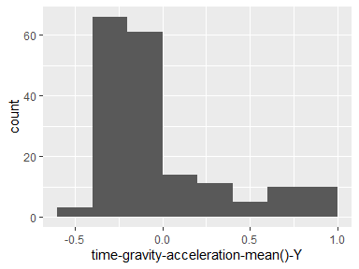

## time-gravity-acceleration-mean()-Z

|  |  |
| --- | --- |
| Feature | Result |
| Variable type | numeric |
| Number of missing obs. | 0 (0 %) |
| Number of unique values | 180 |
| Median | 0.02 |
| 1st and 3rd quartiles | -0.12; 0.15 |
| Min. and max. | -0.5; 0.96 |

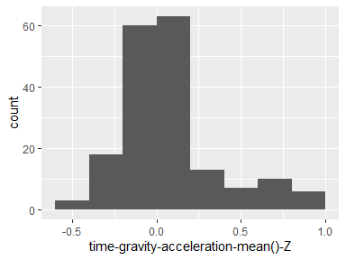

## time-gravity-acceleration-std()-X

|  |  |
| --- | --- |
| Feature | Result |
| Variable type | numeric |
| Number of missing obs. | 0 (0 %) |
| Number of unique values | 180 |
| Median | -0.97 |
| 1st and 3rd quartiles | -0.98; -0.95 |
| Min. and max. | -1; -0.83 |

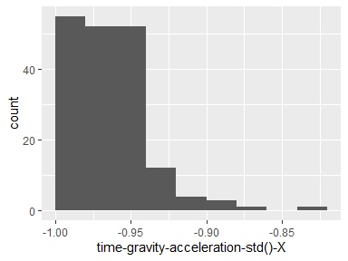

## time-gravity-acceleration-std()-Y

|  |  |
| --- | --- |
| Feature | Result |
| Variable type | numeric |
| Number of missing obs. | 0 (0 %) |
| Number of unique values | 180 |
| Median | -0.96 |
| 1st and 3rd quartiles | -0.97; -0.94 |
| Min. and max. | -0.99; -0.64 |

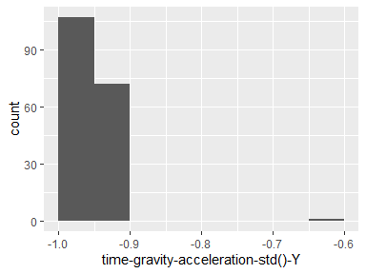

## time-gravity-acceleration-std()-Z

|  |  |
| --- | --- |
| Feature | Result |
| Variable type | numeric |
| Number of missing obs. | 0 (0 %) |
| Number of unique values | 180 |
| Median | -0.95 |
| 1st and 3rd quartiles | -0.96; -0.92 |
| Min. and max. | -0.99; -0.61 |

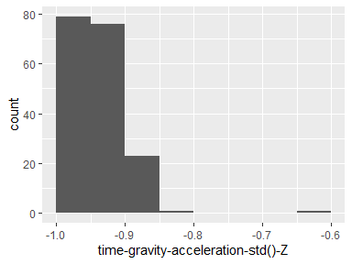

## time-body-acceleration-Jerk-mean()-X

|  |  |
| --- | --- |
| Feature | Result |
| Variable type | numeric |
| Number of missing obs. | 0 (0 %) |
| Number of unique values | 180 |
| Median | 0.08 |
| 1st and 3rd quartiles | 0.07; 0.08 |
| Min. and max. | 0.04; 0.13 |

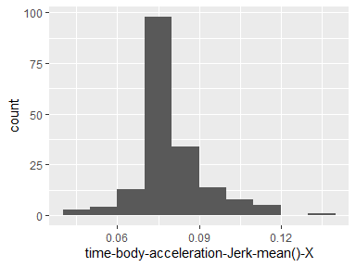

## time-body-acceleration-Jerk-mean()-Y

|  |  |
| --- | --- |
| Feature | Result |
| Variable type | numeric |
| Number of missing obs. | 0 (0 %) |
| Number of unique values | 180 |
| Median | 0.01 |
| 1st and 3rd quartiles | 0; 0.01 |
| Min. and max. | -0.04; 0.06 |

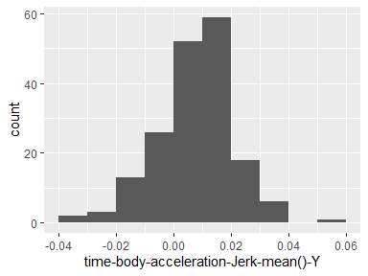

## time-body-acceleration-Jerk-mean()-Z

|  |  |
| --- | --- |
| Feature | Result |
| Variable type | numeric |
| Number of missing obs. | 0 (0 %) |
| Number of unique values | 180 |
| Median | 0 |
| 1st and 3rd quartiles | -0.01; 0 |
| Min. and max. | -0.07; 0.04 |

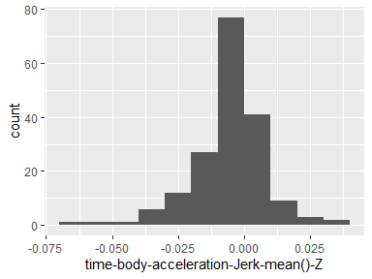

## time-body-acceleration-Jerk-std()-X

|  |  |
| --- | --- |
| Feature | Result |
| Variable type | numeric |
| Number of missing obs. | 0 (0 %) |
| Number of unique values | 180 |
| Median | -0.81 |
| 1st and 3rd quartiles | -0.98; -0.22 |
| Min. and max. | -0.99; 0.54 |

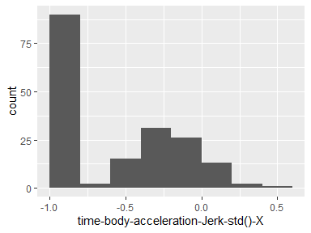

## time-body-acceleration-Jerk-std()-Y

|  |  |
| --- | --- |
| Feature | Result |
| Variable type | numeric |
| Number of missing obs. | 0 (0 %) |
| Number of unique values | 180 |
| Median | -0.78 |
| 1st and 3rd quartiles | -0.97; -0.15 |
| Min. and max. | -0.99; 0.36 |

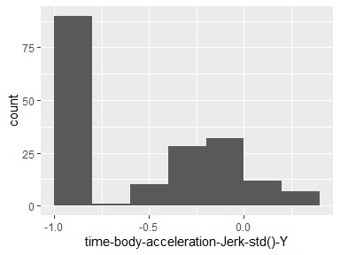

## time-body-acceleration-Jerk-std()-Z

|  |  |
| --- | --- |
| Feature | Result |
| Variable type | numeric |
| Number of missing obs. | 0 (0 %) |
| Number of unique values | 180 |
| Median | -0.88 |
| 1st and 3rd quartiles | -0.98; -0.51 |
| Min. and max. | -0.99; 0.03 |

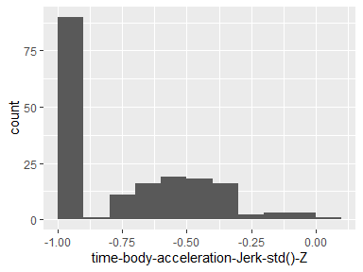

## time-body-gyroscope-mean()-X

|  |  |
| --- | --- |
| Feature | Result |
| Variable type | numeric |
| Number of missing obs. | 0 (0 %) |
| Number of unique values | 180 |
| Median | -0.03 |
| 1st and 3rd quartiles | -0.05; -0.02 |
| Min. and max. | -0.21; 0.19 |

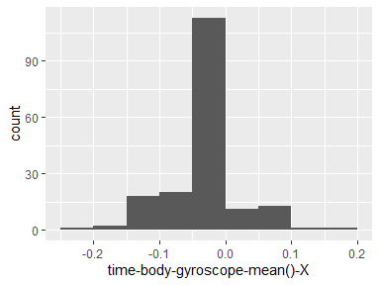

## time-body-gyroscope-mean()-Y

|  |  |
| --- | --- |
| Feature | Result |
| Variable type | numeric |
| Number of missing obs. | 0 (0 %) |
| Number of unique values | 180 |
| Median | -0.07 |
| 1st and 3rd quartiles | -0.09; -0.06 |
| Min. and max. | -0.2; 0.03 |

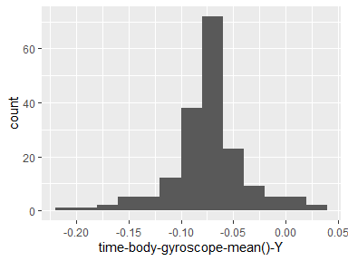

## time-body-gyroscope-mean()-Z

|  |  |
| --- | --- |
| Feature | Result |
| Variable type | numeric |
| Number of missing obs. | 0 (0 %) |
| Number of unique values | 180 |
| Median | 0.09 |
| 1st and 3rd quartiles | 0.07; 0.1 |
| Min. and max. | -0.07; 0.18 |

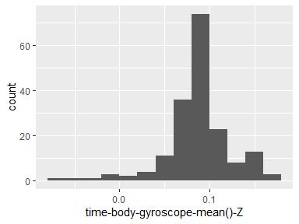

## time-body-gyroscope-std()-X

|  |  |
| --- | --- |
| Feature | Result |
| Variable type | numeric |
| Number of missing obs. | 0 (0 %) |
| Number of unique values | 180 |
| Median | -0.79 |
| 1st and 3rd quartiles | -0.97; -0.44 |
| Min. and max. | -0.99; 0.27 |

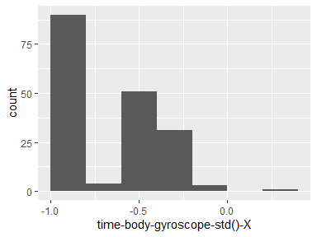

## time-body-gyroscope-std()-Y

|  |  |
| --- | --- |
| Feature | Result |
| Variable type | numeric |
| Number of missing obs. | 0 (0 %) |
| Number of unique values | 180 |
| Median | -0.8 |
| 1st and 3rd quartiles | -0.96; -0.42 |
| Min. and max. | -0.99; 0.48 |

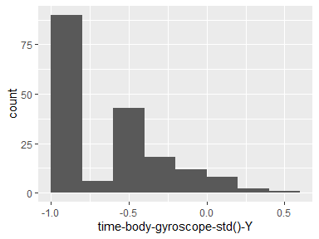

## time-body-gyroscope-std()-Z

|  |  |
| --- | --- |
| Feature | Result |
| Variable type | numeric |
| Number of missing obs. | 0 (0 %) |
| Number of unique values | 180 |
| Median | -0.8 |
| 1st and 3rd quartiles | -0.96; -0.31 |
| Min. and max. | -0.99; 0.56 |

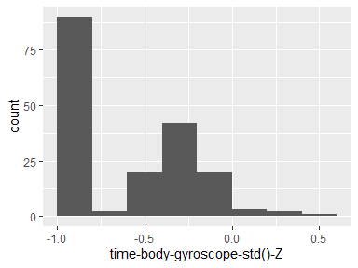

## time-body-gyroscope-Jerk-mean()-X

|  |  |
| --- | --- |
| Feature | Result |
| Variable type | numeric |
| Number of missing obs. | 0 (0 %) |
| Number of unique values | 180 |
| Median | -0.1 |
| 1st and 3rd quartiles | -0.1; -0.09 |
| Min. and max. | -0.16; -0.02 |

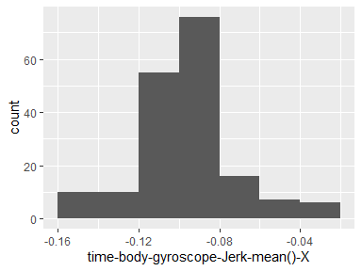

## time-body-gyroscope-Jerk-mean()-Y

|  |  |
| --- | --- |
| Feature | Result |
| Variable type | numeric |
| Number of missing obs. | 0 (0 %) |
| Number of unique values | 180 |
| Median | -0.04 |
| 1st and 3rd quartiles | -0.05; -0.04 |
| Min. and max. | -0.08; -0.01 |

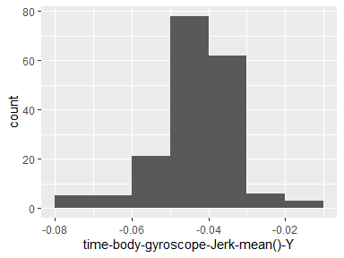

## time-body-gyroscope-Jerk-mean()-Z

|  |  |
| --- | --- |
| Feature | Result |
| Variable type | numeric |
| Number of missing obs. | 0 (0 %) |
| Number of unique values | 180 |
| Median | -0.05 |
| 1st and 3rd quartiles | -0.06; -0.05 |
| Min. and max. | -0.09; -0.01 |

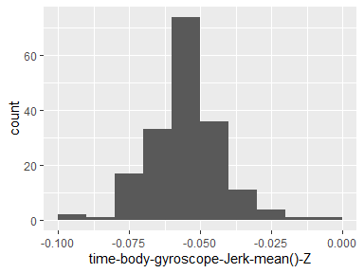

## time-body-gyroscope-Jerk-std()-X

|  |  |
| --- | --- |
| Feature | Result |
| Variable type | numeric |
| Number of missing obs. | 0 (0 %) |
| Number of unique values | 180 |
| Median | -0.84 |
| 1st and 3rd quartiles | -0.98; -0.46 |
| Min. and max. | -1; 0.18 |

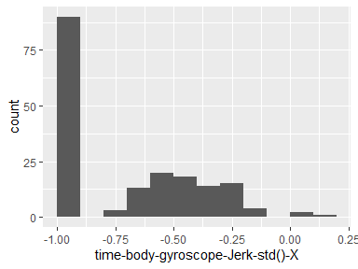

## time-body-gyroscope-Jerk-std()-Y

|  |  |
| --- | --- |
| Feature | Result |
| Variable type | numeric |
| Number of missing obs. | 0 (0 %) |
| Number of unique values | 180 |
| Median | -0.89 |
| 1st and 3rd quartiles | -0.98; -0.59 |
| Min. and max. | -1; 0.3 |

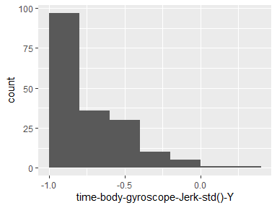

## time-body-gyroscope-Jerk-std()-Z

|  |  |
| --- | --- |
| Feature | Result |
| Variable type | numeric |
| Number of missing obs. | 0 (0 %) |
| Number of unique values | 180 |
| Median | -0.86 |
| 1st and 3rd quartiles | -0.98; -0.47 |
| Min. and max. | -1; 0.19 |

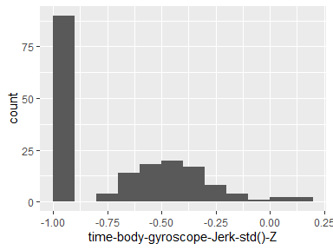

## time-body-acceleration-magnitude-mean()

|  |  |
| --- | --- |
| Feature | Result |
| Variable type | numeric |
| Number of missing obs. | 0 (0 %) |
| Number of unique values | 180 |
| Median | -0.48 |
| 1st and 3rd quartiles | -0.96; -0.09 |
| Min. and max. | -0.99; 0.64 |

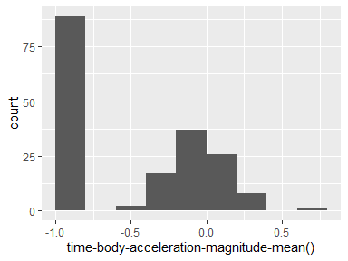

## time-body-acceleration-magnitude-std()

|  |  |
| --- | --- |
| Feature | Result |
| Variable type | numeric |
| Number of missing obs. | 0 (0 %) |
| Number of unique values | 180 |
| Median | -0.61 |
| 1st and 3rd quartiles | -0.94; -0.21 |
| Min. and max. | -0.99; 0.43 |

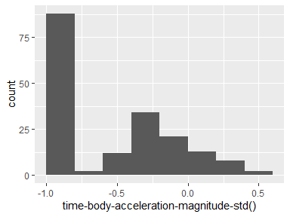

## time-gravity-acceleration-magnitude-mean()

|  |  |
| --- | --- |
| Feature | Result |
| Variable type | numeric |
| Number of missing obs. | 0 (0 %) |
| Number of unique values | 180 |
| Median | -0.48 |
| 1st and 3rd quartiles | -0.96; -0.09 |
| Min. and max. | -0.99; 0.64 |

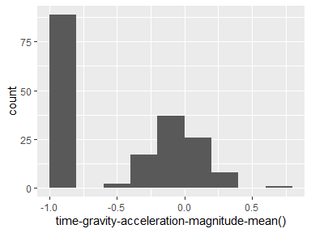

## time-gravity-acceleration-magnitude-std()

|  |  |
| --- | --- |
| Feature | Result |
| Variable type | numeric |
| Number of missing obs. | 0 (0 %) |
| Number of unique values | 180 |
| Median | -0.61 |
| 1st and 3rd quartiles | -0.94; -0.21 |
| Min. and max. | -0.99; 0.43 |

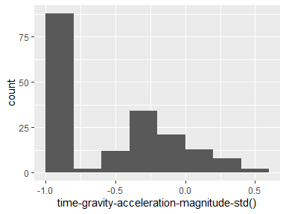

## time-body-acceleration-Jerkmagnitude-mean()

|  |  |
| --- | --- |
| Feature | Result |
| Variable type | numeric |
| Number of missing obs. | 0 (0 %) |
| Number of unique values | 180 |
| Median | -0.82 |
| 1st and 3rd quartiles | -0.98; -0.25 |
| Min. and max. | -0.99; 0.43 |

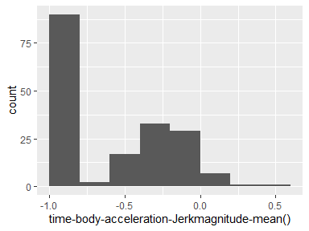

## time-body-acceleration-Jerkmagnitude-std()

|  |  |
| --- | --- |
| Feature | Result |
| Variable type | numeric |
| Number of missing obs. | 0 (0 %) |
| Number of unique values | 180 |
| Median | -0.8 |
| 1st and 3rd quartiles | -0.98; -0.22 |
| Min. and max. | -0.99; 0.45 |

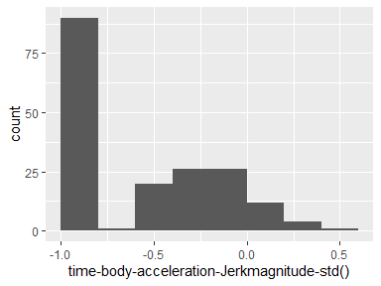

## time-body-gyroscope-magnitude-mean()

|  |  |
| --- | --- |
| Feature | Result |
| Variable type | numeric |
| Number of missing obs. | 0 (0 %) |
| Number of unique values | 180 |
| Median | -0.66 |
| 1st and 3rd quartiles | -0.95; -0.22 |
| Min. and max. | -0.98; 0.42 |

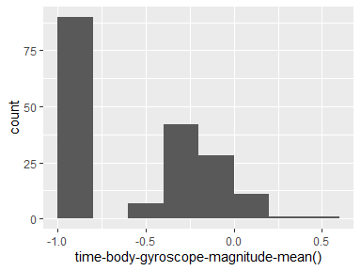

## time-body-gyroscope-magnitude-std()

|  |  |
| --- | --- |
| Feature | Result |
| Variable type | numeric |
| Number of missing obs. | 0 (0 %) |
| Number of unique values | 180 |
| Median | -0.74 |
| 1st and 3rd quartiles | -0.95; -0.36 |
| Min. and max. | -0.98; 0.3 |

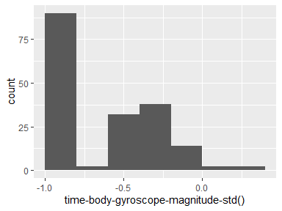

## time-body-gyroscope-Jerkmagnitude-mean()

|  |  |
| --- | --- |
| Feature | Result |
| Variable type | numeric |
| Number of missing obs. | 0 (0 %) |
| Number of unique values | 180 |
| Median | -0.86 |
| 1st and 3rd quartiles | -0.99; -0.51 |
| Min. and max. | -1; 0.09 |

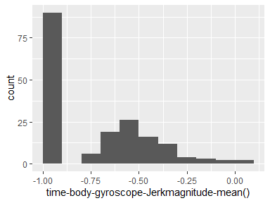

## time-body-gyroscope-Jerkmagnitude-std()

|  |  |
| --- | --- |
| Feature | Result |
| Variable type | numeric |
| Number of missing obs. | 0 (0 %) |
| Number of unique values | 180 |
| Median | -0.88 |
| 1st and 3rd quartiles | -0.98; -0.58 |
| Min. and max. | -1; 0.25 |

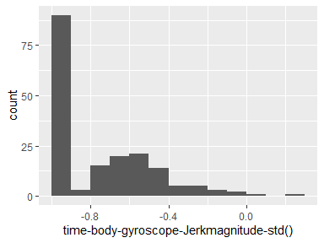

## frequency-body-acceleration-mean()-X

|  |  |
| --- | --- |
| Feature | Result |
| Variable type | numeric |
| Number of missing obs. | 0 (0 %) |
| Number of unique values | 180 |
| Median | -0.77 |
| 1st and 3rd quartiles | -0.98; -0.22 |
| Min. and max. | -1; 0.54 |

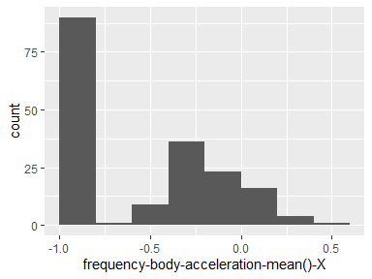

## frequency-body-acceleration-mean()-Y

|  |  |
| --- | --- |
| Feature | Result |
| Variable type | numeric |
| Number of missing obs. | 0 (0 %) |
| Number of unique values | 180 |
| Median | -0.59 |
| 1st and 3rd quartiles | -0.95; -0.06 |
| Min. and max. | -0.99; 0.52 |

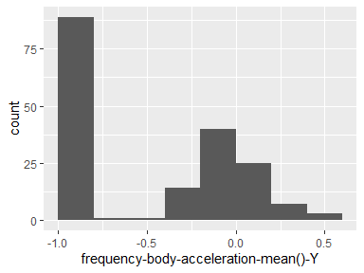

## frequency-body-acceleration-mean()-Z

|  |  |
| --- | --- |
| Feature | Result |
| Variable type | numeric |
| Number of missing obs. | 0 (0 %) |
| Number of unique values | 180 |
| Median | -0.72 |
| 1st and 3rd quartiles | -0.96; -0.32 |
| Min. and max. | -0.99; 0.28 |

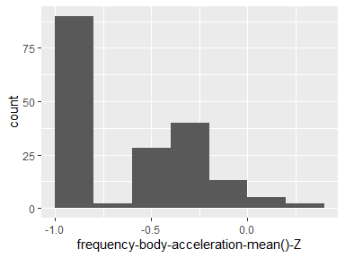

## frequency-body-acceleration-std()-X

|  |  |
| --- | --- |
| Feature | Result |
| Variable type | numeric |
| Number of missing obs. | 0 (0 %) |
| Number of unique values | 180 |
| Median | -0.75 |
| 1st and 3rd quartiles | -0.98; -0.2 |
| Min. and max. | -1; 0.66 |

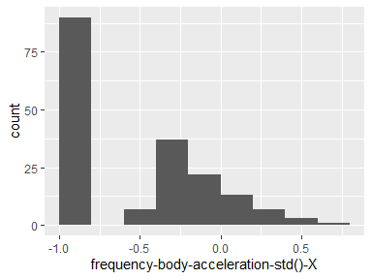

## frequency-body-acceleration-std()-Y

|  |  |
| --- | --- |
| Feature | Result |
| Variable type | numeric |
| Number of missing obs. | 0 (0 %) |
| Number of unique values | 180 |
| Median | -0.51 |
| 1st and 3rd quartiles | -0.94; -0.08 |
| Min. and max. | -0.99; 0.56 |

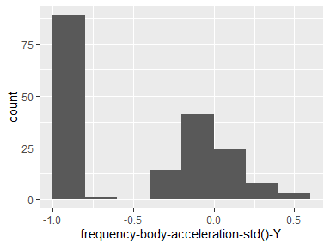

## frequency-body-acceleration-std()-Z

|  |  |
| --- | --- |
| Feature | Result |
| Variable type | numeric |
| Number of missing obs. | 0 (0 %) |
| Number of unique values | 180 |
| Median | -0.64 |
| 1st and 3rd quartiles | -0.95; -0.27 |
| Min. and max. | -0.99; 0.69 |

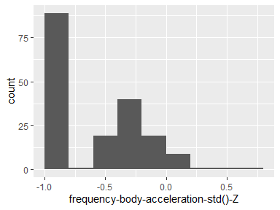

## frequency-body-acceleration-Jerk-mean()-X

|  |  |
| --- | --- |
| Feature | Result |
| Variable type | numeric |
| Number of missing obs. | 0 (0 %) |
| Number of unique values | 180 |
| Median | -0.81 |
| 1st and 3rd quartiles | -0.98; -0.28 |
| Min. and max. | -0.99; 0.47 |

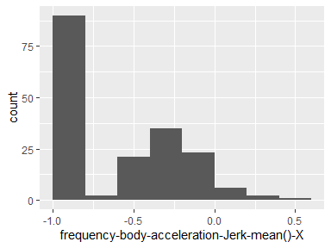

## frequency-body-acceleration-Jerk-mean()-Y

|  |  |
| --- | --- |
| Feature | Result |
| Variable type | numeric |
| Number of missing obs. | 0 (0 %) |
| Number of unique values | 180 |
| Median | -0.78 |
| 1st and 3rd quartiles | -0.97; -0.2 |
| Min. and max. | -0.99; 0.28 |

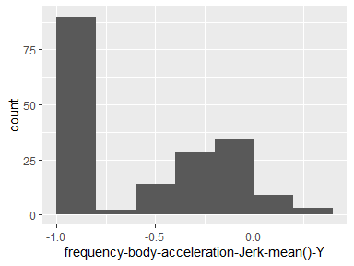

## frequency-body-acceleration-Jerk-mean()-Z

|  |  |
| --- | --- |
| Feature | Result |
| Variable type | numeric |
| Number of missing obs. | 0 (0 %) |
| Number of unique values | 180 |
| Median | -0.87 |
| 1st and 3rd quartiles | -0.98; -0.47 |
| Min. and max. | -0.99; 0.16 |

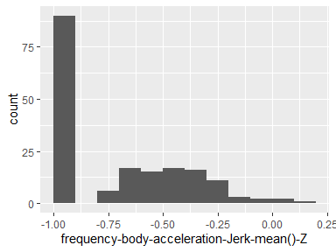

## frequency-body-acceleration-Jerk-std()-X

|  |  |
| --- | --- |
| Feature | Result |
| Variable type | numeric |
| Number of missing obs. | 0 (0 %) |
| Number of unique values | 180 |
| Median | -0.83 |
| 1st and 3rd quartiles | -0.98; -0.25 |
| Min. and max. | -1; 0.48 |

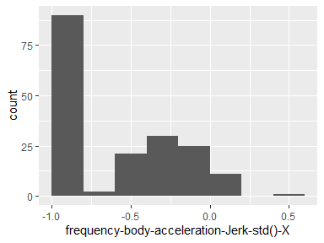

## frequency-body-acceleration-Jerk-std()-Y

|  |  |
| --- | --- |
| Feature | Result |
| Variable type | numeric |
| Number of missing obs. | 0 (0 %) |
| Number of unique values | 180 |
| Median | -0.79 |
| 1st and 3rd quartiles | -0.97; -0.17 |
| Min. and max. | -0.99; 0.35 |

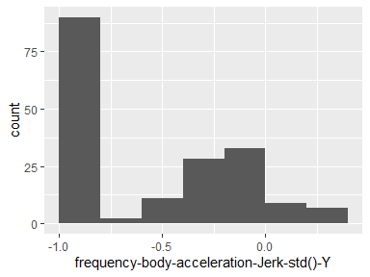

## frequency-body-acceleration-Jerk-std()-Z

|  |  |
| --- | --- |
| Feature | Result |
| Variable type | numeric |
| Number of missing obs. | 0 (0 %) |
| Number of unique values | 180 |
| Median | -0.9 |
| 1st and 3rd quartiles | -0.98; -0.54 |
| Min. and max. | -0.99; -0.01 |

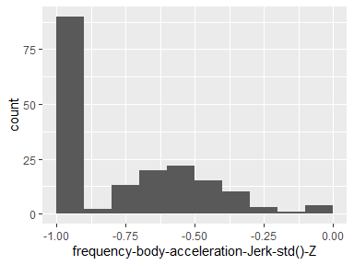

## frequency-body-gyroscope-mean()-X

|  |  |
| --- | --- |
| Feature | Result |
| Variable type | numeric |
| Number of missing obs. | 0 (0 %) |
| Number of unique values | 180 |
| Median | -0.73 |
| 1st and 3rd quartiles | -0.97; -0.34 |
| Min. and max. | -0.99; 0.47 |

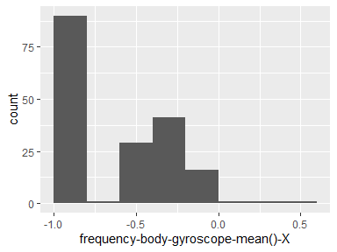

## frequency-body-gyroscope-mean()-Y

|  |  |
| --- | --- |
| Feature | Result |
| Variable type | numeric |
| Number of missing obs. | 0 (0 %) |
| Number of unique values | 180 |
| Median | -0.81 |
| 1st and 3rd quartiles | -0.97; -0.45 |
| Min. and max. | -0.99; 0.33 |

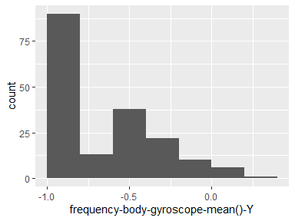

## frequency-body-gyroscope-mean()-Z

|  |  |
| --- | --- |
| Feature | Result |
| Variable type | numeric |
| Number of missing obs. | 0 (0 %) |
| Number of unique values | 180 |
| Median | -0.79 |
| 1st and 3rd quartiles | -0.96; -0.26 |
| Min. and max. | -0.99; 0.49 |

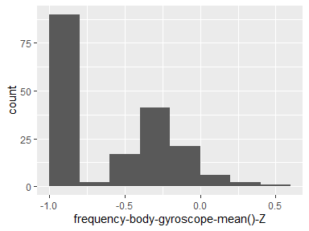

## frequency-body-gyroscope-std()-X

|  |  |
| --- | --- |
| Feature | Result |
| Variable type | numeric |
| Number of missing obs. | 0 (0 %) |
| Number of unique values | 180 |
| Median | -0.81 |
| 1st and 3rd quartiles | -0.98; -0.48 |
| Min. and max. | -0.99; 0.2 |

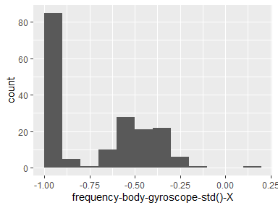

## frequency-body-gyroscope-std()-Y

|  |  |
| --- | --- |
| Feature | Result |
| Variable type | numeric |
| Number of missing obs. | 0 (0 %) |
| Number of unique values | 180 |
| Median | -0.8 |
| 1st and 3rd quartiles | -0.96; -0.42 |
| Min. and max. | -0.99; 0.65 |

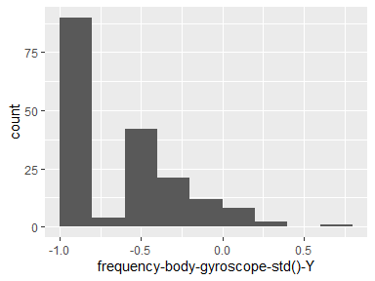

## frequency-body-gyroscope-std()-Z

|  |  |
| --- | --- |
| Feature | Result |
| Variable type | numeric |
| Number of missing obs. | 0 (0 %) |
| Number of unique values | 180 |
| Median | -0.82 |
| 1st and 3rd quartiles | -0.96; -0.39 |
| Min. and max. | -0.99; 0.52 |

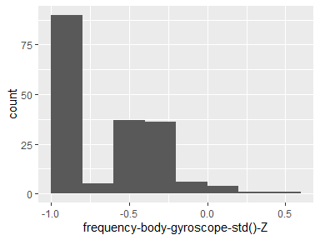

## frequency-body-acceleration-magnitude-mean()

|  |  |
| --- | --- |
| Feature | Result |
| Variable type | numeric |
| Number of missing obs. | 0 (0 %) |
| Number of unique values | 180 |
| Median | -0.67 |
| 1st and 3rd quartiles | -0.96; -0.16 |
| Min. and max. | -0.99; 0.59 |

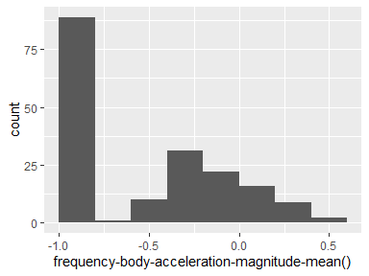

## frequency-body-acceleration-magnitude-std()

|  |  |
| --- | --- |
| Feature | Result |
| Variable type | numeric |
| Number of missing obs. | 0 (0 %) |
| Number of unique values | 180 |
| Median | -0.65 |
| 1st and 3rd quartiles | -0.95; -0.37 |
| Min. and max. | -0.99; 0.18 |

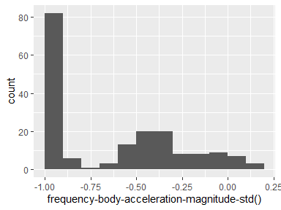

## frequency-body-body-acceleration-Jerkmagnitude-mean()

|  |  |
| --- | --- |
| Feature | Result |
| Variable type | numeric |
| Number of missing obs. | 0 (0 %) |
| Number of unique values | 180 |
| Median | -0.79 |
| 1st and 3rd quartiles | -0.98; -0.19 |
| Min. and max. | -0.99; 0.54 |

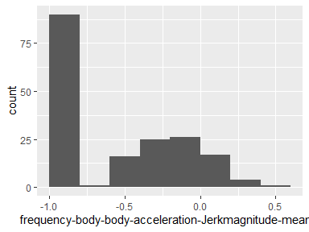

## frequency-body-body-acceleration-Jerkmagnitude-std()

|  |  |
| --- | --- |
| Feature | Result |
| Variable type | numeric |
| Number of missing obs. | 0 (0 %) |
| Number of unique values | 180 |
| Median | -0.81 |
| 1st and 3rd quartiles | -0.98; -0.27 |
| Min. and max. | -0.99; 0.32 |

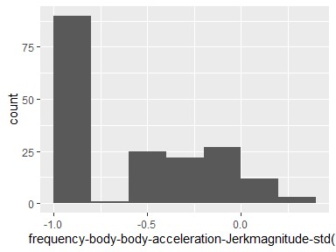

## frequency-body-body-gyroscope-magnitude-mean()

|  |  |
| --- | --- |
| Feature | Result |
| Variable type | numeric |
| Number of missing obs. | 0 (0 %) |
| Number of unique values | 180 |
| Median | -0.77 |
| 1st and 3rd quartiles | -0.96; -0.41 |
| Min. and max. | -0.99; 0.2 |

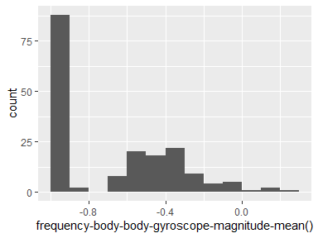

## frequency-body-body-gyroscope-magnitude-std()

|  |  |
| --- | --- |
| Feature | Result |
| Variable type | numeric |
| Number of missing obs. | 0 (0 %) |
| Number of unique values | 180 |
| Median | -0.77 |
| 1st and 3rd quartiles | -0.95; -0.43 |
| Min. and max. | -0.98; 0.24 |

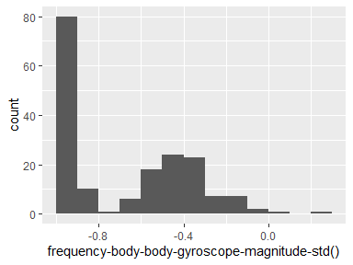

## frequency-body-body-gyroscope-Jerkmagnitude-mean()

|  |  |
| --- | --- |
| Feature | Result |
| Variable type | numeric |
| Number of missing obs. | 0 (0 %) |
| Number of unique values | 180 |
| Median | -0.88 |
| 1st and 3rd quartiles | -0.98; -0.58 |
| Min. and max. | -1; 0.15 |

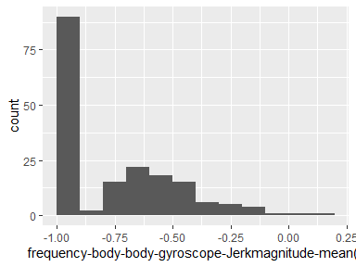

## frequency-body-body-gyroscope-Jerkmagnitude-std()

|  |  |
| --- | --- |
| Feature | Result |
| Variable type | numeric |
| Number of missing obs. | 0 (0 %) |
| Number of unique values | 180 |
| Median | -0.89 |
| 1st and 3rd quartiles | -0.98; -0.61 |
| Min. and max. | -1; 0.29 |

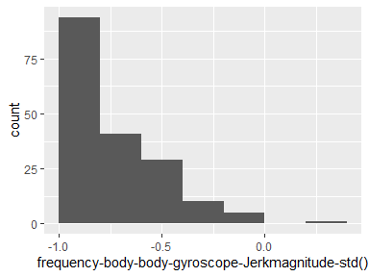

Report generation information:

* Created by Rimdzius, Daniel J (username: rimdzidj).
* Report creation time: Tue Dec 10 2019 12:14:56
* Report was run from directory: C:/Users/rimdzidj/Desktop/Personal/Coursera/JHUCourseraGettingAndCleaningData
* dataMaid v1.3.2 [Pkg: 2019-07-27 from CRAN (R 3.6.1)]
* R version 3.6.1 (2019-07-05).
* Platform: x86_64-w64-mingw32/x64 (64-bit)(Windows 10 x64 (build 16299)).
* Function call: makeDataReport(data = tidy_data, mode = c("summarize", "visualize", "check"), smartNum = FALSE, file = "codebook_tidy_data.Rmd", replace = TRUE, checks = list(character = "showAllFactorLevels", factor = "showAllFactorLevels", labelled = "showAllFactorLevels", haven_labelled = "showAllFactorLevels", numeric = NULL, integer = NULL, logical = NULL, Date = NULL), listChecks = FALSE, maxProbVals = Inf, codebook = TRUE, reportTitle = "Codebook for tidy_data")