Convert the entity relationship model to a relational diagram

*1/Conceptual model :*

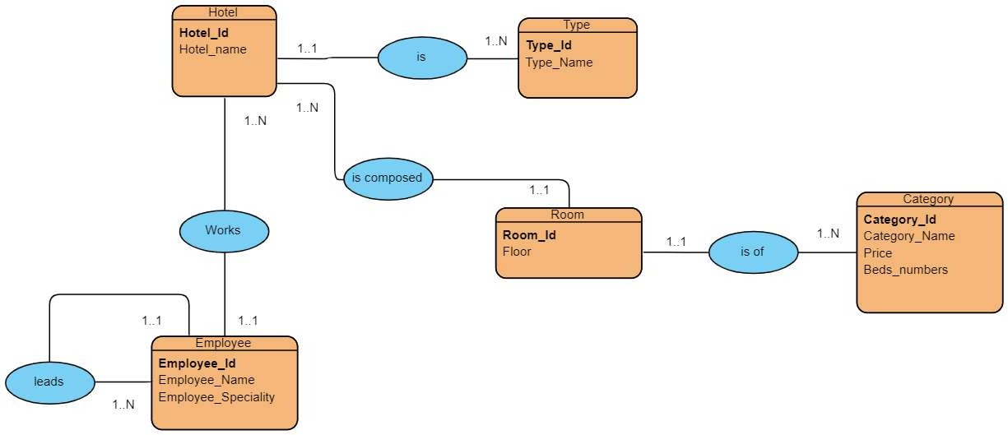

*2/Relational model :*

There is 5 relations each color represents a relational model:

Hotel (**Hotel_Id**, Hotel_name, **#Type_Id**)

Type (**Type_Id**, Type_name)

Employee (**Employee_Id**,Employee_Name, Employee_Speciality, **#Hotel_Id**)

Hotel (**Hotel_Id**, Hotel_name)

Employee (**Employee_Id**, Employee_Name, Employee_Speciality, **#director_Id**)

Room (**Room_Id**, Floor**, #Hotel_ Id**)

Hotel (**Hotel_ Id**, Hotel_name)

Room (**Room_Id**, Floor, **#Category_ Id**)

Category(**Category_Id**,Category_Name,Price,Beds_Numbers)