1. **Paidy Forex SPA welcome screen**

This is the welcome screen of application. For now, you can only add currencies to it. In total 10 currencies can be added and a hint it provided for the same.

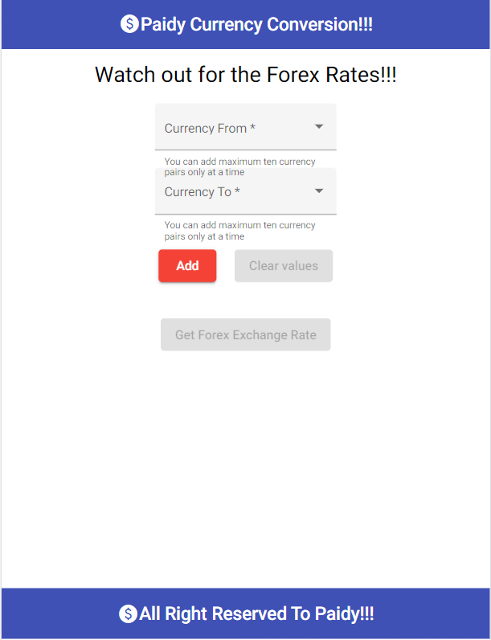

1. **Error Screen When Inputs not selected**

If you don’t select any currency pairs, The specified fields will be highlighted asking you to enter values.

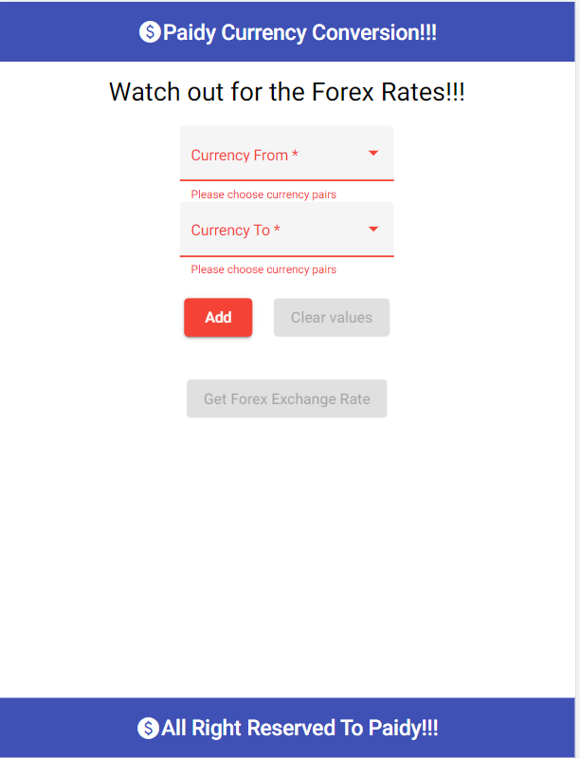

1. **Adding Currency Pairs Screen**

You should be able to add up to 10 currency pairs. When there are more than 10 currency pairs, the add button greys out. If the currency pair has same value of currency in both from and to section, then an error is displayed stating “Currency values cannot be same”. You will be able to see all the currency pairs selected by you for fetching forex rates. Also, clicking on cross icon in the currency pair, you can delete the currency pair from the list to fetch forex rates.

Clear Values button will clear all the selected values.

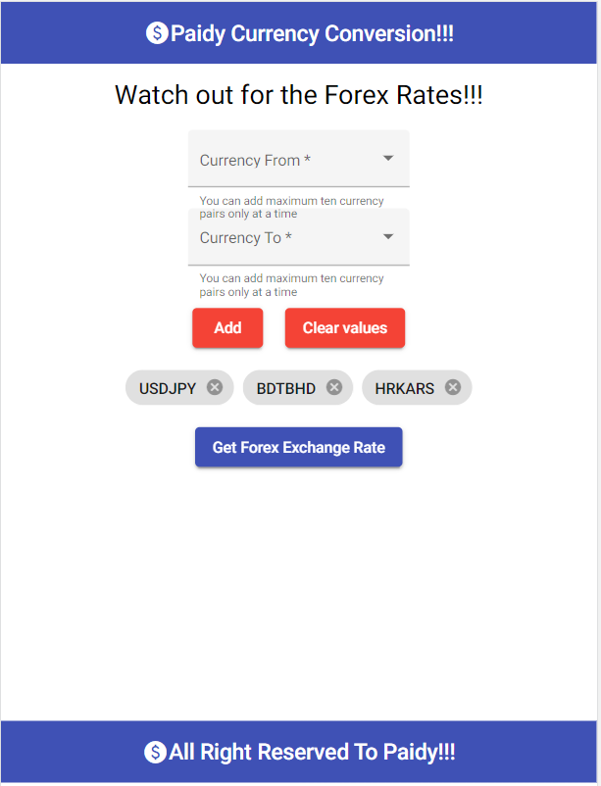

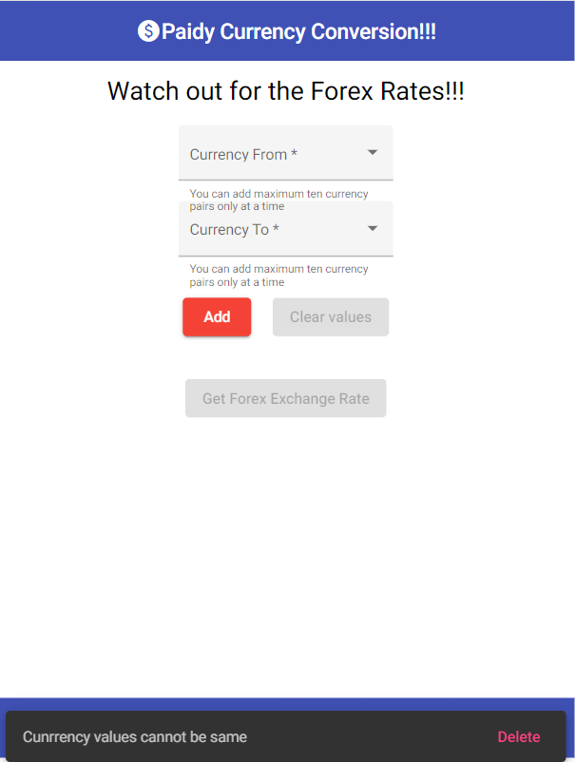

1. **Forex Table Along with Refresh**

Clicking on Get Forex Rates will show up the forex rates table. Clicking on refresh icon will refresh the data. Also, If API takes time for fetching data, Screen shows a loading icon.

If API Fails, then a message is displayed stating “Something went wrong please try again later”.

