Exercise 6A: Analyzing Websites with CRAP

Your Name: Ian Effendi

# Overview

So, you've been web surfing for quite some time now, and you've undoubtedly found some pages that you like and others that you don't like. Sometimes, it's not so easy to really explain why. You now have a new vocabulary with which to describe your thoughts on the matter.

# Part 1: Group Evaluations

1. Follow this link using the browser of your choice.

**http://www.rochesterfirst.com/**

1. Examine this site… at least the first page and a couple of links to sub-pages (pages that are part of the same site).
2. Summarize your opinions and why you came to them here:
   1. Alignment:
      * Images for articles have varying aspect ratios, throwing related articles out of alignment.
      * The side column is not properly aligned; take for example the, “Rochester,” and, “Events,” headings. They are part of the side bar but receive different amounts of indentation.
      * Advertisement containers in some places are sized differently from side bar elements.
      * The website’s navigation elements are aligned, when shown – the supermenu is effective at presenting options to the user.
   2. Proximity:
      * Focus of the webpage is drawn to an unlabeled section that speaks of recent articles, surrounded by various graphics and elements.
      * It’s hard to tell whether the highlighted article is an advertisement (with a caption) or a related article with more to read. There is no call to action near the element, asking users to visit the page, and it’s very close to sponsorship logos and banner adverts.
   3. Repetition:
      * Element styling is not always repeated: the links to related articles, links in the navigation area, and the links in the, “Stay Connected,” section are all styled differently, braking the principle of repetitive design.
      * The, “Read More,” button has a downward chevron while the, “Load More,” button does not, despite having very similar functionality.
      * The TV schedule isn’t styled the same as the rest of the website.
      * Some banner advertisements have a 1px solid black border, while others have no border.
   4. Contrast:
      * The choice of color, a light blue, dark blue, red, silver, and white, doesn’t work well in the implementation chosen. The navigation bar is hard to read in some sections of light blue.
      * There is a putrid green color on the TV schedule page that doesn’t fit with the rest of the website; the white text is still hard to read.
      * When hovering over the search bar’s button that says, “Search,” the button’s color blends with the navigation’s dark blue, making it difficult to read.
   5. Use of color
      * I felt that the light blue and white works well for this website, since it has a large weather information presence. The blue mimics clear skies, and the white is supposed to be akin to the color of clouds.
      * It works well when they have the weather widgets showcasing weather forecasts.
      * Color choice fails when dealing with elements incorporating embedded content, like adverts and the TV schedule embed.
   6. Use of typography
      * The website, officially, uses a single sans-serif font for all of its in-house content. This makes it a little bit difficult to differentiate between titles/headings and article/paragraph content on the webpage.
      * The many adverts with varying font types makes the page visually overwhelming.
      * The use of capitalization isn’t consistent across the website. Some links on the page are in all caps while others are in title-case.
3. Now go into myCourses, into the **Design Principles** discussion, and tell the class your opinions on the design of **http:// rochesterhomepage.net/**.(HINT: You just wrote them in step 3). Each of you should post your thoughts individually – not as a group.
4. After you post your review, read the other student comments about this site. Choose one other student review and summarize below:
   1. Author of message you’re summarizing: **Sam Sorensen**
   2. Alignment:
      * *The sidebar is uncomfortably large and messy; its contents are not aligned and its content is not distinguished from the advertising.*
   3. Proximity:
      * *The elements are placed in what seems to be an arbitrary fashion; some articles look like ads, and vice versa. Elements need to be spaced out more.*
   4. Repetition:
      * *Depending on where you are on the website, the repetition and styling of elements degrades in quality. The format of how articles are displayed changes and it makes it hard for the user to tell elements apart from each other on the page.*
   5. Contrast:
      * *The contrast on the website isn’t terrible, but, it isn’t earthshattering either. The advertising sticks out from the website’s elements, blurring the actual placed content into the background.*
   6. Use of color:
      * *Everything blurs into a form of blue-grey mush. The navigation bar stands out with its bright blue; everything else is an odd mix of grey bits and white bits for articles, news, and more.*
   7. Typography:
      * *The articles and menus all use the same boring sans-serif font, making for a bit of a dry read and can exhaust the reader, although it is clearly legible. The logo itself is a different font, but, it works with the website and is not a distraction.*
5. Do you agree or disagree with this person about the design elements of the page in question (Why?)
   * + Although Sam’s thread on myCourses is indeed lacking in depth, what is highlighted are all valid concerns with regards to the design elements of the page in question. Rochester First’s website is not the best in terms of being user-friendly. It bombards the senses and creates a sense of loss inside the mish-mash of blue-grey design elements; something that Sam noted about the use of color. In terms of meeting its C.R.A.P. principles, I think Rochester First’s website failed, and I believe that if Sam’s post is of any indication, others would certainly agree with that conclusion. One thing to note is that the website is, at least, usable on mobile devices!
6. Reply to their post (politely) to discuss your agreements and disagreements.
   * + *Replied to the post.*

# Part 2: Design Critiques

Pick a web site ***you don’t like*** (in terms of design), and a web site you ***do***, and describe/critique each using the forms attached to this handout. If you are having trouble finding a bad site, try using a random link generator such as:

http://www.uroulette.com/ or   
http://www.randomwebsite.com/

# Part 3: Individual Critiques

Pick a color scheme for your own class page and describe it below. (Describe your color scheme in terms of what color(s) you will use for each element.) Feel free to make these determinations as a team.

Class page palette:

#000000 #FF0000 #FFFFFF #EAEBED #55D6BE

I started off with the first three colors, and am adding the last two colors to my site palette. Originally, my design was inspired by the very black and heavy red color scheme of Persona 5, and wanted to make a visually engaging website, with hopes of it carrying a similar mood.

The blue-green highlight color can be used for navigation aid, or for reinforcing interactive elements that desktop users are interacting with/hovering over.

The red, after receiving feedback, is too strong to use as a complete background – although the Persona 5 series accomplishes a lot with their use of red in-game, their website actually uses black as the grounding color.

The white can be used for the text color while on black elements.

Now, use the space below to sketch an improved layout for your page. Again, work with your neighbors to come up with something really great! A simple wireframe drawn up in the app of your choice, or a hand sketch either scanned or photographed with a phone would be fine.

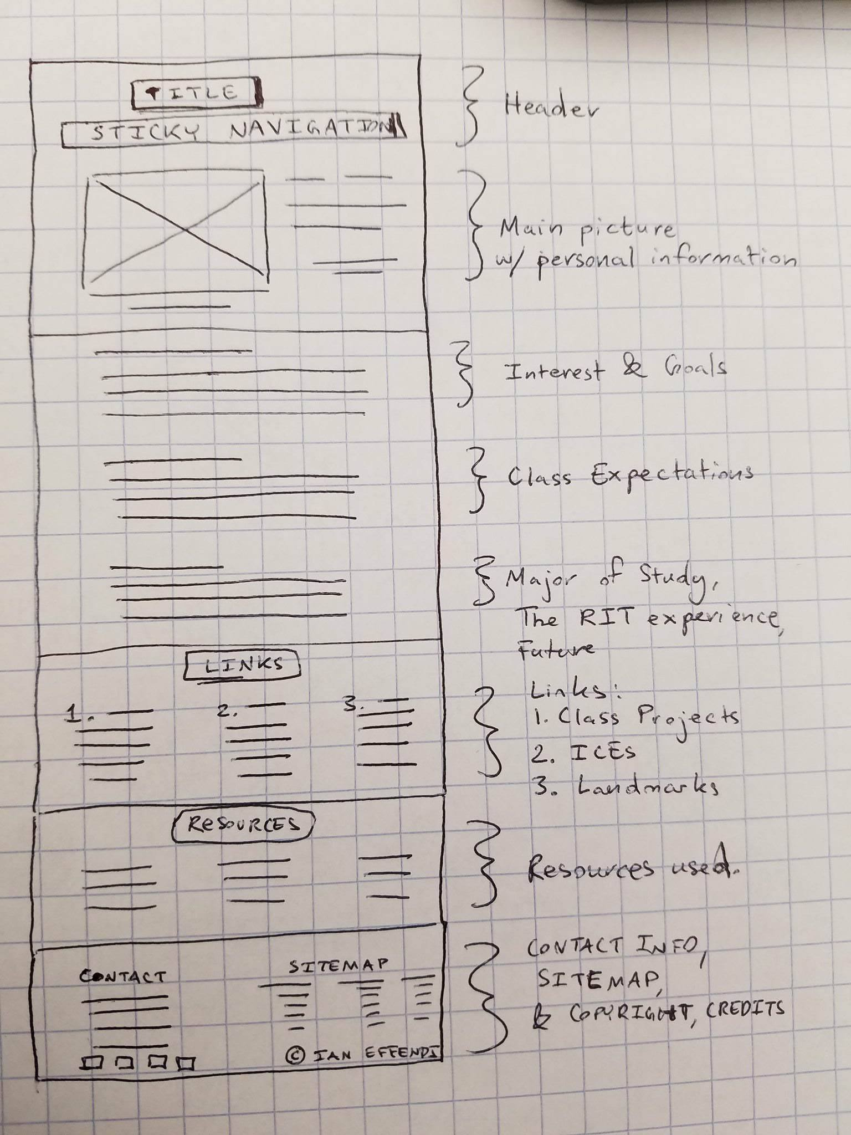

|  |
| --- |
| **bad site: http://wiki.libsdl.org/FrontPage** |
| **Alignment:** How many different styles of alignment can you see on this page? Describe them:  6. One for the sidebar, its links, the search bar buttons, the list in the content section, the panel containing the content, and the links at the bottom of the page.  Where is the strongest alignment line on this page? Why?  The sidebar; it’s a fixed width and the elements do not change no matter what page of the wiki you are on. They appear side by side. |
| **Proximity:** Identify two elements of this site that, due to their proximity, appear to have a relationship.  Headers in the body of the website are not spaced in such a way that it is clear which content is associated with it. Although we know and assume we are reading from top to bottom, left to right, it doesn’t follow the rule in which, when captioning for example, you space separate items away from each other when they aren’t as relative to each other.   Identify information at this site that "hangs" alone.  There is a sticky “Feedback” dropdown element that covers text in the website, at the top left of the screen. It uses a different font as well. |
| **Repetition:** Does the repetition on this page draw attention to anything particular? What?  Repetition on this page is not consistent. In particular, while all links are styled the same default blue, some hyperlinks in the website content have icons while others do not. The icons are not clearly defined and it isn’t clear what they mean. There are more than two fonts used on this page.  Describe the repetitive element(s) used to the best advantage on this site.  The sidebar, although not pleasing to the eye, uses the same style to differentiate sections of links from each other. (Search Wiki, is separated from Quick Links, which is separated from, User Actions). |
| **Contrast:**  Identify the strongest area of contrast at this site.  The sidebar is separate from the main page content.  Are there areas of this site that seem "muddy" or run together because of a   lack of contrast? What are they?  Inside the sidebar, the separate groupings of links utilize a shadow-box styling that makes it very ugly, when over the dark background of the sidebar. It comes across as very excessive and unnecessary. |
| **Color & Type:**  Does the use of color and type on this page enhance or detract from   the content? How?  The website utilizes the default styling for anchor tags, and uses a gray, blue-gray, and light-gray combination of colors for its palette. While the content of the site is legitimate, the actual content |

**Additional Notes:**There is a link to an HTML 4.01 Strict validation for this site, that the creators have provided…and it still doesn’t validate. So it’s an invalid webpage anyhow.

|  |
| --- |
| **good site: https://waltershomes.com/** |
| **Alignment:** How many different styles of alignment can you see on this page? Describe them:  There are many styles of alignment. The sitemap links in the footer all receive their own alignment. The News & Media, as well as, Upcoming Events, sections are all aligned. Navigation bar links in the navigation bar itself are separated based on purpose; calls-to-action are on the right while informational links are on the left.  Where is the strongest alignment line on this page? Why?  The strongest alignment is down the middle of the page; the center aligned text actually works to push readers to scroll down the page (and see the other informational elements). |
| **Proximity:** Identify two elements of this site that, due to their proximity, appear to have a relationship.  The call to action button is very close to the project description element. It identifies to the user that “Price Project” refers directly to the different situations the slideshow presents.   Identify information at this site that "hangs" alone.  The sitemap at the bottom of the page, in the footer, is alone – it’s just a list of the sites. The section is even colored differently from the rest of the page. |
| **Repetition:** Does the repetition on this page draw attention to anything particular? What?  The stylistic motif used to showcase the call to action buttons are reused throughout the page. It’s a very clean design that utilizes the color palette to its best advantage.   Describe the repetitive element(s) used to the best advantage on this site.  The website’s informational sections will grab user attention by utilizing media/graphic, putting in a very small caption beneath it, and using a larger marketing message below it. The layout remains consistent for each of the sections, but, by breaking it up into separate sections, it comes across as feeling very professional and clean. |
| **Contrast:**  Identify the strongest area of contrast at this site.  The most contrast comes in the form of the slideshow that shows up on site loading. (It doesn’t automatically start), and comes across, at first, as a simple hero image. Should more investigative users start to scroll through the slideshow, the call to action button remains strong and continues to pop out for all the images.  Are there areas of this site that seem "muddy" or run together because of a   lack of contrast? What are they?  This site is very clean and polished. It’s clear that they’ve spent a lot of money on developing a website that is easily digested by users. |
| **Color & Type:**  Does the use of color and type on this page enhance or detract from   the content?  The color comes across as very professional and cool, through its uses of light gray, blue, and blue gray, on a white, light gray background. The content pops, and the sections work very well together. |

**Additional Notes:**When you're all done, post this completed file, renamed **Exercise-CRAP-YOURNAME.docx**, to the appropriate dropbox before next class.