**A**

**MST Practical Activity Report**

**Submitted for**

**ENGINEERING DESIGN-II (UTA024)**

**Submitted by:**

**(102103429) DHRUV GARG**

**(102103430) RIMJHIM MITTAL**

**(102103432) HARSH JAIN**

**(102103433) NAVPREET SINGH**

**(102103434) ARMAANDEEP SINGH**

**BE Second Year**

**Batch: 2CO16**

Submitted to-

**Dr Govind Chhimpa**

Professor-EDP CSED



**Computer Science and Engineering Department**

**TIET, Patiala**

**Jan-June 2023**

**ABSTRACT**

In a curriculum of theoretical courses, the Engineering Design Project course provides us with an opportunity to implement the theoretical knowledge into real life applications. The application of Programming and Circuits in real time applications is what this course is all about.

It gives us a clear view of Electronic and Computer-based implementations.  
This also describes the use of some of the significant components of electronics, including capacitors, resistors, LEDs, microcontrollers, operational amplifiers and many more.

The computer part of the project includes all the coding parts required to run the transmitter, receiver and IR sensors circuit, with the help of an Arduino UNO board, breadboard and connecting wires. The coding part is done on the Arduino IDE. It is used for writing code, compiling the code to check if any errors are there and uploading the code to the Arduino. It also includes supervisory control with the help of Zigbee which is done through software called XCTU.

The buggy was designed, which uses an IR sensor, receivers, transmitters and a  
programmable Arduino UNO board to follow a line/path. The code was fed from the computers to the board. An ultrasonic sensor was attached to detect any obstacles and stop.

The Buggy also has the receiver and IR circuit fitments on it. The Receiver circuit is responsible for receiving signals and pulses from the transmitter circuit that is attached on the gantry, which allows the buggy to stop at the gantry.

**DECLARATION**

We declare that this project report is based on our own work carried out during the course of our study in our Engineering-design II Computer Lab under the supervision of **Dr Govind Chhimpa.** We assert that the statements made and conclusions drawn are an outcome of our own research work. We further certify that the work contained in this report is original and has been done by us under the general supervision of our supervisor. We have followed the guidelines provided by the University in writing this report.

We also declare that this project is the outcome of our own effort, that it has not been submitted to any other university for the award of any degree.

INDEX

|  |  |  |
| --- | --- | --- |
| S. No. | Name of Experiments | Page No. |
| 1. | Introduction to Arduino Micro-Controller. | 5-6 |
| 2. | To make a circuit of blinking an LED using Arduino Uno and  breadboard. | 6-10 |
| 3. | To blink multiple LEDs using Arduino Uno and breadboard. | 11-14 |
| 4. | Write a program to design a pattern of sequence of multiple LED’s  using for loop in Arduino. | 15-18 |
| 5. | Write a program to demonstrate sending data from the computer to  the Arduino board and control brightness of LED. | 19-22 |
| 6. | *Serial Communication:*  WAP to print following pattern using for loop.  **************************************************** Roll No.  ****************************  Name:  **********************************  Branch:  **************************** | 23-25 |
| 7. | Write a program to change the intensity of the single LED bulb using :   1. digitalRead () 2. analogRead () | 26-30 |
| 8. | Write a program to change the intensity of the given LED’s for the sequence 35214 in for both forward and reverse order. | 31-34 |
| 9. | To demonstrate control of Dc motor using Forward, backward, left,  right turn motion and clock-wise /anti-clockwise rotation. | 35-36 |

**EXPERIMENT-1**

**OBJECTIVE:** Introduction to Arduino Micro-Controller

**SOFTWARE USED:** Arduino IDE

**HARDWARE USED:**

|  |  |  |
| --- | --- | --- |
| **Sr. No** | **Name of Components** | **Quantity** |
| **1.** | Arduino Uno Micro-Controller | **--** |

**THEORY:**

Arduino UNO is a microcontroller board based on the **ATmega328P**. It has 14 digital input/output pins (of which 6 can be used as PWM outputs), 6 analog inputs, a 16 MHz ceramic resonator, a USB connection, a power jack, an ICSP header and a reset button. It contains everything needed to support the microcontroller; simply connect it to a computer with a USB cable or power it with a AC-to-DC adapter or battery to get started.

Components of Arduino:

* **USB Connector**: This is a printer USB port used to load a program from the Arduino IDE onto the Arduino board. The board can also be powered through this port.
* **Power port**: The Arduino board can be powered through an AC-to-DC adapter or a battery. The power source can be connected by plugging in a 2.1mm center-positive plug into the power jack of the board.
* **Microcontroller**: It is the most prominent black rectangular chip with 28 pins. It acts as the brains of your Arduino. The microcontroller used on the UNO board is Atmega328P.
* **Digital pins:** These pins are labeled as “Digital 0 to 13.” These pins can be used as either input or output pins. When used as output, these pins act as a power supply source for the components connected to them. When used as input pins, they read the signals from the component connected to them.
* **Reset switch**: When this switch is clicked, it sends a logical pulse to the reset pin of the Microcontroller, and now runs the program again from the start.
* **Crystal oscillator:** This is a quartz crystal oscillator which ticks 16 million times a second. On each tick, the microcontroller performs one operation, for example, addition, subtraction, etc.
* **TX – RX LEDs:** TX stands for transmit, and RX for receive. These are indicator LEDs which blink whenever the UNO board is transmitting or receiving data.
* **USB interface chip**: This is a signal translator. It converts signals in the USB level to a level that an Arduino UNO board understands.

**LOGIC-CIRCUIT DIAGRAM:**

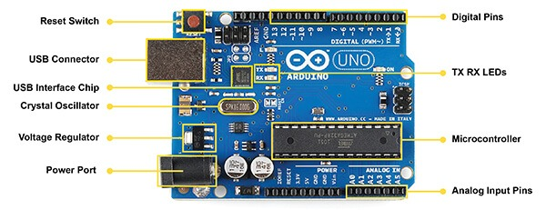

**RESULT ANALYSIS:**

Through the following experiment we learnt about the Arduino UNO board, its different components, their functionalities and working.

**Signature of Faculty**

**EXPERIMENT-2**

**OBJECTIVE:** Write a program to blink a single LED using Arduino and breadboard

**SOFTWARE USED:** Arduino IDE.

**HARDWARE USED:**

|  |  |  |
| --- | --- | --- |
| **Sr No.** | **Name of the Component** | **Value** |
| 1. | Arduino Uno Board | 1 |
| 2. | Breadboard | 1 |
| 3. | Jumper Wires | 2 |
| 4. | LED | 1 |
| 5. | Resistor | 220 ohm |

**THEORY:**

1. **Arduino Uno Board:** Arduino UNO is a microcontroller board based on the **ATmega328P**. It has 14 digital input/output pins (of which 6 can be used as PWM outputs), 6 analog inputs, a 16 MHz ceramic resonator, a USB connection, a power jack, an ICSP header and a reset button. It contains everything needed to support the microcontroller; simply connect it to a computer with a USB cable or power it with a AC-to-DC adapter or battery to get started.

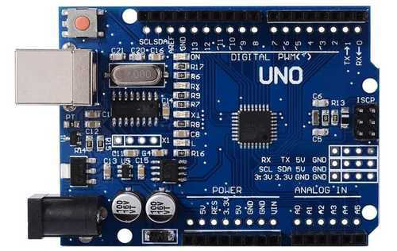

**Fig:** Arduino UNO

1. **Breadboard:** A breadboard, solderless breadboard, or protoboard is a construction base used to build semi-permanent [prototypes](https://en.wikipedia.org/wiki/Prototype) of [electronic circuits.](https://en.wikipedia.org/wiki/Electronic_circuit) Unlike a [perfboard](https://en.wikipedia.org/wiki/Perfboard) or [stripboard](https://en.wikipedia.org/wiki/Stripboard), breadboards do not require [soldering](https://en.wikipedia.org/wiki/Soldering) or destruction of tracks and are hence reusable.

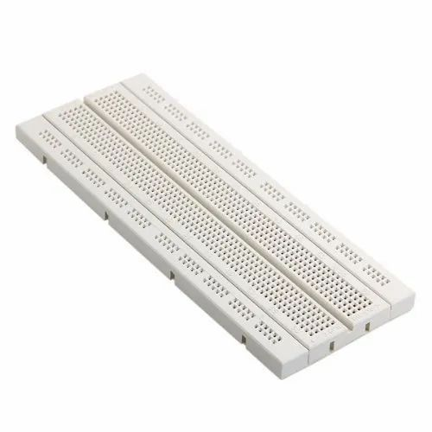

**Fig:** Breadboard

1. **Jumper wires**: Jumper wires are simply wires that have connector pins at each end, allowing them to be used to connect two points to each other without soldering. Jumper wires are typically used with [breadboards](https://blog.sparkfuneducation.com/what-is-a-breadboard) and other prototyping tools in order to make it easy to change a circuit as needed.

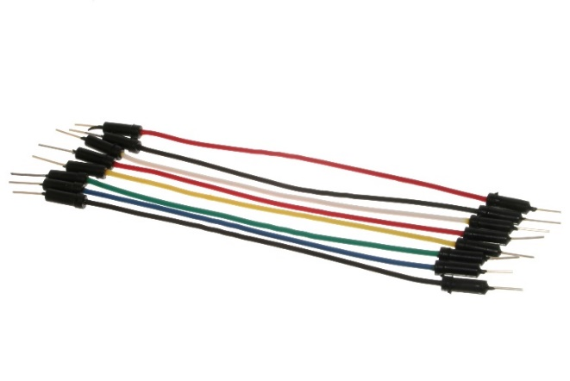

**Fig:** Jumper Wires

1. **LED:** A light-emitting diode (LED) is a semiconductor device that emits light when an electric current flows through it. When current passes through an LED, the electrons recombine with holes emitting light in the process. LEDs allow the current to flow in the forward direction and blocks the current in the reverse direction.

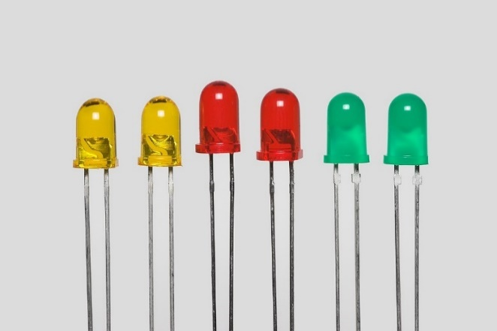

**Fig:** Light Emitting Diode

1. **Resistor**: Resistors are electronic components that obstruct the flow of current. These are passive elements meaning they don’t need an external power source to work. The SI unit of resistance is ohm. The theoretical way to calculate the resistance of a resistor is using Ohm’s law which states that voltage across the element is directly proportional to the current passing in it. The color bands on the resistor can also be used to calculate its value. The resistor used in this experiment is of value: 220 Ω.

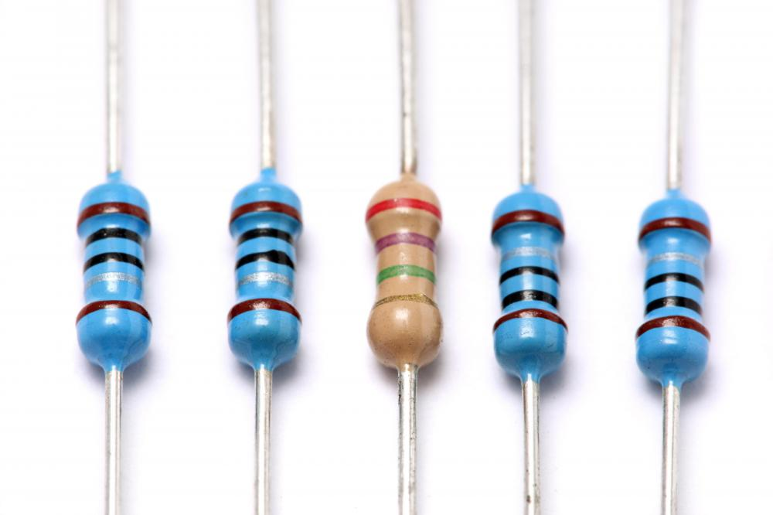

**Fig:** Resistors

**CIRCUIT DIAGRAM:**

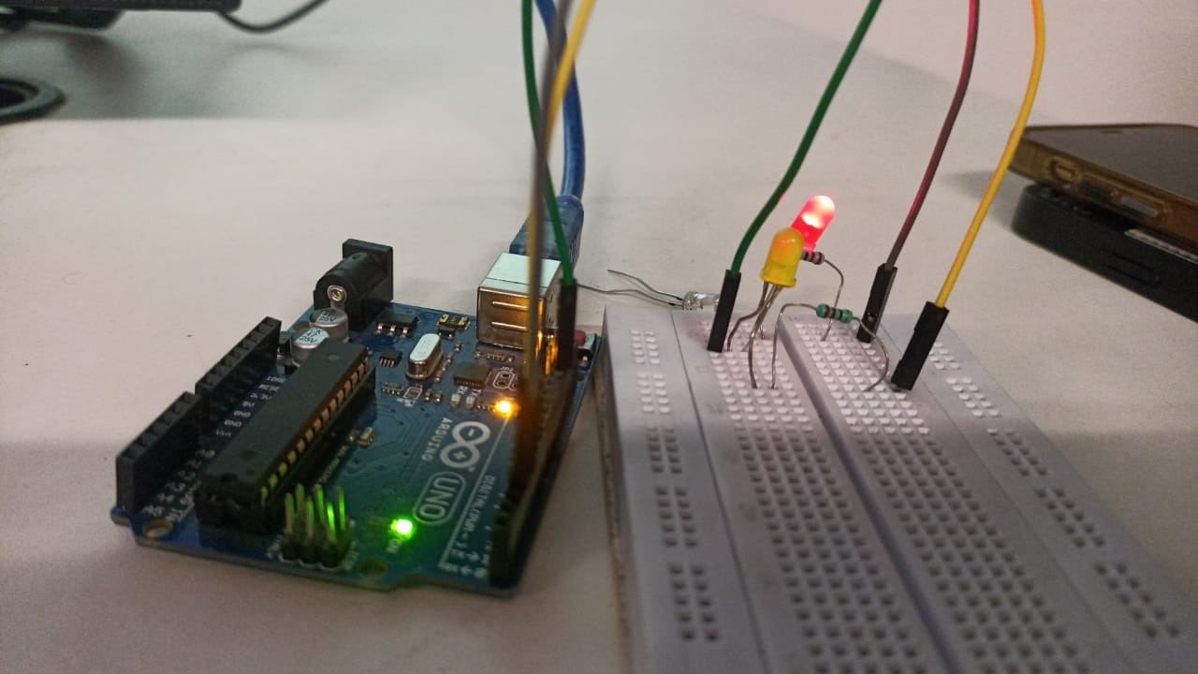

**CODE:**

void setup() {

pinMode(2, OUTPUT);

}

void loop() {

digitalWrite(2, HIGH);

delay(1000);

digitalWrite(2, LOW);

delay(1000);

}

**RESULT ANALYSIS:**

Through the above experiment we learnt how to design a basic led blinking circuit on breadboard. We also learnt about basic functions in arduino like digitalWrite, pinMode, delay.

**Signature of Faculty**

**EXPERIMENT-3**

**OBJECTIVE:** Write a program to blink multiple LED’s using Arduino and breadboard.

**SOFTWARE USED:** Arduino IDE.

**HARDWARE USED:**

|  |  |  |
| --- | --- | --- |
| **Sr No.** | **Name of the Component** | **Value** |
| 1. | Arduino Uno Board | 1 |
| 2. | Breadboard | 1 |
| 3. | Jumper Wires | 10 |
| 4. | LED | 5 |
| 5. | Resistor | 5 x 220 ohm |

**THEORY:**

1. **Arduino Uno Board:** Arduino UNO is a microcontroller board based on the **ATmega328P**. It has 14 digital input/output pins (of which 6 can be used as PWM outputs), 6 analog inputs, a 16 MHz ceramic resonator, a USB connection, a power jack, an ICSP header and a reset button. It contains everything needed to support the microcontroller; simply connect it to a computer with a USB cable or power it with a AC-to-DC adapter or battery to get started.



**Fig:** Arduino UNO

1. **Breadboard:** A breadboard, solderless breadboard, or protoboard is a construction base used to build semi-permanent [prototypes](https://en.wikipedia.org/wiki/Prototype) of [electronic circuits.](https://en.wikipedia.org/wiki/Electronic_circuit) Unlike a [perfboard](https://en.wikipedia.org/wiki/Perfboard) or [stripboard](https://en.wikipedia.org/wiki/Stripboard), breadboards do not require [soldering](https://en.wikipedia.org/wiki/Soldering) or destruction of tracks and are hence reusable.



**Fig:** Breadboard

1. **Jumper wires**: Jumper wires are simply wires that have connector pins at each end, allowing them to be used to connect two points to each other without soldering. Jumper wires are typically used with [breadboards](https://blog.sparkfuneducation.com/what-is-a-breadboard) and other prototyping tools in order to make it easy to change a circuit as needed.

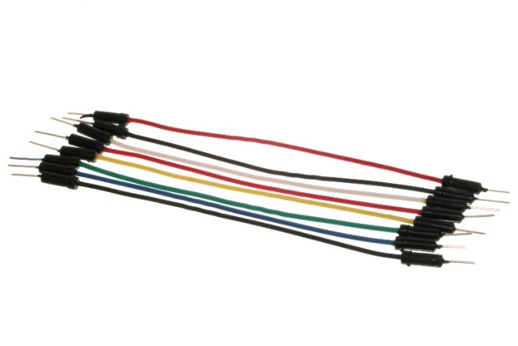

**Fig:** Jumper Wires

1. **LED:** A light-emitting diode (LED) is a semiconductor device that emits light when an electric current flows through it. When current passes through an LED, the electrons recombine with holes emitting light in the process. LEDs allow the current to flow in the forward direction and blocks the current in the reverse direction.

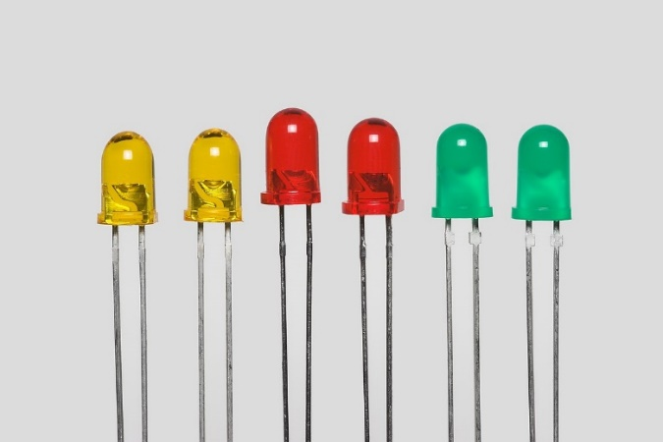

**Fig:** Light Emitting Diode

1. **Resistor**: Resistors are electronic components that obstruct the flow of current. These are passive elements meaning they don’t need an external power source to work. The SI unit of resistance is ohm. The theoretical way to calculate the resistance of a resistor is using Ohm’s law which states that voltage across the element is directly proportional to the current passing in it. The color bands on the resistor can also be used to calculate its value. The resistor used in this experiment is of value: 220 Ω.



**Fig:** Resistors

**CIRCUIT DIAGRAM:**

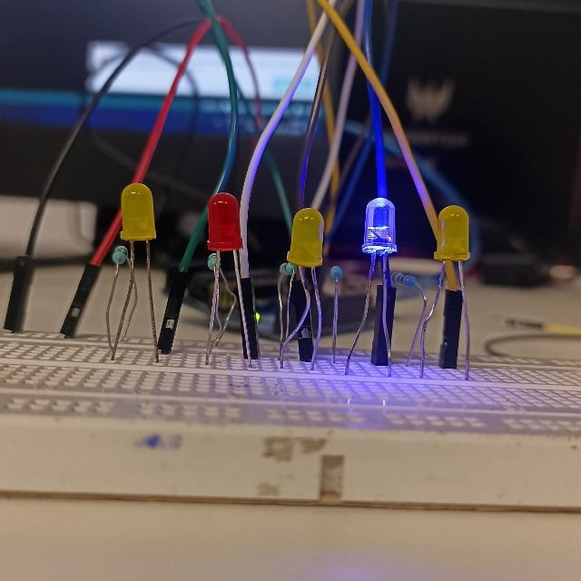

**CODE:**

void setup() {

pinMode(2, OUTPUT);

pinMode(3,OUTPUT);

pinMode(4,OUTPUT);

pinMode(5,OUTPUT);

pinMode(6,OUTPUT);

}

void loop() {

digitalWrite(2, HIGH);

delay(1000);

digitalWrite(3, LOW);

delay(1000);

digitalWrite(4, HIGH);

delay(1000);

digitalWrite(5, LOW);

delay(1000);

digitalWrite(6, HIGH);

delay(1000);

digitalWrite(6, LOW);

delay(1000);

}

**RESULT:**

Through the above experiment we learnt how to design multiple led blinking circuit on breadboard. We also learnt about basic functions in Arduino like digitalWrite, pinMode, delay.

**Signature of Faculty**

**EXPERIMENT-4**

**OBJECTIVE:** Write a program to design a pattern of sequence of multiple LED’s using for loop using Arduino Uno and breadboard.

**SOFTWARE USED:** Arduino IDE

**HARDWARE USED:**

|  |  |  |
| --- | --- | --- |
| **Sr No.** | **Name of the Component** | **Value** |
| 1. | Arduino Uno Board | 1 |
| 2. | Breadboard | 1 |
| 3. | Jumper Wires | 10 |
| 4. | LED | 5 |
| 5. | Resistor | 5 x 220 ohm |

**THEORY:**

1. **Arduino Uno Board:** Arduino UNO is a microcontroller board based on the **ATmega328P**. It has 14 digital input/output pins (of which 6 can be used as PWM outputs), 6 analog inputs, a 16 MHz ceramic resonator, a USB connection, a power jack, an ICSP header and a reset button. It contains everything needed to support the microcontroller; simply connect it to a computer with a USB cable or power it with a AC-to-DC adapter or battery to get started.



**Fig:** Arduino UNO

1. **Breadboard:** A breadboard, solderless breadboard, or protoboard is a construction base used to build semi-permanent [prototypes](https://en.wikipedia.org/wiki/Prototype) of [electronic circuits.](https://en.wikipedia.org/wiki/Electronic_circuit) Unlike a [perfboard](https://en.wikipedia.org/wiki/Perfboard) or [stripboard](https://en.wikipedia.org/wiki/Stripboard), breadboards do not require [soldering](https://en.wikipedia.org/wiki/Soldering) or destruction of tracks and are hence reusable.



**Fig:** Breadboard

1. **Jumper wires**: Jumper wires are simply wires that have connector pins at each end, allowing them to be used to connect two points to each other without soldering. Jumper wires are typically used with [breadboards](https://blog.sparkfuneducation.com/what-is-a-breadboard) and other prototyping tools in order to make it easy to change a circuit as needed.



**Fig:** Jumper Wires

1. **LED:** A light-emitting diode (LED) is a semiconductor device that emits light when an electric current flows through it. When current passes through an LED, the electrons recombine with holes emitting light in the process. LEDs allow the current to flow in the forward direction and blocks the current in the reverse direction.



**Fig:** Light Emitting Diode

1. **Resistor**: Resistors are electronic components that obstruct the flow of current. These are passive elements meaning they don’t need an external power source to work. The SI unit of resistance is ohm. The theoretical way to calculate the resistance of a resistor is using Ohm’s law which states that voltage across the element is directly proportional to the current passing in it. The color bands on the resistor can also be used to calculate its value. The resistor used in this experiment is of value: 220 Ω.



**Fig:** Resistors

**CIRCUIT DIAGRAM:**

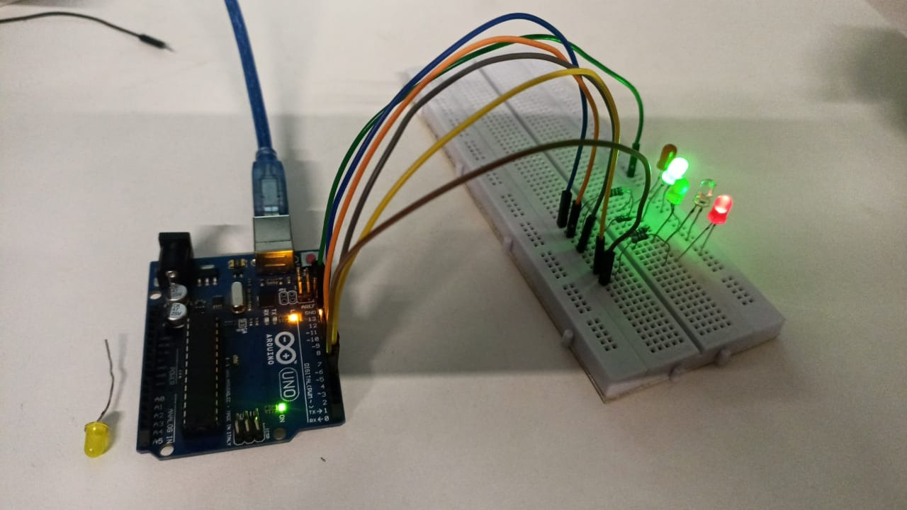

**CODE:**

void setup() {

pinMode(2, OUTPUT);

pinMode(3, OUTPUT);

pinMode(4, OUTPUT);

pinMode(5, OUTPUT);

pinMode(6, OUTPUT);

}

void loop() {

for(int i=2;i<7;i++){

digitalWrite(I,LOW);

delay(300);

digitalWrite(I,HIGH);

}

delay(1000);

int arr[]={2,3,4,5,6};

for (int i=0;i<5;i++){

digitalWrite(arr[i], LOW);

delay (300);

digitalWrite(arr[i], HIGH);

}

delay (1000);

int j=2;

while (j<7) {

digitalWrite(j, LOW);

delay (300);

digitalWrite(j, HIGH);

j++;

}

}

**RESULT ANALYSIS:**

Through the above experiment, we learnt how to use arrays and iterating through the arrays using for and while loops and blinking the led via it.

**Signature of Faculty**

**EXPERIMENT-5**

**OBJECTIVE:** Write a program to demonstrate sending data from the computer to the Arduino board and control brightness of LED.

**SOFTWARE USED:** Arduino IDE

**HARDWARE USED:**

|  |  |  |
| --- | --- | --- |
| **Sr No.** | **Name of the Component** | **Value** |
| 1. | Arduino Uno Board | 1 |
| 2. | Breadboard | 1 |
| 3. | Jumper Wires | 2 |
| 4. | LED | 1 |
| 5. | Resistor | 1 x 220 ohm |

**THEORY:**

1. **Arduino Uno Board:** Arduino UNO is a microcontroller board based on the **ATmega328P**. It has 14 digital input/output pins (of which 6 can be used as PWM outputs), 6 analog inputs, a 16 MHz ceramic resonator, a USB connection, a power jack, an ICSP header and a reset button. It contains everything needed to support the microcontroller; simply connect it to a computer with a USB cable or power it with a AC-to-DC adapter or battery to get started.



**Fig:** Arduino UNO

1. **Breadboard:** A breadboard, solderless breadboard, or protoboard is a construction base used to build semi-permanent [prototypes](https://en.wikipedia.org/wiki/Prototype) of [electronic circuits.](https://en.wikipedia.org/wiki/Electronic_circuit) Unlike a [perfboard](https://en.wikipedia.org/wiki/Perfboard) or [stripboard](https://en.wikipedia.org/wiki/Stripboard), breadboards do not require [soldering](https://en.wikipedia.org/wiki/Soldering) or destruction of tracks and are hence reusable.



**Fig:** Breadboard

1. **Jumper wires**: Jumper wires are simply wires that have connector pins at each end, allowing them to be used to connect two points to each other without soldering. Jumper wires are typically used with [breadboards](https://blog.sparkfuneducation.com/what-is-a-breadboard) and other prototyping tools in order to make it easy to change a circuit as needed.

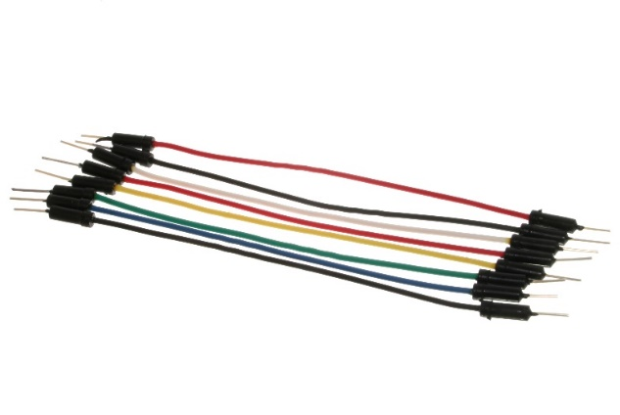

**Fig:** Jumper Wires

1. **LED:** A light-emitting diode (LED) is a semiconductor device that emits light when an electric current flows through it. When current passes through an LED, the electrons recombine with holes emitting light in the process. LEDs allow the current to flow in the forward direction and blocks the current in the reverse direction.

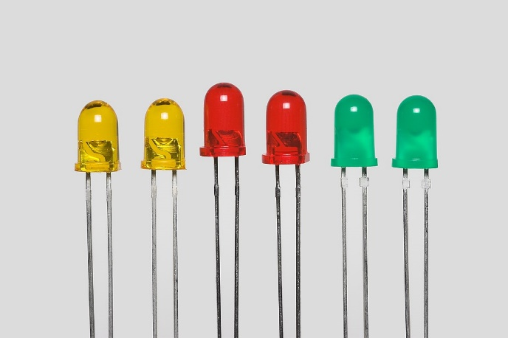

**Fig:** Light Emitting Diode

1. **Resistor**: Resistors are electronic components that obstruct the flow of current. These are passive elements meaning they don’t need an external power source to work. The SI unit of resistance is ohm. The theoretical way to calculate the resistance of a resistor is using Ohm’s law which states that voltage across the element is directly proportional to the current passing in it. The color bands on the resistor can also be used to calculate its value. The resistor used in this experiment is of value: 220 Ω.



**Fig:** Resistors

**CIRCUIT DIAGRAM:**

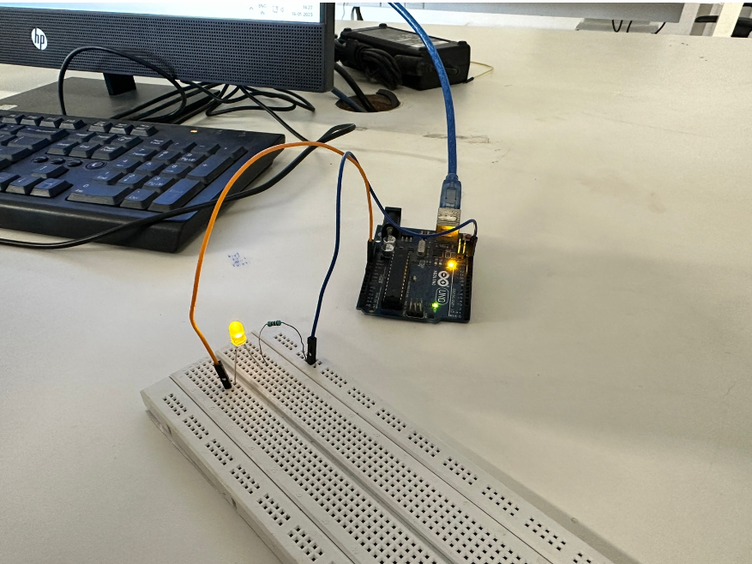

**CODE:**

void setup() {

pinMode(3, OUTPUT);

Serial.begin(9600);

}

void loop(){

byte brightness;

if(Serial.available()){

brightness=Serial.parseInt();

analogWrite(3,brightness);

}

}

**RESULT ANALYSIS:**

In this experiment, we have learnt how we can use analogWrite() function to send data from computer to Arduino board and change the intensity of the LED by providing it with different analog values.

**Signature of Faculty**

**EXPERIMENT-6**

**OBJECTIVE:** Serial Communication:

WAP to print following pattern using for loop:

****************************************************

Roll No._____________________________________________

****************************

Name: ______________________________________________

**********************************

Branch: _____________________________________________

****************************

**SOFTWARE USED:** Arduino IDE

**HARDWARE USED:**

|  |  |  |
| --- | --- | --- |
| **Sr No.** | **Name of the Component** | **Value** |
| 1. | Arduino Uno Board | 1 |

**THEORY:**

1. **Arduino Uno Board:** Arduino UNO is a microcontroller board based on the **ATmega328P**. It has 14 digital input/output pins (of which 6 can be used as PWM outputs), 6 analog inputs, a 16 MHz ceramic resonator, a USB connection, a power jack, an ICSP header and a reset button. It contains everything needed to support the microcontroller; simply connect it to a computer with a USB cable or power it with a AC-to-DC adapter or battery to get started.



**CODE:**

int a=0;

void setup() {

pinMode(9,OUTPUT);

Serial.begin(9600); }

void loop() {

for(int i=0;i<30;i++)

{

Serial.print("*");

}

Serial.println("");

Serial.print("Roll No.");

for(int i=0;i<30;i++)

{

Serial.print("_");

}

Serial.println("");

for(int i=0;i<20;i++)

{

Serial.print("*");

}

Serial.println("");

Serial.print("Name");

for(int i=0;i<20;i++)

{

Serial.print("_");

}

Serial.println("");

for(int i=0;i<20;i++)

{

Serial.print("*");

}

Serial.println("");

Serial.print("Branch");

for(int i=0;i<10;i++)

{

Serial.print("_");

}

Serial.println("");

for(int i=0;i<20;i++)

{

Serial.print("*");

}

delay(100000);

}

**RESULT ANALYSIS:**

In this experiment, we learnt how to input data from the user and print the data on the monitor screen using Serial Monitor.

**Signature of Faculty**

**EXPERIMENT-7**

**OBJECTIVE:** Write a program to change the intensity of the single LED bulb using:

i. digitalRead ()

ii. analogRead ()

**SOFTWARE USED:** Arduino IDE

**HARDWARE USED:**

|  |  |  |
| --- | --- | --- |
| **Sr No.** | **Name of the Component** | **Value** |
| 1. | Arduino Uno Board | 1 |
| 2. | Breadboard | 1 |
| 3. | Jumper Wires | 10 |
| 4. | LED | 1 |
| 5. | Resistor | 1 x 220 ohm |
| 6. | Potentiometer | 1 |

**THEORY:**

1. **Arduino Uno Board:** Arduino UNO is a microcontroller board based on the **ATmega328P**. It has 14 digital input/output pins (of which 6 can be used as PWM outputs), 6 analog inputs, a 16 MHz ceramic resonator, a USB connection, a power jack, an ICSP header and a reset button. It contains everything needed to support the microcontroller; simply connect it to a computer with a USB cable or power it with a AC-to-DC adapter or battery to get started.



**Fig:** Arduino UNO

1. **Breadboard:** A breadboard, solderless breadboard, or protoboard is a construction base used to build semi-permanent [prototypes](https://en.wikipedia.org/wiki/Prototype) of [electronic circuits.](https://en.wikipedia.org/wiki/Electronic_circuit) Unlike a [perfboard](https://en.wikipedia.org/wiki/Perfboard) or [stripboard](https://en.wikipedia.org/wiki/Stripboard), breadboards do not require [soldering](https://en.wikipedia.org/wiki/Soldering) or destruction of tracks and are hence reusable.



**Fig:** Breadboard

1. **Jumper wires**: Jumper wires are simply wires that have connector pins at each end, allowing them to be used to connect two points to each other without soldering. Jumper wires are typically used with [breadboards](https://blog.sparkfuneducation.com/what-is-a-breadboard) and other prototyping tools in order to make it easy to change a circuit as needed.

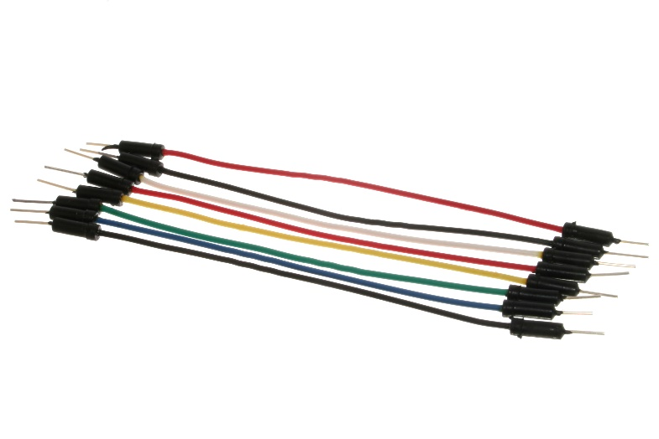

**Fig:** Jumper Wires

1. **LED:** A light-emitting diode (LED) is a semiconductor device that emits light when an electric current flows through it. When current passes through an LED, the electrons recombine with holes emitting light in the process. LEDs allow the current to flow in the forward direction and blocks the current in the reverse direction.

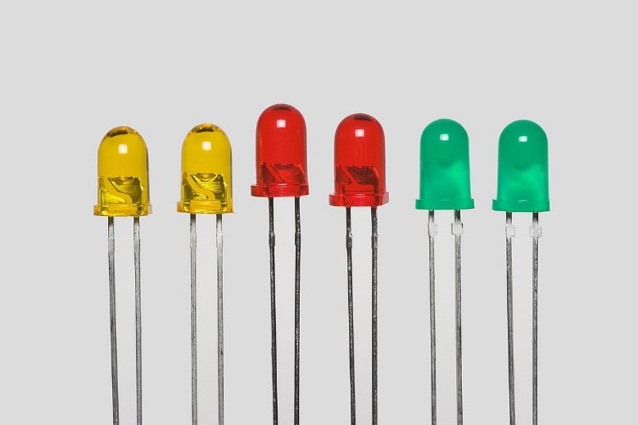

**Fig:** Light Emitting Diode

1. **Resistor**: Resistors are electronic components that obstruct the flow of current. These are passive elements meaning they don’t need an external power source to work. The SI unit of resistance is ohm. The theoretical way to calculate the resistance of a resistor is using Ohm’s law which states that voltage across the element is directly proportional to the current passing in it. The color bands on the resistor can also be used to calculate its value. The resistor used in this experiment is of value: 220 Ω.



**Fig:** Resistors

1. **Potentiometer**: Resistors are electronic components that obstruct the flow of current. These are passive elements meaning they don’t need an external power source to work. The SI unit of resistance is ohm. The theoretical way to calculate the resistance of a resistor is using Ohm’s law which states that voltage across the element is directly proportional to the current passing in it. The color bands on the resistor can also be used to calculate its value. The resistor used in this experiment is of value: 220 Ω.

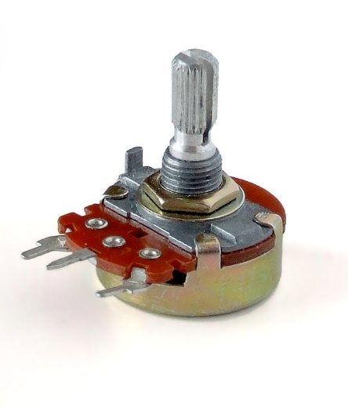

**Fig:** Potentiometer

**CIRCUIT DIAGRAM:**



**CODE:**

i. digitalRead()

void setup() {

pinMode(3,INPUT );

pinMode(9,OUTPUT);

}

void loop()

{

int y=digitalRead(3);

if(y==1)

{

for (int i=255;i>=0;i--)

{

analogWrite(9,i);

delay(20);

}

}

else

{

digitalWrite(9,LOW);

}

}

ii. analogRead()

int a = A5;

int b = 9;

int value = 0;

void setup ()

{

pinMode (a, INPUT);

pinMode (b, OUTPUT);

}

void loop ()

{

value = analogRead(a);

analogWrite (b, value);

}

**RESULT ANALYSIS:**

In this experiment, we learnt how to control the brightness of LED using both digitalRead() and analogRead().

**Signature of Faculty**

**EXPERIMENT-8**

**OBJECTIVE:** Write a program to change the intensity of the given LED’s for the sequence 35214 in for both forward and reverse order

**SOFTWARE USED:** Arduino IDE

**HARDWARE USED:**

|  |  |  |
| --- | --- | --- |
| **Sr No.** | **Name of the Component** | **Value** |
| 1. | Arduino Uno Board | 1 |
| 2. | Breadboard | 1 |
| 3. | Jumper Wires | 10 |
| 4. | LED | 5 |
| 5. | Resistor | 5 x 220 ohm |

**THEORY:**

1. **Arduino Uno Board:** Arduino UNO is a microcontroller board based on the **ATmega328P**. It has 14 digital input/output pins (of which 6 can be used as PWM outputs), 6 analog inputs, a 16 MHz ceramic resonator, a USB connection, a power jack, an ICSP header and a reset button. It contains everything needed to support the microcontroller; simply connect it to a computer with a USB cable or power it with a AC-to-DC adapter or battery to get started.



**Fig:** Arduino UNO

1. **Breadboard:** A breadboard, solderless breadboard, or protoboard is a construction base used to build semi-permanent [prototypes](https://en.wikipedia.org/wiki/Prototype) of [electronic circuits.](https://en.wikipedia.org/wiki/Electronic_circuit) Unlike a [perfboard](https://en.wikipedia.org/wiki/Perfboard) or [stripboard](https://en.wikipedia.org/wiki/Stripboard), breadboards do not require [soldering](https://en.wikipedia.org/wiki/Soldering) or destruction of tracks and are hence reusable.



**Fig:** Breadboard

1. **Jumper wires**: Jumper wires are simply wires that have connector pins at each end, allowing them to be used to connect two points to each other without soldering. Jumper wires are typically used with [breadboards](https://blog.sparkfuneducation.com/what-is-a-breadboard) and other prototyping tools in order to make it easy to change a circuit as needed.

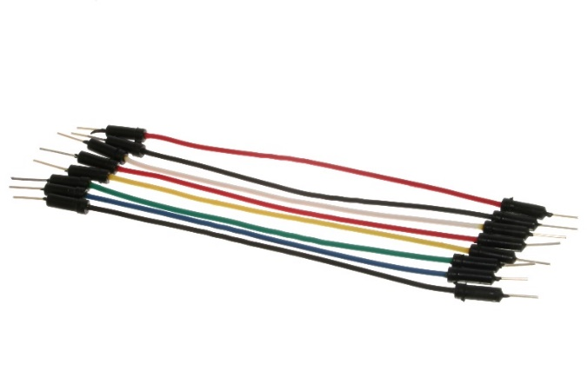

**Fig:** Jumper Wires

1. **LED:** A light-emitting diode (LED) is a semiconductor device that emits light when an electric current flows through it. When current passes through an LED, the electrons recombine with holes emitting light in the process. LEDs allow the current to flow in the forward direction and blocks the current in the reverse direction.



**Fig:** Light Emitting Diode

1. **Resistor**: Resistors are electronic components that obstruct the flow of current. These are passive elements meaning they don’t need an external power source to work. The SI unit of resistance is ohm. The theoretical way to calculate the resistance of a resistor is using Ohm’s law which states that voltage across the element is directly proportional to the current passing in it. The color bands on the resistor can also be used to calculate its value. The resistor used in this experiment is of value: 220 Ω.



**Fig:** Resistors

**CIRCUIT DIAGRAM:**

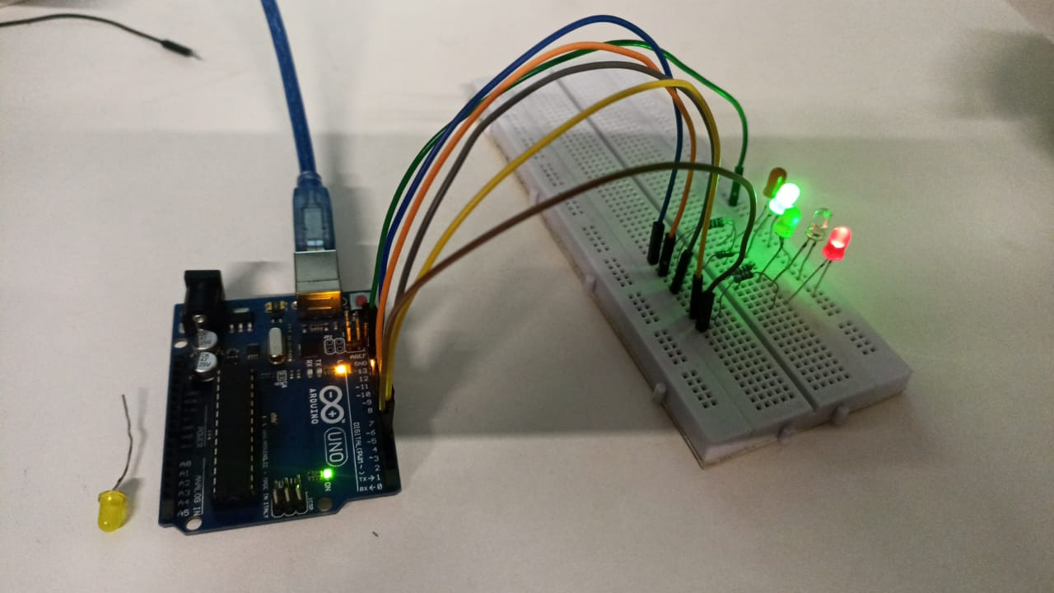

**CODE:**

void setup()

{

pinMode(3, OUTPUT); //1

pinMode(5, OUTPUT); //2

pinMode(6, OUTPUT); //3

pinMode(9, OUTPUT); //4

pinMode(10, OUTPUT); //5

Serial.begin(9600);

}

void loop()

{

analogWrite(6,255);

analogWrite(10,150);

analogWrite(5,50);

analogWrite(3,20);

analogWrite(9,5);

delay(4000);

analogWrite(9,255);

analogWrite(3,150);

analogWrite(5,50);

analogWrite(10,20);

analogWrite(6,5);

delay(4000);

}

**RESULT ANALYSIS:**

In this experiment, we learnt how to control brightness of multiple LED’s using analogRead() and analogWrite() and Serial Monitor

**Signature of Faculty**

**EXPERIMENT-9**

**OBJECTIVE:** To demonstrate control of Dc motor using Forward, backward, left, right turn motion and clock-wise /anti-clockwise rotation.

**SOFTWARE USED:** Arduino IDE

**HARDWARE USED:**

|  |  |  |
| --- | --- | --- |
| **Sr No.** | **Name of the Component** | **Value** |
| 1. | Arduino Uno Board | 1 |
| 2. | Nvis 3302ARD RoboCar | 1 |

**THEORY:**

1. **Arduino Uno Board:** Arduino UNO is a microcontroller board based on the **ATmega328P**. It has 14 digital input/output pins (of which 6 can be used as PWM outputs), 6 analog inputs, a 16 MHz ceramic resonator, a USB connection, a power jack, an ICSP header and a reset button. It contains everything needed to support the microcontroller; simply connect it to a computer with a USB cable or power it with a AC-to-DC adapter or battery to get started.



**Fig:** Arduino UNO

1. **Nvis 3302ARD:** Nvis 3302ARD is capable of sensing environment using various sensor modules and acts accordingly. Nvis RoboCar is a ready assembled unit consisting of strong chassis wheels with different Sensor modules mounted on it. The machine is driven by DC motors which are powered by rechargeable batteries. This Nvis 3302ARD is Atmega328P Micro-controller RoboCar. We can design user defined functions in the Arduino IDE to make the buggy move in our own specified directions like left, right, forward, backward, clockwise and anti-clockwise by setting the pins 5, 6, 7 ,8 on Nvis 3302ARD RoboCar either HIGH/LOW.

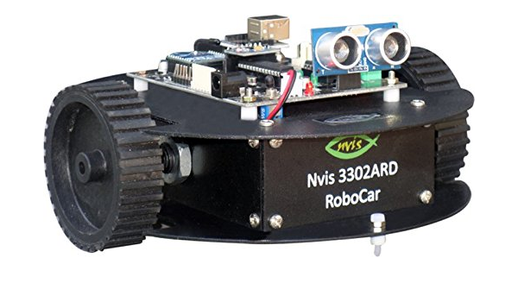

**Fig:** Nvis 3302ARD

**CODE:**

void setup(){

pinMode(5, OUTPUT);

pinMode(6, OUTPUT);

pinMode(7, OUTPUT);

pinMode(8, OUTPUT);

}

void forward(){

digitalWrite(5, HIGH);

digitalWrite(6, LOW);

digitalWrite(7, LOW);

digitalWrite(8, HIGH);

}

void left(){

digitalWrite(5, HIGH);

digitalWrite(6, LOW);

digitalWrite(7, LOW);

digitalWrite(8, LOW);

}

void loop(){

forward();

delay(3000);

left();

delay(1650);

  }

**RESULT ANALYSIS:**

In this experiment we can learnt how to control the movement of the buggy, pins 5 and 8 are for forward movement while pins 6 and 7 control the back wheels. Through the above code we have managed to make the buggy move in a square shape.