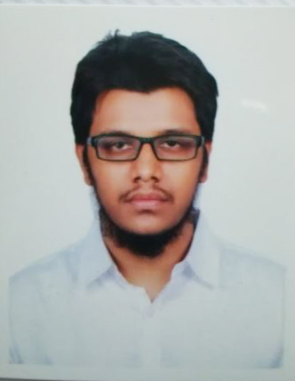
Resume of
Md. Minhajul islam riman
House No- 10, Road No-03, Block-H, 5th Floor,
Mirpur-2, Dhaka-1216.
E-mail: rimon.bd1995@gmail.com
Cell: 01747309064

CARRIER OBJECTIVE:

To join a reputed organization where I shall be able to prove my eligibility by working with the professionals and thus enhance my professional skills.
EXPERIENCE:
EDUCATIONAL QUALIFICATION:

Woven Garments Merchandising

Area of Concentration : WGM
Duration of Course : 6 Month's.
Year of Completion : 2014.
Result(Division/GPA) : 5.00 (Out of 5.00)
Institute Name : BGMEA University of Fashion & Technology (BUFT)

Bachelor of Bba (BBA Hons)

Duration of Course : 4 Year’s.
Year of Completion : 2018
Subject : Management
Result(Division/GPA) : 2.53
Institute Name : Govt Bangla Collage.

Higher Secondary Certificate (H.S.C)

Area of Concentration : Business Management
Duration of Course : 2 Year’s.
Year of Completion : 2012.
Result(Division/GPA) : 4..27 (Out of 5.00)
Institute Name : Betagi Technicel Collage, Barguna
Board : Barishal.

Secondary School Certificate (S.S.C)

Area of Concentration : Vocational
Duration of Course : 10 Year's.
Year of Completion : 2010.
Result(Division/GPA) : 3.68 (Out of 5.00)
Institute Name : Betagi pilot High School, Barguna
Board : Barishal.
COMPUTER LITERACY

► Cisco Certified Network Associate Routing & switching (CCNA)
► SEO Basic .
► Hardworking and networking
► Ms word, Ms excel, Power Point and Internet Browsing.
► Adobe Photoshop, Adobe Illustrator.
► Typing speed per minute 10 words.
HOBBYS & INTERESTS

Interested in social activities, reading books, sports and famous magazines, traveling, watching famous English movies, music, etc.

LANGUEGE PROFICIENCY:

- English: Medium in reading and writing.
- Bengali: Better in reading, writing and speaking.

PERSONAL INFORMATION:

Name | : | Md Minhajul islam riman
Father’s Name | : | Md. Abdul Hakim
Mother’s Name | : | Fatima Begum
Date of Birth | : | 07 Oct 1995
Nationality | : | Bangladeshi
Marital Status | : | Unmarried
Religion | : | Islam (Sunni)
Blood Group | : A (+)
Permanent Address | : | Vill: Betagi, Post: Betagi,  P.S: Betagi, Dist: Barguna
Present Address | : | House No- 10, Road No-03, Block-H, 5th Floor,  Mirpur-2, Dhaka-1216.
EXTRA CURRICULAR ACTIVITIES

* I am a member of “The Hunger project”
* I took part on a workshop on debate, Organized by: Dhaka University Debating Society.
* I am also engaged in cultural activities.
EFERENCE:

DECLARATION:

Here I, Md Minhajul islam riman affirm that the information’s given above is true and up to date. Again I like to add that if I am selected for any position I will serve my best for the organization’s sake.

Signature

