**Screenshots of postman using created REST API**

1. Project showing postman listing all records: get request on API

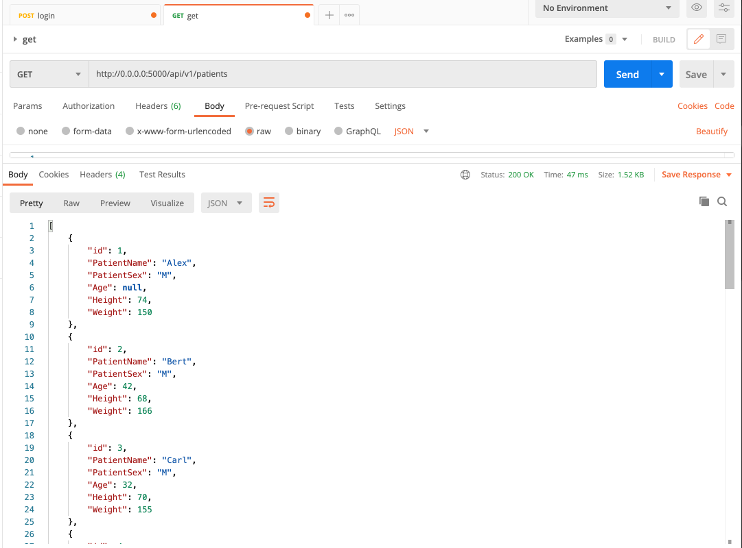

1. Project showing postman one record with a get request:

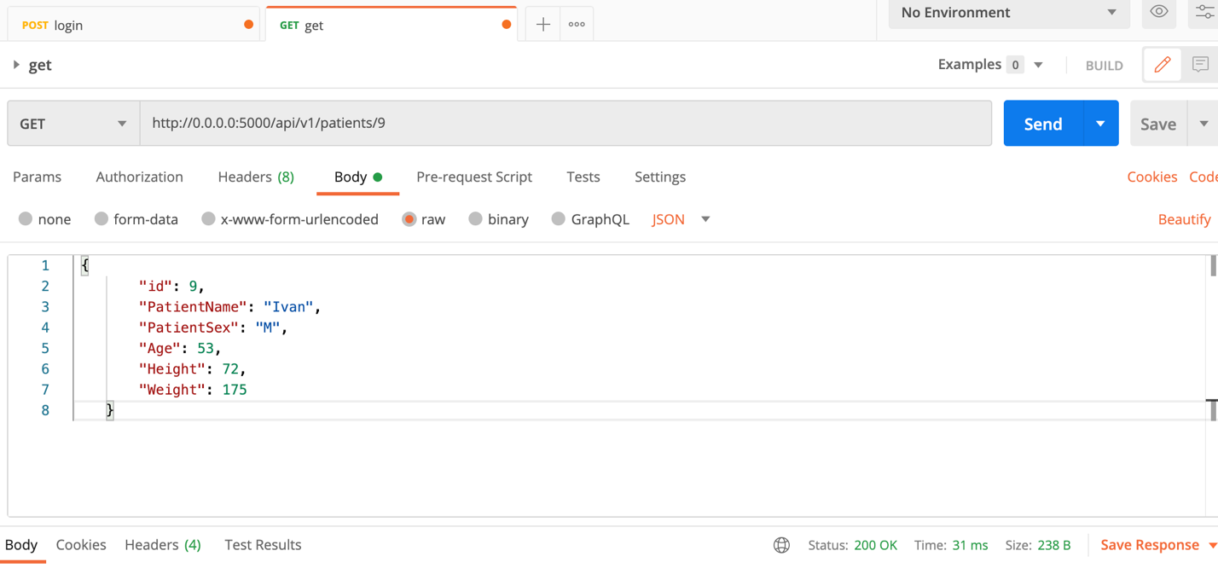

1. Creating a record using post request:

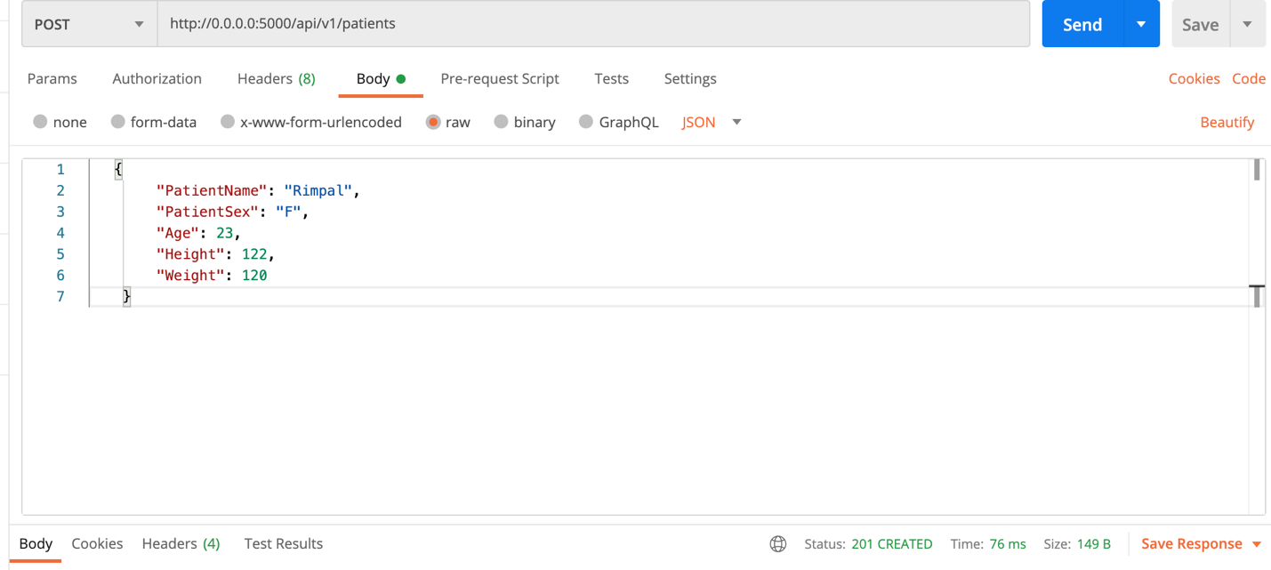

Get request to see if the data is added.

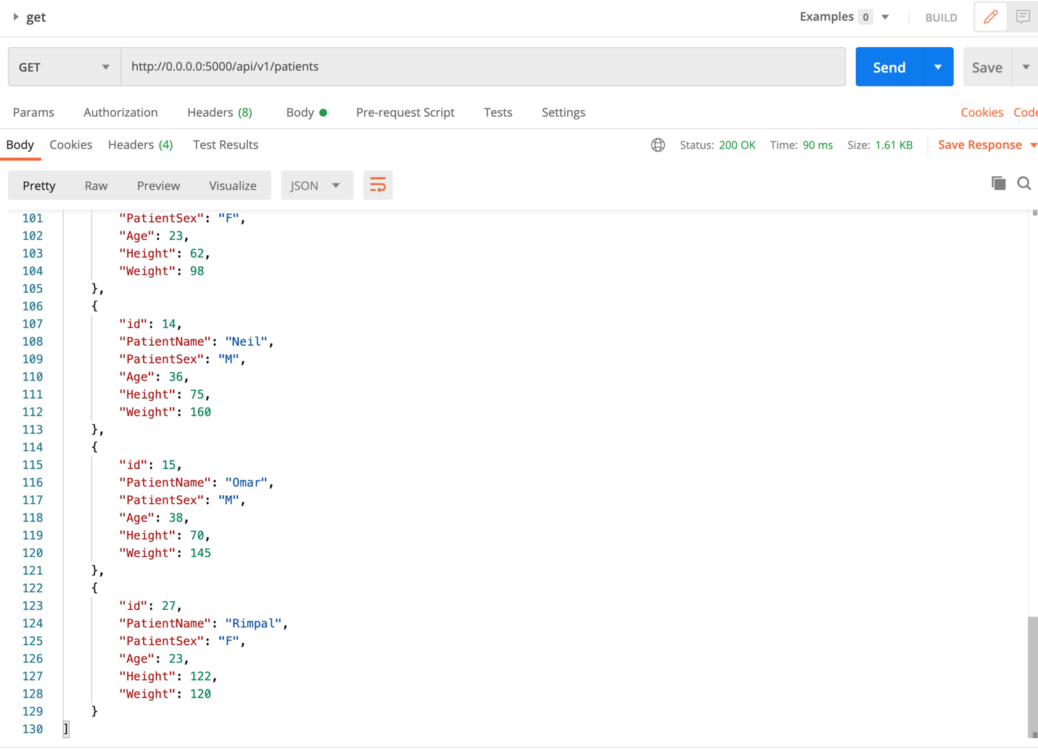

1. Put request to edit data on id: 9, updating weight to be 140 lbs.

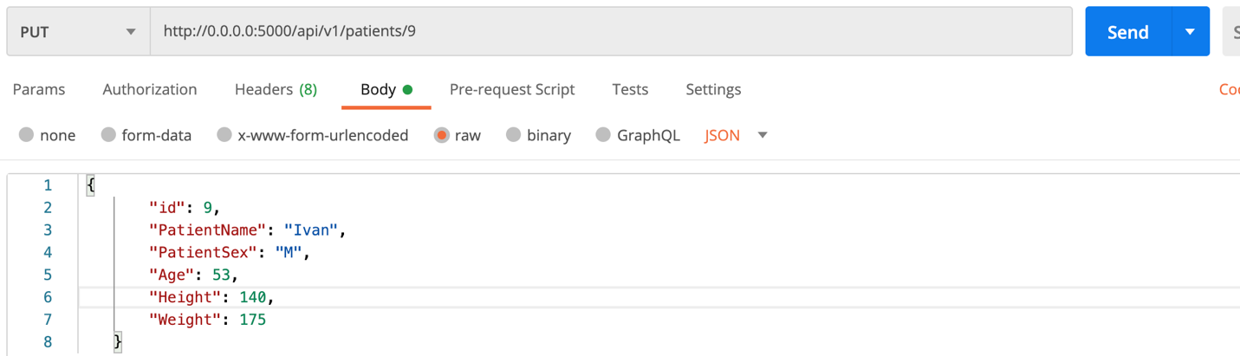

Get request to check updated data.

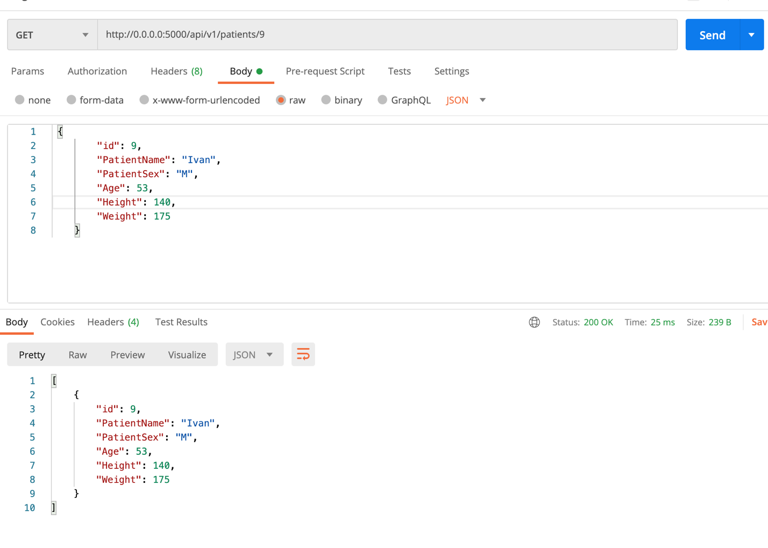

1. Deleting data on id: 15

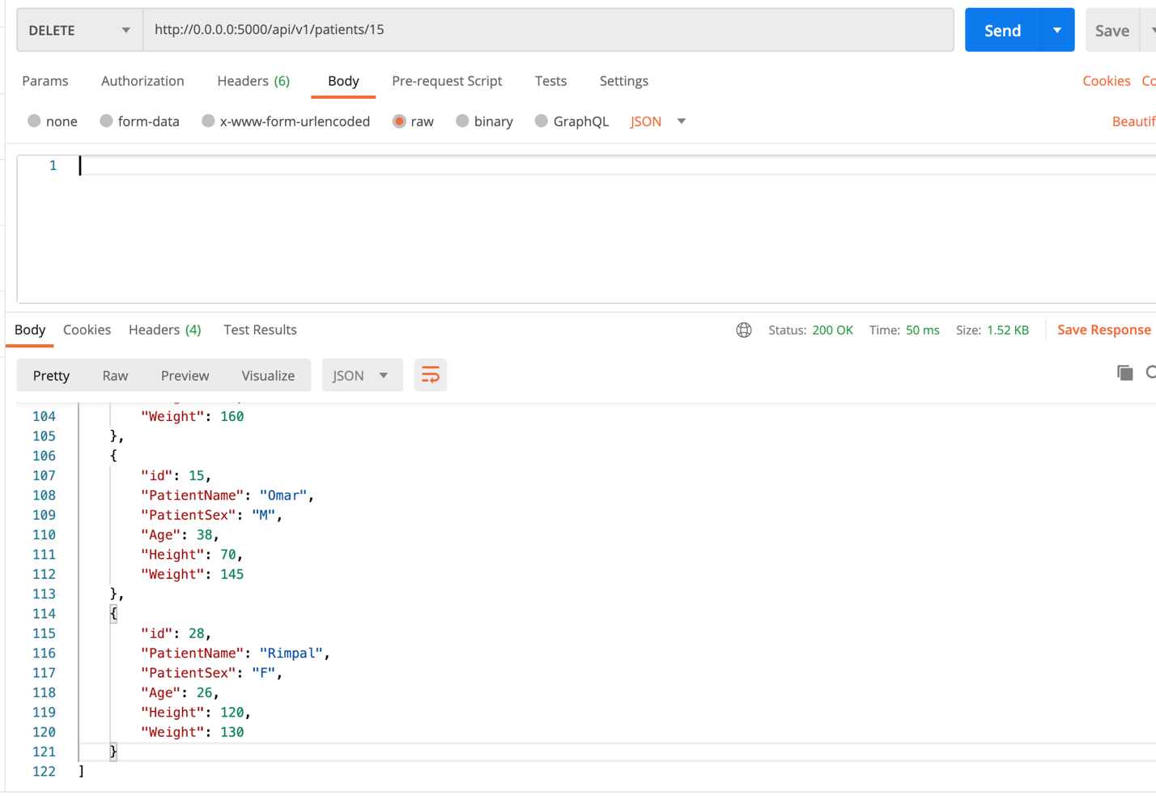

Get request to check if data at id: 15 is deleted.

