**Screenshots for the assignment 3**

[Github repo Link](https://github.com/rimpal1/WebFormsPython)

1. Below screenshot shows the data table in pycharm.

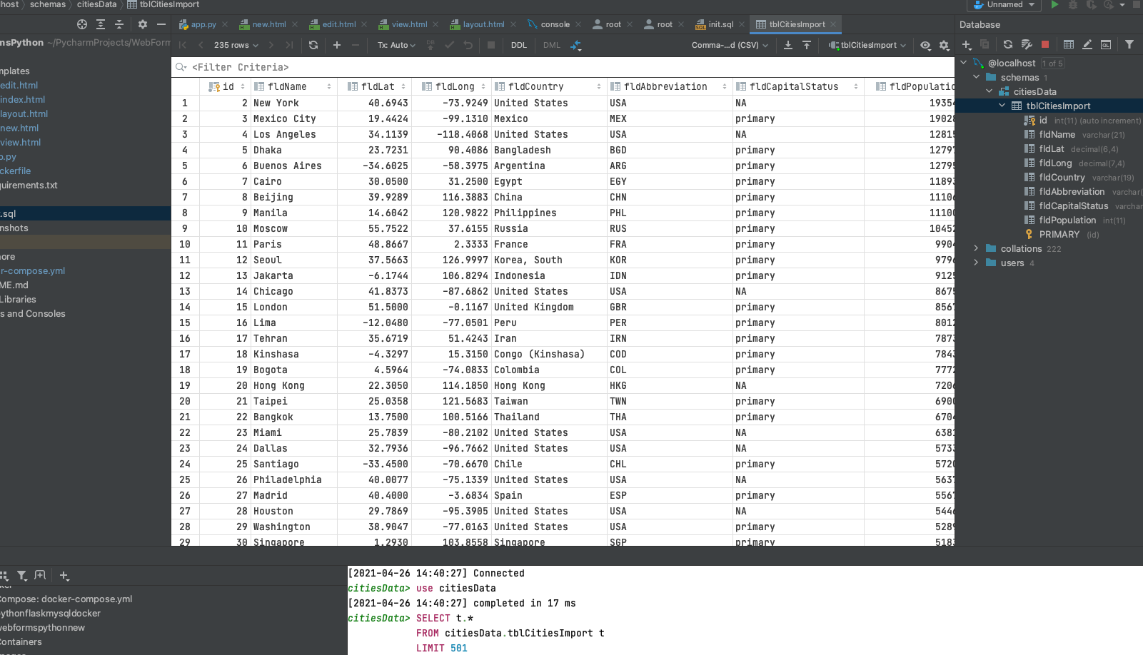

1. Below is the homepage of the website.

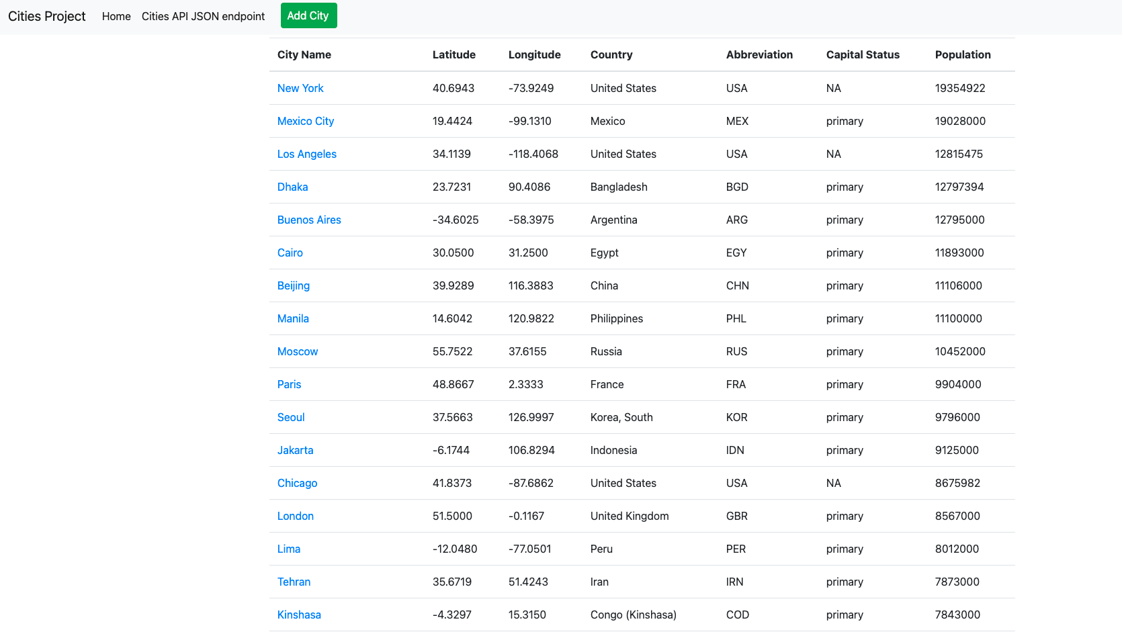

Homepage of the website

1. Below is adding a city to the data. I’m using alert to let the user know that the city has been added to the list.

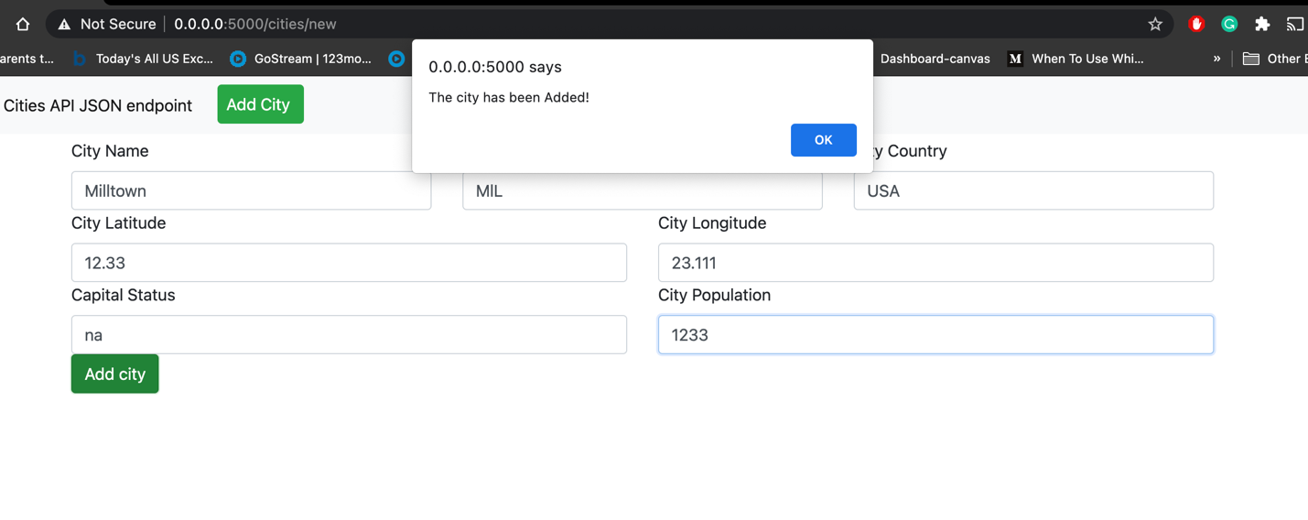

1. Below shows the city has been added into the list.

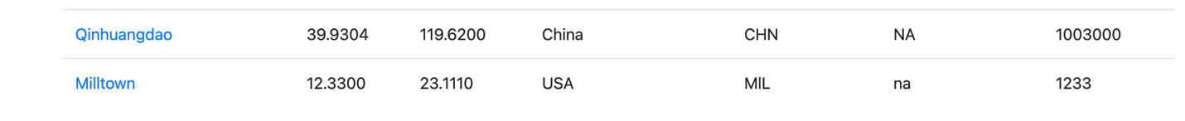

1. Below screenshot shows edit page of a city. I’m using alert to let the user know that the city has been updated.

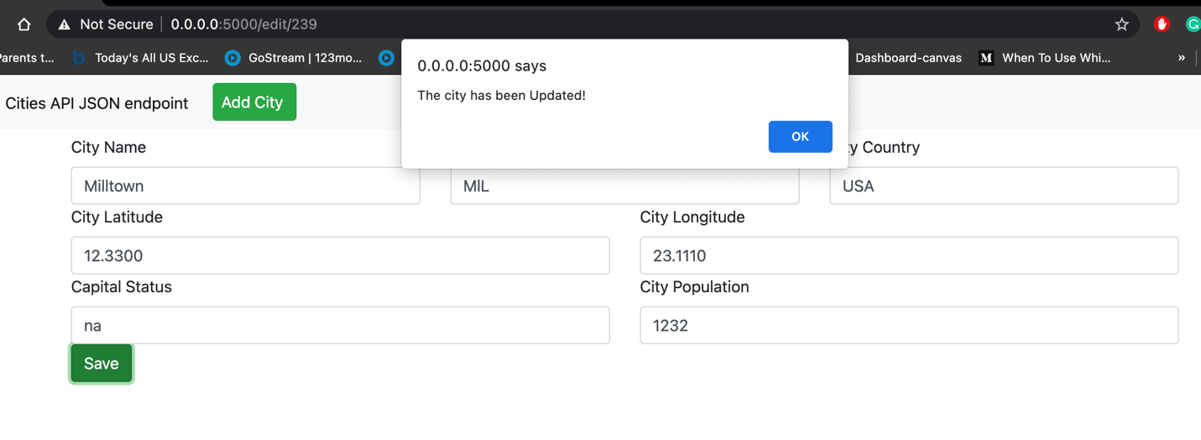

1. Below image shows the added city has been deleted from the list. I’m using alert to let the user know that the selected city has been deleted.

