

Background

RS Enterprises is a fast growing Electronics company. However, due to a paper-based filing system, maintaining customer information and Products details can be time-consuming and a lot of duplication occurs across the business. Also, creating reports to gain valuable insights into the performance of the business has often been inaccurate leading to suboptimal decision-making.

They need Database Design for the company to automate the business and establish a Web presence

Scope

1. Buying products will be easier for customers from various countries.
2. Order can be tracked easily.
3. It will be no longer time consuming to make reports.
4. There will be no duplication occurs.
5. Employee can easily contact to any branch or customer and same for customers as well.
6. Easier for customers to know about the products in stock or not.

Business Rules & Their Implementation

1. Every order must be associated with a valid product. This will prevent invalid orders being entered into the Database.
2. Order date should be prior to shipping date.
3. Payment must be associate with one and only one order. Though customer can order many products in one order.
4. Employees can check the customer placed orders from any branch.

ERD Diagram

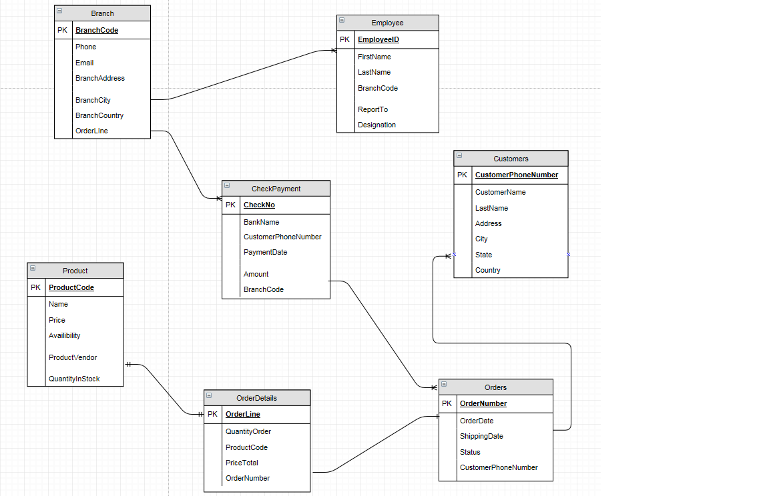

3NF Relational Schema

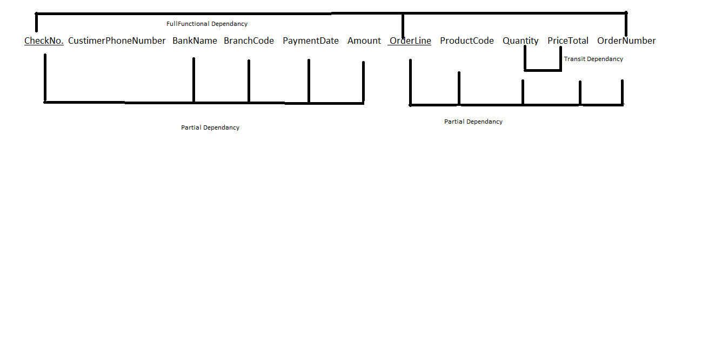

2NF

OrderDetail CheckNo. OrderLine OrderNumber

Payments CheckNo. BankName BranchCode PaymentDate Amount

Product OrderLine ProductCode Quantity PriceTotal OrderNumber

3NF

OrderDetail CheckNo. OrderLine OrderNumber

Product OrderLine ProductCode OrderNumber Quantity PriceTotal

Payments CheckNo. BankName BranchCode PaymentDate Amount

TotalAmount Quantity PriceTotal

Strength & Weakness

* Significant advances in automation and standardization of business.
* Data can be stored externally and backup in a secure place to prevent data loss.
* Front-end software can provide tip text and enforce data integrity, the back-end data can therefore become more standardized and accurate.
* Data is electronic, it can allow for quicker processing of typical transaction

The drawback is less functionality and performance issues when networked, especially with multiple users, not enough to cause problems for 2/3 users but will be unusable at 200 users at same time.