Iris Flower Classification
Task 1 — CodeAlpha Data Science Internship
A Machine Learning Classification Project

1. Project Overview
This project addresses Task 1 of the CodeAlpha Data Science Internship: classifying Iris flowers into three species — Setosa, Versicolor, and Virginica — using their sepal and petal measurements. The goal is to build, evaluate, and compare multiple machine learning classification models to identify the best-performing approach.

Objectives
- Load and explore the Iris dataset (150 samples, 4 features, 3 species)
- Perform exploratory data analysis (EDA) to understand feature relationships
- Preprocess data with train/test split and feature standardization
- Train and compare five classification algorithms
- Evaluate models using accuracy, precision, recall, and F1-score
- Identify the best-performing model

Tools & Libraries
- Python 3
- Pandas & NumPy — data handling
- Matplotlib & Seaborn — visualization
- Scikit-learn — modeling and evaluation

2. Dataset
The classic Iris dataset was used, loaded directly via sklearn.datasets.load_iris(), containing 150 samples evenly split across three species (50 each), with four numeric features: sepal length, sepal width, petal length, and petal width (all in centimeters). The dataset contained no missing values.
Property | Value
Samples | 150
Features | 4 (sepal length/width, petal length/width)
Classes | 3 (Setosa, Versicolor, Virginica)
Missing values | None

3. Exploratory Data Analysis
Several visualizations were generated to understand the relationships between features and species before modeling.

3.1 Pairwise Feature Relationships
The pairplot below shows how each pair of features relates across species. Setosa (one color) is clearly separated from the other two species in nearly every feature pairing, while Versicolor and Virginica show some overlap, especially in sepal measurements.
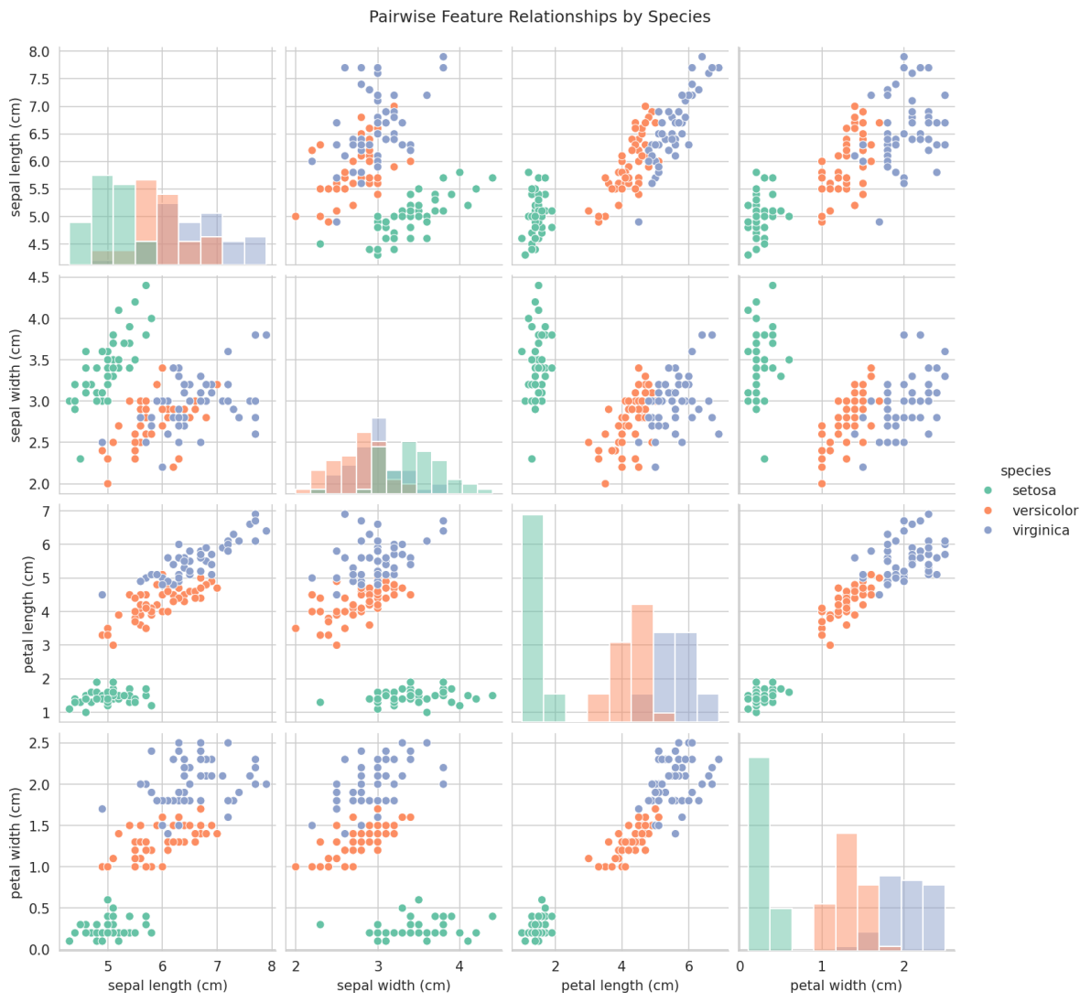
Figure 1: Pairwise relationships between features, colored by species.

3.2 Feature Correlation
The heatmap below shows strong positive correlation between petal length and petal width, suggesting these two features carry similar — and highly discriminative — information for classification.
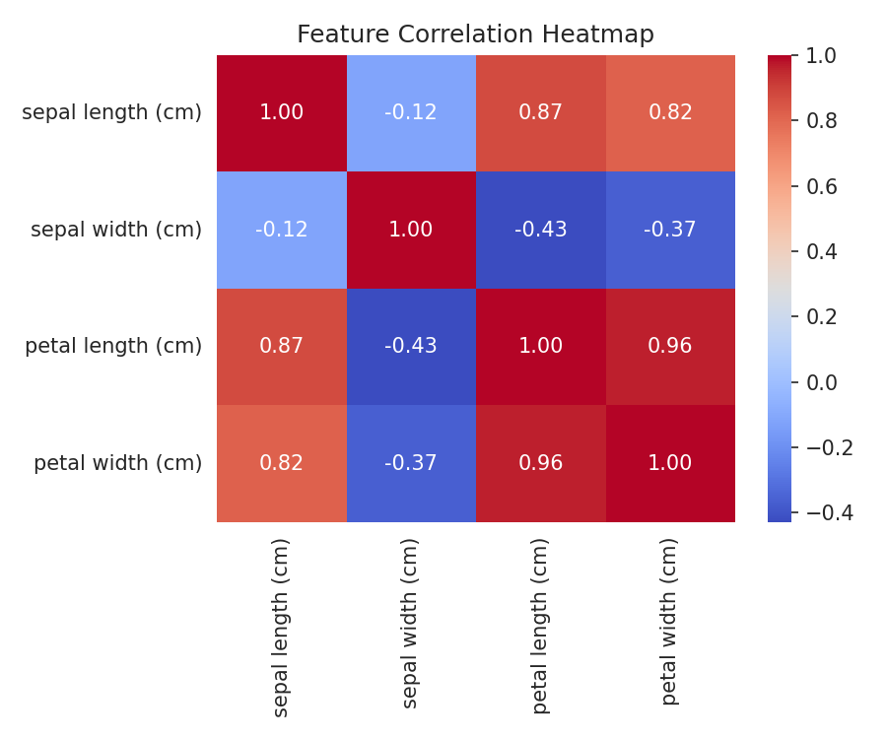
Figure 2: Correlation heatmap of the four numeric features.

3.3 Feature Distributions by Species
Boxplots confirm that petal length and petal width separate the three species most cleanly, while sepal width shows the most overlap between classes.
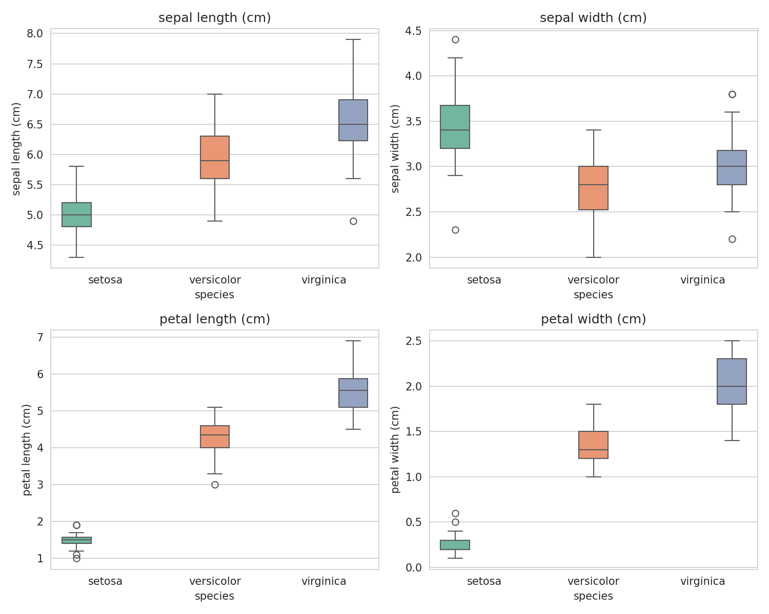
Figure 3: Distribution of each feature across the three species.

4. Data Preprocessing
- Split the data into 80% training and 20% testing sets, stratified by species to preserve class balance
- Standardized features using StandardScaler (zero mean, unit variance) so that no single feature dominates distance-based models like KNN and SVM

5. Model Training & Evaluation
Five classification algorithms were trained on the same preprocessed data and evaluated on the held-out test set:
- Logistic Regression
- K-Nearest Neighbors (k = 5)
- Decision Tree
- Support Vector Machine (linear kernel)
- Random Forest (100 trees)

5.1 Accuracy Comparison
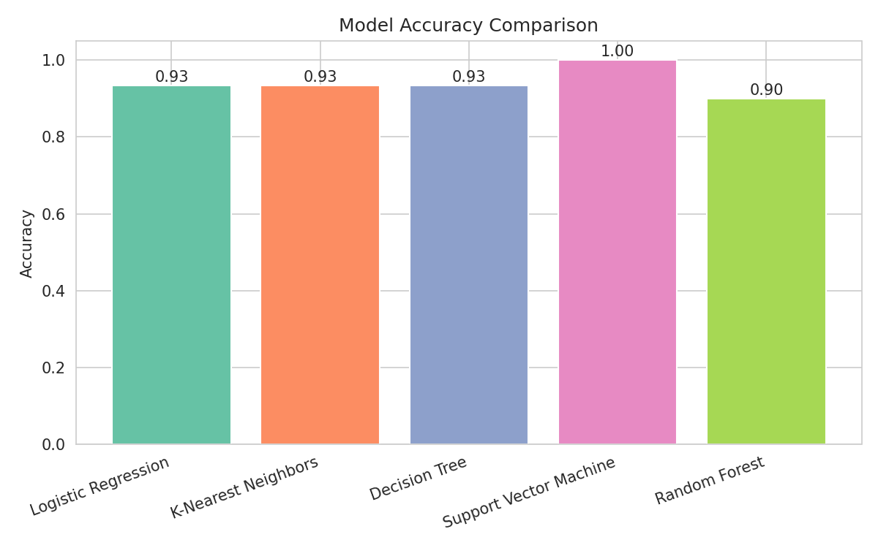
Figure 4: Test accuracy of all five models.
Model | Test Accuracy
Logistic Regression | 93.3%
K-Nearest Neighbors | 93.3%
Decision Tree | 93.3%
Support Vector Machine | 100.0%
Random Forest | 90.0%

5.2 Best Model: Confusion Matrix
The Support Vector Machine achieved perfect classification on the test set. Its confusion matrix below shows zero misclassifications across all three species.
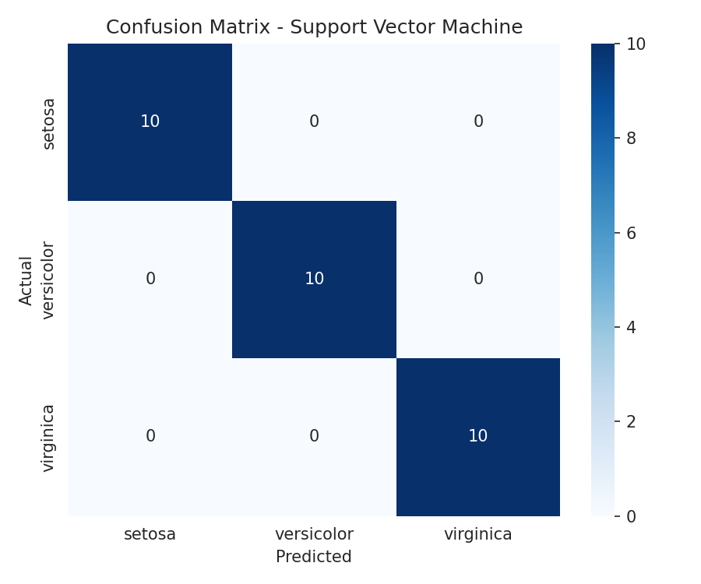
Figure 5: Confusion matrix for the Support Vector Machine (best model).

5.3 Feature Importance
Using the Random Forest model to assess feature importance, petal length and petal width emerged as by far the most informative features for distinguishing species — consistent with the EDA observations.
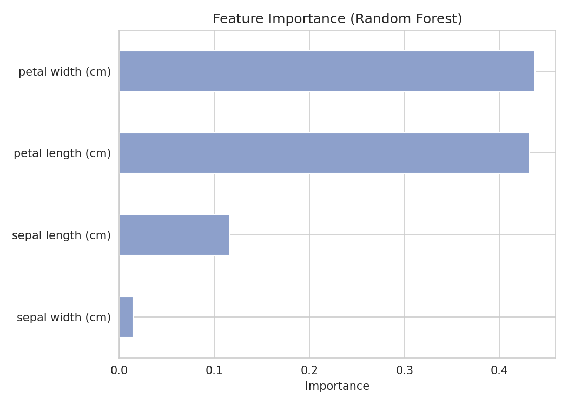
Figure 6: Random Forest feature importance scores.

6. Conclusion & Key Learnings
- The Support Vector Machine (linear kernel) achieved 100% accuracy on the test set, outperforming all other models
- Petal length and petal width are the most discriminative features for species classification
- Setosa is linearly separable from the other two species; most model confusion (where it occurs) happens between Versicolor and Virginica
- Simple, well-tuned models can outperform more complex ones on small, well-separated datasets like Iris

7. Source Code
Full Python script (iris_classification.py) used to perform the analysis, train the models, and generate all figures in this report:
"""
CodeAlpha Data Science Internship - Task 1
Iris Flower Classification

This script:
1. Loads the Iris dataset
2. Performs exploratory data analysis (EDA)
3. Preprocesses the data
4. Trains multiple classification models
5. Evaluates and compares model performance
6. Saves visualizations
"""

import pandas as pd
import numpy as np
import matplotlib.pyplot as plt
import seaborn as sns
from sklearn.datasets import load_iris
from sklearn.model_selection import train_test_split
from sklearn.preprocessing import StandardScaler
from sklearn.linear_model import LogisticRegression
from sklearn.neighbors import KNeighborsClassifier
from sklearn.tree import DecisionTreeClassifier
from sklearn.svm import SVC
from sklearn.ensemble import RandomForestClassifier
from sklearn.metrics import (
accuracy_score,
classification_report,
confusion_matrix,
)

sns.set_style("whitegrid")
RANDOM_STATE = 42

# ---------------------------------------------------------------------
# 1. Load the dataset
# ---------------------------------------------------------------------
iris = load_iris()
df = pd.DataFrame(data=iris.data, columns=iris.feature_names)
df["species"] = pd.Categorical.from_codes(iris.target, iris.target_names)

print("=" * 60)
print("DATASET OVERVIEW")
print("=" * 60)
print(df.head())
print("\nShape:", df.shape)
print("\nClass distribution:\n", df["species"].value_counts())
print("\nMissing values:\n", df.isnull().sum())
print("\nSummary statistics:\n", df.describe())

# ---------------------------------------------------------------------
# 2. Exploratory Data Analysis (EDA)
# ---------------------------------------------------------------------

# Pairplot showing relationships between features by species
pairplot = sns.pairplot(df, hue="species", diag_kind="hist", palette="Set2")
pairplot.fig.suptitle("Pairwise Feature Relationships by Species", y=1.02)
pairplot.savefig("outputs/pairplot.png", dpi=150, bbox_inches="tight")
plt.close()

# Correlation heatmap
plt.figure(figsize=(6, 5))
sns.heatmap(df.drop(columns="species").corr(), annot=True, cmap="coolwarm", fmt=".2f")
plt.title("Feature Correlation Heatmap")
plt.tight_layout()
plt.savefig("outputs/correlation_heatmap.png", dpi=150)
plt.close()

# Boxplots of each feature by species
fig, axes = plt.subplots(2, 2, figsize=(10, 8))
features = iris.feature_names
for ax, feature in zip(axes.flatten(), features):
sns.boxplot(data=df, x="species", y=feature, hue="species", palette="Set2", ax=ax, legend=False)
ax.set_title(feature)
plt.tight_layout()
plt.savefig("outputs/boxplots_by_species.png", dpi=150)
plt.close()

print("\nEDA plots saved to outputs/ folder.")

# ---------------------------------------------------------------------
# 3. Preprocessing
# ---------------------------------------------------------------------
X = df[iris.feature_names]
y = df["species"]

X_train, X_test, y_train, y_test = train_test_split(
X, y, test_size=0.2, random_state=RANDOM_STATE, stratify=y
)

scaler = StandardScaler()
X_train_scaled = scaler.fit_transform(X_train)
X_test_scaled = scaler.transform(X_test)

# ---------------------------------------------------------------------
# 4. Train multiple models and compare
# ---------------------------------------------------------------------
models = {
"Logistic Regression": LogisticRegression(max_iter=200),
"K-Nearest Neighbors": KNeighborsClassifier(n_neighbors=5),
"Decision Tree": DecisionTreeClassifier(random_state=RANDOM_STATE),
"Support Vector Machine": SVC(kernel="linear"),
"Random Forest": RandomForestClassifier(n_estimators=100, random_state=RANDOM_STATE),
}

results = {}
print("\n" + "=" * 60)
print("MODEL TRAINING & EVALUATION")
print("=" * 60)

for name, model in models.items():
model.fit(X_train_scaled, y_train)
y_pred = model.predict(X_test_scaled)
acc = accuracy_score(y_test, y_pred)
results[name] = acc
print(f"\n--- {name} ---")
print(f"Accuracy: {acc:.4f}")
print(classification_report(y_test, y_pred))

# ---------------------------------------------------------------------
# 5. Identify and visualize the best model
# ---------------------------------------------------------------------
best_model_name = max(results, key=results.get)
best_model = models[best_model_name]
print("\n" + "=" * 60)
print(f"BEST MODEL: {best_model_name} (Accuracy: {results[best_model_name]:.4f})")
print("=" * 60)

# Accuracy comparison bar chart
plt.figure(figsize=(8, 5))
bars = plt.bar(results.keys(), results.values(), color=sns.color_palette("Set2"))
plt.ylabel("Accuracy")
plt.title("Model Accuracy Comparison")
plt.ylim(0, 1.05)
plt.xticks(rotation=20, ha="right")
for bar, acc in zip(bars, results.values()):
plt.text(bar.get_x() + bar.get_width() / 2, acc + 0.01, f"{acc:.2f}", ha="center")
plt.tight_layout()
plt.savefig("outputs/model_accuracy_comparison.png", dpi=150)
plt.close()

# Confusion matrix for the best model
y_pred_best = best_model.predict(X_test_scaled)
cm = confusion_matrix(y_test, y_pred_best)
plt.figure(figsize=(6, 5))
sns.heatmap(
cm, annot=True, fmt="d", cmap="Blues",
xticklabels=iris.target_names, yticklabels=iris.target_names
)
plt.xlabel("Predicted")
plt.ylabel("Actual")
plt.title(f"Confusion Matrix - {best_model_name}")
plt.tight_layout()
plt.savefig("outputs/confusion_matrix.png", dpi=150)
plt.close()

# Feature importance (if Random Forest is best, or just show it regardless)
if "Random Forest" in models:
rf = models["Random Forest"]
importances = pd.Series(rf.feature_importances_, index=iris.feature_names).sort_values()
plt.figure(figsize=(7, 5))
importances.plot(kind="barh", color=sns.color_palette("Set2")[2])
plt.title("Feature Importance (Random Forest)")
plt.xlabel("Importance")
plt.tight_layout()
plt.savefig("outputs/feature_importance.png", dpi=150)
plt.close()

print("\nAll plots saved to the outputs/ folder.")
print("Script completed successfully.")

