
CED-329 Advanced Web Engineering

LAB # 09

LAB Title

Exploring Rendering Methods in Next.js – SSR, SSG & CSR

Assessment of CLO: 03, PLO: 05

Student Name: | Rimsha Shaikh
Roll No. | 23fa-009-st
Semester |  | Session

S. No. | Perf. Level  Criteria | Excellent  (2.5) | Good  (2) | Satisfactory  (1.5) | Needs Improvement  (0 ~ 1) | Marks Obtained
1 | Project Execution & Implementation | Fully functional, optimized, and well-structured. | Minor errors, mostly functional. | Some errors, requires guidance. | Major errors, non-functional, or not Performed.
2 | Results & Debugging  Or Troubleshooting | Accurate results with effective debugging  Or Troubleshooting. | Mostly correct, some debugging Or Troubleshooting needed. | Partial results, minimal debugging  Or Troubleshooting. | Incorrect results, no debugging Or Troubleshooting, or not attempted.
3 | Problem-Solving & Adaptability  (VIVA) | Creative approach, efficiently solves challenges. | Adapts well, minor struggles. | Some adaptability, needs guidance. | Lacks innovation or no innovation, unable to solve problems.
4 | Report Quality & Documentation | Clear, structured, with detailed visuals. | Mostly clear, minor gaps. | Some clarity issues, missing details. | Poorly structured, lacks clarity, or not submitted.
Total Marks Obtained Out of 10

Experiment evaluated by
Instructor’s Name | Engr. Fizzah Sohail
Date |  | Signature

- Objective
To understand and implement Server-Side Rendering (SSR), Static Site Generation (SSG), and Client-Side Rendering (CSR) in Next.js. Differentiate between the three rendering strategies based on code behavior and use case.

Task 1: Set Up a Next.js Project
- Open a terminal and run:
npx create-next-app@latest rendering-lab
cd rendering-lab
npm run dev
- Open the project in VS Code.

Task 2: Implement SSR (Server-Side Rendering)
- Inside the /pages directory, create a file named ssr.js.
- Add the following code and explain each line as a comment in your own words:
- Visit: http://localhost:3000/ssr
- Refresh the page multiple times to observe new jokes fetched at request time.
// This function runs on the server before rendering the page
export async function getServerSideProps() {
const res = await fetch('https://official-joke-api.appspot.com/random_joke');
const joke = await res.json();

return {
props: {
joke, // Pass joke as a prop to the component
},
};
}

export default function SSRPage({ joke }) {
return (
<div>
<h1>Server-Side Rendering (SSR)</h1>
<p>{joke.setup}</p>
<p><strong>{joke.punchline}</strong></p>
</div>
);
}

Task 3: Implement SSG (Static Site Generation)
- Inside /pages, create ssg.js.
- Add this code:
- Visit http://localhost:3000/ssr in your browser to see the fetched data.
- Visit: http://localhost:3000/ssg
- Refresh and observe that the joke only changes when regeneration occurs.
export async function getStaticProps() {
const res = await fetch('https://official-joke-api.appspot.com/random_joke');
const joke = await res.json();

return {
props: {
joke,
},
revalidate: 10, // Optional: Regenerate page every 10 seconds
};
}

export default function SSGPage({ joke }) {
return (
<div>
<h1>Static Site Generation (SSG)</h1>
<p>{joke.setup}</p>
<p><strong>{joke.punchline}</strong></p>
</div>
);
}

Task 4: Implement CSR (Client-Side Rendering)
- Inside /pages, create csr.js.
- Add this code:
- Visit: http://localhost:3000/csr
- Note: Data loads after the page renders.
import { useEffect, useState } from "react";

export default function CSRPage() {
const [joke, setJoke] = useState(null);

useEffect(() => {
fetch("https://official-joke-api.appspot.com/random_joke")
.then((res) => res.json())
.then((data) => setJoke(data));
}, []);

return (
<div>
<h1>Client-Side Rendering (CSR)</h1>
{joke ? (
<>
<p>{joke.setup}</p>
<p><strong>{joke.punchline}</strong></p>
</>
) : (
<p>Loading...</p>
)}
</div>
);
}

Lab Assessment: Exploring Rendering Methods in Next.js
Objective:
To have an understanding of rendering methods in Next.js.

Instructions:
  - Push your code to a GitHub repository.
  - Include a README.md explaining the project.
  - Structure your commits properly (e.g., feat: added rendering methods).
  - Summarize the performance differences between SSR, CSR, and SSG.
  - Mention which method is best suited for what use case.

Task 1: Compare SSR, CSR, and SSG Performance
- Implement pages for all three methods.
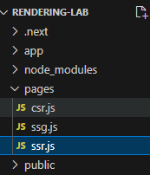
http://localhost:3000/csr
http://localhost:3000/ssr
http://localhost:3000/ssg

- Use Chrome DevTools Network Tab to observe loading times.
http://localhost:3000/csr
Code:
// useState stores the joke; useEffect runs code after rendering

export default function CSR() {
// Stores the joke; null means no joke has loaded yet
const [joke, setJoke] = useState(null);

// Stores any error if the API request fails
const [error, setError] = useState('');

// Runs in the browser after the component renders
useEffect(() => {
// Creates a function to fetch the joke
async function fetchJoke() {
try {
// Requests a joke from the API
const response = await fetch(
'https://official-joke-api.appspot.com/random_joke'
);

// Checks whether the request was successful
if (!response.ok) {
throw new Error('Could not fetch joke');
}

// Converts the response into JavaScript data
const data = await response.json();

// Saves the joke so React updates the page
setJoke(data);
} catch (err) {
// Shows a message if something goes wrong
setError('Unable to load the joke. Please try again.');
}
}

// Calls the function to fetch the joke
fetchJoke();
}, []); // Empty array means run the effect on initial mount

// Displays a message while the joke is loading
if (!joke && !error) {
return <p>Loading joke...</p>;
}

// Displays an error if the request failed
if (error) {
return <p>{error}</p>;
}

// Displays the joke after it has loaded
return (
<main style={{ padding: '30px', fontFamily: 'Arial' }}>
<h1>CSR - Client-Side Rendering</h1>
<h2>{joke.setup}</h2>
<p>{joke.punchline}</p>
<p>Joke ID: {joke.id}</p>
</main>
);
}

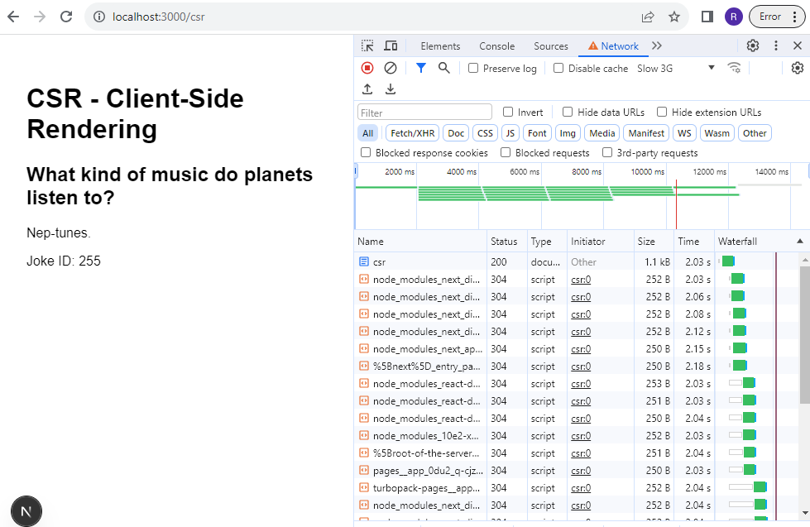
http://localhost:3000/ssr
code:
export default function SSR({ joke }) {
return (
<main>
<h1>SSR - Server-Side Rendering</h1>
<h2>{joke.setup}</h2>
<p>{joke.punchline}</p>
</main>
);
}

// Fetch a new joke whenever the page is requested
export async function getServerSideProps() {
const response = await fetch(
'https://official-joke-api.appspot.com/random_joke'
);

const joke = await response.json();

return {
props: { joke },
};
}

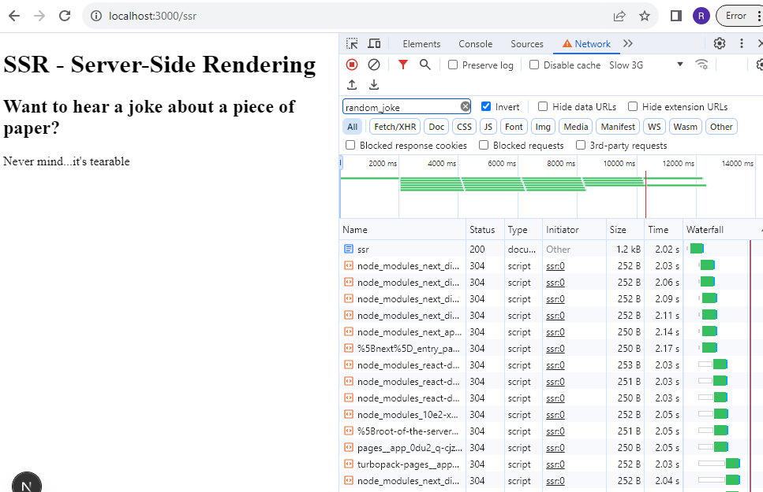
http://localhost:3000/ssg
import React from 'react'; // Imports React for the page component

export default function SSG({ joke }) { // Receives the joke as a prop
return ( // Starts the page content
<main style={{ padding: '30px', fontFamily: 'Arial' }}>
<h1>SSG - Static Site Generation</h1>
<h2>{joke.setup}</h2> {/* Displays the joke's beginning */}
<p>{joke.punchline}</p> {/* Displays the joke's ending */}
<p>Joke ID: {joke.id}</p> {/* Displays the joke ID */}
</main>
);
}

// Fetches data when the page is built and when it is regenerated
export async function getStaticProps() {
// Requests a joke from the API
const response = await fetch(
'https://official-joke-api.appspot.com/random_joke'
);

// Converts the response into JavaScript data
const joke = await response.json();

// Supplies the joke to the page and allows regeneration after 10 seconds
return {
props: { joke },
revalidate: 10,
};
}

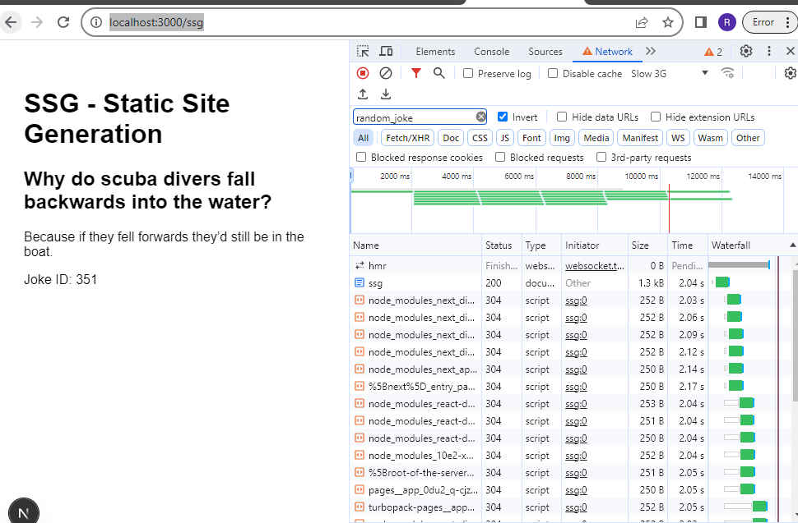

- Record your findings in a short report.

