AIPP LAB TEST-1
SET -3
NAME :Rimsha Mujeeb ROLLNO.: 2503B05138
BATCH :M.Tech(CSE)
_____________________________________________________________________________________________
Q1. Implement a Python class for a stack data structure (`push`, `pop`, `peek`). Use GitHub Copilot to generate code, test its handling of edge cases, and explain any improvements made.
PROMPT:
#Write a Python class named Stack that implements a stack data structure with the methods push(), pop(), and peek().
#Use a Python list internally.
# The Stack function must also implement error handling for empty stack operations.
#Read the input from user and generate the output
CODE:
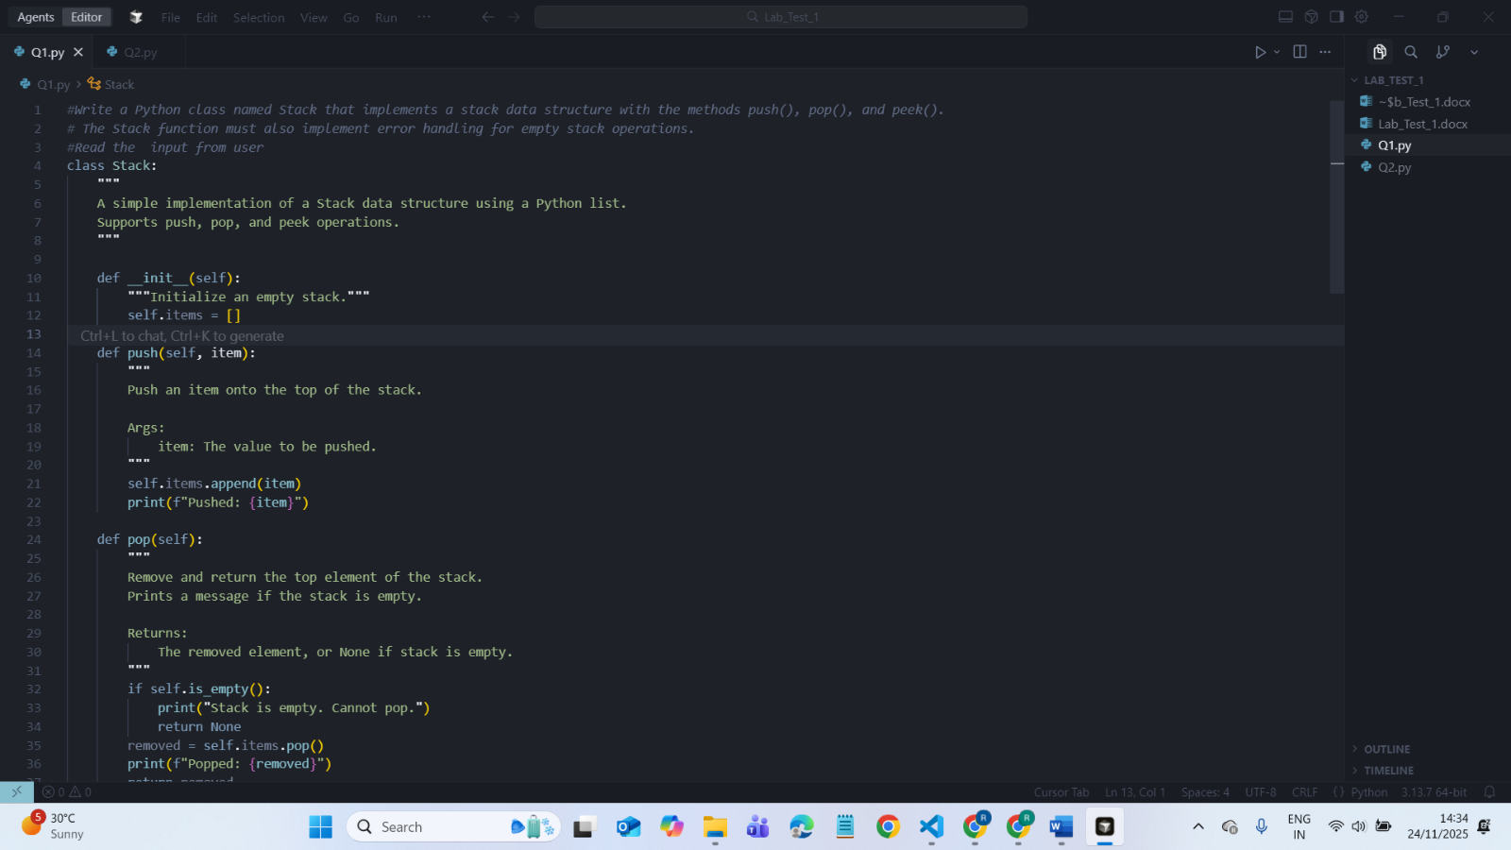
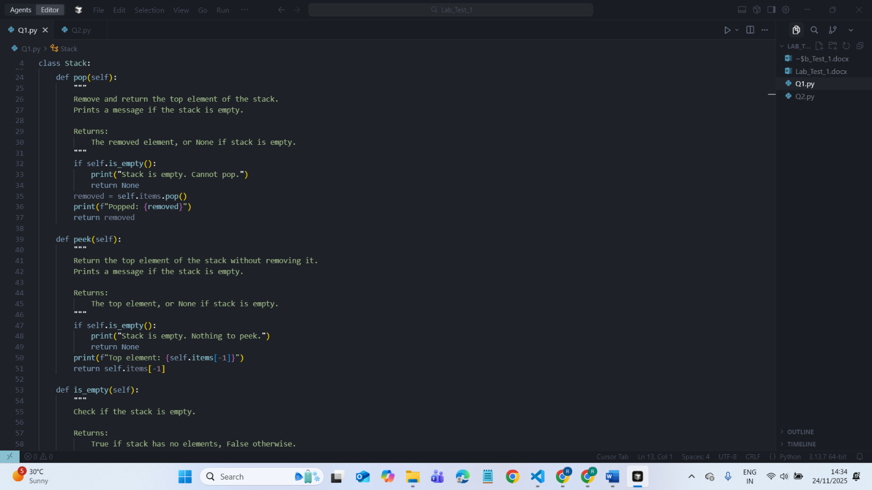
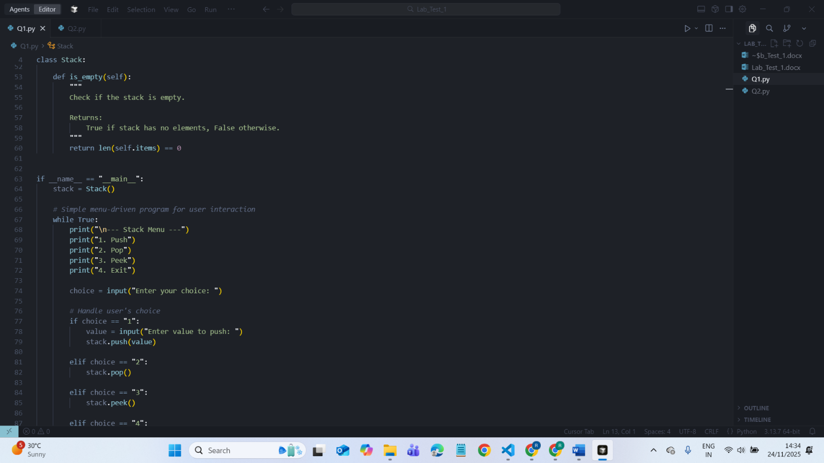
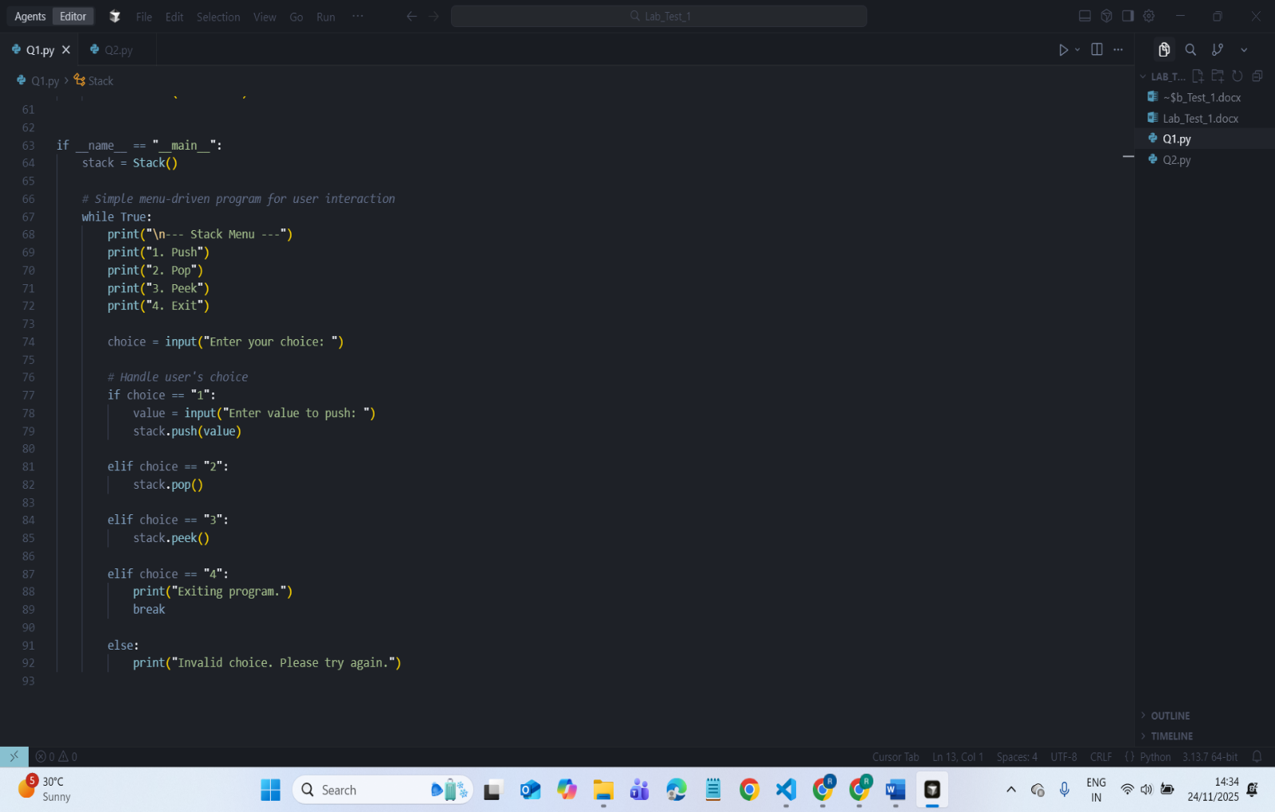
OUTPUT:

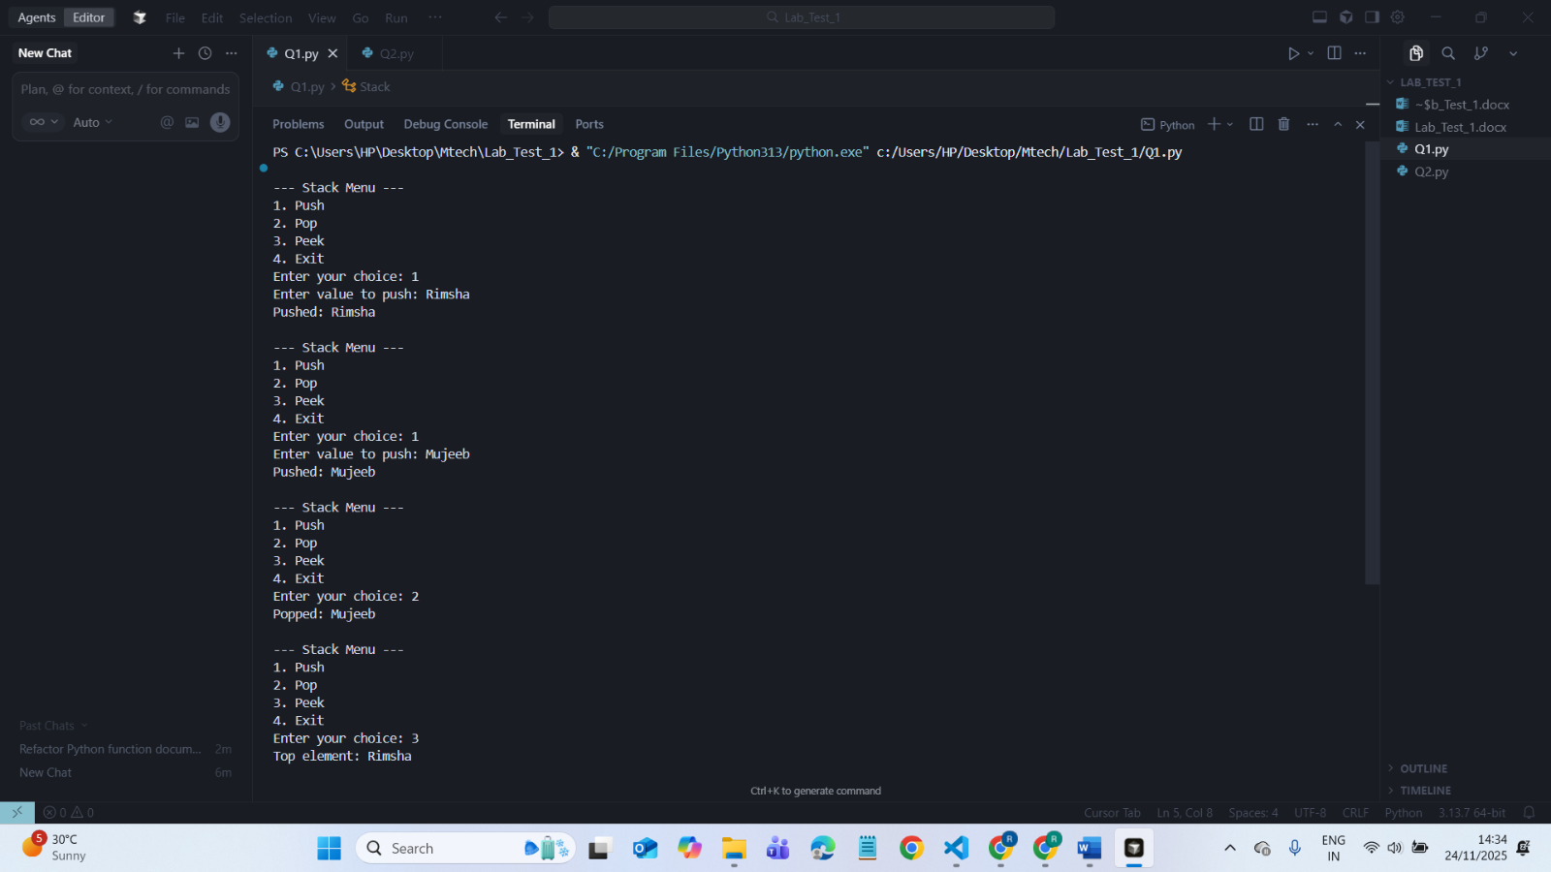
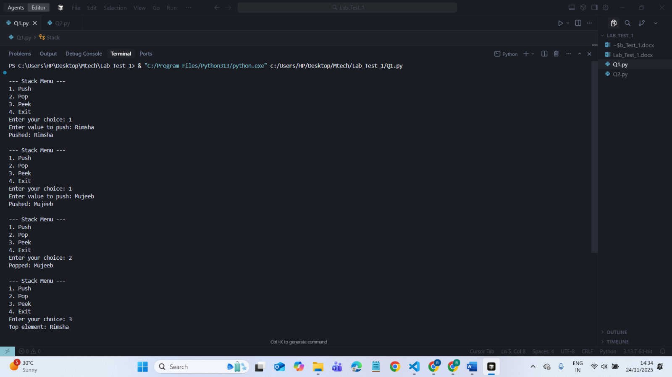
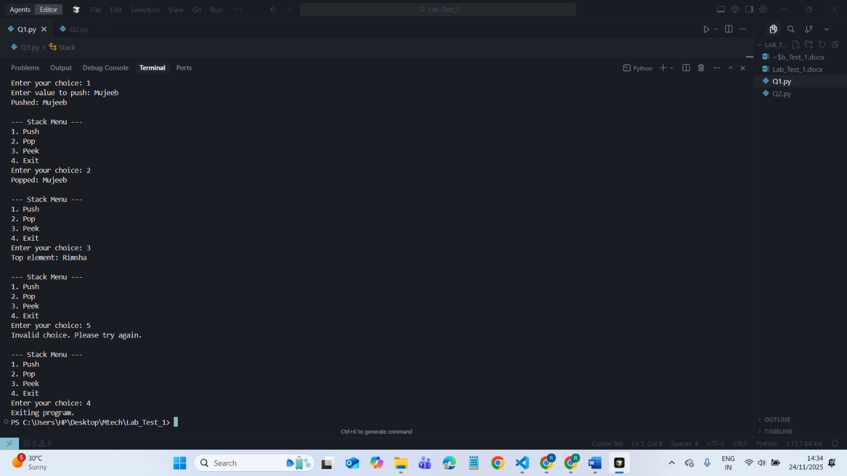
Explanation on improvements:
The code was generated using Cursor AI, and I improved it asking cursor AI to add proper documentation and clearer structure. I included detailed docstrings for each method so the purpose of the functions is easy to follow. Error handling was told to add to cursor AI for empty stack operations to prevent the program from failing when pop or peek is used on an empty stack. Clear print messages were included for push, pop, and peek operations to make the output more understandable. Overall, these updates make the Cursor-AI-generated code easier to use, safer, and more organized.

Q2. Refactor a poorly commented Python function using an AI assistant for automatic documentation. Evaluate clarity and completeness versus manual comments.

PROMPT:
Click Ctrl+I and give the following prompt:
#write a poorly commented python function to calculate the factorial of a number
GIVEN BELOW POORLY COMMENTED PYTHON FACTORIAL FUNCTION:

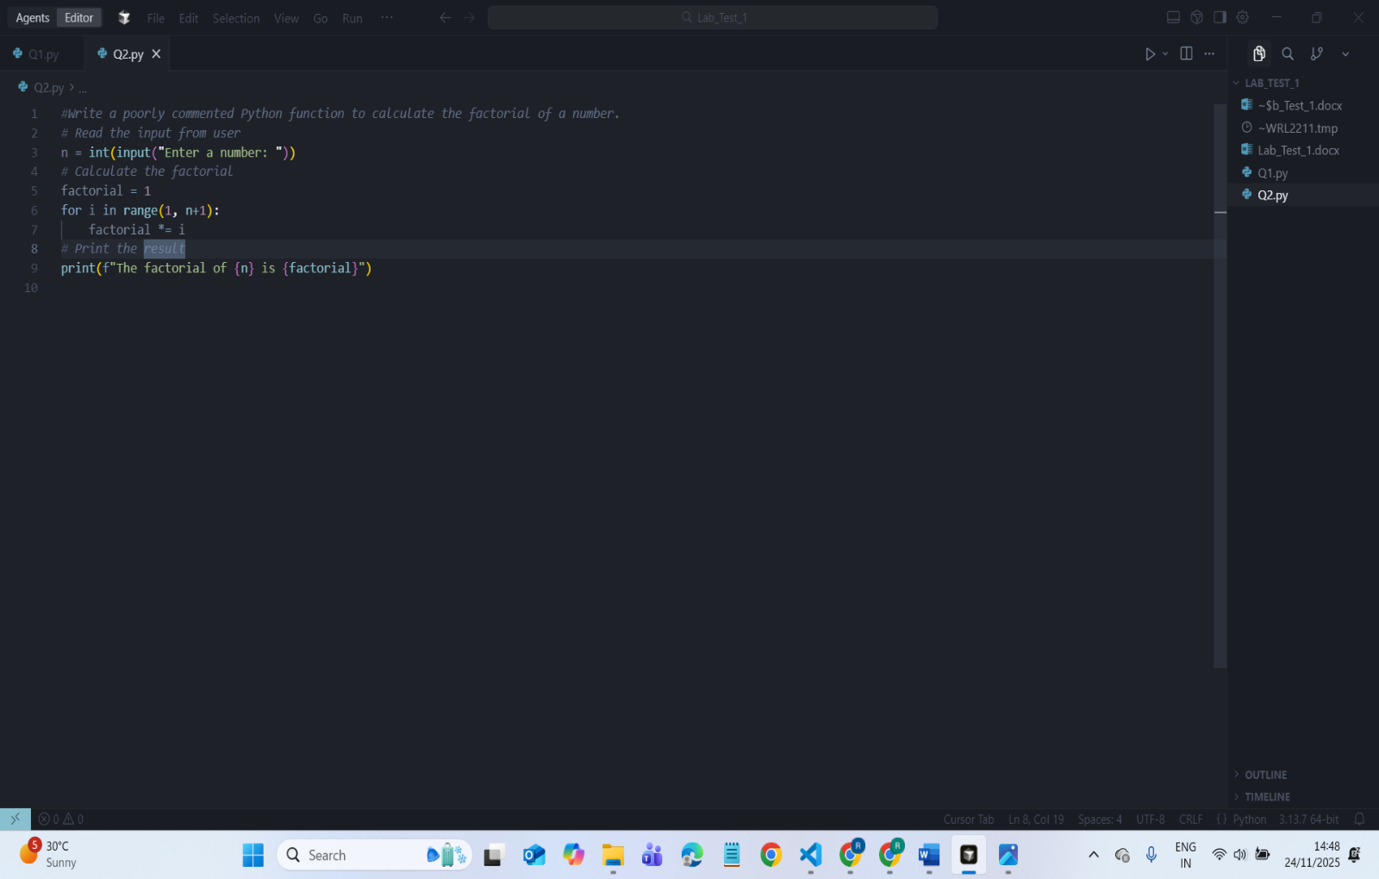

Select the code Click ctrl+k For editing and give the following prompt:
PROMPT:
#Refactor the following poorly commented Python function by improving variable names, adding complete docstrings, adding helpful inline comments, and fixing any missing error handling.
CODE SCREENSHOT GIVEN BELOW:
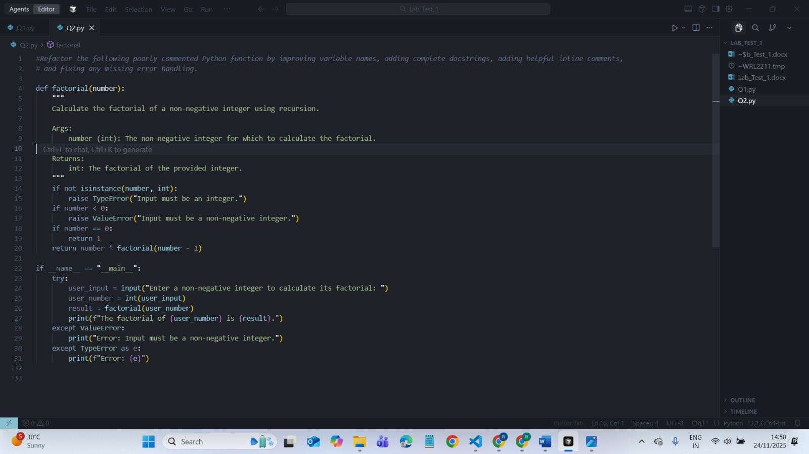
OUTPUT:
