SCHOOL OF COMPUTER SCIENCE AND ARTIFICIAL INTELLIGENCE |  |  |  |  | DEPARTMENT OF COMPUTER SCIENCE ENGINEERING
Program Name: M.Tech/MSC/MCA |  |  |  | Assignment Type: Lab |  |  | Academic Year:2025-2026
Course Coordinator Name |  |  |  | Venkataramana Veeramsetty
Course Code |  |  |  | Course Title |  | AI Assisted Problem Solving Using Python
AssignmentNumber:15.4(Present assignment number)/24(Total number of assignments)
 | Q.No. | Question
 | Q1.  Q2.  Q3.  Q4.  Q5. | Task 1: Connect to a Public API  - Instructions:  - Use Python (or Node.js/JavaScript) to connect to a public API (e.g., OpenWeatherMap or JSONPlaceholder).  - Send a simple GET request to retrieve data.  - Display the response in a readable format (pretty JSON).  - Expected Output:  - Program prints API response (e.g., weather data or posts from JSONPlaceholder).  - Output should be properly formatted JSON (not raw).  PROMPT:  #write a python function that display weather details of a city using weather api without error handling. Display weather details as JSON output.  CODE:  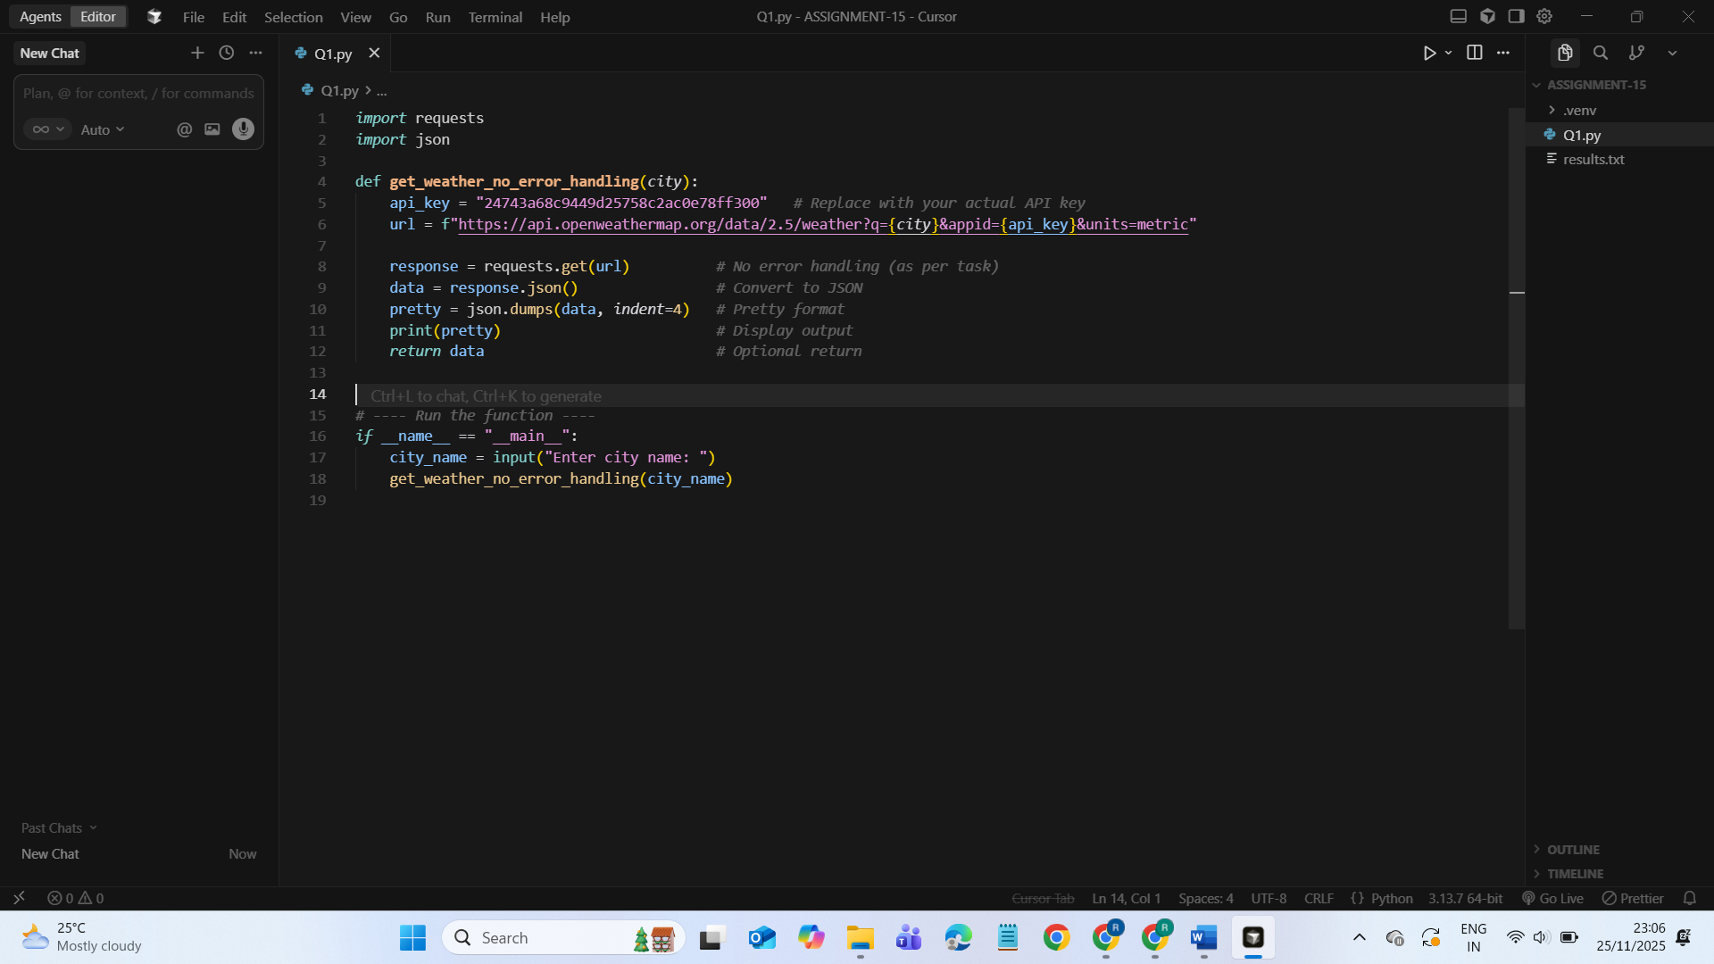  OUTPUT:  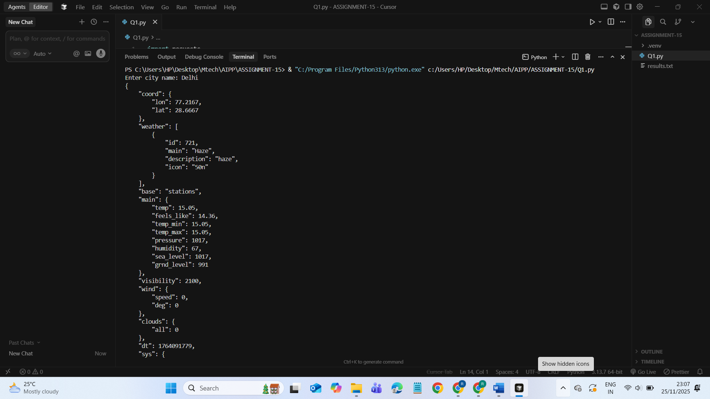  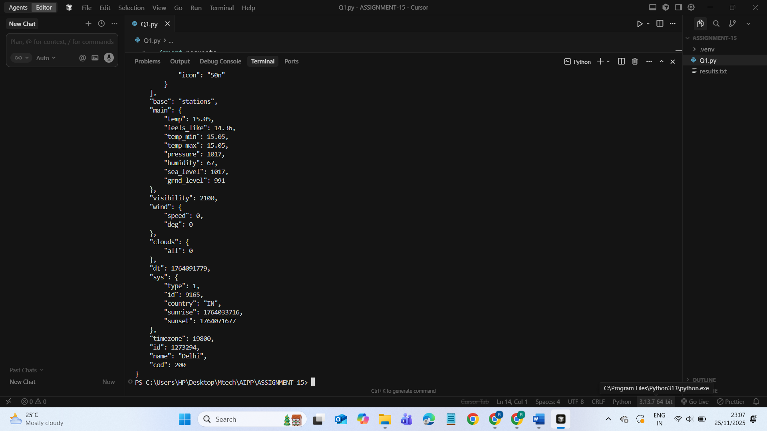  Task 2: Add Error Handling for Invalid API Calls  - Instructions:  - Modify your code from Task 1 to handle errors.  - Include try/except (Python) or try/catch (JavaScript) blocks.  - Handle cases like:  - Invalid URL  - Network timeout  - Wrong API key (if required)  - Print user-friendly error messages.  - Expected Output:  - If the API works, the result is shown as in Task 1.  - If there’s an error, output:  Error: Could not connect to API. Check your API key or network connection.  PROMPT:  #write a python function that display weather details of a city using weather api with error handling. Display weather details as JSON output  CODE:  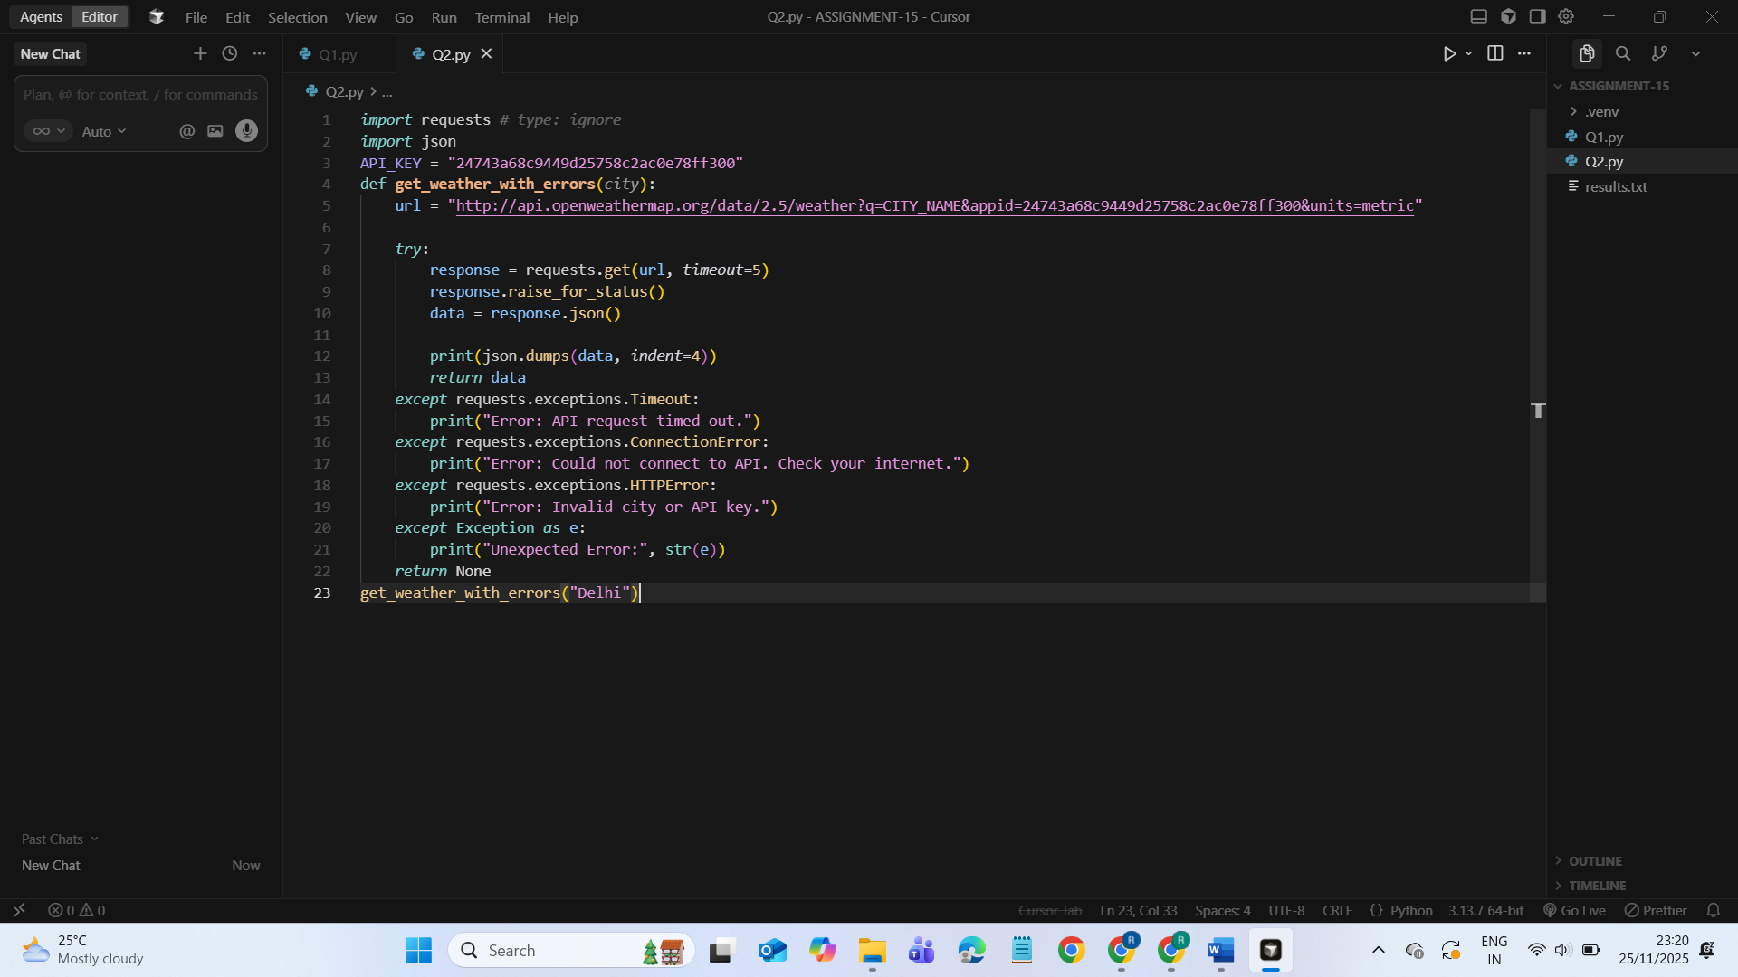  OUTPUT:  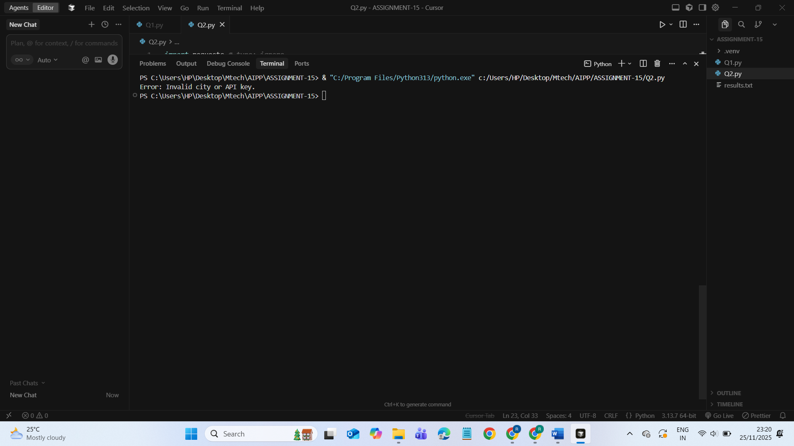  Task 3: Extract and Display Specific Data  - Instructions:  - From the API response (e.g., weather API), extract specific fields (temperature, humidity, description).  - Display them in a user-friendly format (not raw JSON).  PROMPT:  #Write a Python function that connects to the OpenWeatherMap API, retrieves weather data for a given city, and extracts only specific fields: temperature, humidity, and weather description. Display the output in a clean, user-friendly format (not raw JSON). Do not include error handling in this task.  CODE:  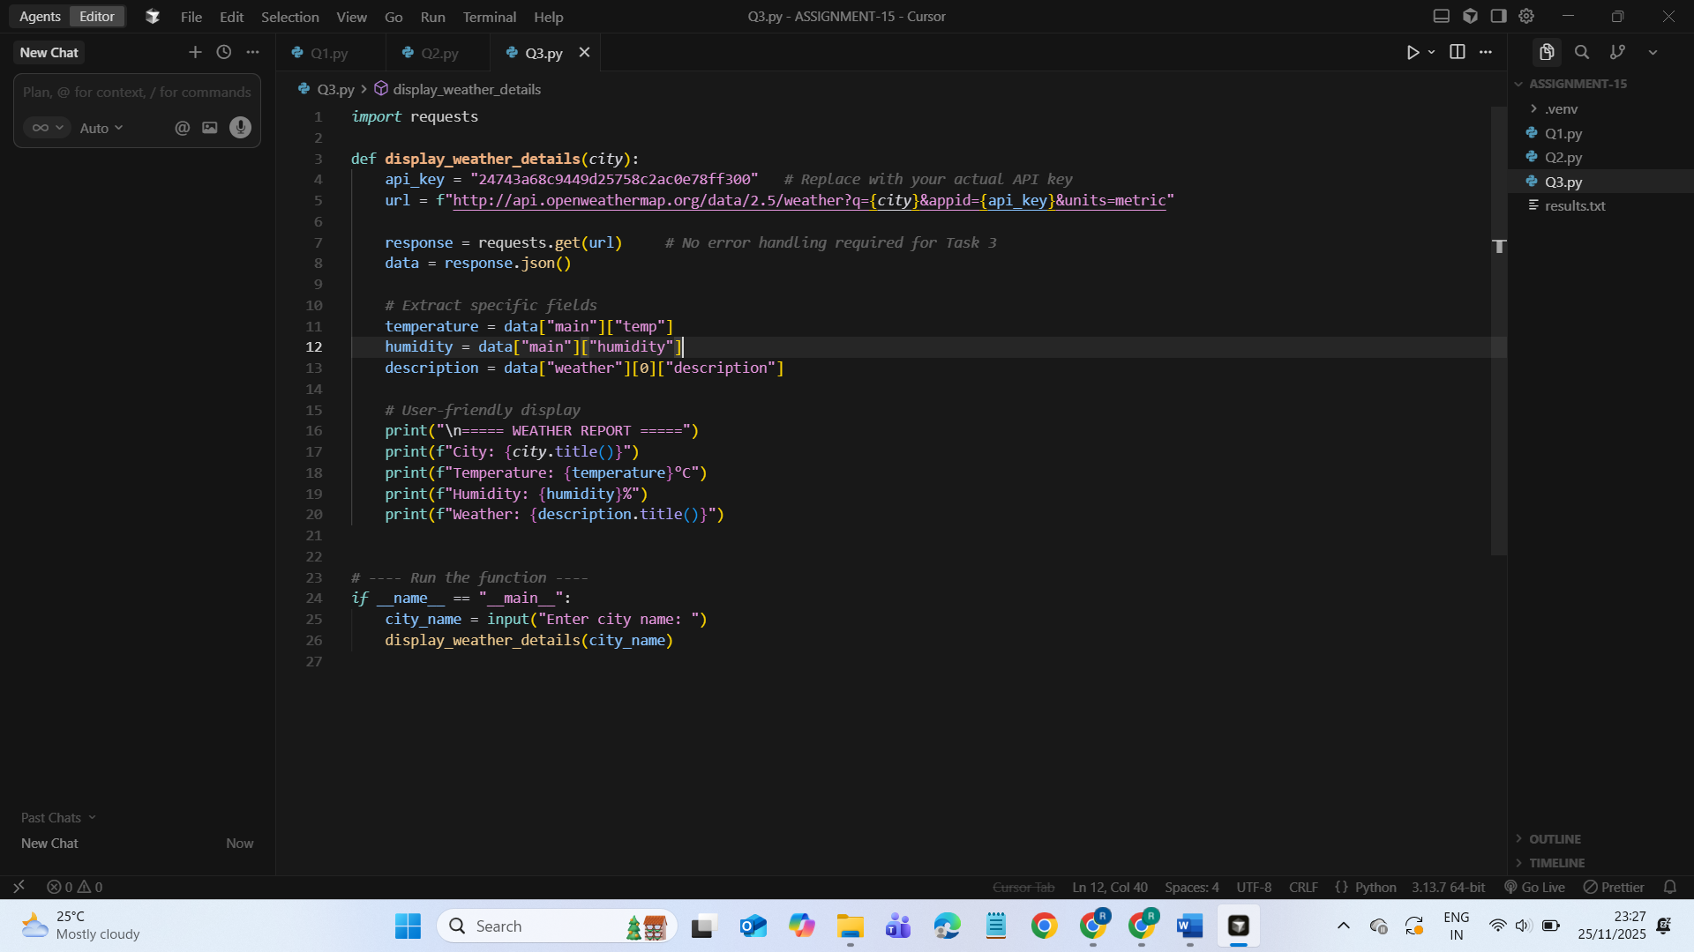  OUTPUT:  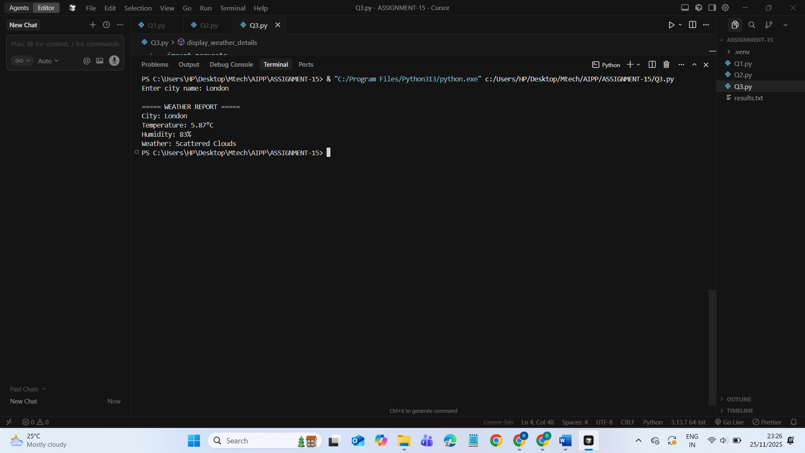  Task 4: Build a Function with Parameters  - Instructions:  - Write a function that accepts a parameter (e.g., city name for weather API).  - The function should call the API dynamically based on user input.  - Include error handling if the city is invalid.  - Expected Output:  - Input: "New York"  - Output:  - City: New York  - Temperature: 22°C  - Humidity: 55%  - Weather: Few clouds  - Input: "xyz123"  - Output:  Error: City not found. Please enter a valid city.  PROMPT:  # write a python function that display weather details of a city using weather api with error handling. Display weather details in user friendly format  CODE:  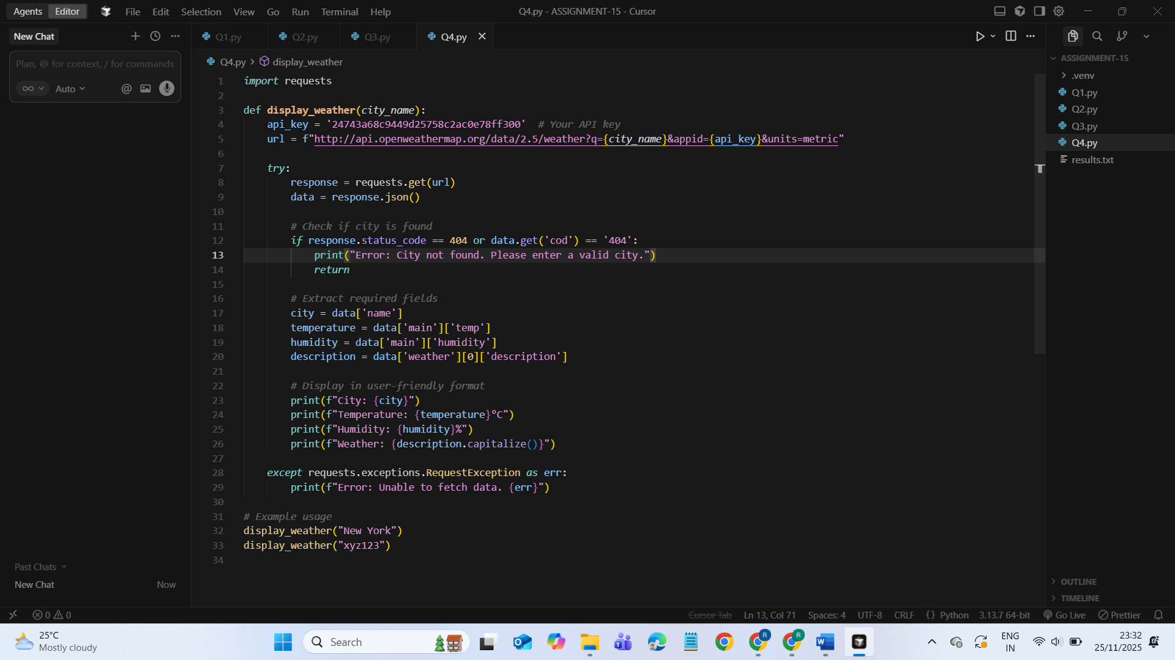  OUTPUT:  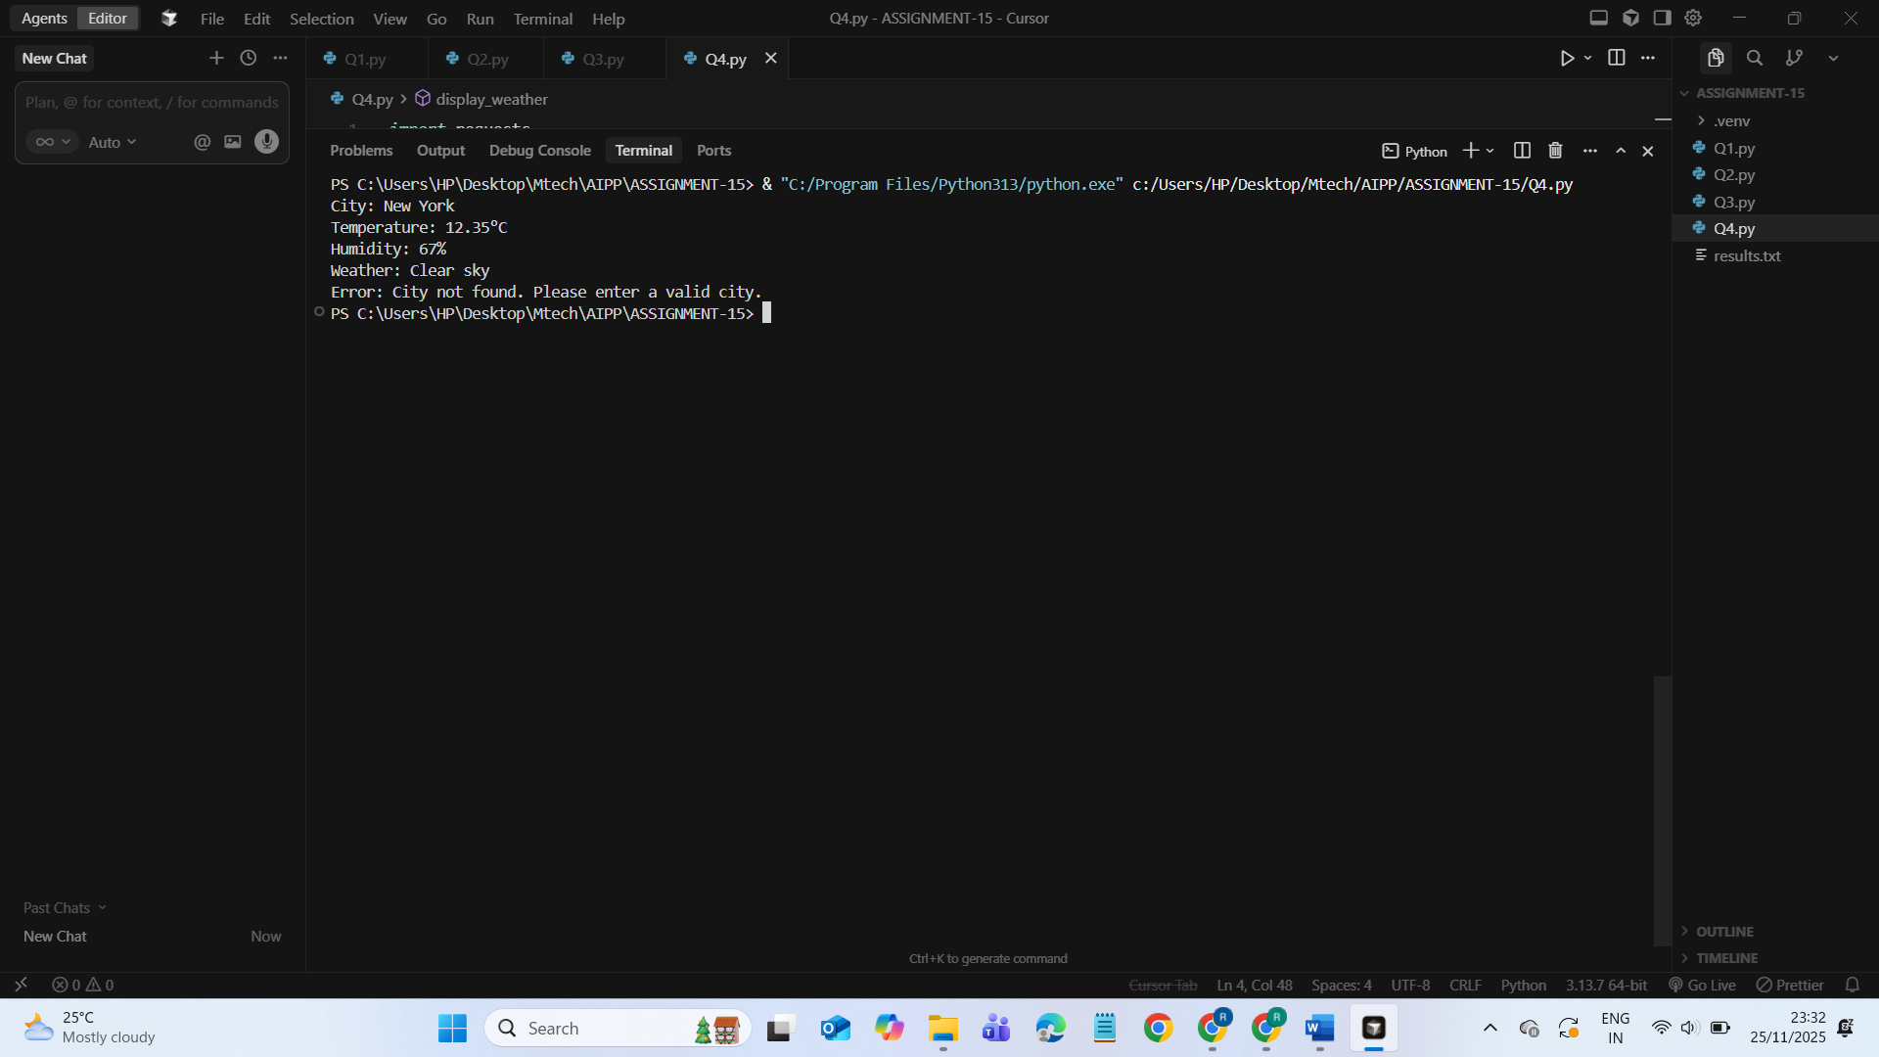  Task 5: Store API Results Locally  - Instructions:  - Extend your function from Task 4.  - Save the extracted API results into a local file (results.json or results.txt).  - Each new request should append results without overwriting old ones.  - Expected Output:  - Console still shows formatted output.  - A local file results.json is created/updated with stored responses like:  - [  - {"city": "London", "temp": 18, "humidity": 60, "weather": "Clear sky"},  - {"city": "New York", "temp": 22, "humidity": 55, "weather": "Few clouds"}  ]  PROMPT:  #write a python function that display weather details of a city using weather api with error handling. Display weather details as JSON output. Store the weather details in current directory as text file, every run output will append  CODE:  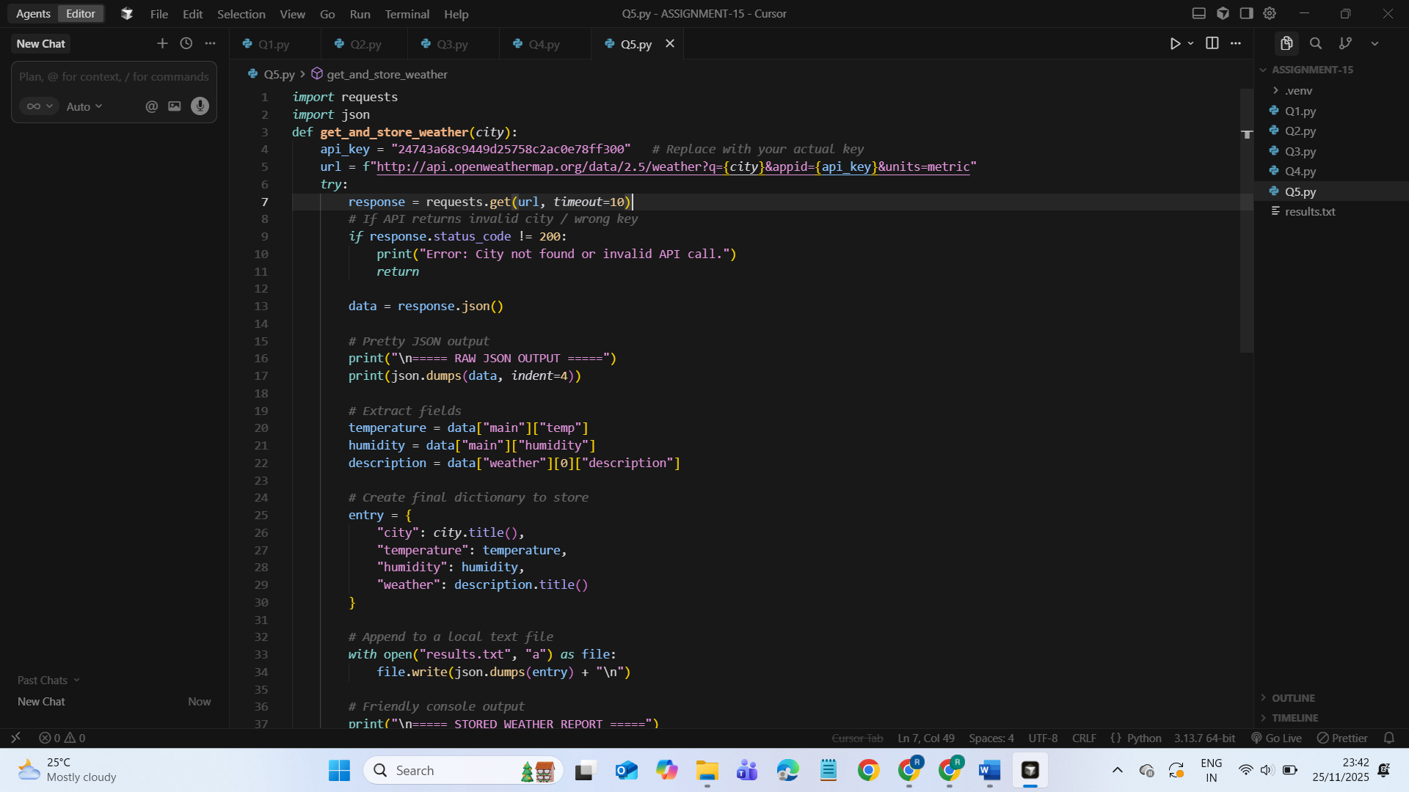  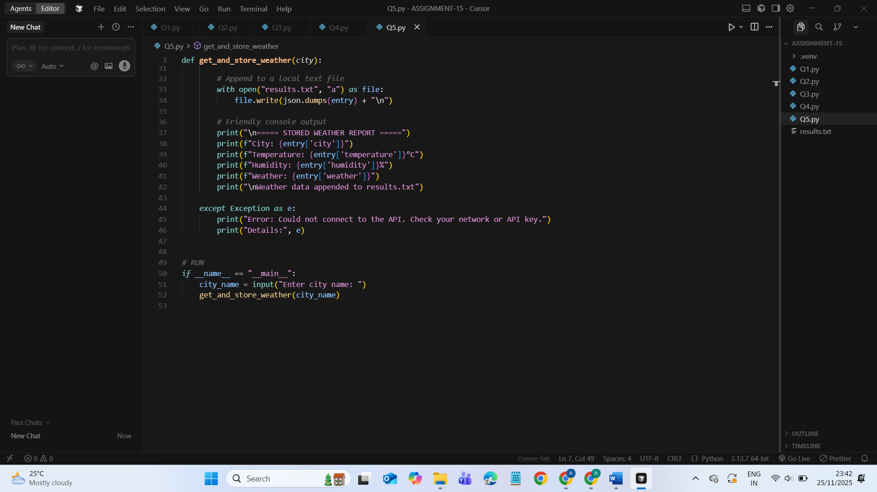  OUTPUT:  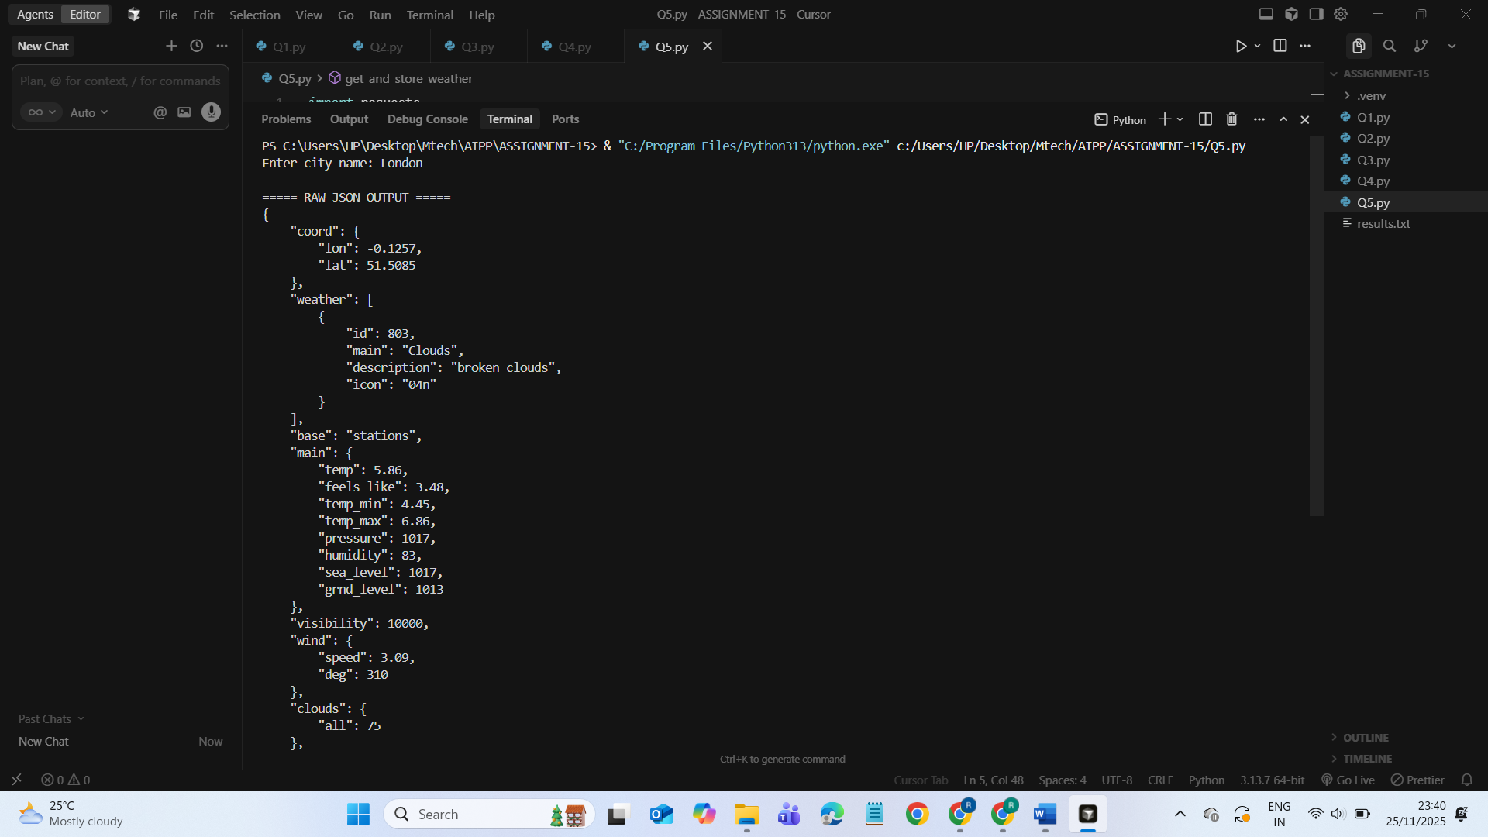  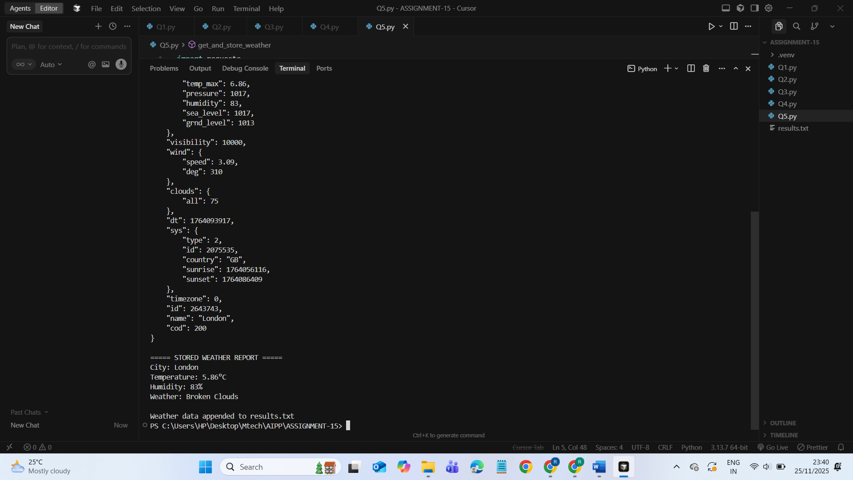  results.txt  